Other Supplementary Material

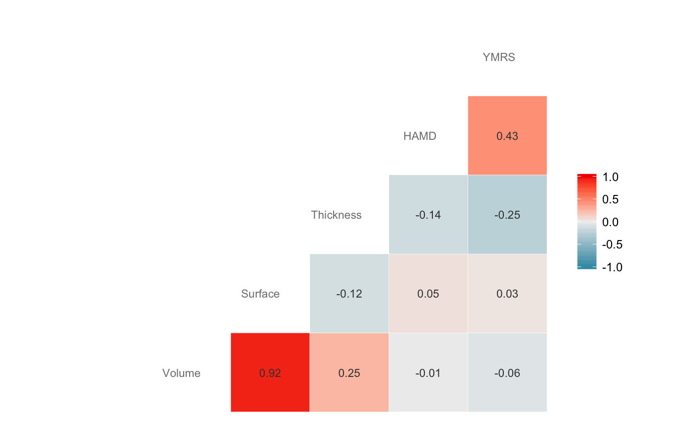
Fig. 1. Correlation heat map between right hemisphere pars triangularis structural measures and clinical scales of mania and depression. Based on 30 individuals with available data within 1 month of scanning.

A subset of the participants has completed the Hamilton Depression Rating Scale (HAM-D) and Young Mania Rating Scale (YMRS) within one month of scanning. There were no statistically significant associations between the cortical measures and the clinical scales, with the greatest negative relationship being between right pars triangularis thickness and YMRS (Pearson r(28) = –.25, p = .19).

