Appendices

Appendix A: Additional Tables and Figures
Figure A.1. Identifying Optimal Diagnostic Short-Forms: Application to DSM-5 AUD
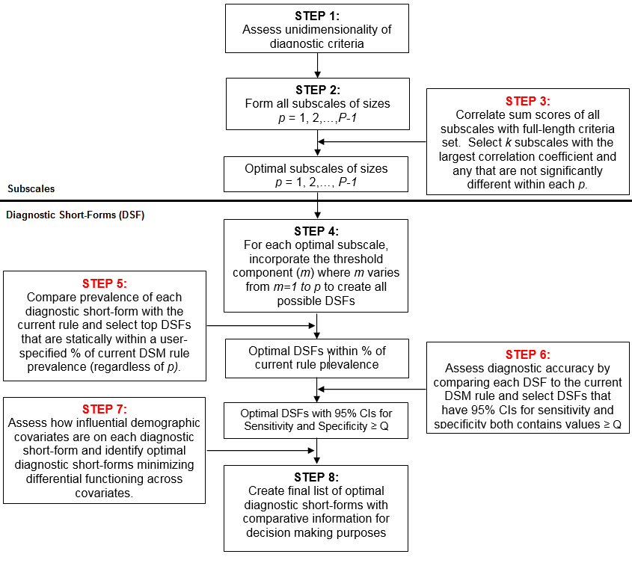

Figure A.2. Pearson Correlations by $p$ for all 2,046 Subscales – Step 3
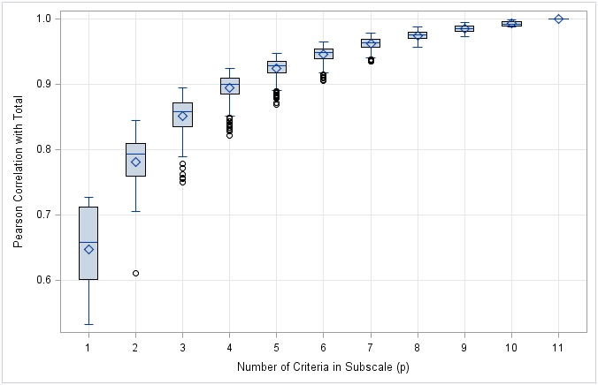

Figure A.3. Difference in Prevalence between DSM-5 AUD and Diagnostic Short-Forms* (values greater than zero indicate DSF prevalence is higher than DSM-5 AUD prevalence, values less than zero indicate DSF prevalence is lower than DSM-5 AUD) – Step 5
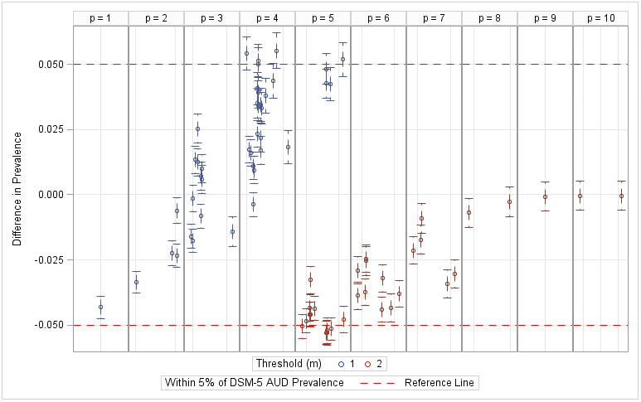
* Only 72 diagnostic short-forms that fall within 5% of DSM-5 AUD prevalence (out of the 401 considered) are shown.

Figure A.4. Sensitivity vs. 1-Specificity for 72 Diagnostic Short-Forms – Step 6
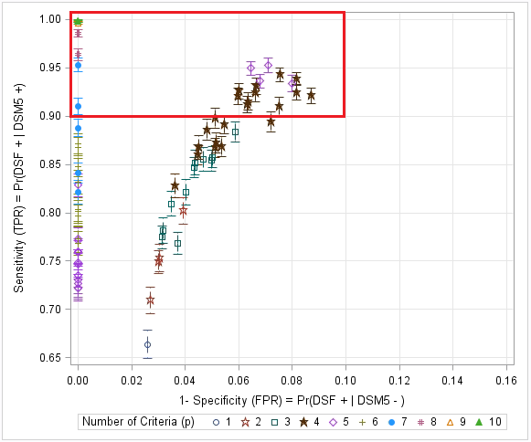
* Red line highlights the 25 diagnostic short-forms that are > 0.90 on both sensitivity and specificity.

Table A.1. Diagnostic Short-forms and Differential Test Functioning – Step 7
DSF Label^{ab} | $$p$$ | $$m$$ | Old vs. Young |  | Male vs. Female |  | Non-White vs. White |  | Any Mood and/or Anxiety Disorder vs. None
 |  |  | Est. (SE) | p-value | Est. (SE) | p-value | Est. (SE) | p-value | Est. (SE) | p-value
510 | 4 | 1 | -0.090 (0.079) | 0.257 | -0.251 (0.076) | 0.001 | 0.096 (0.082) | 0.245 | 0.007 (0.082) | 0.930
860 | 4 | 1 | -0.014 (0.061) | 0.822 | -0.099 (0.056) | 0.077 | -0.211 (0.059) | <0.001 | -0.290 (0.066) | <0.001
864 | 4 | 1 | -0.157 (0.068) | 0.021 | -0.023 (0.066) | 0.729 | -0.039 (0.066) | 0.552 | -0.327 (0.079) | <0.001
866 | 4 | 1 | -0.213 (0.067) | 0.001 | -0.170 (0.068) | 0.012 | -0.235 (0.068) | <0.001 | -0.375 (0.080) | <0.001
884 | 4 | 1 | 0.031 (0.078) | 0.687 | -0.027 (0.066) | 0.681 | -0.224 (0.071) | 0.002 | -0.168 (0.074) | 0.024
892 | 4 | 1 | -0.092 (0.069) | 0.184 | -0.140 (0.067) | 0.038 | 0.051 (0.067) | 0.448 | -0.205 (0.077) | 0.008
894 | 4 | 1 | -0.179 (0.067) | 0.007 | -0.305 (0.068) | <0.001 | -0.183 (0.068) | 0.007 | -0.312 (0.080) | <0.001
896 | 4 | 1 | -0.274 (0.077) | <0.001 | -0.122 (0.082) | 0.139 | -0.088 (0.075) | 0.243 | -0.335 (0.092) | <0.001
988 | 4 | 1 | -0.023 (0.061) | 0.703 | 0.018 (0.056) | 0.753 | 0.068 (0.060) | 0.255 | -0.078 (0.061) | 0.198
992 | 4 | 1 | -0.309 (0.066) | <0.001 | -0.011 (0.066) | 0.863 | -0.028 (0.065) | 0.662 | -0.141 (0.072) | 0.052
1020 | 4 | 1 | -0.256 (0.067) | <0.001 | -0.156 (0.069) | 0.024 | 0.031 (0.067) | 0.642 | -0.114 (0.072) | 0.117
1154 | 4 | 1 | -0.056 (0.063) | 0.371 | -0.045 (0.061) | 0.462 | 0.136 (0.064) | 0.034 | -0.329 (0.069) | <0.001
1406 | 4 | 1 | -0.081 (0.066) | 0.222 | -0.101 (0.062) | 0.107 | 0.071 (0.066) | 0.280 | -0.392 (0.073) | <0.001
1526 | 4 | 1 | 0.025 (0.074) | 0.730 | -0.033 (0.065) | 0.618 | 0.031 (0.069) | 0.651 | -0.063 (0.070) | 0.371
861 | 5 | 1 | -0.065 (0.082) | 0.425 | -0.081 (0.079) | 0.306 | -0.028 (0.079) | 0.728 | -0.313 (0.097) | 0.001
863 | 5 | 1 | -0.199 (0.077) | 0.010 | -0.299 (0.078) | <0.001 | -0.259 (0.078) | 0.001 | -0.348 (0.095) | <0.001
989 | 5 | 1 | -0.272 (0.079) | 0.001 | -0.105 (0.078) | 0.179 | -0.007 (0.077) | 0.929 | -0.058 (0.085) | 0.495
1375 | 5 | 1 | -0.157 (0.073) | 0.032 | -0.026 (0.070) | 0.716 | 0.092 (0.076) | 0.225 | -0.406 (0.083) | <0.001
345 | 7 | 2 | -0.069 (0.068) | 0.315 | -0.095 (0.061) | 0.120 | -0.232 (0.065) | <0.001 | -0.163 (0.070) | 0.019
375 | 7 | 2 | -0.029 (0.093) | 0.755 | -0.007 (0.089) | 0.937 | -0.008 (0.088) | 0.928 | -0.150 (0.096) | 0.120
120 | 8 | 2 | -0.117 (0.106) | 0.272 | -0.073 (0.107) | 0.495 | 0.057 (0.106) | 0.588 | -0.089 (0.110) | 0.417
ª DSF label is the identifier given by the algorithm when all original subscales are enumerated and does not encode any specific information
^{b} Four rules were bypassed from assessment due to very high sensitivity (≥ 97%) and specificity (100%) estimates (DSF 74: p=10, m=2, DSF 26: p=10, m=2, DSF 89: p=9, m=2, DSF 344: p=8, m=2)
Figure A.5. Descriptive Statistics (estimates with 95% CIs) on Optimal Diagnostic Short-Forms for DSM-5 AUD – Step 8
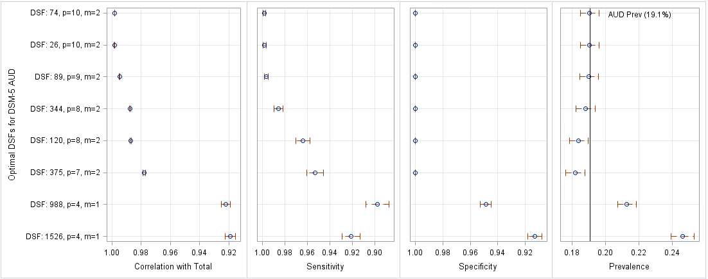
The number after each DSF is a label identifier given by the algorithm when all original subscales are enumerated and does not encode any specific information. P=# of criteria, M=threshold

Table A.2. Version A: DSM-5 AUD Severity vs. DSF 89 AUD Severity in NESARC-III
DSM-5 AUD Severity  (11 criteria) |  | DSF 89 (9 criteria)
 |  | None  (0-1) | Mild  (2-3) | Moderate  (4) | Severe  (5+) | Total
 | None  (0-1) | 20,645  (100.0%) | 0 | 0 | 0 | 20,645  (80.9%)
 | Mild  (2-3) | 18  (0.7%) | 2,606  (99.3%) | 0 | 0 | 2,624  (10.0%)
 | Moderate  (4-5) | 0 | 39  (2.3%) | 704  (59.1%) | 443  (38.5%) | 1,186  (4.4%)
 | Severe  (6+) | 0 | 0 | 4  (0.2%) | 1,319  (99.8%) | 1,323  (4.6%)
 | Total | 20,663  (81.0%) | 2,645  (10.0%) | 708  (2.6%) | 1,762  (6.3%) | 25,778

Table A.3. Distribution of DSM-5 AUD Criteria and Selected Covariates in NESARC-III Split half 1, NESARC-III Split half 2 and Wave 2 NESARC
Criterion / Covariate | Split half 1  (n=12,889) | Split half 2  (n=12,889) | Wave 2 NESARC  (n=22,177)
C1: Used larger amounts / longer | 15.1% | 14.3% | 14.6%
C2: Repeated attempts to quit/control | 13.2% | 12.7% | 12.4%
C3: Much time spent using | 4.8% | 5.1% | 3.0%
C4: Craving | 10.9% | 10.5% | 4.1%
C5: Neglected major roles to use | 1.7% | 2.0% | 1.1%
C6: Social/interpersonal problems | 6.3% | 6.3% | 2.5%
C7: Activities given up to use | 1.7% | 1.8% | 1.0%
C8: Hazardous use | 11.6% | 11.4% | 11.1%
C9: Physical/psychological problems | 7.0% | 7.3% | 5.3%
C10: Tolerance | 9.6% | 9.5% | 8.2%
C11: Withdrawal | 10.5% | 10.7% | 7.9%
Young (<= 44 years old) | 52.4% | 51.6% | 52.2%
Male | 51.1% | 50.3% | 52.1%
White | 81.0% | 80.6% | 75.0%
Any mood and/or anxiety disorders | 22.8% | 21.8% | 17.9%

Figure A.6. Criteria Included/Excluded in Optimal DSFs in both Split Halves*
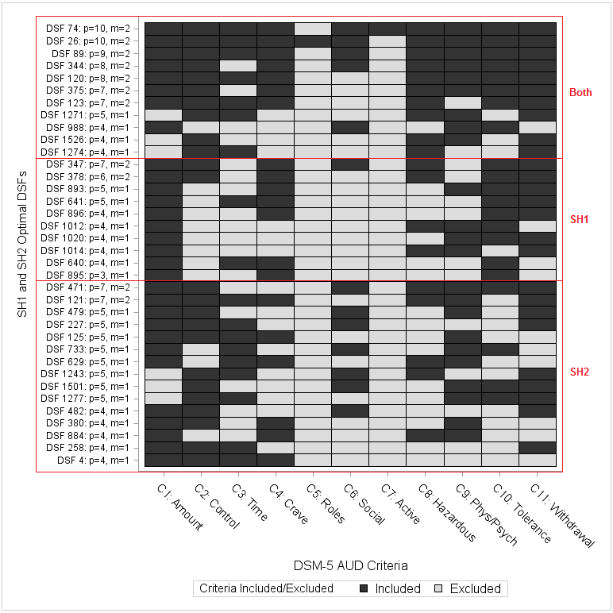
* DSFs ordered by p and combined Sensitivity, Specificity within split-half groups (Both, SH1, SH2)

Figure A.7. Criteria Included/Excluded in Optimal Diagnostic Short-forms for DSM-5 AUD using Wave 2 NESARC
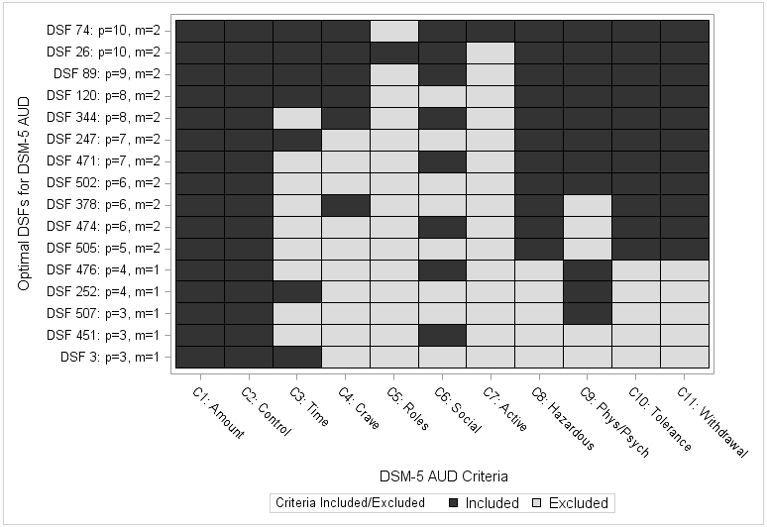

Appendix B: Survey questions from NESARC-III used to elicit each criterion
Figure B.1 Survey Questions used to Elicit C1, C2 and C10
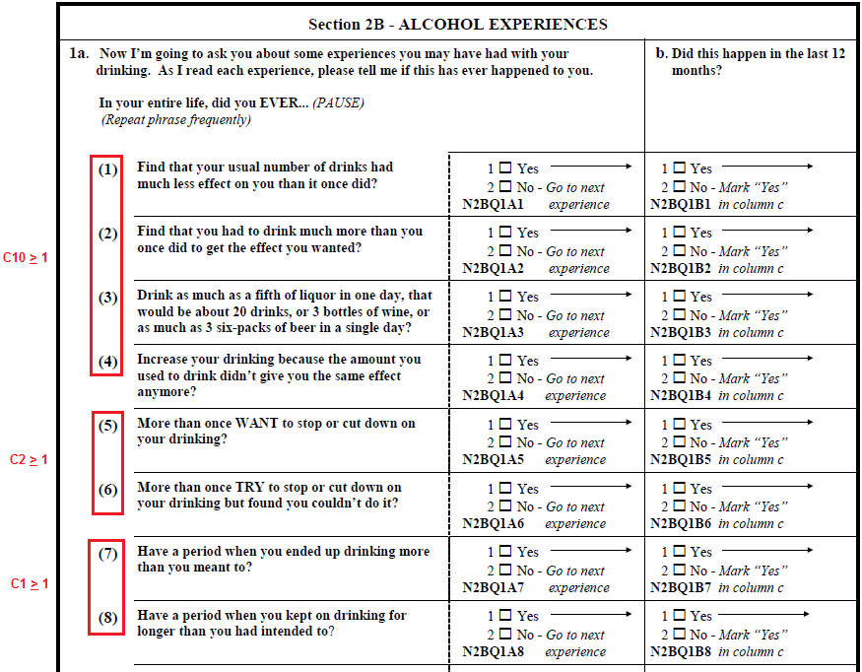

Figure B.2 Survey Questions used to Elicit C3, C4, C7 and C9
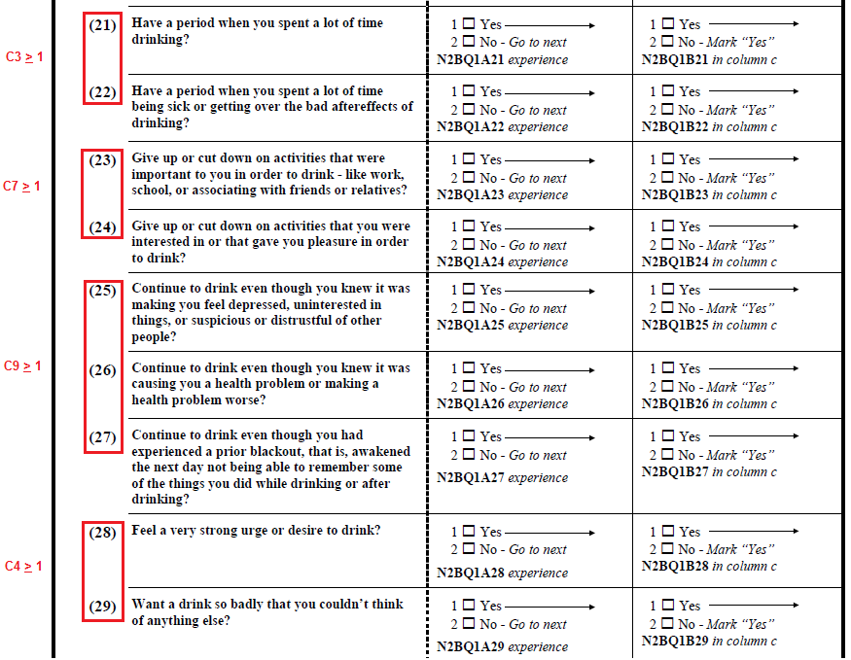

Figure B.3 Survey Questions used to Elicit C5, C6 and C8
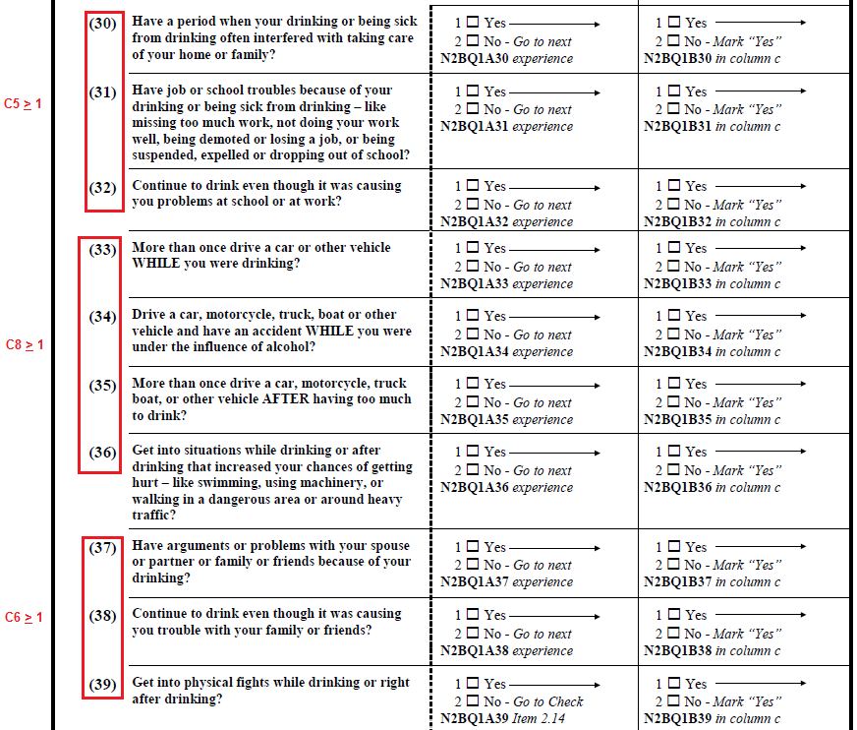

Figure B.4 Survey Questions used to Elicit C11
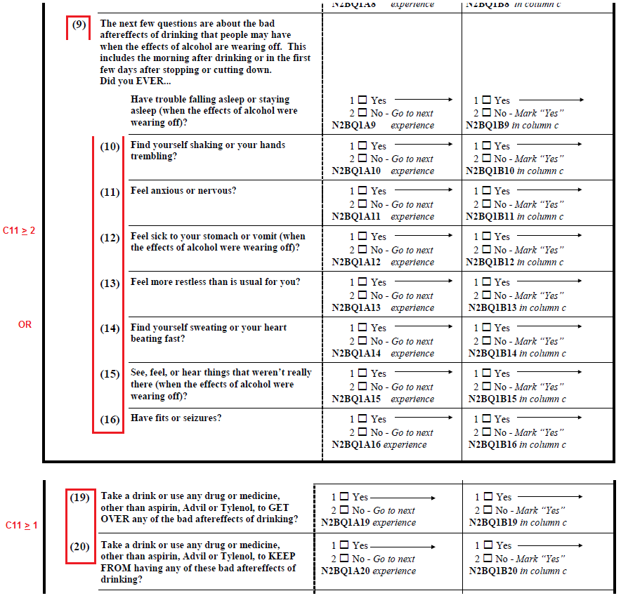

Appendix C: Survey questions from Wave 2 NESARC used to elicit each criterion
Figure C.1 Survey Questions used to Elicit C1, C2 and C10
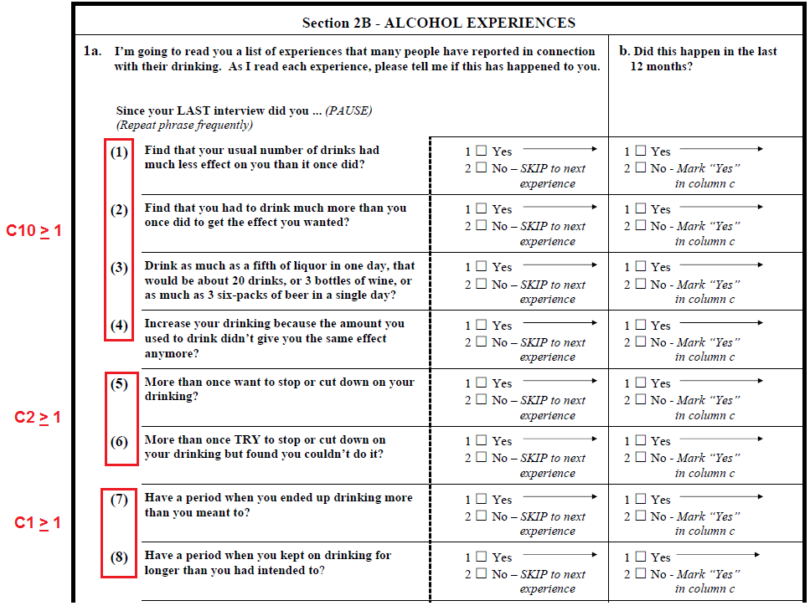

Figure C.2 Survey Questions used to Elicit C11
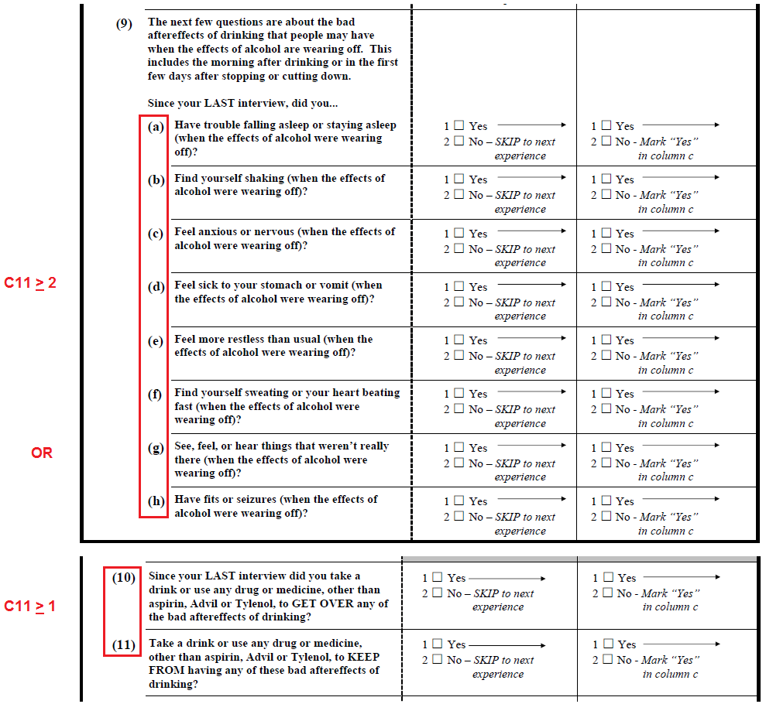

Figure C.3 Survey Questions used to Elicit C3, C5, C7 and C9
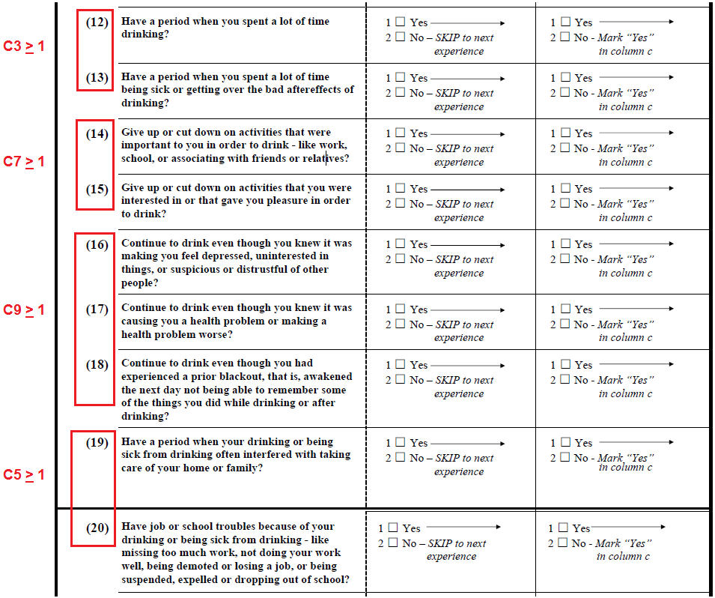

Figure C.4 Survey Questions used to Elicit C6 and C8
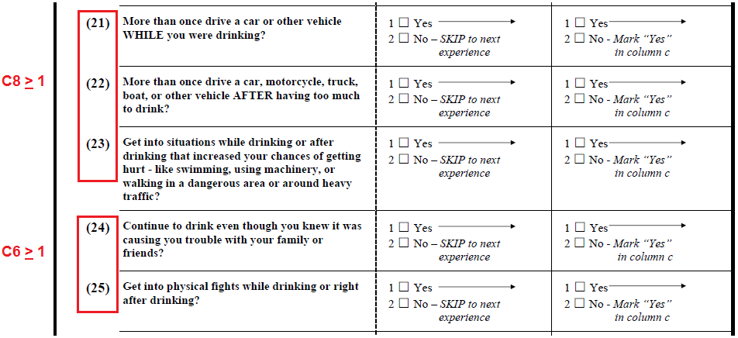

Figure C.5 Survey Questions used to Elicit C4
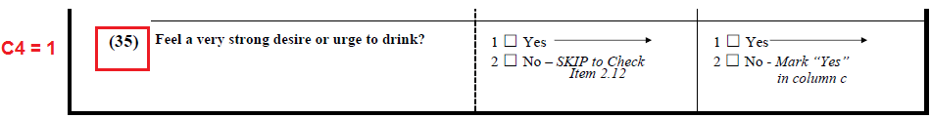

Appendix D: SAS Macro

There are two macros available for download:
- %DSF_v2
  - This macro runs through each step as described in this article and provides a final dataset with the optimal diagnostic short-forms for the specified data set.
- %DSF_TF_v2
  - This macro uses the datasets created in the previous macro to output tables and figures used to investigate findings

Email cheriraffo@gmail.com for downloadable versions.

