Supplementary Figure 1. PRISMA 2009 flow diagram
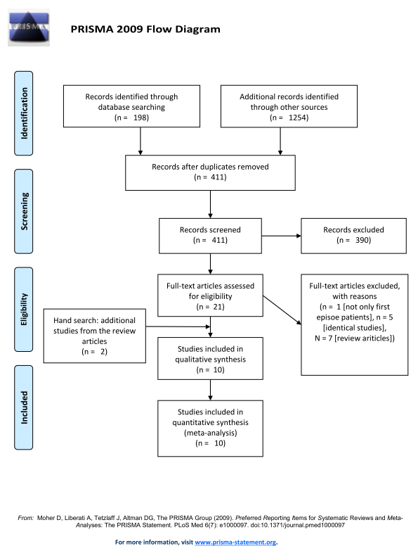
Excluded Studies
Review Articles
Alvarez-Jimenez, M., O'Donoghue, B., Thompson, A., Gleeson, J.F., Bendall, S., Gonzalez-Blanch, C., Killackey, E., Wunderink, L., McGorry, P.D., 2016. Beyond Clinical Remission in First Episode Psychosis: Thoughts on Antipsychotic Maintenance vs. Guided Discontinuation in the Functional Recovery Era. CNS Drugs 30 (5), 357-368.
De Hert, M., Sermon, J., Geerts, P., Vansteelandt, K., Peuskens, J., Detraux, J., 2015. The Use of Continuous Treatment Versus Placebo or Intermittent Treatment Strategies in Stabilized Patients with Schizophrenia: A Systematic Review and Meta-Analysis of Randomized Controlled Trials with First- and Second-Generation Antipsychotics. CNS Drugs 29 (8), 637-658.
Doyle, R., Turner, N., Fanning, F., Brennan, D., Renwick, L., Lawlor, E., Clarke, M., 2014. First-episode psychosis and disengagement from treatment: a systematic review. Psychiatr Serv 65 (5), 603-611.
Goff, D.C., Falkai, P., Fleischhacker, W.W., Girgis, R.R., Kahn, R.M., Uchida, H., Zhao, J., Lieberman, J.A., 2017. The Long-Term Effects of Antipsychotic Medication on Clinical Course in Schizophrenia. Am J Psychiatry 174 (9), 840-849.
Karson, C., Duffy, R.A., Eramo, A., Nylander, A.G., Offord, S.J., 2016. Long-term outcomes of antipsychotic treatment in patients with first-episode schizophrenia: a systematic review. Neuropsychiatr Dis Treat 12, 57-67.
Leucht, S., Tardy, M., Komossa, K., Heres, S., Kissling, W., Salanti, G., Davis, J.M., 2012. Antipsychotic drugs versus placebo for relapse prevention in schizophrenia: a systematic review and meta-analysis. Lancet 379 (9831), 2063-2071.
Zhang, J.P., Gallego, J.A., Robinson, D.G., Malhotra, A.K., Kane, J.M., Correll, C.U., 2013. Efficacy and safety of individual second-generation vs. first-generation antipsychotics in first-episode psychosis: a systematic review and meta-analysis. Int J Neuropsychopharmacol 16 (6), 1205-1218.

Not Only First Episode Patients Study
Wiedemann, G., Hahlweg, K., Muller, U., Feinstein, E., Hank, G., Dose, M., 2001. Effectiveness of targeted intervention and maintenance pharmacotherapy in conjunction with family intervention in schizophrenia. Eur Arch Psychiatry Clin Neurosci 251 (2), 72-84.

Identical Studies
Gaebel, W., Frick, U., Kopcke, W., Linden, M., Muller, P., Muller-Spahn, F., Pietzcker, A., Tegeler, J., 1993. Early neuroleptic intervention in schizophrenia: are prodromal symptoms valid predictors of relapse? Br J Psychiatry Suppl(21), 8-12.
Gaebel, W., Riesbeck, M., Wolwer, W., Klimke, A., Eickhoff, M., von Wilmsdorff, M., Heuser, I., Maier, W., Klosterkotter, J., Falkai, P., Schlosser, R., Schmitt, A., Riedel, M., Klingberg, S., Kopcke, W., Ohmann, C., Moller, H.J., 2014. Rates and predictors of remission in first-episode schizophrenia within 1 year of antipsychotic maintenance treatment. Results of a randomized controlled trial within the German Research Network on Schizophrenia. Schizophr Res 152 (2-3), 478-486.
Godemann, F., Linden, M., Gaebel, W., Kopke, W., Muller, P., Muller-Spahn, F., Tegeler, J., Pietzcker, A., 2003. Is interval medication a successful treatment regimen for schizophrenic patients with critical attitudes towards treatment? Eur Psychiatry 18 (2), 82-84.
Muller, P., Bandelow, B., Gaebel, W., Kopcke, W., Linden, M., Muller-Spahn, F., Pietzcker, A., Schaefer, E., Tegeler, J., 1992. Intermittent medication, coping and psychotherapy. Interactions in relapse prevention and course modification. Br J Psychiatry Suppl(18), 140-144.
Wunderink, L., Nieboer, R.M., Wiersma, D., Sytema, S., Nienhuis, F.J., 2013. Recovery in remitted first-episode psychosis at 7 years of follow-up of an early dose reduction/discontinuation or maintenance treatment strategy: long-term follow-up of a 2-year randomized clinical trial. JAMA Psychiatry 70 (9), 913-920.

Supplementary Figure 2. Risk of bias summary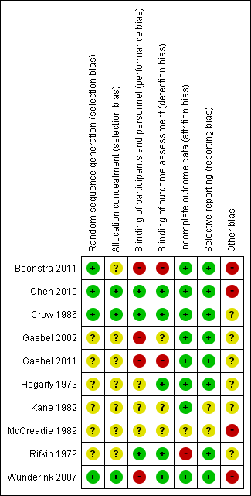

Supplementary Figure 3. Forest plot for the relapse rate at 12 months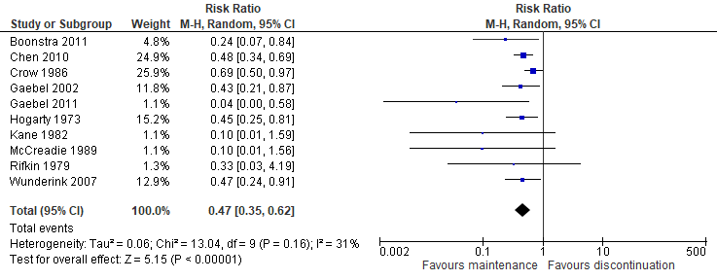

Supplementary Figure 4. Funnel plot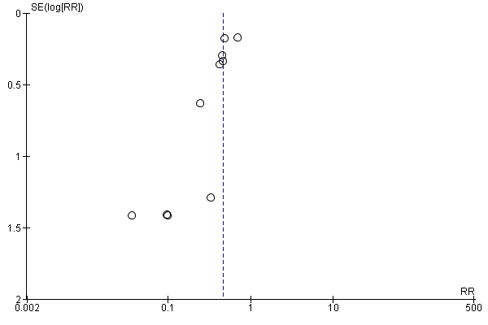

Supplementary Figure 5. Forest plot for the relapse rate at 1 month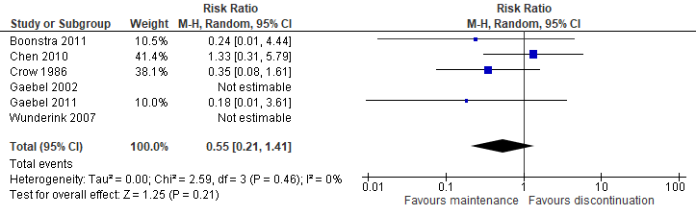

Supplementary Figure 6. Forest plot for the relapse rate at 2 months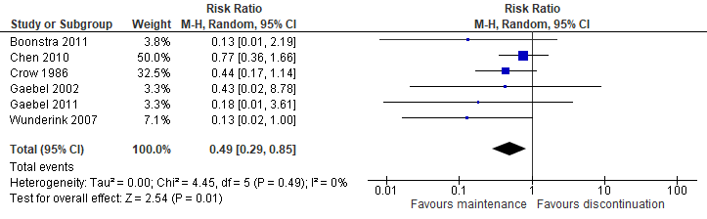

Supplementary Figure 7. Forest plot for the relapse rate at 3 months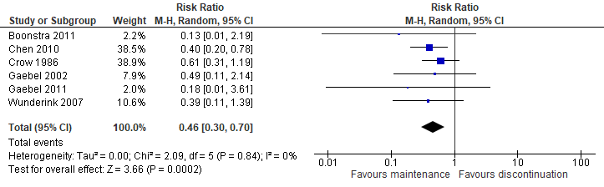

Supplementary Figure 8. Forest plot for the relapse rate at 6 months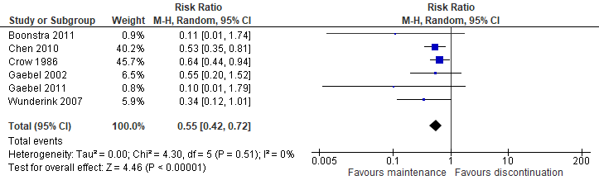

Supplementary Figure 9. Forest plot for the relapse rate at 9 months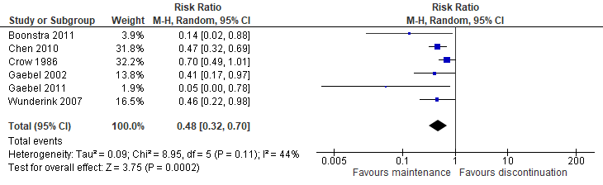

Supplementary Figure 10. Forest plot for the relapse rate at 18–24 months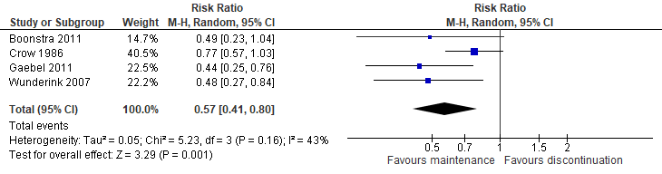

Supplementary Figure 11. Forest plot for discontinuation due to all causes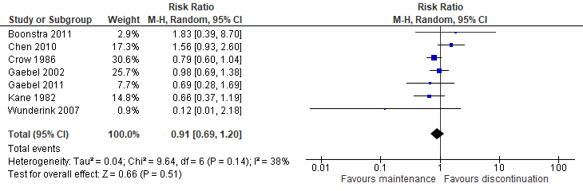

Supplementary Figure 12. Forest plot for discontinuation due to adverse events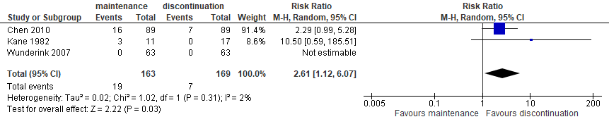

Supplementary Figure 13. Forest plot for discontinuation because of withdrawn consent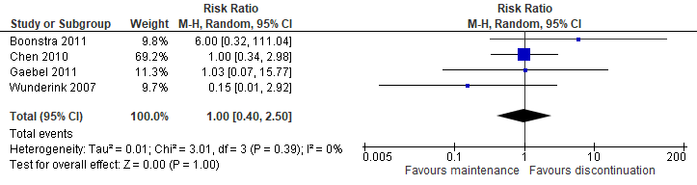

Supplementary Figure 14. Forest plot for discontinuation due to loss to follow-up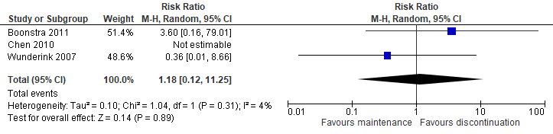

Supplementary Figure 15. Forest plot for Positive and Negative Syndrome Scale positive subscale scores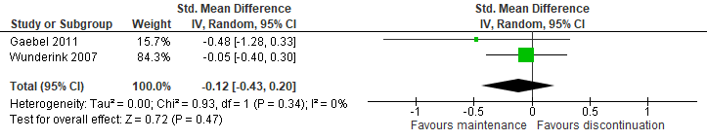

Supplementary Figure 16. Forest plot for Positive and Negative Syndrome Scale negative subscale scores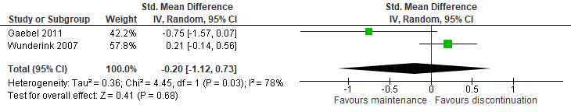

Supplementary Figure 17. Forest plot for Positive and Negative Syndrome Scale general subscale scores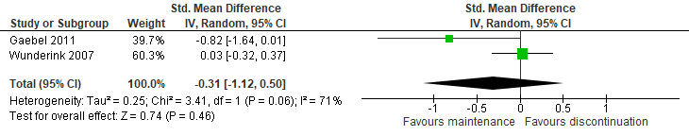

Supplementary Figure 18. Forest plot for quality of life scores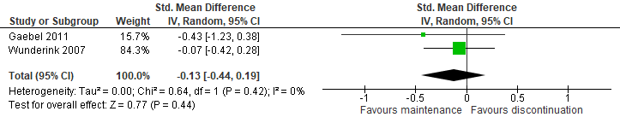

Supplementary Figure 19. Forest plot for extrapyramidal symptoms scores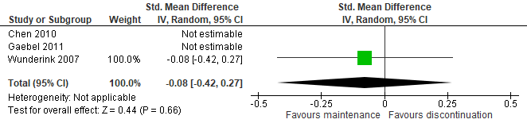

Supplementary Figure 20. Forest plot for the use of anticholinergic drugs/incidence of tremor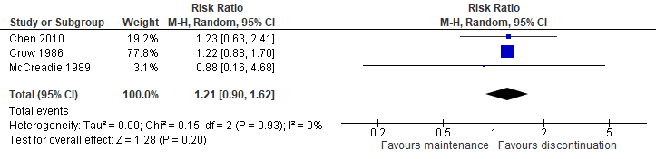

Supplementary Table 1. Definitions of remission and relapse
 | Remission | Relapse
Boonstra 2011 | > 1 PANSS core psychosis item score (delusions, conceptual disorganization, hallucinatory behavior, suspiciousness or persecution) ≤ 3 for > 1 year | > 1 PANSS core psychosis item score (delusions, conceptual disorganization, hallucinatory behavior, suspiciousness or persecution) > 4 and PANSS total score > 20% increase or hospitalization for any psychiatric indication.
Chen 2010 | PANSS delusions score ≤ 2, conceptual disorganization score ≤ 3, hallucinatory behavior score ≤ 2, suspiciousness score ≤ 4, unusual thought content score ≤ 3, CGI-S ≤ 2 for > 8 weeks | PANSS delusions score > 3, conceptual disorganization score > 4, hallucinatory behavior score > 3, suspiciousness score > 5, unusual thought content score > 4, CGI-S > 3, CHI-I > 5 for > 1 week
Crow 1986 | Discharge maintained for > 30 days post index episode | Hospitalization or imminent relapse requiring antipsychotic medication
Gaebel 2002 | NR | BPRS psychosis item score (hostile suspiciousness, though disturbance, activation) > 10, GAS < 20, CGI-S > 6, clinician’s judgement
Gaebel 2011 | NR | PANSS positive score > 10 increase, GAF > 20 decrease, CGI-C > 6
Hogarty 1973 | NR | Clinical deterioration of such magnitude that hospitalization appeared imminent
Kane 1982 | NR | Substantial clinical deterioration with a potential for marked social impairment
McCreadie 1989 | NR | Hospitalization
Rifkin 1979 | No positive symptoms | Significant clinical deterioration with a potential for, or actual, marked social impairment
Wunderink 2007 | Sustained improvement of positive symptoms as measured by  PANSS reﬂecting symptom severity levels at or below the level of response (i.e., clinical improvement to a non-ﬂorid psychotic state for > 1 week, reported by clinician and conﬁrmed by PANSS positive subscale score) for > 6 months | Clinical deterioration for > 1 week having consequences  (increased antipsychotic dose, hospitalization, increased frequency of consultations) reported by clinician and conﬁrmed by > 1 PANSS positive subscale items score > 5

BPRS: Brief Psychiatric Rating Scale, CGI-C: Clinical Global Impression-Global Change, CGI-I: Clinical Global Impression-Global Improvement, CGI-S: Clinical Global Impressions-Severity Illness Scale, GAF: Global Assessment of Functioning, GAS: Global Assessment Scale, NR: not report, PANSS: Positive and Negative Syndrome Scale

Supplementary Table 2. Results of the subgroup analyses
Modulators | Subgroup | N | n | RR | 95% CI | p | I² | NNT | p for subgroup difference
Antipsychotic class | SGAs (quetiapine) alone | 1 | 178 | 0.48 | 0.34–0.69 | <0.0001 | na | 3 | 0.76
 | SGAs and FGAs | 3 | 192 | 0.27 | 0.09–0.80 | 0.02 | 52% | 2
 | FGAs alone | 5 | 254 | 0.51 | 0.31–0.84 | 0.009 | 31% | 3
 | Unknown | 1 | 115 | 0.43 | 0.21–0.87 | 0.02 | na | 3
Placebo use | Placebo-controlled studies | 6 | 432 | 0.53 | 0.39–0.71 | <0.0001 | 22% | 3 | 0.26
 | Non-placebo-controlled studies | 4 | 307 | 0.37 | 0.21–0.64 | 0.0005 | 26% | 3
Diagnosis | Schizophrenia-only studies | 5 | 223 | 0.20 | 0.04–0.95 | 0.04 | 66% | 3 | 0.31
 | Studies with various psychotic disorders | 5 | 516 | 0.45 | 0.35–0.58 | <0.00001 | 0% | 3
Sponsorship | Industry-sponsored studies | 4 | 341 | 0.45 | 0.33–0.61 | <0.00001 | 0% | 3 | 0.08
 | Non-industry-sponsored studies | 5 | 278 | 0.37 | 0.22–0.65 | 0.0005 | 17% | 3
 | Unknown | 1 | 120 | 0.69 | 0.50–0.97 | 0.03 | na | 5
Antipsychotic discontinuation | Studies with abrupt discontinuation of antipsychotics | 4 | 134 | 0.40 | 0.23–0.68 | 0.0009 | 0% | 3 | 0.98
 | Studies where the antipsychotics were discontinued after gradually tapering the dose over several months | 6 | 605 | 0.48 | 0.34–0.69 | <0.0001 | 47% | 3
Remission at baseline | Studies that included only patients remitted at baseline | 5 | 370 | 0.45 | 0.33–0.61 | <0.00001 | 0% | 3 | 0.55
 | Other studies | 5 | 369 | 0.45 | 0.25–0.79 | 0.006 | 59% | 3
Wunderink 2007 study | Wunderink 2007 study | 1 | 128 | 0.47 | 0.24–0.91 | 0.03 | na | 6 | 0.92
 | Other studies | 9 | 611 | 0.45 | 0.32–0.64 | <0.00001 | 39% | 3
Psychological intervention | Studies with known psychological intervention | 7 | 481 | 0.46 | 0.31–0.69 | 0.0001 | 46% | 3 | 0.82
 | Other studies | 3 | 258 | 0.43 | 0.27–0.69 | 0.0005 | 0% | 4

95% CI: 95% confidence interval, FGAs: First-generation antipsychotics, N: number of studies, n: number of patients, na: not applicable, NNT: number-needed-to-treat, RR: risk ratio, SGAs: second generation antipsychotics

Supplementary Table 3. Results of the meta-regression analysis
 | Number of studies | Coefficient | Standard error | 95% confidence interval | Z | p
Total number of patients | 10 | 0.0043 | 0.0032 | –0.0019 to 0.0106 | 1.35 | 0.177
Study duration | 10 | 0.0122 | 0.0255 | –0.0377 to 0.0621 | 0.48 | 0.632
Publication year | 10 | –0.0068 | 0.0102 | –0.0268 to 0.0132 | –0.67 | 0.506
Percentage of males | 7 | –0.0050 | 0.0174 | –0.0391 to 0.0290 | –0.29 | 0.773
Age | 7 | –0.0664 | 0.0741 | –0.212 to 0.0787 | –0.90 | 0.370
Duration of illness | 5 | 0.0024 | 0.0191 | –0.0350 to 0.0398 | 0.13 | 0.899
Antipsychotic dose at baseline | 4 | –1.78 | 1.07 | –3.88 to 0.321 | –1.66 | 0.0968

Supplementary Table 4. Results of the meta-regression analysis: relapse rate and length of time from tapering antipsychotic to antipsychotic discontinuation (6 studies, 605 patients)
 | Point estimate | Standard error | 95% confidence interval | Z | p
Relapse rate at 1 month | –0.119 | 0.0896 | –0.294 to 0.0571 | –1.32 | 0.186
Relapse rate at 2 months | –0.0959 | 0.0568 | –0.207 to 0.0155 | –1.69 | 0.0915
Relapse rate at 3 months | 0.00602 | 0.0442 | –0.0807 to 0.0927 | 0.136 | 0.892
Relapse rate at 6 months | –0.0103 | 0.0315 | –0.0721 to 0.0515 | –0.328 | 0.743
Relapse rate at 9 months | 0.0120 | 0.0265 | –0.0400 to 0.0641 | 0.454 | 0.650
Relapse rate at 12 months | 0.0102 | 0.0241 | –0.0370 to 0.0575 | 0.425 | 0.671

