Online Table 1. PubMed search strategy
- help seek*
- seek* help
- seek* care
- care seek*
- service seek*
- treatment seek*
- service use
- service utilization
- Health Care Utilization [MeSH:noexp]
- Help Seeking Behavior [MeSH:noexp]
- 1 or 2 or 3 or 4 or 5 or 6 or 7 or 8 or 9 or 10
- Mental Health [MeSH:noexp]
- mental illness
- mental health problem
- Mental Disorders [MeSH]
- psychosis [tiab]
- psychotic [tiab]
- schizo* [tiab]
- depression [tiab]
- depressive [tiab]
- bipolar [tiab]
- mania [tiab]
- manic [tiab]
- anxiety [tiab]
- obsessi* [tiab]
- panic [tiab]
- phobia [tiab]
- anorexi* [tiab]
- bulimi* [tiab]
- borderline [tiab]
- narcissis* [tiab]
- personality disorder [tiab]
- self injur* [tiab]
- self harm [tiab]
- suicid* [tiab]
- dementia [tiab]
- substance abuse [tiab]
- substance dependence [tiab]
- 12 or 13 or 14 or 15 or 16 or 17 or 18 or 19 or 20 or 21 or 22 or 23 or 24 or 25 or 26 or 27 or 28 or 29 or 30 or 31 or 32 or 33 or 34 or 35 or 36 or 37 or 38
- Clinical Trial [MeSH]
- randomized controlled trial [pt]
- controlled clinical trial [pt]
- randomized [tiab]
- randomly [tiab]
- trial [ti]
- 40 or 41 or 42 or 43 or 44 or 45
- 11 and 39 and 46

Online Table 2. List of included studies
Albright, G., Goldman, R., Shockley, K. M., McDevitt, F. & Akabas, S. (2012). Using an Avatar-based simulation to train families to motivate veterans with post-deployment stress to seek help at the VA. Games for Health Journal 1, 21-8.
Areán, P. A., Gum, A. M., Tang, L. & Unützer, J. (2007). Service use and outcomes among elderly persons with low incomes being treated for depression. Psychiatric Services 58, 1057-1064.
Asarnow, J. R., Baraff, L. J., Berk, M., Grob, C. S., Devich-Navarro, M., Suddath, R., Piacentini, J. C., Rotheram-Borus, M. J., Cohen, D. & Tang, L. (2011). An emergency department intervention for linking pediatric suicidal patients to follow-up mental health treatment. Psychiatric Services 62, 1303-1309.
Baer, J. S., Garrett, S. B., Beadnell, B., Wells, E. A. & Peterson, P. L. (2007). Brief motivational intervention with homeless adolescents: evaluating effects on substance use and service utilization. Psychology of Addictive Behaviors 21, 582-586.
Bartels, S. J., Coakley, E. H., Zubritsky, C., Ware, J. H., Miles, K. M., Areán, P. A., Chen, H., Oslin, D. W., Llorente, M. D., Costantino, G., Quijano, L., McIntyre, J. S., Linkins, K. W., Oxman, T. E., Maxwell, J. & Levkoff, S. E. (2004). Improving access to geriatric mental health services: a randomized trial comparing treatment engagement with integrated versus enhanced referral care for depression, anxiety, and at-risk alcohol use. American Journal of Psychiatry 161, 1455-1462.
Batterham, P. J., Calear, A. L., Sunderland, M., Carragher, N. & Brewer, J. L. (2016). Online screening and feedback to increase help-seeking for mental health problems: population-based randomised controlled trial. British Journal of Psychiatry Open 2, 67-73.
Bauer, S., Okon, E., Meermann, R. & Kordy, H. (2013). Aftercare based on text messaging: Services across health care sectors for patients with bulima nervosa. Verhaltenstherapie 23, 204-209.
Belsher, B. E., Jaycox, L. H., Freed, M. C., Evatt, D. P., Liu, X., Novak, L. A., Zatzick, D., Bray, R. M. & Engel, C. C. (2016). Mental health utilization patterns during a stepped, collaborative care effectiveness trial for PTSD and depression in the military health system. Medical Care 54, 706-713.
Booth, R. E., Kwiatkowski, C., Iguchi, M. Y., Pinto, F. & John, D. (1998). Facilitating treatment entry among out-of-treatment injection drug users. Public Health Reports Suppl 1, 116-128.
Brooner, R. K., Kidorf, M. S., King, V. L., Peirce, J., Neufeld, K., Stoller, K. & Kolodner, K. (2013). Managing psychiatric comorbidity within versus outside of methadone treatment settings: a randomized and controlled evaluation. Addiction 108, 1942-1951.
Buckley, G. I. & Malouff, J. M. (2005). Using modeling and vicarious reinforcement to produce more positive attitudes toward mental health treatment. Journal of Psychology: Interdisciplinary and Applied 139, 197-209.
Carroll, K. M., Libby, B., Sheehan, J. & Hyland, N. (2001). Motivational interviewing to enhance treatment initiation in substance abusers: an effectiveness study. American Journal on Addictions 10, 335-9.
Casas, R. N., Gonzales, E., Aldana-Aragón, E., Lara-Muñoz Mdel, C., Kopelowicz, A., Andrews, L. & López, S. R. (2014). Toward the early recognition of psychosis among Spanish-speaking adults on both sides of the U.S.-Mexico border. Psychological Services 11, 460-469.
Cheng, T. L., Wright, J. L., Markakis, D., Copeland-Linder, N. & Menvielle, E. (2008). Randomized trial of a case management program for assault-injured youth - Impact on service utilization and risk for reinjury. Pediatric Emergency Care 24, 130-136.
Chisholm, K., Patterson, P., Torgerson, C., Turner, E., Jenkinson, D. & Birchwood, M. (2016). Impact of contact on adolescents' mental health literacy and stigma: The schoolspace cluster randomised controlled trial. BMJ Open 6, e009435.
Christensen, H., Leach, L. S., Barney, L., Mackinnon, A. J. & Griffiths, K. M. (2006). The effect of web based depression interventions on self reported help seeking: randomised controlled trial. BMC Psychiatry 6, 13.
Chung, B., Ong, M., Ettner, S. L., Jones, F., Gilmore, J., McCreary, M., Sherbourne, C., Ngo, V., Koegel, P., Tang, L., Dixon, E., Miranda, J., Belin, T. R. & Wells, K. B. (2014). 12-month outcomes of community engagement versus technical assistance to implement depression collaborative care: a partnered, cluster, randomized, comparative effectiveness trial. Annals of Internal Medicine 161, S23-34.
Ciffone, J. (2007). Suicide prevention: An analysis and replication of a curriculum-based high school program. Social Work 52, 41-49.
Cooper, L. A., Ghods Dinoso, B. K., Ford, D. E., Roter, D. L., Primm, A. B., Larson, S. M., Gill, J. M., Noronha, G. J., Shaya, E. K. & Wang, N. Y. (2013). Comparative effectiveness of standard versus patient-centered collaborative care interventions for depression among African Americans in primary care settings: the BRIDGE Study. Health Services Research 48, 150-174.
Costin, D. L., Mackinnon, A. J., Griffiths, K. M., Batterham, P. J., Bennett, A. J., Bennett, K. & Christensen, H. (2009). Health e-cards as a means of encouraging help seeking for depression among young adults: randomized controlled trial. Journal of Medical Internet Research 11, e42.
Demyan, A. L. & Anderson, T. (2012). Effects of a brief media intervention on expectations, attitudes, and intentions of mental health help seeking. Journal of Counseling Psychology 59, 222-229.
Dueweke, A. R. & Bridges, A. J. (2016). The effects of brief, passive psychoeducation on suicide literacy, stigma, and attitudes toward help-seeking among Latino immigrants living in the United States. Stigma and Health 2, 28-42.
Festinger, D. S., Lamb, R. J., Kirby, K. C. & Marlowe, D. B. (1996). The accelerated intake: a method for increasing initial attendance to outpatient cocaine treatment. Journal of Applied Behavior Analysis 29, 387-389.
Fitzpatrick, C., Conlon, A., Cleary, D., Power, M., King, F. & Guerin, S. (2013). Enhancing the mental health promotion component of a health and personal development programme in Irish schools. Advances in School Mental Health Promotion 6, 122-138.
Fox, J. C., Blank, M., Berman, J. & Rovnyak, V. G. (1999). Mental disorders and help seeking in a rural impoverished population. International Journal of Psychiatry in Medicine 29, 181-195.
Garcia, E. F. Y., Joseph, J., Wilson, M. D., Hinton, L., Simon, G., Ludman, E., Scott, F. & Kravitz, R. L. (2015). Pediatric-based intervention to motivate mothers to seek follow-up for depression screens: The motivating our mothers (MOM) trial. Academic Pediatrics 15, 311-318.
Ghafoori, B., Fisher, D., Korosteleva, O. & Hong, M. (2016). A randomized, controlled pilot study of a single-session psychoeducation treatment for urban, culturally diverse, trauma-exposed adults. Journal of Nervous and Mental Disease 204, 421-30.
Goldberg, H. I., Mullen, M., Ries, R. K., Psaty, B. M. & Ruch, B. P. (1991). Alcohol counseling in a general medicine clinic. A randomized controlled trial of strategies to improve referral and show rates. Medical Care 29, 49-56.
Griffiths, K. M., Bennett, K., Walker, J., Goldsmid, S. & Bennett, A. (2016). Effectiveness of MH-Guru, a brief online mental health program for the workplace: A randomised controlled trial. Internet Interventions 6, 29-39.
Grupp-Phelan, J., McGuire, L., Husky, M. M. & Olfson, M. (2012). A randomized controlled trial to engage in care of adolescent emergency department patients with mental health problems that increase suicide risk. Pediatric Emergency Care 28, 1263-1268.
Gulliver, A., Griffiths, K. M., Christensen, H., Mackinnon, A., Calear, A. L., Parsons, A., Bennett, K., Batterham, P. J. & Stanimirovic, R. (2012). Internet-based interventions to promote mental health help-seeking in elite athletes: an exploratory randomized controlled trial. Journal of medical Internet research 14, e69.
Han, D. Y., Chen, S. H., Hwang, K. K. & Wei, H. L. (2006). Effects of psychoeducation for depression on help-seeking willingness: Biological attribution versus destigmatization. Psychiatry and clinical neurosciences 60, 662-668.
Hao, Z. & Liang, B. (2011). Effect of group guidance on intention of seeking professional psychological help among university students. Chinese Journal of Clinical Psychology 19, 699-702.
Hay, P., Mond, J., Paxton, S., Rodgers, B., Darby, A. & Owen, C. (2007). What are the effects of providing evidence-based information on eating disorders and their treatments? A randomized controlled trial in a symptomatic community sample. Early Intervention in Psychiatry 1, 316-324.
Heerde, J. A., Toumbourou, J. W., Hemphill, S. A. & Olsson, C. A. (2015). Longitudinal prediction of mid-adolescent psychosocial outcomes from early adolescent family help seeking and family support. Journal of Research on Adolescence 25, 310-327.
Holloway, F. & Carson, J. (1998). Intensive case management for the severely mentally ill. Controlled trial. British Journal of Psychiatry 172, 19-22.
Hui, A., Wong, P. W. & Fu, K. W. (2015). Evaluation of an online campaign for promoting help-seeking attitudes for depression using a Facebook advertisement: An online randomized controlled experiment. JMIR Ment Health 2, e5.
John, U., Veltrup, C., Driessen, M., Wetterling, T. & Dilling, H. (2003). Motivational intervention: An individual counselling vs a group treatment approach for alcohol-dependent in-patients. Alcohol and Alcoholism 38, 263-269.
Jorm, A. F., Griffiths, K. M., Christensen, H., Korten, A. E., Parslow, R. A. & Rodgers, B. (2003). Providing information about the effectiveness of treatment options to depressed people in the community: a randomized controlled trial of effects on mental health literacy, help-seeking and symptoms. Psychological Medicine 33, 1071-1079.
Kidorf, M., Disney, E., King, V., Kolodner, K., Beilenson, P. & Brooner, R. K. (2005). Challenges in motivating treatment enrollment in community syringe exchange participants. Journal of Urban Health 82, 456-467.
Kidorf, M., King, V. L., Neufeld, K., Peirce, J., Kolodner, K. & Brooner, R. K. (2009). Improving substance abuse treatment enrollment in community syringe exchangers. Addiction 104, 786-795.
Kim, S. E., Blanc, A. J., Michalopoulos, C., Azocar, F., Ludman, E. J., Butler, D. M. & Simon, G. E. (2011). Does telephone care management help Medicaid beneficiaries with depression? American Journal of Managed Care 17, e375-382.
King, C. A., Eisenberg, D., Zheng, K., Czyz, E., Kramer, A., Horwitz, A. & Chermack, S. (2015). Online suicide risk screening and intervention with college students: a pilot randomized controlled trial. Journal of Consulting and Clinical Psychology 83, 630-636.
Klimes-Dougan, B., Wright, N. & Klingbeil, D. A. (2016). Suicide prevention public service announcements impact help-seeking attitudes: The message makes a difference. Front Psychiatry 7, 124.
Kosyluk, K. A., Al-Khouja, M., Bink, A., Buchholz, B., Ellefson, S., Fokuo, K., Goldberg, D., Kraus, D., Leon, A., Michaels, P., Powell, K., Schmidt, A. & Corrigan, P. W. (2016). Challenging the stigma of mental illness among college students. Journal of Adolescent Health 59, 325-331.
Küfner, H., Hackmann, K., Nees, S., Storz, S., Shaw, R., Reuter, B. & Sonntag, D. (2007). Improving treatment motivation in drug addicts using low-threshold services: Development and evaluation of a motivational program. Suchtmedizin in Forschung und Praxis 9, 208-217.
Labrie, R. A., Peller, A. J., Laplante, D. A., Bernhard, B., Harper, A., Schrier, T. & Shaffer, H. J. (2012). A brief self-help toolkit intervention for gambling problems: a randomized multisite trial. American Journal of Orthopsychiatry 82, 278-289.
Längle, G., Egerter, B., Petrasch, M. & Albrecht-Duerr, F. (2006). How to care for homeless mentally ill men in the community - A randomized intervention study. Psychiatrische Praxis 33, 218-225.
Lara, M. A., Navarro, C., Rubi, N. A. & Mondragon, L. (2003). Two levels of intervention in low-income women with depressive symptoms: Compliance and programme assessment. International Journal of Social Psychiatry 49, 43-57.
Leijten, P., Shaw, D. S., Gardner, F., Wilson, M. N., Matthys, W. & Dishion, T. J. (2015). The family check-up and service use in high-risk families of young children: a prevention strategy with a bridge to community-based treatment. Prevention Science 16, 397-406.
Li, J. & Xu, Y. (2014). Effect of group psychological intervention on enterprise employees seeking professional psychological help and their coping effectiveness. Journal of Neuroscience and Mental Health 14, 274-276.
Lipson, S. K., Speer, N., Brunwasser, S., Hahn, E. & Eisenberg, D. (2014). Gatekeeper training and access to mental health care at universities and colleges. Journal of Adolescent Health 55, 612-619.
Loeber, S., Kiefer, F., Wagner, F., Mann, K. & Croissant, B. (2009). Treatment outcome after inpatient alcohol withdrawal: A comparative study on the influence of motivational interventions. Der Nervenarzt 80, 1085-1092.
Longshore, D., Grills, C. & Annon, K. (1999). Effects of a culturally congruent intervention on cognitive factors related to drug-use recovery. Substance Use & Misuse 34, 1223-1241.
Manuel, J. K., Austin, J. L., Miller, W. R., McCrady, B. S., Tonigan, J. S., Meyers, R. J., Smith, J. E. & Bogenschutz, M. P. (2012). Community reinforcement and family training: a pilot comparison of group and self-directed delivery. Journal of Substance Abuse Treatment 43, 129-136.
McFall, M., Malte, C., Fontana, A. & Rosenheck, R. A. (2000). Effects of an outreach intervention on use of mental health services by veterans with posttraumatic stress disorder. Psychiatric Services 51, 369-374.
McKay, M. M., McCadam, K. & Gonzales, J. J. (1996). Addressing the barriers to mental health services for inner city children and their caretakers. Community Mental Health Journal 32, 353-61.
Mendenhall, A. N., Fristad, M. A. & Early, T. J. (2009). Factors influencing service utilization and mood symptom severity in children with mood disorders: effects of multifamily psychoeducation groups (MFPGs). Journal of Consulting and Clinical Psychology 77, 463-473.
Merchant, R. C., Baird, J. R. & Liu, T. (2015). Short-term efficacy of a brief intervention to reduce drug misuse and increase drug treatment utilization among adult emergency department patients. Academic emergency medicine 22, 1172-1180.
Miller, W. R., Meyers, R. J. & Tonigan, J. S. (1999). Engaging the unmotivated in treatment for alcohol problems: a comparison of three strategies for intervention through family members. Journal of Consulting and Clinical Psychology 67, 688-697.
Ngo, V. K., Asarnow, J. R., Lange, J., Jaycox, L. H., Rea, M. M., Landon, C., Tang, L. & Miranda, J. (2009). Outcomes for youths from racial-ethnic minority groups in a quality improvement intervention for depression treatment. Psychiatric Services 60, 1357-1364.
O'Toole, T. P., Johnson, E. E., Borgia, M. L. & Rose, J. (2015). Tailoring outreach efforts to increase primary care use among homeless veterans: results of a randomized controlled trial. Journal of General Internal Medicine 30, 886-898.
Painter, K., Phelan, J. C., DuPont-Reyes, M. J., Barkin, K. F., Villatoro, A. P. & Link, B. G. (2017). Evaluation of antistigma interventions with sixth-grade students: A school-based field experiment. Psychiatric Services 68, 345-352.
Perry, A., Tarrier, N., Morriss, R., McCarthy, E. & Limb, K. (1999). Randomised controlled trial of efficacy of teaching patients with bipolar disorder to identify early symptoms of relapse and obtain treatment. British Medical Journal 318, 149-153.
Perry, Y., Petrie, K., Buckley, H., Cavanagh, L., Clarke, D., Winslade, M., Hadzi-Pavlovic, D., Manicavasagar, V. & Christensen, H. (2014). Effects of a classroom-based educational resource on adolescent mental health literacy: a cluster randomized controlled trial. Journal of Adolescence 37, 1143-1151.
Possemato, K., Kuhn, E., Johnson, E., Hoffman, J. E., Owen, J. E., Kanuri, N., De Stefano, L. & Brooks, E. (2016). Using PTSD coach in primary care with and without clinician support: A pilot randomized controlled trial. General Hospital Psychiatry 38, 94-98.
Reavley, N. J., McCann, T. V., Cvetkovski, S. & Jorm, A. F. (2014). A multifaceted intervention to improve mental health literacy in students of a multicampus university: a cluster randomised trial. Social Psychiatry and Psychiatric Epidemiology 49, 1655-1666.
Reddy, S., Dick, A. M., Gerber, M. R. & Mitchell, K. (2014). The effect of a yoga intervention on alcohol and drug abuse risk in veteran and civilian women with posttraumatic stress disorder. Journal of Alternative and Complementary Medicine 20, 750-756.
Reynolds, G.S., Bennett, J.B. (2015). A cluster randomized trial of alcohol prevention in small businesses: a Cascade Model of help seeking and risk reduction. American Journal of Health Promotion 29, 182-191.
Rooke, S. E., Gates, P. J., Norberg, M. M. & Copeland, J. (2014). Applying technology to the treatment of cannabis use disorder: comparing telephone versus Internet delivery using data from two completed trials. Journal of Substance Abuse Treatment 46, 78-84.
Ruble, A. E., Leon, P. J., Gilley-Hensley, L., Hess, S. G. & Swartz, K. L. (2013). Depression knowledge in high school students: effectiveness of the adolescent depression awareness program. Journal of Affective Disorders 150, 1025-1030.
Saporito, J. M., Ryan, C. & Teachman, B. A. (2011). Reducing stigma toward seeking mental health treatment among adolescents. Stigma Research and Action 1, 9-21.
Sayal, K., Owen, V., White, K., Merrell, C., Tymms, P. & Taylor, E. (2010). Impact of early school-based screening and intervention programs for ADHD on children's outcomes and access to services: follow-up of a school-based trial at age 10 years. Archives of Pediatrics & Adolescent Medicine 164, 462-469.
Sharp, W., Hargrove, D. S., Johnson, L. & Deal, W. P. (2006). Mental health education: An evaluation of a classroom based strategy to modify help seeking for mental health problems. Journal of College Student Development 47, 419-438.
Sharpe, H., Patalay, P., Vostanis, P., Belsky, J., Humphrey, N. & Wolpert, M. (2017). Use, acceptability and impact of booklets designed to support mental health self-management and help seeking in schools: results of a large randomised controlled trial in England. European Child and Adolescent Psychiatry 26, 315-324.
Shern, D. L., Tsemberis, S., Anthony, W., Lovell, A. M., Richmond, L., Felton, C. J., Winarski, J. & Cohen, M. (2000). Serving street-dwelling individuals with psychiatric disabilities: outcomes of a psychiatric rehabilitation clinical trial. American Journal of Public Health 90, 1873-1878.
Sirey, J. A., Banerjee, S., Marino, P., Halkett, A., Raeifar, E., Paggi, M. & Bruce, M. L. (2016). Improving mental health treatment initiation among depressed community dwelling older adults. American Journal of Geriatric Psychiatry 24, 310-319.
Solomon, P., Draine, J., Mannion, E. & Meisel, M. (1998). Increased contact with community mental health resources as a potential benefit of family education. Psychiatric Services 49, 333-339.
Stecker, T., McGovern, M. P. & Herr, B. (2012). An intervention to increase alcohol treatment engagement: a pilot trial. Journal of Substance Abuse Treatment 43, 161-167.
Stecker, T., McHugo, G., Xie, H., Whyman, K. & Jones, M. (2014). RCT of a brief phone-based CBT intervention to improve PTSD treatment utilization by returning service members. Psychiatric Services 65, 1232-1237.
Steinberg, M. L., Ziedonis, D. M., Krejci, J. A. & Brandon, T. H. (2004). Motivational interviewing with personalized feedback: a brief intervention for motivating smokers with schizophrenia to seek treatment for tobacco dependence. Journal of Consulting and Clinical Psychology 72, 723-728.
Stern, S. B., Walsh, M., Mercado, M., Levene, K., Pepler, D. J., Carr, A., Heppell, A. & Lowe, E. (2015). When they call, will they come? A contextually responsive approach for engaging multistressed families in an urban child mental health center: A randomized clinical trial. Research on Social Work Practice 25, 549-563.
Stevens, J., Klima, J., Chisolm, D. & Kelleher, K. J. (2009). A trial of telephone services to increase adolescent utilization of health care for psychosocial problems. The Journal of Adolescent Health 45, 564-570.
Strathdee, S. A., Ricketts, E. P., Huettner, S., Cornelius, L., Bishai, D., Havens, J. R., Beilenson, P., Rapp, C., Lloyd, J. J. & Latkin, C. A. (2006). Facilitating entry into drug treatment among injection drug users referred from a needle exchange program: Results from a community-based behavioral intervention trial. Drug and Alcohol Dependence 83, 225-232.
Strunk, C. M., King, K. A., Vidourek, R. A. & Sorter, M. T. (2014). Effectiveness of the surviving the Teens suicide prevention and depression awareness program: an impact evaluation utilizing a comparison group. Health education & behavior 41, 605-613.
Surratt, H. L., O'Grady, C., Kurtz, S. P., Levi-Minzi, M. A. & Chen, M. (2014). Outcomes of a behavioral intervention to reduce HIV risk among drug-involved female sex workers. AIDS and Behavior 18, 726-739.
Syzdek, M. R., Addis, M. E., Green, J. D., Whorley, M. R. & Berger, J. L. (2014). A Pilot Trial of Gender-Based Motivational Interviewing for Help-Seeking and Internalizing Symptoms in Men. Psychology of Men & Masculinity 15, 90-94.
Syzdek, M. R., Green, J. D., Lindgren, B. R. & Addis, M. E. (2016). Pilot Trial of Gender-Based Motivational Interviewing for Increasing Mental Health Service Use in College Men. Psychotherapy 53, 124-129.
Tait, R. J., McKetin, R., Kay-Lambkin, F., Carron-Arthur, B., Bennett, A., Bennett, K., Christensen, H. & Griffiths, K. M. (2015). Six-month outcomes of a Web-based intervention for users of amphetamine-type stimulants: randomized controlled trial. Journal of Medical Internet Research 29, e105.
Taylor-Rodgers, E. & Batterham, P. J. (2014). Evaluation of an online psychoeducation intervention to promote mental health help seeking attitudes and intentions among young adults: randomised controlled trial. Journal of Affective Disorders 168, 65-71.
Vaiva, G., Vaiva, G., Ducrocq, F., Meyer, P., Mathieu, D., Philippe, A., Libersa, C. & Goudemand, M. (2006). Effect of telephone contact on further suicide attempts in patients discharged from an emergency department: randomised controlled study. BMJ 332, 1241-5.
Vieland, V., Whittle, B., Garland, A., Hicks, R. & Shaffer, D. (1991). The impact of curriculum-based suicide prevention programs for teenagers: An 18-month follow-up. Journal of the American Academy of Child & Adolescent Psychiatry 30, 811-815.
Walker, D. D., Walton, T. O., Neighbors, C., Kaysen, D., Mbilinyi, L., Darnell, J., Rodriguez, L. & Roffman, R. A. (2017). Randomized trial of motivational interviewing plus feedback for soldiers with untreated alcohol abuse. Journal of consulting and clinical psychology 85, 99-110.
Wechsberg, W. M., Zule, W. A., Riehman, K. S., Luseno, W. K. & Lam, W. K. (2007). African-American crack abusers and drug treatment initiation: barriers and effects of a pretreatment intervention. Substance abuse treatment, prevention, and policy 29, 10.
Wells, K. B., Sherbourne, C., Schoenbaum, M., Duan, N., Meredith, L., Unützer, J., Miranda, J., Carney, M. F. & Rubenstein, L. V. (2000). Impact of disseminating quality improvement programs for depression in managed primary care: a randomized controlled trial. JAMA 283, 212-20.
Winhusen, T., Kropp, F., Babcock, D., Hague, D., Erickson, S. J., Renz, C., Rau, L., Lewis, D., Leimberger, J. & Somoza, E. (2008). Motivational enhancement therapy to improve treatment utilization and outcome in pregnant substance users. Journal of Substance Abuse Treatment 35, 161-173.
Wu, F., Fu, L. M. & Hser, Y. H. (2015). Effects of a recovery management intervention on Chinese heroin users' community recovery through the mediation effect of enhanced service utilization. Journal of Public Health 37, 521-528.

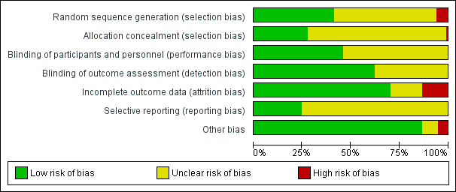
Online Fig. 1. Risk of bias

Online Fig.2. Effect of interventions vs. inactive controls on attitudes towards formal help-seeking at post-intervention
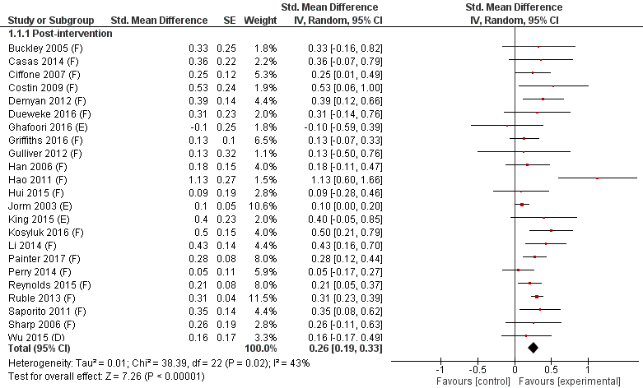

(D) Intervention targeted people with mental illness
(E) Intervention targeted people at risk of mental illness
(F) Intervention targeted members of the general public

Online Fig. 3. Effect of interventions vs. inactive controls on intentions to seek formal help at post-intervention

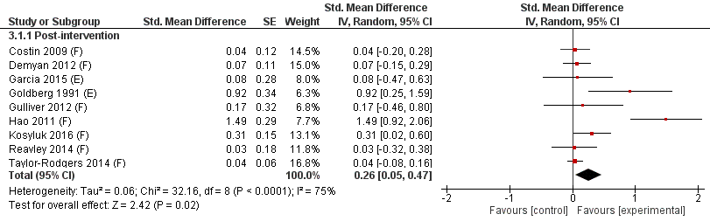

(E) Intervention targeted people at risk of mental illness
(F) Intervention targeted members of the general public

Online Fig. 4. Effect of interventions vs. inactive controls on formal help-seeking behaviours at 1-5 months post-intervention

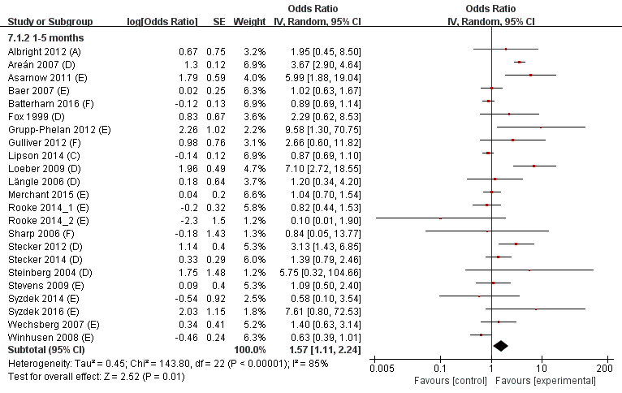

(A) Intervention targeted family members or significant others
(C) Intervention targeted resident advisors or school teachers as gatekeepers
(D) Intervention targeted people with mental illness
(E) Intervention targeted people at risk of mental illness
(F) Intervention targeted members of the general public

Online Fig. 5. Effect of interventions vs. inactive controls on formal help-seeking behaviours at ≥ 6 months post-intervention
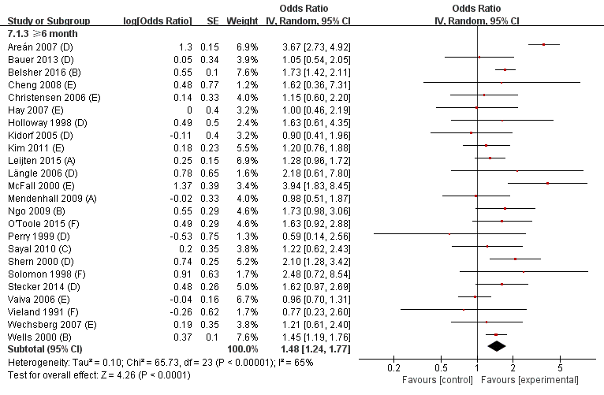
- Intervention targeted family members or significant others
- Intervention targeted primary care/community professionals
(C) Intervention targeted resident advisors or school teachers as gatekeepers
(D) Intervention targeted people with mental illness
(E) Intervention targeted people at risk of mental illness
(F) Intervention targeted members of the general public

