Supplemental Material

Disrupted rich club organization and structural brain connectome in unmedicated bipolar disorder
Methods
- Rich club coefficient
In brief, for a given subject group, we first retained the inter-nodal connections of each of these connections which was presented in at least 50% of all the subjects, and then averaged all FA values for each connection to generate the group-averaged FA-weighted network for this group. Afterward, we calculated the weighted rich club coefficient, $ϕ^{w}(k)$, randomly rich club coefficient, $ϕ_{rand}^{w}(k)$, and normalized rich club coefficient, $ϕ_{norm}^{w}(k)$, for each group. The definition of $ϕ^{w}(k)$ is given by
$ϕ^{w}\left(k\right)= \frac{w_{>k}}{\sum_{l=1}^{E_{>k}}{w_{l}^{ranked}}}$ (1)
where k represents degree, E_{>k} the number of links between those selected nodes, and W_{>k} their collective weight. $ϕ^{w}(k)$ is typically examined relative to the averaged rich club coefficient of a comparable random network $ϕ_{rand}^{w}\left(k\right)$ to determine the extent to which empirically observed connection density between rich club regions exceeds that predicted by a random null model. For each of two group-averaged network, all connections were ranked by weight, resulting in a vector w ^{ranked}. For each degree k, the group of nodes with a degree larger than k was selected. A population of m =1,000 random networks were computed by shuffling the links in the original network, preserving the weights and the degree sequence. The normalized coefficient is defined as
$ϕ_{norm}^{w}\left(k\right)= \frac{ϕ(k)}{ϕ_{rand}(k)}$. (2)
If $ϕ_{norm}^{w}(k)$ > 1 over a range of degree k, then the rich club organization exists in the network (van den Heuvel and Sporns, 2011).
- VBM analysis
Grey matter was examined using FSL-VBM, an optimized VBM style analysis carried out with FSL tools; this yields a measure of difference in local grey matter volume. First, structural images were brain-extracted. Next, tissue-type segmentation was carried out. The resulting grey matter partial volume images were then linearly aligned to MNI 152 standard space, followed by nonlinear registration. The resulting images were averaged to create a study-specific template, to which the native grey matter images were then nonlinearly re-registered. The registered partial volume images were then modulated by dividing by the Jacobian of the warp field. The modulated gray matter segments were then smoothed with an isotropic Gaussian kernel using a sigma of 4mm (technical details are available at www.fmrib.ox.ac.uk/fsl/fslvbm/).
- Robustness analyses
The results of brain network analyses mainly affected by brain parcellation schemes (Wang et al., 2009), selected definition of edge weights (Suyu et al., 2015), and threshold of number of streamlines (NOS) (Cheng et al., 2012) in retaining valid network connections. In this context, we conducted following strategies to test the robustness of our main results.
Definition of nodes
We tested our main findings, which were obtained from the networks reconstructed with the AAL2-atlas, through replication analyses by adopting a high-resolution AAL-atlas containing 1,024 regions (AAL-1,024) (Zalesky et al., 2010).
Definition of edges
Our main results was based on the FA-weighted structural networks thresholding at numbers of streamlines (NOS) ≥ 3. That is for the given two brain regions, if NOS ≥ 3, we retained FA values as edge weights; Otherwise we assumed no connections existed between these two regions. Then, we used the other two definitions of edges, NOS and binary edges, to construct structural networks to test our main results derived from FA-weighted structural networks. We constructed NOS-weighted structural networks following same threshold (NOS ≥ 3).
Thresholds of edges
To evaluate the robustness of the topological properties of brain networks obtained with different thresholds of NOS, we also repeated calculations by taking alternative thresholds, a range from 1 to 6 streamlines counts, to construct FA-weighted structural networks based on AAL2-atlas.
The connectivity matrix was also thresholded by a sparsity value which was defined as the total number of edges in a network divided by the maximum possible number of edges (Achard and Bullmore, 2007). In this way, the resulting graphs would be comprised of the same number of connections, which make cortical networks in the HC and patient groups to have the same wiring cost (Achard and Bullmore, 2007). We thresholded each correlation matrix repeatedly over a wide range of thresholds (10% to 20%) and then estimated the network properties at each threshold value (Liu et al., 2013).
Corrected for ROI volume
As across the set of AAL2-atlas regions, the volumes of the segmented regions are not uniform, the size of an ROI may influence the fiber selection procedure: bigger regions may have a higher probability of being touched by one of the fiber streamlines. Therefore, to control for this effect, we re- calculated the network metrics, in which, during the formation of the FA-weighted connectivity matrix, the number of streamlines between region i and j was normalized by the sum of the volumes of ROI i and j. However, it has been suggested that volume correction may potentially overcompensate volume-driven effects on the streamline count (van den Heuvel and Sporns, 2011).
Sample of BD II
We also did the same network analysis including global and node parameters in 35 patients with only BDII and healthy controls to avoiding the different BD subtypes effect.
Results
Relationship between network parameters and clinical variables
Fig. S1 shows the correlations between the network parameters and clinical variables in the BD patients. We found that B_{i} in CAL.R was significantly positively correlated with the number of episodes (r = 0.336, p = 0.037) and durations of illness (r = 0.463, p = 0.003), but negatively correlated with HDRS scores (r = -0.347, p =0.031) in the BD patients. Note that these correlation analyses were exploratory, and no correction for multiple comparisons was performed.
Figure S1 about here, please
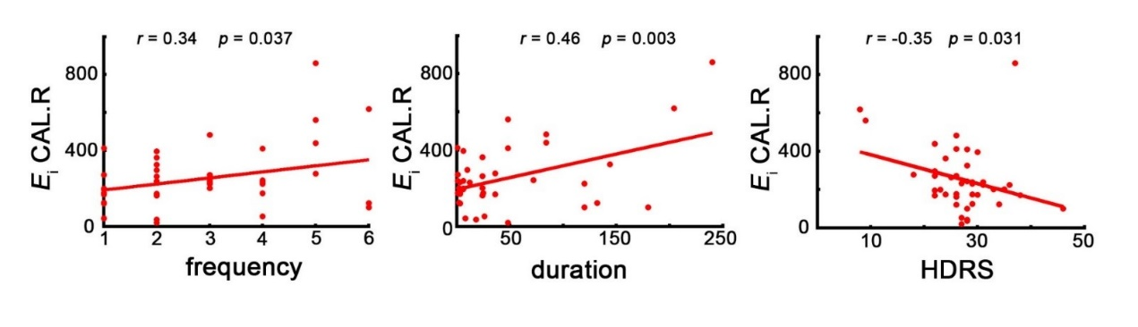
VBM analysis
There were no areas of significant grey matter volume difference between BD patients and controls group (p < 0.05 TFCE cluster corrected for multiple comparison).
Robustness
The results of robustness analyses were showed in Table S3, Table S4, Table S5 and Figure. S2. Those results were similar to those we obtained in the main body of the present study. When different strategies to define brain networks, we found the change tends of the network parameters in the BD group compared with the controls was the same to those derived from our main analysis.
Moreover, we also did the same network analysis in 35 patients with only BDII (18M/17F, age=25.80 ± 8.47 years) and controls (31M/28F, age=27.51 ± 8.40 years), and the results were similar to our main findings (Table S6 and Table S7).
Figure S2 about here, please
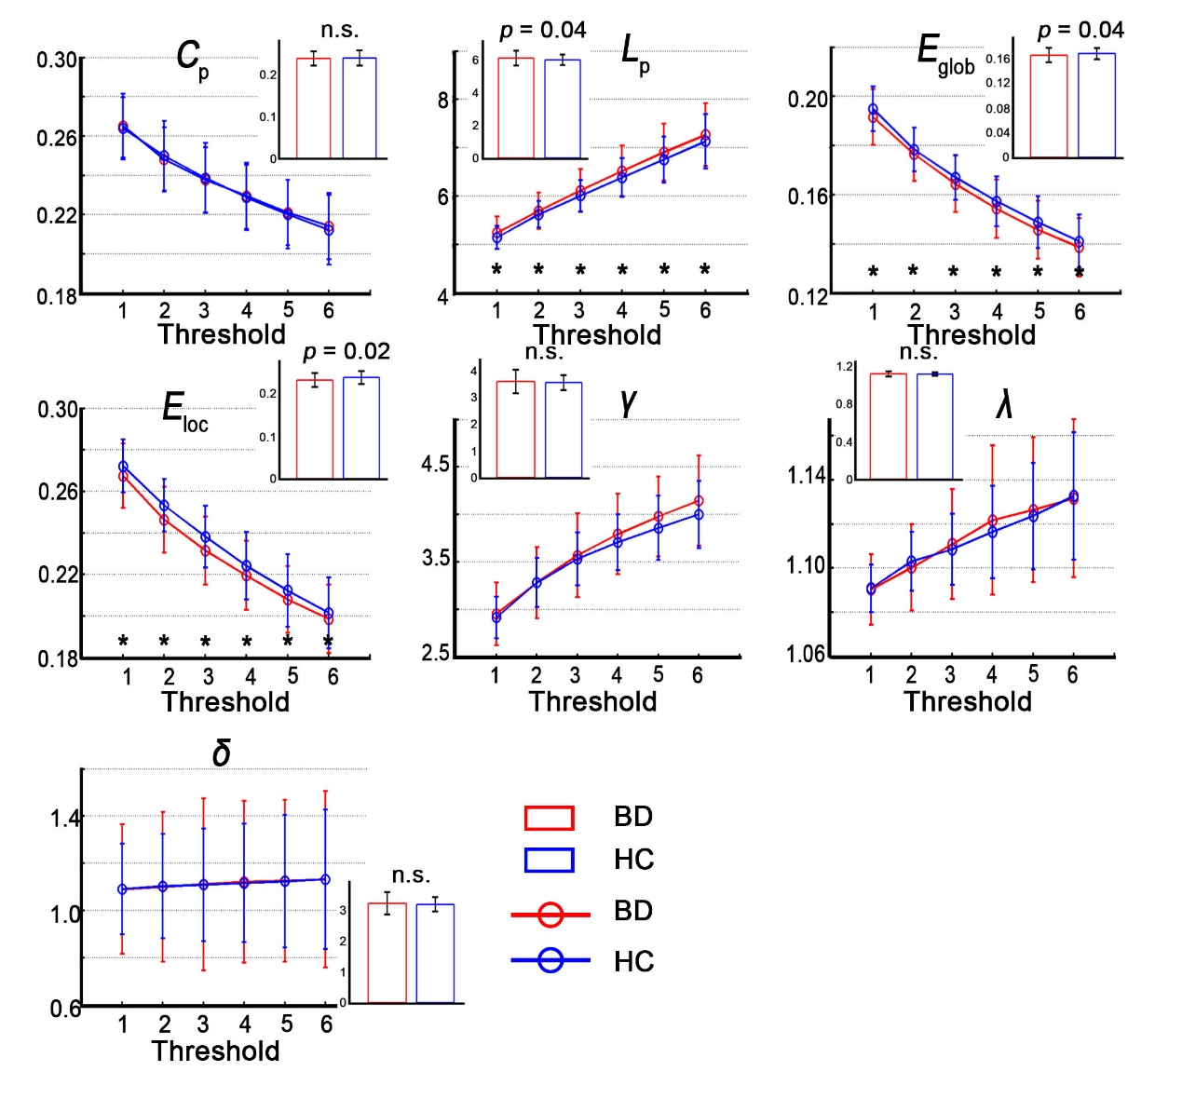
Discussion
There are several limitations of methodology. The definitions of nodes and edge weights definitions, fiber tracking approaches and DT imaging acquisition protocols may affect the findings obtained from whole brain WM structural networks in BD patients. However, there is no widely agreed-on approach for calculating the brain network metrics. This suggests the measures may not be optimally robust just yet. First, we selected a widely applied template, the AAL-120 template, to define the network nodes. Regions on the AAL template differ in size, which may have a confounding effect on the link weight of the network nodes. Therefore, to control for this effect, we reconstructed the structure network, which performed further correction on ROI volume. However, it has been suggested that volume correction may potentially overcompensate volume-driven effects on the streamline count (van den Heuvel MP et al., 2011). In addition, we also used we a high-resolution (~1000 parcels) parcellation (AAL-1024) by randomly subdividing the AAL atlas into 1024 regions with equal size both in the volume and in the average cortical surface. We found that the change tendencies of the network parameters (L_{p}, E_{glob}, E_{loc}) were similar to those for the AAL-120 in the BD patients compared to the controls (Table S4). Zalesky et al. (2010) and Hagmann et al. (2008) (Hagmann et al., 2008) showed that the parcellation scale strongly influences the network metrics. However, it is also reported that this strong dependence does not suggest that any given parcellation scale is more optimal than another.
Table S1 Brain regions included in the revised Automated Anatomical Labeling (AAL2) atlas.
Index | Label | abbreviation |  | Index | Label | abbreviation
1 | Precentral | PreCG |  | 33 | Parietal_Inf | IPG
2 | Frontal_Sup_2 | SFG |  | 34 | SupraMarginal | SMG
3 | Frontal_Mid_2 | MFG | 35 |  | Angular | ANG
4 | Frontal_Inf_Oper | IFGoperc |  | 36 | Precuneus | PCUN
5 | Frontal_Inf_Tri | IFGtriang |  | 37 | Paracentral_Lobule | PCL
6 | Frontal_Inf_Orb_2 | IFGorb |  | 38 | Caudate | CAU
7 | Rolandic_Oper | ROL |  | 39 | Putamen | PUT
8 | Supp_Motor_Area | SMA |  | 40 | Pallidum | PAL
9 | Olfactory | OLF |  | 41 | Thalamus | THA
10 | Frontal_Sup_Medial | SFGmedial |  | 42 | Heschl | HES
11 | Frontal_Med_Orb | PFCventmed |  | 43 | Temporal_Sup | STG
12 | Rectus | REC |  | 44 | Temporal_Pole_Sup | TPOsup
13 | OFCmed | OFCmed |  | 45 | Temporal_Mid | MTG
14 | OFCant | OFCant |  | 46 | Temporal_Pole_Mid | TPOmid
15 | OFCpost | OFCpost |  | 47 | Temporal_Inf | ITG
16 | OFClat | OFClat |  | 48 | Cerebelum_Crus1 | Hcrus I
17 | Insula | INS |  | 49 | Cerebelum_Crus2 | Hcrus II
18 | Cingulate_Ant | ACC |  | 50 | Cerebelum_3 | HIII
19 | Cingulate_Mid | MCC |  | 51 | Cerebelum_4_5 | HIVV
20 | Cingulate_Post | PCC |  | 52 | Cerebelum_6 | HVI
21 | Hippocampus | HIP |  | 53 | Cerebelum_7b | HVIIb
22 | ParaHippocampal | PHG |  | 54 | Cerebelum_8 | HVIII
23 | Amygdala | AMYG |  | 55 | Cerebelum_9 | HIX
24 | Calcarine | CAL |  | 56 | Cerebelum_10 | HX
25 | Cuneus | CUN |  | 57 | Vermis_1_2 | VermisI_II
26 | Lingual | LING |  | 58 | Vermis_3 | VermisIII
27 | Occipital_Sup | SOC |  | 59 | Vermis_4_5 | VermisIV_V
28 | Occipital_Mid | MOG |  | 60 | Vermis_6 | VermisVI
29 | Occipital_Inf | IOG |  | 62 | Vermis_7 | VermisVII
30 | Fusiform | FFG |  | 63 | Vermis_8 | VermisVIII
31 | Postcentral | PoCG |  | 64 | Vermis_9 | VermisIX
32 | Parietal_Sup | SPG |  | 65 | Vermis_10 | VermisX
Note: Fifty-six brain regions were extracted from the right and left hemispheres, separately, and eight vermis to provide 120 regions in total for each subject. The AAL2 atlas is a revised version of AAL atlas from Tzourio-Mazoyer et al (2002).

Table S2 Definitions and interpretations of topological parameters for a given network G(N, V)
 | Measures | Definitions | Notes
Global parameters | Shortest path length | 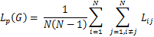 | L_{ij} is the shortest path length between node i and node j by using a "harmonic mean" between all pairs of nodes. L_{p} (G) can reflect the ability of information transfer in parallel over the whole brain network.
 | Global efficiency | 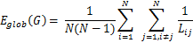 | 1/L_{ij} represents the reciprocal of the "harmonic mean" of shortest path length. E_{global} (G) can quantify the global efficiency of the parallel information process.
 | Local efficiency | 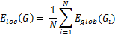 | E_{global} (G_{i}) indicates the global efficiency of the subgraph G_{i} composed of the neighbors of node i. G_{i} represents a subgraph of G. The local efficiency reflects how much the network is fault tolerant, suggesting how efficient the communication is among the neighbors of node i when it is removed.
 | Clustering coefficient | $$C_{p}\left(G\right)= \frac{2}{k_{i}(k_{i}-1)} \sum_{j, k}{{({\overline{w}}_{ij}{\overline{w}}_{jk}{\overline{w}}_{ki})}^{1/3}}$$ | k_{i} represents the degree of node i. The clustering coefficient C_{p} of a network is the average of the clustering coefficient over all nodes, which indicates the extent of local interconnectivity or cliquishness in a network.
 | Small worldness | 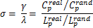 | and are the averaged values of cluster coefficients and shortest path length of 100 random networks with the same N, V and degree distribution as to the real network. We adopted the Maslovs' wiring algorithm.
Nodal parameters | Nodal strength | 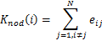 | e_{ij} is the edge for the node i with any connected nodes. The strength of a node is the sum of the network strengths across all the nodes over the whole network.
 | Nodal efficiency | 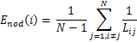 | E_{nod} (i) measures the reciprocal of the average shortest path length between a given node i and all of the other nodes in the network. It quantifies the ability of node i in communication transfer within a network
 | Betweenness centrality | 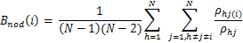 | is the total numbers of the shortest path lengths between node h and j which passes through h for a specific node i.

Table S3 Effects of different streamline counts as the threshold on the global parameters of brain anatomical networks based on the AAL2 atlas.
Network Parameters | Group | Threshold value
 |  | 1 |  | 2 |  | 3 |  | 4 |  | 5 |  | 6
 |  | Mean (SD) | p | Mean (SD) | p | Mean (SD) | p | Mean (SD) | p | Mean (SD) | p | Mean (SD) | p
 | BD | 0.27 (0.02) | 0.488 | 0.25 (0.02) | 0.255 | 0.24 (0.02) | 0.340 | 0.23 (0.02) | 0.429 | 0.22 (0.02) | 0.466 | 0.21 (0.02) | 0.416
 | HC | 0.26 (0.02) |  | 0.25 (0.02) |  | 0.24 (0.02) |  | 0.23 (0.02) |  | 0.22 (0.02) |  | 0.21 (0.02)
 | BD | 5.24 (0.34) | 0.035 | 5.69 (0.38) | 0.083 | 6.11 (0.45) | 0.036 | 6.52 (0.52) | 0.035 | 6.91 (0.59) | 0.042 | 7.27 (0.65) | 0.077
 | HC | 5.14 (0.23) |  | 5.62 (0.27) |  | 6.00 (0.32) |  | 6.38 (0.41) |  | 6.75 (0.48) |  | 7.13 (0.56)
 | BD | 0.19 (0.01) | 0.044 | 0.18 (0.01) | 0.113 | 0.16 (0.01) | 0.041 | 0.15 (0.01) | 0.049 | 0.15 (0.01) | 0.054 | 0.14 (0.01) | 0.091
 | HC | 0.19 (0.01) |  | 0.18 (0.01) |  | 0.17 (0.01) |  | 0.16 (0.01) |  | 0.15 (0.01) |  | 0.14 (0.01)
 | BD | 0.27 (0.02) | 0.038 | 0.25 (0.02) | 0.014 | 0.23 (0.02) | 0.023 | 0.22 (0.02) | 0.074 | 0.21 (0.02) | 0.081 | 0.20 (0.02) | 0.137
 | HC | 0.27 (0.01) |  | 0.25 (0.01) |  | 0.24 (0.01) |  | 0.22 (0.02) |  | 0.21 (0.02) |  | 0.20 (0.02)
γ | BD | 2.95 (0.33) | 0.332 | 3.28 (0.37) | 0.491 | 3.57 (0.44) | 0.219 | 3.79 (0.42) | 0.109 | 3.98 (0.42) | 0.078 | 4.14 (0.47) | 0.078
 | HC | 2.91 (0.22) |  | 3.28 (0.26) |  | 3.53 (0.28) |  | 3.70 (0.30) |  | 3.86 (0.34) |  | 4.00 (0.36)
 | BD | 1.09 (0.02) | 0.418 | 1.10 (0.02) | 0.357 | 1.11 (0.02) | 0.187 | 1.12 (0.03) | 0.141 | 1.13 (0.03) | 0.285 | 1.13 (0.04) | 0.490
 | HC | 1.09 (0.01) |  | 1.10 (0.01) |  | 1.11 (0.02) |  | 1.12 (0.02) |  | 1.12 (0.02) |  | 1.13 (0.03)
 | BD | 2.71 (0.27) | 0.336 | 2.98 (0.32) | 0.468 | 3.21 (0.36) | 0.260 | 3.38 (0.34) | 0.149 | 3.53 (0.34) | 0.087 | 3.66 (0.37) | 0.063
 | HC | 2.67 (0.19) |  | 2.97 (0.22) |  | 3.18 (0.24) |  | 3.32 (0.25) |  | 3.43 (0.28) |  | 3.53 (0.30)
Note: All results were calculated using a nonparametric permutation test (10,000 times). Abbreviations: C_{p,} clustering coefficient; L_{p}, shortest path length; E_{glob}, global efficiency; E_{loc}, local efficiency; λ, normalized characteristic path length; γ, normalized clustering coefficient; δ = λ/γ, small-world characteristic; SD, standard deviation; BD, bipolar disorder; HC, healthy controls.

Table S4 Cross-validation of the main findings of the network properties of brain anatomical networks between the BD patients and the healthy controls in different parcellation schemes of human brain and different definition of edges of the networks.
 | AAL2 (120 regions) / FA-weighted |  |  | AAL-1,024 /  FA-weighted |  |  | AAL2 (120 regions) / NOS-weighted |  |  | AAL2 (120 regions) /  binary |  |  |  | AAL2 (120 regions) / FA-weighted/ corrected for ROI volume
Network parameters | BD | HC | p | BD | HC | p | BD | HC | p | BD | HC | p |  | BD |  | HC | p
 | Mean (SD) | Mean (SD) |  | Mean (SD) | Mean (SD) |  | Mean (SD) | Mean (SD) |  | Mean (SD) | Mean (SD) |  |  | Mean (SD) |  | Mean (SD)
C_{p} | 0.238  (0.017) | 0.239 (0.018) | 0.340 | 0.076 (0.016) | 0.076 (0.015) | 0.269 | 0.018 (0.006) | 0.018 (0.007) | 0.317 | 0.395 (0.024) | 0.399 (0.023) | 0.241 | 0.049  (0.011) |  |  | 0.051  (0.016) |  | 0.300
L_{p} | 6.113  (0.445) | 6.005 (0.325) | 0.037 | 22.875 (5.120) | 22.003 (4.671) | 0.109 | 0.088 (0.016) | 0.086 (0.017) | 0.175 | 2.586 (0.124) | 2.582 (0.100) | 0.243 | 1.338e+04  (1.205e+03) |  |  | 1.345e+04  (1.229e+03) |  | 0.458
E_{glob} | 0.164  (0.011) | 0.167 (0.009) | 0.043 | 0.046 (0.009) | 0.047 (0.009) | 0.096 | 11.698 (1.965) | 11.967 (1.864) | 0.152 | 0.388 (0.018) | 0.388 (0.015) | 0.264 | 7.536e-05  (6.908e-06) |  |  | 7.496e-05  (6.930e-06) |  | 0.468
E_{loc} | 0.232  (0.016) | 0.238 (0.015) | 0.021 | 0.062 (0.014) | 0.064 (0.014) | 0.127 | 20.478 (3.299) | 21.125 (3.410) | 0.172 | 0.576 (0.031) | 0.584 (0.033) | 0.109 | 9.643e-05  (1.174e-05) |  |  | 9.615e-05  (9.937e-6) |  | 0.471
γ | 3.562  (0.420) | 3.529 (0.291) | 0.236 | 28.014 (2.405) | 27.103 (2.695) | 0.140 | 4.462 (0.522) | 4.402 (0.409) | 0.248 | 3.688 (0.428) | 3.667 (0.290) | 0.293 | 4.229  (0.647) |  |  | 4.174  (0.387) |  | 0.265
λ | 1.111  (0.025) | 1.109 (0.016) | 0.208 | 1.274 (0.038) | 1.273 (0.035) | 0.457 | 1.215 (0.055) | 1.227 (0.057) | 0.287 | 1.118 (0.022) | 1.115 (0.014) | 0.159 | 1.125  (0.038) |  |  | 1.118  (0.029) |  | 0.300
δ | 3.205  (0.346) | 3.183 (0.251) | 0.281 | 21.984 (1.646) | 21.295 (1.998) | 0.129 | 3.671 (0.367) | 3.592 (0.348) | 0.186 | 3.297 (0.343) | 3.287 (0.242) | 0.358 | 3.751  (0.491) |  |  | 3.735  (0.328) |  | 0.320
Note: AAL2, the revised Anatomical automatic Labeling atlas with 120 region of interests (ROIs); AAL-1,024, high-resolution randomly generated atlas with 1024 ROIs. The overall direction of changing global parameters was consistent across different parcellation schemes of human brain and definitions of edges.

Table S5 Effects of different sparsity value as the threshold on the global parameters of brain anatomical networks based on the AAL2 atlas.

Network  Metrics | Group | Sparsity Threshold value
 |  | 0.1 |  |  | 0.11 |  | 0.12 |  | 0.13 |  | 0.14 |  | 0.15 |  | 0.16 |  | 0.17 |  | 0.18 |  | 0.19 |  | 0.2
 |  | Mean (SD) | Range | p | Mean (SD) | p | Mean (SD) | p | Mean (SD) | p | Mean (SD) | p | Mean (SD) | p | Mean (SD) | p | Mean (SD) | p | Mean (SD) | p | Mean (SD) | p | Mean (SD) | p
 | BD | 0.43(0.02) | 0.39-0.49 | 0.40 | 0.45(0.02) | 0.38 | 0.45(0.02) | 0.42 | 0.45(0.02) | 0.43 | 0.45(0.02) | 0.43 | 0.45(0.02) | 0.43 | 0.45(0.02) | 0.43 | 0.45(0.02) | 0.43 | 0.45(0.02) | 0.43 | 0.45(0.02) | 0.43 | 0.45(0.02) | 0.44
 | HC | 0.43(0.02) | 0.39-0.47 |  | 0.45(0.02) |  | 0.45(0.02) |  | 0.45(0.02) |  | 0.45(0.02) |  | 0.45(0.02) |  | 0.45(0.02) |  | 0.45(0.02) |  | 0.45(0.02) |  | 0.45(0.02) |  | 0.45(0.02)
 | BD | 2.28(0.06) | 2.19-2.42 | 0.09 | 2.25(0.08) | 0.18 | 2.24(0.08) | 0.19 | 2.24(0.08) | 0.19 | 2.24(0.08) | 0.20 | 2.24(0.08) | 0.19 | 2.24(0.08) | 0.19 | 2.24(0.08) | 0.20 | 2.24(0.08) | 0.19 | 2.24(0.08) | 0.19 | 2.24(0.08) | 0.19
 | HC | 2.27(0.04) | 2.17-2.38 |  | 2.23(0.06) |  | 2.23(0.06) |  | 2.23(0.06) |  | 2.23(0.06) |  | 2.23(0.06) |  | 2.23(0.06) |  | 2.23(0.06) |  | 2.23(0.06) |  | 2.23(0.06) |  | 2.23(0.06)
 | BD | 0.44(0.01) | 0.41-0.46 | 0.10 | 0.45(0.02) | 0.20 | 0.45(0.02) | 0.22 | 0.45(0.02) | 0.21 | 0.45(0.02) | 0.21 | 0.45(0.02) | 0.21 | 0.45(0.02) | 0.21 | 0.45(0.02) | 0.21 | 0.45(0.02) | 0.21 | 0.45(0.02) | 0.21 | 0.45(0.02) | 0.22
 | HC | 0.44(0.01) | 0.42-0.46 |  | 0.45(0.01) |  | 0.45(0.01) |  | 0.45(0.01) |  | 0.45(0.01) |  | 0.45(0.01) |  | 0.45(0.01) |  | 0.45(0.01) |  | 0.45(0.01) |  | 0.45(0.01) |  | 0.45(0.01)
 | BD | 0.65(0.03) | 0.59-0.71 | 0.30 | 0.66(0.03) | 0.18 | 0.66(0.03) | 0.24 | 0.66(0.23) | 0.23 | 0.66(0.03) | 0.23 | 0.66(0.03) | 0.23 | 0.66(0.03) | 0.23 | 0.66(0.03) | 0.24 | 0.66(0.03) | 0.24 | 0.66(0.03) | 0.23 | 0.66(0.03) | 0.24
 | HC | 0.65(0.02) | 0.59-0.69 |  | 0.67(0.02) |  | 0.67(0.02) |  | 0.67(0.02) |  | 0.67(0.02) |  | 0.67(0.02) |  | 0.67(0.02) |  | 0.67(0.02) |  | 0.67(0.02) |  | 0.67(0.02) |  | 0.67(0.02)
γ | BD | 2.98(0.39) | 2.34-4.48 | 0.31 | 3.06(0.33) | 0.36 | 3.06(0.33) | 0.37 | 3.06(0.33) | 0.37 | 3.07(0.33) | 0.32 | 3.06(0.33) | 0.36 | 3.06(0.32) | 0.35 | 3.06(0.32) | 0.40 | 3.06(0.32) | 0.37 | 3.06(0.32) | 0.37 | 3.06(0.33) | 0.31
 | HC | 2.93(0.31) | 2.17-3.53 |  | 3.03(0.22) |  | 3.03(0.22) |  | 3.03(0.21) |  | 3.03(0.22) |  | 3.03(0.22) |  | 3.03(0.22) |  | 3.03(0.22) |  | 3.03(0.22) |  | 3.03(0.23) |  | 3.03(0.22)
 | BD | 1.09(0.02) | 1.07-1.15 | 0.46 | 1.09(0.02) | 0.50 | 1.09(0.02) | 0.49 | 1.09(0.02) | 0.48 | 1.09(0.02) | 0.49 | 1.09(0.02) | 0.49 | 1.09(0.02) | 0.46 | 1.09(0.02) | 0.49 | 1.09(0.02) | 0.49 | 1.09(0.02) | 0.47 | 1.09(0.02) | 0.48
 | HC | 1.09(0.01) | 1.06-1.12 |  | 1.09(0.01) |  | 1.09(0.01) |  | 1.09(0.01) |  | 1.09(0.01) |  | 1.09(0.01) |  | 1.09(0.01) |  | 1.09(0.01) |  | 1.09(0.01) |  | 1.09(0.01) |  | 1.09(0.01)
 | BD | 2.73(0.32) | 2.17-3.89 | 0.31 | 2.80(0.27) | 0.36 | 2.79(0.26) | 0.36 | 2.80(0.27) | 0.37 | 2.80(0.26) | 0.32 | 2.80(0.27) | 0.37 | 2.80(0.26) | 0.35 | 2.79(0.26) | 0.40 | 2.79(0.26) | 0.36 | 2.80(0.26) | 0.37 | 2.80(0.27) | 0.32
 | HC | 2.68(0.26) | 2.01-3.21 |  | 2.77(0.19) |  | 2.77(0.19) |  | 2.77(0.18) |  | 2.77(0.19) |  | 2.77(0.19) |  | 2.77(0.19) |  | 2.77(0.19) |  | 2.77(0.19) |  | 2.77(0.19) |  | 2.77(0.19)

Table S6 The global parameters of the brain anatomical networks in the bipolar disorder (BD) II type patients and the controls (HC).
Network Metrics | Group | Range | Mean(SD) | p value
 | BDII | 0.20-0.26 | 0.24(0.02) | 0.400
 | HC | 0.20-0.29 | 0.24(0.02)
 | BDII | 5.44-7.00 | 6.09(0.38) | 0.253
 | HC | 5.29-6.59 | 6.01(0.32)
 | BDII | 0.14-0.18 | 0.16(0.01) | 0.278
 | HC | 0.15-0.19 | 0.17(0.01)
 | BDII | 0.20-0.26 | 0.23(0.02) | 0.033
 | HC | 0.20-0.27 | 0.24(0.02)
 | BDII | 3.09-4.12 | 3.50(0.31) | 0.416
 | HC | 2.94-4.41 | 3.53(0.28)
 | BDII | 1.07-1.18 | 1.11(0.02) | 0.401
 | HC | 1.07-1.15 | 1.11(0.02)
 | BDII | 2.76-3.63 | 3.15(0.25) | 0.390
 | HC | 2.72-3.99 | 3.19(0.24)

Table S7 Brain regions showing altered nodal parameters (nodal degree K_{i}, nodal efficiency E_{i}, and nodal betweenness B_{i}) of brain structural networks in the BD-II type patients compared with the healthy controls (HC).
Network Metrics | Regions | Group | Mean (SD) | Range | p value
Nodal degree (K_{i}) | IFGorb.L | BDII | 2.88(1.02) | 1.03-5.08 | 6.70E-03
 |  | HC | 2.35(1.05) | 0.73-5.41
Nodal efficiency (E_{i}) | SPG.L | BDII | 0.26(0.03) | 0.20-0.33 | 3.90E-03
 |  | HC | 0.28(0.03) | 0.21-0.36
 | ANG.L | BDII | 0.33(0.04) | 0.24-0.41 | 5.00E-03
 |  | HC | 0.36(0.03) | 0.29-0.44
 | HIII.R | BDII | 0.13(0.11) | 0-0.35 | 1.30E-03
 |  | HC | 0.20(0.11) | 0-0.42
Nodal betweenness (B_{i}) | INS.L | BDII | 274.69(141.64) | 32-610 | 9.00E-04
 |  | HC | 382.24(220.38) | 34-1130
 | CAL.R | BDII | 244.34(157.91) | 20-860 | 5.30E-03
 |  | HC | 164.03(111.01) | 10-506

References:
Achard S & Bullmore E (2007). Efficiency and cost of economical brain functional networks. Plos Computational Biology 3, e17.
Cheng H, Wang Y, Sheng J, Kronenberger WG., Mathews VP, Hummer TA, Saykin AJ (2012). Characteristics and variability of structural networks derived from diffusion tensor imaging. Neuroimage 61, 1153-1164.
Hagmann P, Cammoun L, Gigandet X, Meuli R, Honey CJ, Wedeen V, Sporns O (2008). Mapping the structural core of human cerebral cortex. Plos Biology 6, 1479-1493.
Liu J, Zhao L, Nan J, Li G, Xiong S, von Deneen KM, Gong Q, Liang F, Qin W, Tian J (2013). The trade-off between wiring cost and network topology in white matter structural networks in health and migraine. Experimental Neurology 248, 196-204.
Suyu Z, Yong H, Gaolang G. (2015). Convergence and divergence across construction methods for human brain white matter networks: an assessment based on individual differences. Human Brain Mapping 36, 1995-2013.
van den Heuvel, M P & Sporns O (2011). Rich-club organization of the human connectome. Journal of Neuroscience 31, 15775-15786.
Wang J, Wang L, Zang Y, Yang H, Tang H, Gong Q, Chen Z, Zhu, C, He Y (2009). Parcellation-dependent small-world brain functional networks: a resting-state fMRI study. Human Brain Mapping 30, 1511–1523.
Zalesky A, Harding F, Cocchi L, Yucel M, Pantelis C, Bullmore ET (2010). Whole-brain anatomical networks: Does the choice of nodes matter? Neuroimage 50, 970-983.

Illustrations
Fig. S1 Correlations between the network parameters and clinical variables in the BD patients. Note that these correlation analyses were exploratory, and no correction for multiple comparisons was performed.

Fig. S2 Global parameters of the brain anatomical networks changing with the selected threshold of streamline counts for the bipolar disorder (BD) patients and the controls (HC). The threshold of the streamline counts (n = 1, 2, 3, 4, 5, and 6) was the minimum number of streamline counts connecting a pair of regions when constructing the networks based on the AAL2 atlas. The BD patients showed significant decreases in E_{glob}, and local efficiency E_{loc}, but significant increases in L_{p} compared with the controls (p < 0.05, permutation test). The symbol “*” indicates p < 0.05 for between-group differences. The inserted histogram indicates the between-group comparisons corresponding to a threshold of n = 3. The bar height represents the mean value and the error bar represents the standard deviation for the given network parameters over all subjects in each group. Abbreviations: C_{p}, clustering coefficient; L_{p}, shortest path length; E_{glob}, global efficiency; E_{loc}, local efficiency; λ, normalized characteristic path length; γ, normalized clustering coefficient; δ = λ / γ, small-world characteristic.

