Kappelmann et. al. Online Supplementary Material

Materials and Methods
Study population

Online Supplementary Figure 1:

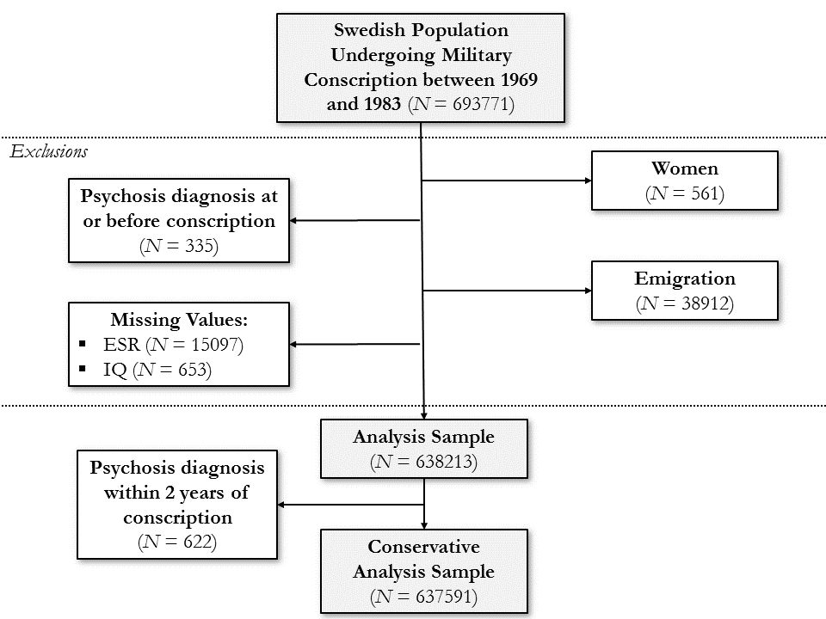
Figure Caption: Participation of women in military service was voluntary and not compulsory.

Results
Relationship of IQ and Psychoses

Online Supplementary Table 1: Analysis of Association between IQ and the Development of Psychoses
 | Schizophrenia |  |  |  | Other Non-Affective psychoses
 | Total Sample, No. | No. of cases (%) | HR (IQ+1) [95% CI] | P-value | Total Sample, No. | No. of cases (%) | HR (IQ+1) [95% CI] | P-value
Unadjusted estimates | 633080 | 5398 (0.85) | 0.963 [0.961, 0.964] | <0.001 | 632815 | 5133 (0.81) | 0.974 [0.972, 0.976] | <0.001
Adjusted estimates† | 633080 | 5398 (0.85) | 0.961 [0.960, 0.963] | <0.001 | 632815 | 5133 (0.81) | 0.973 [0.971, 0.975] | <0.001
Adjusted estimates excluding patients diagnosed within 2 years† | 632662 | 4980 (0.79) | 0.962 [0.960, 0.964] | <0.001 | 632611 | 4929 (0.78) | 0.973 [0.971, 0.975] | <0.001

¹ Adjustments have been made for household crowding, winter birth, parental socioeconomic status at 8-12 years, migration status, and parental history of non-affective psychoses.

Association of ESR and IQ

Online Supplementary Table 2: Test of Linearity for Association between IQ and ESR

Model | Residual Degrees of Freedom | Residual Sum of Squares | Degrees of Freedom | Sum of Squares | P-Value
Dummy model¹ | 638211 | 143512579
Linear model² | 638209 | 143512361 | 2 | 218.56 | 0.615

¹ The dummy model codes ESR in bands 0-3, 4-6, 7-10, and ≥11mm/h as done in other analyses.
² The linear model re-codes ESR bands of 0-3, 4-6, 7-10, and ≥11mm/h into values -1.5, -0.5, 0.5, and 1.5, respectively.

Relationship of ESR and Psychoses

Online Supplementary Table 3: Analysis of the Association between ESR and Subsequent Non-Affective Psychoses

ESR (mm/h) | No. (% of total)¹ | Case, No. (%) | Unadjusted |  | Adjusted²
 |  |  | HR [95% CI] | P-value | HR [95% CI] | P-value
Schizophrenia
0-3 | 467073 (73.78) | 3932 (0.84) | 1.00 [reference] | - | 1.00 [reference] | -
4-6 | 111204 (17.57) | 958 (0.86) | 1.04 [0.97, 1.12] | 0.258 | 1.04 [0.97, 1.12] | 0.234
7-10 | 34783 (5.49) | 326 (0.94) | 1.11 [0.99, 1.25] | 0.064 | 1.12 [1.00, 1.26] | 0.048*
≥11 | 20020 (3.16) | 182 (0.91) | 1.05 [0.90, 1.22] | 0.546 | 1.05 [0.91, 1.22] | 0.500
Other Non-Affective Psychoses
0-3 | 466991 (73.80) | 3850 (0.82) | 1.00 [reference] | - | 1.00 [reference] | -
4-6 | 111131 (17.56) | 885 (0.80) | 0.98 [0.91, 1.06] | 0.629 | 0.98 [0.91, 1.06] | 0.667
7-10 | 34697 (5.48) | 240 (0.69) | 0.83 [0.73, 0.95] | 0.006* | 0.84 [0.74, 0.96] | 0.008*
≥11 | 19996 (3.16) | 158 (0.79) | 0.92 [0.78, 1.08] | 0.301 | 0.92 [0.79, 1.08] | 0.335

¹ Cases of other non-affective psychosis were excluded from the analysis of schizophrenia and vice versa.
² Adjustments have been made for household crowding, winter birth, parental socioeconomic status at 8-12 years, migration status, and parental history of non-affective psychoses.
* P<0.05.

Co-relative Control Analysis of the ESR-IQ Association

Online Supplementary Table 4: Co-Relative Analyses using Linear Mixed-Effects Regression for Association between ESR and IQ

 | Mean Difference in IQ [95% CI]*
 | No. | 4-6mm/h | 7-10mm/h | ≥11mm/h
General population | 638213 | -0.48 [-0.58, -0.38] | -0.95 [-1.12, -0.79] | -1.57 [-1.78, -1.36]
Cousins | 61590 | -0.09 [-0.33, 0.14] | -0.70 [-1.05, -1.56] | -1.11 [-1.56, -0.66]
Half siblings | 21488 | 0.29 [-0.09, 0.68] | -0.04 [-0.61, 0.53] | -0.96 [-1.68, -0.24]
Full siblings | 110010 | -0.02 [-0.17, 0.14] | -0.21 [-0.44, 0.03] | -0.68 [-0.98, -0.38]
* The group with ESR 0-3mm/h has been used as reference category for all analyses.

Mediation/Moderation of the ESR and Psychoses Relationship by IQ

Online Supplementary Table 5: Mediation of the ESR and Psychoses Relationship by IQ

 | Schizophrenia² |  | Other Non-Affective Psychoses²
 | Standardised effect (standard error) | P-Value | Standardised effect (standard error) | P-Value
Unadjusted
Direct effect | Criteria not met¹ | - | -0.028 (0.009) | 0.002
Indirect effect via IQ at 18-20 years | Criteria not met¹ | ⁻ | 0.003 (<0.001) | <0.001
Total effect | Criteria not met¹ | - | -0.024 (0.009) | 0.007
Adjusted³
Direct effect | 0.013 (0.007) | 0.070 | -0.026 (0.010) | 0.008
Indirect effect via IQ at 18-20 years | 0.004 (<0.001) | <0.001 | 0.003 (<0.001) | <0.001
Total effect | 0.018 (0.007) | 0.015 | -0.023 (0.010) | 0.008

¹ Mediation of the ESR and schizophrenia relationship was not calculated as the unadjusted main effect of ESR on schizophrenia did not reach significance, which is a prerequisite for mediation.
² Since effects of ESR on psychoses were specific to the difference between ESR of 0-3mm/h and ESR of 7-10mm/h in main analyses, the sample for mediation analysis was reduced to individuals falling into these ESR bands only. Furthermore, individuals with respective other diagnosis were excluded as well as individuals diagnosed within 2 years for adjusted analyses. Final sample sizes were: n=505946 for adjusted schizophrenia analysis and n=505946 for unadjusted and 501524 for adjusted analyses of other non-affective psychoses.
³ Adjustments have been made for household crowding, winter birth, parental socioeconomic status at 8-12 years, migration status, and parental history of non-affective psychoses and by excluding individuals diagnosed within 2 years of conscription.

Online Supplementary Figure 2:
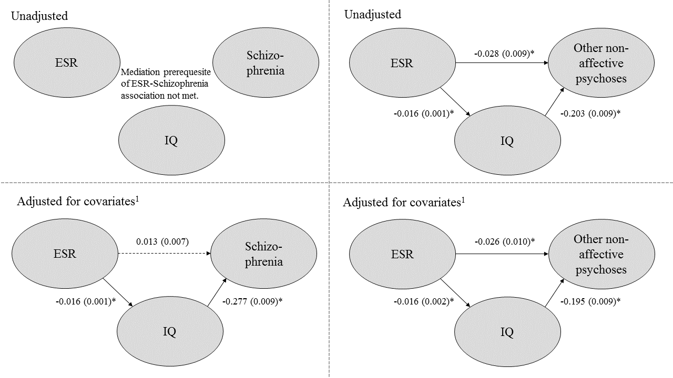

¹ Adjustments have been made for household crowding, winter birth, parental socioeconomic status at 8-12 years, migration status, and parental history of non-affective psychoses and by excluding individuals diagnosed within 2 years of conscription.
* Significance at P<0.05 is indicated by * and by non-dashed arrows.
Online Supplementary Table 6: Interaction Analyses of ESR and IQ on Non-Affective Psychoses

 | Schizophrenia |  |  | Other Non-Affective Psychoses
N=638213 | Β (SE) | OR [95% CI] | P-value | Β (SE) | OR [95% CI] | P-value
Intercept | -4.908 (0.018) | - | <0.001* | -4.852 (0.017) | - | <0.001*
ESR: 4-6mm/h | -0.010 (0.042) | 0.990 [0.911, 1.074] | 0.816 | -0.044 (0.040) | 0.957 [0.884, 1.034] | 0.271
ESR: 7-10mm/h | 0.015 (0.070) | 1.015 [0.881, 1.161] | 0.832 | -0.256 (0.076) | 0.774 [0.665, 0.895] | <0.001*
ESR: ≥11mm/h | 0.038 (0.090) | 1.039 [0.867, 1.231] | 0.668 | -0.120 (0.092) | 0.887 [0.736, 1.058] | 0.196
IQ¹ | 0.037 (0.001) | 1.037 [1.035, 1.040] | <0.001* | 0.025 (0.001) | 1.025 [1.023, 1.028] | <0.001*
ESR: 4-6mm/h * IQ² | 0.002 (0.003) | 1.002 [0.997, 1.007] | 0.420 | -0.000 (0.003) | 1.000 [0.995, 1.005] | 0.874
ESR: 7-10mm/h * IQ² | 0.006 (-0.002) | 1.006 [0.998, 1.014] | 0.118 | 0.008 (0.005) | 1.008 [0.999, 1.017] | 0.086
ESR: ≥11mm/h * IQ² | -0.002 (0.005) | 0.998 [0.988, 1.009] | 0.735 | 0.005 (0.006) | 1.005 [0.994, 1.016] | 0.352

¹ IQ has been centered, to M=0 and SD=15, and reversed for these analyses to allow interpretation of the ESR main effects as well as the interaction.
² The interaction ORs specify the added OR of non-affective psychoses for every 1-point decrease in IQ in individuals exposed to the respective higher ESR level on top of the main effect ORs.
* P<0.05.

Sensitivity Analyses of the ESR-Psychoses Association

Online Supplementary Table 7: Sensitivity Analyses – Hazard Ratio (HR) for Psychotic Disorders for Each One-Point Increase in ESR

Regression Models | Schizophrenia |  |  |  | Other Non-affective Psychoses
 | No. | Case, No. | HR (95% CI) | P-Value | No. | Case, No. | HR (95% CI) | P-Value
Unadjusted analysis | 633080 | 5398 | 1.002 [0.994, 1.010] | 0.661 | 632815 | 5133 | 0.995 [0.987, 1.004] | 0.269
After adjusting for potential confounders and excluding participants diagnosed with psychosis within 2 years of conscription¹ | 632662 | 4980 | 1.004 [0.996, 1.012] | 0.337 | 632611 | 4929 | 0.996 [0.988, 1.005] | 0.363
After adjusting for potential confounders, excluding participants diagnosed with psychosis within 2 years of conscription, and excluding those with suspected infection (ESR>22mm/h)¹ | 629691 | 4958 | 1.009 [0.999, 1.019] | 0.070 | 629633 | 4900 | 0.990 [0.979, 1.000] | 0.053
¹ Regression models were adjusted for household crowding, winter birth, parental socioeconomic status at 8-12 years, migration status, and parental history of non-affective psychoses.

Online Supplementary Table 8: Sensitivity Analyses – Hazard Ratios (HR) for Schizophrenia for Quartiles of ESR

ESR |  | Unadjusted estimates (n=633080) |  | After adjusting for potential confounders and excluding participants diagnosed with psychosis within 2 years of conscription (n=632662)¹ |  | After adjusting for potential confounders, excluding participants diagnosed with psychosis within 2 years of conscription, and excluding those with suspected infection (ESR>22mm/h; n=629691)¹
Quartile | Range (mm/h) | HR [95% CI] | P-Value | HR (95% CI) | P-Value | HR (95% CI) | P-Value
1 | 0.00-1.87 | 1 [reference] | - | 1 [reference] | - | 1 [reference] | -
2 | 1.87-2.18 | 1.00 [0.92, 1.08] | 0.944 | 1.01 [0.93, 1.09] | 0.887 | 1.01 [0.93, 1.09] | 0.883
3 | 2.18-4.00 | 1.03 [0.95, 1.11] | 0.480 | 1.04 [0.96, 1.12] | 0.384 | 1.04 [0.96, 1.12] | 0.381
4 | 4.00-95.8² | 1.05 [0.97, 1.13] | 0.211 | 1.05 [0.97, 1.14] | 0.191 | 1.06 [0.98, 1.14] | 0.177
¹ Regression models were adjusted for household crowding, winter birth, parental socioeconomic status at 8-12 years, migration status, and parental history of non-affective psychoses.
² After the exclusion of individuals with ESR>22mm/h, the total range of ESR values for this quartile reduced to 6.40-19.99mm/h.

Online Supplementary Table 9: Sensitivity Analyses – Hazard Ratios (HR) for Other Non-affective Psychoses Association for ESR Quartiles

ESR |  | Unadjusted analysis (n=632815) |  | After adjusting for potential confounders and excluding participants diagnosed with psychosis within 2 years of conscription (n=632611)¹ |  | After adjusting for potential confounders, excluding participants diagnosed with psychosis within 2 years of conscription, and excluding those with suspected infection (ESR>22mm/h; n=629633)¹
Quartile | Range (mm/h) | HR [95% CI] | P-Value | HR (95% CI) | P-Value | HR (95% CI) | P-Value
1 | 0.00-1.87 | 1 [reference] | - | 1 [reference] | - | 1 [reference] | -
2 | 1.87-2.18 | 0.99 [0.91, 1.06] | 0.707 | 0.98 [0.90, 1.06]³ | 0.533³ | 0.98 [0.90, 1.06] ³ | 0.533³
3 | 2.18-4.00 | 1.09 [1.01, 1.17] | 0.029 | 1.07 [0.99, 1.16] | 0.074 | 1.07 [0.99, 1.16] | 0.074
4 | 4.00-95.8² | 0.94 [0.87, 1.02] | 0.145 | 0.94 [0.87, 1.02] | 0.161 | 0.94 [0.87, 1.02] | 0.125
¹ Regression models were adjusted for household crowding, winter birth, parental socioeconomic status at 8-12 years, migration status, and parental history of non-affective psychoses.
² After the exclusion of individuals with ESR>22mm/h, the total range of ESR values for this quartile reduced to 6.40-22mm/h.
³ The proportional hazards assumption for this predictor was violated.

Online Supplementary Table 10: Sensitivity Analyses – Hazard Ratios (HR) for Schizophrenia for ESR Deciles

ESR |  | Unadjusted analysis (n=633080) |  | After adjusting for potential confounders and excluding participants diagnosed with psychosis within 2 years of conscription (n=632662)¹ |  | After adjusting for potential confounders, excluding participants diagnosed with psychosis within 2 years of conscription, and excluding those with suspected infection (ESR>22mm/h; n=629691)¹
Decile | Range (mm/h) | HR [95% CI] | P-Value | HR [95% CI] | P-Value | HR (95% CI) | P-Value
1 | 0.00-1.04 | 1 [reference] | - | 1 [reference] | - | 1 [reference] | -
2 | 1.04-1.11 | 0.97 [0.87, 1.09] | 0.657 | 0.95 [0.85, 1.07] | 0.404 | 0.95 [0.85, 1.07] | 0.403
3 | 1.11-2.00 | 0.98 [0.87, 1.10] | 0.706 | 0.98 [0.87, 1.10] | 0.720 | 0.98 [0.87, 1.10] | 0.722
4 | 2.00-2.09 | 0.98 [0.87, 1.11] | 0.756 | 0.96 [0.85, 1.09] | 0.529 | 0.96 [0.85, 1.09] | 0.531
5 | 2.09-2.18 | 1.05 [0.92, 1.19] | 0.480 | 1.04 [0.91, 1.18] | 0.594 | 1.04 [0.91, 1.18] | 0.593
6 | 2.18-3.00 | 1.03 [0.92, 1.16] | 0.597 | 1.03 [0.91, 1.16] | 0.632 | 1.03 [0.91, 1.16] | 0.631
7 | 3.00-3.33 | 0.99 [0.88, 1.12] | 0.865 | 0.98 [0.86, 1.11] | 0.716 | 0.98 [0.86, 1.11] | 0.718
8 | 3.33-4.44 | 1.06 [0.95, 1.20] | 0.303 | 1.05 [0.93, 1.18] | 0.470 | 1.05 [0.93, 1.18] | 0.468
9 | 4.44-6.40 | 0.97 [0.86, 1.10] | 0.662 | 0.94 [0.83, 1.06] | 0.328 | 0.94 [0.83, 1.07] | 0.330
10 | 6.40-95.80² | 1.10 [0.98, 1.23] | 0.114 | 1.12 [0.99, 1.26] | 0.072 | 1.12 [1.00, 1.27] | 0.056
¹ Regression models were adjusted for household crowding, winter birth, parental socioeconomic status at 8-12 years, migration status, and parental history of non-affective psychoses.
² After the exclusion of individuals with ESR>22mm/h, the total range of ESR values for this decile reduced to 6.40-19.99mm/h.

Online Supplementary Table 11: Sensitivity Analyses – Hazard Ratios (HR) for Other Non-affective Psychoses for ESR Deciles

ESR |  | Unadjusted analysis (n=632815) |  | After adjusting for potential confounders and excluding participants diagnosed with psychosis within 2 years of conscription(n=632611)¹ |  | After adjusting for potential confounders, excluding participants diagnosed with psychosis within 2 years of conscription, and excluding those with suspected infection (ESR>22mm/h; n=629633)¹
Decile | Range (mm/h) | HR [95% CI] | P-Value | HR [95% CI] | P-Value | HR (95% CI) | P-Value
1 | 0.00-1.04 | 1 [reference] | - | 1 [reference] | - | 1 [reference] | -
2 | 1.04-1.11 | 0.97 [0.86, 1.09] | 0.580 | 0.98 [0.87, 1.10] | 0.713 | 0.98 [0.87, 1.10] | 0.713
3 | 1.11-2.00 | 0.99 [0.88, 1.12] | 0.898 | 0.99 [0.88, 1.12] | 0.904 | 0.99 [0.88, 1.12] | 0.904
4 | 2.00-2.09 | 1.03 [0.92, 1.17] | 0.581 | 1.02 [0.90, 1.15] | 0.749 | 1.02 [0.90, 1.15] | 0.749
5 | 2.09-2.18 | 1.01 [0.89, 1.15] | 0.882 | 0.98 [0.86, 1.12] | 0.802 | 0.98 [0.86, 1.12] | 0.803
6 | 2.18-3.00 | 1.08 [0.96, 1.22] | 0.201 | 1.07 [0.94, 1.20] | 0.303 | 1.07 [0.94, 1.20] | 0.303
7 | 3.00-3.33 | 1.09 [0.96, 1.23] | 0.168 | 1.08 [0.96, 1.22] | 0.215 | 1.08 [0.96, 1.22] | 0.215
8 | 3.33-4.44 | 1.05 [0.93, 1.19] | 0.387 | 1.04 [0.92, 1.17] | 0.550 | 1.04 [0.92, 1.17] | 0.549
9 | 4.44-6.40 | 0.99 [0.87, 1.12] | 0.822 | 0.99 [0.88, 1.12] | 0.906 | 0.99 [0.88, 1.12] | 0.907
10 | 6.40-95.80² | 0.91 [0.80, 1.03] | 0.116 | 0.91 [0.80, 1.12] | 0.123 | 0.89 [0.78, 1.01] | 0.074
¹ Regression models were adjusted for household crowding, winter birth, parental socioeconomic status at 8-12 years, migration status, and parental history of non-affective psychoses.
² After the exclusion of individuals with ESR>22mm/h, the total range of ESR values for this decile reduced to 6.40-22mm/h.

