Supplemental Materials
Dissociation In Victims of Childhood Abuse or Neglect: A Meta-Analytic Review
by R. Vonderlin et al., 2018, submitted to Psychological Medicine

Appendix A: Table of included studies and study information
Table A1.
Included studies in the meta-analysis and extracted study information.
# | Cite | report | DES | abuse/neglect types | single/comb | population | control | moderator information | assess
1 | Agargun (2003) | article | 2 | SA, PA | no / no | students | no |  | 1
2 | Akyuz (2005) | article | 5 | SA, PA, EA, PN, EN | no / no | general population | yes | onset, parent | 4
3 | Akyuz (2007) | article | 4 | SA, PA, EA, N | no / no | prisoners | yes |  | 4
4 | Alvarez (2015) | article | 10 | SA, PA, EA, PN, EN | no / no | patients, general population | no |  | 4
5 | Anderson (1993) | article | 1 | SA | no / no | patients | no | onset, duration | 3
6 | Anderson (1996) | article | 1 | SA | no / no | patients | no | penetr, parent | 0
7 | Atlas (1994) | article | 3 | SA, PA | yes / yes | patients | no |  | 3
8 | Beddard-Gilligan (2015) | article | 1 | A | no / no | patients | yes |  | 2
9 | Bieber (1997) | dissert | 3 | SA, PA | yes / yes | patients | no | onset, duration, penetr, parent | 4
10 | Boysan (2009) | article | 3 | SA, PA | yes / yes | students | no | none | 0
11 | Brodsky (1994) | dissert | 5 | A, SA, PA | yes / yes | inpatients | yes | onset, penetr, parent | 1
12 | Brown (1997) | dissert | 1 | SA | no / no | general population | no | onset, duration, parent | 0
13 | Campbell (2000) | dissert | 3 | SA, PA, EA | no / no | prisoners | yes | onset | 1
14 | Castro-Fernandez (2015) | article | 2 | SA, PA | no / no | patients | no |  | 4
15 | Chard (2005) | article | 1 | SA | no / no | general population | no | onset | 4
16 | Chu (1999) | article | 2 | SA, PA | no / no | patients | yes | onset | 4
17 | Draijer (1999) | article | 6 | SA, PA | yes / yes | patients | yes | penetr, parent | 3
18 | Dunn (1994) | article | 1 | A | no / no | patients | yes |  | 0
19 | Egeland (1995) | article | 1 | A | no / no | general population | no |  | 0
20 | Eisen (1993) | article | 1 | A | no / no | students | yes |  | 0
21 | Eisen (1998) | article | 2 | SA, PA | no / no | students | yes |  | 0
22 | Elhai (2001a) | article | 1 | SA | no / no | patients | no |  | 3
23 | Elhai (2001b) | article | 1 | SA | no / no | patients | no | onset, penetr | 3
24 | Ellason (1996) | article | 1 | SA, PA | no / yes | patients | no |  | 3
25 | Ellason (2003) | article | 2 | A | no / no | patients | no |  | 0
26 | Everill (1995) | article | 1 | SA | no / no | patients | yes | onset, duration | 2
27 | Ferguson (1997) | article | 3 | SA, PA, EA | yes / no | general population | yes |  | 4
28 | Fisher (2000) | dissert | 1 | SA | no / no | general population | no | onset, duration, penetr, parent | 2
29 | Francia-Martinez (2003) | article | 3 | A, SA | no / no | patients | no |  | 4
30 | Geraerts (2006) | article | 1 | SA | no / no | general population | no |  | 0
31 | Goff (1991) | article | 1 | A | no / no | patients | yes |  | 0
32 | Gold (1999) | article | 1 | SA | no / no | patients | no | onset, duration, penetr, parent | 2
33 | Gold (2008) | article | 2 | SA | no / no | general population | no | onset, duration | 2
34 | Granot (2011) | article | 1 | SA | no / no | patients | no | onset, duration | 1
35 | Hansen (1997) | article | 2 | SA | no / no | patients | no | onset, duration, parent | 3
36 | Herzog (1993) | article | 1 | SA | no / no | patients | yes | onset, penetr, parent | 2
37 | Keaney (1996) | article | 2 | SA | no / no | patients | yes | onset, duration, penetr, parent | 3
38 | Leavitt (1994) | article | 1 | SA | no / no | patients | yes | onset, duration, penetr, parent | 3
39 | Lipschitz (1996) | article | 7 | SA, PA | yes / yes | patients | no | parent | 4
40 | Mayran (1995) | dissert | 1 | SA | no / no | patients | no | duration, penetr | 3
41 | McCarthy (1994) | article | 2 | SA, PA | no / no | patients | yes |  | 4
42 | Negata (1999) | article | 1 | PA | no / no | patients | yes |  | 1
43 | Offen (2003) | article | 1 | SA | no / no | patients | yes |  | 0
44 | Peles (2012) | article | 2 | SA | no / no | patients | no | onset, penetr | 4
45 | Peles (2014) | article | 2 | SA | no / no | general population, patients | no | onset | 1
46 | Peles (2016) | article | 2 | SA | no / no | general population, patients | no | onset | 1
47 | Pribor (1993) | article | 3 | SA, PA, EA | no / no | patients | yes |  | 1
48 | Roelofs (2002) | article | 3 | SA, PA, EN | no / no | patients | no | duration | 3
49 | Romans (1999) | article | 4 | SA | no / no | general population | yes | onset, penetr | 1
50 | Sanders (1989) | article | 2 | PA, EA | no / yes | students | yes |  | 1
51 | Schultz (2001) | dissert | 1 | SA | no / no | students | no | penetr | 0
52 | Shearer (1994) | article | 3 | SA, PA | yes / yes | patients | yes |  | 3
53 | Stoler (2001) | dissert | 1 | SA | no / no | general population | no | onset, parent | 0
54 | Sullivan (2003) | dissert | 3 | SA, PA | yes / yes | patients | no |  | 0
55 | Swett (1993) | article | 3 | SA, PA | yes / yes | patients | yes | onset, parent | 4
56 | Terock (2016) | article | 10 | A, SA, PA, EA, EN, PN | yes / yes | patients | no |  | 4
57 | Twaite (2004) | article | 2 | SA, PA | no / no | general population | yes |  | 1
58 | van den Bosch (2003) | article | 4 | SA, PA, N | yes / yes | patients | yes |  | 3
59 | Vogel (2009) | article | 5 | SA, PA, EA, EN, PN | no / no | patients | no |  | 4
60 | Waldinger (1994) | article | 6 | SA, PA | no / no | patients | yes | onset | 1
61 | Yuecel (2002) | article | 2 | A, N | no / no | patients | yes |  | 4
62 | Zelikovsky (2002) | article | 2 | PA, EA | yes / yes | students | yes |  | 4
63 | Zingman (2006) | dissert | 1 | SA | no / no | prisoners | no |  | 4
63 | Zlotnik (1995) | article | 2 | SA, PN | no / yes | patients | yes | onset, penetr, parent | 2
65 | Zlotnik (1996) | article | 1 | SA, PA | no / yes | patients | yes | onset, parent | 0

Note. A = abuse; N = neglect; SA = sexual abuse; PA = physical abuse; EA = emotional abuse; PN = physical neglect; EN = emotional neglect; single = only one abuse type is present; comb = combination of abuse types is present; DES = number of dissociative experience scale scores extracted; assess = method to assess maltreatment: 0 – single item measure, 1 - measure developed for the current study, 2 - unstructered interview, 3 - structured interview, 4 - application of validated questionnaire, 1data was provided by contacted author and is not available from the primary paper.

Table A2.
DES Scores for single and combined experiences of abuse and neglect.
Diagnostic Group | K | k | N | M | 95% CI | I² | Q
Single Experiences
Sexual Abuse | 12 | 12 | 363 | 20.7 | [17.8, 23.6] | 70.6% | 36.3**
Physical Abuse | 11 | 11 | 484 | 19.8 | [17.2, 22.4] | 65.3% | 28.6**
Emotional Abuse | 3 | 3 | 266 | 14.8 | [8.7, 20.9] | 94.9% | 49.4**
Combined Experiences
Physical & Sexual Abuse | 13 | 13 | 687 | 33.4 | [28.5, 38.3] | 90.4% | 185.8**
Physical & Emotional Abuse | 2 | 2 | 127 | 20.3 | [14.6, 25.9] | 78.9% | 4.7*
Note. K = number of samples. k = number of studies. N = sample size. M = mean DES score. CI = 95 % Confidence interval. I² = heterogeneity statistic. Q = Cochran’s Q heterogeneity statistic.
* p < .05; ** p < .01

Table A3.
Summary of Intercorrelations of abuse characteristic variables.
Abuse Characteristic | 1. | 2. | 3.
1. Age of onset | -
2. Duration | - .66** | -
3. Penetration | -. 34 | .61 | -
4. Parental Abuse | -. 52** | .82** | .16
Note. * p < .05; ** p < .01

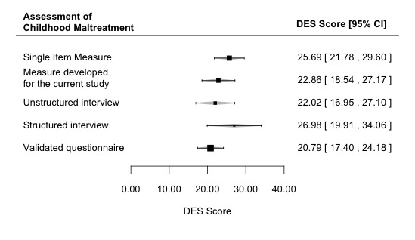
Figure A1. Assessment of childhood maltreatment and DES scores.
Appendix B: Funnel Plots of Standardized Mean Difference Scores for abuse subtypes and neglect

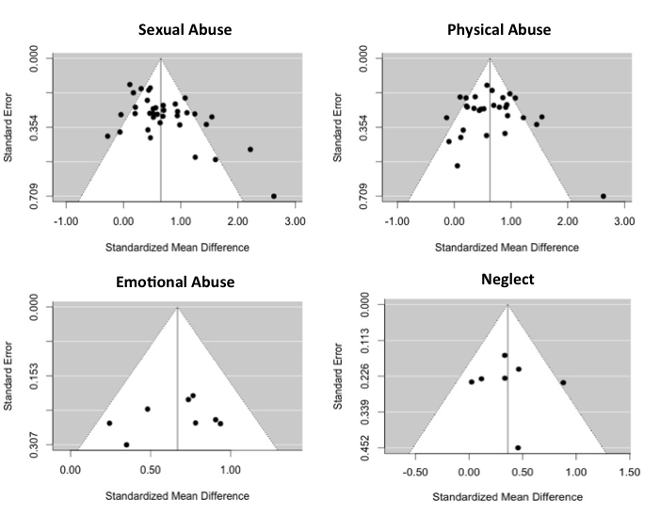Figure B1. funnel plots of standardized mean difference scores for abuse subtypes and neglect
Appendix C: Forest Plots of Abuse/Neglect Subgroup Analysis

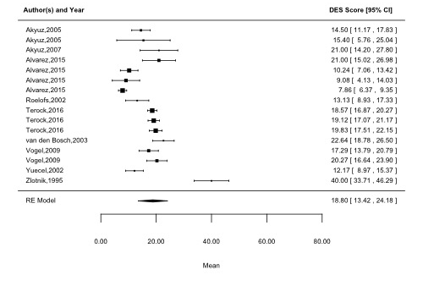
Figure C.1 Descriptive data of studies reporting DES scores for all types of neglect

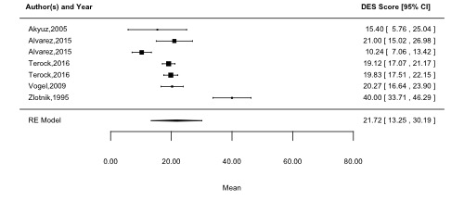
Figure C.2 Descriptive data of studies reporting DES scores for physical neglect

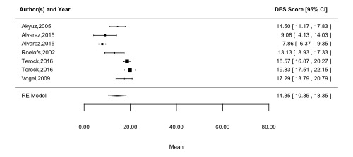
Figure C.3 Descriptive data of studies reporting DES scores for emotional neglect

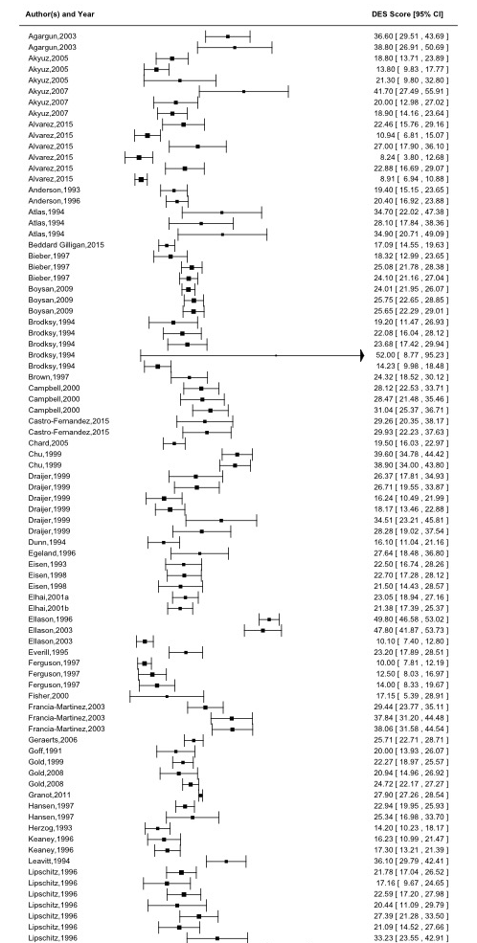
to be continued on the next page
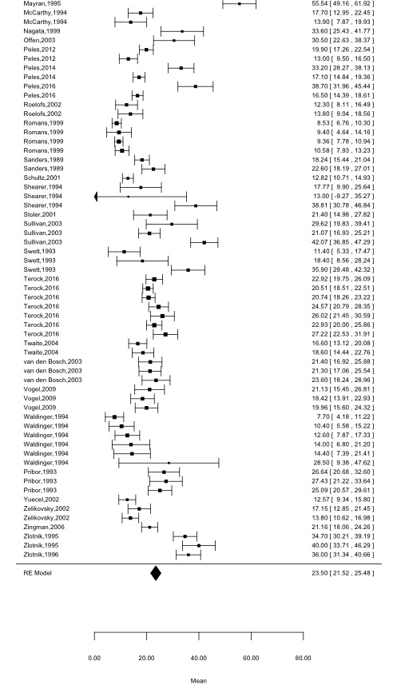
Figure C.4 Descriptive data of studies reporting DES scores for all types of abuse
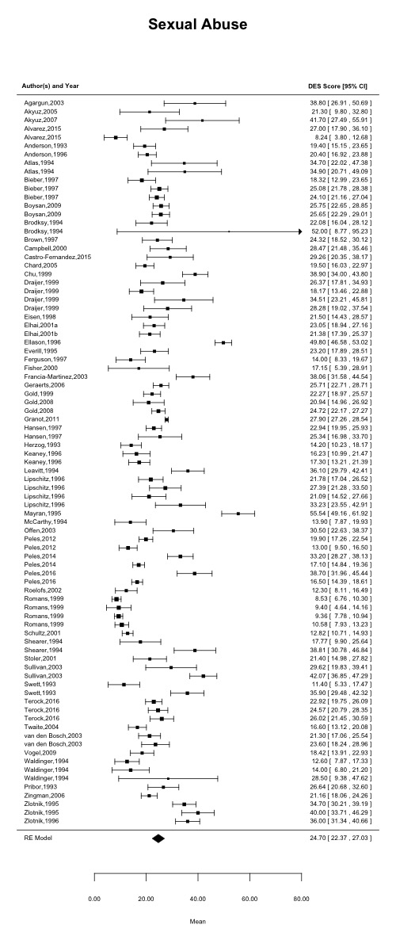
Figure C.5 Descriptive data of studies reporting DES scores for sexual abuse
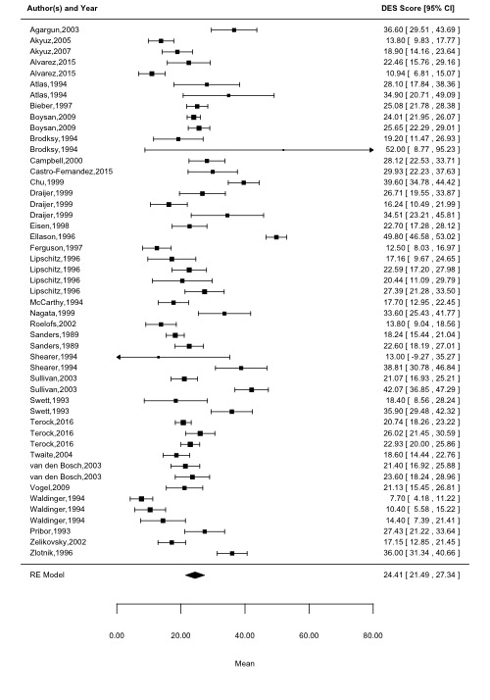
Figure C.6 Descriptive data of studies reporting DES scores for physical abuse

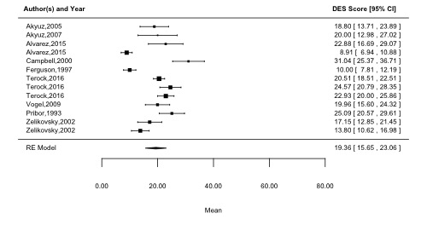
Figure C.7 Descriptive data of studies reporting DES scores for emotional abuse

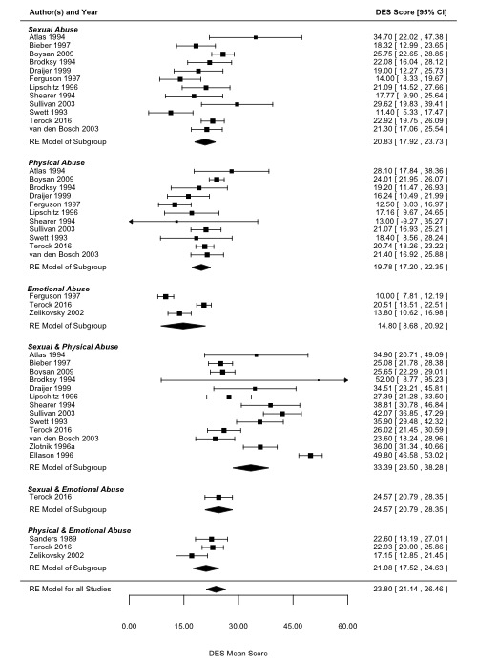
Figure C.8 Descriptive data of studies reporting DES scores for single types of sexual abuse, physical abuse, emotional abuse and combinations of sexual and physical abuse, sexual and emotional abuse, physical and emotional abuse.

Appendix D: References included in the Meta-Analysis

Agargun, M. Y., Kara, H., Özer, Ö. A., Selvi, Y., Kiran, Ü., & Kiran, S. (2003). Nightmares and dissociative experiences: The key role of childhood traumatic events. Psychiatry and Clinical Neurosciences, 57, 139-145.
Akyüz, G., Kuğu, N., Şar, V., & Doğan, O. (2007). Trauma and dissociation among prisoners. Nordic Journal of Psychiatry, 61, 167-172.
Akyüz, G., Sar, V., Kugu, N., & Doğan, O. (2005). Reported childhood trauma, attempted suicide and self-mutilative behavior among women in the general population. European Psychiatry, 20, 268-273.
Álvarez, M.-J., Masramon, H., Peña, C., Pont, M., Gourdier, C., Roura-Poch, P., & Arrufat, F. (2015). Cumulative effects of childhood traumas: Polytraumatization, dissociation, and schizophrenia. Community Mental Health Journal, 51, 54-62.
Anderson, C. L., & Alexander, P. C. (1996). The relationship between attachment and dissociation in adult survivors of incest. Psychiatry, 59, 240-254.
Anderson, G., Yasenik, L., & Ross, C. A. (1993). Dissociative experiences and disorders among women who identify themselves as sexual abuse survivors. Child Abuse & Neglect, 17, 677-686.
Atlas, J. A., & Hiott, J. (1994). Dissociative experience in a group of adolescents with history of abuse. Perceptual and Motor Skills, 78, 121-122.
Bedard‐Gilligan, M., Jakob, J. M. D., Doane, L. S., Jaeger, J., Eftekhari, A., Feeny, N., & Zoellner, L. A. (2015). An investigation of depression, trauma history, and symptom severity in individuals enrolled in a treatment trial for chronic PTSD. Journal of Clinical Psychology, 71, 725-740.
Bieber, E. E. (1997). Dissociative experiences in relation to childhood incestuous abuse. (Doctoral Dissertation), Retrieved from ProQuest Dissertation Publishing (UMI Microform 9731454).
Boysan, M., Goldsmith, R. E., Çavuş, H., Kayri, M., & Keskin, S. (2009). Relations among anxiety, depression, and dissociative symptoms: The influence of abuse subtype. Journal of Trauma & Dissociation, 10, 83-101.
Brodsky, B. S. (1994). The role of dissociative experiences in borderline personality disorder. (Doctoral Dissertation), Retrieved from ProQuest Dissertation Publishing (UMI Microform 9544271).
Brown, L. E. (1997). A comparison of coping styles and body image of abused and non-abused women. (Doctoral Dissertation), Retrieved from ProQuest Dissertation Publishing (UMI Microform 9828936).
Campbell, L. M. (1999). Dissociative tendencies and violent behavior in a male forensic psychiatric population. (Doctoral Dissertation), Retrieved from ProQuest Dissertation Publishing (UMI Microform 9941933).
Castro-Fernandez, M. P., Perona-Garcelan, S., Senin-Calderon, C., & Rodriguez-Testal, J. F. (2015). Relacion entre trauma, dissociacion y sintomas psicoticos positivos [Relationship of trauma, dissociation, and positive psychotic symptoms]. Accion Psicologica, 12, 95-108.
Chard, K. M. (2005). An evaluation of cognitive processing therapy for the treatment of posttraumatic stress disorder related to childhood sexual abuse. Journal of Consulting and Clinical Psychology, 73, 965-971.
Chu, J. A., Frey, L. M., Ganzel, B. L., & Matthews, J. A. (1999). Memories of childhood abuse: Dissociation, amnesia, and corroboration. American Journal of Psychiatry, 156, 749-755.
Draijer, N., & Langeland, W. (1999). Childhood trauma and perceived parental dysfunction in the etiology of dissociative symptoms in psychiatric inpatients. American Journal of Psychiatry, 156, 379-385.
Dunn, G. E., Ryan, J. J., & Dunn, C. E. (1994). Trauma symptoms in substance abusers with and without histories of childhood abuse. Journal of Psychoactive Drugs, 26, 357-360.
Egeland, B., & Susman-Stillman, A. (1996). Dissociation as a mediator of child abuse across generations. Child Abuse & Neglect, 20, 1123-1132.
Eisen, M. L. (1993). Assessing the hypnotizability of college students from addictive families. Contemporary Hypnosis, 10, 11-17.
Eisen, M. L., & Carlson, E. B. (1998). Individual differences in suggestibility: Examining the influence of dissociation, absorption, and a history of childhood abuse. Applied Cognitive Psychology, 12, 47-61.
Elhai, J. D., Flitter, J. M. K., Gold, S. N., & Sellers, A. H. (2001). Identifying subtypes of women survivors of childhood sexual abuse: An MMPI-2 cluster analysis. Journal of Traumatic Stress, 14, 157-175.
Elhai, J. D., Gold, S. N., Mateus, L. F., & Astaphan, T. A. (2001). Scale 8 elevations on the MMPI-2 among women survivors of childhood sexual abuse: Evaluating posttraumatic stress, depression, and dissociation as predictors. Journal of Family Violence, 16, 47-57.
Ellason, J. W., Ross, C. A., & Day, H. (2003). Spirituality and ego strength in dissociative identity disorder. American Journal of Pastoral Counseling, 6, 43-49.
Ellason, J. W., Ross, C. A., & Fuchs, D. L. (1996). Lifetime axis I and II comorbidity and childhood trauma history in dissociative identity disorder. Psychiatry, 59, 255-266.
Everill, J. T., Waller, G., & Macdonald, W. (1995). Reported sexual abuse and bulimic symptoms: The mediating role of dissociation. Dissociation, 8, 155-159.
Ferguson, K. S., & Dacey, C. M. (1997). Anxiety, depression, and dissociation in women health care providers reporting a history of childhood psychological abuse. Child Abuse & Neglect, 21, 941-952.
Fisher, N. K. (2000). Mental representations of attachment and caregiving in women sexually abused during childhood: Links to the intergenerational transmission of trauma? (Doctoral Dissertation), Retrieved from ProQuest Dissertation Publishing (UMI Microform 9959177).
Francia-Martínez, M., de Torres, I. R., Alvarado, C. S., Martínez-Taboas, A., & Sayers, S. (2003). Dissociation, depression and trauma in psychiatric inpatients in Puerto Rico. Journal of Trauma & Dissociation, 4, 47-61.
Geraerts, E., Smeets, E., Jelicic, M., Merckelbach, H., & van Heerden, J. (2006). Retrieval inhibition of trauma-related words in women reporting repressed or recovered memories of childhood sexual abuse. Behaviour Research and Therapy, 44, 1129-1136.
Goff, D. C., Brotman, A. W., Kindlon, D., Waites, M., & Amico, E. (1991). Self-reports of childhood abuse in chronically psychotic patients. Psychiatry Research, 37, 73-80.
Gold, S. N., Hill, E. L., Swingle, J. M., & Elfant, A. S. (1999). Relationship between childhood sexual abuse characteristics and dissociation among women in therapy. Journal of Family Violence, 14, 157-171.
Gold, S. N., Ketchman, S. A., Zucker, I., Cott, M. A., & Sellers, A. H. (2008). Relationship between dissociative and medically unexplained symptoms in men and women reporting childhood sexual abuse. Journal of Family Violence, 23, 569-575.
Granot, M., Somer, E., Zisman-Ilani, Y., Beny, A., Sadger, R., Mirkin, R., . . . Yovell, Y. (2011). Characteristics of response to experimental pain in sexually abused women. The Clinical Journal of Pain, 27, 616-622.
Hansen, C., & Gold, S. N. (1997). Relations between the DES and two MMPI-2 dissociation scales. Dissociation: Progress in the Dissociative Disorders, 10, 29-37.
Herzog, D. B., Staley, J. E., Carmody, S., Robbins, W. M., & van der Kolk, B. A. (1993). Childhood sexual abuse in anorexia nervosa and bulimia nervosa: A pilot study. Journal of the American Academy of Child & Adolescent Psychiatry, 32, 962-966.
Keaney, J. C., & Farley, M. (1996). Dissociation in an outpatient sample of women reporting childhood sexual abuse. Psychological Reports, 78, 59-65.
Leavitt, F. (1994). Clinical correlates of alleged satanic abuse and less controversial sexual molestation. Child Abuse & Neglect, 18, 387-392.
Lipschitz, D. S., Kaplan, M. L., Sorkenn, J., Chorney, P., & Asnis, G. M. (1996). Childhood abuse, adult assault, and dissociation. Comprehensive Psychiatry, 37, 261-266.
Mayran, L. W. (1994). Aspects of hopelessness, dissociative features, and negative early life experiences in DID and non-DID inpatient groups. (Doctoral Dissertation), Retrieved from ProQuest Dissertation Publishing (UMI Microform 9533370).
McCarthy, M. K., Goff, D. C., Baer, L., Cioffi, J., & Herzog, D. B. (1994). Dissociation, childhood trauma, and the response to fluoxetine in bulimic patients. International Journal of Eating Disorders, 15, 219-226.
Nagata, T., Kiriike, N., Iketani, T., Kawarada, Y., & Tanaka, H. (1999). History of childhood sexual or physical abuse in Japanese patients with eating disorders: Relationship with dissociation and impulsive behaviours. Psychological Medicine, 29, 935-942.
Offen, L., Waller, G., & Thomas, G. (2003). Is reported childhood sexual abuse associated with the psychopathological characteristics of patients who experience auditory hallucinations? Child Abuse & Neglect, 27, 919-927.
Peles, E., Adelson, M., Seligman, Z., Bloch, M., Potik, D., & Schreiber, S. (2014). Psychiatric comorbidity differences between women with history of childhood sexual abuse who are methadone-maintained former opiate addicts and non-addicts. Psychiatry Research, 219, 191-197.
Peles, E., Potik, D., Schreiber, S., Bloch, M., & Adelson, M. (2012). Psychiatric comorbidity of patients on methadone maintenance treatment with a history of sexual abuse. European Neuropsychopharmacology, 22, 883-891.
Peles, E., Seligman, Z., Bloch, M., Potik, D., Sason, A., Schreiber, S., & Adelson, M. (2016). Sexual Abuse and its Relation to Chronic Pain among Women from a Methadone Maintenance Clinic versus a Sexual Abuse Treatment Center. Journal of Psychoactive Drugs, 48, 279-287.
Pribor, E. F., Yutzy, S. H., Dean, J. T., & Wetzel, R. D. (1993). Briquet’s syndrome, dissociation, and abuse. American Journal of Psychiatry, 150, 1507-1511.
Roelofs, K., Keijsers, G. P., Hoogduin, K. A., Näring, G. W., & Moene, F. C. (2002). Childhood abuse in patients with conversion disorder. American Journal of Psychiatry, 159, 1908-1913.
Romans, S. E., Martin, J. L., Morris, E., & Herbison, G. P. (1999). Psychological defense styles in women who report childhood sexual abuse: A controlled community study. American Journal of Psychiatry, 156, 1080-1085.
Sanders, B., McRoberts, G., & Tollefson, C. (1989). Childhood stress and dissociation in a college population. Dissociation: Progress in the Dissociative Disorders, 2, 17-23.
Schultz, T. (2001). Memory recall among individuals reporting child sexual abuse: The role of suggestibility, dissociation, and closeness to the perpetrator. (Doctoral Dissertation), Retrieved from ProQuest Dissertation Publishing (UMI Microform 3004744).
Shearer, S. L. (1994). Dissociative phenomena in women with borderline personality disorder. American Journal of Psychiatry, 151, 1324-1328.
Stoler, L. R. (2000). Recovered and continuous memories of childhood sexual abuse: A quantitative and qualitative analysis. (Doctoral Dissertation), Retrieved from ProQuest Dissertation Publishing (UMI Microform 9988236).
Sullivan, B. J. (2002). Dissociative and self-destructive behavioral outcomes of childhood abuse in psychiatric inpatients. (Doctoral Dissertation), Retrieved from ProQuest Dissertation Publishing (UMI Microform 3080974).
Swett, C., & Halpert, M. (1993). Reported history of physical and sexual abuse in relation to dissociation and other symptomatology in women psychiatric inpatients. Journal of Interpersonal Violence, 8, 545-555.
Terock, J., van der Auwera, S., Janowitz, D., Spitzer, C., Barnow, S., Miertsch, M., . . . Grabe, H. J. (2016). From childhood trauma to adult dissociation: The role of PTSD and alexithymia. Psychopathology, 49, 374-382.
Twaite, J. A., & Rodriguez-Srednicki, O. (2004). Childhood sexual and physical abuse and adult vulnerability to PTSD: The mediating effects of attachment and dissociation. Journal of Child Sexual Abuse, 13, 17-38.
van den Bosch, L., Verheul, R., Langeland, W., & van den Brink, W. (2003). Trauma, dissociation, and posttraumatic stress disorder in female borderline patients with and without substance abuse problems. Australian and New Zealand Journal of Psychiatry, 37, 549-555.
Vogel, M., Spitzer, C., Kuwert, P., Möller, B., Freyberger, H. J., & Grabe, H. J. (2009). Association of childhood neglect with adult dissociation in schizophrenic inpatients. Psychopathology, 42, 124-130.
Waldinger, R. J., Swett Jr, C., Frank, A., & Miller, K. (1994). Levels of dissociation and histories of reported abuse among women outpatients. The Journal of Nervous and Mental Disease, 182, 625-630.
Yücel, B., Özyalcin, S., Sertel, H. Ö., Çamlica, H., Ketenci, A., & Talu, G. K. (2002). Childhood traumatic events and dissociative experiences in patients with chronic headache and low back pain. The Clinical Journal of Pain, 18, 394-401.
Zelikovsky, N., & Lynn, S. J. (2002). Childhood psychological and physical abuse: Psychopathology, dissociation, and Axis I diagnosis. Journal of Trauma & Dissociation, 3, 27-58.
Zingman, M. L. (2003). Incarcerated women: Impact of childhood sexual abuse and family functioning on dissociation and psychological distress. (140), Retrieved from ProQuest Dissertation Publishing (UMI Microform 3127198).
Zlotnick, C., Shea, M. T., Pearlstein, T., Begin, A., Simpson, E., & Costello, E. (1996). Differences in dissociative experiences between survivors of childhood incest and survivors of assault in adulthood. The Journal of Nervous and Mental Disease, 184, 52-54.
Zlotnick, C., Shea, M. T., Zakriski, A., Costello, E., Begin, A., Pearlstein, T., & Simpson, E. (1995). Stressors and close relationships during childhood and dissociative experiences in survivors of sexual abuse among inpatient psychiatric women. Comprehensive Psychiatry, 36, 207-212.

