**Increased hippocampal engagement during learning as a marker of sensitivity to transient psychotomimetic effects of delta-9-THC**

**Authorline:** Sagnik Bhattacharyya, MD, PhD1; Thomas Sainsbury, BSc1; Paul Allen, PhD1; Chiara Nosarti , PhD1; Zerrin Atakan, FRCPsych1; Vincent Giampietro, PhD2; Michael Brammer, PhD2; Philip K McGuire, MD, PhD, FRCPsych1

**Supplementary Material**

**Supplementary Methods, Supplementary Tables & Supplementary Figures**

**Supplementary Methods**

The study was conducted in accordance with the declaration of Helsinki and was granted ethical approval by the joint South London and Maudsley and IOP NHS research committee. All participants gave informed written consent to be part of the study.

**Participants**

Out of a total of 39 healthy volunteers who took part in the study, 2 dropped out after the first session and another could not continue because of adverse drug reactions, resulting in a final sample of 36 healthy volunteers for whom all data was available. All of them were right-handed English-speaking males. None of them had a lifetime personal or family history (in first-degree relatives) of mental illness. History of mental illness was assessed on the basis of a standard psychiatric interview by an experienced psychiatrist. The mean age of this sample was 25.97±5.58 and they had a mean National adult reading test (NART) score of 97.7±6. Use of alcohol, cannabis and other illicit drugs was assessed using the Addiction Severity index ([McLellan *et al.*, 1980](#_ENREF_19)). All of the subjects had used cannabis more than once but upto 25 times within their lifetime. In addition all of the participants drank less than 21 units/week of alcohol and none used any other illicit drugs on a regular basis (eTable 1). Participants were asked to abstain from all recreational drugs for the duration of the study and one month prior to it.

**Experimental design**

Each participant attended two sessions that were separated by at least a month interval. At each of these sessions either a single dose of 10mg of THC (approximately 99.6% pure, THC-pharm, Frankfurt, Germany) or a placebo (a gelatine capsule matched in weight and appearance to the THC capsule) was administered to the subjects employing a double-blind design. The order of drug administration was pseudo-randomised to ensure that an equal number of participants received either drug at each session. During each of the sessions participants were required to complete a paired associate verbal learning task while their brain activity (as indexed using blood oxygen level-dependent haemodynamic response; BOLD) was measured using functional Magnetic Resonance Imaging (fMRI).

Prior to these sessions, participants were asked to abstain from smoking for 4 hours, drinking alcohol for 24 hours and taking caffeine for the 12 hours before each session. On the night before the session all subjects were asked to get at least 6 hours sleep. They ate a standardised light breakfast on the morning of the scan after overnight fast. Each participant then passed a negative urine drug screen (using immunometric assay kits) on the morning of each session for opiates, cocaine, amphetamines, benzodiazepines and THC to ensure that no traces of these drugs were in their systems. Each session began (prior to drug administration) with psychopathological ratings and a venous blood sample. This blood sample was taken via the insertion of an indwelling catheter into a subcutaneous vein of the non-dominant forearm of the subject. Psychological ratings and blood samples were subsequently repeated 1, 2, and 3 hours after drug administration. Psychological ratings and blood sampling were carried out at each of the time points outside the MRI scanner.

Blood samples from pilot studies demonstrated that the concentration of THC in blood plateaued at approximately between 1 and 2 hours after ingestion of the drug giving a stable concentration for scans to be conducted. MRI scans were therefore performed starting 1 hour after ingestion of the drug and these lasted no longer than 60 minutes. Participants were asked to complete a verbal paired associate task lasting about 12.5 minutes while they were scanned. This task has previously been useful in fMRI studies investigating the effect of THC on verbal memory ([Bhattacharyya *et al.*, 2009](#_ENREF_5)).

**The Verbal Paired Associate Task**

The verbal paired associate learning task ([Bhattacharyya *et al.*, 2009](#_ENREF_5)) consisted of three different conditions (encoding, recall and baseline) that were presented sequentially and involved visual presentation of stimuli. During the encoding condition participants were presented with two words presented visually. To promote encoding, participants were required to decide whether these words went well together in terms of their meaning. Their answers, either ‘yes’ or ‘no’, were communicated verbally and then noted down by the researcher.

For the recall condition, participants were presented with a single word from one of the pairs that had previously been presented in the encoding condition. The missing word from that pair was replaced with a question mark. Participants were required to recall and articulate the missing word. If the subject could not recall the missing word then they were required to say ‘pass’.

During the baseline condition, participants were presented with pairs of words printed with identical or different fonts. These words were different to those that had been presented during the encoding and recall conditions and these word pairs were not repeated across baseline blocks. This ensured that learning was kept to a minimum to allow the effect of the encoding and recall conditions on neural activity to be identified through comparison of the baseline fMRI data with that of the encoding and recall conditions.

The stimuli for all of the conditions were presented in 40-second blocks. Each of the blocks consisted of 8 word pairs and the three conditions were presented sequentially in the same order (encoding then recall followed by the baseline condition). The appearance of the different word pairs in each block was randomised. Preceding each block, participants were reminded of the task for that block by a visual prompt. For the encoding condition this was ‘Do these words go well together?’, for the recall condition ‘Which word was associated with this?’ and for the baseline condition ‘Are these fonts the same?’. Participants practiced the task beforehand using a set of word pairs that were different to those that were then presented during the actual fMRI task. Recall scores were recorded as a measure of task performance.

All words used in this task were drawn from the Medical Research Council Psycholinguistic Database ([Coltheart, 1981](#_ENREF_10)). These are words that have been matched for frequency of use, number of letters, familiarity and comprehension (Kučera and Francis, 1967).

Whilst 4 blocks were presented, only the results from the first 3 blocks are reported here. This is because an analysis of task performance revealed that the participants stopped learning after the 3 blocks and almost all scored maximally on the recall task.

**Behavioural data acquisition.**

An experienced clinical researcher determined the psychotomimetic effects of THC using the Positive and Negative Symptom Scale (PANSS) ([Kay *et al.*, 1987](#_ENREF_16)). Whilst PANSS is usually employed in clinical trials of schizophrenia to rate positive and negative symptoms of psychosis as well as other symptoms that are commonly present in those with psychosis (general psychopathology), it has also been used in a number of other studies investigating the transient psychotomimetic effects of THC ([Atakan *et al.*, 2013](#_ENREF_2), [Bhattacharyya *et al.*, 2012a](#_ENREF_3), [Bhattacharyya *et al.*, 2012b](#_ENREF_4), [Bhattacharyya *et al.*, 2009](#_ENREF_5), [D'Souza *et al.*, 2005](#_ENREF_11), [D'Souza *et al.*, 2004](#_ENREF_12))

In addition to psychotic symptoms, participants’ state of anxiety and intoxication were assessed using the State-Trait Anxiety Inventory (STAI) ([Spielberger, 1983](#_ENREF_20))and the Analogue Intoxication scale (AIS) ([Mathew *et al.*, 1992](#_ENREF_18)) respectively. All psychological ratings including PANSS were carried out while participants were outside the scanner.

**Classification of participants on the basis of sensitivity to THC**

For the purpose of this investigation, we established *a priori* criteria to define transient psychosis induced by THC, which were used to classify the participants into those who experienced transient psychotomimetic effects (TP) and those who did not (NP). Classification was carried out following completion of all data acquisition. Participants were identified as having experienced transient psychotic symptoms and allocated to the TP group if they scored 3 or more on any of the PANSS positive subscale items that measured psychotic symptoms (Delusions, Hallucinations, Suspiciousness/ Persecution) during any of the time-points when ratings were obtained following THC administration ([Atakan *et al.*, 2013](#_ENREF_2)). Each item of PANSS ([Kay *et al.*, 1987](#_ENREF_16)) is scored on a 7-point Likert scale, with a score of 1 denoting that the item being measured is “absent”, a score of 2 denoting that it is “minimal” (indicating “questionable or subtle or suspect pathology” and a score of 3 denoting “mild” (indicating “a symptom whose presence is clearly established but not pronounced”). A score of 3 was used as the cut-off as this is the threshold used in the clinical setting to indicate clear, unambiguous presence of a psychotic symptom ([Kay *et al.*, 1987](#_ENREF_16)). While PANSS does not describe the score of ‘3’ as a threshold, in practice the score of ‘3’ becomes a threshold for denoting presence of a symptom, as a score of ‘2’ indicates “Questionable pathology; may be at the upper extreme of normal limits”. This is also the scoring threshold used in the clinical setting, especially in the context of clinical trials of antipsychotic medications to indicate clear, unambiguous presence of these symptoms. For the item ‘Delusions’, a score of 3 on PANSS refers to “Mild- Presence of one or two delusions that are vague, uncrystallized, and not tenaciously held. Delusions do not interfere with thinking, social relations, or behavior.” For “Hallucinatory Behaviour”, a score of 3 denotes “Mild- One or two clearly formed but infrequent hallucinations, or else a number of vague abnormal perceptions which do not result in distortions of thinking or behaviour.”, while for “Suspiciousness/ Persecution”, a score of 3 indicates “Mild - Presents a guarded or even openly distrustful attitude, but thoughts, interactions and behaviour are minimally affected.” Higher scores on each of these items indicate greater severity, while a score of 2 indicates “Questionable pathology; may be at the upper extreme of normal limits”. Psychotic symptoms scored in these participants were otherwise comparable to that observed in a clinical situation except that they were transient in nature, a characteristic that is typical of psychotic symptoms observed under the experimental THC challenge condition. In order to classify participants between those who experienced transient anxiety (TA) and those who did not (NA) under the influence of THC, we used the change in their STAI score over time in response to THC administration. Using the Reliable Change Index ([Jacobson and Truax, 1991](#_ENREF_15)), we estimated that a 4-point change in STAI score (by deducting baseline STAI score from the peak STAI score following THC) would reliably differentiate those who experienced anxiety from those who did not experience anxiety following THC administration. Therefore any participant, who had over a 4-point change in their STAI, when baseline STAI score was deducted from their peak post-THC STAI score, was allocated to the TA group, while participants who had less than a 4-point change in their score were in the NA group.

**Image Acquisition**

Functional MRI images were acquired at the Maudsley hospital using a 1.5 Tesla GE Signa system (GE Medical Systems, Milwaukee, WI, USA). During the verbal learning task a gradient-echo sequence was used to acquire one hundred and forty-eight T2\* weighted images at 16 near-axial planes (7 mm thick, inter-slice gap 0.7 mm) parallel to the inter-commissural (AC-PC) plane with a repetition time (TR) of 5000msec (image volume acquisition over 1500msec and period between clustered acquisition of image volumes 3500 msec), TE of 40 msec and flip angle of 70˚ (FOV 24 x 24 cm and matrix 642). The inter-stimulus interval was 5000msec. The first 4 (dummy) volumes were discarded to allow for T1 equilibration effects. During the first 1500msec of the TR images were acquired, for the remaining 3500msec the scanner was silent. Each of the visual stimuli that were presented to the subject during the verbal learning task were shown to the subject at the beginning of each silent period. This allowed for each trial to be performed and verbal response to be recorded without the interference of scanner noise. We employed this strategy of using an acquisition sequence in which image acquisition was compressed into the initial part of the each TR, thereby creating a ‘silent’ period when images were not being acquired and the scanner did not produce acoustic noise([Amaro *et al.*, 2002](#_ENREF_1)), in order to minimise the potential effect of articulation of verbal responses during the task on brain activation. As verbal responses during the task were restricted to these ‘silent’ periods, any head movement associated with articulation occurred outside the time when the images were being acquired, reducing the likelihood of motion-correlated artifacts([Bullmore *et al.*, 1999a](#_ENREF_8)). Furthermore, in the absence of acoustic scanner noise, participants did not need to shout their responses. An inversion recovery EPI dataset (TR 3000msec, TE 40 msec, flip angle 90˚, near-axial slices, 3mm thick, inter-slice gap 0.3mm, in-plane resolution 1.5mm) was acquired to facilitate anatomic localization of the functional data.

**Statistical analysis**

**Image analysis**

XBAM\_v4.1 (<http://www.brainmap.co.uk>), a non-parametric data analysis software package developed at the Institute of Psychiatry, Psychology & Neuroscience (King’s College London) was used for analysing fMRI data. The non-parametric approach minimises assumptions about the distribution of the data. This is important in the analysis of fMRI data because the distribution of data may not necessarily follow a normal Gaussian distribution ([Brammer *et al.*, 1997](#_ENREF_6)),([Thirion *et al.*, 2007](#_ENREF_22)). By using medians rather than averages as a test statistic, XBAM is less sensitive to the effects of outlier values misrepresenting the distribution of the data ([Hayasaka and Nichols, 2003](#_ENREF_14)). The test statistic is computed in this method by standardizing for individual differences in residual noise before embarking on a second- level, multi-subject testing, using robust permutation-based methods, employing a mixed-effects approach.

Images were first realigned to correct for head motion ([Bullmore *et al.*, 1999a](#_ENREF_8)). This involved the computation of a 3D volume consisting of the average intensity at each voxel over the whole experiment, which was used as a template. The 3D image volume at each time-point was then realigned to this template by computing the combination of rotations (around the x, y and z axes) and translations (in x, y and z) that maximised the correlation between the image intensities of the volume in question and the template 3D volume. The data were then smoothed by the application of a 7.2mm full-width-at-half-maximum Gaussian filter to average the relative intensities of neighbouring voxels. Activation maps were created for each individual by modelling the BOLD signal using 2 gamma-variate functions, peaking at 4 and 8 seconds to allow for variability in haemodynamic delay. Then, using the constrained BOLD effects model, a best fit between the weighted sum of these convolutions and the change over time at each voxel was computed ([Friman *et al.*, 2003](#_ENREF_13)). This reduces the possibility of the model-fitting procedure giving rise to mathematically plausible, but physiologically implausible results. Following the least squares fitting of this model to the data, the sum of squares (SSQ) ratio (ratio of the SSQ of deviations from the mean image intensity due to the model component over the whole time series to the SSQ of deviations due to the residuals) was estimated for each voxel and this was followed by permutation testing to determine which voxels were significantly activated ([Bullmore *et al.*, 2001](#_ENREF_7)). This addresses the problem associated with the use of the F statistic that the residual degrees of freedom are often unknown in fMRI time series due to the presence of coloured noise in the signal. Data were permuted by the wavelet-based method described and characterized previously ([Bullmore *et al.*, 2001](#_ENREF_7)), which permits data driven calculation of the null distribution of SSQ under the assumption of no experimentally-determined response. This distribution can then be used to threshold the activation maps at any desired type 1 error rate. Activated voxels were then grouped into clusters using a method described before ([Bullmore *et al.*, 1999b](#_ENREF_9)), which has been shown to give excellent cluster-wise type 1 error control. SSQ ratio maps for each individual were transformed into standard stereotactic space ([Talairach and Tournoux, 1988](#_ENREF_21)) using a two-stage warping procedure ([Brammer *et al.*, 1997](#_ENREF_6)) for the purpose of localization of activations. As a first step, an average image intensity map for each individual over the course of the experiment was computed. We then computed the transformations required to map this image to the structural scan for each individual and then from ‘structural space’ to the Talairach template by maximizing the correlation between the images at each stage. The SSQ ratio and BOLD effect size maps were then transformed into Talairach space using these transformations. Group activation maps were computed for each group (TP vs NP or TA vs NA) in each drug condition by determining the median SSQ ratio at each voxel (over all individuals) in the observed and permuted data maps. Medians were used to minimize outlier effects. The distribution of median SSQ ratios over all intracerebral voxels from the permuted data was then used to derive the null distribution of SSQ ratios. This allows group activation maps to be thresholded at the desired voxel or cluster-level type 1 error rate. This gave group activation maps for each condition that could be compared against each other using non-parametric repeated-measure analysis of variance (ANOVA) ([Brammer *et al.*, 1997](#_ENREF_6)). The voxel-wise statistical threshold was set at p=0.05 and the cluster-wise thresholds were adjusted to ensure that the number of false positive clusters per brain would be <1 (regions that survive this critical statistical threshold and the corresponding p values are reported). This excluded any areas of activation, which did not meet this threshold of significance. By conducting analyses at a cluster-level, data from more than one voxel is integrated into the test statistic giving greater sensitivity and it also allows for a reduction in the search volume or overall number of required tests for whole brain analysis. In comparison to analysis at the voxel level, cluster level analyses thereby helps mitigate the multiple comparisons problem.

For each drug condition, we contrasted each of the active (encoding or recall) conditions of the verbal memory task against the baseline (fonts) condition at the individual subject level to generate contrast of interest map (‘encoding minus baseline’ and for ‘recall minus baseline’ conditions) for each subject, which were used for subsequent group-level analyses. As the baseline condition of the task was designed to keep learning to a minimum this analysis was used to exclude those areas that were involved in the completion of a task involving verbal stimuli but that were not crucial to learning and memory.

Analysis of variance compared the TP group and NP during the placebo condition in order to assess differences in functional activation during the contrast of interest (for ‘encoding minus baseline’ and for ‘recall minus baseline’ conditions) in the absence of THC. Henceforth, for the purposes of simplicity, ‘encoding minus baseline’ and ‘recall minus baseline’ contrasts will be referred to as ‘encoding’ and ‘recall’ respectively, unless otherwise specified. To test the robustness of these group differences in activation and whether they were driven by outliers, we carried out a ‘leave one subject out’ (LOSO) analysis, which involved repeating the ANOVA with a different subject from the TP group being left out on each repeat. A total of 14 repeat ANOVAs were carried out, once with each of the 14 TP subjects being left out. We then examined whether these neural activation differences during the encoding and recall conditions were specific to the sub-groups classified according to sensitivity to the psychotomimetic effects of THC (TP vs NP) or were similar to that between subgroups classified based on sensitivity to anxiogenic effects of THC (TA vs NA). One-way analysis of variance compared task-related neural activation differences (during encoding and recall conditions) between the TA and NA groups under the placebo condition to examine whether similar group differences exist between TA and NA groups as between TP and NP groups. Further, comparisons (using 2-way ANOVA) were then made between the drug given, TP and NP groups and the interaction of effects between them. The statistical values of the brain regions (clusters) differentially activated in these analyses, which were the mean of the SSQ ratio values of all the voxels in the respective clusters, were extracted to an IBM SPSS version 22 (IBM Corp. Released 2013; IBM SPSS Statistics for Windows, Version 22.0. Armonk, NY: IBM Corp.), where they could be plotted into graphs accompanying the brain activation maps. They were also used to identify correlation with behavioural data. A similar approach was employed to compare TA and NA groups.

**Social demographic and behavioural analysis**

Behavioural data was recorded and analysed using SPSS version 22 (see above). Comparisons between the socio-demographic characteristics of the two groups (such as age, NART score and number of years in education) and task performance (recall score) were carried out using two-sample *t-*tests. Differences in symptomatic data between the groups at 2 hours after THC and placebo administration did not fit normal distribution. Mann-whitney U tests were therefore used to assess differences in the means. We used the 2-hour time point because this is around the time that THC level peaked in peripheral blood and because scans were acquired closer to this time point (between 1-2hrs).

**REFERENCES:**

**Amaro, E., Jr., Williams, S. C., Shergill, S. S., Fu, C. H., MacSweeney, M., Picchioni, M. M., Brammer, M. J. & McGuire, P. K.** (2002). Acoustic noise and functional magnetic resonance imaging: current strategies and future prospects. *Journal of Magnetic Resonance Imaging* **16**, 497-510.

**Atakan, Z., Bhattacharyya, S., Allen, P., Martin-Santos, R., Crippa, J. A., Borgwardt, S. J., Fusar-Poli, P., Seal, M., Sallis, H., Stahl, D., Zuardi, A. W., Rubia, K. & McGuire, P.** (2013). Cannabis affects people differently: inter-subject variation in the psychotogenic effects of Delta9-tetrahydrocannabinol: a functional magnetic resonance imaging study with healthy volunteers. *Psychological Medicine* **43**, 1255-67.

**Bhattacharyya, S., Atakan, Z., Martin-Santos, R., Crippa, J. A., Kambeitz, J., Prata, D., Williams, S., Brammer, M., Collier, D. A. & McGuire, P. K.** (2012a). Preliminary report of biological basis of sensitivity to the effects of cannabis on psychosis: AKT1 and DAT1 genotype modulates the effects of delta-9-tetrahydrocannabinol on midbrain and striatal function. *Molecular Psychiatry* **17**, 1152-5.

**Bhattacharyya, S., Crippa, J. A., Allen, P., Martin-Santos, R., Borgwardt, S., Fusar-Poli, P., Rubia, K., Kambeitz, J., O'Carroll, C., Seal, M. L., Giampietro, V., Brammer, M., Zuardi, A. W., Atakan, Z. & McGuire, P. K.** (2012b). Induction of psychosis by Delta9-tetrahydrocannabinol reflects modulation of prefrontal and striatal function during attentional salience processing. *Archives of General Psychiatry* **69**, 27-36.

**Bhattacharyya, S., Fusar-Poli, P., Borgwardt, S., Martin-Santos, R., Nosarti, C., O'Carroll, C., Allen, P., Seal, M. L., Fletcher, P. C., Crippa, J. A., Giampietro, V., Mechelli, A., Atakan, Z. & McGuire, P.** (2009). Modulation of mediotemporal and ventrostriatal function in humans by Delta9-tetrahydrocannabinol: a neural basis for the effects of Cannabis sativa on learning and psychosis. *Archives of General Psychiatry* **66**, 442-51.

**Brammer, M. J., Bullmore, E. T., Simmons, A., Williams, S. C., Grasby, P. M., Howard, R. J., Woodruff, P. W. & Rabe-Hesketh, S.** (1997). Generic brain activation mapping in functional magnetic resonance imaging: a nonparametric approach. *Magnetic Resonance Imaging* **15**, 763-70.

**Bullmore, E., Long, C., Suckling, J., Fadili, J., Calvert, G., Zelaya, F., Carpenter, T. A. & Brammer, M.** (2001). Colored noise and computational inference in neurophysiological (fMRI) time series analysis: resampling methods in time and wavelet domains. *Human Brain Mapping* **12**, 61-78.

**Bullmore, E. T., Brammer, M. J., Rabe-Hesketh, S., Curtis, V. A., Morris, R. G., Williams, S. C., Sharma, T. & McGuire, P. K.** (1999a). Methods for diagnosis and treatment of stimulus-correlated motion in generic brain activation studies using fMRI. *Human Brain Mapping* **7**, 38-48.

**Bullmore, E. T., Suckling, J., Overmeyer, S., Rabe-Hesketh, S., Taylor, E. & Brammer, M. J.** (1999b). Global, voxel, and cluster tests, by theory and permutation, for a difference between two groups of structural MR images of the brain. *IEEE Transactions in Medical Imaging* **18**, 32-42.

**Coltheart, M.** (1981). The MRC Psycholinguistic Database. *Quarterly Journal of Experimental Psychology* **33A**, 497-505.

**D'Souza, D. C., Abi-Saab, W. M., Madonick, S., Forselius-Bielen, K., Doersch, A., Braley, G., Gueorguieva, R., Cooper, T. B. & Krystal, J. H.** (2005). Delta-9-tetrahydrocannabinol effects in schizophrenia: implications for cognition, psychosis, and addiction. *Biological Psychiatry* **57**, 594-608.

**D'Souza, D. C., Perry, E., MacDougall, L., Ammerman, Y., Cooper, T., Wu, Y. T., Braley, G., Gueorguieva, R. & Krystal, J. H.** (2004). The psychotomimetic effects of intravenous delta-9-tetrahydrocannabinol in healthy individuals: implications for psychosis. *Neuropsychopharmacology* **29**, 1558-72.

**Friman, O., Borga, M., Lundberg, P. & Knutsson, H.** (2003). Adaptive analysis of fMRI data. *Neuroimage* **19**, 837-45.

**Hayasaka, S. & Nichols, T. E.** (2003). Validating cluster size inference: random field and permutation methods. *Neuroimage* **20**, 2343-56.

**Jacobson, N. S. & Truax, P.** (1991). Clinical significance: a statistical approach to defining meaningful change in psychotherapy research. *Journal of Consulting & Clinical Psychology* **59**, 12-9.

**Kay, S. R., Fiszbein, A. & Opler, L. A.** (1987). The positive and negative syndrome scale (PANSS) for schizophrenia. *Schizophrenia Bulletin* **13**, 261-76.

**Kučera, H. & Francis, W. N.** (1967). *Computational analysis of present-day American English*. Dartmouth Publishing Group.

**Mathew, R. J., Wilson, W. H., Humphreys, D. F., Lowe, J. V. & Wiethe, K. E.** (1992). Regional cerebral blood flow after marijuana smoking. *Journal of Cerebral Blood Flow & Metabolism* **12**, 750-8.

**McLellan, A. T., Luborsky, L., Woody, G. E. & O'Brien, C. P.** (1980). An improved diagnostic evaluation instrument for substance abuse patients. The Addiction Severity Index. *Journal of Nervous & Mental Disease* **168**, 26-33.

**Spielberger, C. D.** (1983). *Manual for the state/trait anxiety inventory (form Y) : (self evaluation questionnaire)*. Consulting Psychologists Press: Palo Alto.

**Talairach, J. & Tournoux, P.** (1988). *[Co-planar Stereotaxic Atlas of the Human Brain.]*. Thieme Medical New York.

**Thirion, B., Pinel, P., Meriaux, S., Roche, A., Dehaene, S. & Poline, J. B.** (2007). Analysis of a large fMRI cohort: Statistical and methodological issues for group analyses. *Neuroimage* **35**, 105-20.

**Supplementary Tables:**

**Supplementary Table 1A: Previous exposure to psychoactive substances in study participants**

|  |  |
| --- | --- |
| **Lifetime Illicit drug use** | |
| Cannabis | <5 times: 12 subjects;  5-25 times: 24 subjects |
| Amphetamines | 5 subjects\*/¥ (4 subjects had experimented a few times and 1 had used small quantities from time to time) |
| LSD/ Psilocybin | 10 subjects ‡ (all had experimented a few times) |
| Cocaine | 3 subjects (all had experimented a few times) |
| Opiate | 2 subjects (both had experimented a few times) |
| MDMA | 11 subjects\*\*/\*\*\*; (all of them had experimented a few times) |
| **Other psychoactive substances (current use)** | |
| Nicotine | 9 subjects;  Mean number of cigarettes smoked/ day- 1.19 (SD-3.18) (range 0-15/ day);  2 subjects smoked >10 cigarettes/day lifetime; only 1 subject smoked at that level at the time of the study. |
| Caffeine | 33 subjects; Mean number of cups of coffee, tea or caffeinated drinks/ day- 2.42 (SD- 1.86) (range 0-11) |

\* 1 subject had experimented with both amphetamines and LSD/Psilocybin

¥ 1 subject had used amphetamines once a day for 4 weeks about 4 years before study

‡ 1 subject had experimented with both opiates & Psilocybin

\*\* 1 subject had experimented with both LSD/ Psilocybin and MDMA

\*\*\* 1 subject had experimented with both MDMA and opiates.

**Supplementary Table 1B: Previous exposure to psychoactive substances in the two subgroups (Transiently psychotic: TP; Non-psychotic: NP) of study participants**

|  |  |  |  |  |
| --- | --- | --- | --- | --- |
| **Lifetime Alcohol and Illicit drug use** | | | | |
| **Psychoactive substance** | **Pattern of use (n)** | **TP** | **NP** | ***p* value** |
| Alcohol | Drinks only at weekends (moderate amounts) | 8 | 8 | p>0.1 |
| Drinks everyday in moderate amounts | 2 | 5 |
| Drinks occasionally | 3 | 8 |
| Drinks everyday moderately, some days is drunk | 1 | 1 |
| Amphetamines | No use | 10 | 21 | p>0.1 |
| Experimental use | 3 | 1 |
| Occasional use (small quantities from time to time) | 1 | 0 |
| LSD/ Psilocybin | No use | 11 | 15 | p>0.1 |
| Experimental use | 3 | 7 |
| Occasional use (small quantities from time to time) | 0 | 0 |
| Cocaine | No use | 13 | 20 | p>0.1 |
| Experimental use | 1 | 2 |
| Occasional use (small quantities from time to time) | 0 | 0 |
| Opiate | No use | 13 | 21 | p>0.1 |
| Experimental use | 1 | 1 |
| Occasional use (small quantities from time to time) | 0 | 0 |
| MDMA | No use | 10 | 15 | p>0.1 |
| Experimental use | 4 | 7 |
| Occasional use (small quantities from time to time) | 0 | 0 |
| **Other psychoactive substances (current use)** | |  |  |  |
| Nicotine (number of cigarettes/ day) (Mean±SD) | | 1.36 (3.97) | 1.09 (2.66) | 0.81 |
| Cannabis (number of times lifetime) (Mean±SD) | | 12.28 (7.67) | 14.16 (7.02) | 0.47 |
| Caffeine (number of cups of coffee) (Mean±SD) | | 2.45 (2.18) | 2.40 (1.68) | 0.95 |

Supplementary Table 2. Symptomatic and task performance data. Table showing the mean and standard deviation (SD) values for the positive and negative symptom subscale (PANSS) total score, each of the PANSS subscales, State-trait anxiety inventory- state subscale (STAI), Analogue intoxication scale (AIS) and recall scores. Data shown is for 2 hours after ∆9-tetrahydrocannabinol (THC) and placebo (PLB) administration.

|  |  |  |  |  |  |  |
| --- | --- | --- | --- | --- | --- | --- |
|  | **Transiently psychotic**  **Mean (SD)** | **Non-psychotic**  **Mean (SD)** | ***p* value** | **Transiently anxious**  **Mean (SD)** | **Non-anxious**  **Mean (SD)** | ***p* value** |
| **PANSS positive symptoms** |  |  |  |  |  |  |
| 2 hrs after PLB treatment | 7.36 (0.75) | 7.55 (1.01) | 0.77 | 7.22 (0.54) | 7.28 (0.57) | 0.79 |
| 2 hrs after THC treatment | 13.00 (3.70) | 7.23 (0.69) | <0.001 | 10.28 (4.04) | 8.94 (3.03) | 0.18 |
| **PANSS negative symptoms** |  |  |  |  |  |  |
| 2 hrs after PLB treatment | 7.50 (1.87) | 7.41 (1.14) | 0.64 | 7.50 (1.24) | 7.39 (1.65) | 0.44 |
| 2 hrs after THC treatment | 10.29 (2.61) | 7.91 (1.63) | <0.001 | 9.56 (2.17) | 8.11 (2.34) | 0.037 |
| **PANSS general psychopathology score** |  |  |  |  |  |  |
| 2 hrs after PLB treatment | 17.29 (2.01) | 16.68 (1.39) | 0.911 | 17.00 (1.53) | 16.83 (1.82) | 0.50 |
| 2 hrs after THC treatment | 25.93 (5.66) | 19.23 (3.18) | <0.001 | 23.22 (5.81) | 20.44 (4.65) | 0.097 |
| **PANSS total score** |  |  |  |  |  |  |
| 2 hrs after PLB treatment | 32.14 (3.90) | 31.27 (2.47) | 0.42 | 31.72 (2.82) | 31.50 (3.4) | 0.52 |
| 2 hrs after THC treatment | 49.00 (8.84) | 34.59 (4.14) | <0.001 | 43.06 (9.84) | 37.33 (8.45) | 0.05 |
| **STAI state score** |  |  |  |  |  |  |
| 2 hrs after PLB treatment | 15.71 (8.94) | 10.18 (7.67) | 0.83 | 10.33 (6.87) | 14.33 (9.66) | 0.22 |
| 2 hrs after THC treatment | 26.79 (11.99) | 15.55 (11.03) | 0.008 | 24.72 (11.81) | 15.11 (11.63) | 0.016 |
| **AIS score** |  |  |  |  |  |  |
| 2 hrs after PLB treatment | 2.08 (2.69) | 1.27 (1.55) | 0.40 | 2.03 (2.54) | 1.27 (1.34) | 0.88 |
| 2 hrs after THC treatment | 7.44 (2.08) | 4.24 (2.82) | 0.001 | 7.03 (1.80) | 3.81 (2.97) | <0.001 |
| **Recall score** |  |  |  |  |  |  |
| Between 1-2 hrs after PLB treatment | 29.28 (4.82) | 30.68 (1.70) | 0.22 | 30.66 (2.08) | 29.61 (4.17) | 0.34 |
| Between 1-2 hrs after THC treatment | 30.00 (3.50) | 30.18 (2.51) | 0.85 | 30.22 (2.66) | 30.00 (3.18) | 0.22 |

**Supplementary Table 3A. Brain regions engaged by the encoding condition of the verbal learning task independent of drug condition.**

Regions survive critical threshold of <1 false positive cluster

|  |  |  |  |  |  |
| --- | --- | --- | --- | --- | --- |
|  | Talairach Coordinates | | | Cluster size |  |
| Area | **x** | **y** | **z** | **No. of voxels** | ***p* value** |
| Superior frontal gyrus | 0 | 4 | 48 | 58 | 0.0035 |
| Precentral gyrus | 51 | -7 | 37 | 196 | 0.0035 |
| 54 | -4 | 15 | 267 | 0.0035 |
| -47 | -15 | 42 | 181 | 0.001 |
| -54 | -7 | 9 | 6 | 0.001 |
| Postcentral gyrus | -47 | -11 | 15 | 46 | 0.001 |
| -43 | -19 | 37 | 37 | 0.001 |
| Inferior frontal gyrus | -29 | 30 | -7 | 21 | 0.001 |
| 22 | 30 | 9 | 126 | 0.0035 |
| Insula | -36 | 15 | 4 | 128 | 0.001 |
| 36 | 19 | -2 | 9 | 0.0035 |
| Claustrum | 29 | 19 | 4 | 59 | 0.0035 |
| Anterior cingulate/ medial prefrontal cortex | -4 | 7 | 42 | 100 | 0.001 |
| Hippocampus | -29 | -41 | 4 | 16 | 0.001 |
| -25 | -15 | -13 | 0.001 |
| 36 | -33 | 4 | 71 | 0.0035 |
| Parahippocampal gyrus / Amygdala | 25 | -7 | -13 | 15 | 0.0035 |
| Parahippocampal gyrus | -25 | -15 | -7 | 11 | 0.001 |
| Superior temporal gyrus | 43 | -26 | -2 | 54 | 0.0035 |
| 43 | -26 | -7 | 51 | 0.0035 |
| 58 | -30 | 9 | 4 | 0.0035 |
| Fusiform gyrus | 22 | -81 | -13 | 23 | 0.0035 |
| -25 | -44 | 15 | 57 | 0.001 |
| -18 | -85 | -13 | 0.001 |
| Lingual gyrus | -11 | -78 | 4 | 26 | 0.001 |
|  | 18 | -81 | 4 | 84 | 0.0035 |
| Middle Occipital gyrus | 25 | -85 | -7 | 74 | 0.0035 |
| Posterior cingulate | -29 | -41 | 9 | 12 | 0.001 |
|  | 18 | -67 | 9 | 4 | 0.0035 |
| Cuneus | -4 | -78 | 15 | 12 | 0.001 |
|  | 11 | -78 | 15 | 30 | 0.0035 |
| Striatum | -18 | -7 | -2 | 24 | 0.001 |
|  | -22 | -37 | 20 | 7 | 0.001 |
| Cerebellum | -36 | -67 | -18 | 37 | 0.001 |
|  | 36 | -67 | -24 | 22 | 0.0035 |
|  | 25 | -81 | -18 |  | 0.0035 |

**Supplementary Table 3B. Brain regions engaged by the recall condition of the verbal learning task independent of the drug condition.**

Regions survive critical threshold of <1 false positive cluster

|  |  |  |  |  |  |
| --- | --- | --- | --- | --- | --- |
|  | Talairach Coordinates | | | Cluster size |  |
| Area | **x** | **y** | **z** | **No. of voxels** | ***p* value** |
| Precentral gyrus | -51 | -7 | 9 | 280 | 0.001 |
| -40 | -19 | 37 | 0.001 |
| -43 | -15 | 48 | 0.001 |
| 47 | -11 | 31 | 137 | 0.003 |
| 58 | 0 | 15 | 0.003 |
| 51 | -7 | 37 | 0.003 |
| Postcentral gyrus | -43 | -19 | 42 | 109 | 0.001 |
| Inferior frontal gyrus | -43 | 15 | -13 | 139 | 0.001 |
| Insula | 43 | -22 | -2 | 44 | 0.003 |
| -29 | 26 | 4 | 89 | 0.001 |
| Superior Temporal Gyrus | 54 | -30 | 4 | 127 | 0.003 |
| 36 | -33 | 15 | 0.003 |
| -54 | -4 | 4 | 62 | 0.001 |
| Middle Temporal Gyrus | -54 | -44 | 9 | 42 | 0.001 |
| Parahippocampal gyrus- Hippocampus | -22 | -19 | -13 | 10 | 0.008 |
| Parahippocampal gyrus- Amygdala | -25 | 0 | -13 |  | 0.008 |
| Fusiform gyrus | 22 | -81 | -13 | 8 | 0.003 |
| Lingual gyrus | -11 | -81 | -7 | 95 | 0.008 |
| 11 | -74 | -7 | 13 | 0.003 |
| Middle Occipital gyrus | 29 | -81 | -7 | 6 | 0.003 |
| Precuneus | -25 | -63 | 48 | 131 | 0.008 |
| Cuneus | -14 | -74 | 15 | 55 | 0.008 |
| 4 | -74 | 20 | 13 | 0.003 |
| Thalamus | -11 | -19 | 15 | 87 | 0.008 |
| Caudate | 18 | -11 | 20 | 61 | 0.003 |
| 18 | -11 | 26 | 0.003 |
| Midbrain- substantia nigra | -14 | -19 | -2 | 11 | 0.008 |
| Cerebellum | 4 | -67 | -24 | 50 | 0.008 |
| 4 | -63 | -13 | 0.008 |
| -4 | -63 | -18 | 48 | 0.008 |
| -32 | -63 | -13 | 0.008 |

Supplementary Table 4. Brain regions differentially engaged in those sensitive to psychotomimetic effects of THC (TP) versus those who were not (NP) during the encoding and recall conditions of the verbal learning task under placebo and under THC.

Unless otherwise stated, regions survive critical threshold of <1 false positive cluster. a These clusters did not survive the threshold to yield <1 false positive cluster.

|  |  |  |  |  |  |
| --- | --- | --- | --- | --- | --- |
|  | Talairach Coordinates | | | Cluster size |  |
| Area | **x** | **y** | **z** | **No. of voxels** | ***p* value** |
| Group effect on task under placebo condition |  |  |  |  |  |
| Encoding condition |
| (TP>NP) |
| L. Hippocampus | -29 | -11 | -13 | 59 | 0.001 |
| R. Superior Temporal Gyrus | 58 | -26 | 4 | 43 | 0.004 |
| L. Anterior cingulate | -11 | 41 | -2 | 33 | 0.006 |
| R. Precentral gyrus | 36 | -15 | 31 | 39 | 0.004 |
| L. Paracentral lobule | -18 | -41 | 48 | 58 | 0.002 |
| (NP>TP) |  |  |  |  |  |
| R. Cerebellum, posterior lobe | 14 | -59 | -13 | 50 | 0.004 |
| L. Cerebellum, posterior lobe | -33 | -67 | -13 | 121 | 0.0002 |
| Recall condition |  |  |  |  |  |
| (TP>NP) |  |  |  |  |  |
| R. Cerebellum, anterior lobe | 7 | -52 | -24 | 32 | 0.01 |
| R. Middle Temporal gyrus | 47 | -15 | -13 | 43 | 0.002 |
| L. Medial Frontal gyrus, | 0 | 48 | 31 | 33 | 0.01 |
| (NP>TP) |  |  |  |  |  |
| R. Cerebellum, posterior lobe | 33 | -74 | -18 | 67 | <0.001 |
| R. Precuneus | 25 | -56 | 31 | 75 | <0.001 |
| R. Precentral gyrus | 51 | 0 | 26 | 24 | 0.005 |
| L. Precentral gyrus | -33 | 11 | 31 | 34 | 0.006 |
| L. Inferior Parietal lobule | -29 | -41 | 26 | 46 | 0.006 |
| R. Cingulate gyrus | 14 | -37 | 20 | 69 | 0.003 |
| Group (TP vsNP) X drug Interaction (THC vs Placebo) |  |  |  |  |  |
| Encoding condition |  |  |  |  |  |
| L. cerebellum, anterior lobe | -18 | -59 | -24 | 118 | 0.003 |
| R. Middle frontal gyrus | 32 | -4 | 42 | 67 | 0.001 |
| R. Precentral gyrus | 32 | -7 | 37 | 33 | 0.001 |
| L. Cingulate gyrus | -4 | -15 | 37 | 106 | 0.001 |
| Recall condition a |  |  |  |  |  |
| R. Cerebellum, posterior lobe | 4 | -44 | -40 | 57 | <0.05 |
| R. Superior temporal gyrus | 51 | 0 | 4 | 26 | <0.05 |
| L. Insula | -29 | 22 | 4 | 26 | <0.05 |
| R. Lingual gyrus | 7 | -70 | 4 | 32 | <0.05 |
| L. Superior Frontal gyrus | -25 | 48 | 20 | 31 | <0.05 |
| R. Precentral gyrus | 51 | -15 | 31 | 33 | <0.05 |
| L. Inferior Parietal lobule | -43 | -52 | 37 | 11 | <0.05 |
| R. Insula | 32 | -41 | 26 | 39 | <0.05 |
| L. Precentral gyrus | -43 | -4 | 42 | 11 | <0.05 |
| L. cingulate gyrus | 7 | 4 | 31 | 49 | <0.05 |
| L. Precuneus | -7 | -70 | 48 | 20 | <0.05 |

Supplementary Table 5. Brain regions differentially engaged in those sensitive to anxiogenic effects of THC (TA) versus those who were not (NA) during the encoding and recall conditions of the verbal learning task

Regions survive critical threshold of <1 false positive cluster.

|  |  |  |  |  |  |
| --- | --- | --- | --- | --- | --- |
|  | Talairach Coordinates | | | Cluster size |  |
| Area | **x** | **y** | **z** | **No. of voxels** | ***p* value** |
| Group effect on task in the absence of THC |  |  |  |  |  |
| Encoding condition |
| (TA>NA) |
| L. Fusiform gyrus | -25 | -74 | -13 | 38 | 0.002 |
| L. Precuneus | -25 | -67 | 37 | 36 | 0.005 |
| L. Middle Frontal gyrus | -32 | 15 | 42 | 23 | 0.006 |
| Recall condition |  |  |  |  |  |
| (TA>NA) |  |  |  |  |  |
| R. Fusiform gyrus/ Cerebellum | 43 | -63 | -13 | 32 | 0.006 |
| (NA>TA) |  |  |  |  |  |
| L. Caudate | -14 | 4 | 20 | 65 | 0.002 |
| L. Cingulate Gyrus | -11 | -26 | 37 | 46 | 0.003 |

**Supplementary Figures:**

**Supplementary Figure 1: Task performance: effect of drug**

**Line graphs showing recall task performance (Mean; error-bars represent standard error of mean) over repeated trials of the verbal learning task under the placebo (dashed black line) and THC (continuous green line) conditions.**

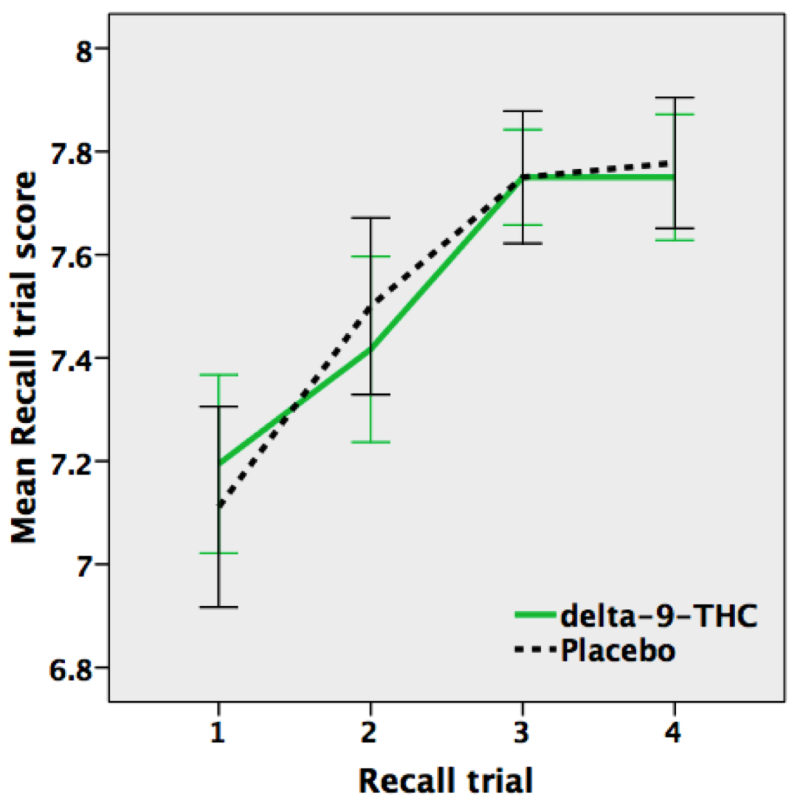

**Supplementary Figure 2A: Brain regions activated by the encoding condition of the verbal paired associate task independent of repetition and drug condition (display threshold: cluster p <0.01)**

**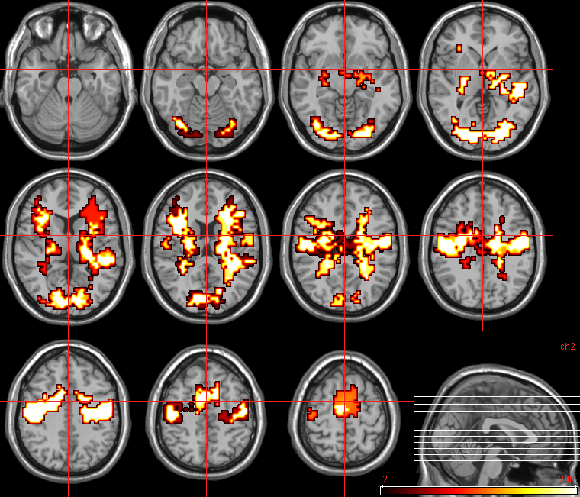**

**Supplementary Figure 2B: Brain regions activated by the recall condition of the verbal paired associate task independent of repetition and drug condition (display threshold: cluster p <0.01)**

**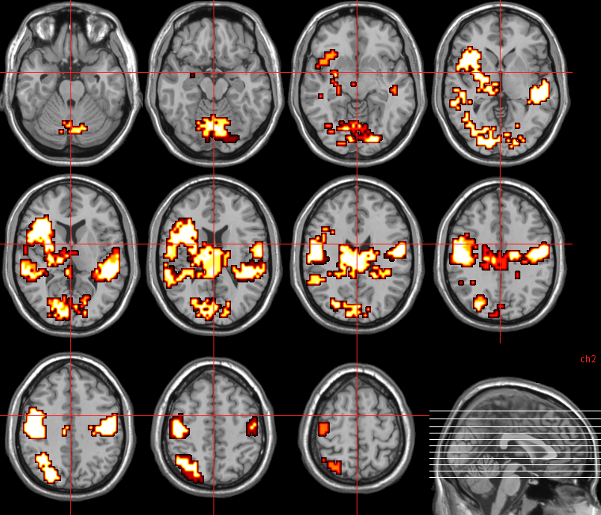**

**Supplementary Figure 3: Significant differences in brain activity between TP and NP groups in the placebo condition during the recall condition of the verbal paired associate task**

1. Greater engagement in the TP group relative to the NP group in the left medial frontal (1) and right middle temporal (2) gyri and cerebellum (3); (display threshold: cluster p <0.015).
2. Greater engagement in the NP group relative to the TP group in the left inferior parietal lobule (1), precentral gyrus (2) bilaterally, precuneus (3) and cingulate (4) gyrus on the right side and cerebellum (5); (display threshold: cluster p <0.007).

**eFigure 3A_Rev.pdf**

**eFigure 3B_Rev.pdf**

**Supplementary Figure 4: Significant differences in brain activity between TA and NA groups in the placebo condition during the encoding condition of the verbal paired associate task**

Greater engagement (shown in red) in the TA group relative to the NA group (A & B) in the left fusiform gyrus (1), precuneus (2) and middle frontal gyrus (3) (cross-hair); (display threshold: cluster p <0.01).

**eFigure 4_Rev.pdf**

**Supplementary Figure 5: Significant differences in brain activity between TA and NA groups in the placebo condition during the recall condition of the verbal paired associate task**

A. Greater engagement (shown in red) in the TA group relative to the NA group in the right fusiform gyrus (cross-hair; 1) extending to the cerebellum; (display threshold: cluster p <0.01).

B. Greater engagement (shown in blue) in the NA group relative to the TA group in the body of caudate (cross-hair; 2) and cingulate gyrus on the left side; (display threshold: cluster p <0.01).

**eFigure 5_Rev.pdf**