Supplementary materials

Supplemental Table 1 Baseline characteristics of study sample included and excluded for the prospective analysis
 | Included  (n=10,692) | Excluded  (n=4,953) | P-value
Birth year
<1940 | 6.5 | 2.1 | <0.0001
1940-1949 | 66.2 | 71.2
1950-1959 | 27.4 | 26.7
Race/ethnicity
Caucasian- Australian/New Zealander | 45.5 | 65.9 | <0.0001
Caucasian- European | 32.3 | 22.3
Caucasian- American | 9.6 | 3.3
Japanese | 2.3 | 0.1
African American/Black | 5.1 | 1.3
Other | 5.3 | 7.1
Education level
≤10 years | 42.1 | 47.4 | <0.0001
11-12 years | 17.6 | 17.0
>12 years | 40.3 | 35.7
Body mass index
Normal weight (<25 kg/m²) | 49.1 | 45.9 | 0.0003
Overweight (25-29.9 kg/m²) | 30.3 | 31.1
Obese (≥30 kg/m²) | 20.6 | 22.9
Smoking status
Never | 55.2 | 53.8 | 0.0012
Past smoker | 28.5 | 27.5
Current smoker | 16.3 | 18.7
Menopausal status
Hysterectomy/oophorectomy | 18.6 | 25.1 | <0.0001
Unknown due to hormone use | 14.6 | 16.6
Premenopause | 20.3 | 20.2
Perimenopause | 30.1 | 24.2
Natural postmenopause | 16.3 | 13.9
Current use of menopausal hormone therapy
No | 79.7 | 75.9 | <0.0001
Yes | 20.3 | 24.1
Frequency/severity of sleep difficulties
Never | 40.1 | 34.9 | <0.0001
Rarely/mild | 23.1 | 19.1
Sometimes/moderate | 24.0 | 29.8
Often/severe | 12.8 | 16.2
Frequency/severity of vasomotor symptoms
Never | 44.9 | 42.2 | <0.0001
Rarely/mild | 20.4 | 17.1
Sometimes/moderate | 20.7 | 24.7
Often/severe | 14.0 | 16.1
Frequency/severity of depressed mood
Never | 51.8 | 51.7 | 0.0009
Rarely/mild | 25.2 | 23.1
Sometimes/moderate | 16.6 | 18.8
Often/severe | 6.4 | 6.4
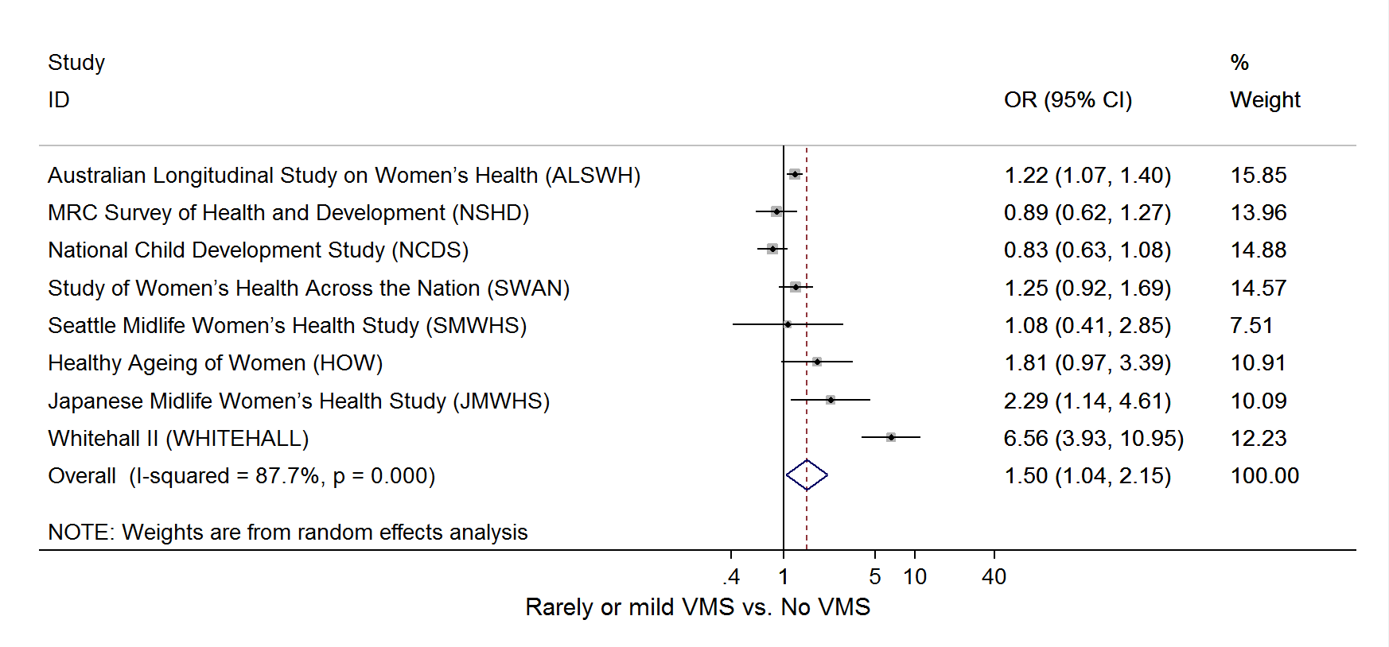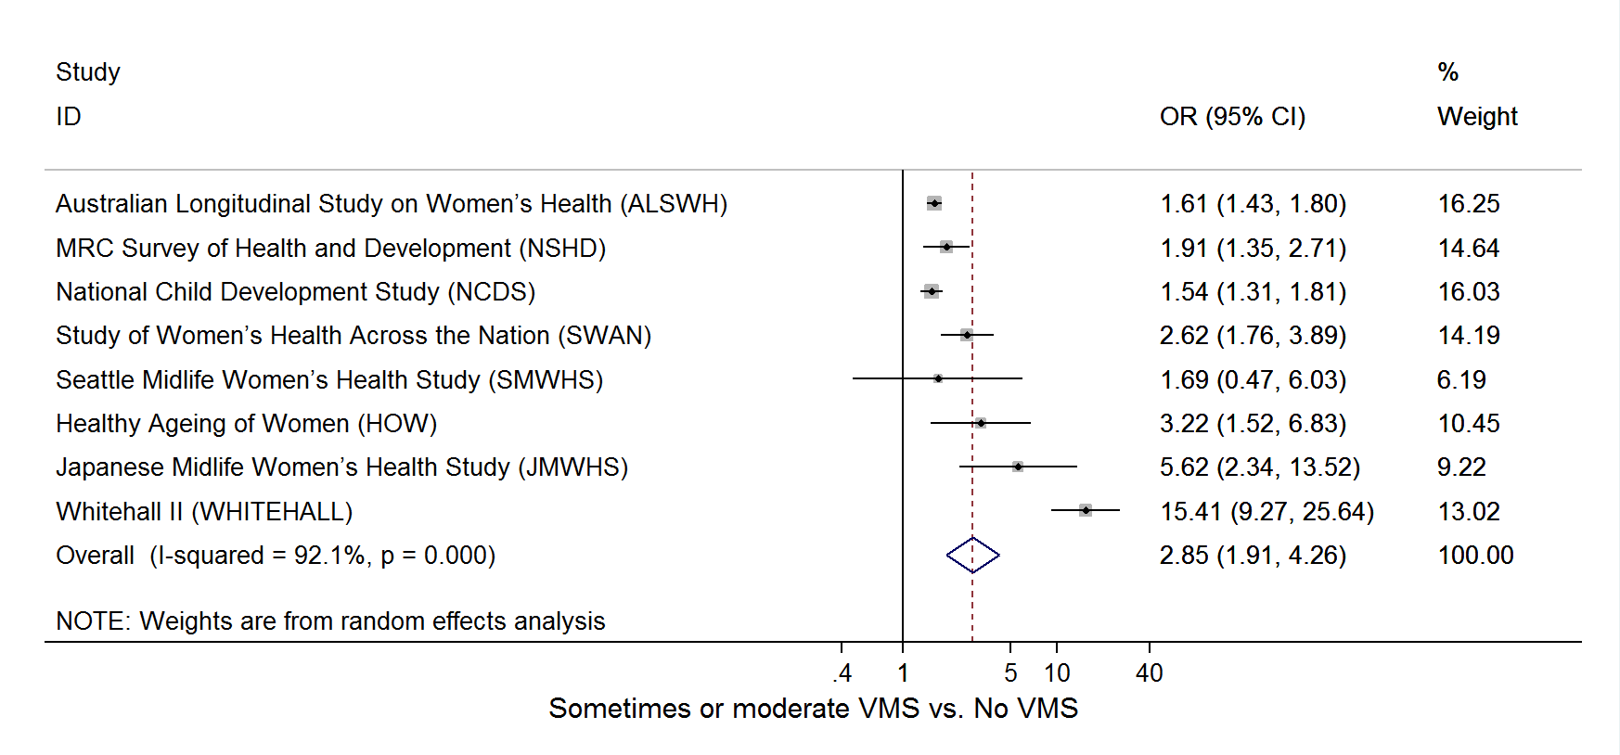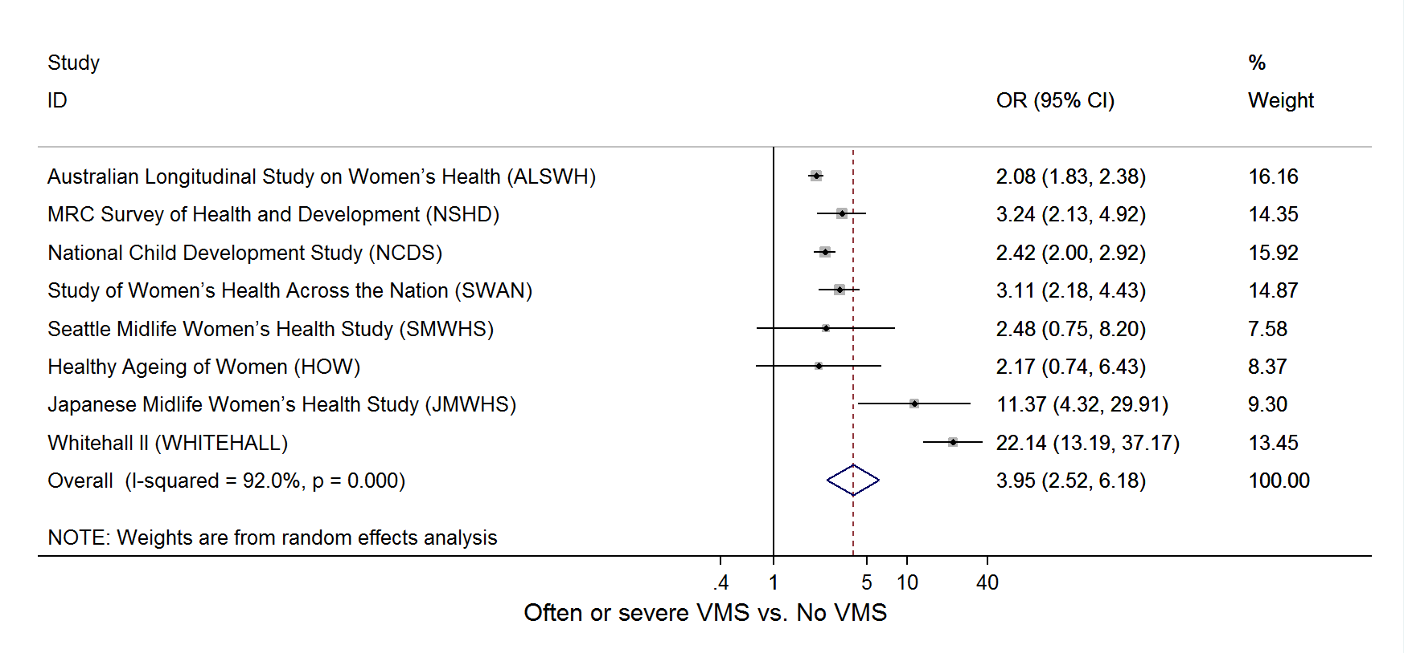
Supplemental Figure 1 Forest plot of study-specific effect estimates of the cross-sectional association between vasomotor symptoms and depressed mood at baseline. Odds ratios (ORs) were presented on a log scale. Effect estimates were fully adjusted for menopausal status, concurrent use of menopausal hormone therapy, race/ethnicity, education, smoking status, and BMI. Data for SWAN were additionally adjusted for study site.

