Supplemental Material

Supplemental Material 1: Morphed Faces Task 2
Supplemental Material 2: Social Goals Task 3
Practice Vignettes 3
Vignettes 3
Internal Consistency 4
Supplemental Material 3: Potential Confounding Factors 5
Supplemental Material 4: Outliers and Categorical Data 5
Mahalanobis Distance 5
Influence of Categorical Data (i.e. residential/community or diagnostic group) 6
Supplemental Material 5: Exploring different types of trauma 8
Does Amygdala Fear Modulation interact with prior Abuse in predicting CU traits? 8
Does Amygdala Fear Modulation interact with prior Neglect in predicting CU traits? 9
Supplemental Material 6: Exploring Effects of level of PTSD and Anxiety 11
Supplemental Material 7: Visualizing the moderated mediation 12

Supplemental Material 1: Morphed Faces Task
The experimental design was adapted from Marsh and colleagues (Marsh et al., 2008). Specifically, participants were shown photographs of faces of 10 men and women from the Pictures of Facial Affect series (Marsh et al., 2008) displaying either neutral expressions or fearful expressions of differing intensities (50, 100 or 150%). Neutral expressions (0% fear) were morphed into fearful expressions to create composites (50% or 100% intensity) or by extrapolating to create exaggerated expressions (150% intensity), see Figure 2. The neutral expressions were created by morphing neutral into happy expressions and taking the 25% composite, following previous indications that neutral expressions may appear threatening (Phillips et al., 2004). Each trial started with the presentation of a face (2000ms), after which a fixation cross was displayed (900ms). Participants were asked to identify the gender by button press. Each run consisted of 40 face trials randomly interspersed with 40 fixation trials (1000ms) in order to jitter stimulus presentation. The total task involved two runs, totaling ~6 minutes.
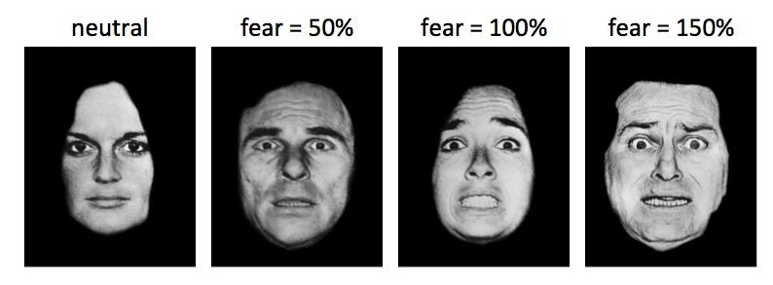
Examples of morphed expressions. Shown are four examples of morphed expressions. Examples are taken from different actors with fear intensity increasing from left to right.
Marsh, A. A., E. C. Finger, D. G. Mitchell, M. E. Reid, C. Sims, D. S. Kosson, K. E. Towbin, E. Leibenluft, D. S. Pine, and R. J. Blair. 2008. “Reduced Amygdala Response to Fearful Expressions in Children and Adolescents with Callous-Unemotional Traits and Disruptive Behavior Disorders.” Am J Psychiatry 165 (6):712–20. https://doi.org/10.1176/appi.ajp.2007.07071145.

Phillips, Mary L., Leanne M. Williams, Maike Heining, Catherine M. Herba, Tamara Russell, Christopher Andrew, Ed T. Bullmore, et al. 2004. “Differential Neural Responses to Overt and Covert Presentations of Facial Expressions of Fear and Disgust.” NeuroImage 21 (4):1484–96. https://doi.org/10.1016/j.neuroimage.2003.12.013.

Supplemental Material 2: Social Goals Task
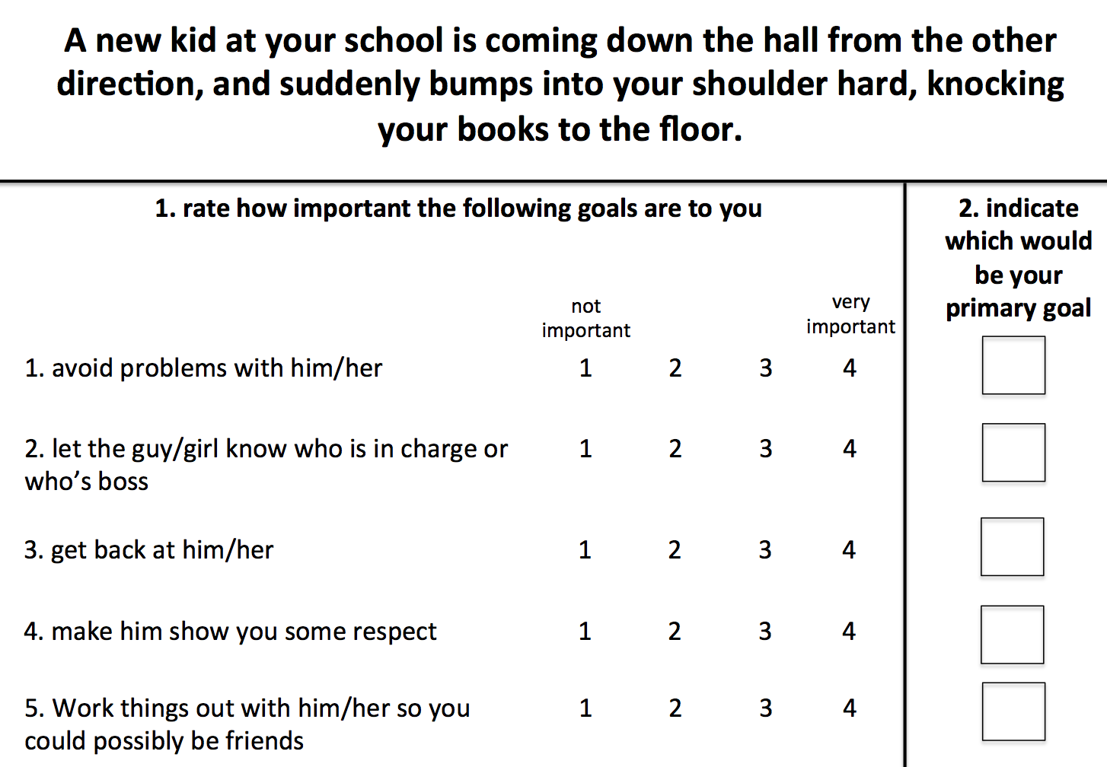

Practice Vignettes
- You are in the library checking out books for a project. A kid grabs the book you need right before you are about to take it off the shelf.
- You are outside for recess. A kid runs to the swing that you were about to use, and starts swinging on it instead.

Vignettes
- A new kid at your school is coming down the hall from the other direction, and suddenly bumps into your shoulder hard, knocking your books to the floor.
- A kid laughs when you walk down the hallway and accidentally trip.
- You are throwing balls in the schoolyard with your classmates. One kid never throws the ball to you.
- During lunch, a kid pushes in front of you in the line waiting for food.
- You are talking to your classmates about a TV show that you really like and one of them says that it’s stupid.

Internal Consistency
 | Cronbach’s α
Avoid Conflict | .739
Reconciliation | .846
Dominance | .804
Revenge | .740
Forced Respect | .792

Supplemental Material 3: Potential Confounding Factors
Response times correlated with age and gender and ICU scores correlated with IQ. In addition, a considerable proportion of the youth in this study was on psychotropic medication, as medications were not withheld at the time of the scan. Moreover, anonymous reviewers raised concerns that motion and/or DBD symptoms could have been driving our interaction finding. Therefore, we repeated our key analysis within our bilateral amygdala ROIs and included age, IQ, gender, psychotropic medication, average T-score on the CBCL DMS-IV oriented ODD and CD subscales and average motion per TR as additional nuisance regressors. This revealed that the fear intensity modulated BOLD response in the right amygdala maintained an interaction between ICU and CTQ (32 voxels, Z=2.94, Cohen’s d=0.35, xyz=19.2;-4.5;-25.0).

Supplemental Material 4: Outliers and Categorical Data

Mahalanobis Distance
Extreme cases might have invalidated the case for a dimensional analytical approach to the data, thereby leading to a spurious interaction effect between ICU and CTQ. To address this issue, we performed a Mahalanobis Distance (MD) analysis in order to calculate how many standard deviations each youth is away from the mean of our sample distribution, given our variable space. We calculated the MD for each participant on four variables: the ICU, the CTQ, the CBCL Anxiety T-score and the CBCL PTSD T-score. We then calculated a p-value per participant, under the Χ²-distribution, to determine whether their MD value should be considered an outlier. 4 participants were identified at p<=.05. We reran our main analysis excluding these participants. This showed that the fear intensity modulated BOLD response in the right amygdala still showed an interaction between ICU and CTQ (28 voxels, Z=3.41, Cohen’s d=0.41, xyz=19.2;-2.5;18.0). Thus, it is unlikely that extreme cases, at least with respect to their ICU, CTQ, Anxiety and PTSD scores, could have determined our interaction finding.

Influence of Categorical Data (i.e. residential/community or diagnostic group)
Categorically different subgroups of participants might have invalidated the case for a dimensional analytical approach. Below, we display a scatterplot between the ICU and CTQ, with data points marked according to diagnostic group. We fitted a linear trend line separately for each diagnostic group. The equation for each trend line is shown, as well as the correlation coefficient. Fisher’s r-to-z transformations showed that none or the correlations differed significantly from each other (all p>.484). This suggests that the relationship between the ICU and the CTQ does not depend on diagnostic group.

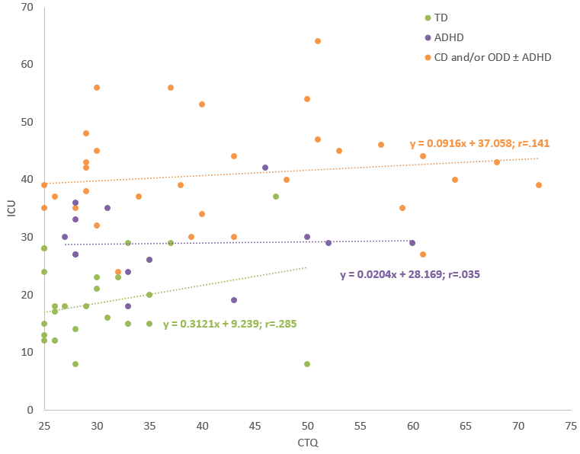

Next, we display scatterplots between ICU and CTQ separately for each placement group (residential vs. community) and fitted a linear trend line separately for each group. A Fisher’s r-to-z transformation showed that these correlations did not significantly differ from each other (p=.653). This suggests that the relationship between the ICU and the CTQ does not depend on participant source.

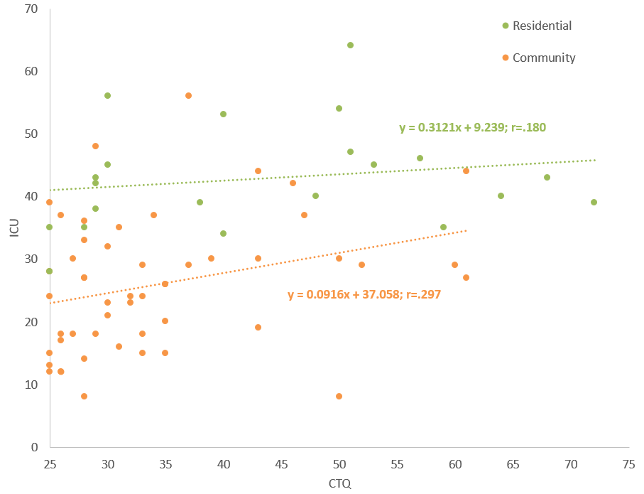

Supplemental Material 5: Exploring different types of trauma
All analyses were conducted using the total scores for the five trauma subscales of the CTQ. However, it is possible that type of trauma matters in the interaction with the ICU. To address this possibility, we repeated our key analysis twice, once using Neglect scores (Emotional Neglect + Physical Neglect) and once using Abuse scores (Emotional Abuse + Physical Abuse + Sexual Abuse) of the CTQ. This revealed comparable interactions between ICU and both Neglect and Abuse in right amygdala on the fear intensity modulated BOLD response as those between ICU and CTQ total score (though only the cluster showing an interaction with Abuse scores survived an FWE correction at αuse s). For details see Supplemental Material 3a (Abuse) and 3b (Neglect).

Does Amygdala Fear Modulation interact with prior Abuse in predicting CU traits?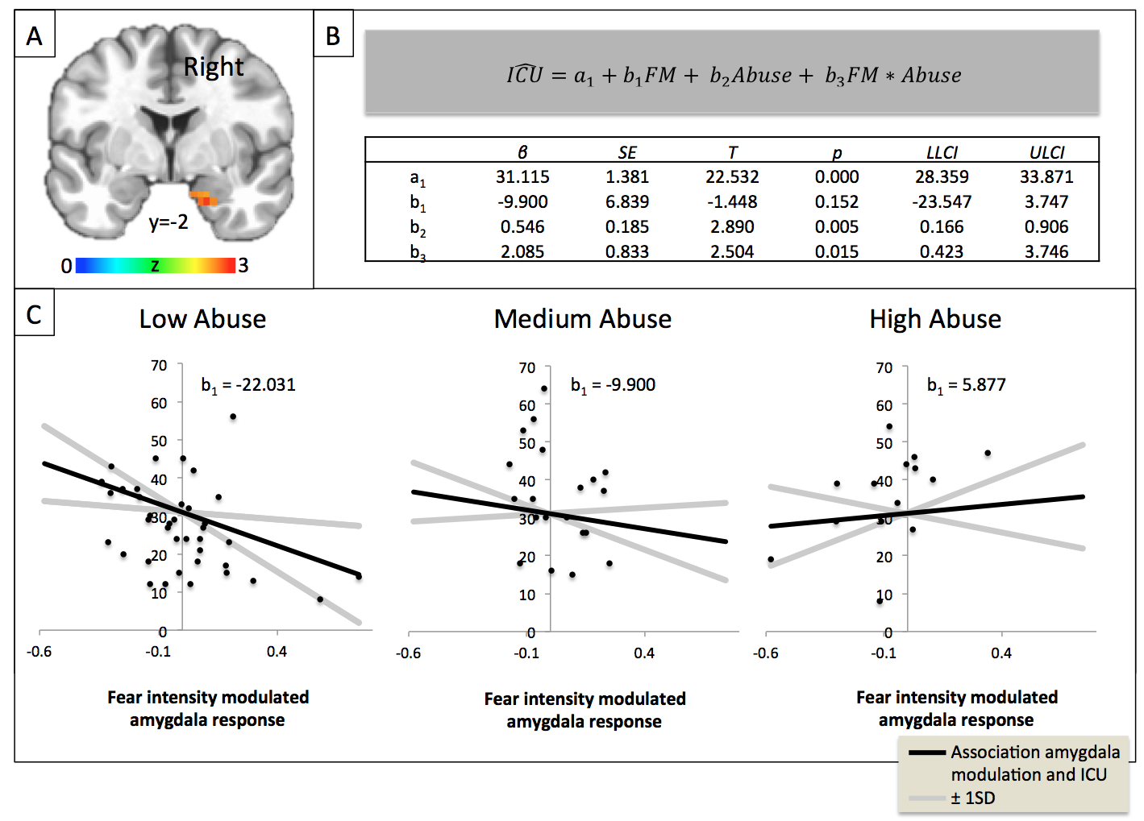
Panel A) The fear intensity modulated BOLD response in right amygdala (24 voxels, Z=3.00, Cohen’s d=0.35, xyz=19.2;-4.5;-25.0) showed an interaction between ICU and Abuse scores (Abuse scores were obtained by summing the Emotional Abuse, Physical Abuse and Sexual Abuse subscales of the CTQ) at p<.05 uncorrected, also surviving small volume correction (FWE α=0.05). Panel B) A moderation model was tested using the PROCESS macro for SPSS (Hayes, 2013), similar to the model represented in Figure 3 in the main paper. Shown is the linear regression equation for predicted ICU scores, where FM stands for Fear Modulated Amygdala Response. The table contains Beta estimates (β), standard errors (SE), t-statistic (T), p-value (p) and Lower (LLCI) and Upper Limit Confidence Intervals (ULCI) for the coefficients of the linear regression model from panel B; i.e. a₁=constant, b₁=main effect of amygdala fear modulation on ICU score, b₂=main effect of Abuse score on ICU score, b₃=moderation of amygdala fear modulation on ICU score by Abuse score. Panel C) Trend lines and associated confidence intervals for conditional effect of fear intensity modulated BOLD response on ICU at values (-1 SD; mean; +1 SD) of Abuse. The Johnson-Neyman Technique shows that higher fear intensity modulated amygdala responses predict lower ICU scores for relatively low levels of Abuse (Abuse<=18.8). Fear intensity modulated amygdala responses were not significantly correlated with ICU scores at medium to high levels of prior trauma (Abuse>18.8).

Does Amygdala Fear Modulation interact with prior Neglect in predicting CU traits?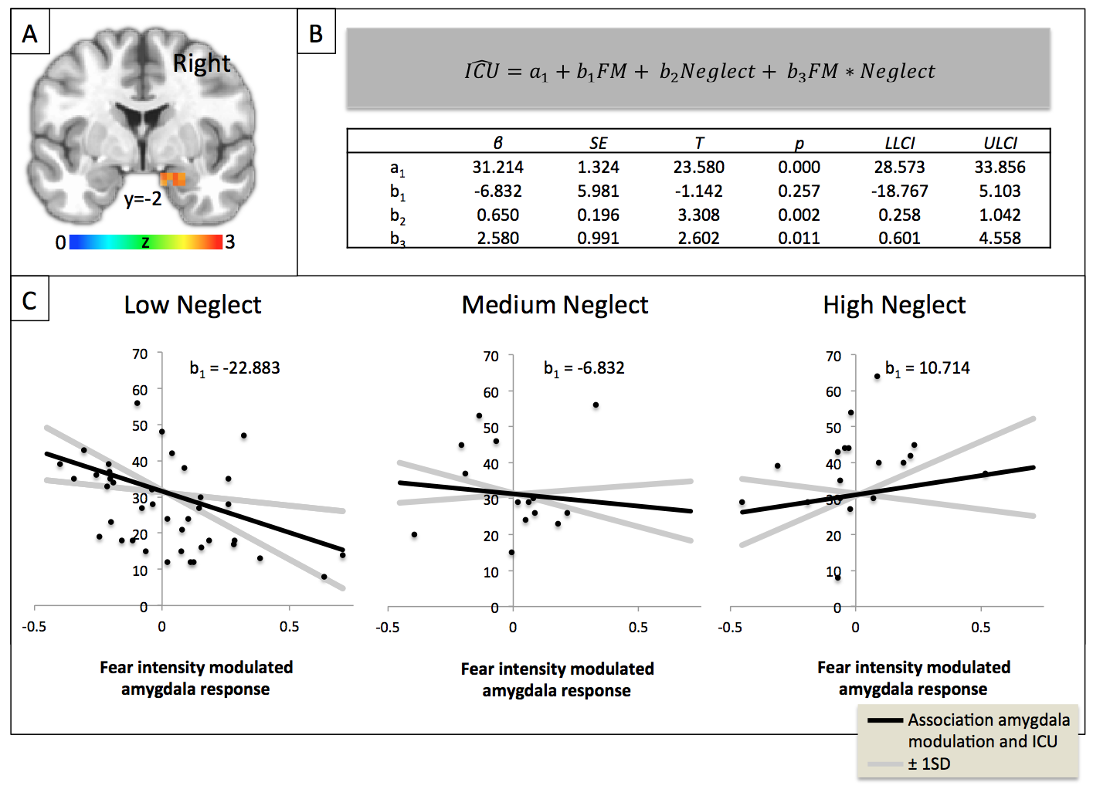
Panel A) The fear intensity modulated BOLD response in right amygdala (15 voxels, Z=2.46, Cohen’s d=0.29, xyz=19.2;2.5-18.0) showed an interaction between ICU and CTQ Neglect scores (Neglect scores were obtained by summing the Emotional Neglect and Physical Neglect of the CTQ) at p<.05 uncorrected, also surviving small volume correction (FWE α=0.05). Panel B) A moderation model was tested using the PROCESS macro for SPSS (Hayes, 2013), similar to the model represented in Figure 3 in the main paper. Shown is the linear regression equation for predicted ICU scores, where FM stands for Fear Modulated Amygdala Response. The table contains Beta estimates (β), standard errors (SE), t-statistic (T), p-value (p) and Lower (LLCI) and Upper Limit Confidence Intervals (ULCI) for the coefficients of the linear regression model from panel B; i.e. a₁=constant, b₁=main effect of amygdala fear modulation on ICU score, b₂=main effect of Neglect score on ICU score, b₃=moderation of amygdala fear modulation on ICU score by Neglect score. Panel C) Trend lines and associated confidence intervals for conditional effect of fear intensity modulated BOLD response on ICU at values (-1 SD; mean; +1 SD) of Neglect. The Johnson-Neyman Technique shows that higher fear intensity modulated amygdala responses predict lower ICU scores for relatively low levels of Neglect (Neglect<=14.3) and higher fear intensity modulated amygdala responses predict higher ICU scores for relatively high levels of Neglect (Neglect>=34.3). Fear intensity modulated amygdala responses were not significantly correlated with ICU scores at medium levels of prior trauma (14.3<CTQ<34.3).

Supplemental Material 6: Exploring Effects of level of PTSD and Anxiety
The goal of the current study was to determine whether level of prior trauma exposure moderated the relationship between CU traits and amygdala responsiveness to fearful expressions. However, prior trauma is related to the development of PTSD specifically and anxiety more generally. As such, one might expect that level of PTSD and anxiety symptoms would similarly moderate the relationship of CU traits with amygdala responsiveness as prior trauma exposure. To test this, we ran two linear regression models (AFNI’s 3dttest++) on the fear intensity beta coefficients within our amygdala ROIs: (i) using ICU, CBCL Anxiety T-scores and the interaction between ICU and CBCL Anxiety T-scores and (ii) using the ICU, CBCL PTSD T-scores and the interaction between ICU and CBCL PTSD T-scores as predictor variables. Both level of anxiety (8 voxels, Z=2.51, Cohen’s d=0.30, xyz=19.2;-8.0;-18.0) and particularly level of PTSD (24 voxels, Z=3.02, Cohen’s d=0.36, xyz=22.8;-8;-18.0) interacted with the ICU on the fear intensity modulated amygdala response at p<.05 uncorrected. Indeed, only the symptomatology particularly related to prior trauma exposure, PTSD symptomatology, survived an FWE correction at α=0.05.

Supplemental Material 7: Visualizing the moderated mediation
We examined whether the indirect effect of fear intensity modulation in the amygdala on SGI through CU traits was moderated by prior trauma (Figure 5, panel A). To this end, we expressed SGI as a function of fear intensity modulated amygdala responses and prior trauma (see Methods section and Figure 5, panel B). Model estimates are summarized in Figure 5 (panel C). The bootstrapped model revealed a significant moderated mediation: the indirect effect of fear intensity modulation in the amygdala on SGI through CU traits is moderated by prior trauma (Index of moderated mediation = -.0455; SE = .0254). The conditional indirect effect of fear intensity modulated responses on SGI at values of CTQ are listed in panel D. This shows that there is only a significant negative association between SGI and fear intensity modulated amygdala responses at low levels of prior trauma (CTQ=25, but not at medium or high levels of trauma). This effect is visualized in the graph below. To visualize this indirect effect, we used the estimates from Figure 5, panel D and the linear regression model for SGI to plot trend lines for the association between SGI and fear intensity modulated amygdala responses at low, medium and high levels of prior trauma.

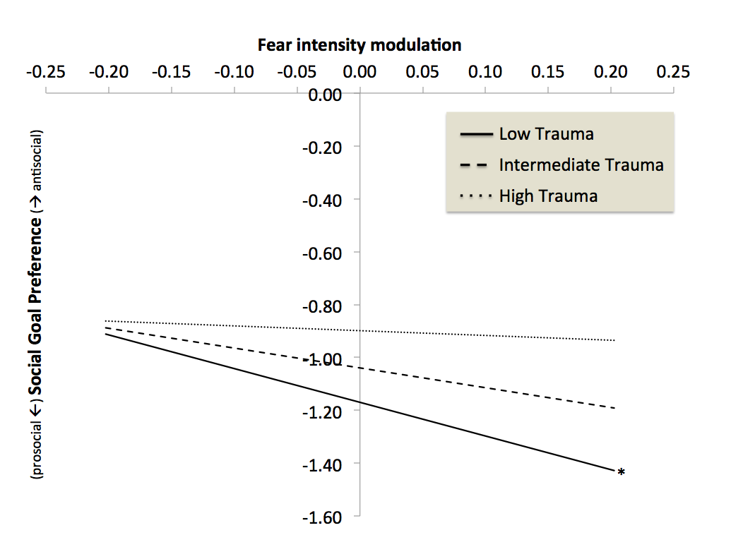
Trend lines for the association between Social Goal Importance and fear intensity modulated amygdala responses at low, medium and high levels of prior trauma. * denotes significant association. Derived from beta estimates provided by PROCESS at the following values for CTQ: Low [-1 SD CTQ score], Medium [mean CTQ score] and High [+1 SD CTQ score]

