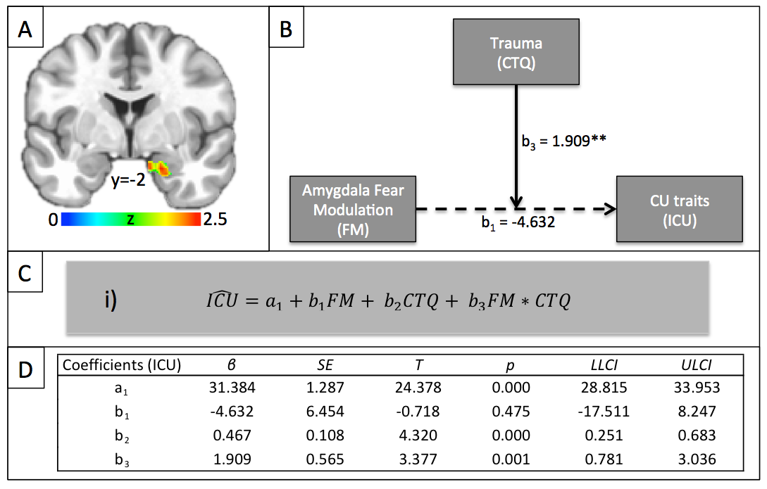
sFigure 1: Does Amygdala Fear Modulation interact with prior Trauma in predicting CU traits? Panel A) The fear intensity modulated BOLD response in right amygdala (29 voxels, Z=2.53, Cohen’s d=0.30, xyz=19.2;2.5-18.0) showed an interaction between ICU and CTQ (small volume corrected). Panel B) The moderation model (i.e. model 1) tested using the PROCESS macro for SPSS (Hayes, 2013). Numbers reflect beta estimates (see also panel D). **=p<.01. Solid arrows reflect statistically significant effects; i.e. the main effect of amygdala fear modulation on ICU score is not significant. However, the effect of amygdala fear modulation on CU traits is significantly moderated by prior trauma. Panel C) Linear regression equation used to predict ICU scores. Panel D) Beta estimates (β), standard errors (SE), t-statistic (T), p-value (p) and Lower (LLCI) and Upper Limit Confidence Intervals (ULCI) for the coefficients of the linear regression model from panel C; i.e. a₁=constant, b₁=main effect of amygdala fear modulation on ICU score, b₂=main effect of CTQ score on ICU score, b₃=moderation of amygdala fear modulation on ICU score by CTQ score.

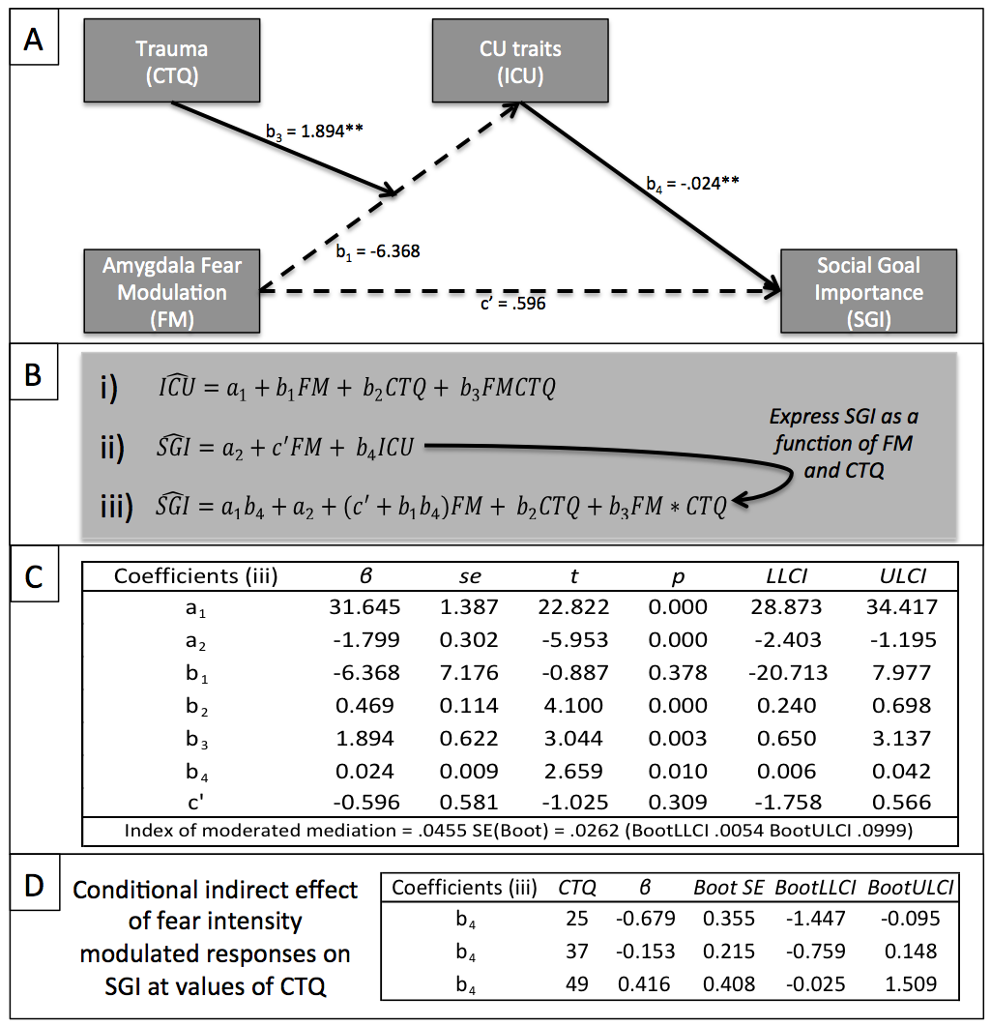
sFigure 2: Is the indirect effect of fear intensity modulation in the amygdala on Social Goal Importance through CU traits moderated by prior trauma? Panel A) Moderated mediation model tested using the PROCESS macro for SPSS (Hayes, 2013). Numbers reflect beta estimates. **=p<.01. Solid arrows reflect statistically significant effects. Panel B) The linear regression model for ICU scores (i) was used to express Social Goal Importance (ii) in terms of fear intensity modulated BOLD responses and prior trauma (iii). Panel C) Beta estimates (β), standard errors (SE), t-statistic (T), p-value (p) and Lower (LLCI) and Upper Limit Confidence Intervals (ULCI) for the coefficients of the linear regression model from panel B (iii). Panel D) Conditional indirect effect of fear intensity modulated responses on Social Goal Importance at values of CTQ.

