Supplementary Figure S1. Proactive inhibition: response slowing as a function of stop-signal probability
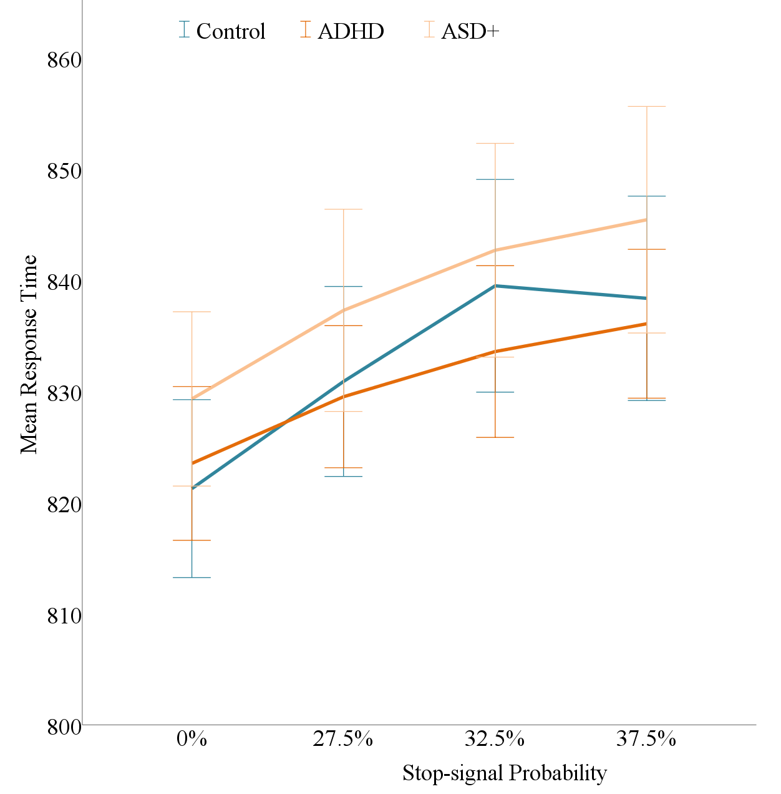
Note. Supplementary Figure S1 shows response time slowing as a function of increasing stop-signal probability. For proactive inhibition, we found a within-subject main effect of stop-signal probability on mean response time (F(2.71,271) = 57.92, p <0.001), where an increase in stop-signal probability was associated with proactive slowing of response times (see supplementary Figure S1). However, we found no group by stop-signal probability interaction and thus no evidence for differential proactive inhibition between groups (F(5.43,271) = 1.25, p =0.285). The error bars show mean response times plus and minus one standard error, separately for each group.

ADHD, Attention-deficit/hyperactivity disorder; ASD+, autism spectrum disorder and symptoms of ADHD.

