Other supplementary material

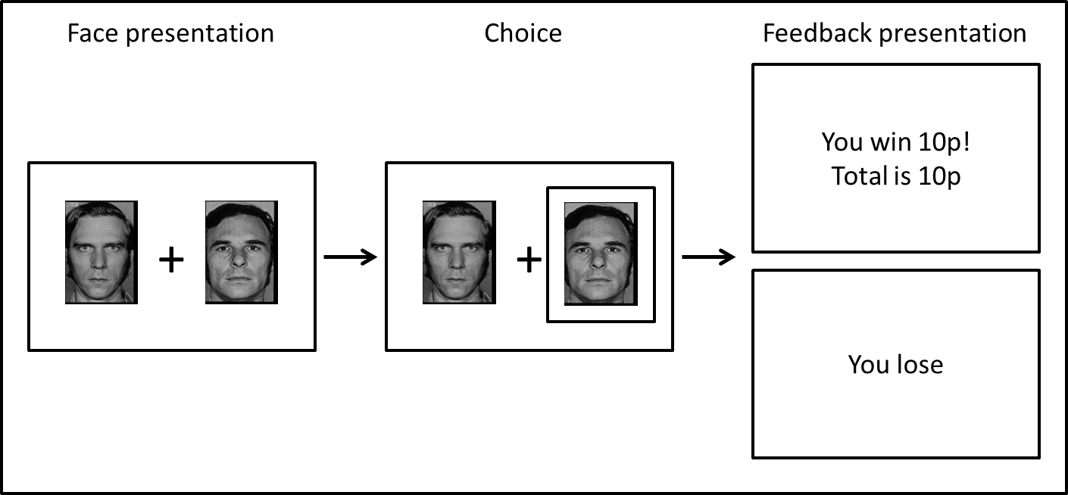
Supplementary Figure 1. Schematic of task sequence (neutral block). Background and text colours are inverted. The chosen face was highlighted with a yellow box surrounding it.

Supplementary Table 1. Significant clusters of group differences in reward prediction error (RPE) related activation during wins
Region | Side | k | z | MNI
Win RPE: HC > NTR
Cerebellum | L&R | 1736 | 3.69 | 0 | -54 | -20
Lingual gyrus |  |  |  | 2 | -74 | -14
Occipital fusiform gyrus |  |  |  | 16 | -78 | -12
Cerebellum |  |  |  | -24 | -80 | -26
Cerebellum |  |  |  | 16 | -64 | -18
Occipital pole |  |  |  | 12 | -90 | 4
Angular gyrus | R | 690 | 3.41 | 50 | -66 | 32
Supramarginal gyrus |  |  |  | 42 | -48 | 4
Angular gyrus |  |  |  | 46 | -54 | 18
Angular gyrus |  |  |  | 34 | -50 | 38
Angular gyrus |  |  |  | 42 | -54 | 18
Angular gyrus |  |  |  | 54 | -54 | 18
Win RPE: TRS > NTR
Precentral gyrus | R | 991 | 3.75 | 64 | 2 | 26
Precentral gyrus |  |  |  | 54 | -4 | 28
Supramarginal gyrus |  |  |  | 62 | -28 | 22
Postcentral gyrus |  |  |  | 62 | -6 | 30
Precentral gyrus |  |  |  | 48 | -6 | 30
Precentral gyrus |  |  |  | 58 | 0 | 12
Cerebellum | L&R | 1988 | 3.77 | 4 | -54 | -20
Cerebellum |  |  |  | -18 | -38 | -24
Cerebellum |  |  |  | 16 | -46 | -22
Cerebellum |  |  |  | -10 | -44 | -22
Cerebellum |  |  |  | 12 | -46 | -22
Cerebellum |  |  |  | 12 | -54 | -34

Supplementary Table 2. Greater effect of emotional bias on loss-related reward prediction error (RPE) signal in treatment resistant schizophrenia (TRS) compared to non-treatment resistant schizophrenia (NTR)
Region | Side | k | z | MNI
Loss RPE (emotional > neutral): Effect of emotional bias TRS > NTR
Thalamus | 1373 | L | 3.52 | -6 | -10 | 14
Caudate |  |  |  | -18 | -4 | 16
Caudate |  |  |  | -16 | 0 | 16
Thalamus |  |  |  | -12 | -10 | 16
Thalamus |  |  |  | -20 | -22 | 18
Thalamus |  |  |  | 0 | -18 | 16

