Scatterplots

Fig.2. Scatterplot of attention/vigilance and neglect in controls
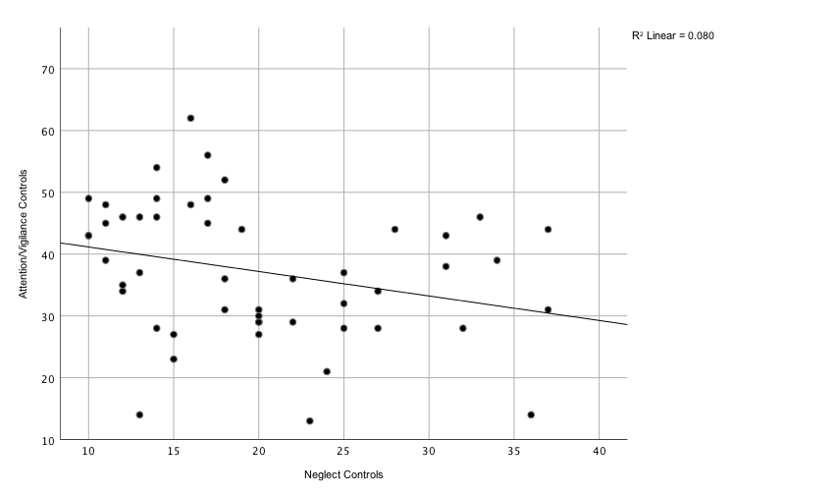

Fig.3. Scatterplot of verbal learning and neglect in patients

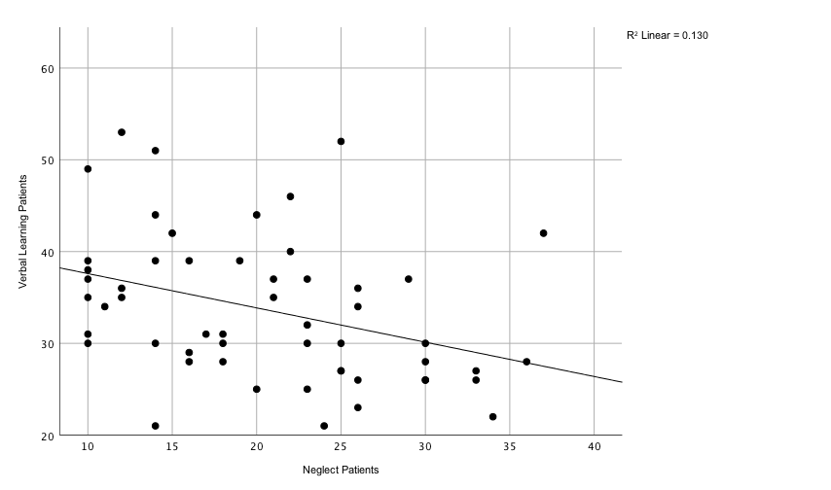

Fig.4. Scatterplot of MCCB overall composite score and neglect in patients
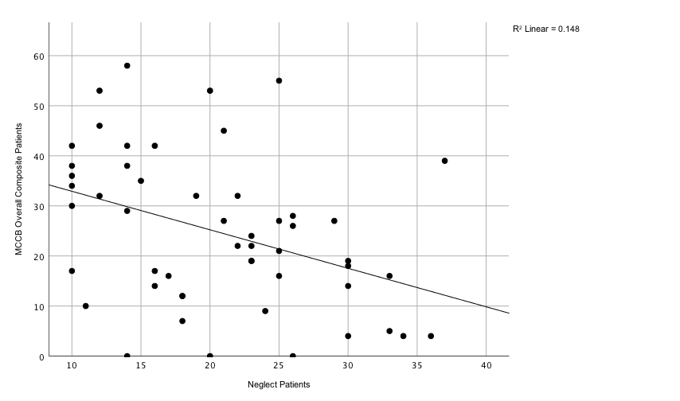

Boxplots

Fig.5. Distribution of abuse in controls
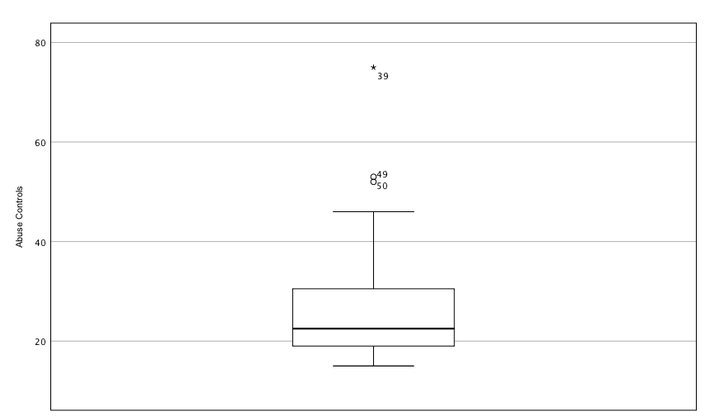

Fig.6. Distribution of neglect in controls
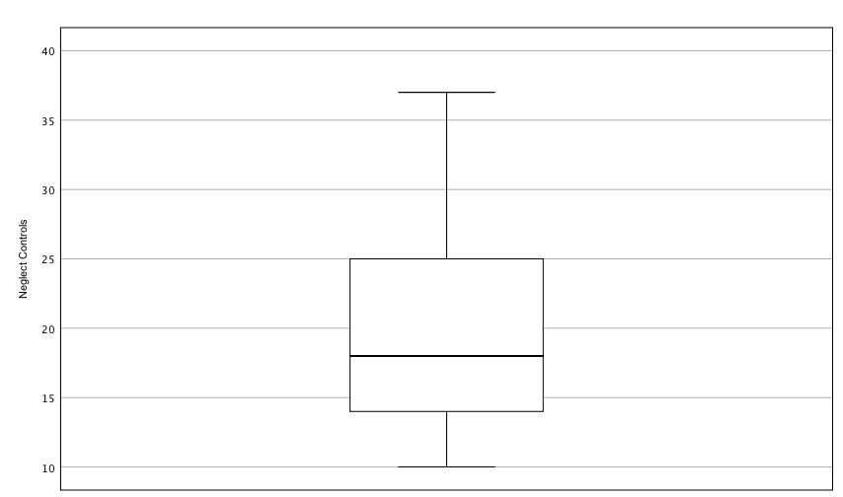

Fig.7. Distribution of abuse in patients
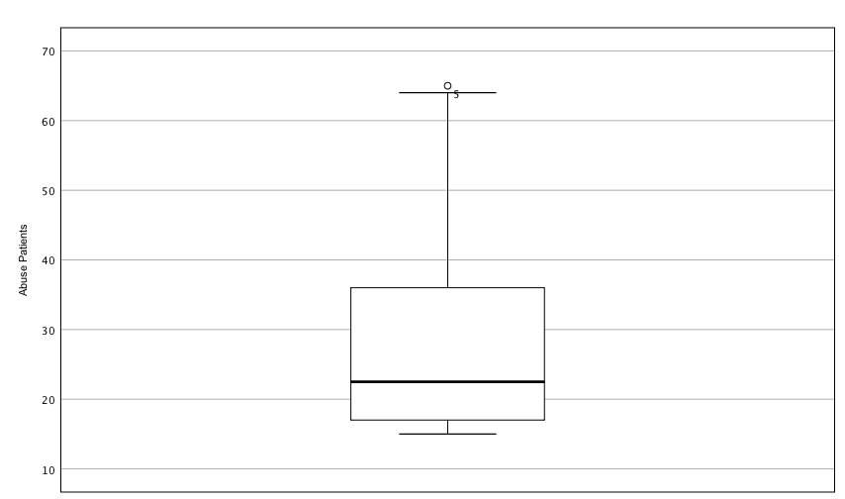

Fig.8. Distribution of neglect in patients
