Supplemental Materials

Assessment of Contemporaneous Life Stress
Study participants were asked if any of the following 45 events occurred in the last year: 1) Death of a parent; 2) Major personal injury or illness; 3) Major argument with parents ; 4) Beginning an undergraduate program at university; 5) Moving away from home; 6) Failing a number of courses; 7) Minor violation of the law (e.g., speeding ticket); 8) Getting kicked out of college; 9) Pregnancy (either yourself or being the father); 10) Minor car accident; 11) Major violation of the law (e.g., sentenced with jail term, regarding self); 12) Moving out of town with parents; 13) Spouse or boy/girlfriend died; 14) Establishing new steady relationship with partner; 15) Finding a part time job; 16) Sex difficulties with boy/girlfriend; 17) Failing a course; 18) Major change of health in close family member; 19) Major car accident (car wrecked, people injured); 20) Death of your best or very close friend; 21) Serious illness of your best or very close friend; 22) Serious personal crisis experienced by family member or very good friend; 23) Major housing problems; 24) Breaking up of parent's marriage/divorce; 25) Losing a part time or a full time job; 26) Major and/or chronic financial problems); 27) Major argument with boy/girlfriend or spouse; 28) Parent losing a job; 29) Switch in program within same college or university; 30) Losing a good friend; 31) Change of job; 32) Break up with boy/girlfriend or spouse; 33) Minor financial problems; 34) Major conflict with a family member or very close friend; 35) Assault, rape, or mugging; 36) Major difficulties at work; 37) Lost driver's license; 38) Pet died; 39) Was robbed 40) Infidelity on the behalf of the spouse / significant other; 41) Birth of a child; 42) Abortion; 43) Miscarriage; 44) Found out that cannot have children ; 45) Child died. Respondents noted the occurrence (Yes/No) of the event and the total number of events was summed together. Commonly reported events included: Moving away from home (n=365); Beginning an undergraduate program at university (n=350); Break-up with boy/girlfriend or spouse (n=251); Establishing new steady relationship with partner (n=239); Minor financial problems (n=214); Major argument with parents (n=210); and Serious personal crisis experienced by family member or very good friend (n=169).

Additional Information about our card-guessing task
To probe reward-related corticostriatal circuit function, participants completed a card-guessing paradigm consisting of three blocks each of predominantly positive feedback (80% correct guess), predominantly negative feedback (20% correct guess), and no feedback during BOLD fMRI. In each block, participants played a card-guessing game resulting in positive or negative feedback for each trial. Participants were told that their performance on this game would determine a monetary reward to be received and were unaware of the fixed outcome probabilities associated with each block. Instead, all participants received $10. During each trial, subjects had 3 seconds to guess, via button press, whether the value of an upcoming visually presented card would be greater or less than 5. After a choice was made, the numerical value of the card was presented (higher or lower) for 500 milliseconds and followed by appropriate feedback (green “up” arrow for positive feedback on a correct trial; red “down” arrow for negative feedback on an incorrect trial) for an additional 500 milliseconds. One incongruent trial was included within each task block (e.g., one of five trials during positive feedback blocks was incorrect, resulting in negative feedback) and all blocks were pseudo-randomly ordered to minimize expectancy effects and to increase participant engagement throughout the task. In addition to positive and negative feedback trials, participants also completed control trial blocks where valenced feedback was not presented. For these trials, subjects were instructed to simply make alternating button presses during the presentation of an “x” (3 seconds), which was followed by an asterisk (500 milliseconds) and a yellow circle (500 milliseconds). Of note, participants were excluded if the average percentage of winning or losing per block was <60% (due to missed behavioral responses).

Relations between sample demographics and fMRI behavioral metrics
Given past reports of behavioral differences during reward processing tasks, we examined relations between sample demographics and fMRI behavioral metrics. For this work, we examined correlations between the number of frames during our fMRI scans censored due to movement, behavioral accuracy during blocks of positive and negative feedback, and average response times during blocks of positive and negative feedback. As shown in Table S1, total internalizing symptoms was related to poorer behavioral accuracy during blocks of negative feedback. In addition, higher reports of recent stress were related to slower average response times during blocks of positive feedback, as well as during blocks of negative feedback.

Of note, there were no relations between corticostriatal connectivity and movement, behavioral accuracy, or average response times (all p’s < 0.21). Furthermore, connections between stress exposure, internalizing symptoms, and corticostriatal connectivity remained unchanged when controlling for task behavioral metrics. When controlling for response times, the interaction of higher early and recent stress was related to heightened VS-mPFC (β=0.198, p<0.005). Similarly, heightened VS-mPFC was related to greater internalizing symptoms after controlling for response times (β=0.09, p=0.005).

Relations between task-based activity, stress-exposure, and internalizing symptoms
While our manuscript primarily focused on task-based connectivity, we also explored task-based activity levels in the VS and mPFC in relation to stress-exposure and internalizing symptoms. For the VS, we extracted activity levels using the canonical ROI detailed in the main manuscript. For the mPFC, we used the cluster that emerged from our PPI analyses. Mean-level of activity for positive > negative feedback was extracted for each area. We then constructed regression models with task-based activity levels (for either the VS or mPFC) as the dependent variable, and age, sex, early stress, recent stress, and early-recent stress interaction as independent variables. For the VS, this interaction was not significant (β=0.026, p=0.46). This interaction was, however, significant for the mPFC ROI (β=-0.08, p=0.02), but opposite to past reports-- with greater levels of early and recent stress, lower levels of activity was seen in this region.

We also examined whether internalizing symptomatology related to task-based activity and connectivity. For these analyses, we constructed regression models with total score on the MASQ as the dependent variable, and age, sex, and task-based activity levels (for both the VS and mPFC), and left VS-mPFC task-based connectivity as independent variables. Our relation between left VS-mPFC connectivity and internalizing symptomatology remained similar to the main manuscript (β=0.09, p=0.006). Internalizing symptomatology was not related to VS task-based activity (β=-0.03, p=0.38), and related at a “trend-level” for mPFC task-based activity (β=-0.06, p=0.066). The correlation between VS-mPFC connectivity and internalizing symptomatology was significantly different from the correlation between internalizing symptomatology and mPFC task-based activity (t=-3.29, p<.005).

Analyses Using Categorical CTQ Cutoffs
While the CTQ provides a continuous self-report of childhood trauma and maltreatment, we also completed analyses using a categorical indicator of maltreated (versus not). Each subscale (emotional, physical and sexual abuse, and emotional and physical neglect) can be broken down into a moderate/severe categorical grouping. Based on similar past work (S1), we used the following CTQ cutoffs: >13 for emotional abuse; >10 for physical abuse; >8 for sexual abuse; >15 for emotional neglect; and >10 for physical neglect. These cutoff scores have been used with good specificity and sensitivity to classify maltreated subjects (S2). Participants with any subscale score equal or higher than these cutoffs were classified as maltreated (total n=184; emotional abuse n=58; physical abuse n=46; sexual abuse n=32; emotional neglect n=65; physical neglect n=88). We then examined the interaction between this binary indicator and more contemporaneous stress (using the mean centered Life Events Scale for Students). Paralleling the results in the main manuscript, we saw a relation between Left VS-mPFC connectivity and the interaction of a categorical CTQ variable and more contemporaneous stress (β=0.193, p=0.009); subjects with higher recent life stress who had suffered maltreatment had heightened connectivity between the Left VS-mPFC. The interaction is depicted in Figure S1. Similarly, regression models for only maltreated participants found heightened left VS-mPFC connectivity after more contemporaneous stress in this group (β=0.226, p=0.002). A similar relation was not seen for non-maltreated participants (β=-0.008, p=0.826; difference between correlation z=2.86, p<0.001).

Exploratory Analyses Examining Potential Non-Linear Effects of Stress
While we explored linear relations in the main manuscript, potential effects may be non-linear in nature. To delve into this possibility, we completed exploratory analyses examining interactions between early and more contemporaneous stress in groups with lower, as well as higher, levels of early stress. For these analyses, we first divided our sample using the binary (categorical) cutoffs detailed earlier of maltreated (n=184) and non-maltreated individuals (n=742). We then constructed regression models in each group where left VS-mPFC connectivity was entered as the dependent variable, and early and contemporaneous stress, and the interaction of these two forms of stress were entered as independent variables. For these models, age and sex were also entered as independent variables of non-interest.

In both groups, we noted similar findings to those in the manuscript, with the interaction of early and more recent stress related to heightened left VS-mPFC connectivity; however the relations were significantly stronger in the maltreated group. The interaction effect was β=0.599, p<.005 for maltreated individuals, while in non-maltreated individuals, this association was β=0.09, p=0.02. We found these effects were significantly different from one another (z=7.25, p<.005), and are depicted in Figure S2.

We also investigated if the relations between internalizing symptoms and left VS-mPFC connectivity differed between groups. Using these same categorical groups, we constructed regression models in each group where the total score on the MASQ was entered as the dependent variable, and age, sex, and left VS-mPFC connectivity were entered as independent variables. In maltreated individuals, heightened left VS-mPFC connectivity was related to greater total scores on the MASQ (β=0.2176, p=0.003). For non-maltreated individuals, this association was only present at a trend level (β=0.066, p=.06). These two correlations were, again, significantly different from one another (z=1.93, p=0.03) and are depicted in Figure S3.

PPI Analyses for the right ventral striatum
While the analyses in the main manuscript focused on task-dependent coupling for the left ventral striatum (VS), similar results were found if we used the right VS as a seed region in PPI analyses. Focusing on positive > negative feedback, we examined whole-brain relations between PPI estimates (our dependent variable), maltreatment, recent life stress, and the interaction of these two forms of stress (our independent variables). This interaction was related to coupling between the right VS and the mPFC (x=+12, y=+64, z=+6, β=0.193, k=1006 voxels, p<.05 corrected; shown in Figure S4). Similar to the results in the main manuscript, heightened coupling between the right VS and the mPFC was seen in individuals who had experienced maltreatment (as assessed by the CTQ), as well as more-recent life stress (as assessed by the LESS). This cluster in the mPFC overlapped with the area that emerged in our analyses with the left VS (shown in Figure S5. No other regions emerged as significant for the interaction, or for maltreatment and recent life stress in isolation.

Using the right VS as a seed, we extracted PPI parameters for mPFC and completed regression analyses with symptoms of mood dysregulation. This model was similar to the ones described in the main manuscript controlling for age and sex, and revealed a relation between right VS-mPFC coupling and the total score on the MASQ (β=0.066, p=0.046). Paralleling analyses with the main manuscript, heightened coupling between the right VS-mPFC was related to greater symptoms of mood and anxiety.

Valence-specific coupling and symptoms of mood dysregulation
Motivated by our findings of valence specificity in connectivity, we completed exploratory analyses focused on specific clusters of symptoms of mood dysregulation and the reward-related connectivity differences discovered previously. These analyses employed the Center for Epidemiologic Studies-Depression (CES-D) questionnaire (S3), as well as the subscales of the Mood and Anxiety Symptom Questionnaire-Short Form, MASQ (S4). The CES-D has 4 separate factors: depressive affect, somatic symptoms, positive affect, and interpersonal relations, while the Mood and Anxiety Symptom Questionnaire-Short Form has 2 specific subscales: Anxious Arousal and Anhedonic Depression (as well as 2 general subscales which were not investigated: General Distress Anxiety; General Distress Depression). For these analyses, we examined relations between these separate factors and VS-mPFC connectivity, for 1) Positive feedback versus control blocks, and 2) Negative feedback versus control blocks.

Bivariate correlations were calculated to assess the relation between reward-related connectivity and CES-D factors, controlling for age and sex. As noted in Table S2, and connecting to past work by Admon and Pizzagalli (S5), the only significant relation that emerged was between the CES-D positive affect subscale and VS-mPFC connectivity for positive feedback > control blocks (β=0.068, p=.03). This relation was not seen between CES-D positive affect subscale and VS-mPFC connectivity for negative feedback > control blocks (β=0. 033, p=.31). These two correlations were significantly different from one another (using a one-tailed test, comparing dependent correlations, t=1.83, p=0.03). To probe specificity, we also tested whether the correlation between VS-mPFC connectivity (Positive Feedback > Control) and the CES-D positive affect subscale was significantly different compared to relations for VS-mPFC connectivity and the other CES-D subscales. The correlation for the positive affect subscale and VS-mPFC connectivity was indeed significantly different than those for VS-mPFC connectivity and the depressive affect subscale (t= -2.38, p=0.01) or the interpersonal relations subscale (t= -2.69, p<0.01). The difference between the correlations for the positive affect subscale and VS-mPFC connectivity was only a “trend-level” compared to the correlation for VS-mPFC connectivity and the somatic symptoms subscale (t= -1.55, p=0.06). For the MASQ, VS-mPFC connectivity for (positive feedback > control blocks) was related to the anhedonic depression subscale (β=0.07, p=.02), but not the anxious arousal subscale (β=0.0003, p=.99). Collectively, these results provide preliminary evidence that heightened reward-related connectivity for positive feedback might relate to lower positive affect.

Analyses controlling for early socioeconomic status and general cognitive ability
To rule out the influence of other potential confounding variables, we constructed regression models analogous to those in the main manuscript, but with inclusion of early socioeconomic status and general cognitive ability as additional independent variables.

Early socioeconomic status was a composite measure based on participant self-report of parental education. During intake, individuals noted the highest level of education for both his/her mother and father separately. Those categories included: No High School Degree; GED; High School Degree; Technical Training; Some college; Associates Degree; Bachelors; Post-Bachelors w/ no additional degree; Masters; and MD/PhD/JD/PharmD. These categories were recoded as the total number of years of schooling for each category (10 for No High School Degree; 12 for GED and High School Degree; 14 for Technical Training, Some college, and Associates Degree; 16 for Bachelors; 18 for Post-Bachelors w/ no additional degree; 20 = Masters; 22 = MD/PhD/JD/PharmD). These values were then z-scored within the sample (for mother and father separately) and then averaged for each participant. General cognitive ability was measured via the Wechsler Abbreviated Scale of Intelligence, which included Vocabulary and Matrix Reasoning subtests (S6).

When controlling for early socioeconomic status and general cognitive ability, the relation between left VS-mPFC connectivity and the interaction of early and recent stress remained similar to the effects noted in the main manuscript (β=0.198, p<.005). The relation between left VS-mPFC connectivity and internalizing also remained significant when controlling for early socioeconomic status and general cognitive ability (β=0.089, p=.0059).

Analyses focused on potential dependence of stress exposure
Given correlations between early and contemporaneous stress (and potential causal connections), we completed analyses using residualized (contemporaneous) stress scores. For these analyses, we first constructed linear regression models with the LESS as the dependent variable and the CTQ, age, and sex as independent variables. We then saved the residuals of this model and entered these values into a regression model analogous to the model in the main manuscript (age, sex, CTQ, residualized LESS, and CTQ * LESS interaction as independent variables, and left VS-mPFC connectivity as the dependent variable). This new model yielded similar patterns to those noted in our original analyses-- heightened VS-mPFC connectivity for individuals exposed to high early and high contemporaneous stress, β=0. 173, p<0.005). This interaction is depicted in Figure S6.

Table S1.

 | Internalizing Symptoms (MASQ) | Early Stress (CTQ) | Recent Stress (LESS)
Movement During Task (# of censored frames) | r= 0.04, p=0.20 | r= 0.02, p=0.38 | r= 0.03, p=0.33
Behavioral accuracy during blocks of positive feedback | r= -0.03, p=0.28 | r= -0.052, p=0.11 | r= -0.005, p=0.87
Behavioral accuracy during blocks of negative feedback | r= -0.069, p=0.03 | r= -0.04, p=0.21 | r= -0.05, p=0.10
Average response times during blocks of positive feedback | r=0.052, p=0.11 | r=0.06, p=0.06 | r=0.09, p=0.002
Average response times during blocks of negative feedback | r=0.03, p=0.25 | r=0.023, p=0.47 | r=0.06, p=0.03

Table S2.

 | LVS-mPFC Connectivity for Positive Feedback > Control Blocks | LVS-mPFC Connectivity for Negative Feedback > Control Blocks
CES-D Depressive affect subscale | r=-0.013, p=0.692 | r=-0.026, p=0.42
CES-D Somatic symptoms subscale | r= 0.012, p=0.699 | r=-0.019, p=0.56
CES-D Positive affect subscale | r= 0.068, p=0.03* | r=0.033, p=0.31
CES-D Interpersonal relations subscale | r=-0.035, p=0.27 | r=-0.045, p=0.16

Caption: This table details correlations between connectivity and clusters of internalizing symptoms. Four different subscales from the CES-D are reported in the table’s rows, while valence specific connectivity between the left VS and mPFC are noted in the columns. The only significant relation emerged for positive feedback > control blocks connectivity and positive affect. Higher connectivity was related to higher scores (indicating greater problems with this cluster of depressive symptoms).

Figure S1.

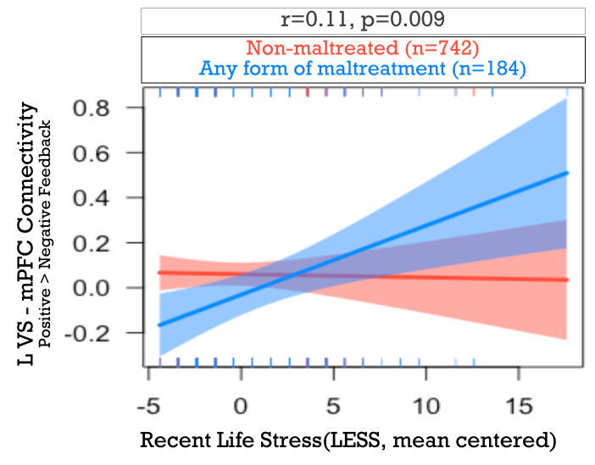

Caption: Rather than using a continuous measure of early stress (the CTQ), we examined a binary cut-off of the measure, in interaction with recent life stress. Left VS-mPFC connectivity for positive > negative feedback is shown on the vertical axis. As such, we found that maltreated individuals (shown in the blue line) had greater internalizing symptoms when they were also exposed to higher recent life stress (horizontal axis). A similar relation was not seen in individuals classified as non-maltreated (shown in red). These results parallel findings using the continuous CTQ.

Figure S2.

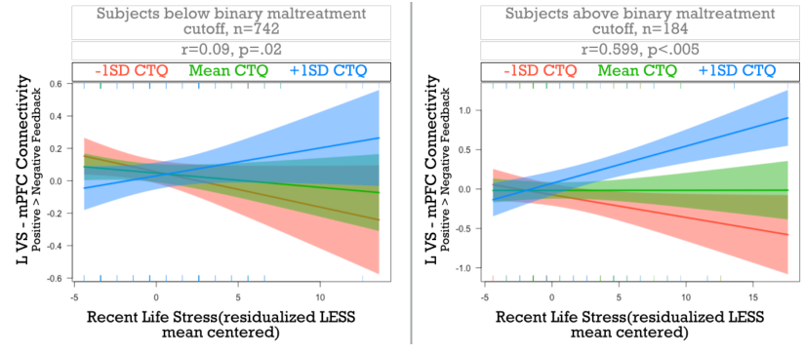

Caption: To investigate potential non-linear effects of stress, we ran analyses focused on the interaction of early and recent life stress (using continuous measures; horizontal axis) in individuals categorized as non-maltreated (left panel) or maltreated (right panel). Left VS-mPFC connectivity for positive > negative feedback is shown on the vertical axis. Levels of maltreatment are also shown, with lower (red), mean (green), and higher (blue) CTQ scores depicted in the figure. We see similar, and potentially stronger, effects as those reported in the main manuscript. With higher early and recent stress, we see higher left VS-mPFC connectivity.

Figure S3.

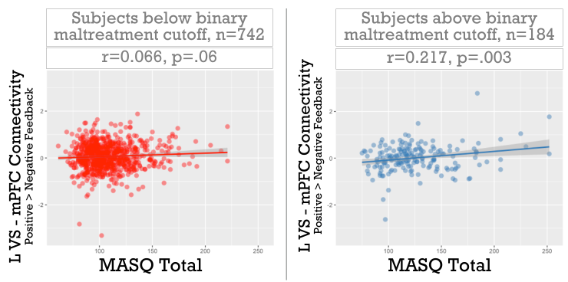

Caption: We also investigate the relation between internalizing symptoms (horizontal axis) and left VS-mPFC connectivity (vertical axis) for individuals classified as non-maltreated (left panel) or maltreated (right panel). With increasing left VS-mPFC connectivity, we see higher internalizing symptoms.

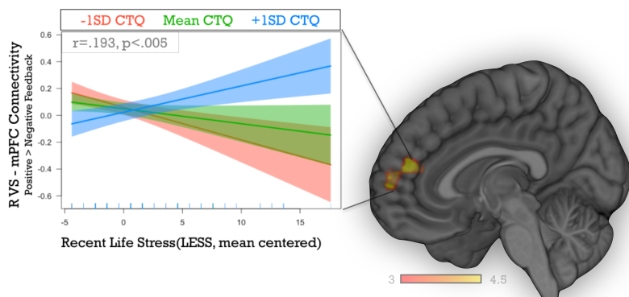
Figure S4.

Caption: Whole-brain regression analyses indicated that the interaction of maltreatment and recent life stress was related to heightened right VS-mPFC task-dependent coupling for positive > negative feedback. These results parallels analyses for the left VS-mPFC task-dependent coupling. On the right side of the figure, this mPFC cluster is shown. The left side of the figure depicts this interaction, with recent life stress graphed on the horizontal axis and right VS-mPFC coupling on the vertical axis. Levels of maltreatment are also shown, with lower (red), mean (green), and higher (blue) CTQ scores depicted in the figure.

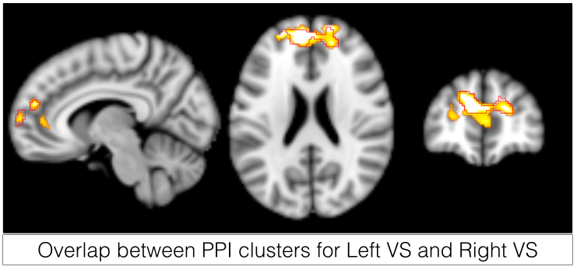
Figure S5.

Caption: This figure depicts similarities in the clusters that emerged from our PPI analyses. Both analyses revealed heightened coupling between the left (or right) VS and mPFC for the interaction of maltreatment and recent life stress. The yellow-orange colors depict results when using the left VS as a seed, the red outline depicts results when using the right VS as a seed.

Figure S6.

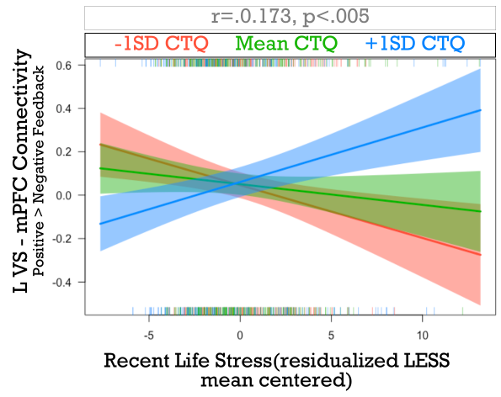

Caption: We examined how the dependence of stress influenced the relations found in the main manuscript. We examined a residualized recent stress score (created by saving the residuals from a regression where the CTQ predicted the LESS score; horizontal axis) and the interaction with early life stress (with low levels of maltreatment shown in red; mean levels shown in green; and high levels depicted in blue). Left VS-mPFC connectivity is on the vertical axis. This new metric of recent life stress yielded parallel findings to those in the main manuscript.

Supplemental References
S1. Heim, C., Young, L. J., Newport, D. J., Mletzko, T., Miller, A. H., & Nemeroff, C. B. (2008). Lower CSF oxytocin concentrations in women with a history of childhood abuse. Molecular Psychiatry, 14(10), 954–958. http://doi.org/10.1038/mp.2008.112
S2: Bernstein, D. P., Ahluvalia, T., Pogge, D., & Handelsman, L. (1997). Validity of the Childhood Trauma Questionnaire in an adolescent psychiatric population. Journal of the American Academy of Child and Adolescent Psychiatry, 36(3), 340–348. http://doi.org/10.1097/00004583-199703000-00012
S3: Weissman MM, Sholomskas D, Pottenger M, Prusoff BA, Locke BZ (1977): Assessing depressive symptoms in five psychiatric populations: a validation study. American Journal of Epidemiology. 106: 203–214.
S4: Clark, L. A., & Watson, D. (1991). Tripartite model of anxiety and depression: psychometric evidence and taxonomic implications. Journal of Abnormal Psychology, 100(3), 316–336.
S5. Admon R, Pizzagalli DA (2015): Corticostriatal pathways contribute to the natural time course of positive mood. Nature Communications. 6: 10065.
S6: Axelrod, B. N. (2002). Validity of the Wechsler abbreviated scale of intelligence and other very short forms of estimating intellectual functioning. Assessment, 9(1), 17–23. http://doi.org/10.1177/1073191102009001003

