SUPPLEMENTAL TABLES
 | Control (N=18) | PMDD  (N=18)
Asian | 3 | 3
Black | 2 | 1
Hispanic/Latina | 6 | 0
White/Caucasian | 4 | 14
Two or more of these | 3 | 0
Supplemental table 1: Self-reported ethnic background of research participants (N=18 per group).

 | Control  (N=18) | PMDD  (N=18)
Follicular (M ± SD) | 0.62 ± 0.28 | 0.91 ± 0.77
Luteal (M ± SD) | 6.12 ± 4.92 | 7.21 ± 5.69
Supplemental Table 2. Serum progesterone levels in PMDD and Control women. Values indicated are means and standard deviations for N = 18 per group. As expected, progesterone levels were significantly higher in the luteal phase than in the follicular phase irrespective of study group.

 | DRSP Symptom |  | Follicular (Days 8-12) Mean ± SD | Late Luteal (Last 5 Premenstrual Days) Mean ± SD
1 | Depressed
 |  | PMDD | 1.35 ± 0.44 | 3.49 ± 0.71
 |  | Control | 1.00 ± 0.00 | 1.01 ± 0.03
2 | Anxious
 |  | PMDD | 1.31 ± 0.39 | 3.56 ± 0.62
 |  | Control | 1.00 ± 0.01 | 1.02 ± 0.03
3 | Mood Swings
 |  | PMDD | 1.26 ± 0.34 | 3.57 ± 0.69
 |  | Control | 1.00 ± 0.00 | 1.01 ± 0.03
4 | Irritability
 |  | PMDD | 1.20 ± 0.29 | 3.53 ± 0.57
 |  | Control | 1.00 ± 0.01 | 1.02 ± 0.04
5 | Decreased Interest in Activities
 |  | PMDD | 1.27 ± 0.39 | 3.49 ± 0.79
 |  | Control | 1.00 ± 0.00 | 1.00 ± 0.02
6 | Impaired Concentration
 |  | PMDD | 1.25 ± 0.32 | 3.29 ± 0.67
 |  | Control | 1.00 ± 0.01 | 1.01 ± 0.03
7 | Fatigue
 |  | PMDD | 1.41 ± 0.44 | 3.95 ± 0.80
 |  | Control | 1.01 ± 0.06 | 1.05 ± 0.07
8 | Increased Appetite
 |  | PMDD | 1.22 ± 0.32 | 3.66 ± 0.80
 |  | Control | 1.02 ± 0.06 | 1.02 ± 0.04
9 | Increased Sleep or Insomnia
 |  | PMDD | 1.38 ± 0.49 | 3.79 ± 0.90
 |  | Control | 1.02 ± 0.06 | 1.04 ± 0.06
10 | Overwhelmed
 |  | PMDD | 1.21 ± 0.30 | 3.35 ± 0.76
 |  | Control | 1.00 ± 0.00 | 1.01 ± 0.02
11 | Breast pain
 |  | PMDD | 1.26 ± 0.43 | 3.60 ± 1.01
 |  | Control | 1.01 ± 0.04 | 1.10 ± 0.16
12 | Impaired Productivity
 |  | PMDD | 1.28 ± 0.41 | 3.44 ± 0.70
 |  | Control | 1.01 ± 0.05 | 1.01 ± 0.02
13 | Social Impairment
 |  | PMDD | 1.26 ± 0.41 | 3.41 ± 0.79
 |  | Control | 1.00 ± 0.01 | 1.01 ± 0.02
14 | Impaired Relationships
 |  | PMDD | 1.19 ± 0.30 | 3.31 ± 0.66
 |  | Control | 1.00 ± 0.00 | 1.01 ± 0.02
15 | DRSP Total
 |  | PMDD | 1.27 ± 0.33 | 3.53 ± 0.63
 |  | Control | 1.01 ± 0.02 | 1.01 ± 0.05

Supplemental Table 3. Self-reported symptom severity from the Daily Record of Severity of Problems. Participants self-reported the severity of each symptom on the DRSP on a scale from 1 to 6 for the duration of their participation in the study. Average symptom reports for women with PMDD and controls are reported during the follicular phase (cycle days 8 to 12) and during the late luteal phase (the last 5 days before the onset of menses). N=18 per group.

Region | Cluster size | MNI coordinates | Z
Lingual gyrus | 2777 | -6, -88, -6 | 5.89
Angular gyrus | 1827 | 48, -56, 40 | 4.80
Middle frontal gyrus | 1815 | 46, 22, 44 | 4.86
Precuneus | 621 | 6, -70, 50 | 3.88
Frontal pole | 577 | 32, 54, -2 | 4.21
Supplemental Table 4. Activation associated with regulation of negative emotions across both groups and phases. Contrasting activation during negative, far trials against negative, close trials revealed regulation-related activity in the lingual gyrus, angular gyrus, middle frontal gyrus, precuneus, and frontal pole. Whole-brain cluster correction was used (Z>2.3, P<0.05). These data reflect brain activation combined across both PMDD and control groups and both follicular and luteal sessions, N=36 (18 PMDD, 18 controls).

SUPPLEMENTAL FIGURES
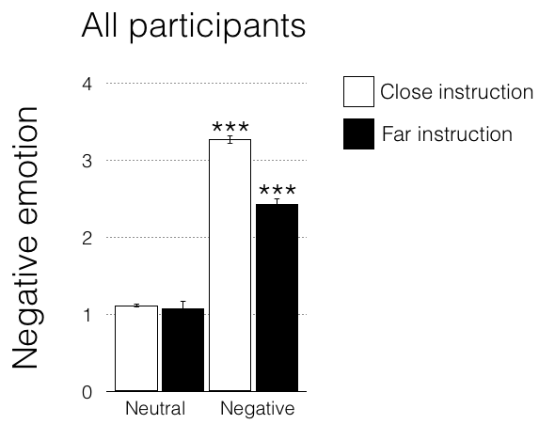
Supplemental figure 1: Performance on the emotion regulation task. During the emotion regulation task, participants reported significantly more negative emotion in response to negative trials compared to neutral trials, and significantly less negative emotion during “negative, far” trials compared to “negative, close” trials, indicating successful emotion regulation. This was assessed using a 2x2 mixed-model ANOVA, with a significant main effect of valence (negative/neutral), F(1,240) = 2412.0, p < 0.05, a significant main effect of instruction (close/far), F(1,240) = 155.18, p < 0.05, and a significant valence-by-instruction interaction, F(1,240) = 125.90, p < 0.05. Post-hoc paired t-tests revealed that all trial types differed significantly from one another (p < 0.05) except for the comparison of neutral, close to neutral, far trials (p = 0.37). Error bars indicate ± 1 SEM. ***denotes significant difference from all other trial types at p < 0.0001.
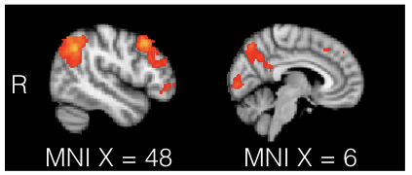
Supplemental Figure 2. Brain regions activated by emotion regulation across group and menstrual phase. Contrast of “negative far” and “negative close” trials showed increased activity during “negative far” trials (i.e., during regulation of negative emotions) in the angular gyrus, middle frontal gyrus, and frontal pole (left panel, MNI X=48) and precuneus and lingual gyrus (right panel, MNI X=6).

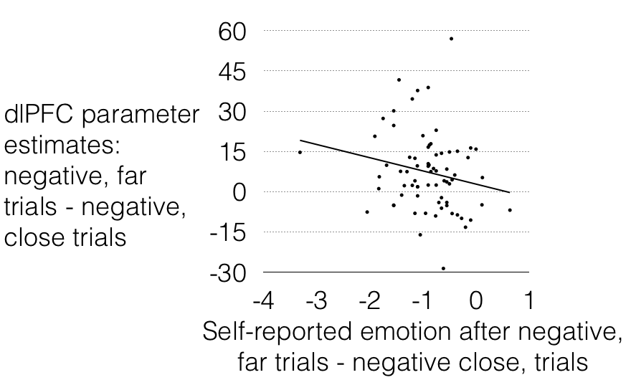
Supplemental Figure 3. Relationship between emotion regulation-related activation in the right dorsolateral prefrontal cortex activity and self-reported emotion regulation. Neural correlates of emotion regulation (parameter estimates of right dlPFC activity in negative, far trials contrasted against parameter estimates in negative, close trials) showed a negative correlation with the difference between “negative, far” ratings and “negative, close” ratings. Plotted are data from both groups and both sessions; each point represents a single session, r(70) = 0.20, p = 0.03. Removing outliers >1.5 inter-quartile range (IQR) below quartile 1 or >1.5 IQR above quartile 3 increases the statistical significance of this finding to r(67) = 0.23, p = 0.0089 (not shown).
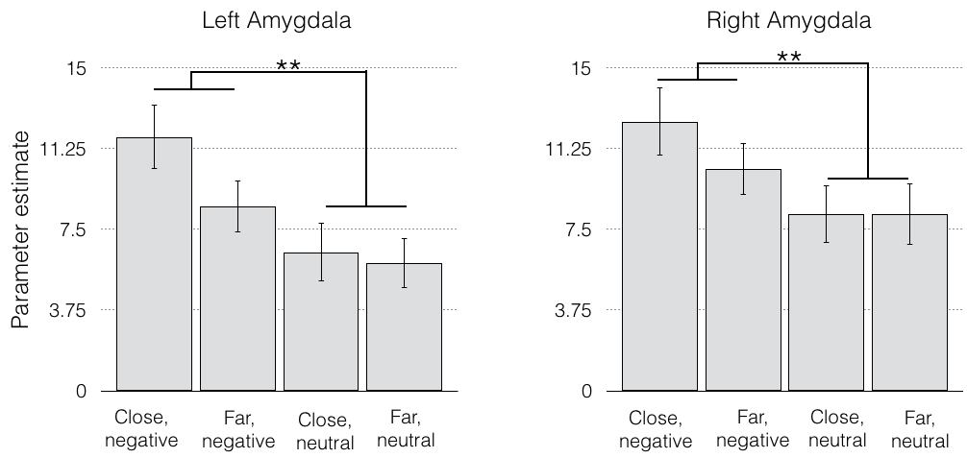
Supplemental figure 4: Amygdala activation in response to each trial type during the emotion regulation task. A significant main effect of valence was found in both the left [F_{(1,249)} = 13.4, p = 0.0003] and right [F_{(1,249)} = 7.75, p = 0.0058] amygdala (all participants combined). No main effect of instruction was found, nor was an instruction-by-valence interaction (ps > 0.05). **p < 0.01

SUPPLEMENTAL METHODSHEALTH: General healthiness was assessed by a nurse practitioner. This included a health history and physical examination resulting in no notable symptoms in the following bodily systems: eyes, ears/nose/mouth/throat, cardiovascular, gastrointestinal, respiratory, musculoskeletal, integumentary, neurologic, endocrinologic, psychiatric (except PMDD in the PMDD group), hematologic/lymphatic, or genitourinary. Participants’ vital signs (temperature, blood pressure, pulse, respiration rate, weight, and height) were also assessed.
STIMULUS PRESENTATION: Each of the four runs contained an equivalent number of trials per condition. Images (160 total) were presented once, counterbalanced across sessions and participants. The condition (close/far) assigned to each image was counterbalanced across participants, and the order of image presentation was randomized between participants, with no condition repeated more than three times consecutively. The inter-stimulus intervals between image off-set and response prompt and between response and onset of the next trial were jittered (12), sampled from an exponential distribution with a mean of 3 s (range: 0.5-6 s). A white fixation cross on a black background appeared during the inter-stimulus interval between response and onset of the next trial. The total scan time was ~60 min, with ~32 min of task time. Before scanning, participants were trained using 10 practice trials (images not presented during scanning).
The presentation and timing of stimuli and response-collection periods were programmed using MATLAB® R2010a (Mathworks, Natick, MA) and the Psychtoolbox (version 3.0.10, www.psychtoolbox.org) (Brainard, 1997, Pelli, 1997) on an Apple PowerMac laptop running Mac OSX version 10.6 (Apple Computers, Cupertino, CA). Visual stimuli were presented using a projector at the rear of the bore of the MRI scanner, and participants viewed them via a mirror mounted on the head coil.
FMRI DATA ACQUISITION: Two volumes at the beginning of each EPI run were discarded to allow for T1 equilibrium effects. For registration purposes, a T2-weighted matched-bandwidth (MBW) high-resolution anatomical scan (same slice prescription as EPI) and a magnetization-prepared rapid-acquisition gradient echo (MPRAGE) high-resolution scan [slice thickness, 1 mm; 176 slices per slab; TR, 2530 s; TE, 3.31 ms; flip angle, 7°; matrix, 256 x 256; FOV, 256 mm; sagittal orientation] were acquired from each participant. The orientation for matched bandwidth and EPI scans was oblique axial to maximize brain coverage and to optimize signal from ventral prefrontal regions.
PSYCHOPHYSIOLOGICAL INTERACTION (PPI) ANALYSIS: PPI analysis was performed to test for main and interacting effects of group and phase on functional connectivity of the bilateral amygdala and the right dlPFC during the emotion regulation task. The PPI was modeled in FSL using eight explanatory variables (EVs): close, negative trials; close, neutral trials; far, negative trials; far, neutral trials; all cue presentations; all rating response epochs; a physiological vector; and an interaction vector. The physiological vector was defined as the time-course of the dlPFC ROI (identical ROI as that used in the main text), and the interaction vector was defined as the product of this physiological vector and the EV modeling the negative, far stimuli. These vectors were convolved with a double-gamma hemodynamic response function and then submitted to second-level analysis to test for a main effect of PPI in the positive and negative directions, as well as group and phase effects on the PPI. A PPI effect (i.e., functional connectivity of dlPFC) was observed in bilateral amygdala only at p < 0.05 (uncorrected), and no main effects or interactions of group or phase were found using cluster-correction (height threshold Z>2.3, cluster threshold P<0.05).

