Supplementary Figures
A Longitudinal Mediation Analysis of the Effect of Negative-Self Schemas on Positive Symptoms via Negative Affect
Edo S. Jaya, Leonie Ascone, and Tania M. Lincoln

Content:
S.Figure 1 Participants flow chart
S.Figure 2 Visual representation of the statistical longitudinal mediation model

S. Figure 1 Participants flow chart.

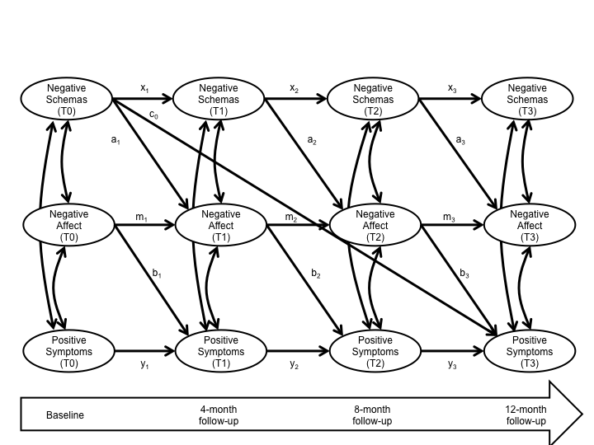
S. Fig 2 Visual reprentation of the statistical longitudinal mediation model.

Note. Negative schemas = Negative-self schemas. T0 = baseline. T1 = month 4. T2 = month 8. T3 = month 12. x = time-lagged pathways of the predictor in the model. m = time-lagged pathways of the mediator in the model. y = time-lagged pathways of the outcome in the model. a = time-lagged pathways from predictor to mediator in a mediation model. b = time-lagged pathways from mediator to outcome in a mediation model. c = time-lagged pathway from predictor to outcome in a mediation model (total-effect pathway).

