SUPPLEMENTAL MATERIAL

Detailed Methods: By comparison to other cities, the proportion of subjects aged 65–74 years was lower in Dijon (53%) than Montpellier (64%) and the Bordeaux cohort had a lower education level and income than Dijon. Dijon participants completing the follow-up were characterized by; a higher proportion of females, more university education, arrhythmia and cancer. Included participants were also younger, less likely to have heart disease, less likely to smoke, and less likely to be using psychotropic drugs than participants lost to follow-up or deceased.

Blood Pressure Assessment
Blood pressure (BP) was recorded at each clinic visit after the participant rested at least 5 min in a seated position. A total of 3 measurements were recorded separated by 2 min (3 BP readings per clinic visit). BPV was calculated between baseline and year 4 as; Coefficient of Variation: calculated as SD/mean BP. The correlation between BPV with mean systolic and diastolic BP was r = .49 and r = .12 respectively prior to transformation. We applied a log transformation to BPV because of a non-Gaussian distribution which reduced the correlation between BPV with mean systolic and diastolic BP (r = .03 and r = .02 respectively after transformation. A subset of the Dijon cohort (N = 1454) underwent home BP monitoring at 2 year follow-up, completing 18 consecutive BP measures over 3 days. The CV of systolic BPV derived from home BP monitoring was highly associated with longer term BPV over 8 years (β = 3.09, SE = .84; p <.001) supporting the validity of clinic visit-to-visit BPV (Tully and Tzourio, 2017).

Magnetic Resonance Imaging
Positioning in the magnet was based on a common landmark for all participants—the orbito-meatal line—so that the entire brain, including cerebellum and mid-brain, was contained within the field of view of acquisition. T1 and T2 datasets were readily reconstructed, and visually checked for major artifacts before further analysis. Raw data were converted to the ACR-NEMA standard format and then transformed for analysis and storage at the Department of Neurofunctional Imaging, Caen.
T1, T2 and PD bias-corrected volumes were segmented into seven classes using the same multispectral algorithm (Zijdenbos and Dawant, 1994): (1) cerebrospinal fluid, (2) grey matter, (3) caudate nucleus (CN), (4) lenticular nucleus (LN), (5) thalamus (THA), (6) white matter and (7) WMH. Initial model parameters values (mean and standard deviation of voxel intensities of each class in each modality) were measured in regions of interest (ROIs) drawn on MR slices of two sub-samples of ten subjects either free or showing a large number of WMH. Subjects of both sub-samples were selected by two experienced neuroradiologists by careful visual inspection. The ROIs were manually drawn by a single operator using CAPP software (CIMx Co, Milford, OH), with the following restrictions: (1) cerebrospinal fluid ROIs were extracted from lateral ventricles; (2) each ROI had to be 2 mm distant from other border classes; (3) ROIs were drawn on the modality providing the best contrast of the corresponding class. The voxel intensity distribution of each class and mode was checked to not significantly depart from a Gaussian distribution. An example MRI for quartile of WMH is shown in eFig 1.
The MR image analysis contained three major steps: 1) preprocessing, including registration, nonbrain tissue removal, and bias field correction; 2) detection of WMH in T2 images, including removal of false positives; 3) postprocessing including generation of WML probability maps at the individual and sample levels, morphometry, localization, and classification of WML.

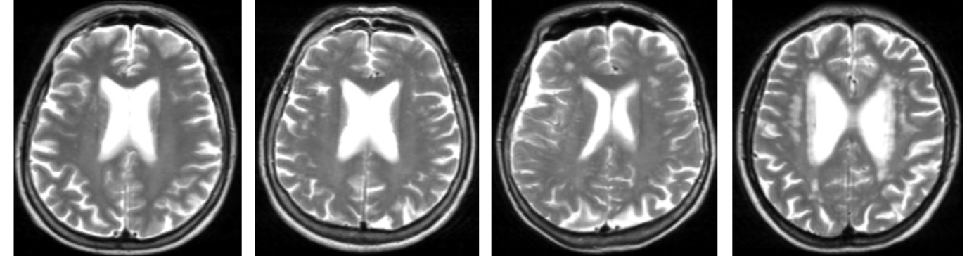

A B C D

eFig 1. Four T2-weighted MRI images showing the extent of white matter lesions (WML) in each quartile of total WML volume
The T2-weighted MRI images shows 4 separate individuals by total white matter lesion volume, A) first quartile of WML volume (0-25th percentile), B) second quartile of WML volume (26th-50th percentile), C) third quartile of WML volume (51st-75th percentile), D) fourth quartile of WML volume (76th–100th percentile). LIGHT GRAY = white matter; DARK GRAY = gray matter.

Covariate Assessment
A standardized questionnaire was administered covering demographic characteristics, daily life habits and medical. Education was measured based on the number of full-years of education and included primary education or less (less than 5 years), short secondary education (5-9 years), full secondary education (10-12 years), higher education/degree (vocational preparation, technical college, bachelor degree or equivalent). Assessment of the number of alcoholic drinks (g per week), tobacco and coffee consumption was collected by a designated survey with the Mini Nutritional Assessment (Guigoz et al., 1996). Comorbidities were defined according to International Classification of Diseases 10th revision criteria. Diabetes was defined as medication use for diabetes or fasting plasma glucose ≥7.0 mmol/L. Coronary heart disease was defined as any myocardial infarction, coronary artery bypass or percutaneous intervention, or peripheral vascular disease. The diagnosis and classification of incident strokes (excluded from our analyses) were made by a blinded expert panel that reviewed all existing medical information including, where available, cerebral imaging, according to International Classification of Diseases 10th revision criteria (Alpérovitch et al., 2015). Stage of chronic kidney disease (CKD) was calculated from glomerular filtration rate (mL/min/1.73 m²) according to the Guidelines of the National Kidney Foundation (2002); stage 1 (≥90), stage 2 (60-89), stage 3 (30-59), stage 4 (15-29), stage 5 (<15 or dialysis), as validated in a French population cohort (Froissart et al., 2005).
Determination of the apolipoprotein E ε4 allele (APOE) was carried out at the Lille Genopole (Lille, France, http://www.genopole.fr/). DNA samples were transferred to the French Centre National de Génotypage for genotyping. APOE genotyping was performed using the fluorogenic 5ʹ-nuclease assay with TaqMan chemistry (Applied Biosystems, Foster City, CA, USA). Medications use was determined at interview, and, where feasible, the medications themselves were brought to each interview. All drugs were coded according to the WHO ATC classification (World Health Organization, 2002). Drug use for BP was explicitly differentiated from use for other cardiovascular diseases (Brindel et al., 2006). Psychotropic medication was recorded and included use of anti-depressants (serotonin reuptake inhibitors, tri- and tetra-cyclics, monoamine oxidase inhibitors), psychostimulants, nootropics, psycholeptics and psychoanaleptics.

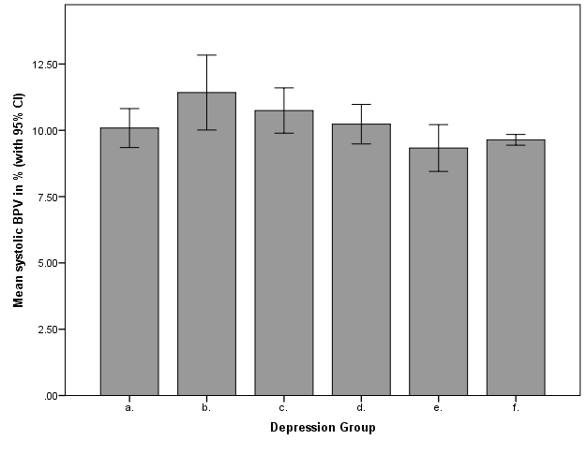
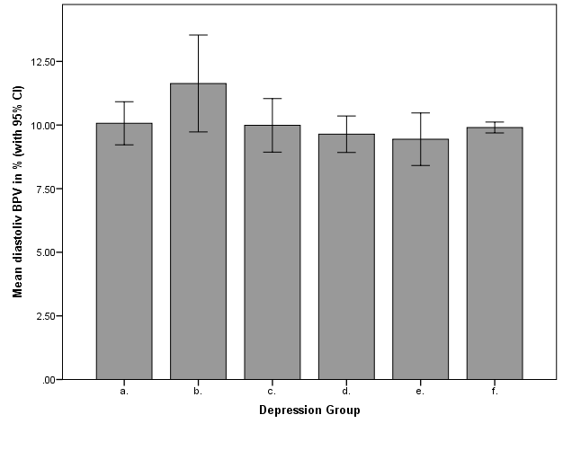
eFig 2. Mean blood pressure variability by depression group
Box plot graph showing the mean and 95% CI for blood pressure variability.
a. No depression disorder-symptomatic; b. LOD-symptomatic; c. EOD-symptomatic; d. LOD-asymptomatic; e. EOD-asymptomatic; d. No depression disorder-asymptomatic
BPV, blood pressure variability; CI, confidence interval; EOD, early onset depression; LOD, late onset depression;
Supplement Table 1. Association between depression and diastolic blood pressure variability over 10 years (N = 2812)

 | Step 1  Age, sex, education and mean systolic BP adjusted |  |  | Step 2  + additional covariates
Depression onset | β | SE | P | β | SE | P
Late onset depression, onset age >60 years | .01 | .03 | .97 | -.01 | .03 | .99
Early onset depression, onset age <60 years | .03 | .04 | .57 | .02 | .04 | .72
Symptomatic on CESD; ≥ 2 or more assessments
Late onset depression, onset age >60 years | .01 | .06 | .88 | .02 | .06 | .73
Early onset depression, onset age <60 years | .08 | .08 | .28 | .06 | .08 | .45
No depression disorder | -.01 | .04 | .93 | .02 | .04 | .54
Asymptomatic on CESD; ≤ 1 or less assessments
Late onset depression, onset age >60 years | -.01 | .05 | .87 | .02 | .05 | .70
Early onset depression, onset age <60 years | -.02 | .07 | .78 | .06 | .08 | .45
No depression | Reference | - | - | Reference | - | -
Any depression at baseline = current major depression or dysthymia
BP, blood pressure;
Step 1 adjusted for age, sex, education and mean systolic blood pressure
Step 2 additionally adjusted for antihypertensive drug use for hypertension, coronary heart disease, stroke, arrhythmia, chronic kidney disease, diabetes, body mass index, hypercholesterolemia, smoking status, alcohol intake, coffee consumption, apolipoprotein E ε4 allele, cancer, and psychotropic drugs.

Supplement Table 2. Raw cognitive test scores at baseline in the depression groups (N = 2812)
 | Late Onset Depression |  | Early Onset Depression |  | No Depression Disorder
 | Symptomatic  N = 105 | Asymptomatic  N = 200 | Symptomatic  N = 51 | Asymptomatic  N = 74 | Symptomatic  N = 190 | Asymptomatic  N = 2192
IST, median IQR | 48 (40-55) | 49 (43-58) | 47 (41-57) | 50 (44-57) | 48 (40-55) | 51 (44-58)
BVRT, median IQR | 11 (10-13) | 12 (10-13) | 12 (10-13) | 12 (10-13) | 11 (10-13) | 12 (11-13)
MMSE, median IQR | 27 (26-28) | 28 (27-29) | 28 (26-29) | 28 (27-29) | 28 (26-29) | 28 (27-29)
TMT-A, median IQR | 50 (44-55) | 47 (41-55) | 46 (41-52) | 49 (44-57) | 50 (45-55) | 46 (41-52)
TMT B/A, median IQR | 1.92 (1.49-2.42) | 1.95 (1.59-2.40) | 1.82 (1.37-2.15) | 1.82 (1.40-2.34) | 1.92 (1.49-2.37) | 1.90 (1.54-2.41)
FTT, median IQR | 40 (34-48) | 43 (37-49) | 40 (35-47) | 44 (37-52) | 45 (36-52) | 45 (38-52)
BVRT, Benton Visual Retention Test; FTT, finger tapping test; IST, Isaac’s Set Test; IQR, interquartile range; MMSE, Mini Mental State Examination; TMT-A, Trail Making Test-Part A; TMT-B, Trail Making Test Part B; TMT B/A, ratio of time to complete Trail Making Test Part B divided by time to complete Trail Making Test Part A.
Baseline scores shown for each of the cognitive tests. FTT was first administered in wave 4 (7 years follow-up).

Supplement Table 3. Association between depression onset and diastolic blood pressure variability with cognitive function over 10 year follow-up (N = 2812)
 | IST  Slope (95% CI) | P | BVRT  Slope (95% CI) | P | MMSE  Slope (95% CI) | P | TMT A  Slope (95% CI) | P | TMTB/A  Slope (95% CI) | P | FTT  Slope (95% CI) | P
Symptomatic on CESD; ≥ 2 or more assessments
Late onset depression | -2.32 (-4.41 to -.24) | .029* | -.43 (-.83 to -.02) | .041* | -.32 (-.69 to .05) | .093 | -1.32 (-3.47 to .83) | .23 | .05 (-.09 to .18) | .52 | -1.91 (-4.22 to .40) | .10
Early onset depression | -1.87 (-4.27 to .52) | .13 | -.01 (-.45 to .43) | .97 | -.09 (-.59 to .42) | .74 | -1.14 (-4.32 to 2.04) | .48 | .14 (-.03 to .31) | .10 | 8.45 (-11.37 to 28.28) | .40
No depression disorder | -1.70 (-3.56 to .16) | .074 | -.33 (-.64 to -.03) | .034* | -.24 (-.56 to .09) | .16 | -.39 (-2.03 to 1.26) | .64 | .05 (-.07 to .17) | .45 | 2.53 (-3.57 to 8.62) | .42
Asymptomatic on CESD; ≤ 1 or less assessments
Late onset depression | .09 (-1.20 to 1.37) | .90 | -.03 (-.24 to .19) | .81 | -.03 (-.25 to .20) | .81 | .46 (-.85 to 1.77) | .49 | .05 (-.03 to .12) | .21 | -.14 (-1.65 to 1.37) | .86
Early onset depression | .74 (-1.42 to 2.90) | .50 | .18 (-.18 to .54) | .33 | .04 (-.31 to .39) | .83 | 2.31 (.48 to 4.14) | .014* | -.05 (-.20 to .11) | .55 | 1.16 (-1.56 to 3.89) | .40
No depression history | Reference | - | Reference | - | Reference | - | Reference | - | Reference | - | Reference | -
Diastolic BPV (log) | -.54 (-1.27 to .19) | .15 | -.18 (-.29 to -.07) | .001** | -.12 (-.24 to -.01) | .039* | -.82 (-1.57 to -.07) | .014* | -.03 (-.07 to .02) | .29 | -.59 (-1.62 to .44) | .26
BPV, blood pressure variability; BVRT, Benton Visual Retention Test; EOD, early onset depression; FTT, Finger Tapping Test; IST, Isaac’s Set Test; LOD, late onset depression; MMSE, Mini Mental State Examination; TMTB, Trail Making Test Part B;

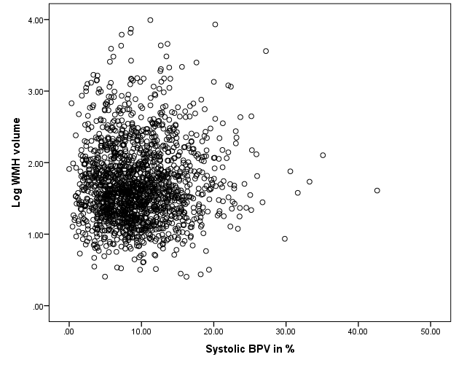
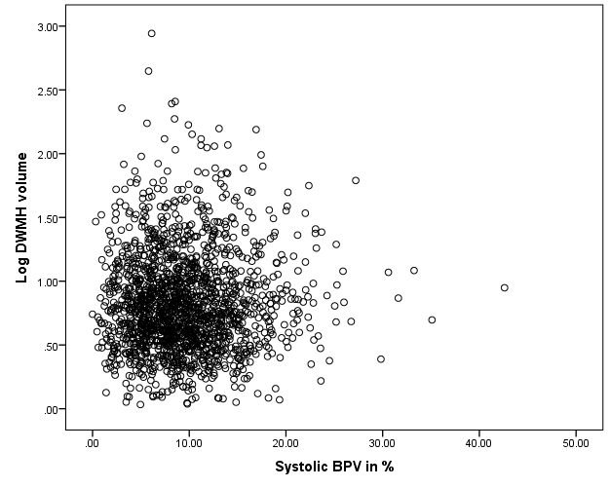
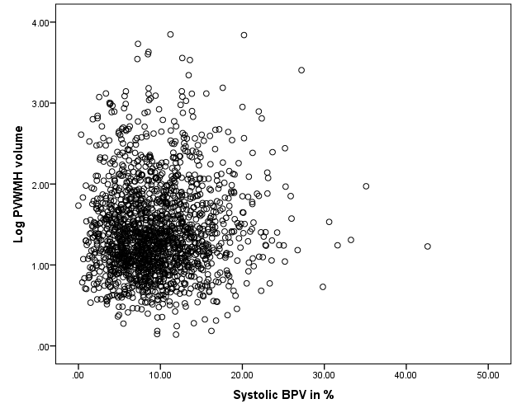
eFig 3. Scatterplot of systolic blood pressure variability and WMH volume
Scatterplot showing systolic BPV in % (x-axis) and log WMH volume in cm³ (y-axis) for total, deep and periventricular WMH
BPV, blood pressure variability; DWMH, deep white matter hyperintensities; PWMH, periventricular white matter hyperintensities; WMH, white matter hyperintensities;

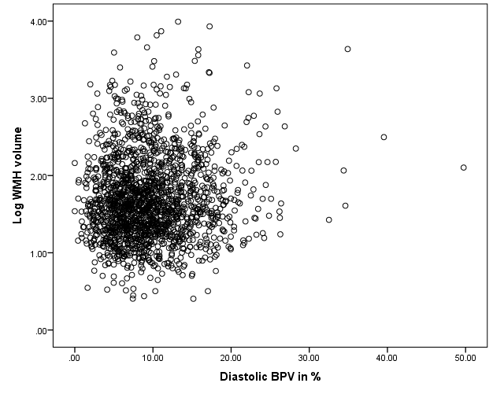
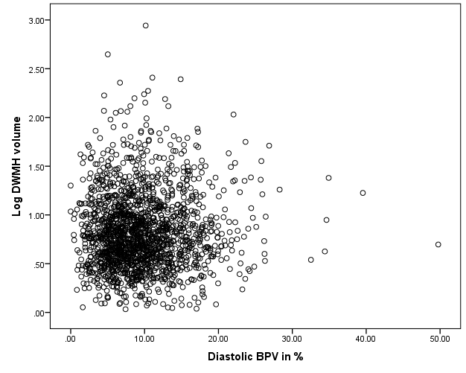
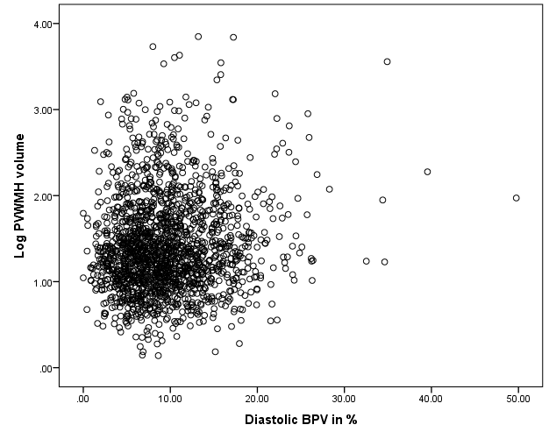

eFig 4. Scatterplot of diastolic blood pressure variability and WMH volume
Scatterplot showing diastolic BPV in % (x-axis) and log WMH volume in cm³ (y-axis) for total, deep and periventricular WMH
BPV, blood pressure variability; DWMH, deep white matter hyperintensities; PWMH, periventricular white matter hyperintensities; WMH, white matter hyperintensities;
SUPPLEMENTAL MATERIAL REFERENCES
Alpérovitch, A, Kurth, T, Bertrand, M, Ancelin, M-L, Helmer, C, Debette, STzourio, C (2015). Primary prevention with lipid lowering drugs and long term risk of vascular events in older people: population based cohort study. British Medical Journal 350, h2335.
Brindel, P, Hanon, O, Dartigues, JF, Ritchie, K, Lacombe, JM, Ducimetiere, P, Alperovitch, ATzourio, C (2006). Prevalence, awareness, treatment, and control of hypertension in the elderly: the Three City study. Journal of Hypertension 24, 51-58.
Froissart, M, Rossert, J, Jacquot, C, Paillard, MHouillier, P (2005). Predictive performance of the modification of diet in renal disease and Cockcroft-Gault equations for estimating renal function. Journal of the American Society of Nephrology 16, 763-773.
Guigoz, Y, Vellas, BGarry, PJ (1996). Assessing the nutritional status of the elderly: The Mini Nutritional Assessment as part of the geriatric evaluation. Nutrition Reviews 54, S59-65.
National Kidney Foundation (2002). K/DOQI clinical practice guidelines for chronic kidney disease: evaluation, classification, and stratification. American Journal of Kidney Diseases 39, S1-266.
Tully, PJTzourio, C (2017). Psychiatric correlates of blood pressure variability in the elderly: The Three City cohort study Physiology and Behavior 168, 91-97.
World Health Organization (2002). Guidelines for ATC classification and DDD assignment. Norwegian Institute of Public Health: Oslo, Norway.
Zijdenbos, APDawant, BM (1994). Brain segmentation and white matter lesion detection in MR images. Critical Review in Biomedical Engineering 22 401–465.

