Supplementary material

Outcomes of a psycho-education and monitoring programme to prevent compulsory admission to psychiatric inpatient care: a randomised controlled trial
Lay B, Kawohl W, Rössler W

Comparison of patients who completed the programme to those who dropped out
During the 24-month programme we lost more patients in the intervention group (44; 37.0%) than in the TAU group (26; 21.8% of the baseline sample). Premature termination of participation happened particularly at the very beginning of the study: e.g., 21 patients assigned to the intervention group already dropped out during baseline assessment, before the intervention started. The majority of patients who did not remain in the study up to t2, dropped out already during the first three months (Figure S1).
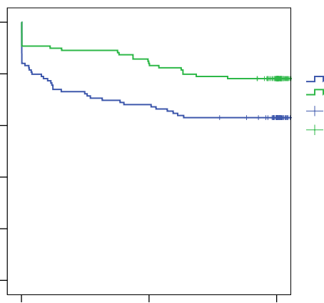
1.0

0.8

0.6

0.4

0.2

0.0

0 365 730

Time in days
Treatment group
Intervention
TAU
Intervention-censored
TAU-censored
Treatment group
Intervention
TAU
Intervention-censored
TAU-censored
Cum. Survival

Supplementary Figure S1. Survival functions for treatment groups
To further analyse the potential bias due to dropout, we compared baseline characteristics of participants who completed the programme to those of dropouts. Results suggest that, at the bivariate level, risk of dropout is associated with treatment group, socio-demographic factors (age, nationality, living situation, occupational status) and length of illness, whereas other variables of the psychiatric patient’s history and type of disorder were not found to be significantly associated with dropout risk (Table S1).
Using these baseline variables simultaneously in a model, the Cox regression identified four significant predictors. According to this regression model, the risk to leave the study prematurely was significantly increased in patients participating in the intervention group, and higher in patients at a younger age, of foreign nationality and with a high number of compulsory psychiatric admission in the past.

Supplementary Table S1. Predictors of dropout during 24 months of preventive monitoring (Cox regression analyses)
 | Single covariates |  |  |  | Model  Forward selected covariates
Predictor variable (baseline data) |  | HR | 95% CI | P value |  | HR | 95% CI | P value
Intervention (vs. TAU) |  | 1.90 | (1.17 – 3.08) | .010 |  | 2.16 | (1.31 – 3.56) | .003
Ageª |  | 0.63 | (0.51 – 0.77) | <.001 |  | 0.64 | (0.52 – 0.79) | <.001
Foreign national (vs. Swiss) |  | 1.91 | (1.14 – 3.20) | .015 |  | 2.12 | (1.23 – 3.67) | .007
Compulsory psychiatric admissions prior  to intervention^{b} |  | 1.56 | (1.06 – 2.28) | .022 |  | 1.65 | (1.13 – 2.41) | .009
Length of illnessª |  | 0.75 | (0.61 – 0.93) | .010
Living situation: Alone vs. |  |  |  | .017
With child(ren) |  | 1.17 | (0.45 – 3.02) | .753
With partner |  | 0.69 | (0.33 – 1.46) | .331
With others / unknown |  | 1.96 | (1.16 – 3.30) | .012
Occupation: Unemployed / homemaker vs. |  |  |  | .039
Sheltered employment |  | 0.26 | (0.06 – 1.07) | .062
Regular labor market |  | 0.54 | (0.28 – 1.03) | .061
Sex: male (vs. female) |  | 1.17 | (0.73 – 1.87) | .510
Compulsory admission: danger to others (vs. to self) |  | 1.01 | (0.60 – 1.70) | .965
ICD-10 Diagnosis: Other diagnoses vs. |  |  |  | .292
Psychotic disorders (F2; F30-31) |  | 0.81 | (0.48 – 1.38) | .440
Personality disorders (F6) |  | 1.38 | (0.74 – 2.58) | .313

Note. HR = hazard rate; CI = confidence interval
TAU = Treatment as usual
ª Age, length of illness in units of 10 years
^{b} N of compulsory admissions log-transformed
Final model statistics: Global chi² = 39.95; df = 4; P < 0.001

