Supplemental material
SM 1 Methods
SM 1.1 Participant
AN patients were recruited from specialized eating disorder programs of a university child and adolescent psychiatry and psychosomatic medicine department and diagnosed according to DSM-V criteria using semi-structured clinical interviews. All AN patients were admitted to eating disorder programs of a university child and adolescent psychiatry and psychosomatic medicine department and were assessed within 96 hours after the beginning of a behaviorally-oriented nutritional rehabilitation program. Comorbid psychiatric diagnoses were made by an expert clinician and included examination of the participant and careful archival chart review (including medical and psychiatric history, physical examination and several psychiatric screening instruments). The patients were amenorrheic with two exceptions: One patient took oral contraceptives, thus the natural menstrual cycle could not be evaluated and the other continued to maintain a menstrual cycle.
Exclusion criteria and possible confounding variables, e.g. the use of psychotropic medications and medical comorbidities, were obtained using the SIAB-EX and our own semi-structured interview.
HC participants were excluded if they had any history of psychiatric illness, a lifetime BMI below the 10th age percentile (if younger than 18 years) or BMI below 18.5kg/m² (if older than 18 years), or were currently obese (BMI not over 97th age percentile if younger than 18 years; BMI not over 30kg/m² if older than 18 years). Participants of all study groups were excluded if they had a lifetime history of any of the following clinical diagnoses: organic brain syndrome, schizophrenia, substance dependence, psychosis NOS, bipolar disorder, bulimia nervosa or binge-eating disorder (or “regular” binge eating - defined as bingeing at least once weekly for three or more consecutive months). Further exclusion criteria for all participants were IQ lower than 85; psychotropic medication within four weeks prior to the study; current substance abuse; current inflammatory, neurologic or metabolic illness; chronic medical or neurological illness that could affect appetite, eating behavior, or body weight (e.g., diabetes); clinical relevant anemia; pregnancy; breast feeding.
Pairwise case-control age-matching was carried out using the Munkres algorithm (Munkres 1957) resulting in a maximum difference of 1.6 years between the individuals within one pair.
Study data were collected between May 2014 and September 2015 and managed using secure, web-based electronic data capture tools REDCap (Research Electronic Data Capture; Harris et al. 2009).
SM 1.2 Clinical measures
For all participants, current diagnoses of eating disorders were evaluated by the expert form of the SIAB-EX (Fichter & Quadflieg 1999), a well-validated 87-item semi-standardized interview that assesses the prevalence and severity of specific eating-related psychopathology over the past three months. The interview provides diagnoses according to the ICD-10 and DSM-IV. Interviews were conducted by clinically experienced and trained research assistants under the supervision of the attending child and adolescent psychiatrist.
Intelligence quotient (IQ) was assessed with a short version of the German adaption of the Wechsler Adult Intelligence Scale (Von Aster et al. 2006) for participants aged 16 years and older or a short version of the German adaption of the Wechsler Intelligence Scale for Children (Daseking et al. 2007) for participants aged 15 years or younger. Self-reported hunger (“How hungry are you?”) was assessed with the use of a visual analogue scale ranging from “not at all” (value of 0) to “extremely” (value of 10; Blundell et al. 2010) after the scanning session.
SM 1.3 Task and Stimuli
To ensure the attention and wakefulness of the participant, an attention capture task was introduced between each mini-block (10 trials of one stimulus category) of the task. Specifically, a crosshair was presented centrally for 1309ms and either the left or the right part of the horizontal line turned red, while the rest of the crosshair remained white. The participant was asked to indicate the position of the red part of the horizontal line with a button-press. Immediately before and after the attention capture task, a completely white crosshair was presented for 4-6s (jitter).
Neutral (arousal=2.55(0.47)) and social stimuli (arousal=4.5(0.9)) presented in the task differed significantly regarding their arousal (T(44.24)=10.64; p<0.001).

SM 1.4 Functional Connectivity
On the first level, the physiological activity was obtained by calculating the first eigen-variate across the voxel within the source region and adjusting for the effects of interest. For every participant a whole-brain GLM analysis was performed using the following regressors: the deconvolved physiological activity of the seed region, the three psychological factors (food supraliminal, neutral supraliminal and social supraliminal), and the three products of the physiological activity and each psychological factor (referred as “PPI regressors”). On the second level, the contrast images food_{supra}>neutral_{supra} and social_{supra}>neutral_{supra} were subjected to a two-sample t-test using SPM8. For the hypothesis-based approach findings were small volume corrected by using the limbic target-regions (ventral striatum, amygdala, orbitofrontal cortex and insula). The masks of the amygdala, insula and orbitofrontal cortex were created by merging the left and right frontal label from the Automated Anatomical Labelling (AAL) atlas provided in the Wake Forest University (WFU) PickAtlas for SPM (Figure SM 1.4). The mask of the ventral striatum was specified by binarizing a probabilistic map with a threshold value of 0.4.

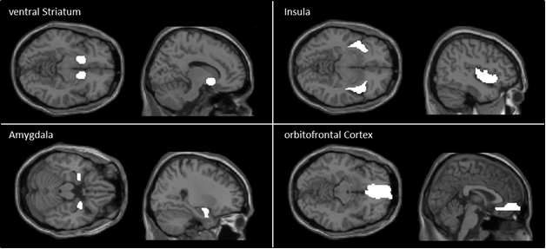
Figure SM 1.4: Mask of the ventral striatum, insula, amygdala, orbitofrontal cortex used in the hypothesis-based approach of the functional connectivity analysis.

SM 2 Results
SM 2.1 Stimulus-specific activation pattern during subliminal and supraliminal stimulation condition
We assume that our task works as intended as we found that in both, the subliminal as well as the supraliminal stimulation condition, stimulus-specific activation patterns were apparent in HC. In detail, the contrast social_{sublim}>neutral_{sublim} in HC showed increased activation in brain regions including the ventral striatum (T=7.23; p_{FWE}=0.05; Figure 2A); a region known to play a central role in reward processing (Wang et al. 2016), while no cluster associated with reward processing was found for the contrast food_{sublim}>neutral_{sublim} (Figure 2B). Also the contrast social_{supra}>neutral_{supra} showed increased activity in regions associated with reward processing including the ventral striatum, the anterior cingulate cortex and the insula (T=9.74; p_{FWE}<0.05; Figure 2C). When investigating the contrast food_{supra}>neutral_{supra} we found increased activity in clusters known to be involved in food processing (van der Laan et al. 2011) e.g. the ventral striatum, ventral anterior cingulate cortex, posterior fusiform gyrus and superior parietal lobule (T=3.34; p_{unc.}<0.001; Figure 2D)
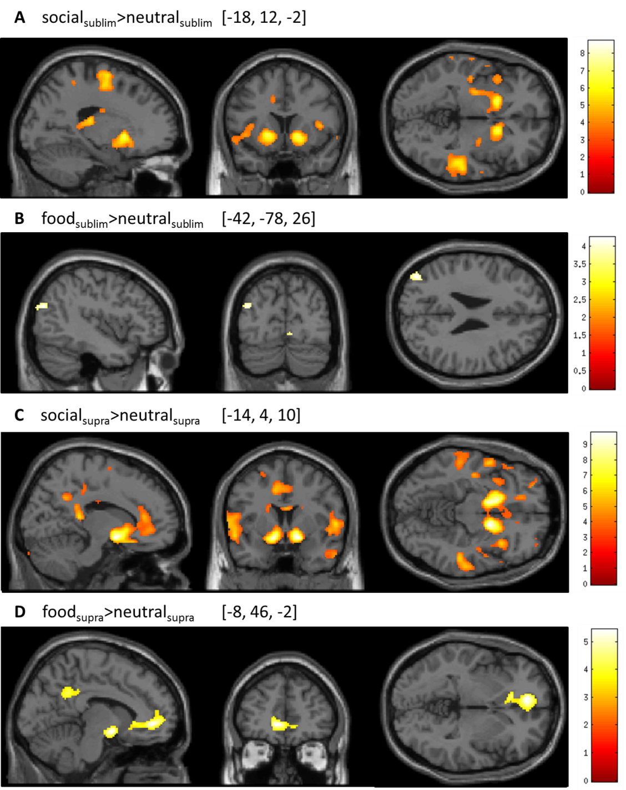
Figure SM 2.1: Test of stimulus type specific activation patterns under subliminal and supraliminal stimulation condition. Brain maps are displayed at p=0.001 for visualization purpose only; Coordinates in Montreal Neurological Institute (MNI) space [x, y, z]; color bars represent t-values.

SM 2.2 Control analyses: Effect of age
 | IFJ  F (p) | SOG  F (p) | FFG/PHG  F (p)
Age | 0.29 (0.595) | 0.145 (0.705) | 1.113 (0.295)
Group | 5.00 (0.029) | 0.10 (0.756) | 0.30 (0.588)
Stimulation condition | 85.89 (<0.001) | 558.00 (<0.001) | 974.241 (<0.001)
Stimulus type | 12.40 (<0.001) | 8.07 (<0.001) | 4.543 (0.011)
Group*stimulation condition | 12.07 (0.001) | 0.73 (0.394) | 0.55 (0.459)
Group*stimulus type | 8.85 (<0.001) | 3.45 (0.033) | 3.36 (0.036)
Stimulation condition*stimulus type | 2.18 (0.115) | 6.35 (0.002) | 2.80 (0.062)
Group*stimulation condition*stimulus type | 11.722 (<0.001) | 6.073 (0.003) | 10.907 (<0.001)
To test whether our main findings were influenced by age we reanalyzed the data including age as a covariate in the linear mixed model. Results were essentially identical to those obtained using the linear mixed model without age as covariate and age itself did not explain variance. The statistics of the analyses are reported in the table below.
Table SM 2.2: Main effects and interaction effect of the linear mixed model (based on extracted ß-values for each relevant cluster) with age as covariate; IFJ=inferior frontal junction; SOG=superior occipital gyrus; FFG/PHG=fusiform gyrus/parahipocampal gyrus.

SM 2.3 Control analyses: Effect of comorbidities
To investigate whether our main findings were influenced by psychiatric comorbidities, we rerun the linear mixed model after excluding all subjects who had a comorbid diagnosis (n=3). The results matched the findings obtained from the original sample. The statistics of the analyses are reported in the table below.

 | IFJ  F (p) | SOG  F (p) | FFG/PHG  F (p)
Group | 4.35 (0.041) | 0.29 (0.593) | 0.837 (0.364)
Stimulation condition | 92.31 (<0.001) | 590.32 (<0.001) | 1038.308 (<0.001)
Stimulus type | 10.95 (<0.001) | 9.22 (<0.001) | 4.608 (0.011)
Group*stimulation condition | 15.22 (0.001) | 2.801 (0.095) | 2.446 (0.119)
Group*stimulus type | 9.49 (<0.001) | 4.721 (0.010) | 4.222 (0.015)
Stimulation condition*stimulus type | 2.016 (0.135) | 6.222 (0.002) | 2.940 (0.054)
Group*stimulation condition*stimulus type | 11.42 (<0.001) | 5.952 (0.003) | 11.232 (<0.001)
Table SM 2.3: Main effects and interaction effect of the linear mixed model (based on extracted ß-values for each relevant cluster) excluding patients with comorbid diagnosis; IFJ=inferior frontal junction; SOG=superior occipital gyrus; FFG/PHG=fusiform gyrus/parahipocampal gyrus.

SM 2.4 Control analyses: Effect of AN subtype
To test whether the AN subtype (binge/purge) has influenced the result we excluded the AN patients diagnosed with binge/purge subtype (n=2) and reanalyzed the data using the linear mixed model. On the whole, we found that excluding those patients has not relevantly influenced our findings. The statistics of the analyses are reported in the table below.
 | IFJ  F (p) | SOG  F (p) | FFG/PHG  F (p)
Group | 3.71 (0.059) | 0.22 (0.884) | .266 (0.608)
Stimulation condition | 90.102 (<0.001) | 535.350 (<0.001) | 925.626 (<0.001)
Stimulus type | 11.221 (<0.001) | 7.975 (<0.001) | 4.633 (0.01)
Group*stimulation condition | 13.807 (<0.001) | 0.756 (0.385) | .349 (0.555)
Group*stimulus type | 10.005 (<0.001) | 3.241 (0.040) | 3.354 (0.036)
Stimulation condition*stimulus type | 2.645 (0.073) | 5.888 (0.003) | 2.796 (0.063)
Group*stimulation condition*stimulus type | 11.681 (<0.001) | 5.785 (0.003) | 10.644 (<0.001)
Table SM 2.4: Main effects and interaction effect of the linear mixed model (based on extracted ß-values for each relevant cluster) excluding patients diagnosed with the binge/purge subtype of AN; IFJ=inferior frontal junction; SOG=superior occipital gyrus; FFG/PHG=fusiform gyrus/parahipocampal gyrus.
References
Blundell J, De Graaf C, Hulshof T, Jebb S, Livingstone B, Lluch A, Mela D, Salah S, Schuring E, Van Der Knaap H, Westerterp M (2010). Appetite control: methodological aspects of the evaluation of foods. Obesity Reviews 11, 251–270.
Daseking M, Petermann U, Petermann F (2007). Intelligenzdiagnostik mit dem HAWIK-IV. Kindheit und Entwicklung 16, 250–259.
Fichter M, Quadflieg N (1999). SIAB. Struckturiertes Inventar fuer anorektische und Bulimische Essstoerungen nach DSM-IV und ICD-10. Huber: Bern.
Harris PA, Taylor R, Thielke R, Payne J, Gonzalez N, Conde JG (2009). Research electronic data capture (REDCap)—a metadata-driven methodology and workflow process for providing translational research informatics support. Journal of biomedical informatics 42, 377–381.
van der Laan LN, de Ridder DTD, Viergever MA, Smeets PAM (2011). The first taste is always with the eyes: A meta-analysis on the neural correlates of processing visual food cues. NeuroImage 55, 296–303.
Munkres J (1957). Algorithms for the assignment and transportation problems. Journal of the Society for Industrial & Applied Mathematics 5, 32–38.
Von Aster M, Neubauer A, Horn R (2006). Wechsler Intelligenztest für Erwachsene (WIE). Deutschsprachige Bearbeitung und Adaptation des WAIS-III von David Wechsler. Frankfurt/Main, Germany: Harcourt Test Services
Wang KS, Smith DV, Delgado MR (2016). Using fMRI to study reward processing in humans: past, present, and future. Journal of Neurophysiology 115, 1664–1678.

