Supplementary material

Figure S1. Volumes of grey matter, white matter and sub-cortical structures for participants with ASD and controls by scanning site

Caption Fig S1. Panels a) – i) show right and left brain volumes in cubic millimeter (mm³) for participants with ASD and controls by scanning site. Circles represent brain volume of each participant. a = California Institute of Technology; b = Carnegie Mellon University; c = Kenny Krieger Institute; d = University of Leuven Sample 1; e = University of Leuven Sample 2; f = Ludwig Maximilians University Munich; g = NYU Langone Medical Center; h = Oregon Health and Science University; i= Olin, Institute of Living at Hartford Hospital; j = University of Pittsburgh School of Medicine; k = San Diego State University; l = Stanford University; m = Trinity Center for Health Sciences; n = University of California Los Angeles Sample 1; o = University of California Los Angeles Sample 2; p = University of Michigan Sample 1; q = University of Michigan Sample 2; r = University of Utah School of Medicine; s = Yale Child Study Center

a)

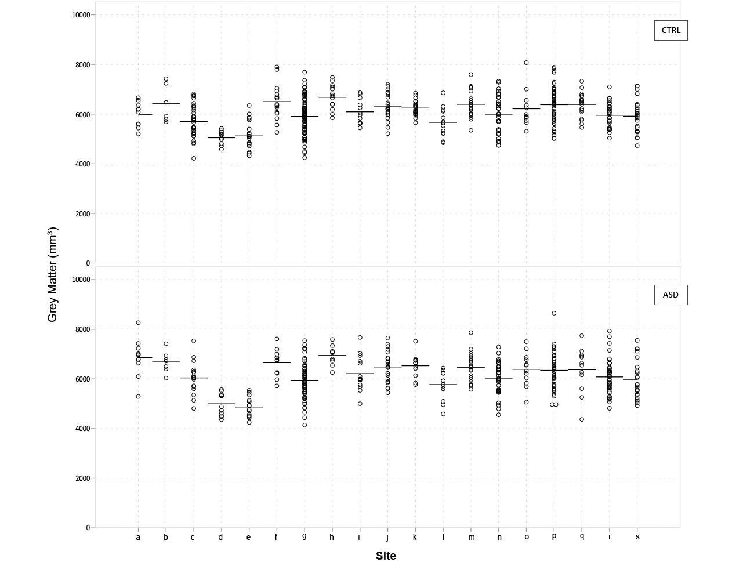

b)

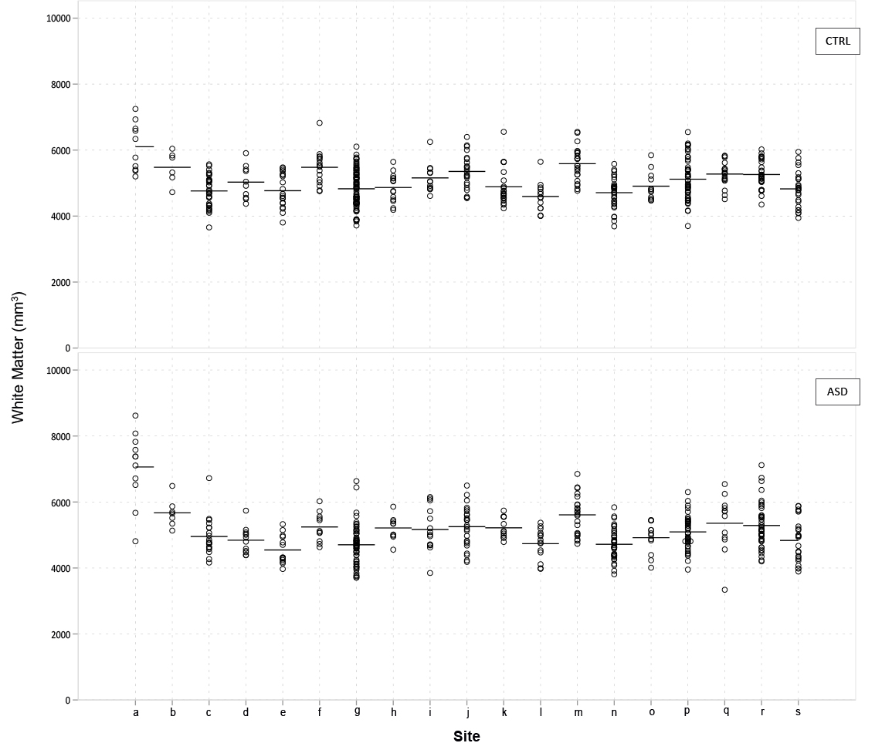
c)
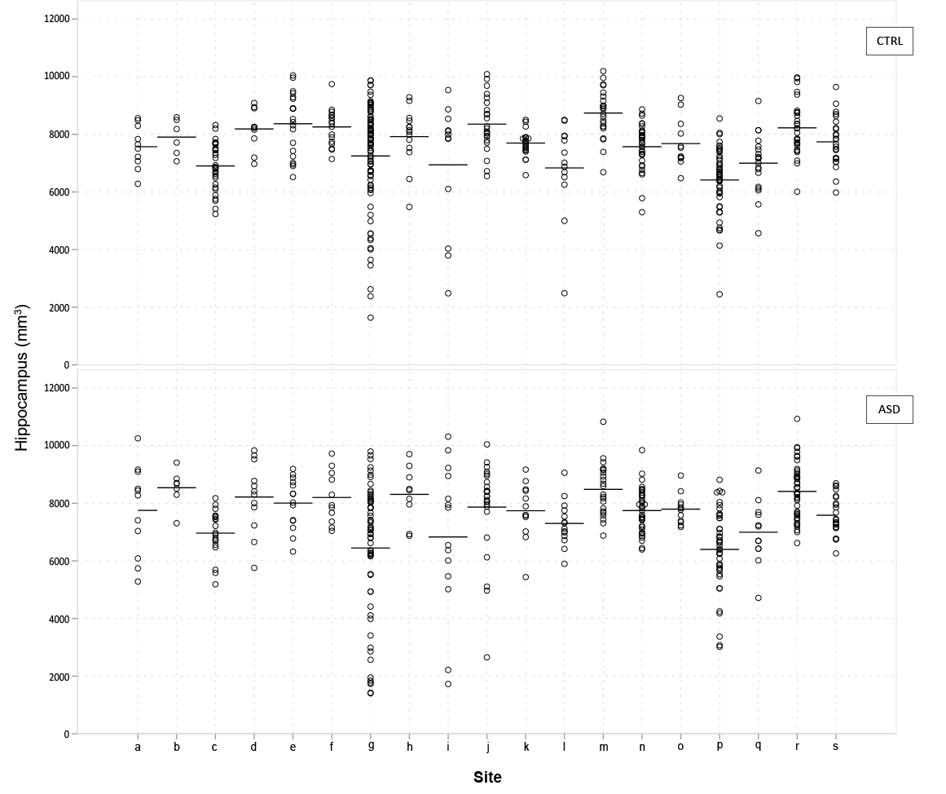
d)
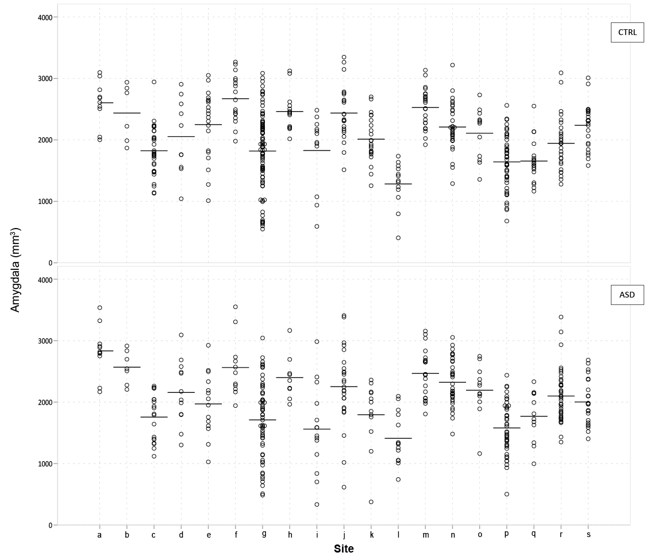
e)
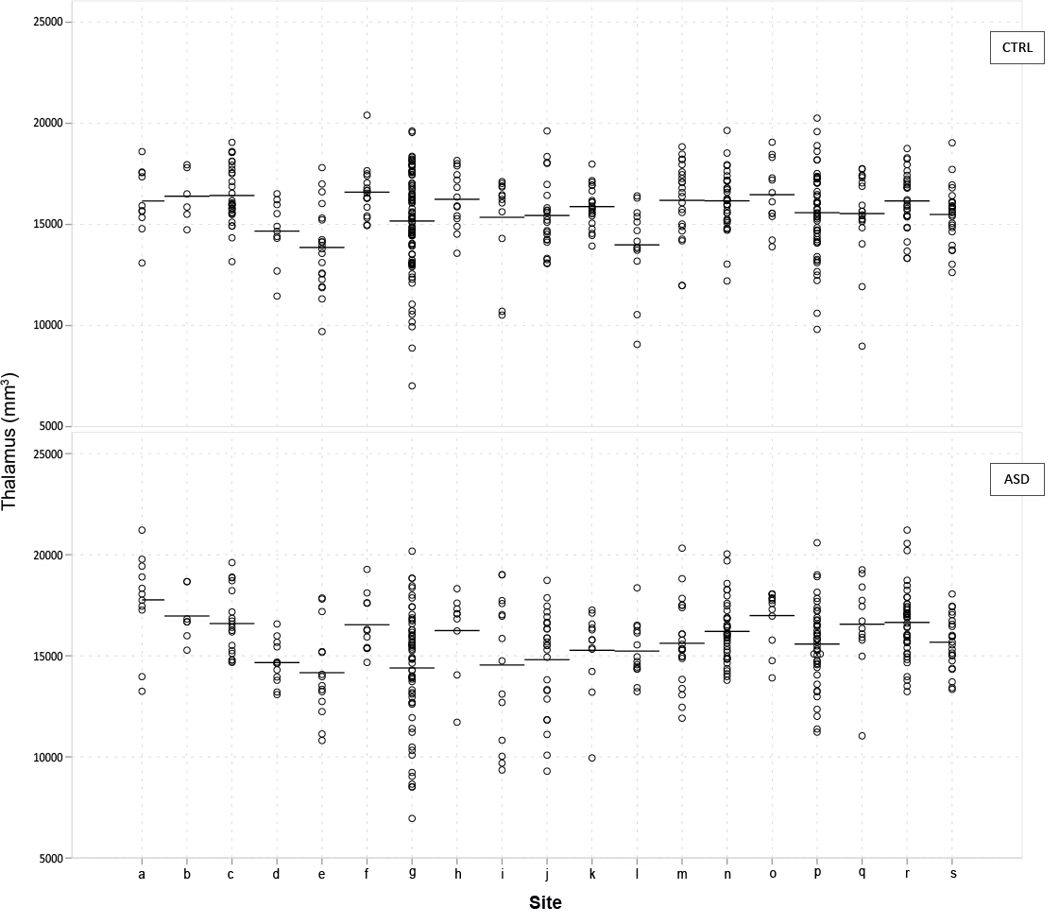
f)
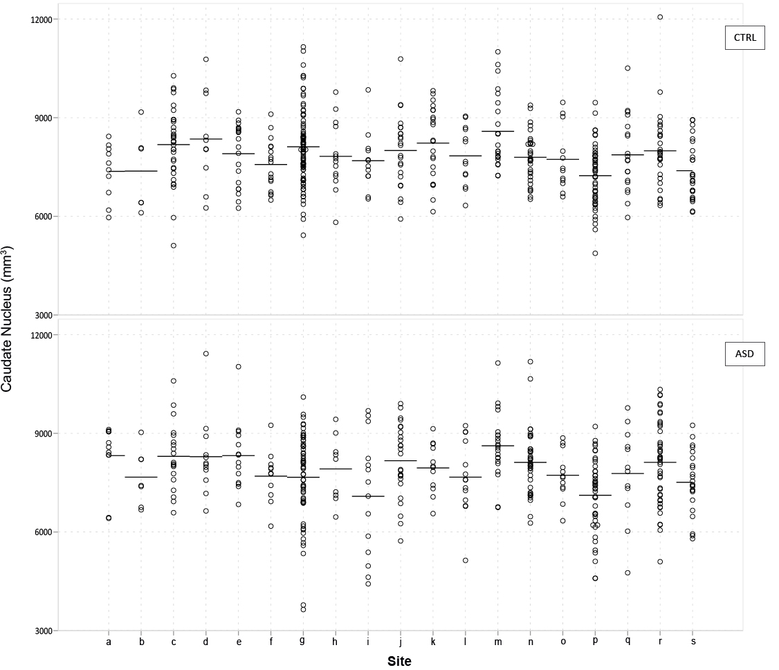

g)

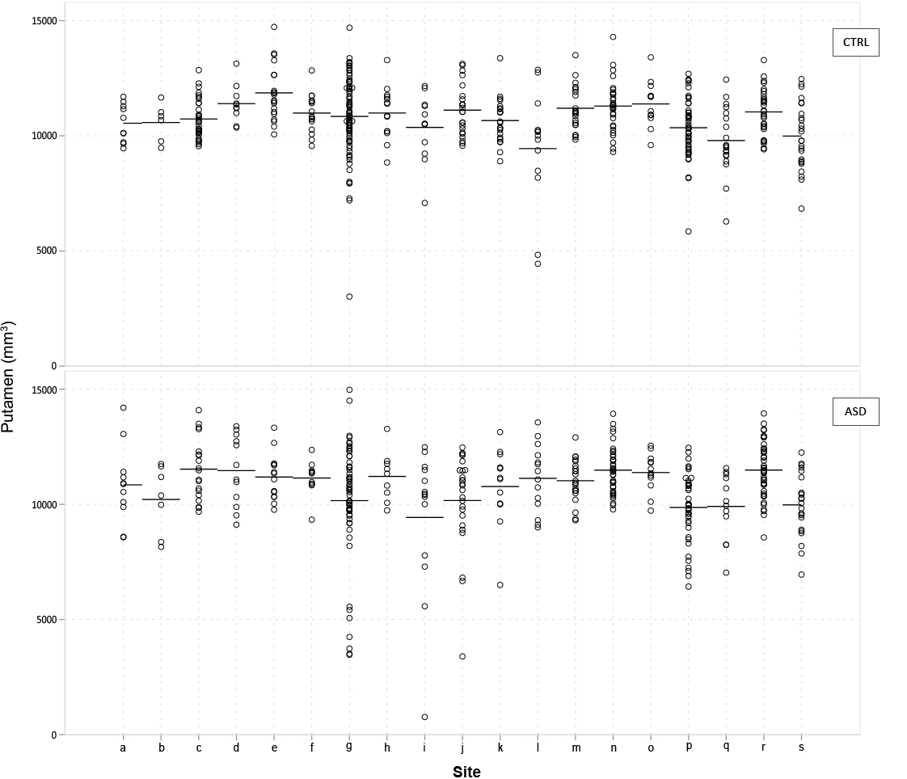

h)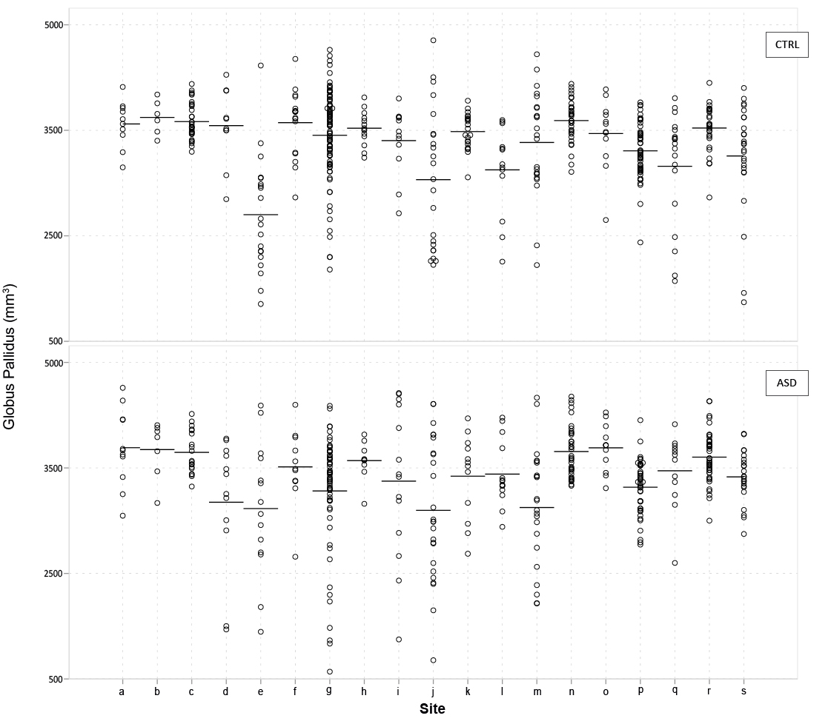

i)
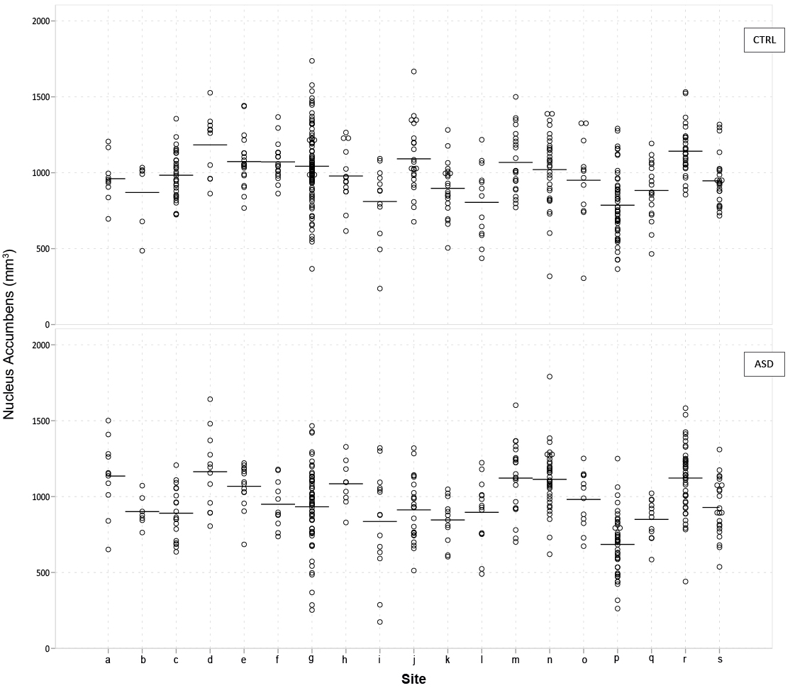

Figure S2. Age of participants with ASD and controls by study site
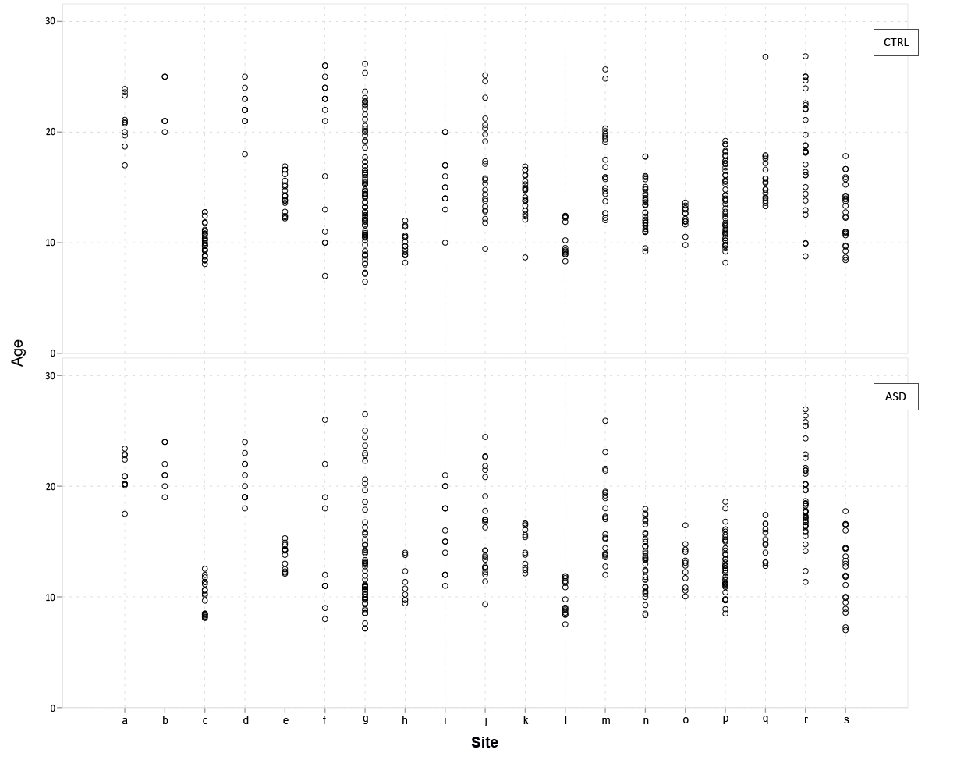
Caption Fig S2. Circles represent age of each individual. See Figure S1 for explanation of study site abbreviations.

Figure S3. Full scale IQ for participants with ASD and controls by study site
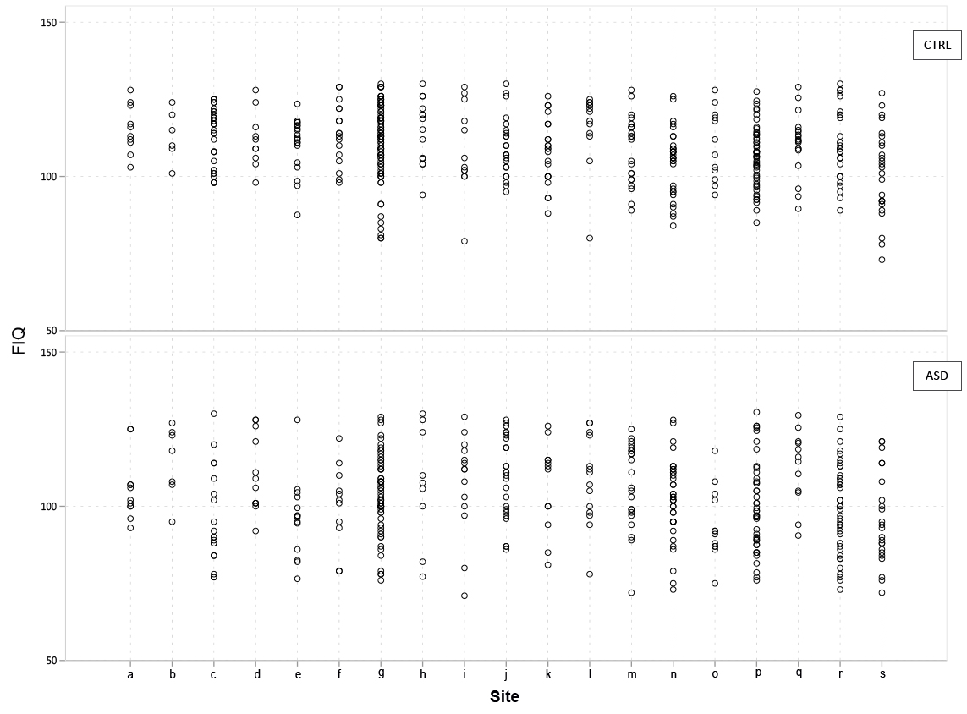Caption Fig S3. Circles represent FIQ scores of each individual. FIQ= full scale IQ. See Figure S1 for explanation of study site abbreviations.

Figure S4. Case number of gender for participants with ASD and controls by study site

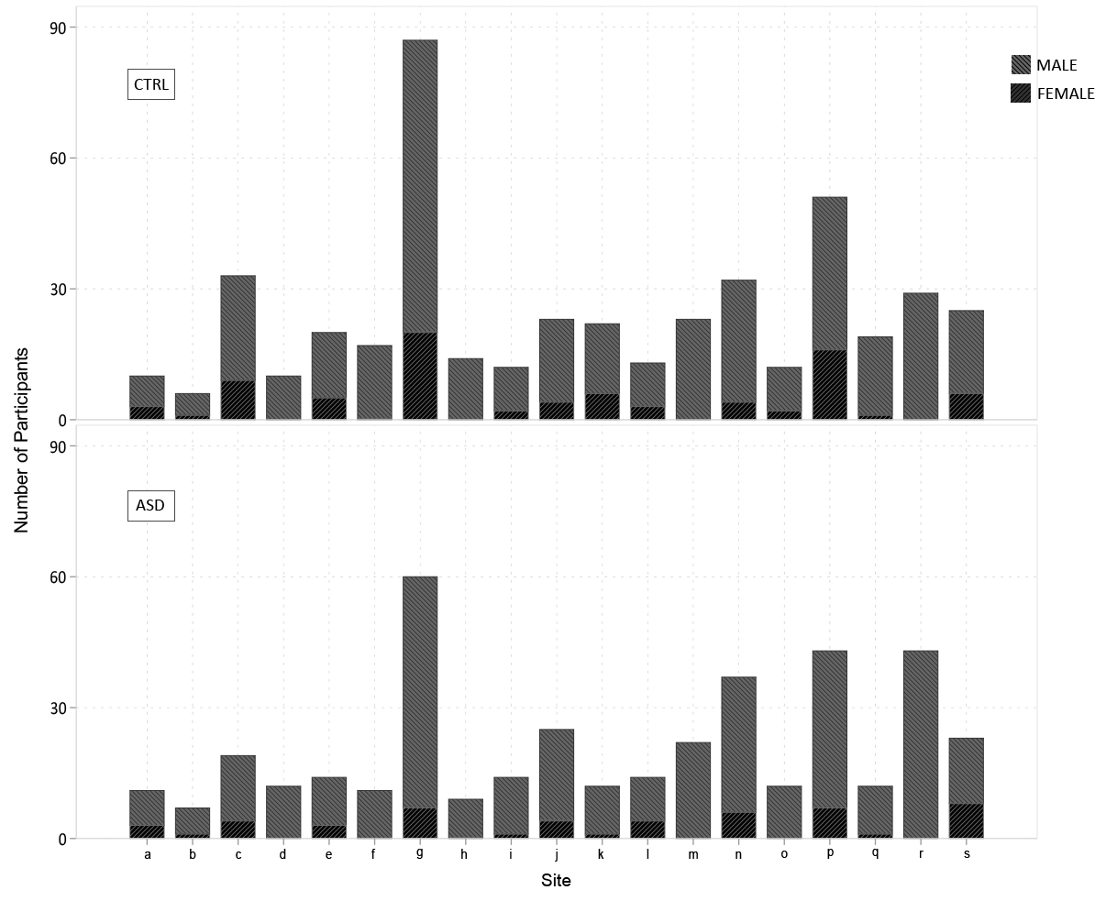Caption Fig S4. See Figure S1 for explanation of study site abbreviations.

Figure S5. Number of participants with ASD and controls by scanning site
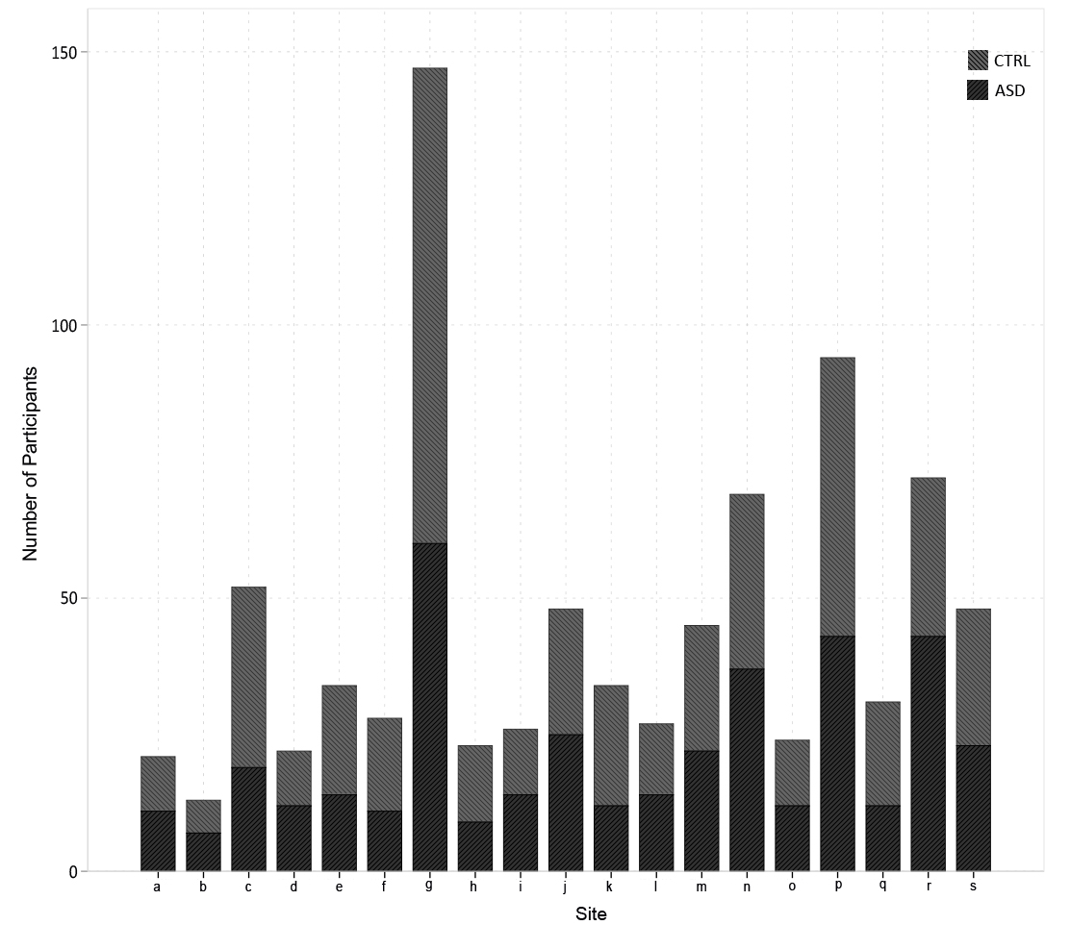Caption Fig S5. See Figure S1 for explanation of scanning site abbreviations.
Figure S6. DSM-IV-TR diagnostic categories by scanning site

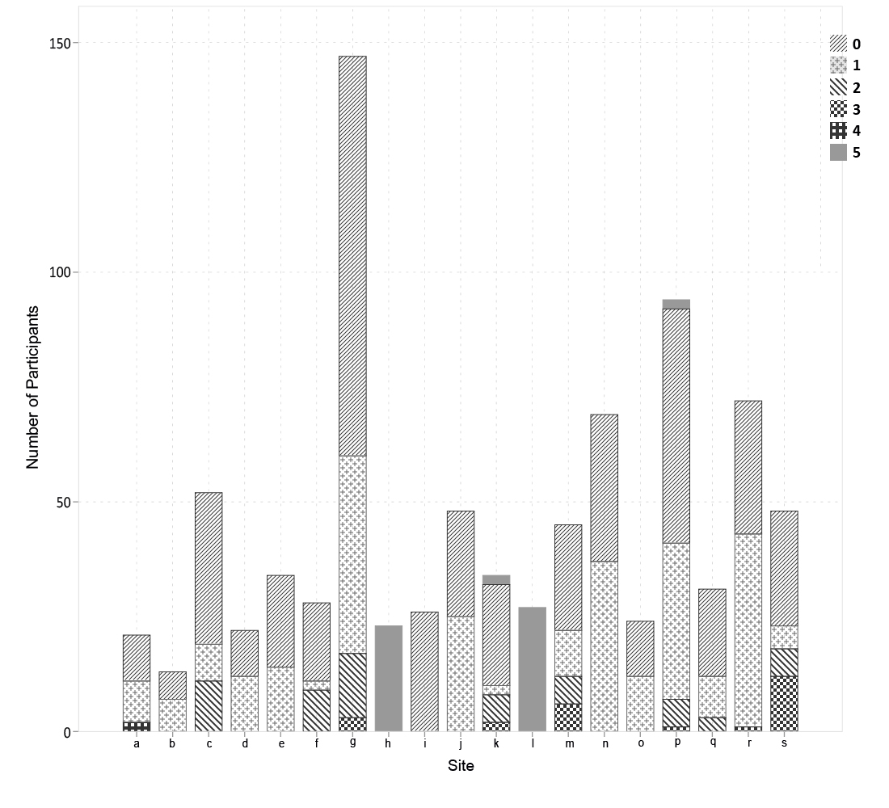
Caption Fig S6. See Figure S1 for explanation of scanning site abbreviations. DSM-IV-TR= fourth and text revised edition of the Diagnostic and Statistical Manual of Mental Disorder; DSM-IV-TR codes: 0 = Control; 1 = Autism; 2 = Aspergers; 3 = PDD-NOS; 4 = Asperger or PDD-NOS 5 = not available.

