Online Supplement 1: Obsessive-compulsive, ADHD, and tic symptom assessment
Obsessive-compulsive symptoms: The OCD assessment component of the TICS includes an obsessive-compulsive symptom (OCS) checklist (80 items) and measures of severity modified from the Yale-Brown Obsessive-Compulsive Scale (Y-BOCS) (Goodman et al 1989a, Goodman et al 1989b), as well as age of onset. Severity of obsessions and compulsions was characterized jointly (e.g., severity of obsessions and/or compulsions) by time, interference, and distress when symptoms were worst. The highest possible sum score of these severity items was 12. OCS symptom checklist items were dichotomized according to lifetime presence or absence. Items were excluded if data were only available for <75% of the sample and if they were vague or not OCD specific (e.g., "has ritualized eating behaviors," "is bothered by certain sounds or noises"); 59 OCS items were included in the final analyses.

ADHD symptoms: ADHD symptom data in the TICS Inventory were collected using modified versions of multiple self-report forms across different waves of data collection, including the Conners’ Parent Rating Scale (Conners 1998), Conners’ Adult ADHD Rating Scales (Conners et al 1999), and the Swanson, Nolan, and Pelham questionnaire (Swanson 1992). For these analyses, symptom questions from each wave of data collection were mapped onto the 18 DSM-IV-TR ADHD symptoms in a dichotomous fashion (i.e., each symptom was rated present or absent). For example, if the item “Has difficulty sustaining attention in tasks or play activities, more so than his or her friends” on the Conners’ Adult ADHD Rating Scales was marked as occurring “often” or “frequently”, the DSM-IV-TR symptom “often has difficulty sustaining attention in tasks or play activities” was marked as present. Age of onset was also assessed. ADHD symptom severity was not examined because these data were not consistently available across waves of data collection.

Tic severity: Tic severity items on the TICS Inventory were modified from the Yale Global Tic Severity Scale (YGTSS) (Leckman et al 1989) and were characterized by frequency, intensity, and interference of symptoms. The highest score resulting from summing the modified severity questions was 15.

References for Supplemental Material
Conners CK (1998). Rating scales in attention-deficit/hyperactivity disorder: Use in assessment and treatment monitoring. The Journal of clinical psychiatry 59 Suppl 7, 24-30
Conners CK, Erhart D, Sparrow E (1999). Conners’ Adult ADHD Rating Scales, Technical Manual. Multi-Health Systems: New York
Goodman WK, Price LH, Rasmussen SA, Mazure C, Delgado P, Heninger GR, Charney DS (1989a). The Yale-Brown Obsessive Compulsive Scale. II. Validity. Archives of General Psychiatry 46, 1012-1016
Goodman WK, Price LH, Rasmussen SA, Mazure C, Fleischmann RL, Hill CL, Heninger GR, Charney DS (1989b). The Yale-Brown Obsessive Compulsive Scale. I. Development, use, and reliability. Archives of General Psychiatry 46, 1006-1011
Leckman JF, Riddle MA, Hardin MT, Ort SI, Swartz KL, Stevenson J, Cohen DJ (1989). The Yale Global Tic Severity Scale: Initial testing of a clinician-rated scale of tic severity. Journal of the American Academy of Child and Adolescent Psychiatry 28, 566-573
Swanson JM (1992). School-Based Assessments and Interventions for ADD Students. KC Publishing: Irvine, CA

Supplemental Table S1. Sample characteristics
 | Probands only  (N=1191) |  |  | Probands & family members (N=3494)
 | N | M | SD | N | M | SD
Age | 1191 | 15.3 | 10.0 | 3494 | 30.6 | 17.2
TS age onset | 1131 | 5.8 | 2.5 | 1692 | 6.1 | 2.7
Tic severity ª | 1181 | 11.4 | 2.6 | 3490 | 4.1 | 4.6
OCD age onset | 442 | 7.1 | 4.0 | 712 | 8.2 | 5.3
OCD severity ^{b} | 694 | 4.3 | 3.4 | 2442 | 3.0 | 3.3
 | N | f | % | N | f | %
Male | 1191 | 944 | 79.3 | 3494 | 2140 | 61.2
TS | 1191 | 1191 | 100 | 3494 | 1841 | 52.7
OCD | 1135 | 570 | 50.2 | 3286 | 1125 | 34.2
ADHD | 1116 | 628 | 56.3 | 3220 | 1013 | 31.5
Mood Disorders | 498 | 132 | 26.5 | 1603 | 487 | 30.4
Anxiety Disorders | 507 | 176 | 34.7 | 1620 | 515 | 31.8
Disruptive Behavior Disorders | 390 | 121 | 31.0 | 662 | 192 | 29.0
ADHD, attention-deficit/hyperactive disorder; CMVTD, chronic motor or vocal tic disorder; f, frequency; M, mean; OCD, obsessive-compulsive disorder; SD, standard deviation; TS, Tourette syndrome
ª Tic severity maximum score = 15; ^{b} OCD severity maximum score = 12

Supplemental Table S2. Fit statistics for OCD exploratory principal components models (59 Items)

Model | Number of free parameters | χ^{2a} | df | RMSEA | 95% CI
Individual models
1-factor | 59 | 5460.10 | 1642 | .04 | .04-.05
2-factor | 117 | 4208.03 | 1594 | .04 | .04-.04
3-factor | 174 | 3346.69 | 1537 | .03 | .03-.03
4-factor | 230 | 2679.33 | 1481 | .03 | .02-.03
5-factor | 285 | 2334.74 | 1426 | .02 | .02-.03
6-factor | 339 | 2049.95 | 1372 | .02 | .02-.02
7-factor | 392 | 1830.62 | 1319 | .02 | .02-.02
8-factor | 444 | 1657.82 | 1267 | .02 | .01-.02
Comparisons between adjacent models
1-factor against 2-factor |  | 901.66 | 58
2-factor against 3-factor |  | 682.47 | 57
3-factor against 4-factor |  | 545.57 | 56
4-factor against 5-factor |  | 334.01 | 55
5-factor against 6-factor |  | 264.31 | 54
6-factor against 7-factor |  | 228.29 | 53
7-factor against 8-factor |  | 185.51 | 52
OCD, obsessive-compulsive symptoms; RMSEA, root mean square error of approximation.
The baseline χ2 (df) model fit for the baseline model was 29982.17 (1711). Only 1- to 8-factor models are presented because models with >8 factors failed to converge on a plausible model.
ª All χ² values are significant at p<.0001.
Supplemental Table S3. Non-loading items in the OCD EFA model

Item | F1 | F2 | F3 | F4 | F5 | F6 | F7 | F8
 | Reassurance/Scrupulosity | Symmetry/Exactness | Contamination | Aggressive urges | Fear of harm | Perfectionism | Superstitions | Hoarding
Feels like needs to know or remember certain things | 0.27 | 0.34 | -0.05 | -0.02 | 0.06 | -0.11 | 0.10 | 0.27
Fears that will harm other because not careful enough | 0.24 | -0.03 | -0.03 | 0.20 | 0.37 | -0.02 | 0.11 | 0.22
Checks (more than once) on things (e.g., gas and electrical appliances, door locks) | 0.32 | 0.30 | 0.08 | -0.14 | 0.08 | 0.04 | 0.20 | 0.07
Is excessively concerned with a part of body or an aspect of appearance | 0.16 | 0.16 | 0.19 | 0.21 | -0.07 | 0.02 | 0.11 | 0.07
Has violent or horrific images in mind | 0.15 | 0.01 | 0.12 | 0.33 | 0.16 | -0.05 | 0.09 | 0.05
Checks that nothing terrible did happen or will happen | 0.37 | -0.06 | 0.27 | 0.15 | 0.04 | 0.30 | 0.07 | 0.03
Fears being responsible for something else terrible happening (such as fire or burglary) | 0.19 | 0.07 | 0.06 | 0.22 | 0.35 | 0.00 | 0.20 | 0.03
Checks that did not or will not harm self | 0.29 | -0.07 | 0.34 | 0.25 | -0.01 | 0.29 | 0.00 | 0.03
Has forbidden or upsetting sexual thoughts, images, or impulses | 0.34 | 0.02 | 0.00 | 0.36 | 0.12 | -0.18 | 0.05 | -0.01
Has compulsions that involve cleaning household items or other inanimate objects | 0.09 | 0.37 | 0.31 | 0.02 | -0.12 | 0.19 | 0.23 | -0.06
Has counting compulsions | 0.20 | 0.15 | -0.10 | 0.28 | -0.12 | 0.20 | 0.35 | -0.07
EFA, exploratory factor analysis; OCD, obsessive compulsive disorder

Supplemental Table S4. Correlations between OCD factors

 | F1 | F2 | F3 | F4 | F5 | F6 | F7 | F8
 | Reassurance/Scrupulosity | Symmetry/Exactness | Contamination | Aggressive urges | Fear of harm | Perfectionism | Superstitions | Hoarding
F1 | 1
F2 | 0.42ª | 1
F3 | 0.43ª | 0.27ª | 1
F4 | 0.45ª | 0.36ª | 0.30ª | 1
F5 | 0.43ª | 0.28ª | 0.28ª | 0.38ª | 1
F6 | -0.08 | -0.05 | -0.01 | -0.08 | -0.14 | 1
F7 | 0.56ª | 0.46ª | 0.41ª | 0.43ª | 0.31ª | -0.15 | 1
F8 | 0.42ª | 0.35ª | 0.30ª | 0.40ª | 0.21ª | 0.02 | 0.42ª | 1

ª Indicates significant correlations P ≤ 0.05

Supplemental Table S5. Fit statistics for ADHD symptoms exploratory principal components models (18 items)

Model | Number of free parameters | χ^{2a} | df | RMSEA | 95% CI
Individual models
1-factor | 18 | 1885.29 | 135 | .10 | .10-.11
2-factor | 35 | 556.77 | 118 | .06 | .05-.06
3-factor | 51 | 289.65 | 102 | .04 | .03-.05
4-factor | 66 | 213.34 | 87 | .04 | .03-.04
Comparisons between adjacent models
1-factor against 2-factor |  | 678.49 | 17
2-factor against 3-factor |  | 194.97 | 16
3-factor against 4-factor |  | 71.06 | 15
RMSEA, root mean square error of approximation
The baseline χ2 (df) model fit for the baseline model was 21156.85 (153).
ª All χ2 values are significant at P<.0001.
Supplemental Table S6. Factor loadings for ADHD symptoms exploratory factor model

 | F1 inattentive | F2 hyperactive/impulsive
Cronbach’s alpha | 0.89 | 0.87
Item
Often does not follow through on instructions and fails to finish schoolwork, chores, or duties in the workplace | 0.89 | 0.06
Often has trouble organizing activities. | 0.89 | 0.00
Is often forgetful in daily activities | 0.88 | -0.02
Often avoids, dislikes, or doesn't want to do things that take a lot of mental effort for a long period of time | 0.82 | -0.01
Often loses things needed for tasks and activities | 0.79 | -0.01
Often does not give close attention to details or makes careless mistakes in schoolwork, work, or other activities. | 0.74 | 0.12
Often has trouble keeping attention on tasks or play activities. | 0.68 | 0.23
Is often easily distracted | 0.61 | 0.34
Often does not seem to listen when spoken to directly. | 0.58 | 0.28
Is often "on the go" or often acts as if "driven by a motor" | -0.16 | 0.91
Often blurts out answers before questions have been finished | -0.02 | 0.90
Often excessively runs about or climbs when and where it is not appropriate | -0.10 | 0.89
Often interrupts or intrudes on others | 0.06 | 0.85
Often fidgets with hands or feet or squirms in seat when sitting still is expected | 0.04 | 0.77
Often gets up from seat when remaining in seat is expected | 0.03 | 0.76
Often talks excessively | 0.00 | 0.74
Often has trouble waiting one's turn | 0.14 | 0.72
Often has trouble playing or doing leisure activities quietly | 0.14 | 0.71

Primary loadings are in bold. The correlation between factors was .61 (P < 0.05).
Supplemental Table S7. Fit statistics and class size for nested, factor sum score-based LCA solutions

 | 1 class | 2 classes | 3 classes
OCD & ADHD factor sum scores, probands and family members
Entropy | – | .929 | .926
LMR p-value | – | <.0001 | <.0001
BIC | 4009.335 | -5469.710 | -8316.519
n of LC1 | 3493 | 2694 | 2421
n of LC2 |  | 799 | 210
n of LC3 |  |  | 862
OCD & ADHD factor sum scores, probands only
Entropy | – | .883 | .893
LMR p-value | – | .0001 | <.0001
BIC | 3748.362 | 1292.116 | 426.382
n of LC1 | 1191 | 309 | 372
n of LC2 |  | 882 | 732
n of LC3 |  |  | 87
BIC, Bayesian information criterion; LMR, Lo, Mendel, and Rubin parametric likelihood ratio test
Bold lettering indicates best fitting solution based on low BIC, significant LMR results, and clinically interpretable classes. Classes greater than 3 failed to converge for both probands and probands with family members; therefore, summary statistics are only presented for up to 3 classes.

Supplemental Figure S1. Scree plots of EFA for OCD and ADHD symptoms (probands only)

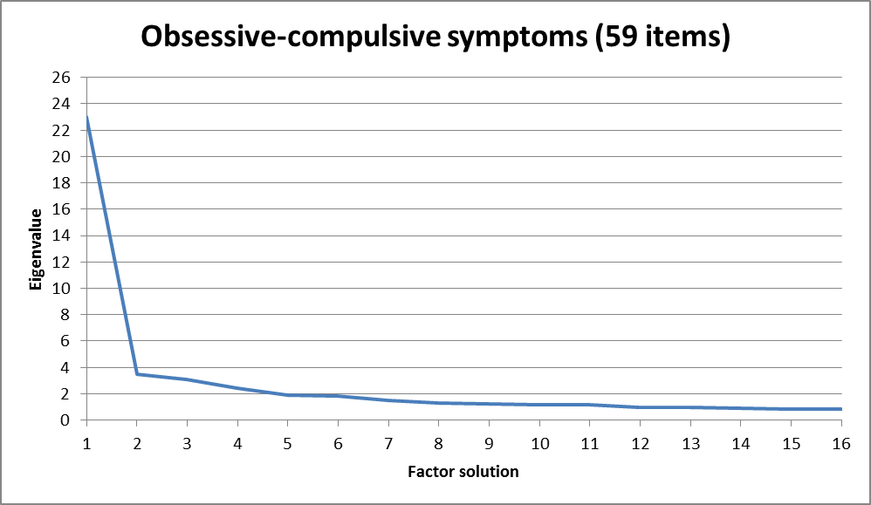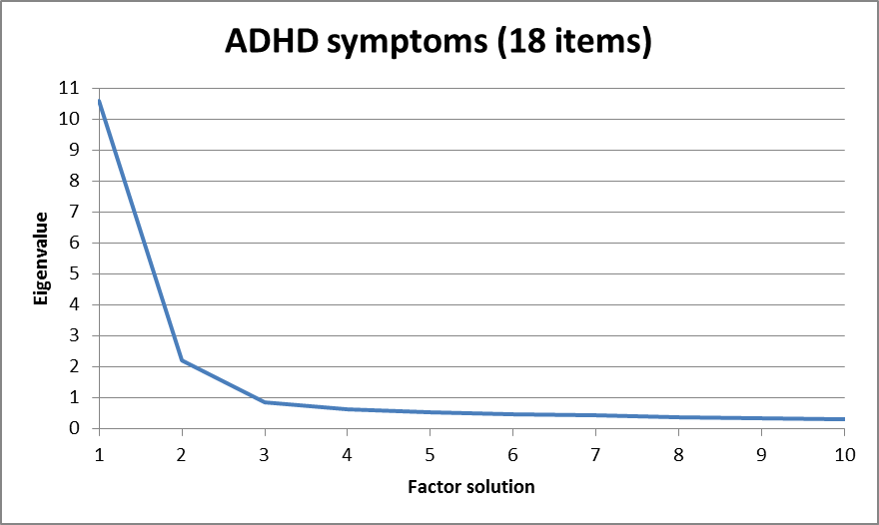

Horizontal axes have been truncated to allow clear visualization of the inflection point (“elbow”) of each scree plot.
Supplemental Figure S2. Probability of endorsement of ADHD and OCD symptom items among nested, factor sum score-based latent classes (proband and family members)

