Supplementary Information
Introduction
Table S1. Summary of Prior Inspiratory Breathing Load Literature
 |  |  | Findings by Condition |  | Additional Findings
Study | Task | Contrast of Interest (Populations/Treatment) | Breathing Load Anticipation | Breathing Load
Cross-sectional
Haase et al., 2016 | Breathing Load Task | adults low in resilience > high in resilience | ↑parahippocampal gyrus, ↑ caudate | ↑MPFC | low resilience > high resilience (main effect of group) in insula
Berk et al., 2015 | Breathing Load Task | adolescent alcohol and marijuana substance users > controls | ↓insula | ↑insula, ↑MPFC, ↑IFG
Paulus et al., 2012 | Breathing Load Task | controls > elite athletes | ↓insula | ↑insula
Stewart et al., 2015 | Breathing Load Task | stimulant users > remitted stimulant users > controls | ↓insula | ↓insula, ↓IFG
Stewart et al., 2014 | Decision-making Reward/Punishment Task + Breathing Load Task Combination | stimulant users > controls | N/A | ↓insula, ↓ACC
Stewart et al., 2013 | Decision-making Reward/Punishment Task + Breathing Load Task Combination | young adult stimulant users > remitted stimulant users > controls | N/A | ↓RMFG, ↓sgACC, ↓putamen, ↓IFG
Treatment Outcome
Haase et al., 2014 | Breathing Load Task | pre-mindfulness > post-mindfulness (healthy military population) | N/A | ↑insula, ↑ACC
Haase et al., 2015 | Breathing Load Task | pre-mindfulness > post-mindfulness (elite athlete population) | ↓insula, ↓ACC | N/A
MPFC, medial prefrontal cortex; RIFG, right inferior frontal gyrus; ACC, anterior cingulate cortex; sgACC, subgenual anterior cingulate cortex

Results summarized in Table S1 informed hypotheses for this study. The majority of prior studies using an identical breathing load task to the one used in the current study suggest that less healthy or resilient individuals (i.e., individuals low in self-reported resilience, substance users, and individuals assessed before a mindfulness intervention) relative to healthy or more resilient individuals (i.e., individuals high in resilience, healthy controls, elite athletes, or individuals assessed after a mindfulness intervention) tend to show reduced activation during breathing load anticipation and increased activation during breathing load (Berk et al. 2015; Haase et al. 2015; Haase et al. 2016; Haase et al. 2014; Paulus et al. 2012). In contrast, Stewart and colleagues have reliably found across three studies (Stewart et al. 2013; Stewart et al. 2015; Stewart et al. 2014) that stimulant users compared with controls show reduced activation during both anticipation and processing of aversive breathing load. Of note, data from two out of three of these studies were acquired from a version of the breathing load task that combines an uncertain monetary reward or loss decision-making paradigm with intermittent breathing loads, and therefore may not be comparable to data from the breathing load task alone.

Materials and Methods
Participants
Participants remitted from anorexia nervosa (RAN) maintained more than 85% ideal body weight, regular menstrual cycles, and had no eating disorder behaviors for the 12 months before participation. To confirm eating disorder history, trained masters-level or higher research staff administered a modified version of the Structured Clinical Interview for DSM-IV-TR (SCID-I) Module H (First et al. 2002) that uses language from the Eating Disorder Examination (Fairburn et al. 2008) to comprehensively assess eating disorder behaviors (binge eating, compensatory behaviors). Duration of illness and lowest post-pubertal body mass index were both obtained as part of this history. Current and past psychiatric diagnoses were assessed using the Mini International Neuropsychiatric Interview (Sheehan et al. 1998). Control women (CW) reported regular menstrual cycles since menarche.
All participants were right-handed. Women with any alcohol or substance dependence diagnosis in the past 3 months, lifetime bipolar or psychotic disorder, lifetime attention deficit hyperactivity disorder, use of psychotropic medication in the 3 months prior to participation, or any reported medical or neurologic concerns or conditions contraindicative to MRI were excluded.
Breathing Load Paradigm
Before scanning, to confirm that participants could tolerate the paradigm, participants were provided with task instructions and completed four, 1-minute breathing load trials (no load, 10, 20, and 40 cm H20/L/sec inspiratory breathing loads).
Accuracy and reaction time on the continuous performance task were examined as indices of the extent to which breathing load altered sustained attention. This button-pressing task was also included to ensure participants paid attention to the anticipatory cues.
Cardiac and respiratory data were acquired using a fingertip pulse oximeter and a pneumatic belt around the upper abdomen, respectively. Cardiac data were sampled every 100 Hz and respiratory data were sampled at 25 Hz. Breathing rate was calculated as the time between inspiratory peaks, and breathing rate standard deviation within each task condition was used to estimate breathing rate variability within groups.

Clinical Symptoms and State Measures
To corroborate clinical interview information and further confirm remitted eating disorder status, residual eating disorder symptoms were measured using The Eating Disorder Inventory-2 (Garner 1991). The Beck Depression Inventory (BDI-II; Beck et al. 1996) measured depressive symptoms. Temperament and Character Inventory (TCI) Harm Avoidance subscale scores (TCI-HA; Cloninger et al. 1994), and the Spielberger State-Trait Anxiety Inventory scores (STAI; Spielberger et al. 1970), which measure anxious temperament and trait anxiety, respectively, were available for a subset of participants (TCI-HA: n_{CW} = 23 n_{RAN} = 13; STAI-T: n_{CW} = 19, n_{RAN} = 15).
Image Acquisition
T2*-weighted echo-planar images were acquired on a 3T General Electric Discovery MR 750 (Milwaukee, WI) using the following parameters: 252 volumes, TR = 2 s, TE = 30 ms, flip angle= 90°, FOV 24 cm, 64 × 64 matrix, 3.75 × 3.75 mm in-plane resolution, 40 3.0 mm ascending interleaved axial slices) using an 8-channel brain array coil. High-resolution T1-weighted FSPGR anatomical images were acquired using the following parameters: MR 750: flip angle = 8°, 256 × 256 matrix, 172 1 mm sagittal slices, TR = 8.1 s, TE = 3.17 ms, 1 × 1mm in-plane resolution.
MRI preprocessing
Structural and functional image processing and analysis was completed using the Analysis of Functional Neuroimages (AFNI) software package (Cox 1996), FSL, and R statistical packages. Echo planar images were slice-time and motion-corrected and aligned to high-resolution anatomic images using align_epi_anat.py in AFNI. Volumes with >10% voxels marked as outliers using 3dToutcount were censored. On average, 5.72% of all volumes were censored. Registration of skull-stripped T1-weighted images to the Montreal Neurological Institute 152 atlas was performed using FNIRT (http://fsl.fmrib.ox.ac.uk/fsl/; FMRIB Analysis Group, University of Oxford, Oxford, United Kingdom). Functional data were aligned to standard space, resampled to 3 mm isotropic voxels, and smoothed with a Gaussian spatial filter (blurred to 6 mm full width at half maximum).
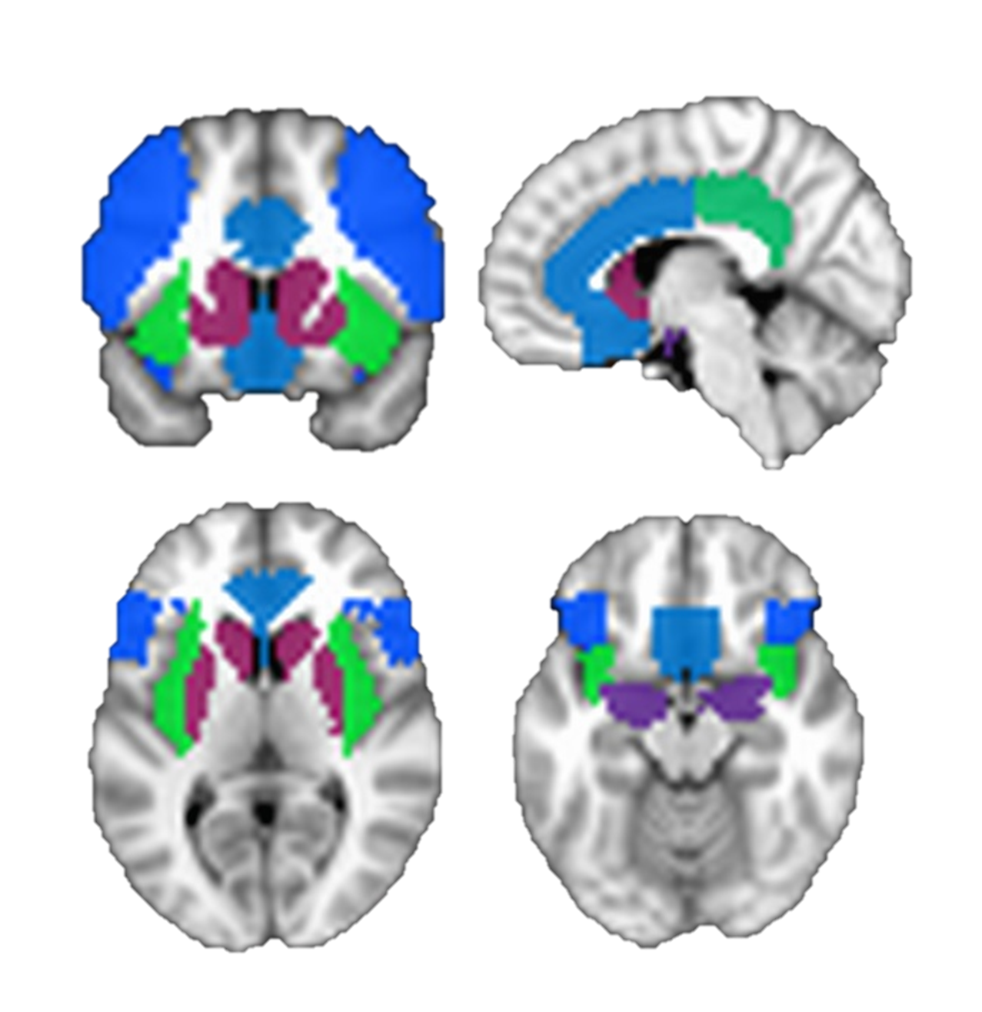
Figure S1. Aversive Interoceptive Network Search Regions of Interest. A priori search regions of interest included bilateral ventrolateral and dorsolateral prefrontal cortices (royal blue), bilateral insula (neon green), bilateral striatum (maroon), bilateral anterior and mid-cingulate (blue), bilateral posterior cingulate (kelly green), and bilateral amygdala (violet).
Statistical Analyses
Within-condition Analyses. Three task conditions (anticipation, breathing load, and post-breathing load) and six motion regressors of no interest were convolved with a modified hemodynamic response function using AFNI’s 3dDeconvolve. Beta weights for the three conditions of interest were converted to percent signal change.
Across-condition Time Course Analyses. Secondary analyses examined group differences in the time course of BOLD responses over the entire course of breathing load periods (from anticipation to breathing load to post-breathing load), modeled with AFNI’s 3dDeconvolve TENT function. We derived the beta value of each voxel across the time series from 3 TRs (6 s) before the onset of each breathing load trial (i.e., the anticipation condition) to 27 TRs (54 s) after the onset of each 20-TR breathing load trial.
Past Comorbidities and AN Subtype. To examine the potential impact of a past diagnosis of MDD, an anxiety disorder, and AN subtype on our results, we compared RAN participants with and without these historical comorbidities on mean activation in clusters identified in our between-group t-tests.
Exploratory Group x Condition Voxelwise Analysis. We conducted an exploratory LME analysis to test whether the fixed effect of group (RAN, CW) interacted with condition (anticipation, breathing load, post-breathing load) to predict percent signal change values in our a priori search regions of interest. AFNI’s 3dClustSim was used to set the whole brain volume threshold of 4 contiguous voxels for a per voxel p < 0.0001 threshold and a corrected cluster-wise p < 0.0001.

Results
Participants
Table S2. Participant Demographics and Characteristics
 | CW  (n = 25)  Mean (SD) | RAN  (n = 17)  Mean (SD) | T or Χ² | p
Characteristics
Age | 26.2 (7.7) | 26.8 (4.5) | 0.32 | 0.750
Current BMI | 22.0 (1.6) | 21.6 (2.3) | 0.58 | 0.568
Education (years) | 15.3 (1.3) | 15.9 (2.1) | 1.06 | 0.294
Lifetime Diagnoses
MDD (%) | 0 | 64.7 | 21.92 | < 0.001
GAD (%) | 0 | 11.8 | 3.09 | 0.079
Any anxiety disorder (%) | 8.0 | 35.3 | 4.89 | 0.027
Substance use disorder (%) | 0 | 5.9 | 1.51 | 0.220
Self-Report Scores
Beck Depression Inventory-II | 0.4 (0.7) | 1.8 (1.4) | 3.74 | 0.001
STAI-Trait | 23.5 (3.0) | 27.3 (4.5) | 2.91 | 0.007
TCI Harm Avoidance | 7.2 (4.4) | 13.1 (6.2) | 3.30 | 0.002
RAN, women remitted from anorexia nervosa; CW, healthy control women; BMI, body mass index; MDD, major depressive disorder; GAD, generalized anxiety disorder; STAI, Spielberger State-Trait Inventory; TCI, Temperament and Character Inventory

Task Performance and VAS Ratings
Because of technical difficulties, continuous performance task data for one RAN participant and two CW participants were not collected. Across both groups, there was a main effect of condition on reaction time, such that both groups responded faster during breathing load compared to anticipation and compared to post-breathing load. Both groups responded more slowly post-breathing load than during anticipation (Table S3).

Table S3. Behavioral Performance and VAS Ratings
Continuous Performance Task
Accuracy (%) |  | F |  | p
Condition |  | 0.22 |  | 0.642
Group |  | 2.97 |  | 0.093
Group x Condition |  | 0.47 |  | 0.625
Reaction Time |  | F |  | p
Condition |  | 34.49 |  | < 0.001
Group |  | 0.20 |  | 0.655
Group x Condition |  | 0.67 |  | 0.516
Reaction Time Condition Post-hocs (LSD) |  |  |  |  |  |  |  | Mean Difference |  |  | SE |  | p
Anticipation > Load |  |  |  |  |  |  |  | 67.5 |  |  | 13.4 |  | < 0.001
Post-Breathing Load > Load |  |  |  |  |  |  |  | 130.1 |  |  | 19.5 |  | < 0.001
Post-Breathing Load > Anticipation |  |  |  |  |  |  |  | 62.7 |  |  | 13.5 |  | < 0.001
VAS Ratings
VAS Item | F |  | p
Pleasant
Group | 0.027 |  | 0.870
Time | 3.159 |  | 0.083
Group x Time | 1.001 |  | 0.323
Unpleasant
Group | 0.381 |  | 0.541
Time | 2.991 |  | 0.092
Group x Time | 0.180 |  | 0.674
Intense
Group | 1.359 |  | 0.251
Time | 1.359 |  | 0.251
Group x Time | 0.351 |  | 0.557
 |  | CW  (n = 24ª)  Mean (SD) |  |  |  | RAN  (n = 17)  Mean (SD) |  |  |  | t or U |  | p
Pre-Scan
Pleasant |  | 7.4 (10.6) |  |  |  | 8.5 (11.5) |  |  |  | 0.339 |  | 0.737
Unpleasant |  | 52.4 (20.4) |  |  |  | 55.5 (24.0) |  |  |  | 0.454 |  | 0.652
Intense |  | 30.2 (29.2) |  |  |  | 45.1 (30.2) |  |  |  | 1.604 |  | 0.117
Post-Scan
Pleasant |  | 11.9 (18.0) |  |  |  | 9.7 (10.5) |  |  |  | 0.445 |  | 0.659
Unpleasant |  | 55.4 (26.2) |  |  |  | 60.8 (23.1) |  |  |  | 0.683 |  | 0.499
Intense |  | 37.4 (35.1) |  |  |  | 46.8 (28.4) |  |  |  | 0.904 |  | 0.372
Faintness |  | 7.7 (13.9) |  |  |  | 13.9 (28.0) |  |  |  | 144.0 |  | 0.132^{b}
Choking |  | 3.2 (7.3) |  |  |  | 9.5 (17.1) |  |  |  | 128.0 |  | 0.024^{b}
Heart Palpitations |  | 3.9 (8.4) |  |  |  | 12.8 (26.9) |  |  |  | 156.5 |  | 0.160^{b}
Chest Pain |  | 3.0 (6.3) |  |  |  | 20.2 (4.9) |  |  |  | 155.5 |  | 0.151^{b}
Abdominal Distress |  | 2.0 (4.6) |  |  |  | 1.8 (3.0) |  |  |  | 181.5 |  | 0.471^{b}
ªOne CW participant did not complete post-scan VAS ratings.
^{b}Due to significant violations of the normality assumption, independent samples Mann-Whitney U tests were used for between-group comparisons.

Group Differences in Heart Rate and Respiration
Usable heart rate and respiratory data were not acquired for all participants because of hardware malfunction. A total of 13 RAN and 15 CW participants had complete respiratory data across both runs of the task, and 9 RAN and 8 CW participants had complete heart rate data across both runs of the task.
Results of preliminary analyses of available cardiac data confirmed that there was no group (CW, RAN) x condition (anticipation, breathing load, post-load) interaction (p = 0.149) nor were there main effects of group (p = 0.462) or condition (p = 0.957) on heart rate. In addition, there was no group x condition interaction (p = 0.151), nor were there main effects of group (p = 0.934) or condition (p = 0.132) on heart rate variability.
There was a quadratic main effect of condition across both groups on breathing rate (p < 0.001) and breathing rate variability (p < 0.001) such that both groups increased their breathing rate and breathing variability from anticipation to breathing load and both groups slightly decreased their breathing rate and variability after breathing load. However, there were no group x condition interactions on breathing rate or breathing rate variability (p = 0.995 and p = 0.460, respectively) or main effects of group on breathing rate (p = 0.305) or variability (p = 0.489).
Results of analyses including participants who had at least one run of respiratory data (RAN n = 15, CW n = 23) were unchanged, as were results of analyses including participants who had at least one run of cardiac data (RAN n = 11, CW n = 15).
Although limited by missing data, findings from these analyses of available physiological data suggest that our imaging results are not better accounted for by differences in heart rate or breathing speed or style in response to the aversive paradigm.

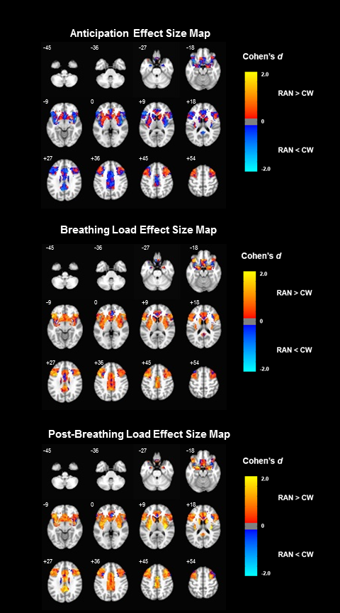
Figure S2. Effect Size Maps for Within-condition Group Differences in Peak Activation (Cohen’s d). Effect sizes (ranging from -2.0 to 2.0) for between-group differences masked to our six search regions of interest are shown for each condition. RAN > CW activation is shown in warm colors, CW > RAN activation is shown in cool colors. RAN, women remitted from anorexia nervosa; CW, healthy control women. Coordinates are presented in LPI format.

Table S4. Exploratory Whole-Brain Voxelwise Group x Condition Mixed Effects Analysis
 |  |  |  | Center of Mass MNI Coordinates |  |  |  | Post-hoc Pairwise Comparisons
Hem | Region | BA | voxels | x | y | z | F | Between-group, within-condition | Within-group, between-condition
R | Cingulate Gyrus | 24 | 246 | 3 | -1 | 49 | 12.862 | Post-Load: RAN>CW | RAN: Post-Load>Load and Anticipation
R | Precentral Gyrus | 4 | 172 | 31 | -27 | 55 | 12.409 | Post-Load: RAN>CW | RAN: Post-Load>Load and Anticipation
L | Precentral Gyrus | 4 | 107 | -17 | -33 | 60 | 13.092 | Post-Load: RAN>CW | RAN: Post-Load>Load and Anticipation
R | Thalamus |  | 105 | 13 | -20 | 8 | 12.845 | Post-Load: RAN>CW | RAN: Post-Load>Load and Anticipation
L | Thalamus |  | 105 | -10 | -21 | 8 | 13.434 | Post-Load: RAN>CW | RAN: Post-Load>Load and Anticipation; CW: Post-Load>Anticipation
R | Cerebellum |  | 82 | 2 | -48 | -17 | 12.399 | Post-Load: RAN>CW | RAN: Post-Load>Load and Anticipation
R | Posterior Insula | 13 | 59 | 34 | -20 | 14 | 13.863 | Post-Load: RAN>CW | RAN: Post-Load>Load and Anticipation
R | Cuneus | 30 | 38 | 1 | -75 | 7 | 11.829 | Post-Load: RAN>CW | RAN: Post-Load>Load and Anticipation
R | Precuneus | 31 | 36 | 11 | -34 | 48 | 12.379 | Post-Load: RAN>CW | RAN: Post-Load>Load and Anticipation
L | Lingual Gyrus | 19 | 34 | -18 | -68 | -7 | 12.463 | Post-Load: RAN>CW | RAN: Post-Load>Load and Anticipation
L | Transverse Temporal Gyrus | 41 | 29 | -37 | -28 | 13 | 11.985 | Post-Load: RAN>CW | RAN: Post-Load>Load and Anticipation
L | Postcentral Gyrus | 40 | 28 | -53 | -23 | 15 | 13.146 | Post-Load: RAN>CW | RAN: Post-Load>Load and Anticipation
L | Postcentral Gyrus | 4 | 28 | -50 | -17 | 43 | 12.787 | Post-Load: RAN>CW | RAN: Post-Load> Anticipation
L | Caudate |  | 26 | -19 | 10 | 15 | 12.871 | Post-Load: RAN>CW | RAN: Post-Load>Load and Anticipation
R | Precentral Gyrus | 6 | 26 | 30 | -8 | 52 | 12.842 | Post-Load: RAN>CW | RAN: Post-Load>Load and Anticipation
R | Posterior Cingulate | 30 | 22 | 19 | -58 | 10 | 13.128 | Post-Load: RAN>CW | RAN: Post-Load>Load and Anticipation
L | Middle Temporal Gyrus | 21 | 21 | -65 | -50 | -1 | 13.496 | Post-Load: RAN>CW | RAN: Post-Load>Load and Anticipation
R | Cingulate Gyrus | 23 | 21 | 6 | -47 | 26 | 12.044 | Post-Load: RAN>CW | RAN: Post-Load>Load and Anticipation
R | Posterior Insula | 13 | 19 | 50 | -25 | 19 | 12.823 | Post-Load: RAN>CW | RAN: Post-Load>Load and Anticipation
R | Lingual Gyrus | 19 | 18 | 24 | -72 | -9 | 11.182 | Post-Load: RAN>CW | RAN: Post-Load>Load and Anticipation
R | Middle Temporal Gyrus | 21 | 16 | 58 | -58 | 3 | 12.679 | Post-Load: RAN>CW | RAN: Post-Load>Load and Anticipation
L | Anterior Cingulate | 32 | 16 | -10 | 34 | 26 | 12.692 | Post-Load: RAN>CW | RAN: Post-Load> Anticipation
R | Superior Frontal Gyrus | 6 | 16 | 9 | 9 | 56 | 12.708 |  | RAN: Post-Load>Load and Anticipation
R | Inferior Temporal Gyrus | 37 | 14 | 50 | -70 | -5 | 12.321 | Post-Load: RAN>CW | RAN: Post-Load>Load and Anticipation
L | Paracentral Lobule | 6 | 13 | 0 | -33 | 64 | 11.379 | Post-Load: RAN>CW | RAN: Post-Load> Anticipation
L | Posterior Cingulate | 30 | 12 | -21 | -56 | 6 | 13.047 | Post-Load: RAN>CW | RAN: Post-Load>Load and Anticipation
R | Superior Frontal Gyrus | 10 | 12 | 25 | 48 | 21 | 12.636 | Post-Load: RAN>CW | RAN: Post-Load>Load and Anticipation
L | Precentral Gyrus | 6 | 12 | -40 | -10 | 52 | 12.808 | Post-Load: RAN>CW | RAN: Post-Load>Load and Anticipation
L | Cerebellum | 19 | 11 | -1 | -60 | -6 | 12.652 | Post-Load: RAN>CW | RAN: Post-Load>Load and Anticipation
L | Superior Occipital Gyrus | 19 | 11 | -35 | -81 | 24 | 11.706 | Post-Load: RAN>CW | RAN: Post-Load>Load and Anticipation
L | Superior Frontal Gyrus | 8 | 11 | -17 | 40 | 44 | 13.164 | Post-Load: RAN>CW | RAN: Post-Load> Anticipation
L | Fusiform Gyrus | 37 | 10 | -33 | -56 | -14 | 14.069 | Post-Load: RAN>CW | RAN: Post-Load>Load and Anticipation
R | Medial Frontal Gyrus | 10 | 10 | 6 | 51 | 13 | 11.961 | Post-Load: RAN>CW | RAN: Post-Load>Load and Anticipation
R | Middle Frontal Gyrus | 10 | 10 | 41 | 41 | 19 | 11.250 | Post-Load: RAN>CW | RAN: Post-Load>Load and Anticipation
R | Cingulate Gyrus | 23 | 10 | 5 | -27 | 31 | 12.630 | Post-Load: RAN>CW | RAN: Post-Load>Load and Anticipation; CW: Post-Load>Anticipation
R | Postcentral Gyrus | 3 | 10 | 46 | -22 | 59 | 14.057 | Post-Load: RAN>CW | RAN: Post-Load>Load and Anticipation
L | Precuneus | 31 | 9 | -18 | -72 | 20 | 13.220 | Post-Load: RAN>CW | RAN: Post-Load>Load and Anticipation
L | Lingual Gyrus | 18 | 8 | -26 | -79 | -9 | 13.184 | Post-Load: RAN>CW | RAN: Post-Load>Load and Anticipation
R | Mid-Insula | 13 | 8 | 41 | -4 | -9 | 11.622 |  | RAN: Post-Load>Load and Anticipation; CW: Post-Load>Anticipation
L | Middle Temporal Gyrus | 19 | 8 | -40 | -72 | 7 | 11.980 | Post-Load: RAN>CW | RAN: Post-Load>Load and Anticipation
L | Cuneus | 19 | 8 | -11 | -87 | 35 | 12.380 | Post-Load: RAN>CW | RAN: Post-Load> Anticipation
L | Middle Frontal Gyrus | 8 | 8 | -31 | 36 | 44 | 12.674 | Post-Load: RAN>CW | RAN: Post-Load> Anticipation
L | Postcentral Gyrus | 40 | 8 | -33 | -39 | 56 | 12.735 | Post-Load: RAN>CW | RAN: Post-Load>Load and Anticipation
L | Cerebellum | 20 | 7 | -24 | -39 | -24 | 11.523 |  | RAN: Post-Load>Load and Anticipation
R | Inferior Frontal Gyrus | 46 | 7 | 48 | 46 | 0 | 12.333 | Post-Load: RAN>CW | RAN: Post-Load>Load and Anticipation
L | Cuneus | 17 | 7 | -7 | -89 | 6 | 10.876 | Post-Load: RAN>CW | RAN: Post-Load>Load and Anticipation
R | Cuneus | 18 | 7 | 21 | -87 | 20 | 12.920 | Post-Load: RAN>CW | RAN: Post-Load>Load and Anticipation
L | Inferior Parietal Cortex | 40 | 7 | -58 | -36 | 25 | 11.219 | Post-Load: RAN>CW | RAN: Post-Load>Load and Anticipation
L | Precentral Gyrus | 6 | 7 | -33 | -13 | 65 | 12.692 | Post-Load: RAN>CW | RAN: Post-Load>Load and Anticipation
L | Cerebellum |  | 6 | -1 | -59 | -25 | 12.264 | Post-Load: RAN>CW | RAN: Post-Load>Load and Anticipation
R | Parahippocampal Gyrus | 28 | 6 | 31 | -17 | -18 | 11.536 | Post-Load: RAN>CW | RAN: Post-Load>Load and Anticipation
L | Parahippocampal Gyrus | 27 | 6 | -27 | -31 | -10 | 11.423 |  | RAN: Post-Load>Load and Anticipation
R | Cuneus | 18 | 6 | 6 | -89 | 13 | 12.873 | Post-Load: RAN>CW | RAN: Post-Load> Anticipation
R | Claustrum | 13 | 6 | 31 | -6 | 13 | 11.641 | Post-Load: RAN>CW | RAN: Post-Load>Load and Anticipation; CW: Post-Load>Anticipation
L | Middle Frontal Gyrus | 6 | 6 | -25 | -7 | 52 | 11.386 | Post-Load: RAN>CW | RAN: Post-Load>Load and Anticipation
L | Superior Frontal Gyrus | 6 | 6 | -20 | 6 | 59 | 11.892 | Post-Load: RAN>CW | RAN: Post-Load>Load and Anticipation
R | Paracentral Gyrus | 5 | 6 | 6 | -47 | 60 | 12.159 | Post-Load: RAN>CW | RAN: Post-Load>Load and Anticipation
Coordinates are presented in LPI format. RAN, women remitted from anorexia nervosa; CW, healthy control women; Hem, hemisphere; L, left; R, right; BA, Brodmann area; MNI, Montreal Neurological Institute; per voxel p < 0.0001, clusterwise p < 0.0001; pairwise post-hoc comparisons p <0.0001, Bonferroni corrected.
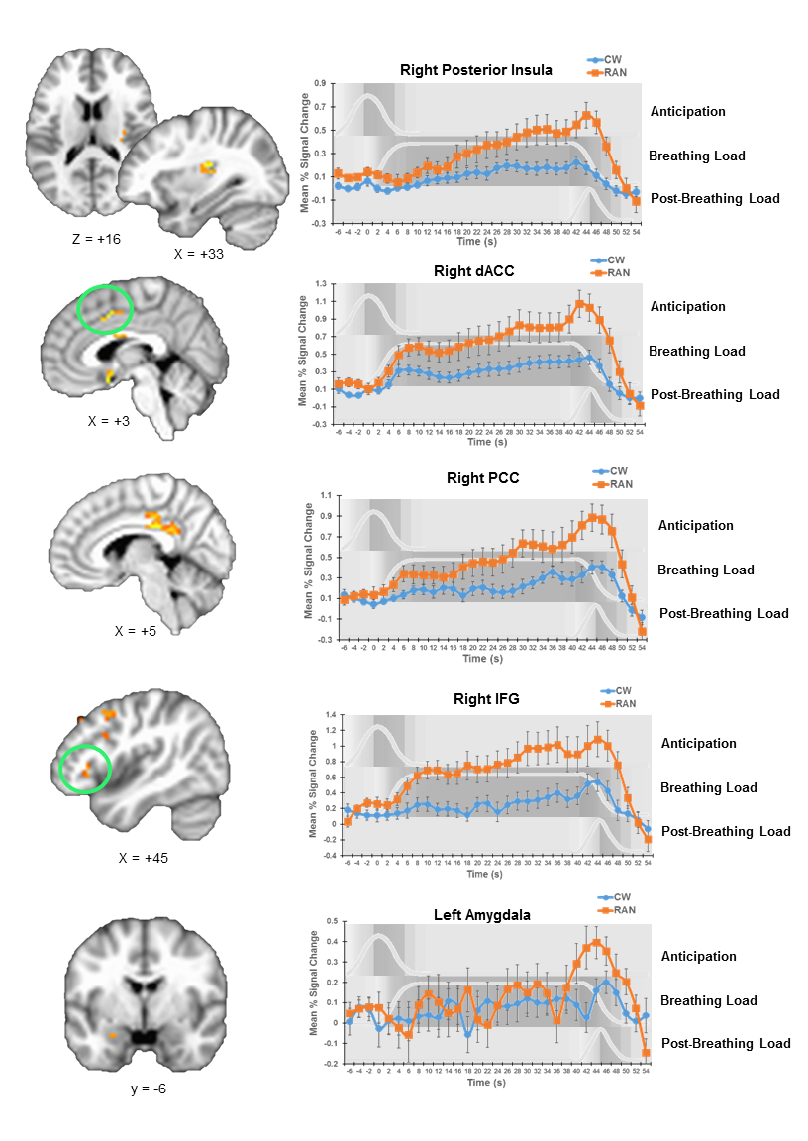
Figure S3. Additional Clusters with Group Differences in Time Courses of Activation (voxel-wise p < 0.01, cluster-wise p < 0.05, small-volume corrected). Error bars represent standard error of the mean. When multiple clusters are shown, the graphs correspond to circled clusters. RAN, women remitted from anorexia nervosa; CW, healthy control women; dACC, dorsal anterior cingulate cortex; PCC, posterior cingulate cortex; IFG, inferior frontal gyrus.
Exploratory Associations with Clinical Variables 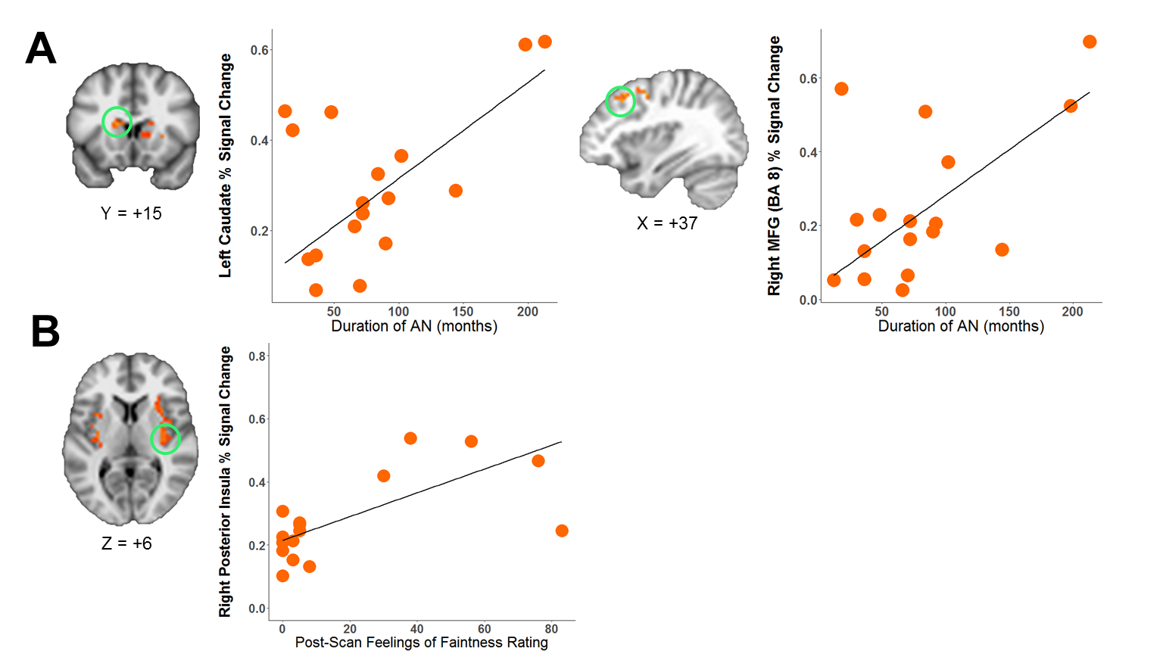
Figure S4. Associations of Post-Breathing Load Neural Activation with Clinical Measures (p < 0.05, Bonferroni corrected for multiple comparisons). A) Associations with AN Severity. RAN participants with the longest durations of illness showed the greatest hyperactivation of left caudate (t = 3.95, p < 0.0001) and right MFG (t = 3.93, p < 0.0001) after breathing load termination.
B) Association with Self-Reported Sensation. RAN participants with the highest post-scan feelings of faintness ratings showed the greatest hyperactivation of right posterior insula after breathing load termination (t = 4.03, p < 0.0001). RAN, women remitted from anorexia nervosa; MFG, middle frontal gyrus.
In our RAN sample, duration of illness was unassociated with age (p = 0.066), trait anxiety (p = 0.872) or harm avoidance (p = 0.163). Lowest post-pubertal BMI was also unrelated to trait anxiety (p = 0.608) or harm avoidance (p = 0.578). These results suggest that in our sample, duration of illness and lowest BMI may be markers or proxies of past AN illness severity that are independent of general anxiety symptomatology. Duration of AN remission was unrelated to neural activation in our sample.
Because of incomplete TCI and STAI-T data, and because STAI-T data were collected up to three months before scanning and TCI data were collected up to 12 months before scanning, results from these measures should be interpreted with caution. Uncorrected results suggest higher harm avoidance scores tended to be associated with more pronounced deactivation of right insula during breathing load anticipation (p = 0.013) in the RAN group, but harm avoidance was unassociated with activation in this region in CW.
In RAN participants, the relationship between activation and trait anxiety showed a pattern opposite to that seen with AN severity markers and harm avoidance. RAN participants with higher STAI-T scores showed increased activation during breathing load in bilateral IFG and MFG, right PCC, right caudate, and left putamen (ps < 0.00001) and greater activation after breathing load in left IFG (p < 0.001). STAI-T was unrelated to CW activation. Trait anxiety and harm avoidance were positively associated in CW (r = 2.10; p = 0.036), but were unassociated in our RAN sample (p = 0.934), indicating that RAN women who endorsed more cognitive symptoms of anxiety assessed by the STAI-T did not necessarily endorse the cognitive and behavioral avoidance symptoms of anxiety assessed by the TCI harm avoidance subscale. Taken together, our findings may preliminarily suggest that RAN participants with reduced aversive anticipatory signals and those who exert greater neural effort during times of stress may be less cognitively anxious but have a history of more severe past AN (i.e., more severe eating avoidance), and may be more behaviorally avoidant in general. Future study is needed to comprehensively investigate the relative contributions of current and past anxiety symptoms and eating disorder symptoms to aversive interoceptive anticipation and processing in individuals with AN.
Restricted ranges of Interoceptive Awareness subscale scores from the Eating Disorders Inventory-2 (CW range = 0-3; RAN range = 0-2) precluded any analysis of the relationship between these scores and neural activation. VAS ratings of pleasantness, unpleasantness, and intensity were unrelated to activation in any condition in either group.
AN Subtype and Past Comorbidities
RAN women with a history of the restricting AN subtype (AN-R; n = 11) and those with a history of the binge-eating/purging subtype (AN-B/P; n = 6) did not differ in mean peak activation in any condition (all ps > 0.126). These results suggest that AN subtype did not appreciably contribute to our findings. RAN women with (n = 6) versus without (n = 11) a past anxiety disorder did not differ in mean peak activation in any condition (all ps > 0.104), nor did those with (n = 11) versus without (n = 6) past major depression (all ps > 0.200).

References

Beck AT, Steer RA Brown GK (1996). Manual for the Beck Depression Inventory-II. Psychological Corporation: San Antonio, TX.
Berk L, Stewart JL, May AC, Wiers RW, Davenport PW, Paulus MP Tapert SF (2015). Under pressure: adolescent substance users show exaggerated neural processing of aversive interoceptive stimuli. Addiction 110, 2025-2036.
Cloninger CR, Przybeck TR Svrakic DM (1994). The Temperament and Character Inventory (TCI): A guide to its development and use. Center for Psychobiology of Personality, Washington University St. Louis, MO.
Cox RW (1996). AFNI: Software for analysis and visualization of functional magnetic resonance neuroimages. Computers and Biomedical Research 29, 162-173.
Fairburn CG, Cooper Z O'Connor M (2008). Eating Disorder Examination (Edition 16.0D). In Cognitive Behavior Therapy and Eating Disorders (ed. C. G. Fairburn). Guilford Press: New York.
First MB, Spitzer RL, Gibbon M Williams JBW (2002). Structured Clinical Interview for DSM-IV-TR Axis I Disorders, Research Version, Patient Edition (SCID-I/P). Biometrics Research, New York State Psychiatric Institute: New York.
Garner DM (1991). Eating Disorder Inventory-2 Professional Manual. Psychological Assessment Resources: Odessa, FL.
Haase L, May AC, Falahpour M, Isakovic S, Simmons AN, Hickman SD, Liu TT Paulus MP (2015). A pilot study investigating changes in neural processing after mindfulness training in elite athletes. Frontiers in Behavioral Neuroscience 9, 229.
Haase L, Stewart JL, Youssef B, May AC, Isakovic S, Simmons AN, Johnson DC, Potterat EG Paulus MP (2016). When the brain does not adequately feel the body: Links between low resilience and interoception. Biological Psychology 113, 37-45.
Haase L, Thom NJ, Shukla A, Davenport PW, Simmons AN, Paulus MP Johnson DC (2014). Mindfulness-based training attenuates insula response to an aversive interoceptive challenge. Social Cognitive and Affective Neuroscience, nsu042.
Paulus MP, Flagan T, Simmons AN, Gillis K, Kotturi S, Thom N, Johnson DC, Van Orden KF, Davenport PW Swain JL (2012). Subjecting elite athletes to inspiratory breathing load reveals behavioral and neural signatures of optimal performers in extreme environments. PLos ONE 7.
Sheehan DV, Lecrubier Y, Sheehan KH, Amorim P, Janavs J, Weiller E, Hergueta T, Baker R Dunbar GC (1998). The Mini-International Neuropsychiatric Interview (M.I.N.I.): the development and validation of a structured diagnostic psychiatric interview for DSM-IV and ICD-10. The Journal of Clinical Psychiatry 59 22-33.
Spielberger CD, Gorsuch RL Lushene RD (1970). State-Trait Anxiety Inventory Manual. Consulting Psychologists Press: Palo Alto, CA.
Stewart JL, Flagan TM, May AC, Reske M, Simmons AN Paulus MP (2013). Young adults at risk for stimulant dependence show reward dysfunction during reinforcement-based decision making. Biological Psychiatry 73, 235-41.
Stewart JL, Juavinett AL, May AC, Davenport PW Paulus MP (2015). Do you feel alright? Attenuated neural processing of aversive interoceptive stimuli in current stimulant users. Psychophysiology 52, 249-262.
Stewart JL, May AC, Poppa T, Davenport PW, Tapert SF Paulus MP (2014). You are the danger: Attenuated insula response in methamphetamine users during aversive interoceptive decision-making. Drug and Alcohol Dependence 142, 110-119.

