Online Supplementary Material for:
Hyper-responsivity to losses in the anterior insula during economic choice scales with depression severity
Jan B. Engelmann, Gregory S. Berns, Boadie W. Dunlop

Contents

- Supplementary Text
  - Text S1. Expected value analyses show an absence of choice difficulty effects on choices and response latency.
  - Text S2: Anxiety (HAMA score) does not influence Choices and Response Latency.

- Supplementary Tables
  - Table S1. Clinical and demographic characteristics of the healthy control (HC) and major depressive disorder (MDD) participants
  - Table S2. Regression results reflecting the role of depression in revealed preferences (models 1 and 2) and choice latencies (models 3 and 4).
  - Table S3. ROI analysis of the relationship between loss aversion (√λ) and neural gain-loss coding using iteratively reweighted least squares (IRLS) robust regression.
  - Table S4. Whole brain between-groups analysis of the interaction between group (HC / MDD) and neural gain-loss coding.
  - Table S5. Whole brain within-groups analysis of neural gain-loss coding.
  - Table S6. Whole brain analysis of the modulatory role of HAMD on gain-loss coding in depressed subjects.
  - Table S7. ROI analysis of the relationship between HAMD scores and neural gain-loss coding using iteratively reweighted least squares (IRLS) robust regression.
  - Table S8. ROI analysis of the relationship between HAMA scores and neural gain-loss coding using iteratively reweighted least squares (IRLS) robust regression.

- Supplementary Figures
  - Figure S1. Model-free illustration of reaction time patterns (mean RT) as a function of (a) loss and (b) gain amount for each group.
  - Figure S2. Regions of interest (ROIs) used in the combined ROI mask.
  - Figure S3. Additional regions in bilateral caudate nucleus that show group differences in neural gain-loss coding.
  - Figure S4. Whole brain analysis of the interaction between group and neural gain-loss coding showing differential neural gain-loss coding in HC and MDD subjects
  - Figure S5. ROI analyses of modulatory role of HAMD scores on neural coding of losses.
  - Figure S6. ROI analyses of the modulatory role of HAMA scores on neural coding of losses.

Supplementary Text

Text S1: Expected value analyses show an absence of choice difficulty effects on choices and response latency.
In order to identify potential influences of choice difficulty on decisions and response times across groups, regression analyses using expected value (EV = 0.5 * Gain Amount + 0.5 * Loss Amount) instead of separate gain and loss amounts were performed. Specifically, expected value reflects choice difficulty, such that EV magnitudes around zero lead to decisions with relatively greater difficulty compared to large positive and negative EV magnitudes. As predicted, expected value influenced choices (coefficient = 0.296; p < 0.0001), but we did not observe a main effect of EV on response latencies (coefficient = 2.11, p = 0.49). Importantly, EV did not differentially influence MDD and HC decisions (interaction between group and EV coefficient = -0.013; p = 0.81), as well as response latencies (interaction coefficient = -6.74; p = 0.22). Moreover, using absolute values for EV (absolute EV = |0.5 * Gain Amount + 0.5 * Loss Amount|) did not change these results. Together, these results indicate that both choices and response latencies are not confounded by EV, lending further support to the notion that response latency effects reported in the main paper are due to the influences of the valence of monetary amounts (gains vs. losses) in MDD participants. Specifically, EV did not influence response latencies of subjects from both groups, and there was no differential impact of EV on response latencies across groups.

Text S2: Anxiety (HAMA score) does not influence Choices and Response Latency.
To test the specificity of the effects of MDD on choices and response latencies, we performed additional analyses investigating the effects of trait anxiety (assessed via HAMA scores) on both trial-by-trial decisions and response latencies. We ran equivalent models to the ones reported in the main paper, except that depression (HAMD) scores were replaced by anxiety (HAMA) scores. We found that anxiety does not influence choices (main effect coefficient = -0.011, p = 0.478) and does not interact with gains and losses (gains interaction coefficient = -0.001, p = 0.665; losses interaction coefficient = 0.005, p = 0.850). Finally, no three-way interaction between gains, losses and anxiety was observed for choices (interaction coefficient = 0.000, p = 0.694).
Analyses of response latencies, however, showed a significant main effect of HAMA scores (main effect coefficient = 21.059, p < 0.001). Moreover, while anxiety does not influence the effect of gains and losses on response latency (gains interaction coefficient = -0.396, p = 0.244), a marginally significant interaction between HAMA scores and losses was observed (losses interaction coefficient = 0.589, p = 0.085). Moreover, no three-way interaction between gains, losses and anxiety was observed (interaction coefficient = -0.027, p = 0.386).
Finally, to test the robustness of our results, we entered HAMA scores as an additional a priori confounding variable using otherwise equivalent models as those reported in the paper (Table S2) for choice and response latency analyses. Results for the analyses of choices and response latencies reported in the paper and Table S2 did not change. Together, these results indicate that while depression (HAMD) and anxiety (HAMA) correlate (r = 0.77, p < 0.001), the effects of depression severity on the relationship between gain magnitude and response latency reported in the paper are specific to HAMD scores and could not be observed for HAMA scores. Moreover, controlling for the influence of anxiety did not change the results reported in the paper.

Supplementary Tables

Table S1. Clinical and demographic characteristics of the healthy control (HC) and major depressive disorder (MDD) participants

 | HC (N=23) | MDD (N=19) | p-value
Sex, Male:Female | 9:14 | 9:10 | .85
Smoker, Yes:No | 2:21 | 4:15 | .38
Mean Age, yrs (SD) | 33.7 (11.6) | 37.6 (11.0) | .27
Mean Annual Income, US$ (SD) | 47,439 (34,770) | 30,526 (21,128) | .06
WASI IQ, Total (SD) | 119.5 (11.3) | 114.2 (12.6) | .16
HAMD | 1.00 (1.38) | 22.84 (4.17) | <0.001
HAMA | 0.88 (1.68) | 17.44 (5.73) | <0.001

HAMD: Hamilton Depression Rating Scale; HAMA: Hamilton Anxiety Rating Scale;
WASI: Wechsler Abbreviated Scale of Intelligence

Table S2. Robust regression results reflecting the role of depression in revealed preferences (models 1 and 2) and choice latencies (models 3 and 4). Significant effects are indicated in bold.
Dependent Variable | Accept lottery (logit) |  |  | Choice latency (ols)
 | (1) Group | (2) HAMD |  | (3) Group | (4) HAMD
 | Coef./(SE) | Coef./(SE) |  | Coef./(SE) | Coef./(SE)
Gains | 0.14 | 0.16 | ***** | -9.12 | -9.43 | *****
 | (0.034) | (0.037) |  | (1.767) | (1.886)
Losses | 0.25 | 0.26 | ***** | 15.40 | 15.24 | ****
 | (0.031) | (0.034) |  | (4.198) | (4.502)
Depression | -0.48 |  |  | 342.12 |  | **
 | (0.355) |  |  | (142.838)
HAMD |  | -0.03 |  |  | 16.10 | ***
 |  | (0.017) |  |  | (5.988)
Gains x Losses | 0.0002 | 0.0003 |  | -1.33 | -1.37 | *****
 | (0.002) | (0.002) |  | (0.276) | (0.278)
Gains x Depression | 0.007 |  |  | -9.33 |  | **
 | (0.043) |  |  | (3.875)
Gains x HAMD |  | -0.001 |  |  | -0.36 | *
 |  | (0.002) |  |  | (0.209)
Losses x Depression | -0.04 |  |  | 8.52
 | (0.065) |  |  | (7.301)
Losses x HAMD |  | -0.003 |  |  | 0.368
 |  | (0.003) |  |  | (0.332)
Gains x Losses x Depression | 0.001 |  |  | -0.59
Depression | (0.002) |  |  | (0.454)
Gains x Losses x HAMD |  | 0.000 |  |  | -0.0206
HAMD |  | (0.0001) |  |  | (0.022)
N (# clusters) | 10080 (42) | 10080 (42) |  | 9869(42) | 9869 (42)
AIC | 8157 | 8097 |  | 161356 | 161342
R² | 0.582 | 0.586 |  | 0.107 | 0.109
Prob. > Chi² | < 0.0001 | < 0.0001 |  | <0.0001 | < 0.0001
Split-half reliability (standard deviation) | 0.83  (0.21) | 0.74  (0.36) |  | 0.99 (0.0015) | 0.99 (0.00017)
Logit (columns 1 and 2) and OLS (column 3 and 4) coefficient estimates from robust regression analyses. Lottery acceptance with binary grouping variable (depression, Column 1) and depression severity (HAMD, column 2); choice latency (in ms) with binary grouping variable (depression, column 3) and depression severity (HAMD, column 4). “Gains” reflect the magnitude of potential wins on a given trial t and “Losses” reflect the magnitude of potential losses on a given trial t. “Depression” is a dummy variable reflective of group (HC, MDD). “HAMD” reflects depression severity assessed via the Hamilton Depression Rating Scale. A priori confounders were included as outlined in the text. Split-half reliability values reflect the mean Spearman-Brown-adjusted correlation coefficient estimates from equivalent regression analyses using random subsets of exactly half the data implemented in a permutation-testing framework (N = 5000).
Significance levels: ***** p < 0.001, **** p < 0.005, *** p < 0.01, ** p < 0.05, * p < 0.1.

Table S3. ROI analysis of the relationship between loss aversion (√λ) and neural gain-loss coding using iteratively reweighted least squares (IRLS) robust regression. FDR-corrected height threshold of p < 0.05 (k > 5).

Structure | L/R | Cluster Size | T Max | X | Y | Z
Anterior Insula | left | 201 | 6.61 | -33 | 20 | -2
Anterior Insula | right | 202 | 7.7 | 36 | 20 | -2
Caudate | right | 183 | 8.11 | 12 | 11 | 4
Caudate | left | 181 | 7.52 | -12 | 11 | 7
DMPFC, ACC | bil. | 66 | 7.13 | 0 | 32 | 28
DMPFC | bil. | 11 | 3.51 | -3 | 17 | 49

Table S4. Whole brain between-groups analysis of the interaction between group (HC / MDD) and neural gain-loss coding. FWE cluster-corrected extent threshold of p < 0.05 (k > 239, with an initial cluster-forming height threshold p < 0.005).

Structure | L/R |  | Cluster Size | Peak T |  | X | Y | Z
Superior frontal gyrus / supplementary motor area |  | left | 441 |  | 4.89 | -6 | 11 | 64
Inferior frontal gyrus |  | left | 330 |  | 4.48 | -33 | 29 | -17

Table S5. Whole brain within-groups analyses of HC and MDD subjects for regions showing neural gain-loss coding. FWE cluster-corrected extent threshold of p < 0.05 (k > 239, with an initial cluster-forming height threshold p < 0.005); regions showing activation at relaxed thresholds are shown in italics.

Structure |  | L/R | Cluster Size | Peak T | X | Y | Z
Healthy Controls
 | Middle/inferior frontal gyrus | left | 411 | 5.72 | -33 | 50 | 1
 | vmPFC | right | 468 | 4.48 | 18 | 32 | 1
 | dlPFC / middle frontal gyrus | left | 385 | 4.47 | -24 | 26 | 58
 | Intraparietal sulcus | left | 492 | 4.47 | -36 | -85 | 13
 | Inferior frontal gyrus | right | 297 | 4.31 | 42 | 59 | -2
 | Posterior middle temporal gyrus | left | 233 | 6.64 | -48 | -43 | -8
MDD
 | Superior frontal gyrus / SMA | Bil. | 161 | -5.46 | -3 | 11 | 64
 | Pre / post central gyrus | Left | 172 | -4.52 | -45 | -22 | 58
Table S6. Whole brain analysis of correlation between HAMD score and neural gain-loss coding in MDD subjects. FWE cluster-corrected extent threshold of p < 0.05 (k > 239, with an initial cluster-forming height threshold p < 0.005); regions showing activation at relaxed thresholds are shown in italics.

Structure | L/R | Cluster Size | Peak T | X | Y | Z
Occipital lobe / cuneus / precuneus | bilateral | 9076 | 7.13 | -45 | -85 | 25
Insula | left | 465 | 5.76 | -39 | 11 | 7
Posterior cingulate cortex | bilateral | 233 | 6.05 | 0 | -28 | 49

Table S7. ROI analysis of the relationship between HAMD scores and neural gain-loss coding using iteratively reweighted least squares (IRLS) robust regression. FDR-corrected height threshold of p < 0.05 (k > 5).

Structure | L/R | Cluster Size | T Max | X | Y | Z
VMPFC | bil. | 448 | -9.29 | -3 | 41 | -5
Anterior Insula | left | 28 | -5.77 | -33 | 29 | -8
Anterior Insula | left | 9 | -3.93 | -39 | 17 | -17
Anterior Insula | right | 23 | -3.97 | 48 | 20 | -8
Anterior Insula | right | 14 | -4.3 | 36 | 26 | 7
Caudate | left | 104 | -5.9 | -9 | 14 | 1
Caudate | right | 76 | -5.3 | 12 | 17 | -2
Caudate (dorsal) | right | 16 | -3.13 | 18 | 8 | 16
DMPFC | bil. | 7 | -3.25 | -3 | 5 | 49

Table S8. ROI analysis of the relationship between HAMA scores and neural gain-loss coding using iteratively reweighted least squares (IRLS) robust regression. FDR-corrected height threshold of p < 0.05 (k > 5).

Structure | L/R | Cluster Size | T Max | x | y | z
VMPFC | bil. | 66 | 4.37 | 0 | 38 | -5
VMPFC | bil. | 42 | 4.45 | 0 | 44 | -20
Anterior Insula | right | 238 | 6.29 | 39 | 23 | -2
Anterior Insula | left | 143 | 7.25 | -33 | 23 | -5
Caudate | left | 102 | 6.47 | -9 | 11 | 7
Caudate | right | 90 | 4.31 | 15 | 14 | 7
DMPFC | bil. | 7 | 3.47 | 0 | 14 | 46

Supplementary Figures

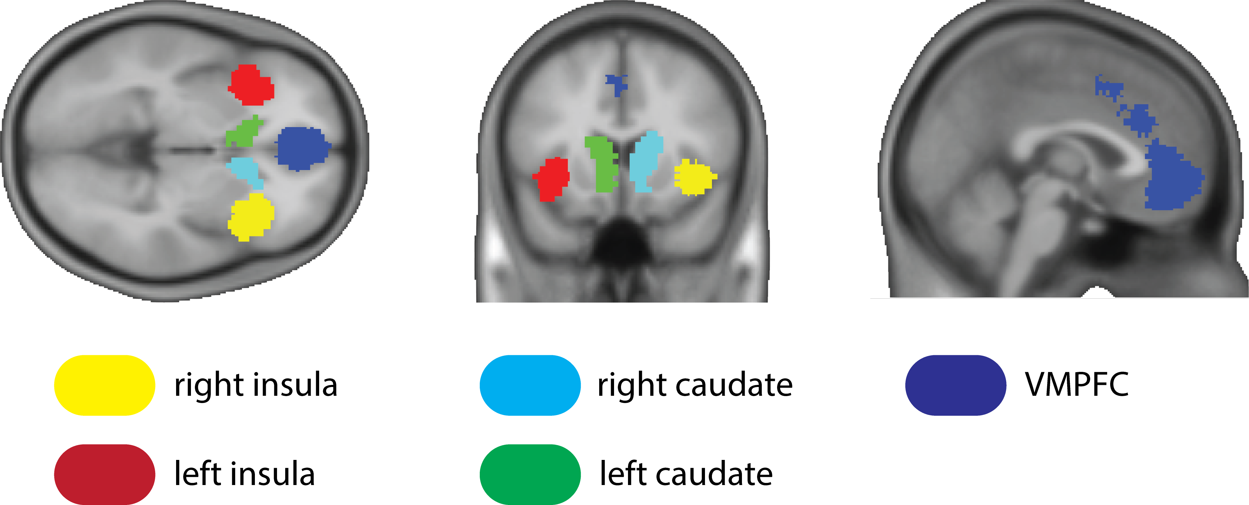

Figure S1. Regions of interest (ROIs) used in the combined ROI mask. Analyses of value-related responses were restricted to a single combined ROI mask that included truly independent ROIs in bilateral AI (taken from the meta-analysis by Bartra et al., 2013 for negative effects of subjective value) and VMPFC (taken from the meta-analysis by Bartra et al., 2013 for positive effects of subjective value and thresholded at Z=8.5 to separate VMPFC from other activations), as well as caudate nucleus (a custom anatomical mask was created by limiting the Automated Anatomical Labeling (AAL) template for the caudate to all voxels below z = 20). Separate regions are shown in different colors for illustration purposes, but were employed in a combined mask that included a total of 1875 voxels.

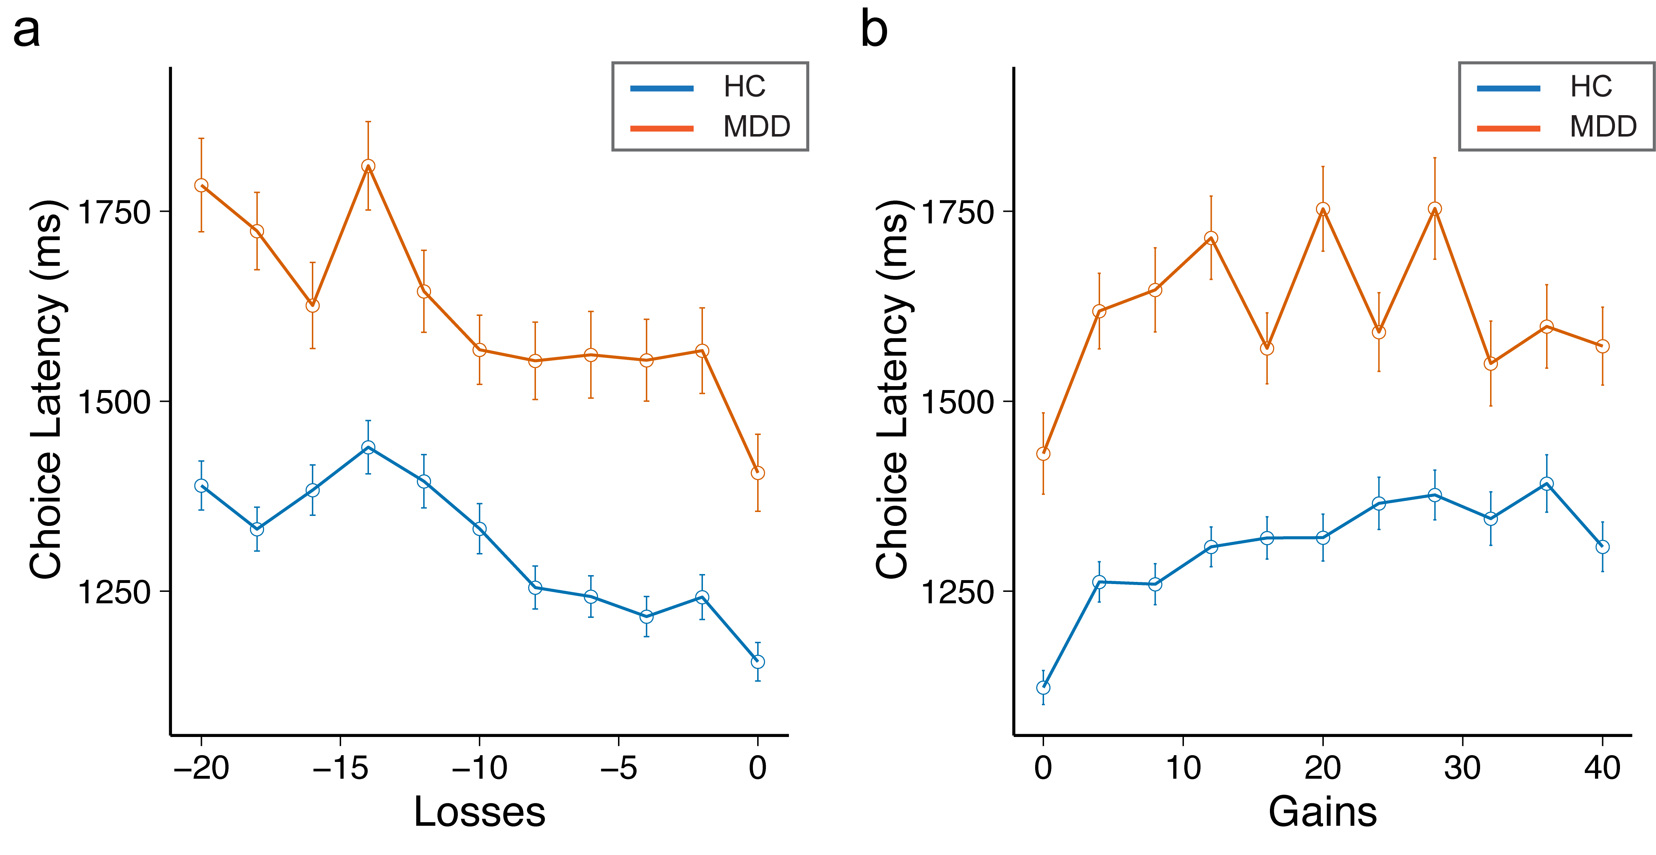
Figure S2. Model-free illustration of reaction time patterns (mean RT) as a function of (a) loss and (b) gain amount for each group. The negative relationship between mean RT and increasing loss amounts is clearly visible for both groups, while only a positive relationship between mean RT and gain amounts is present in the HC, but not in MDD group.

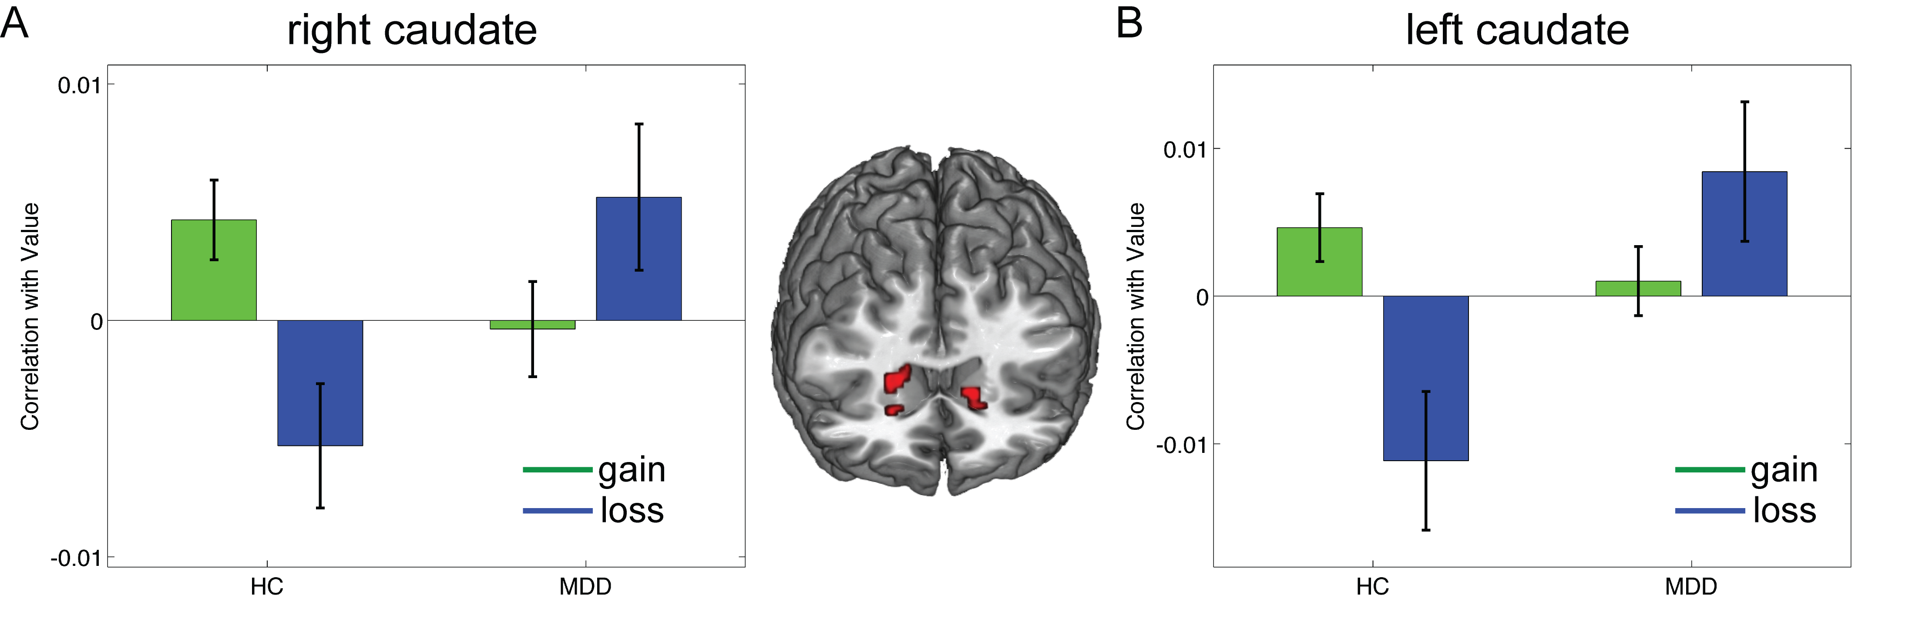

Figure S3. ROI analyses at a relaxed threshold of p < 0.005, uncorrected, identified additional regions in bilateral caudate nucleus that show group differences in neural gain-loss coding. Specifically, interaction effects were observed in left (-18, 23, -2; k = 13) and right caudate nucleus (21, 26, -2, k = 23).

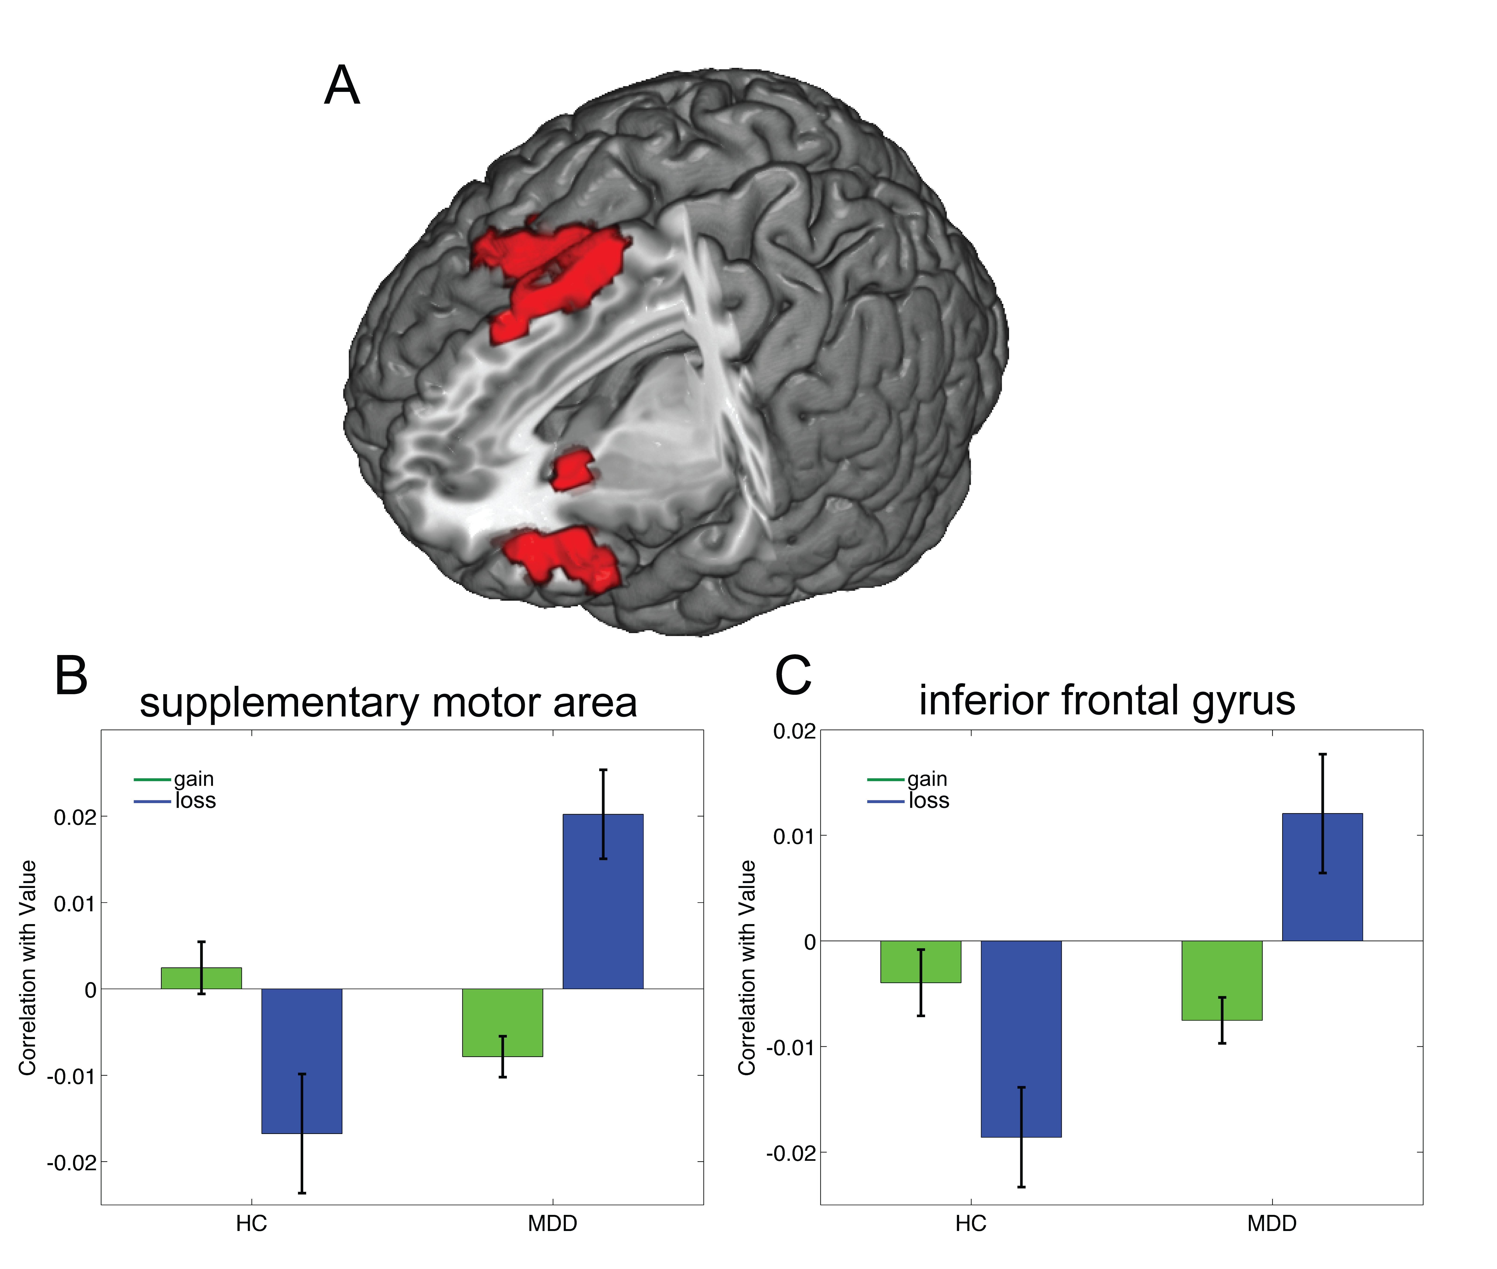
Figure S4. Whole brain analysis of the interaction between group and neural gain-loss coding showing differential neural gain-loss coding in HC and MDD subjects at an FWE-corrected extent threshold of p < 0.05 (k > 260, initial cluster-forming height threshold p < 0.005). The supplemental motor area (B: -6, 11, 64; k = 441) and inferior frontal gyrus (C: -33, 29, -17; k = 330) show a significant interaction between group and neural gain-loss coding. Specifically, as shown for analyses in our ROIs, neural coding of losses is reversed in MDD subjects compared to healthy control subjects.

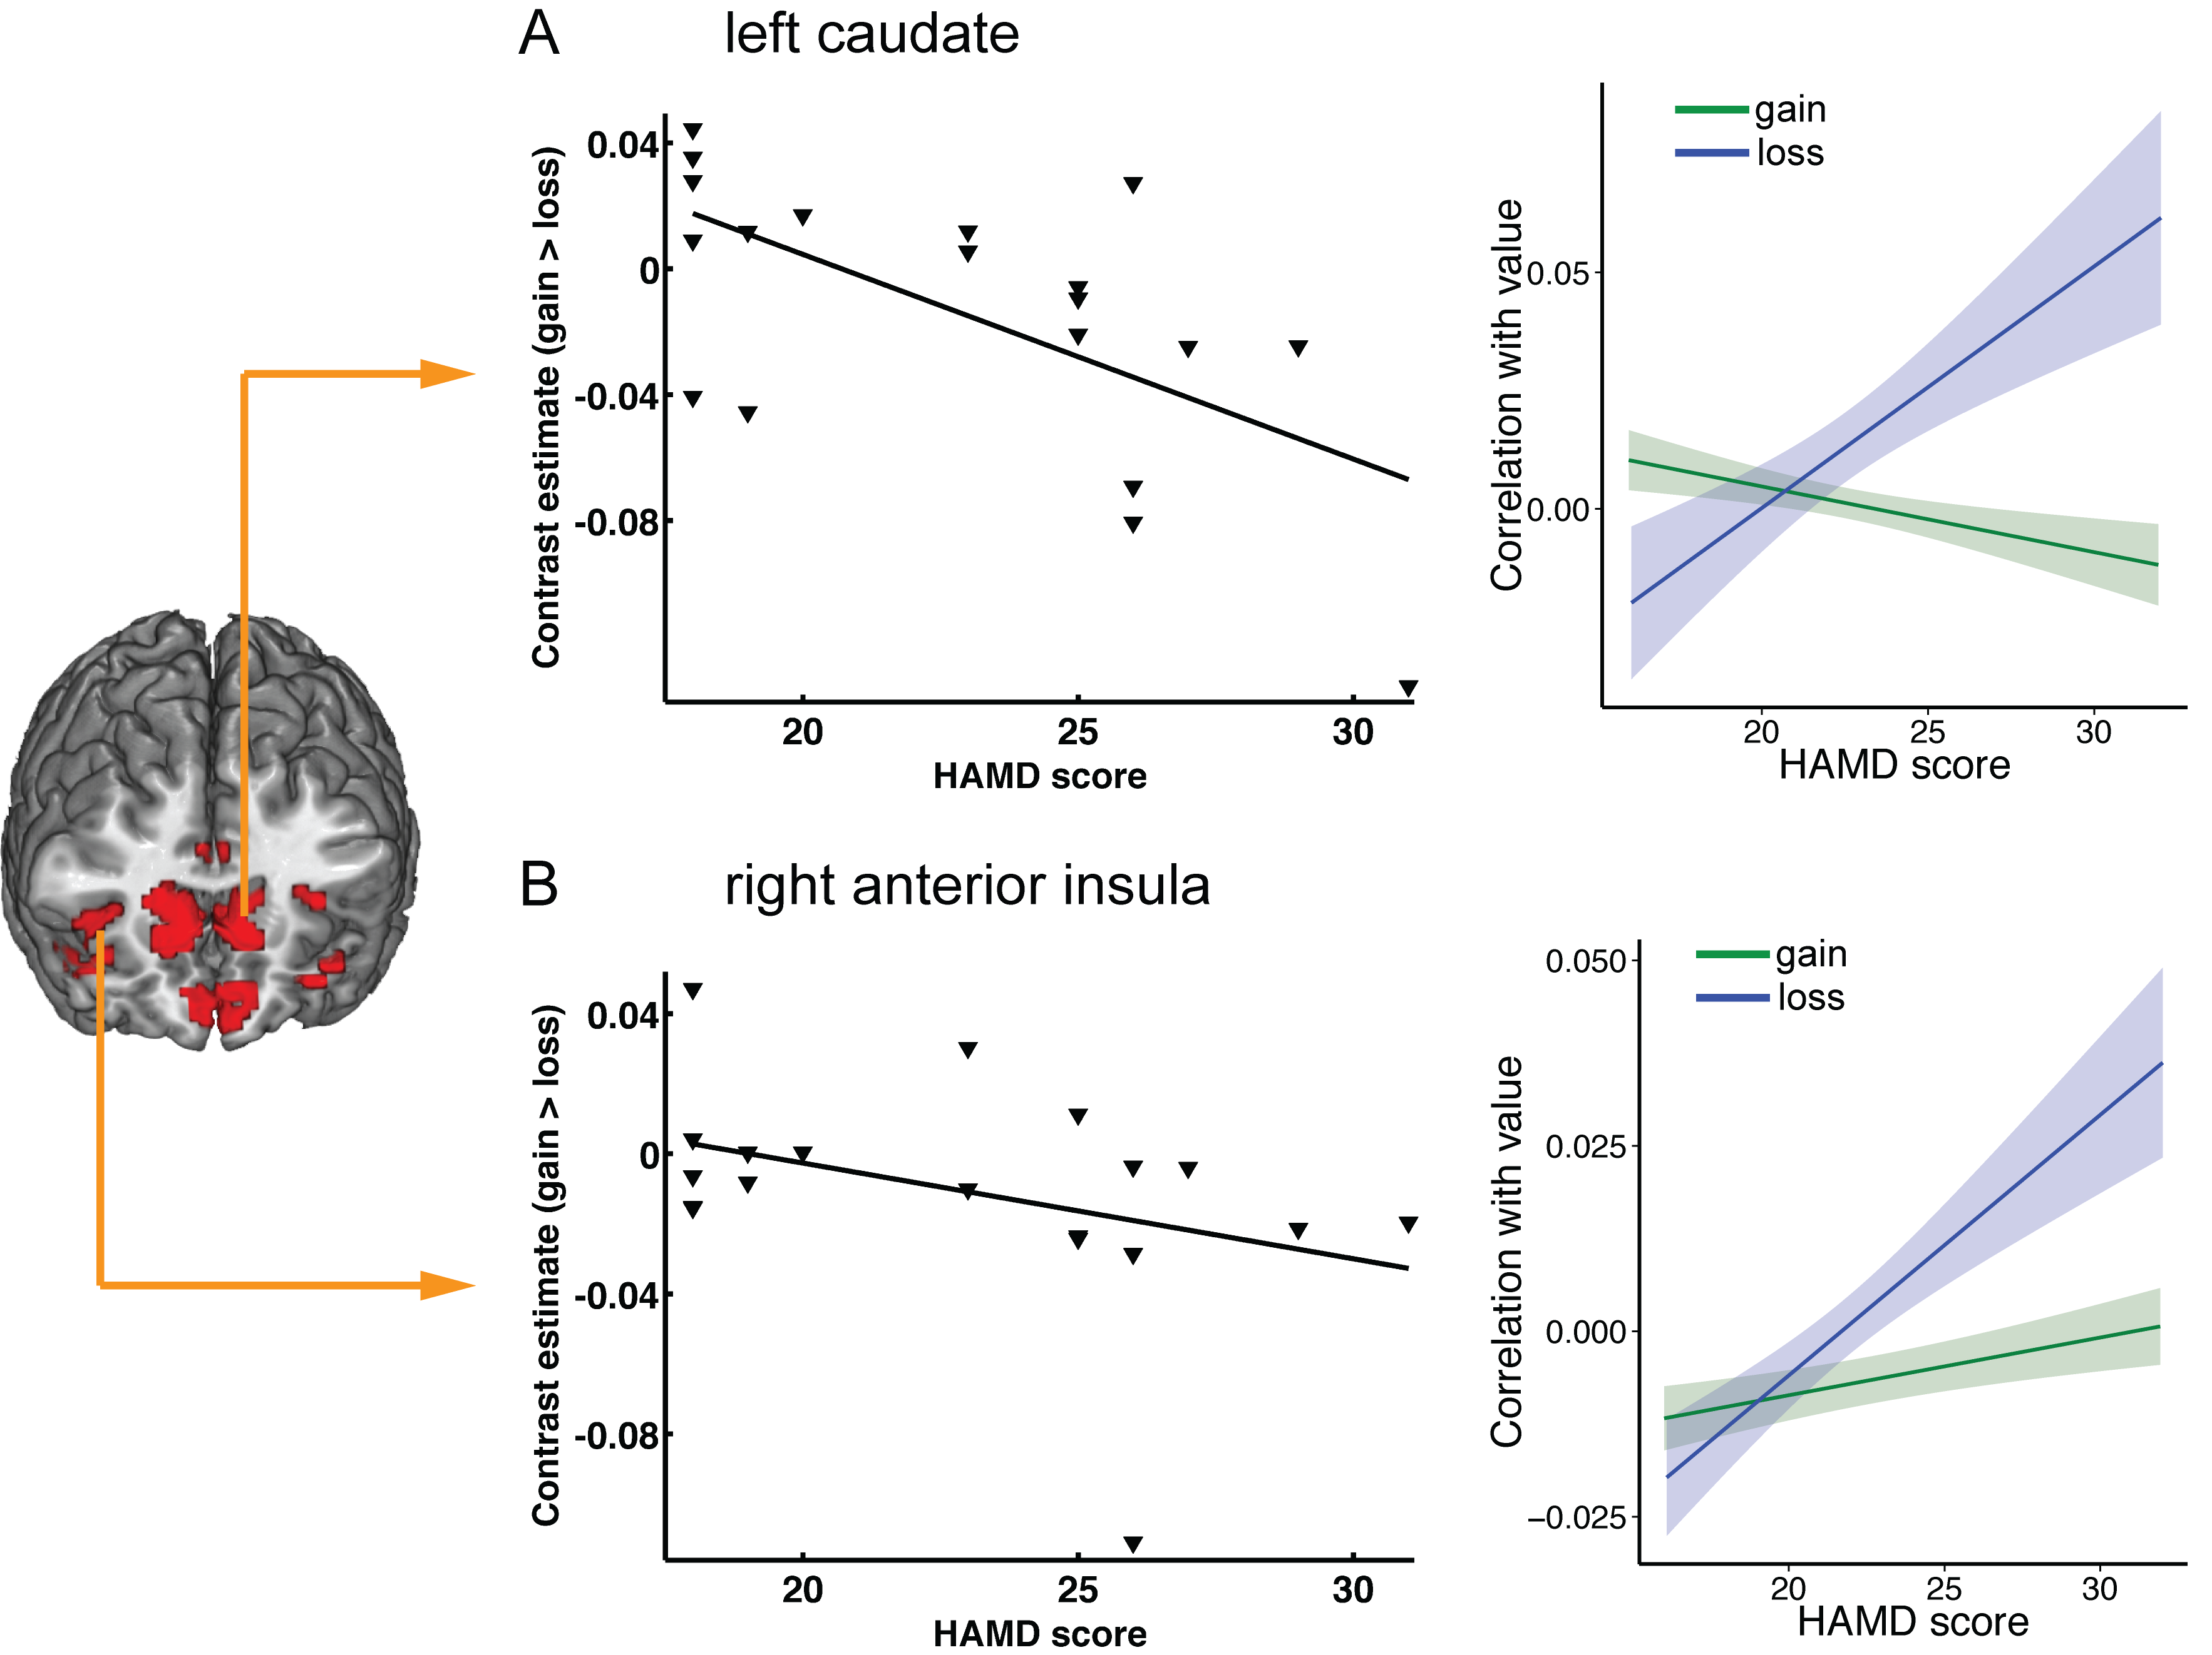

Figure S5. ROI analyses of modulatory role of HAMD scores on neural coding of losses. In addition to the results reported in the main paper, HAMD scores modulate the neural coding of losses in (A) left caudate (-3, 5, -5, k = 92) and (C) right anterior insula (36, 29, 7, k = 23) at a relaxed threshold of p < 0.005, uncorrected. Specifically, increasing HAMD scores are associated with increased neural coding of losses, but not gains. The decomposition of the contrast effect into separate gain and loss components using robust regression analysis (right column) illustrates that increasing levels of HAMD scores are specifically associated with increased encoding of losses, but not gains, which confirms results from our ROI analyses of valuation regions.

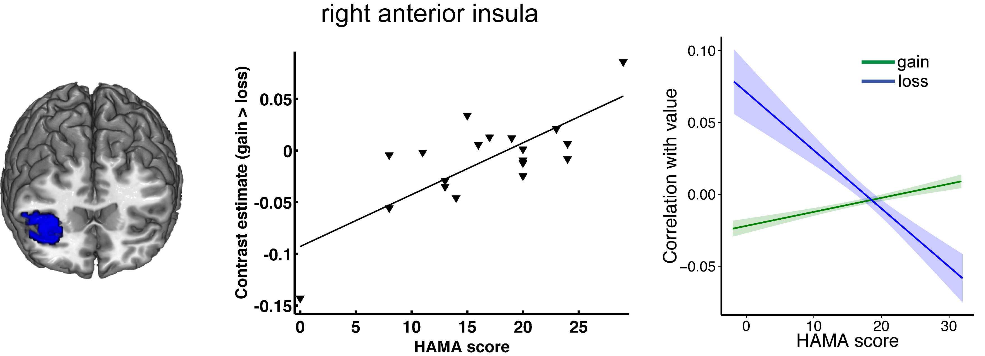

Figure S6. ROI analyses of modulatory role of HAMA scores on neural coding of losses. HAMA scores modulate the neural coding of losses, such that increasing HAMA scores are associated with a negative coding of losses in right anterior insula (54, 23, 7, k = 282, SV FWE corrected p = 0.05). Line plots show results from regression analyses that illustrate the influence of anxiety severity on neural gain-loss coding. The decomposition of the contrast effect into separate gain and loss components using robust regression analysis (right column) illustrates that increasing levels of HAMA scores are specifically associated with decreasing encoding of losses, but not gains.

