Supplement 1.

MRI acquisition 2
MRI pre-processing pipeline 2
White matter tractography 3

Figure S 1. Impaired connections reproduced with the Craddock-90 parcellation scheme 4
Figure S 2. Networks satisfying a linear pattern of decline from early to chronic schizophrenia: results across connection densities of 20%, 30% and 40% 5
Figure S 3. White matter connectivity disruptions in early and chronic stages of schizophrenia: results across t-statistic thresholds of 2.5, 3 and 3.5 6
Figure S 4. Total streamlines across the four study groups 7
Figure S 5. Fractional anisotropy reductions in early stages of schizophrenia overlap with a more extensive network of reductions found in chronic stages of illness 8
Figure S 6. Widespread FA-weighted network satisfying a linear pattern of decline from early to chronic stages of schizophrenia 9

MRI acquisition

Sixty diffusion-weighted volumes and 10 diffusion-unweighted (b0) volumes were obtained with an echo planar imaging sequence. Acquisition parameters were as follows: b-value = 3000s/mm², slice thickness = 2mm, image matrix = 104 x 104, in plane voxel resolution = 2 x 2 mm, field of view = 208 x 208, repetition time = 7750 ms, echo time = 112 ms, flip angle = 90°.

MRI pre-processing pipeline

The imaging data were pre-processed and registered to normalized stereotaxic space with the FMRIB Software Library (FSL; Jenkinson et al., 2012). Pre-processing involved visual inspection for artifacts, during which six scans were removed from the analysis (1 control and 5 patients) due to poor image quality (cerebellar cropping and movement artifact) and another scan removed (1 patient), due to an incomplete imaging sequence. The remaining scans (sample population described in Table 1) underwent correction for motion and gradient-induced currents using affine registration to the first b0 image; computation of an FA volume by fitting a tensor to the raw data using the FMRIB diffusion toolkit (FDT) and nonlinear normalisation of the FA volume to Montreal Neurological Institute (MNI) space, with the FMRIB58 FA image as the registration target. Registration followed a two-step procedure: first, the affine transformation was computed to match the FA volume to the template (FLIRT; Andersson et al., 2007); next, nonlinear normalisation applied the deformation field that warps the original FA volume to the template, setting the previous affine transformation as the starting estimate (FNIRT; Andersson et al., 2010).

White matter tractography

Automated whole-brain fiber tracking was performed in native diffusion space for each individual to generate millions of streamlines tracing out the trajectories of all major cortico-cortical, cortico-subcortical and cerebellar fiber bundles. A total of five million streamlines were seeded from randomly positioned coordinates comprising a white matter mask for each subject. The white matter mask was derived in FSL (Jenkinson et al., 2012) from each subjects T1-weighted white matter segments (FAST; Zhang et al., 2001), which were registered to individualized FA space (FLIRT; Andersson et al., 2007) and then binarized in FSL. Each streamline was propagated using the second order integration over fiber orientation distributions (iFOD2) probabilistic tractography algorithm (Tournier et al., 2010). Streamlines were guided by fiber orientations inferred using spherical deconvolution with a maximum harmonic order (l_{max}) of 8 (Tournier et al., 2007). Propagation was terminated if either a minimum angle threshold of 45° was violated or the streamline propagated beyond the white matter mask. Streamlines terminating in white matter were eliminated, where white matter was defined as any voxel comprising the white matter mask. These steps were performed using the MRtrix package, Version 3.10 (Tournier et al., 2012).

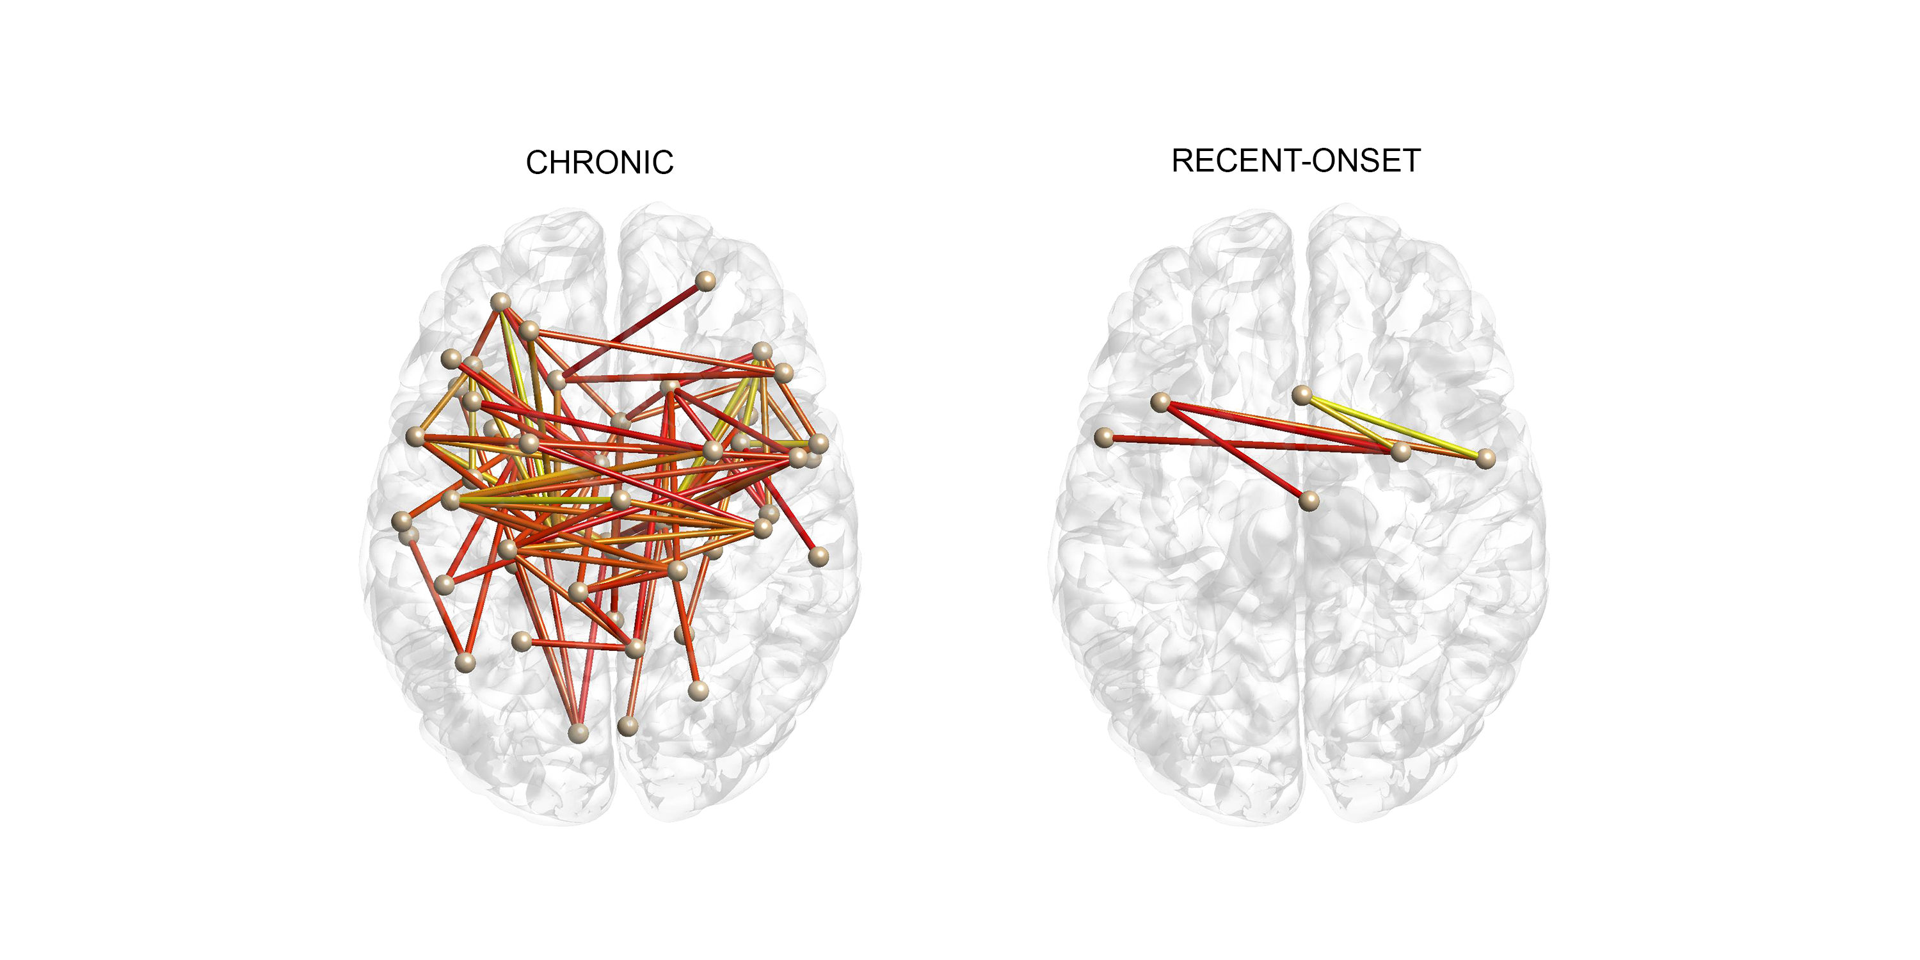
Figure S 1. Impaired connections reproduced with the Craddock-90 parcellation scheme
Axial views of impaired connections in chronic and recent-onset patients identified using the Craddock-99 parcellation scheme (streamline-weighted network). Edge colour reflects the effect-size, ranging from 3 (red) to 5.5 (yellow). Reanalyzing streamline count with Craddock-90 revealed a consistent network of disruptions in chronic (94 disrupted edges) and recent-onset patients (6 disrupted edges) with schizophrenia. Specifically, significantly reduced streamline counts (p < .05) were colocalized to fiber bundles disrupted in the AAL-defined subnetworks, including the anterior callosal fibres across both patient groups. Replication with a different parcellation scheme suggests our findings are robust to the choice of nodes and variation in node size.

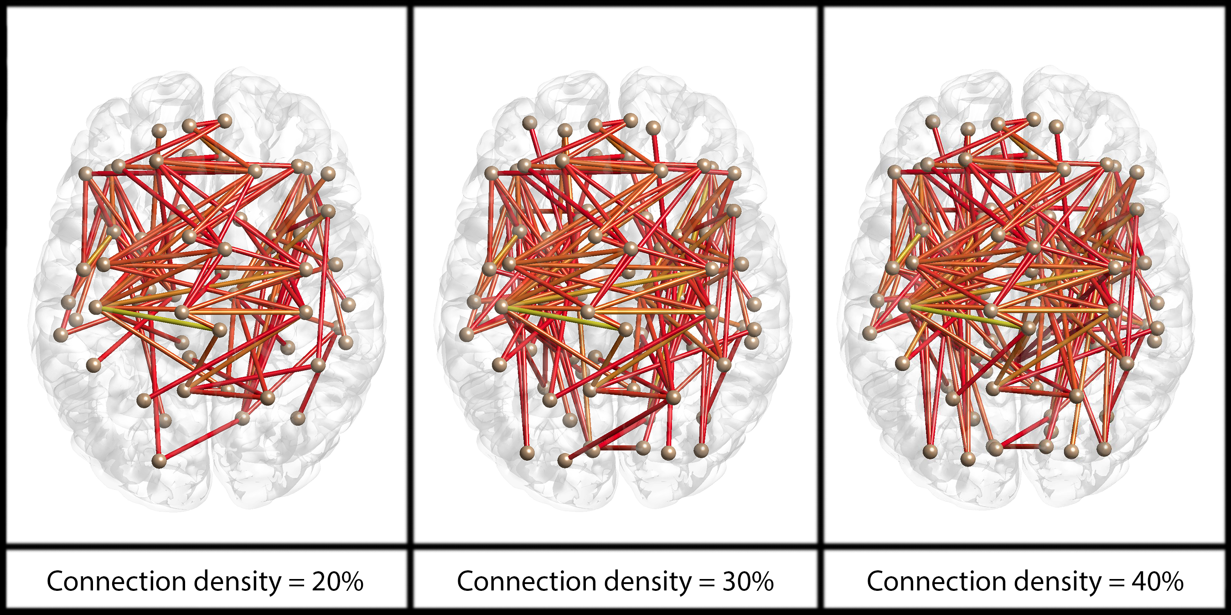

Figure S 2. Networks satisfying a linear pattern of decline from early to chronic schizophrenia: results across connection densities of 20%, 30% and 40%
Connection colour reflects t-statistic magnitude, ranging from 3 (red) to 5.5 (yellow).
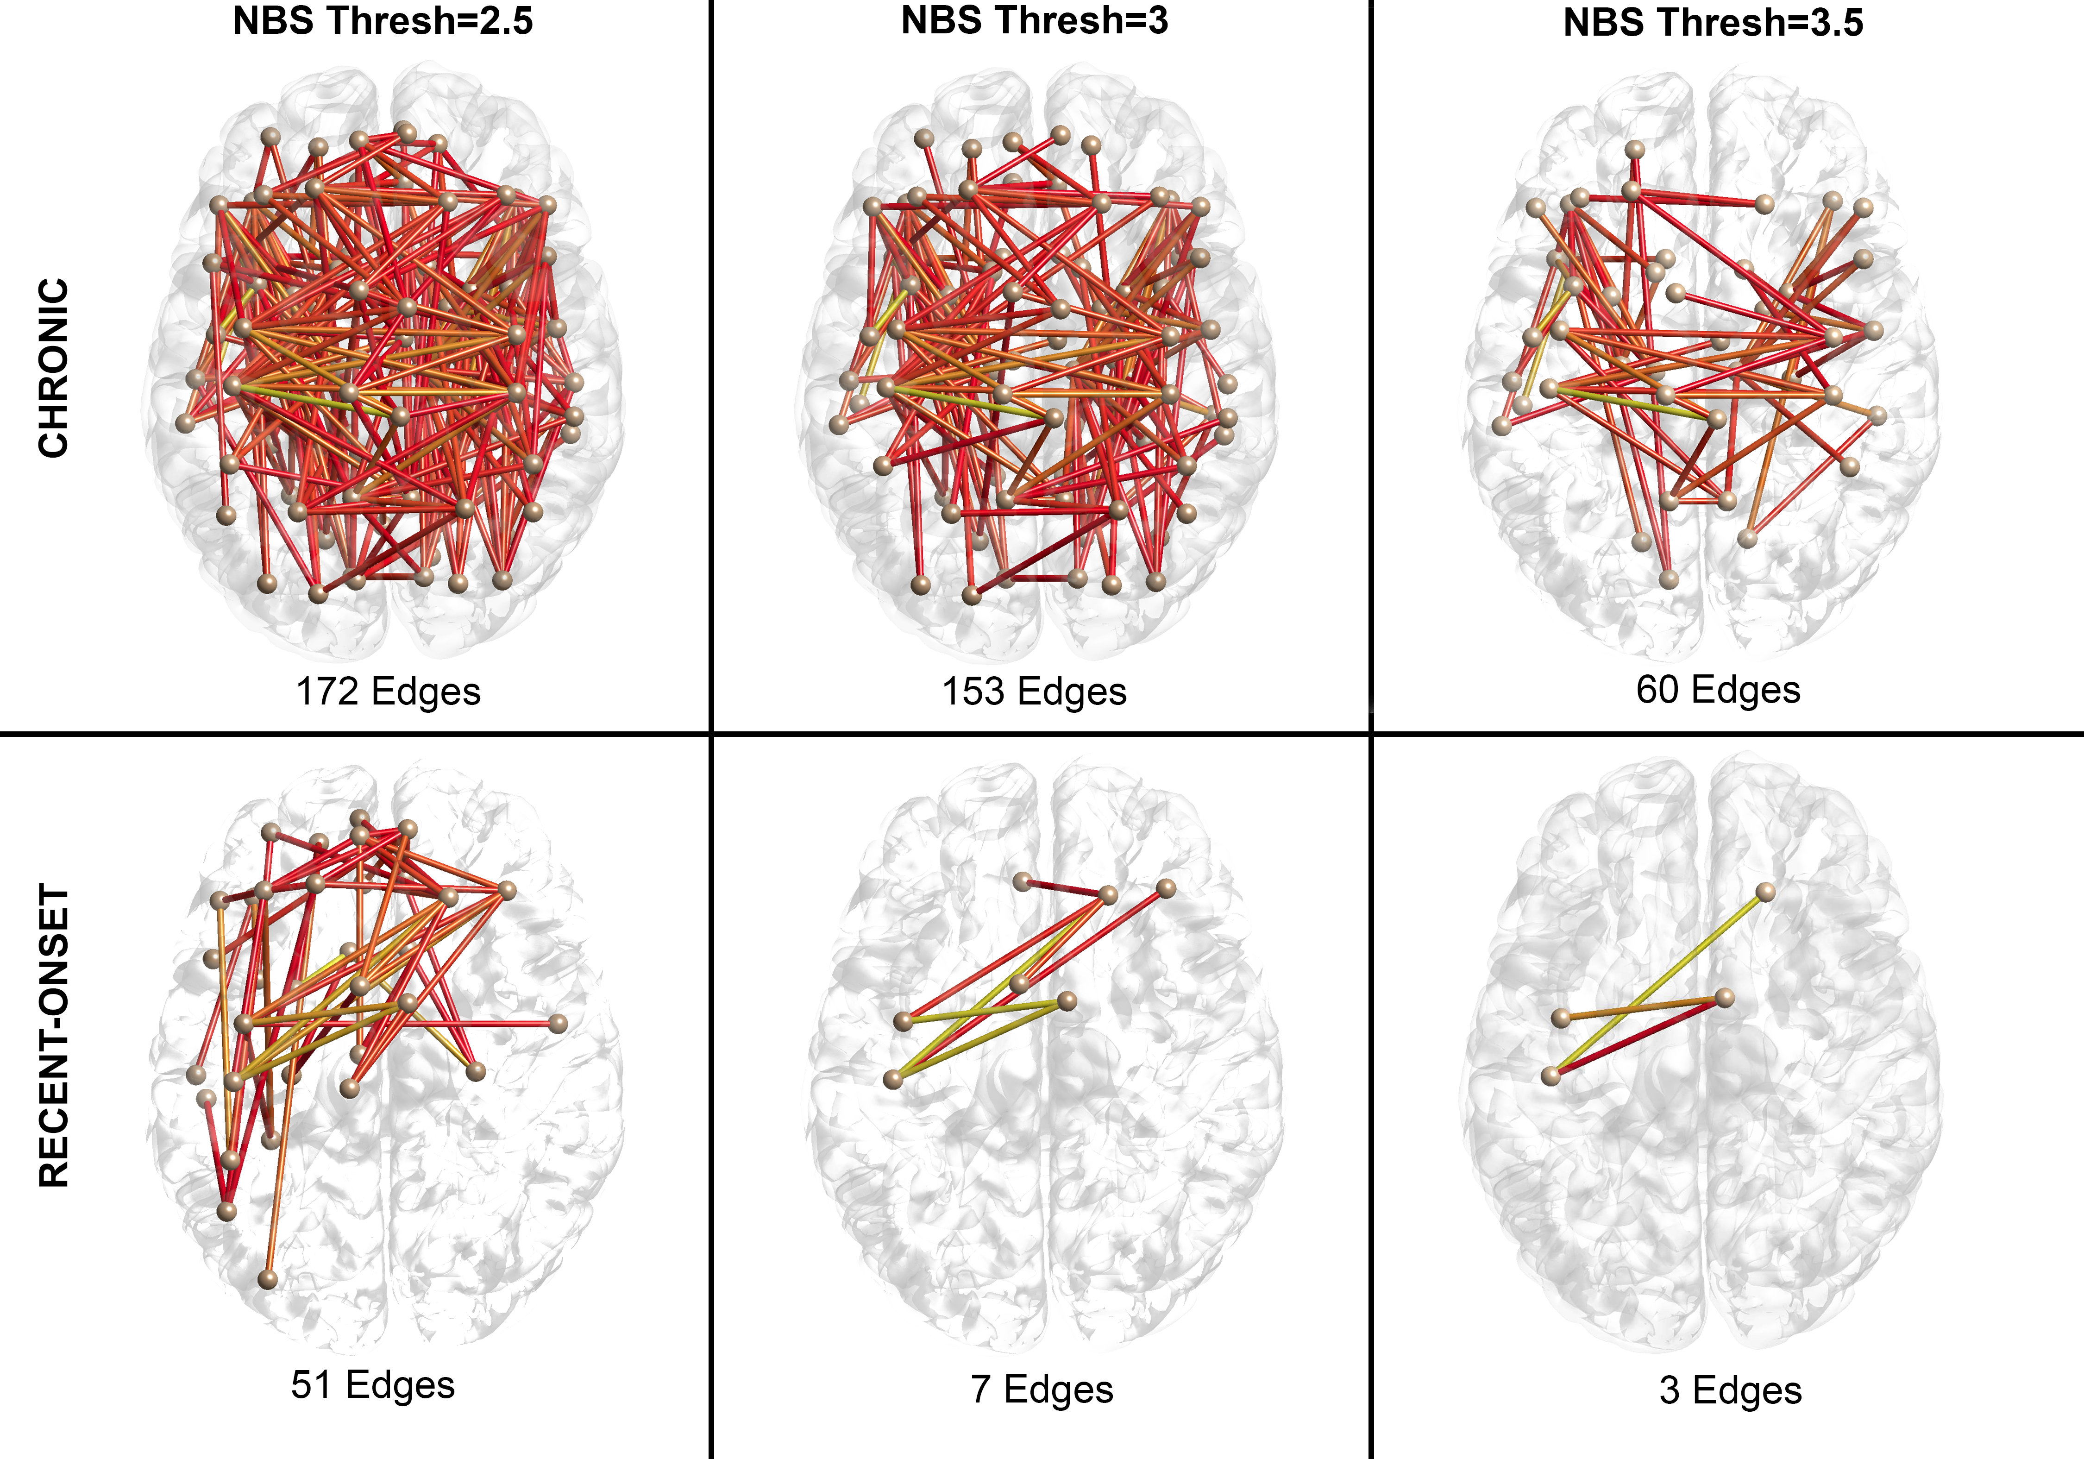
Figure S 3. White matter connectivity disruptions in early and chronic stages of schizophrenia: results across t-statistic thresholds of 2.5, 3 and 3.5
Connection colour reflects t-statistic magnitude, ranging from 3 (red) to 5.5 (yellow). Thresh = Threshold.

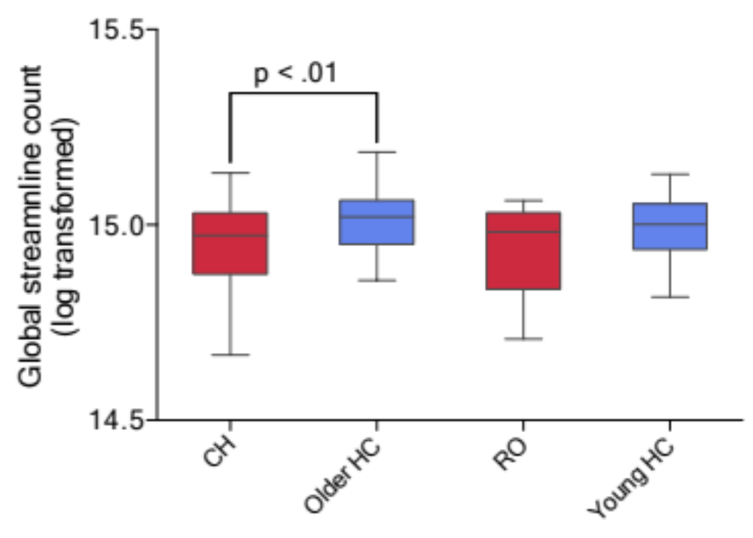
Figure S 4. Total streamlines across the four study groups
Boxplots represent mean global streamline number for chronic (CH) patients, older controls (Older HC), recent-onset (RO) patients and younger controls (Young HC). Patients are shown in red and controls in blue. Boxes represent 25th and 75th percentiles and whiskers represent 10th and 90th percentiles.

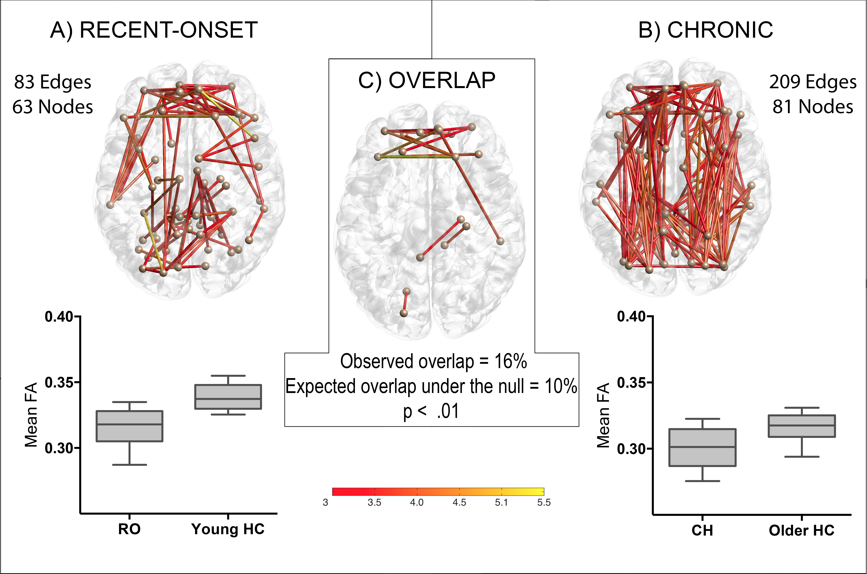
Figure S 5. Fractional anisotropy reductions in early stages of schizophrenia overlap with a more extensive network of reductions found in chronic stages of illness
Connections with reduced FA in recent-onset (A) and chronic (B) patients. Connection colour reflects t-statistic magnitude, ranging from red (low) to yellow (high). Boxplots represent network-averaged FA for recent-onset (RO) patients, younger controls (Young HC), chronic (CH) patients and older controls (Older HC). Boxes represent 25th and 75th percentiles and whiskers represent 10th and 90th percentiles. C) Disrupted connections in recent-onset patients significantly overlapped with a more extensive network of disrupted connections found in chronic patients.

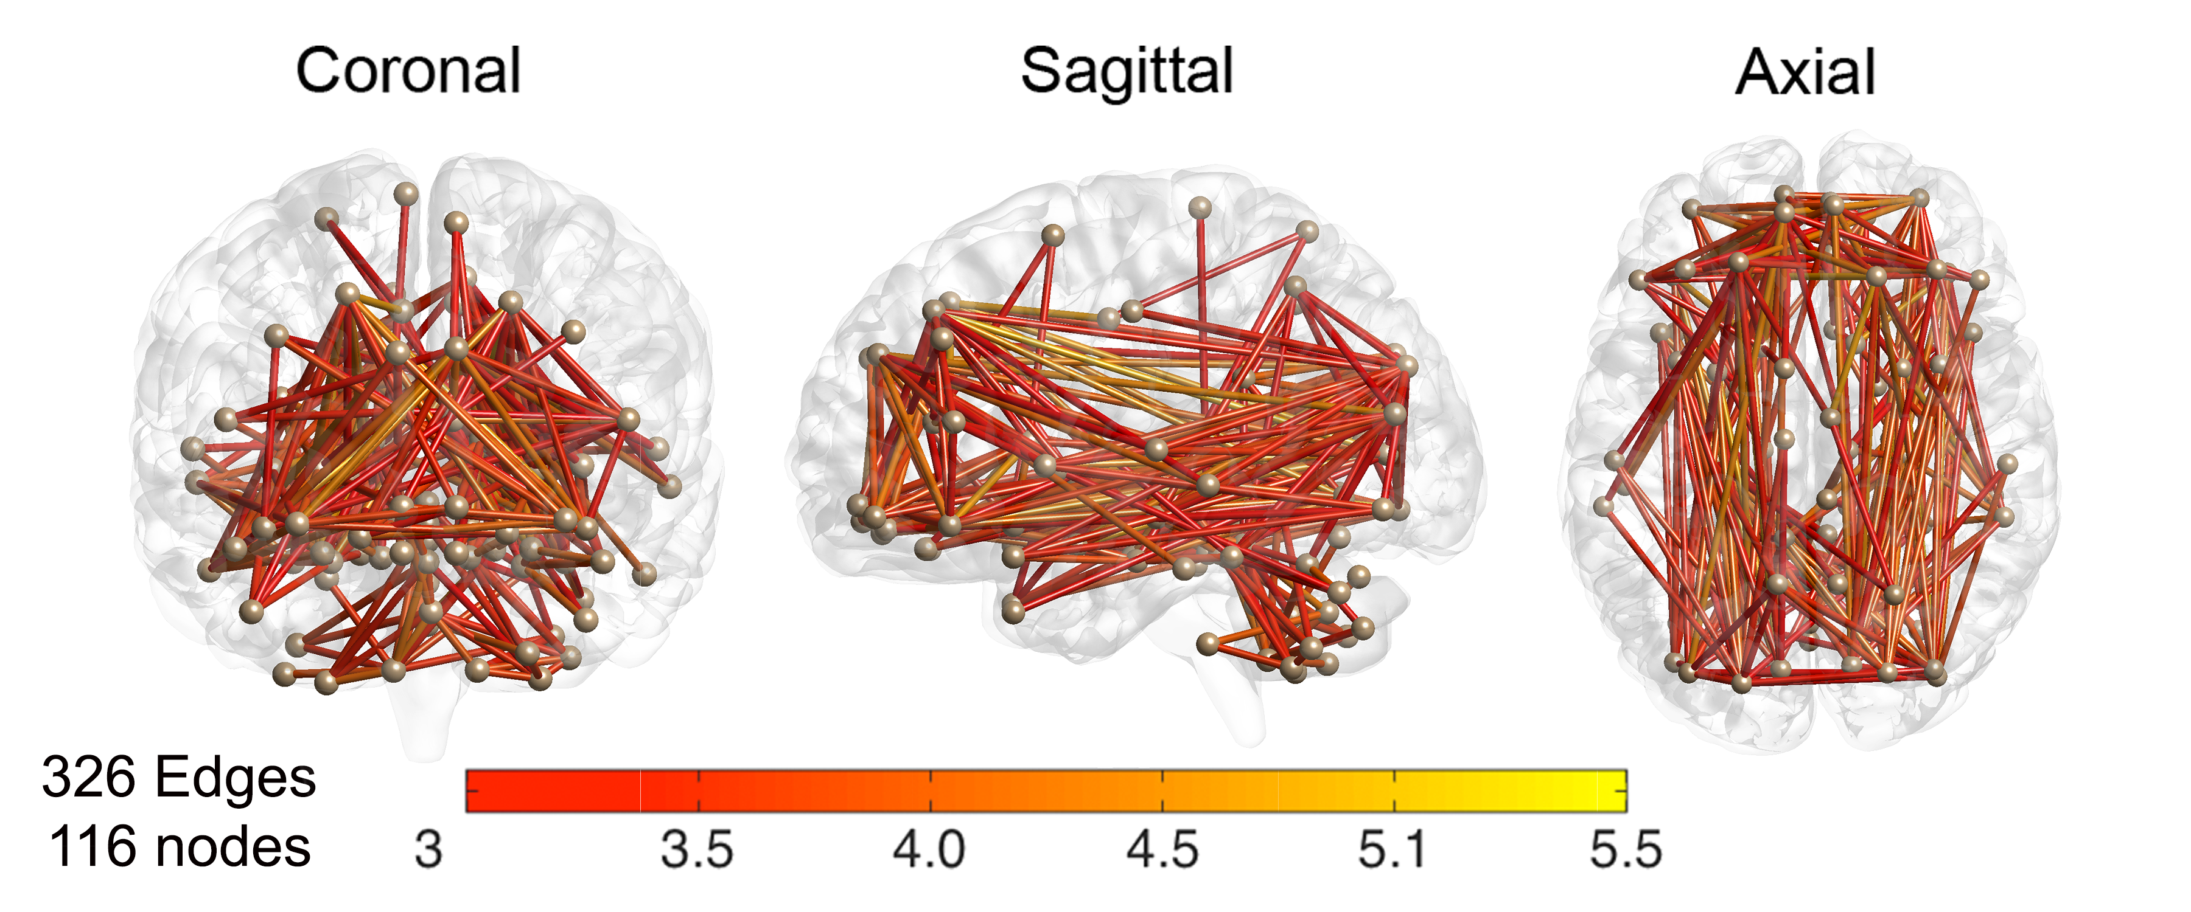

Figure S 6. Widespread FA-weighted network satisfying a linear pattern of decline from early to chronic stages of schizophrenia
Network of white matter connections that satisfied a linear pattern of decline whereby FA was highest in controls, lowest in chronic patients and midway between these extremities in recent-onset patients.

References

Andersson J, Jenkinson M, Smith S (2007). Non-linear optimisation. FMRIB Technical Report.
Andersson J, Jenkinson M, Smith S (2010). Non-linear registration, aka spatial normalisation. .
Jenkinson M, Beckmann CF, Behrens TE, Woolrich MW, Smith SM (2012). Fsl. Neuroimage 62, 782-790.
Tournier J, Calamante F, Connelly A (2007). Robust determination of the fibre orientation distribution in diffusion MRI: non-negativity constrained super-resolved spherical deconvolution. NeuroImage 35, 1459-1472.
Tournier J, Calamante F, Connelly A (2010). Improved probabilistic streamlines tractography by 2nd order integration over fibre orientation distributions. In Proc. 18th Annual Meeting of the Intl. Soc. Mag. Reson. Med.(ISMRM), p. 1670.
Tournier J, Calamante F, Connelly A (2012). MRtrix: diffusion tractography in crossing fiber regions. International Journal of Imaging Systems and Technology 22, 53-66.
Zhang Y, Brady M, Smith S (2001). Segmentation of brain MR images through a hidden Markov random field model and the expectation-maximization algorithm. IEEE transactions on medical imaging 20, 45-57.

