Online Supplementary Material
Do DSM-5 Section II Personality Disorders and Section III Personality Trait Domains Reflect the Same Genetic and Environmental Risk Factors?
T. Reichborn-Kjennerud, R. F. Krueger, E. Ystrom, F. A. Torvik, T. H. Rosenström, S. H. Aggen, S. C. South, M. C. Neale, G. P. Knudsen , K. S. Kendler, N. O. Czajkowski.

Text: Attrition analyses Page 2
Table S1. Model fit for the AE model, and the AE model Page 3 for which the specific genetic effect for a given PD was set to 0 at wave 1 and wave 2.
Table S2. Genetic and environmental variance for DSM-PDs Page 4 and proportion shared with PID-5 domains at wave 1 and 2 from the full AE model
Figure S1a. The proportion of genetic and individual specific Page 5 environmental variance for each DSM-PD that is shared with the PID-5-NBF factors, and unique to each PD at wave 1in the best-fitting models
Figure S1b. The proportion of genetic and individual specific Page 6 environmental variance for each DSM-PD that is shared with the PID-5-NBF factors, and unique to each PD at wave 2 in the best-fitting model
Table S3. Environmental correlations between PID-5 and the Page 7 PD symptom counts at wave 1 and wave 2 based on best-fitting model
References Page 8

Attrition analyses
Detailed previous analyses have, shown that cooperation in the first interview was strongly predicted by female sex, monozygosity and higher educational status, but not by symptoms of psychiatric disorders or substance abuse (Tambs et al., 2009). Participation in wave 2 was predicted by high education (p<0.001 adjusted for sex and age), female sex (p=0.003) and monozygosity (p=0.001). Non-participants in wave 2 had on average 0.82 more sub-threshold PD criteria than participants (p<0.001). Of the 10 PDs assessed at wave 1, criteria were significantly higher in non-participants in wave 2 only for ASPD (0.09 criteria difference, p<0.001) and narcissistic PD (0.09 p=0.002). Neither the total number of axis I disorders nor any specific disorder was significantly higher in the non-participation group (Reichborn-Kjennerud et al., 2015).

Table S1. Model fit for the AE model, and the AE model with specific genetic effect for a given PD criteri counts set to 0.
 | AIC for AE model | AIC for AE model with no specific A for PD
Wave 1*
Schitzotypal | -2554.885 | -2555.339
Schizoid | -2618.04 | -2617.458
Paranoid | -891.5554 | -891.7443
Histrionic | -263.2433 | -261.0847
Narcissitic | -592.4801 | -590.4186
Antisocial | -2715.883 | -2715.403
Borderline | -632.7333 | -633.2535
Avoidant | -831.3306 | -827.9182
Dependent | -1025.229 | -1023.176
Obsessive-Compulsve | 485.0138 | 487.6148
Wave 2**
Schitzotypal | -3187.798 | -3189.114
Paranoid | -2570.762 | -2572.724
Antisocial | -3471.62 | -3473.62
Borderline | -1749.344 | -1751.344
Avoidant | -2163.242 | -2164.185
Obsessive-Compulsve | -67.90163 | -66.16574
*PID-5-NBF domains measured 10 years after the DSM-IV PD criteria counts
** PID-5-NBF domains and DSM-IV PD criteria counts measured concurrently
Lowest AIC indicated in bold.

Table S2. Genetic and environmental variance for DSM-PDs and proportion shared with PID-5 domains at wave 1 and 2 from the full AE model

 | Genetic Effects |  |  | Individual Environmental Effects
 | a² | % Shared  with PID-5 | % Unique | e² | % Shared  with PID-5 | % Unique
Wave 1*
Paranoid | 0,19 | 60,85 | 39,15 | 0,81 | 2,10 | 97,90
Schizoid | 0,27 | 54,74 | 45,26 | 0,73 | 1,10 | 98,90
Schitzotypal | 0,26 | 58,75 | 41,25 | 0,74 | 3,90 | 96,10
Antisocial | 0,41 | 52,08 | 47,92 | 0,59 | 4,40 | 95,60
Borderline | 0,36 | 67,13 | 32,87 | 0,64 | 3,88 | 96,12
Histrionic | 0,33 | 42,25 | 57,75 | 0,67 | 2,98 | 97,02
Narcissitic | 0,25 | 38,55 | 61,45 | 0,75 | 1,60 | 98,40
Avoidant | 0,35 | 57,23 | 42,77 | 0,65 | 7,65 | 92,35
Dependent | 0,30 | 54,64 | 45,36 | 0,70 | 3,72 | 96,28
Obsessive-Compulsve | 0,27 | 27,72 | 72,28 | 0,73 | 4,77 | 95,23
Wave 2**
Paranoid | 0,18 | 91,85 | 8,15 | 0,82 | 9,69 | 90,31
Schitzotypal | 0,31 | 75,08 | 24,92 | 0,69 | 6,34 | 93,66
Antisocial | 0,38 | 100,00 | 0,00 | 0,62 | 3,25 | 96,75
Borderline | 0,30 | 100,00 | 0,00 | 0,70 | 9,10 | 90,90
Avoidant | 0,30 | 76,27 | 23,73 | 0,71 | 20,54 | 79,46
Obsessive-Compulsve | 0,22 | 43,26 | 56,74 | 0,79 | 7,52 | 92,48

a², Total genetic variance (heritability) for DSM PDs
e², Total environmental variance for DSM PDs
*PID-5-NBF domains measured 10 years after the DSM-IV PD criteria counts
** PID-5-NBF domains and DSM-IV PD criteria counts measured concurrently

Figure S1a. The proportion of genetic and individual specific environmental variance for each DSM-PD that is shared with the PID-5-NBF factors, and unique to each PD at wave 1in the best-fitting models

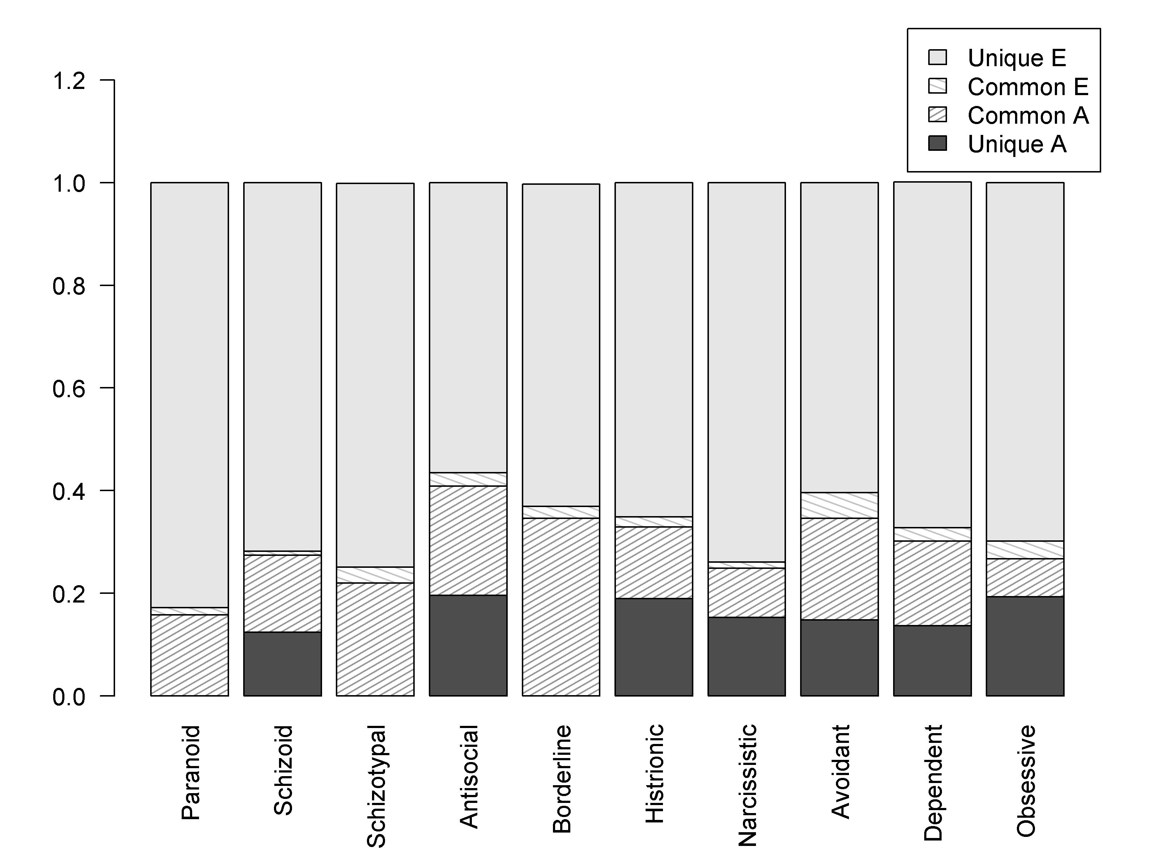
Figure S1b. The proportion of genetic and individual specific environmental variance for each DSM-PD that is shared with the PID-5-NBF factors, and unique to each PD at wave 2in the best-fitting model
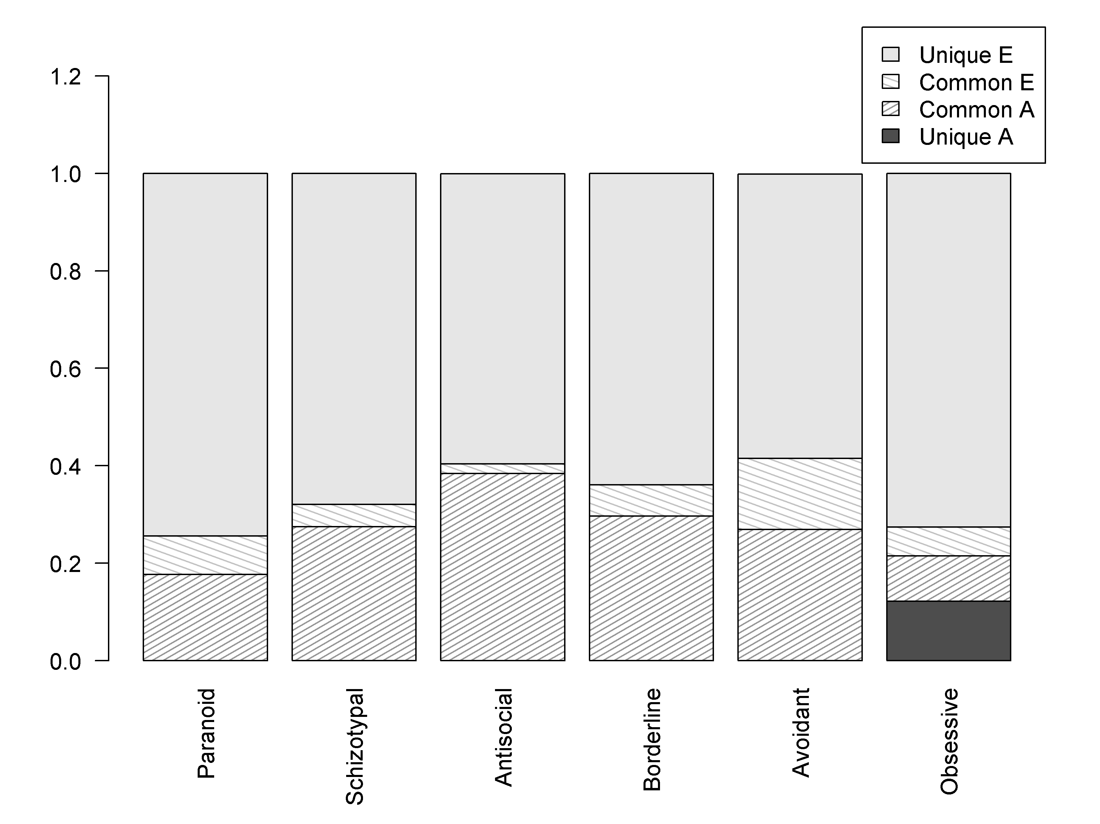

Table S3. Environmental correlations between PID-5 and the DSM-IV PD criteria counts at wave 1 and wave 2 based on best-fitting model.
 | Negative  affectivity | Detachment | Antagonism | Disinhibition | Compulsivity | Psychotisism
Wave 1*
Paranoid | 0.09  ( 0.01 , 0.17 ) | 0.11  ( 0.02 , 0.2 ) | 0.06  ( -0.03 , 0.14 ) | 0.01  ( -0.08 , 0.1 ) | 0.04  ( -0.06 , 0.12 ) | 0.07  ( -0.02 , 0.15 )
Schizotypal | 0.17  ( 0.06 , 0.27 ) | 0.17  ( 0.06 , 0.27 ) | 0.07  ( -0.04 , 0.17 ) | 0.07  ( -0.03 , 0.17 ) | 0.06  ( -0.04 , 0.16 ) | 0.08  ( -0.01 , 0.17 )
Schizoid | 0.03  ( -0.07 , 0.13 ) | 0.06  ( -0.04 , 0.16 ) | -0.01  ( -0.11 , 0.09 ) | 0.04  ( -0.06 , 0.14 ) | 0.01  ( -0.09 , 0.11 ) | 0.08  ( -0.01 , 0.18 )
Antisocial | 0.1  ( -0.01 , 0.21 ) | 0.08  ( -0.03 , 0.19 ) | 0.2  ( 0.09 , 0.3 ) | 0.05  ( -0.06 , 0.15 ) | 0.09  ( -0.02 , 0.19 ) | 0.11  ( 0.01 , 0.21 )
Histrionic | 0.11  ( 0.02 , 0.19 ) | 0.01  ( -0.07 , 0.1 ) | 0.1  ( 0.02 , 0.19 ) | 0.09  ( 0 , 0.17 ) | 0.02  ( -0.06 , 0.11 ) | 0.13  ( 0.05 , 0.22 )
Narcissistic | 0.03  ( -0.05 , 0.12 ) | 0.01  ( -0.07 , 0.1 ) | 0.06  ( -0.03 , 0.14 ) | 0.08  ( -0.01 , 0.16 ) | 0.06  ( -0.02 , 0.15 ) | 0.1  ( 0.02 , 0.18 )
Borderline | 0.14  ( 0.05 , 0.22 ) | 0.11  ( 0.02 , 0.2 ) | 0.04  ( -0.05 , 0.13 ) | 0.11  ( 0.03 , 0.2 ) | 0.12  ( 0.04 , 0.21 ) | 0.16  ( 0.07 , 0.24 )
Avoidant | 0.22  ( 0.13 , 0.3 ) | 0.22  ( 0.13 , 0.3 ) | 0  ( -0.09 , 0.09 ) | 0.03  ( -0.06 , 0.11 ) | 0.12  ( 0.03 , 0.2 ) | 0.15  ( 0.07 , 0.23 )
Dependent | 0.15  ( 0.06 , 0.23 ) | 0.11  ( 0.02 , 0.2 ) | 0.06  ( -0.03 , 0.14 ) | 0.11  ( 0.02 , 0.19 ) | 0.1  ( 0.02 , 0.18 ) | 0.16  ( 0.08 , 0.25 )
Obsessive-Compulsive  Compulsive | 0.12  ( 0.04 , 0.19 ) | 0.11  ( 0.03 , 0.19 ) | 0.09  ( 0.01 , 0.17 ) | 0.03  ( -0.05 , 0.11 ) | 0.2  ( 0.13 , 0.28 ) | 0.11  ( 0.02 , 0.19 )
Wave 2**
Paranoid | 0.22  ( 0.13 , 0.31 ) | 0.23  ( 0.13 , 0.32 ) | 0.19  ( 0.09 , 0.29 ) | 0.05  ( -0.05 , 0.15 ) | 0.1  ( 0 , 0.2 ) | 0.18  ( 0.08 , 0.27 )
Schizotypal | 0.12  ( 0.01 , 0.23 ) | 0.19  ( 0.07 , 0.29 ) | 0.2  ( 0.09 , 0.31 ) | 0.06  ( -0.05 , 0.17 ) | 0.07  ( -0.04 , 0.18 ) | 0.09  ( -0.01 , 0.18 )
Antisocial | -0.01  ( -0.13 , 0.11 ) | 0.02  ( -0.11 , 0.14 ) | 0.16  ( 0.04 , 0.28 ) | 0.06  ( -0.06 , 0.18 ) | 0  ( -0.12 , 0.12 ) | 0.04  ( -0.08 , 0.15 )
Borderline | 0.24  ( 0.16 , 0.31 ) | 0.17  ( 0.08 , 0.26 ) | 0.1  ( 0.01 , 0.19 ) | 0.16  ( 0.07 , 0.25 ) | 0.05  ( -0.04 , 0.14 ) | 0.24  ( 0.16 , 0.33 )
Avoidant | 0.34  ( 0.25 , 0.42 ) | 0.36  ( 0.27 , 0.45 ) | 0.04  ( -0.06 , 0.14 ) | 0.07  ( -0.02 , 0.17 ) | 0.27  ( 0.19 , 0.36 ) | 0.24  ( 0.15 , 0.33 )
Obsessive-Compulsive | 0.17  ( 0.09 , 0.25 ) | 0.1  ( 0.01 , 0.18 ) | 0.13  ( 0.05 , 0.22 ) | 0.04  ( -0.04 , 0.13 ) | 0.24  ( 0.16 , 0.32 ) | 0.16  ( 0.08 , 0.25 )
95% confidence intervals are given in parentheses
*PID-5-NBF domains measured 10 years after the DSM-IV PD criteria counts
** PID-5-NBF domains and DSM-IV PD criteria counts measured concurrently
.

References
Reichborn-Kjennerud T, Czajkowski N, Ystrom E, Orstavik R, Aggen SH, Tambs K, Torgersen S, Neale MC, Roysamb E, Krueger RF, Knudsen GP, Kendler KS (2015). A longitudinal twin study of borderline and antisocial personality disorder traits in early to middle adulthood. Psychological Medicine 45, 3121-31.
Tambs K, Ronning T, Prescott CA, Kendler KS, Reichborn-Kjennerud T, Neale MC, Torgersen S, Harris JR (2009). The Norwegian Institute of Public Health twin study of mental health: examining recruitment and attrition bias. Twin Research and Human Genetics 12, 158-68.

