Supplementary materials
Results
Reaction times
Mean reaction times were based on correctly predicted trials. Comparison of non-depressed and depressed PD patients revealed no significant interactions with GROUP as a between-subject factor, but there was a significant DRUG*REVERSAL interaction (F_{(1,39)}=5.65, p=0.022) across groups. This interaction was driven by a simple main effect of DRUG on reversal trials (F_{(1,39)}=6.89, p=0.012). Patients responded more slowly on reversal trials when they were tested ON versus OFF medication. There was no drug effect on non-reversal trials (p=0.2). There was also a main effect of REVERSAL (F_{(1,39)}=5.69, p=0.022). Patients responded significantly faster on reversal trials compared with non-reversal trials. And a main effect of DRUG (F_{(1,39)}=5.50, p=0.024). Patients responded significantly faster when they were ON versus OFF medication. There were no significant interactions with VALENCE as factor en no significant main effects of GROUP or VALENCE.

Outcome-general reversal related brain signal
Unexpected outcomes (collapsed across reward and punishment, both patient groups and drug sessions) revealed significant BOLD signal changes (p<0.05 cluster-level FWE-corrected threshold across the whole-brain combined with a cluster-forming threshold of p<0.001 uncorrected) in the bilateral anterior insular cortex, the bilateral middle frontal cortex and the anterior cingulate cortex relative to expected outcomes (Figure S1 and Table S2).

Valence-specific BOLD signal changes during expected outcomes
Whole brain analyses revealed differences in BOLD signal changes during expected outcomes [expected reward – expected punishment] between depressed and non-depressed patients. There was a significant (p<0.05 cluster-level FWE-corrected threshold across the whole-brain combined with a cluster-forming threshold of p<0.001 uncorrected) group difference in BOLD signal in the bilateral ventral anterior cingulate cortex (x=12, y=48, z=10, T=4.58, p_{wb_fwe}=0.012). Decomposition of this interaction revealed that expected reward induced significantly greater increases in BOLD signal in the ventral anterior cingulate cortex than expected punishment in depressed patients (x=-1, y=48, z=8, T=4.64, p_{wb_fwe}<0.001). This effect was not observed in non-depressed patients (Figure S2).

Discussion
In addition to the between-group difference in striatal BOLD signal elicited by unexpected outcomes reported in the main text, we also observed between-group differences in BOLD signal elicited by expected outcomes in the ventral anterior cingulate cortex (ACC). Specifically, in contrast to non-depressed patients, depressed patients exhibited significantly greater increases in ventral ACC BOLD signal elicited by expected reward relative to expected punishment. The ventral ACC is part of the brain’s limbic system and tightly connected with for instance the amygdala, hypothalamus and nucleus accumbens (Bush et al., 2000, Etkin et al., 2011). Aberrant ventral ACC function has been a consistent finding in depressed individuals (non-PD) ((Rive et al., 2013, Drevets and Savitz, 2008), for a meta-analysis see (Pizzagalli, 2011)). Interestingly, enhanced activation of the ventral ACC has been particularly observed in studies where depressed individuals or individuals with a remitted depression performed at the same level as healthy controls (Rose et al., 2006, Walter et al., 2009, Wagner et al., 2006, Schoning et al., 2009) and was hypothesized to reflect over-recruitment of these areas as compensatory mechanism (Pizzagalli, 2011). Similarly in our sample, enhanced recruitment of the ventral ACC in patients with a PD-related depression (history) was accompanied by unimpaired performance on expected reward relative to expected punishment trials. Together, this would concur with the hypothesis that patients with PD-related depression (history) exhibit a general reward learning deficit, which surfaces more readily on reversal trials due to its higher demands for learning. Thus, it is possible that over-recruitment of the ventral ACC enables them to overcome this deficit during the less demanding non-reversal trials, while they fail to do so during the more demanding reversal trials.

References
BUSH, G., LUU, P. & POSNER, M. I. 2000. Cognitive and emotional influences in anterior cingulate cortex. Trends in Cognitive Sciences, 4, 215-222.
DREVETS, W. C. & SAVITZ, J. 2008. The Subgenual Anterior Cingulate Cortex in Mood Disorders. Cns Spectrums, 13, 663-681.
ETKIN, A., EGNER, T. & KALISCH, R. 2011. Emotional processing in anterior cingulate and medial prefrontal cortex. Trends in Cognitive Sciences, 15, 85-93.
PIZZAGALLI, D. A. 2011. Frontocingulate Dysfunction in Depression: Toward Biomarkers of Treatment Response. Neuropsychopharmacology, 36, 183-206.
RIVE, M. M., VAN ROOIJEN, G., VELTMAN, D. J., PHILLIPS, M. L., SCHENE, A. H. & RUHE, H. G. 2013. Neural correlates of dysfunctional emotion regulation in major depressive disorder. A systematic review of neuroimaging studies. Neuroscience and Biobehavioral Reviews, 37, 2529-2553.
ROSE, E. J., SIMONOTTO, E. & EBMEIER, K. P. 2006. Limbic over-activity in depression during preserved performance on the n-back task. Neuroimage, 29, 203-215.
SCHONING, S., ZWITSERLOOD, P., ENGELIEN, A., BEHNKEN, A., KUGEL, H., SCHIFFBAUER, H., LIPINA, K., PACHUR, C., KERSTING, A., DANNLOWSKI, U., BAUNE, B. T., ZWANZGER, P., REKER, T., HEINDEL, W., AROLT, V. & KONRAD, C. 2009. Working-Memory fMRI Reveals Cingulate Hyperactivation in Euthymic Major Depression. Human Brain Mapping, 30, 2746-2756.
WAGNER, G., SINSEL, E., SOBANSKI, T., KOHLER, S., MARINOU, V., MENTZEL, H. J., SAUER, H. & SCHLOSSER, R. G. M. 2006. Cortical inefficiency in patients with unipolar depression: An event-related MRI study with the Stroop task. Biological Psychiatry, 59, 958-965.
WALTER, M., HENNING, A., GRIMM, S., SCHULTE, R. F., BECK, J., DYDAK, U., SCHNEPF, B., BOEKER, H., BOESIGER, P. & NORTHOFF, G. 2009. The Relationship Between Aberrant Neuronal Activation in the Pregenual Anterior Cingulate, Altered Glutamatergic Metabolism, and Anhedonia in Major Depression. Archives of General Psychiatry, 66, 478-+.
Table S1. Depression diagnosis and antidepressant use
Subject | Age | DD* | Current diagnosis | Past diagnosis | Antidepressant use
1 | 62 | 2,51 |  | Dysthymic disorder around PD diagnosis | 0
2 | 60 | 2,51 |  | Adjustment disorder with depressed mood after receiving PD diagnosis | 0
3 | 59 | 12,76 |  | Minor depressive disorder around PD diagnosis | 0
4 | 59 | 2,84 |  | Minor depressive disorder around PD diagnosis | 0
5 | 54 | 1,84 | Minor depressive disorder |  | 0
6 | 54 | 5,08 |  | Minor depressive disorder after receiving PD diagnosis | 0
7 | 46 | 1,75 |  | Minor depressive disorder 3 years before PD diagnosis | 0
8 | 63 | 2,92 |  | Minor depressive disorder 2 years before PD diagnosis | 0
9 | 64 | 4,09 |  | Major depressive disorder during puberty, MDD 1 year before PD diagnosis | 0
10 | 65 | 7,26 |  | Minor depressive disorder after receiving PD diagnosis | 0
11 | 58 | 8,01 |  | Minor depressive disorder 6 months before PD diagnosis | 0
12 | 56 | 7,26 |  | Major depressive disorder 6 years after PD diagnosis | 0
13 | 54 | 2,75 | Minor depressive disorder | Postnatal depression | 0
14 | 64 | 5,34 |  | Major depressive disorder around PD diagnosis | 1
15 | 55 | 3,51 |  | Minor depressive disorder after PD diagnosis | 1
16 | 51 | 2,51 | Major depressive disorder |  | 1
17 | 64 | 6,76 | Major depressive disorder | Four past major depressive episodes, first episode at 44 years of age, 2 episodes within 5 years before PD diagnosis, one episode 4 years after diagnosis | 1
18 | 58 | 7,34 |  | Minor depressive disorder at 38 years of age, minor depressive disorder 6 years after PD diagnosis | 1
19 | 65 | 14,52 | Minor depressive disorder |  | 1
* DD = disease duration Parkinson’s disease (years from diagnosis)
Table S2. Outcome-general reversal related brain signal
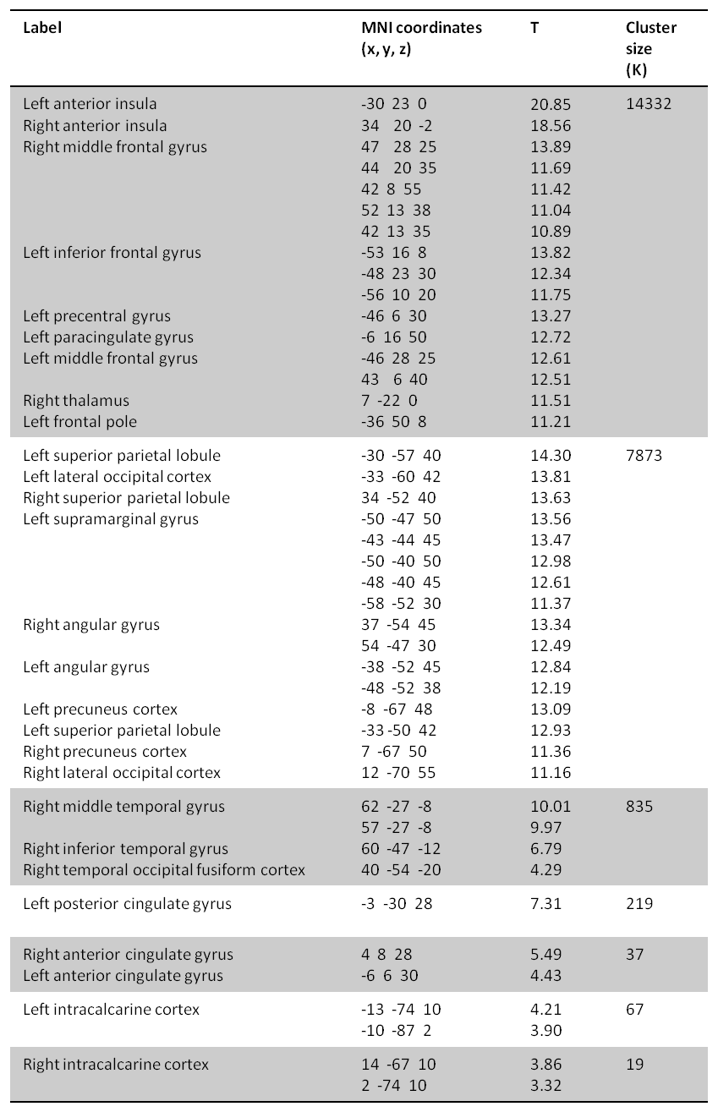
Outcome-general reversal-related [unexpected outcomes – expected outcomes] increases in BOLD signal across patient groups and drug sessions. Peaks at p<0.001 uncorrected.

Figure S1. Outcome-general reversal related BOLD signal
Fig. S1 Outcome-general, reversal-related [unexpected outcomes – expected outcomes] increases in BOLD signal. Results presented at a p<0.05 cluster-level FWE-corrected threshold across the whole-brain combined with a cluster-forming threshold of p<0.001 uncorrected.

Figure S2. BOLD signal during expected outcomes
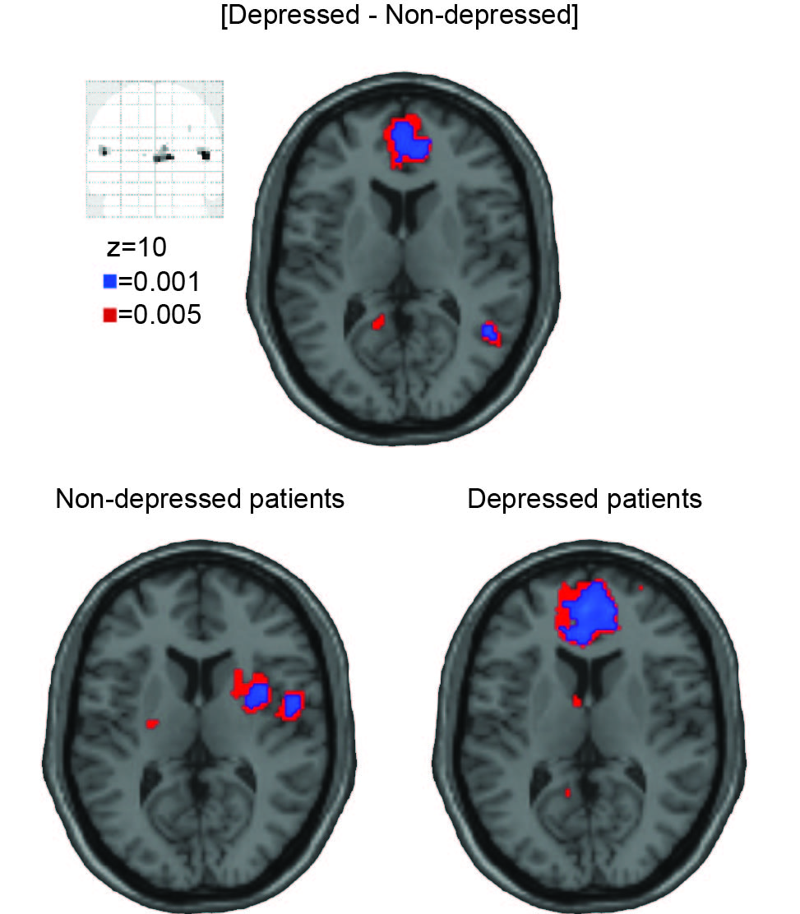
Fig. S2 Valence-specific [expected reward – expected punishment] BOLD signal changes in the ventral anterior cingulate cortex for the contrast [depressed - non-depressed patients] and for both groups separately (non-depressed patients and depressed patients). Data presented at p<0.001 uncorrected (blue) and at p<0.005 uncorrected (red). The group difference in the ventral anterior cingulated cortex survives a p<0.05 cluster-level FWE-corrected threshold across the whole-brain combined with a cluster-forming threshold of p<0.001 uncorrected.

