SUPPLEMENTARY MATERIAL

A. Overview of study selection
Search strategy
We searched the electronic databases PUBMED, PsycINFO, and Embase for relevant articles using a broad set of search terms: (trauma OR childhood abuse OR abuse OR early life stress OR maltreatment OR stress exposure OR Bullying OR emotional abuse OR sexual abuse OR physical abuse) AND (eating disorders OR anorexia nervosa OR anorexia OR bulimia OR binge eating). Additional literature was traced through backward searches in which the references that were made to the seminal papers on the association of interest (Oppenheimer et al. 1985 [219 citations]; Root and Fallon, 1988 [141 citations]) were checked. In addition, the reference sections of the identified articles were reviewed in order to detect papers that we may have missed in our previous efforts to detect the papers that met our inclusion criteria.
The majority of the studies (83%) included only females and in only 3 studies (47, 90, 100) the majority of subjects was male. The mean age of the included samples was ~25 years. Most of the studies were performed in the USA (32%), the UK (22%), and Canada (14%).

Figure S1. Flowchart on identification, screening and inclusion of eligible publications
Additional unique records identified through backward searches and reference lists of papers
(n = 22)
Unique records identified through databases PUBMED, PsycINFO, EMBASE, and Web of Science
(n = 3,938)
Identification

Records excluded
(n = 3,829)
Records screened after duplications were removed
(n = 3,960)
Screening

Eligibility
Full-text articles excluded: n = 49, because of:
- No ED diagnosis (n = 24)
- No CM (n=20)
- No data available (n = 5)

Full-text articles assessed for eligibility
(n = 131)

Studies included in quantitative synthesis
(n = 82)
Included

B. Quality assessment of the included studies
Quality of the included studies was assessed using the Newcastle-Ottawa Scale (NOS; Wells et al. 2015) as recommended by the Cochrane Collaboration (2015). Overall quality of an individual study was defined as the number of items on the three scales that composes the NOS (i.e. selection, comparability, and exposure) that was met by the study. NOS scores of half of the studies were performed twice to calculate agreement over assessments. Agreement among assessment proved to be good (Cohen’s Kappa = 0.81; standard error = 0.19). Below on page 2 and 3 (Table S1 [studies that included a control group] and Table S2 [studies that did not include a control group], detailed information is provided on the inferred methodological quality of the included studies. In case there were differences, we took the mean quality score between the two ratings as the “quality score” of an individual study. Quality of the studies was not part of the inclusion or exclusion criteria but was related to individual study outcome by means of meta-regression analyses.

Table S1 Newcastle-Ottawa quality assessment of studies that included a (healthy or psychiatric) reference group
 | Selection | Comparability | Exposure | Total
Steiger & Zanko, 1990 | * | * | ** | 4
Stuart et al. 1990 | ** | --- | * | 3
Folsom et al. 1993 | *** | * | ** | 6
Rorty et al. 1994 | *** | --- | ** | 5
Garfinkel et al. 1995 | *** | --- | ** | 5
Kern & Hastings, 1995 | *** | * | * | 5
Olivardia et al. 1995 | ** | * | --- | 3
Sullivan et al. 1995 | ** | --- | ** | 4
Brown et al. 1997 | ** | --- | --- | 2
Casper & Lyubomirsky, 1997 | ** | * | --- | 3
Fairburn et al. 1997 | *** | --- | * | 4
Favaro & Santonastaso, 1997 | ** | --- | ** | 4
Friedman et al. 1997 | ** | --- | * | 3
Welch et al. 1997 | *** | --- | * | 4
Fairburn et al. 1998 | *** | --- | * | 4
Favaro et al. 1998 | *** | --- | * | 4
Deep et al. 1999 | *** | * | * | 5
Steiger et al. 2000 | ** | --- | * | 3
Webster & Palmer, 2000 | *** | --- | * | 4
Karwautz et al. 2001 | ** | * | * | 4
Grilo & Masheb, 2001 | *** | --- | * | 4
Nagata et al. 2001 | ** | --- | ** | 4
Waller et al. 2001 | ** | --- | ** | 4
Schoemaker et al. 2002 | **** | * | * | 6
Striegel-Moore et al. 2002 | *** | * | * | 5
Léonard et al. 2003 | ** | * | * | 4
Rayworth et al. 2004 | ** | ** | ** | 6
Steiger et al. 2004 | ** | * | ** | 5
Wentz et al. 2005 | ** | ** | * | 5
Kugu et al. 2006 | *** | * | ** | 6
Allison et al. 2007 | ** | --- | * | 3
Corstorphine et al. 2007 | ** | --- | * | 3
Cumella & Kally, 2008 | ** | * | ** | 5
Sanci et al. 2008 | *** | * | * | 5
Favaro et al. 2010 | ** | * | ** | 5
Machado et al. 2010 | *** | * | * | 5
Mangweth-Matzek et al. 2010 | *** | * | ** | 6
Steiger et al. 2010 | * | --- | ** | 3
Jaite et al. 2012 | *** | * | ** | 6
Sachs-Ericsson et al. 2012 | ** | * | * | 4
Brewerton et al. 2014 | *** | * | * | 5
Machado et al. 2014 | *** | * | ** | 6
Monteleone et al. 2015 | *** | * | ** | 6
* Indicates that one point is added

Table S2 Newcastle-Ottawa quality assessment of studies that did not include a reference group
 | Selection | Comparability | Exposure | Total
Oppenheimer et al. 1985 | ** | N.A. | ** | 4
Root & Fallon, 1988 | ** | N.A. | * | 3
Palmer et al. 1990 | *** | N.A. | ** | 5
Waller 1992 | * | N.A. | * | 2
Herzog et al. 1993 | * | N.A. | * | 2
Pitts & Waller 1993 | * | N.A. | * | 2
Schmidt et al. 1993 | *** | N.A. | ** | 5
Pope et al. 1994 | * | N.A. | * | 2
Waller 1994 | * | N.A. | ** | 3
Fullerton et al. 1995 | ** | N.A. | ** | 4
Schmidt et al. 1995 | ** | N.A. | * | 2
Sullivan et al. 1995 | ** | N.A. | ** | 4
Steiger et al. 1996 | ** | N.A. | ** | 4
Anderson et al. 1997 | ** | N.A. | * | 3
Waller 1998 | ** | N.A. | * | 3
Matsunaga et al. 1999 | * | N.A. | * | 2
Mahon et al. 2001 | ** | N.A. | * | 3
Romans et al. 2001 | ** | N.A. | * | 3
Grilo & Masheb, 2002 | ** | N.A. | ** | 4
Hartt & Waller, 2002 | * | N.A. | * | 2
Basurte et al. 2004 | * | N.A. | * | 2
Lockwood et al. 2004 | * | N.A. | --- | 1
Van Gerko et al. 2005 | ** | N.A. | * | 3
Vaz Leal et al. 2005 | * | N.A. | * | 2
Carter et al. 2006 | * | N.A. | * | 2
Nickel et al. 2006 | ** | N.A. | ** | 4
Claes & Vandereycken, 2007 | ** | N.A. | ** | 4
Feldman & Meyer, 2007 | * | N.A. | * | 2
Hepp et al. 2007 | * | N.A. | * | 2
Wonderlich et al. 2007 | ** | N.A. | ** | 4
Bardone-Cone et al. 2008 | ** | N.A. | ** | 4
Favaro et al. 2008 | * | N.A. | * | 2
Richardson et al. 2008 | ** | N.A. | * | 3
Steiger et al. 2008 | ** | N.A. | * | 3
Kong & Bernstein, 2009 | * | N.A. | * | 2
Becker & Grilo, 2011 | ** | N.A. | * | 3
Backholm et al. 2013 | ** | N.A. | ** | 4
Castellini et al. 2013 | ** | N.A. | * | 3
Tasca et al. 2013 | ** | N.A. | * | 3
Groleau et al. 2014 | * | N.A. | * | 2
Racine & Wildes, 2015 | ** | N.A. | * | 3
* Indicates that one point is added

C. Description of included studies

Table S3 Basic characteristics of the included studies
Author, year | Diagnostic assessment | Childhood maltreatment assessment, before age in years (between brackets) | Eating disorder severity / characteristic and/or comorbidity assessment
Oppenheimer et al. 1985 | DSM-III (current) | Life events questionnaire (< 16 y) | None
Root & Fallon, 1988 | DSM-III (current) | Bulimia and related eating disorder screen (< 16) | None
Palmer et al. 1990 | DSM-III (current) | Sexual life events questionnaire (< 16 ) | None
Steiger & Zanko, 1990 | DSM-III-R (current) | Self constructed questionnaire (< 20) | None
Stuart et al. 1990 | DSM-III-R (current) | Victimization inventory (< 18) | None
Waller, 1992 | DSM-III-R (current) | Sexual life events questionnaire (< 18) | EAT-26, bingeing, BMI, vomiting
Folsom et al. 1993 | DSM-III-R (current) | Sexual life events questionnaire (< 18) | EDI, SCL-90 depression and anxiety
Herzog et al. 1993 | DSM-III-R (current) | Traumatic antecedents interview (< 18) | None
Pitts & Waller 1993 | DSM-III-R (current) | Sexual life events questionnaire (< 18) | EAT-26, bingeing, vomiting
Schmidt et al. 1993 | DSM-III-R (current) | Sexual life events questionnaire (< 16) | None
Pope et al. 1994 | DSM-III-R (lifetime) | Interview (< 18) | None
Rorty et al. 1994 | DSM-III-R (lifetime) | Questionnaire and interview (< 14) | PD and anxiety/depression/substance abuse comorbidity (DSM-III-R, current)
Waller 1994 | DSM-III-R (current) | Sexual life events questionnaire (< 14) | BPD comorbidity (DSM-III-R, current)
Fullerton et al. 1995 | DSM-III-R (current) | Interview (< 18) | Alcohol use, suicide attempts
Garfinkel et al. 1995 | DSM- III-R (current) | N.K. (< 18) | None
Kern & Hastings, 1995 | DSM- III-R (current) | Interview (< 16) | None
Olivardia et al. 1995 | DSM- III-R (current) | Life events questionnaire (< 16) | None
Schmidt et al. 1995 | DSM- III-R (current) | Sexual life events questionnaire (< 14) | None
Sullivan et al. 1995 | DSM-III-R (current) | Interview (< 16) | Age at onset, vomiting, purging, BMI, suicide attempts, alcohol/drug dependence
Steiger et al. 1996 | DSM-III-R (current) | Interview (< 14) | PD comorbidity (DSM-III-R, current)
Anderson et al. 1997 | DSM-III-R (current) | Interview (< 17) | BDI, EAT, binging + vomiting
Brown et al. 1997 | DSM-III-R (current) | Sexual life events questionnaire (< 18) | None
Casper & Lyubomirsky, 1997 | DSM-III-R (current) | Interview (< 17) | None
Fairburn et al. 1997 | DSM-IV (current) | Interview (N.K.) | None
Favaro & Santonastaso, 1997 | DSM-III-R (current) | Interview (< 18) | Suicidality
Friedman et al. 1997 | DSM-IV (current) | Interview (< 18) | None
Welch et al. 1997 | DSM-IV (current) | Interview (< 18) | None
Fairburn et al. 1998 | DSM-IV (current) | Interview (N.K.) | None
Favaro et al. 1998 | DSM-III-R (current) | Interview (< 18) | Suicidality, bingeing + vomiting
Waller 1998 | DSM-IV (current) | Interview (< 14) | EAT-26
Deep et al. 1999 | DSM-III-R (current) | Interview (< 18) | Substance dependence (DSM-III, current)
Matsunaga et al. 1999 | DSM-III-R (lifetime) | Interview (< 18) | Vomiting, purging, suicide attempts
Steiger et al. 2000 | DSM-IV (current) | Childhood trauma interview (< 14) | BPD comorbidity (DSM-IV)
Webster & Palmer, 2000 | DSM-III-R (current) | Sexual life events questionnaire and lack of care index (< 16) | None
Grilo & Masheb, 2001 | DSM-IV (current) | Childhood trauma questionnaire (< 18) | BDI
Karwautz et al. 2001 | DSM-IV (lifetime) | Interview (< 18) | None
Mahon et al. 2001 | ICD-10 (current) | Interview (< 16) | None
Nagata et al. 2001 | DSM-IV (current) | Questionnaire (< 18) | None
Romans et al. 2001 | ICD-10 (current) | Interview (< 16) | None
Waller et al. 2001 | DSM-III-R (current) | Interview (< 14) | BDI, bingeing, vomiting
Grilo & Masheb, 2002 | DSM-IV (current) | Childhood Trauma Interview (< 18) | PD comorbidity (DSM-IV, current)
Hartt & Waller, 2002 | DSM-IV (current) | Child abuse and trauma scale (< 14) | BITE, vomiting, purging
Schoemaker et al. 2002 | DSM-III-R (current) | Interview (< 18) | Dual diagnosis-, substance use-, and other comorbidity (DSM-III-R, current)
Table S4 continues on the next page

Table S4 continued
Striegel-Moore et al. 2002 | DSM-IV (current) | Oxford assessment (< 18) | None
Léonard et al. 2003 | DSM-IV (current) | Childhood Trauma Interview (< 14) | Vomiting; purging; EAT-26
Basurte et al. 2004 | DSM-IV (current) | Interview (< 18) | Borderline personality traits
Lockwood et al. 2004 | DSM-IV (current) | Interview (< 14) | None
Rayworth et al. 2004 | DSM-IV (current) | Childhood trauma questionnaire (< 18) | None
Steiger et al. 2004 | DSM-IV (current) | Childhood Trauma Interview (< 14) | None
Van Gerko et al. 2005 | DSM-IV (current) | Interview (< 14) | Vomiting; purging
Vaz Leal et al. 2005 | DSM-IV (current) | Interview (< 18) | Vomiting, purging, EAT-40, SCL-90
Wentz et al. 2005 | DSM-III-R (lifetime) | Sexual life events inventory (< 18) | None
Carter et al. 2006 | DSM-IV (current) | Interview (< 18) | EDE-Q, SCL-90, BDI
Kugu et al. 2006 | DSM-IV (current) | Childhood abuse and neglect questionnaire (< 16) | None
Nickel et al. 2006 | DSM-IV (current) | Question (< 18) | Suicidality
Allison et al. 2007 | DSM-IV (current) | Childhood trauma questionnaire (< 18) | None
Claes & Vandereycken, 2007 | DSM-IV (current) | Trauma questionnaire (NK) | Self injurious behaviour
Corstorphine et al. 2007 | DSM-IV (current) | Interview (< 14) | Impulsivity, suicide attempts
Feldman & Meyer, 2007 | DSM-IV (lifetime) | Question (< 18) | None
Hepp et al. 2007 | DSM-IV (lifetime) | Interview (< 17) | None
Wonderlich et al. 2007 | DSM-IV (current) | Childhood trauma questionnaire (< 18) | Anxiety, bingeing, EDE, mood, vomiting
Bardone-Cone et al. 2008 | DSM-IV (lifetime) | Childhood trauma questionnaire (< 18) | None
Cumella & Kally, 2008 a, b | DSM-IV (lifetime) | Question (< 18) | None
Richardson et al. 2008 | DSM-IV (lifetime) | Childhood trauma interview (< 14) | DSM-IV axis I comorbidity
Sanci et al. 2008 | DSM-IV (lifetime) | Questionnaire (< 16) | None
Steiger et al. 2008 | DSM-IV (current) | Childhood trauma interview (< 18) | None
Kong & Bernstein, 2009 | DSM-IV TR (current) | Childhood trauma questionnaire (< 18) | EDI, BDI
Favaro et al. 2010 | DSM-IV (lifetime) | Question (< 18) | None
Mangweth-Matzek et al. 2010 | Email DSM-IV (current) | Interview (< 18) | None
Steiger et al. 2010 | DSM-IV (current) | Childhood trauma interview (< 14) | None
Becker & Grilo, 2011 | DSM-IV (current) | Childhood trauma questionnaire (< 18) | EDE, BDI
Jaite et al. 2012 | DSM-IV (current) | Childhood trauma interview (< 18) | None
Sachs-Ericsson et al. 2012 | DSM-IV (current) | Interview (< 18) | None
Backholm et al. 2013 | DSM-IV | Interview (< 17) | None
Castellini et al. 2013 | DSM-IV (current) | Childhood abuse questionnaire (< 17) | EDE, purging, EDE
Tasca et al. 2013 | DSM-IV (current) | Child abuse and trauma scale (< 18) | None
Brewerton et al. 2014 | DSM-IV (lifetime) | Interview (< 18) | None
Groleau et al. 2014 | DSM-IV TR (current) | Childhood trauma interview (< 18) | None
Machado et al. 2014 | DSM-IV (lifetime) | Oxford risk factor interview (N.K.) | None
Racine et al. 2014 | DSM-IV (current) | Childhood trauma questionnaire (< 18) | None
Monteleone et al. 2015 | DSM-IV (current) | Childhood trauma questionnaire (< 18) | Age at onset, BITE
Racine & Wildes, 2015 | DSM-IV TR (current) | Childhood trauma questionnaire (< 18) | BMI, EDE
Abbreviations: BITE, bulimic investigatory test (Henderson and Freeman, 1987); BDI, Beck’s depression inventory (Beck et al. 1988); BPD, bipolar disorder; DSM, diagnostic and statistical manual of mental disorders (APA, 2000/2013); EAT, eating attitudes test (Mintz and O’Halloran, 2000); EDE, eating disorder examination (Luce and Crowther, 1999); EDI, eating disorder inventory (Wear and Pratz, 1987); PD, Personality disorder; SCL-90, Symptom Check list 90 (Derogatis and Cleary, 1977).

D. Supplementary Figures
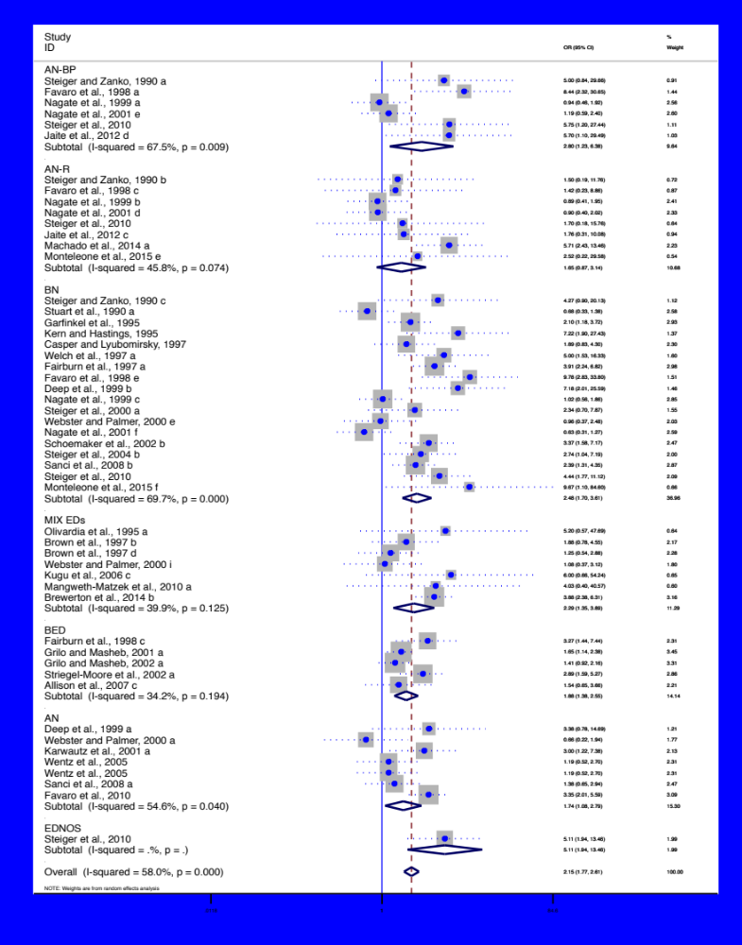
Figure S2. Forest-plot showing that sexual CM (yes vs. no) is associated with increased odds on an ED [analysis vs. healthy controls] – by type of ED

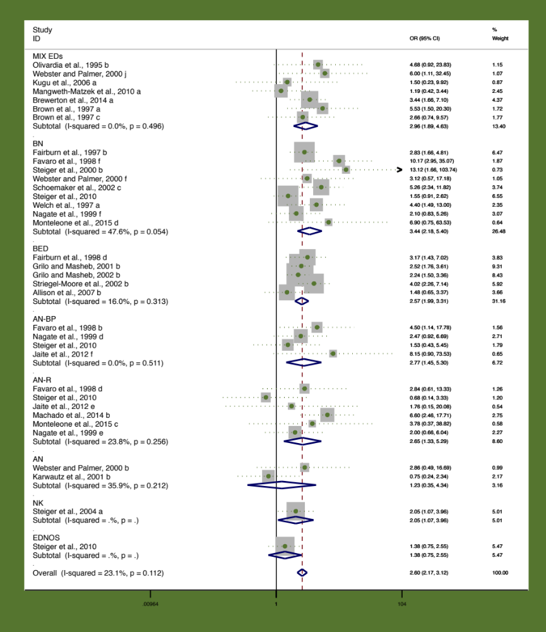
Figure S3. Forest-plot showing that physical CM (yes vs. no) is associated with increased odds on an ED [analysis vs. healthy controls] – by type of ED

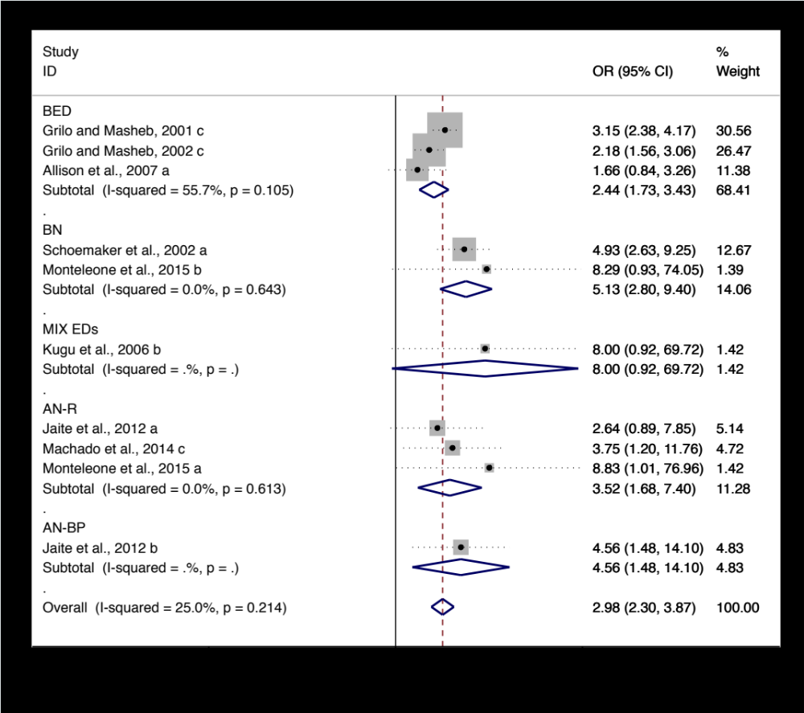
Figure S4. Forest-plot showing that emotional CM (yes vs. no) is associated with increased odds on an ED [analysis vs. healthy controls] – by type of ED
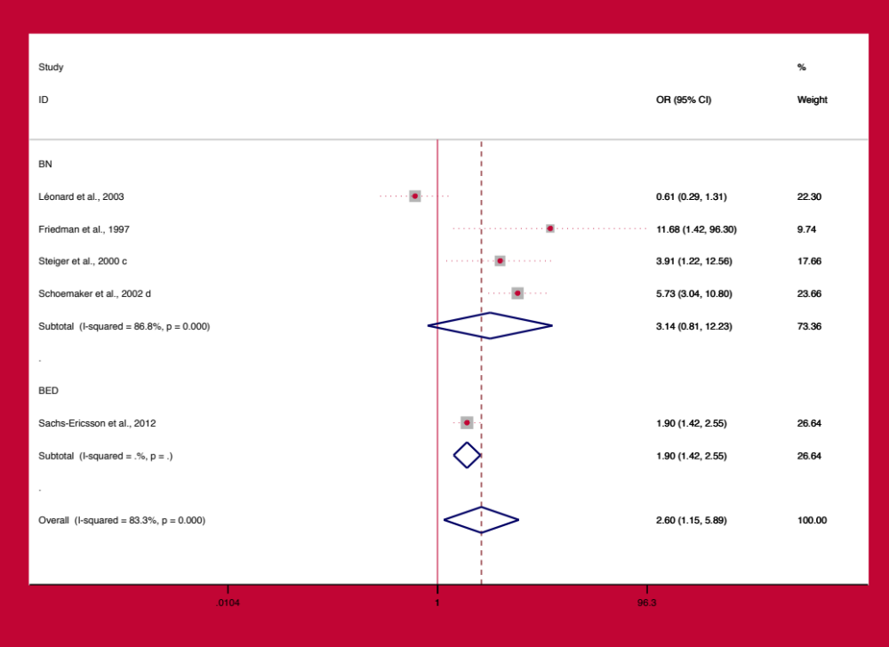
Figure S5. Forest-plot showing that double CM exposure (yes vs. no) is associated with increased odds on an ED [analysis vs. healthy controls] – by type of ED

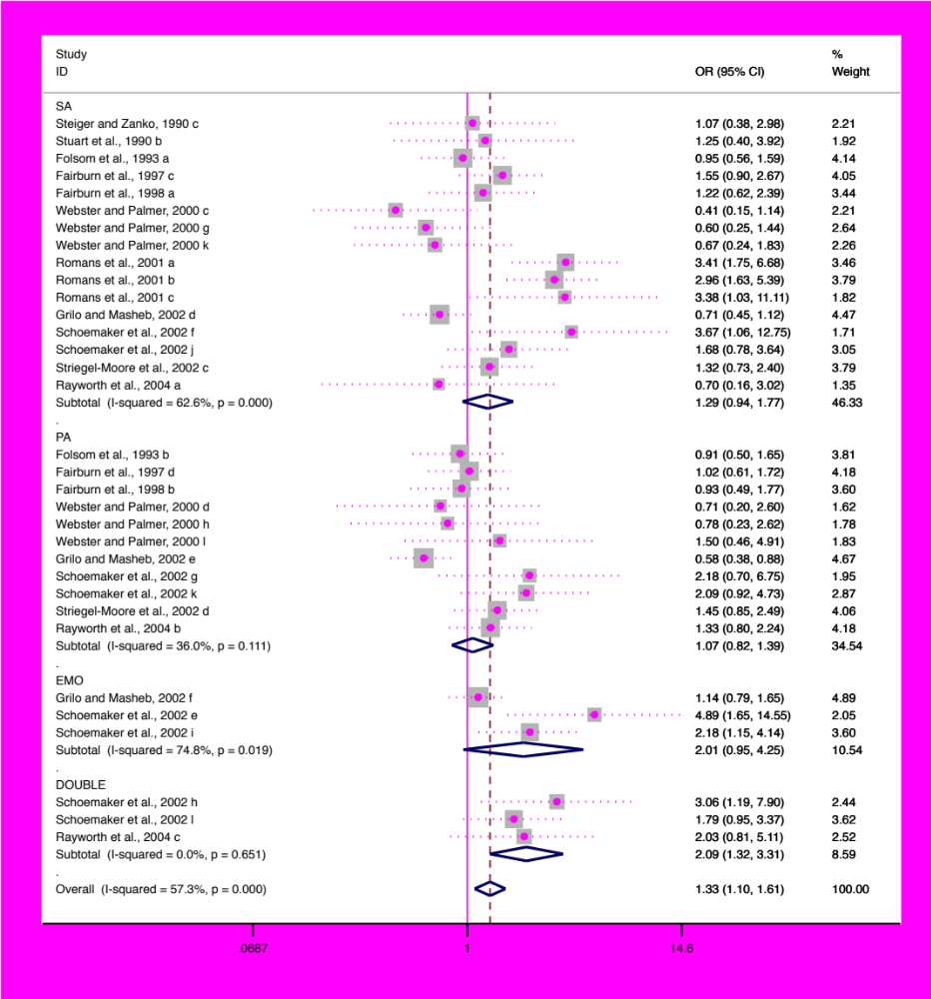
Figure S6. Forest-plot showing that exposure to CM (yes vs. no) is associated with increased odds on an ED [analysis vs. psychiatric controls] – by type of CM

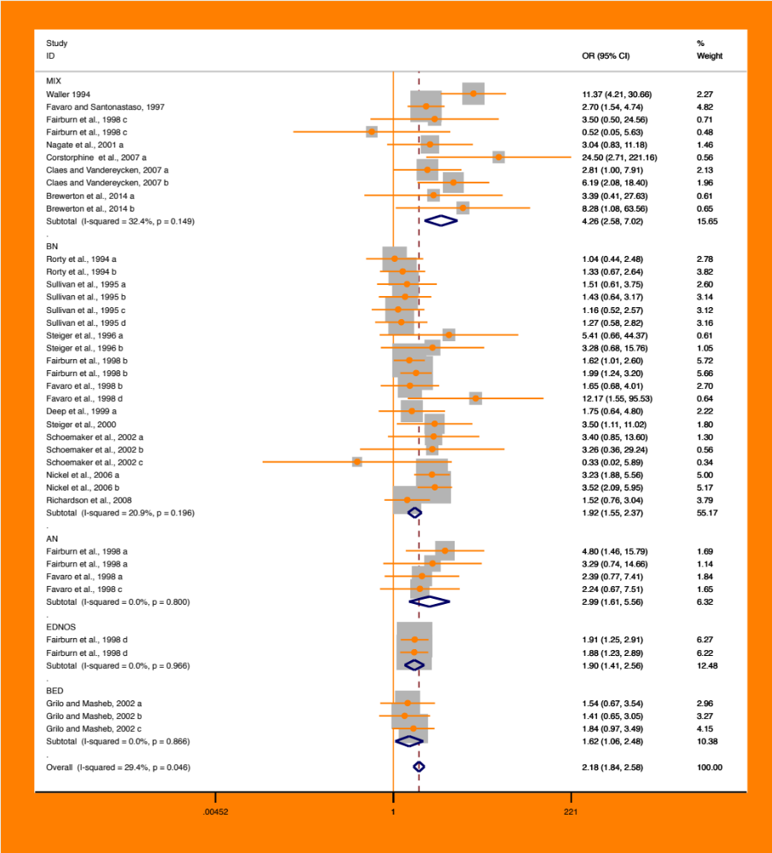
Figure S7. Forest-plot showing that CM (yes vs. no) is associated with increased odds on axis I and II comorbidity and suicidality/self-harm in patients with an ED – by type of ED

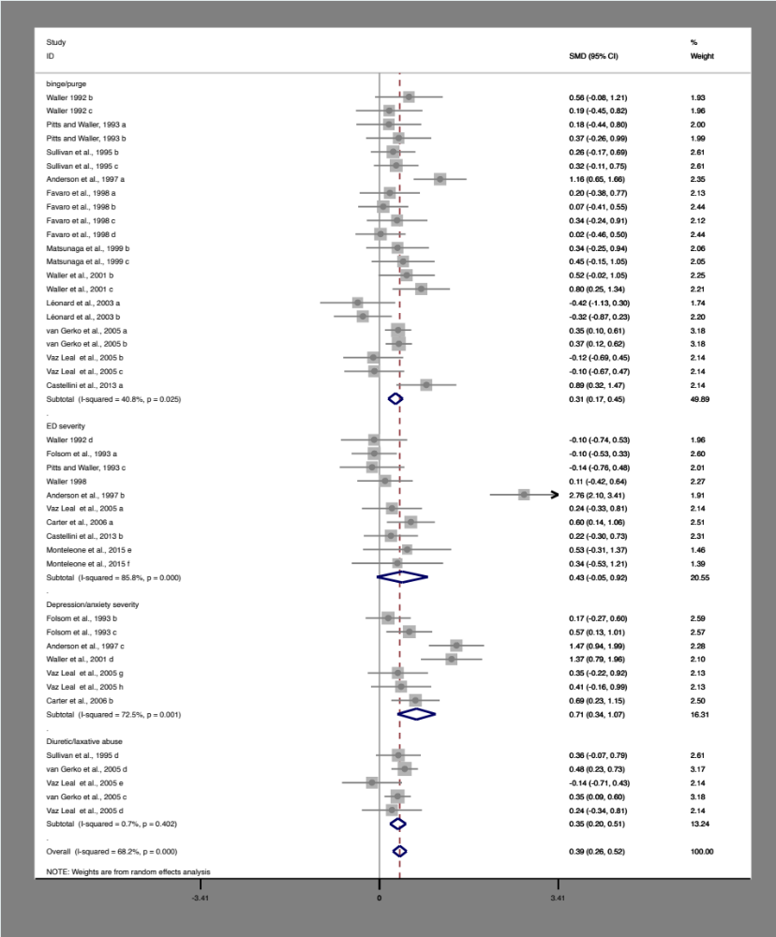
Figure S8. Forest-plot showing that any CM (yes vs. no) within patients with an ED is associated with a higher frequency of bingeing and purging, a higher severity of ED/depression/anxiety severity levels, and a higher use of diuretics and laxatives.

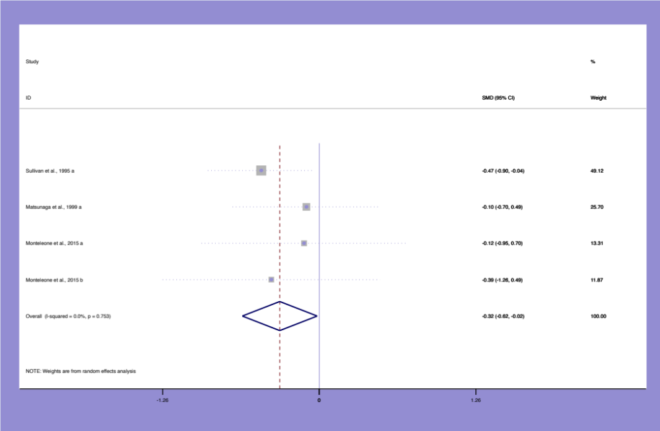Figure S9. Forest-plot showing that any CM (yes vs. no) within patients with an ED is associated with an earlier age at onset.

References to the papers that were included in the meta-analysis
Oppenheimer R, Howells K, Palmer RL, Chaloner DA (1985). Adverse sexual experience in childhood and clinical eating disorders: a preliminary description. Journal of Psychiatric Research 19, 357-361.

Root MPP, Fallon P (1988). The incidence of victimization experiences in a bulimic sample. Journal of Interpersonal Violence 3, 161-173.

Palmer RL, Oppenheimer R, Dignon A, Chaloner DA, Howells K (1990). Childhood sexual experiences with adults reported by women with eating disorders: an extended series. British Journal of Psychiatry 156, 699-703.

Steiger H, Zanko M (1990). Sexual traumata among eating-disordered, psychiatric, and normal female groups. Journal of Interpersonal Violence 5, 74-86.

Stuart GW, Laraia MT, Ballenger JC, Lydiard RB (1990). Early family experiences of women with bulimia and depression. Archives of Psychiatric Nursing 4, 43-52.

Waller G (1992). Sexual abuse and the severity of bulimic symptoms. British Journal of Psychiatry 161, 90-93.

Folsom V, Krahn D, Nairn K, Gold L, Demitrack MA, Silk KR (1993). The impact of sexual and physical abuse on eating disordered and psychiatric symptoms: a comparison of eating disordered and psychiatric inpatients. International of Journal Eating Disorders 13, 249-257.

Herzog Db, Staley JE, Carmody S, Robbins WM, van der Kolk BA (1993). Childhood sexual abuse in anorexia nervosa and bulimia nervosa: a pilot study. Journal of the American Academy of Child Psychiatry 32, 962-966

Pitts C, Waller G (1993). Self-denigratory beliefs following sexual abuse: association with the symptomatology of bulimic disorders. International Journal of Eating Disorders 13, 407-410.

Schmidt UH, Tiller J, Treasure JL (1993). Setting the scene for eating disorders: childhood care, classification and course of illness. Psychological Medicine 23: 663-672.

Pope HG, Mangweth B, Brooking Negrão MA, Hudson JI, Cordas TA (1994). Childhood sexual abuse and bulimia nervosa: a comparison of American, Austrian, and Brazilian women. American Journal of Psychiatry 151, 732-737.

Rorty M, Yager J, Rossotto E (1994). Childhood sexual, physical, and psychological abuse and their relationship to comorbid psychopathology in bulimia nervosa. International Journal of Eating Disorders 21, 317-334.

Waller G (1994). Childhood sexual abuse and borderline personality disorder in the eating disorders. Child Abuse and Neglect 18, 97-101.

Fullerton DT, Wonderlich SA, Gosnell BA (1995). Clinical characteristics of eating disorder patients who report sexual or physical abuse. International Journal of Eating Disorders 17, 243-249.

Garfinkel PE, Lin E, Goering P, Spegg C, Goldbloom DS, Kennedy S Kaplan AS, Woodside D. (1995). Bulimia nervosa in a Canadian community sample: prevalence and comparison of subgroups. American Journal of Psychiatry 152, 1052-1058.

Kern J, Hastings T (1995). Differential family environment of bulimics and victims of childhood sexual abuse: achievement orientation. Journal of Clinical Psychology 51, 499-506.

Olivardia R, Pope HG, Mangweth B, Hudson JL (1995). Eating disorders in college men. American Journal of Psychiatry 1995; 152: 1279-1285.

Schmidt U, Evans K, Tiller J, Treasure J (1995). Puberty, sexual milestones and abuse: how are they related in eating disorder patients. Psychological Medicine 25, 413-417.

Sullivan PF, Bulik CM, Carter FA, Joyce PR (1995). The significance of a history of childhood sexual abuse in bulimia nervosa. British Journal of Psychiatry 167, 679-682.

Steiger H, Jabalpurwala S, Champagne J (1996). Axis II comorbidity and developmental adversity in bulimia nervosa. Journal of Nervous and Mental Disease 184, 555-560.

Anderson KP, Laporte D, Brandt H, Crawford S (1997). Sexual abuse and bulimia: response to inpatient treatment and preliminary outcome. Journal of Psychiatric Research 31, 621-633.

Brown L, Russell J, Thornton C, Dunn S (1997). Experiences of physical and sexual abuse in Australian general practice attenders and an eating disordered population. Australian and New Zealand Journal of Psychiatry 31, 398-404.

Casper RC, Lyubomirsky S (1997). Individual psychopathology relative to reports of unwanted sexual experiences as predictor of a bulimic eating pattern. International Journal of Eating Disorders 21, 229-236.

Fairburn CG, Welch SL, Doll HA, Davies BA, O’Conner ME (1997). Risk Factors for Bulimia Nervosa. Archives of General Psychiatry 54, 509-517.

Favaro A, Santonastaso P (1997). Suicidality in eating disorders: clinical and psychological correlates. Acta Psychiatrica Scandinavia 95, 508-514.

Friedman MA, Wilfley DE, Welch RR, Kunce JT (1997). Self-directed hostility and family functioning in normal-weight bulimics and overweight binge eaters. Addictive Behaviour 22, 367-375.

Welch SL, Doll HA, Fairburn CG (1997). Life events and the onset of bulimia nervosa. Psychological Medicine 27, 515-522.

Fairburn CG, Doll HA, Welch SL, Hay PJ, Davies BA, O’Connor ME (1998). Risk factors for binge eating disorders: a community-based, case control study. Archives of General Psychiatry 55, 425-432.

Favaro A, Grave D, Santonastaso P (1998). Impact of a history of physical and sexual abuse in eating disordered and asymptomatic subjects. Acta Psychiatrica Scandinavia 97, 358-363.

Waller G (1998). perceived control in eating disorders: relationship with reported sexual abuse. International Journal of Eating Disorders 23, 213-216.

Deep AL, Lilenfeld LR, Plotnicov KH, Pollice C, Kaye WH (1999). Sexual abuse in eating disorder subtypes and control women: the role of comorbid substance dependence in bulimia nervosa. International Journal of Eating Disorders 25, 1-10.

Matsunaga H, Kaye WH, McConaha CRN, Plotonicov K, Pollice CBA, Rao R, Stein D (1999). Psychopathological characteristics of recovered bulimics who have a history of physical or sexual abuse. Journal of Nervous and Mental Disease 187, 472-477.

Steiger H, Léonard S, Kin NMK, Ladouceur C, Ramdoyal D, Young SN (2000). Childhood abuse and platelet tritiated-paroxetine binding in bulimia nervosa: implications for borderline personality disorder. Journal of Clinical Psychiatry 61, 427-435.

Webster JJ, Palmer RL (2000). The childhood and family background of women with clinical eating disorders: a comparison with women with major depression and women without psychiatric disorder. Psychological Medicine 30, 53-60.

Grilo CM, Masheb RM (2001). Childhood psychological, physical, and sexual maltreatment in outpatients with binge eating disorder: frequency and associations with gender, obesity, and eating related psychopathology. Obesity Research XX, 320-325.

Karwautz A, Rabe-Hesketh S, Hu X, Zhao J, Sham P, Collier DA, Treasure JL (2001). Individual-specific risk factors for anorexia nervosa: a pilot study using a discordant sister-pair design. Psychological Medicine 31, 317-329.

Mahon J, Bradley NS, Harvey PK, Winston AP, Palmer RL (2001). Childhood trauma has dose effect relationship with dropping out from psychotherapeutic treatment for bulimia nervosa: a replication. International Journal of Eating Disorders 30, 138-148.

Nagata H, Kaye WH, Kiriki N, Rao R, Plotnicov KH (2001). Physical and sexual abuse histories in patients with eating disorders: A comparison of Japanese and American patients. Psychiatry and Clinical Neuroscience 55, 333-340.

Romans SE, Gendall KA, Martin JL, Mullen PE (2000). Child sexual abuse and later disordered eating: a New Zealand epidemiological study. International Journal of Eating Disorders 29, 280-392.

Waller G, Meyer C, Ohanian V, Elliott P, Dickson C, Sellings J (2001). The psychopathology of bulimic women who report childhood sexual abuse: the mediating role of core beliefs. Journal of Nervous and Mental Disease 189, 700-708.

Grilo CM, Masheb RM (2002). Childhood maltreatment and personality disorders in adult patients with binge eating disorder. Acta Psychiatrica Scandinavia 106, 183-188.

Hartt J, Waller G (2002). Child abuse, dissociation, and core beliefs in bulimic disorders. Child Abuse and Neglect 26, 923-938.

Schoemaker C, Smit F, van Bijl R, Vollebergh WAM (2002). Bulimia Nervosa following psychological and multiple child abuse: support for the self-medication hypothesis in a population-based cohort study. International Journal of Eating Disorders 32, 381-388.

Striegel-Moore RH, Dohm F-A, Pike KM, Wifley DE, Fairburn CG (2002). Abuse, bullying, and discrimination as risk factors for binge eating disorder. American Journal of Psychiatry 159, 1902-1907.

Léonard S, Steiger H, Kao A (2003). Childhood and adulthood abuse in bulimic and nonbulimic women: prevalence and psychological correlates. International Journal of Eating Disorders 33, 397-405.

Basurte E, Díaz-Marsá M, Martín O, Carrasco JL (2004). Traumatic childhood background, impulsiveness and hypothalamus-pituitary-adrenal dysfunction in eating disorders; a pilot study. Actas Españolas Psiquiatricas 32, 149-152.

Lockwood R, Lawson R, Waller G (2004). Compulsive features in the eating disorders: a role for trauma. Journal of Nervous and Mental Disease 192, 247-249.

Rayworth BB, Wise LA, Harlow BL (2004). Childhood abuse and risk of eating disorders in women. Epidemiology 15, 271-278.

Steiger H, Gauvin L, Israël M, Kin NMKN, Young SN, Roussin J (2004). Serotonin function, personality variations and childhood abuse in women with bulimia-spectrum eating disorders. Journal of Clinical Psychiatry 65, 830-837.

Van Gerko K, Hughes ML, Hamil M, Waller G (2005). Reported childhood sexual abuse and eating-disordered cognitions and behaviors. Child Abuse and Neglect 18, 375-382.

Vaz Leal FJ, Guisado Marcias JA, Garcia-Herraiz MA, López Vinuesa B, Monge Bautista M, Bolivar Perálvarez M (2005). History of sexual abuse in patients with bulimia nervosa: its influence on clinical status. Actas Españolas Psiquiatricas 33, 135-140.

Wentz E, Gillberg IC, Gillberg G, Råstman M (2005). Fertility and history of sexual abuse at 1-year follow-up of adolescent-onset anorexia nervosa. International Journal of Eating Disorders 37, 294-298.

Carter JC, Bewell C, Blackmore E, Woodside DB (2006). The impact of childhood abuse in anorexia nervosa. Child Abuse Neglect 30, 257-269.

Kugu N, Akyuz G, Dogan O, Ersan E, Izgic F (2006). The prevalence of eating disorders among University students and the relationship with some individual characteristics. Aus NZ Journal Psychiatry 40, 129-135.

Nickel C, Simek M, Moleda A, Muehlbacher M, Buschmann W, Fartacek R Bachler E, Egger C, Rother WK, Loew TH, Nickel MK (2006). Suicide attempts versus suicidal ideation in bulimic female adolescents. Pediatrics International 2006; 48, 374-381.

Allison KC, Grilo CM, Masheb RM, Stunkard AJ (2007). High self-reported rates of neglect and emotional abuse, by persons with binge eating disorder and night eating syndrome. Behaviour Research and Therapy 45, 2874-2883.

Claes L, Vandereycken W (2007). Is there a link between traumatic experiences and self-injurious behaviors in eating-disordered patients? Treatment and Prevention 15, 305-315.

Corstorphine E, Waller G, Lawson R, Ganis C (2007). Trauma and multiple-impulsivity in the eating disorders. Eating Behaviour 8, 23-30.

Feldman MB, Meyer IH (2007). Childhood abuse and eating disorders in gay and bisexual men. International Journal of Eating Disorders 49, 418-423.

Hepp U, Spindler A, Schnyder U, Kraemer B, Milos G (2007). Post-traumatic stress disorder in women with eating disorders. Eating and Weigth Disorders 12, 24-27.

Wonderlich SA, Rosenfeldt S, Crosby RD, Mitchell JE, Engel SG, Smyth J, Miltenberger R (2007). The effects of childhood trauma on daily mood lability and comorbid psychopathology in bulimia nervosa. Journal of Traumatic Stress 20, 77-87.

Bardone-Cone AM, Maldonado CR, Crosby RD, Mitchell JE, Wonderlich SA, Joiner Jr. TE et al (2008). Revisiting differences in individuals with bulimia nervosa with and without a history of anorexia nervosa: eating pathology, personality, and maltreatment. International Journal of Eating Disorders 41, 697-704.

Cumella EJ, Kally Z (2008). Comparison of middle-age and young women inpatients with eating disorders. Eating and Weight Disorders 13, 183-190.

Richardson J, Steiger H, Schmitz N, Joober R, Bruce KR, Israel M, Gauvin L, Anestin AS, Dandurand C, Howard H, de Guzman R (2008). Relevance of the 5-HTTLPR polymorphism and childhood abuse to increased psychiatric comorbidity in women with bulimia spectrum disorders. Journal of Clinical Psychiatry 69, 981-990.

Sanci L, Coffey C, Olsson C, Reid S, Carlin JB, Patton G (2008). Childhood sexual abuse and eating disorders in females. Findings from the Victorian adolescent health cohort study. Archives of Pediatric and Adolescent Medicine 162, 261-267.

Kong S, Bernstein K (2009). Childhood trauma as a predictor of eating psychopathology and its mediating variables in patients with eating disorders. Journal of Clinical Nursing 18, 1897-1907.

Steiger H, Richardson J, Joober R, Israel M, Bruce KR, Ying Kin NMK, Howard H, Anestin A, Dandurand C, Gauvein L (2008). Dissocial behavior, the 5HTTLPR polymorphism, and maltreatment in women with bulimic syndromes. American Journal of Medical Genetics part B (Neuropsychiatric Genetics) 147B, 128-130.

Favaro A, Tenconi E, Santonastaso P (2010). The interaction between perinatal factors and childhood abuse in the risk of developing anorexia nervosa. Psychological Medicine 40, 657-665.

Mangweth-Matzek B, Rupp CI, Hausmann A, Gusmerotti S, Kemmler G, Biebl W (2010). Eating disorders in men: current features and childhood factors. Eating and Weight Disorders 15, 15-22.

Steiger H, Richardson J, Schmitz N, Israel M, Bruce KR, Gauvin L (2010). Trait-defined eating disorder subtypes and history of childhood abuse. International Journal of Eating Disorders 43, 428-423.

Becker DF, Grilo CM (2011). Childhood maltreatment in women with binge-eating disorder: associations with psychiatric comorbidity, psychological functioning, and eating pathology. Eating and Weight Disorders 16, 113-120.

Jaite C, Schneider N, Hilbert A, Pfeiffer E, Lehmkuhl U, Salbach-Andrae H (2012). Etiological role of childhood emotional trauma and neglect in adolescent anorexia nervosa: a cross-sectional questionnaire analysis. Psychopathology 45, 61-66.

Sachs-Ericsson N, Keel PK, Selby EA, Verona E, Cougle JR, Palmer E (2012). Parental disorders, childhood abuse, and binge eating in a large community sample. International Journal of Eating Disorders 45, 316-325.

Castellini G, Lo Suaro C, Lelli L, Godini L, Vignozzi L, Rellini AH, Faravelli C, Maggi M, Ricca V (2013). Childhood sexual abuse moderates the relationship between sexual functioning and eating disorder psychopathology in anorexia nervosa: a 1-year follow-up study. International Society of Sexual Medicine 10, 2190-2200.

Jaite C, Schneider N, Hilbert A, Pfeiffer E, Lehmkuhl U, Salbach-Andrae H (2012). Etiological role of childhood emotional trauma and neglect in adolescent anorexia nervosa: a cross-sectional questionnaire analysis. Psychopatholy 45, 61-66.

Tasca GA, Ritchie K, Zachariades F, Proulx G, Trinneer A, Balfour L, Demidenko N, Hayden G, Wong A, Bissada H (2013). Attachment insecurity mediates the relationship between childhood trauma and eating disorder psychopathology in a clinical sample: a structural equation model. Child Abuse and Neglect 37, 926-933.

Backholm K, Isomaa R, Birgegård A (2013). The prevalence and impact of trauma history in eating disorder patients. European Journal of Psychotraumatology 4, 1-8.

Brewerton TD, Rance SJ, Dansky BS, O’Neil PM, Kilpatrick DG (2014). A comparison of women with child-adolescent versus adult onset binge eating: results from the National Women’s Study. International Journal of Eating Disorders 47, 836-843.

Groleau P, Joober R, Israel M, Zeramdini N, DeGuzman R, Steiger H (2014). Methylation of the dopamine D2 receptor (DRD2) gene promotor in women with bulimia-spectrum disorder: associations with borderline personality disorder and exposure to childhood abuse. Journal of Psychiatric Research 48, 121-127.

Machado BC, Gonçalves SF, Martins C, Hoek HW, Machado PP (2014). Risk factors and antecedent life events in he development of anorexia nervosa: A Portuguese case-control study. European Eating Disorders Reviews 22, 243-251.

Monteleone AM, Monteleone P, Serino I, Scognamiglio P, Di Genio M, Naj M (2015). Childhood trauma and cortisol awakening response in symptomatic patients with anorexia nervosa and bulimia nervosa. International Journal of Eating Disorders AOP. DOI: 10.1002/eat.22375

Racine SE, Wildes JE (2015). Emotion dysregulation and anorexia nervosa: an exploration of the role of childhood abuse. International Journal of Eating Disorders 48, 55-58.

References to the papers used in the supplement

Wells GA, Shea B, O’Connel D. The Newcastle-Ottawa Scale (NOS) for assessing the quality non-randomized studies in meta-analyses. Ottawa Healthcare Institute: http://www.ohri.ca, accessed 18 February 2015.
The Cochrane Collaboration Handbook. http://www.cochrane.org, accessed 18 February 2015.

