**Supplementary methods and results**

**Functional ALFF Analysis details**

After removed the global linear trends and regressed the effects of the mean time course of the entire brain, white matter, and cerebrospinal fluid (CSF), a fALFF map for each participant was obtained and then was bandpass filtered (0.01-0.08 Hz). For standardization purposes, the ALFF of each voxel was divided by the global mean ALFF value. After removed the global linear trends and regressed the effects of the mean time course of the entire brain, white matter, and cerebrospinal fluid (CSF), a fALFF map for each participant was obtained and then was bandpass filtered (0.01-0.08 Hz). For standardization purposes, the ALFF of each voxel was divided by the global mean ALFF value.

**Exploratory analysis of the predictive effect of 5H fALFF changes**

The clusters obtained by correlation analysis were set as regions-of-interest (ROIs). Subsequently, the fALFF value of these ROIs at 5H and the baseline for each individual were subtracted. The change of fALFF was calculated as⊿fALFF5H = .Finally, the correlation between the⊿fALFF5H (increase or decrease) and the ⊿HAMD were analyzed using SPSS19.0 software. The sensitivity, specificity, positive predict value (PPV), and negative predict value (NPV) value for⊿fALFF5H as predictors of 8 W outcomes were calculated as follows: i) sensitivity = the proportion of the RP who also had the according value of⊿fALFF5H; ii) specificity = the proportion of the NRP participants who did not have the according value of⊿fALFF5H; iii) PPV= the proportion of the participants who had⊿fALFF5H who went on to achieve a later remission; and iv) NPV= the proportion of the participants who did not have ⊿fALF5H who did not achieve a later remission. Using the ⊿fALFF5H of these ROIs and the efficacy to the SSRI (presence or absence of a response) of each patient, Receiver Operating Characteristic (ROC) analyses were performed to identify the optimal cut-off value of the ⊿fALFF5H for each ROI to predict the later response. The area under the ROC curve (AUC) was calculated to assess the prediction efficacy of the⊿fALFF5H of these ROIs. The difference of ⊿fALFF5H between RP and NRP for all five ROIs were compared by two sample t-test in SPSS.

We also calculated the cut-off value of the fALFF5H of each ROI. In the caudate ROI, the optimal cut-off value was -1.3475% of the increase with a sensitivity of 82.6% and a specificity of 73.3%. For the middle temporal gyrus, the value is above 3.65% of the increase. However, for the occipital cortices and temporal lobe, it was above -1.58%, -2.52% and 2.92% of the reduction. Further comparison of fALFF5H for all five ROIs confirmed the clear different reactivity between RP and NRP. The reaction of fALFF5H showed almost contrary changes for RP and NRP separately.

**Supplementary Table S1:** Clinical data of 48 MDD patients who received escitalopram treatment.

|  |  |  |  |  |  |  |  |  |  |  |  |  |
| --- | --- | --- | --- | --- | --- | --- | --- | --- | --- | --- | --- | --- |
| **Serial**  **number** | **Sex** | **Age**  **(years)** | **Duration (months)** | **Education**  **(years)** | **MRI**  **Scan times** | **HAMD**  **base** | **HAMD**  **4 week** | **HAMD**  **8 week** | **HAMA**  **base** | **HAMA**  **4 week** | **HAMA**  **8 week** | **Reason of Drop-out or data excluded** |
| **P1** | **F** | **35** | **24** | **15** | **4** | **25** | **24** | **14** | **26** | **28** | **12** |  |
| **P2** | **M** | **25** | **8** | **16** | **4** | **27** | **16** | **19** | **23** | **15** | **17** |  |
| **P3** | **F** | **34** | **9** | **15** | **4** | **24** | **15** | **11** | **28** | **15** | **14** |  |
| **P4** | **F** | **38** | **2** | **9** | **2** | **25** | **-** | **-** | **14** | **-** | **-** | **AE** |
| **P5** | **F** | **37** | **19** | **15** | **4** | **21** | **17** | **7** | **18** | **12** | **5** |  |
| **P6** | **F** | **36** | **8** | **16** | **4** | **30** | **23** | **12** | **22** | **14** | **10** |  |
| **P7** | **M** | **19** | **2** | **6** | **4** | **33** | **29** | **22** | **30** | **10** | **14** |  |
| **P8** | **F** | **25** | **24** | **15** | **4** | **27** | **10** | **13** | **19** | **12** | **17** |  |
| **P9** | **F** | **39** | **4** | **9** | **2** | **34** | **-** | **-** | **28** | **-** | **-** | **AE** |
| **P10** | **F** | **43** | **19** | **15** | **4** | **23** | **11** | **17** | **21** | **9** | **7** |  |
| **P11** | **F** | **35** | **2** | **15** | **4** | **28** | **8** | **5** | **21** | **22** | **5** |  |
| **P12** | **F** | **22** | **4** | **13** | **4** | **23** | **23** | **2** | **18** | **4** | **6** |  |
| **P13** | **M** | **19** | **2** | **16** | **4** | **24** | **3** | **3** | **18** | **7** | **5** |  |
| **P14** | **F** | **26** | **20** | **15** | **4** | **23** | **4** | **0** | **21** | **23** | **18** |  |
| **P15** | **F** | **27** | **19** | **12** | **4** | **21** | **22** | **19** | **18** | **18** | **12** |  |
| **P16** | **F** | **40** | **15** | **10** | **4** | **22** | **18** | **16** | **18** | **14** | **3** |  |
| **P17** | **F** | **35** | **17** | **16** | **3** | **23** | **-** | **-** | **20** | **-** | **-** | **Withdraw inform consent** |
| **P18** | **F** | **48** | **24** | **10** | **4** | **24** | **16** | **10** | **13** | **18** | **7** |  |
| **P19** | **F** | **39** | **14** | **9** | **4** | **20** | **17** | **11** | **15** | **10** | **4** |  |
| **P20** | **F** | **36** | **6** | **15** | **4** | **25** | **8** | **4** | **14** | **13** | **7** |  |
| **P21** | **F** | **19** | **3** | **6** | **4** | **22** | **12** | **4** | **14** | **9** | **3** |  |
| **P22** | **F** | **37** | **48** | **16** | **4** | **24** | **8** | **7** | **19** | **10** | **6** |  |
| **P23** | **M** | **19** | **4** | **12** | **3** | **20** | **14** | **-** | **17** | **13** | **-** | **Non-compliance** |
| **P24** | **F** | **27** | **16** | **13** | **4** | **24** | **12** | **7** | **15** | **8** | **4** |  |
| **P25** | **F** | **42** | **12** | **9** | **4** | **22** | **8** | **3** | **13** | **10** | **12** |  |
| **P26** | **F** | **41** | **8** | **13** | **4** | **26** | **14** | **8** | **15** | **6** | **10** |  |
| **P27** | **F** | **19** | **10** | **12** | **4** | **20** | **8** | **2** | **14** | **7** | **4** |  |
| **P28** | **M** | **45** | **24** | **12** | **2** | **29** | **-** | **-** | **20** | **-** | **-** | **Withdraw inform consent** |
| **P29** | **F** | **27** | **18** | **16** | **3** | **24** | **7** | **-** | **14** | **17** | **-** | **Non-compliance** |
| **P30** | **F** | **21** | **12** | **10** | **4** | **19** | **12** | **4** | **10** | **9** | **8** |  |
| **P31** | **F** | **22** | **5** | **16** | **4** | **26** | **8** | **14** | **15** | **6** | **4** |  |
| **P32** | **F** | **32** | **23** | **14** | **3** | **23** | **10** | **-** | **14** | **12** | **-** | **AE** |
| **P33** | **F** | **40** | **5** | **16** | **4** | **25** | **5** | **3** | **17** | **6** | **3** |  |
| **P34** | **M** | **28** | **15** | **12** | **4** | **22** | **4** | **3** | **14** | **8** | **4** |  |
| **P35** | **M** | **29** | **18** | **16** | **4** | **20** | **10** | **4** | **17** | **8** | **5** |  |
| **P36** | **F** | **34** | **23** | **12** | **4** | **21** | **11** | **0** | **13** | **14** | **4** |  |
| **P37** | **F** | **18** | **3** | **16** | **4** | **19** | **13** | **4** | **12** | **18** | **13** |  |
| **P38** | **M** | **22** | **8** | **16** | **4** | **18** | **10** | **10** | **11** | **7** | **6** | **Head motion** |
| **P39** | **F** | **23** | **3** | **15** | **4** | **33** | **31** | **15** | **22** | **10** | **4** |  |
| **P40** | **M** | **34** | **8** | **15** | **4** | **17** | **9** | **5** | **9** | **3** | **0** |  |
| **P41** | **M** | **20** | **6** | **12** | **4** | **19** | **13** | **2** | **13** | **7** | **2** |  |
| **P42** | **M** | **22** | **8** | **16** | **2** | **25** | **-** | **-** | **14** | **-** | **-** | **Withdraw inform consent** |
| **P43** | **M** | **27** | **2** | **16** | **4** | **25** | **9** | **3** | **19** | **10** | **2** |  |
| **P44** | **F** | **41** | **9** | **16** | **4** | **24** | **5** | **3** | **16** | **6** | **3** |  |
| **P45** | **M** | **24** | **24** | **15** | **4** | **20** | **13** | **10** | **12** | **7** | **5** | **Head motion** |
| **P46** | **M** | **34** | **8** | **16** | **4** | **19** | **7** | **3** | **14** | **10** | **9** |  |
| **P47** | **F** | **26** | **12** | **15** | **4** | **22** | **17** | **12** | **13** | **15** | **7** |  |
| **P48** | **F** | **19** | **2** | **14** | **4** | **24** | **16** | **10** | **15** | **9** | **6** |  |

MDD, major depressive disorder; Sex: M, male, F, female; HAMD, Hamilton Depression Rating Scale; HAMA, Hamilton Anxiety Scale; AE, Adverse events

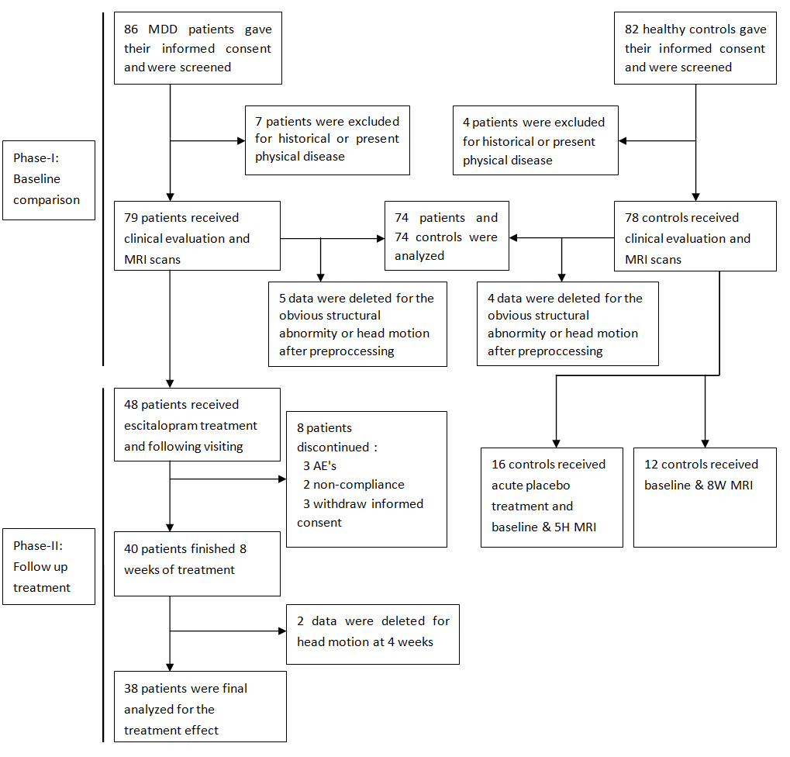

**Supplementary Fig. S1:** Research procedure. MDD, major depressive disorder; AE, Adverse Events.

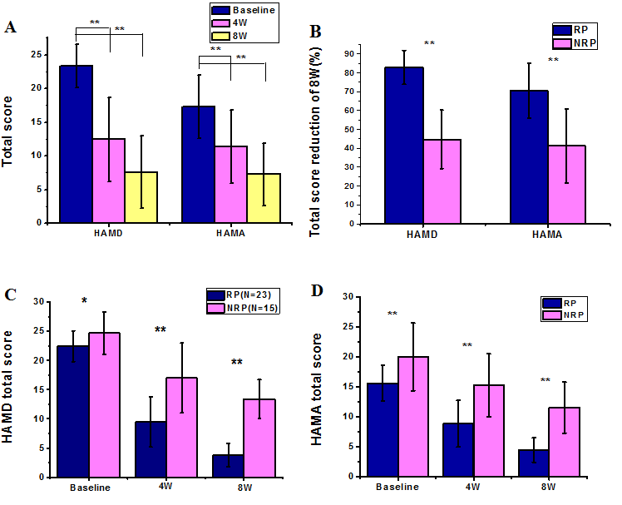

**Supplementary Fig. S2:** The clinical results of escitalopram treatment of 38 MDD.

**Supplementary Table S2:** Brain regions were differences were measured between major depression and healthy controls at baseline.

|  |  |  |  |  |  |  |  |
| --- | --- | --- | --- | --- | --- | --- | --- |
| **Brain region** | **Hemisphere** | **Brodmann area** | **Cluster size**  **(voxels)** | **t** | **MNI**  **(x y z)** | | |
| **MDD>HC** |  |  |  |  |  | | |
| **Superior Temporal Gyrus** | **R** | **38** | **35** | **3.91** | **39** | **18** | **-24** |
| **Superior Temporal Gyrus** | **L** | **22** | **23** | **3.36** | **-48** | **-18** | **3** |
| **Superior Temporal Gyrus, Insula** | **R** | **13** | **30** | **3.30** | **48** | **-30** | **21** |
| **Middle Temporal Gyrus** | **R** | **21** | **29** | **3.41** | **57** | **-45** | **6** |
| **Cerebellum Posterior Lobe** | **R** |  | **32** | **4.18** | **12** | **63** | **-36** |
| **Cerebellum Anterior Lobe** | **R,L** |  | **44** | **3.57** | **0** | **-51** | **-21** |
| **MDD<HC** |  |  |  |  |  |  |  |
| **Angular** | **R** | **40**  **39** | **97** | **4.22**  **3.82** | **60**  **48** | **-54**  **-69** | **30**  **45** |
| **Superior Frontal Gyrus** | **R** | **10** | **32** | **4.00** | **24** | **57** | **24** |
| **Superior Frontal Gyrus** | **R** | **8** | **45** | **3.87** | **24** | **33** | **45** |
| **Superior Frontal Gyrus** | **L** | **8** | **68** | **3.77** | **-21** | **33** | **51** |
| **Superior Frontal Gyrus** | **R,L** | **8** | **32** | **3.58** | **0** | **30** | **51** |
| **Medial Frontal Gyrus** | **R** | **10** | **30** | **3.83** | **6** | **57** | **18** |
| **Inferior Frontal Gyrus** | **R** | **9** | **29** | **3.72** | **48** | **12** | **24** |
| **Precuneus** | **L** | **7** | **30** | **3.36** | **-3** | **-72** | **39** |
| **Precuneus** | **R** | **31** | **23** | **3.28** | **9** | **-54** | **33** |

MDD: major depressive disorder; HC: healthy controls.

.

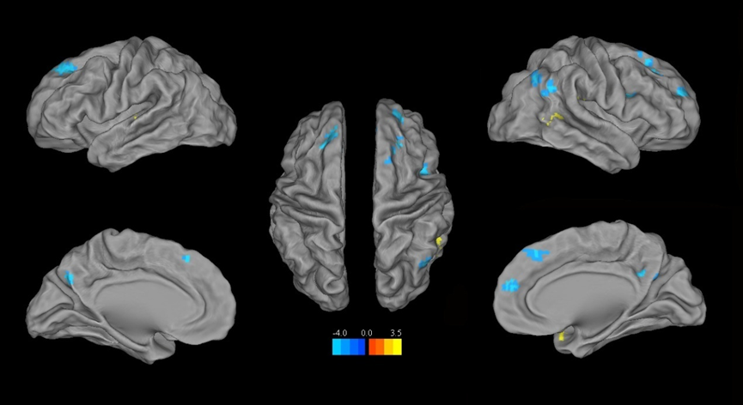

**Supplementary Fig. S3:** Abnormal fALFF of 74 MDD compared with 74 controls. Compared with healthy controls, participants with depression showed decreased bilateral fALFF in the dorsolateral prefrontal cortex, middle cingulate cortex, posterior cingulate cortex, and right angular gyrus, while increased signal in the bilateral temporal lobe

**Supplementary Table S3:** Brain regions were brain activity was measured in response to escitalopram in remitted (RP) and non-remitted patients (NRP) at different time points (5 hours, 5H; 4 weeks, 4W; 8 weeks, 8W) vs. baseline.

|  |  |  |  |  |  |  |  |  |
| --- | --- | --- | --- | --- | --- | --- | --- | --- |
|  | **Brain region** | **Hemisphere** | **Brodmann area** | **Cluster size**  **(voxels)** | ***t*** | **MNI**  **(x y z)** | | |
| ***RP*** |  |  |  |  |  |  |  |  |
| ***5H-Base*** | ***Increase*** |  |  |  |  |  |  |  |
|  | **Medial Frontal Gyrus** | **R, L** | **10** | **34** | **4.53** | **-3** | **66** | **15** |
|  | **Anterior Cingulate** | **R,L** | **32** | **24** | **3.88** | **-3** | **30** | **18** |
|  | **Insula, Putamen** | **L** |  | **31** | **5.24** | **-36** | **6** | **-9** |
|  | **Cerebellum Posterior Lobe** | **R** |  | **32** | **5.06** | **36** | **-60** | **-45** |
|  | ***Decrease*** |  |  |  |  |  |  |  |
|  | **Occipital Lobe,** **Lingual Gyrus** | **R, L** | **18, 19** | **1062** | **5.67** | **21** | **-72** | **-9** |
|  | **Precuneus** | **R** | **19** | **103** | **5.54** | **21** | **-87** | **39** |
|  | **Fusiform Gyrus** | **R** | **37** | **23** | **4.64** | **39** | **-54** | **-18** |
|  | **Middle Temporal Gyrus** | **R** | **19** | **26** | **4.03** | **54** | **-75** | **9** |
| ***4W-Base*** | ***Increase*** |  |  |  |  |  |  |  |
|  | **Superior Frontal Gyrus,**  **Anterior Cingulate**  **Supp_Motor_Area** | **R, L** | **8, 9** | **700** | **5.98** | **-9** | **15** | **63** |
|  | **Middle Frontal Gyrus** | **R** | **46** | **55** | **4.74** | **48** | **39** | **24** |
|  | **Middle Frontal Gyrus** | **R** | **8** | **24** | **4.11** | **42** | **15** | **42** |
|  | **Inferior Frontal Gyrus,** | **L** | **9** | **64** | **5.42** | **-51** | **18** | **33** |
|  | **Middle Temporal Gyrus** | **R** | **21** | **78** | **5.36** | **60** | **-24** | **-15** |
|  | **Precentral Lobe** | **L** | **6** | **57** | **4.40** | **-33** | **-3** | **45** |
|  | **Parietal Lobe** | **L** | **40** | **31** | **4.33** | **-45** | **-51** | **45** |
|  | ***Decrease*** |  |  |  |  |  |  |  |
|  | **Occipital Lobe** | **R** | **18** | **24** | **4.37** | **15** | **-72** | **-12** |
|  | **Thalamus** | **R, L** |  | **57** | **4.68** | **9** | **-9** | **15** |
|  | **Brainstem, Pons** | **R, L** |  | **34** | **4.14** | **0** | **-33** | **-39** |
|  | **Cerebellum Anterior Lobe** | **R, L** | **30** | **30** | **3.61** | **6** | **-39** | **-6** |
| ***8W-Base*** | ***Increase*** |  |  |  |  |  |  |  |
|  | **Superior Frontal Gyrus** | **R, L** | **9** | **22** | **4.61** | **3** | **48** | **39** |
|  | **Inferior Frontal Gyrus** | **R** | **46** | **31** | **3.85** | **54** | **27** | **21** |
|  | ***Decrease*** |  |  |  |  |  |  |  |
|  | **Medial Frontal Gyrus** | **L** | **6** | **23** | **4.21** | **-57** | **-9** | **6** |
| ***NRP*** |  |  |  |  |  |  |  |  |
| ***5H-Base*** | ***Increase*** |  |  |  |  |  |  |  |
|  | **Cingulum_Mid,**  **Anterior Cingulate** | **R, L** | **32, 9** | **22** | **5.77** | **6** | **27** | **30** |
|  | **Angular** | **R** | **39** | **27** | **4.97** | **33** | **-63** | **39** |
|  | **Middle Frontal Gyrus,**  **Precentral Lobe** | **R** | **9** | **20** | **3.75** | **51** | **12** | **33** |
| ***4W-Base*** | ***Increase*** |  |  |  |  |  |  |  |
|  | **Middle Frontal Gyrus** | **L** | **10** | **38** | **8.15** | **-30** | **42** | **18** |
|  | **Precentral Lobe** | **L** | **9** | **30** | **5.09** | **-45** | **9** | **36** |
|  | **Anterior Cingulate** | **L** | **9** | **24** | **5.00** | **-12** | **39** | **24** |
|  | **Precuneus** | **R** | **19** | **35** | **5.87** | **36** | **-75** | **36** |
|  | ***Decrease*** |  |  |  |  |  |  |  |
|  | **Lingual Gyrus** | **R** | **18** | **21** | **4.00** | **-27** | **-69** | **-3** |
| ***8W-Base*** | ***Increase*** |  |  |  |  |  |  |  |
|  | **Middle Frontal Gyrus** | **L** | **10** | **35** | **5.20** | **-30** | **57** | **12** |
|  | **Precuneus** | **L** | **7** | **27** | **4.70** | **-3** | **-78** | **45** |

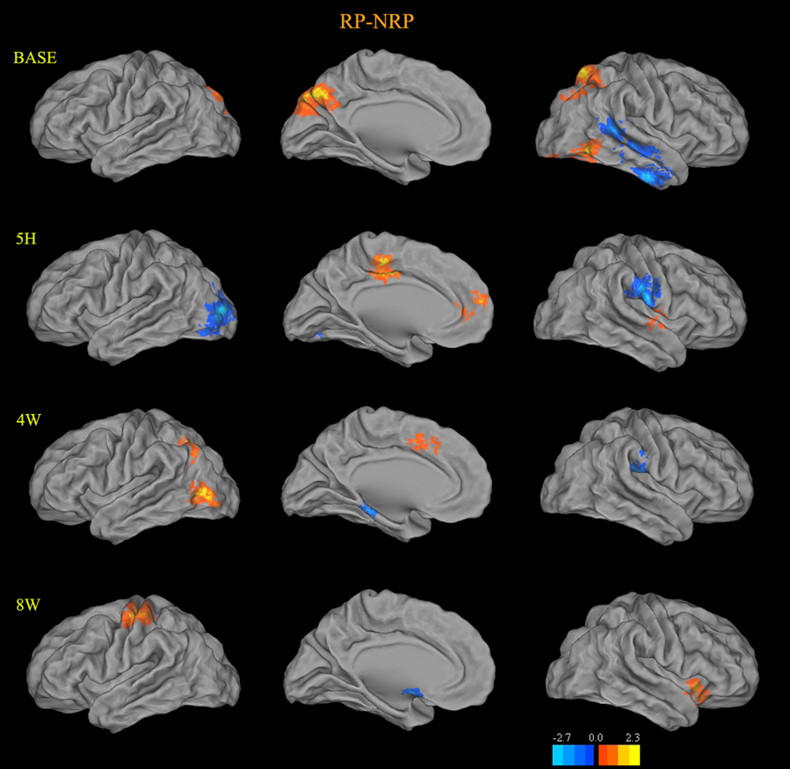 **Supplementary Fig. S4:** Differences in brain activity between remitters (RP) and non-remitters (NRP) during treatment with escitalopram. Comparison between RP and NRP revealed the difference of brain activity before and after escitalopram treatment. The RP showed increased activities in occipital lobe and precuneus, but decreased activities in right temporal lobe. After taking single dose of escitalopram at 5H, the significantly lower activities of left occipital lobe, right supramarginal gyrus and post-central gyrus, while higher activities of ACC, MCC and right superior temporal gyrus were found in RP than NRP. For 4W, the significantly lower activities of left parahippocampal gyrus and right supramarginal gyrus, while higher activities of left MCC, occipital lobe and angular gyrus, were found in RP. As for 8W, relatively higher activities of left VLPFC, pre- and post-central lobe but lower activities of subgenual ACC and thalamus were found in RP. Abbreviations: RP, remitted patients; NRP, non-remitted patients; 5 H, 5 hours; 4 W, 4 weeks; 8 W, 8weeks; ACC, anterior cingulate cortex; MCC, midcingulate cortex; VLPFC, ventral lateral prefrontal cortex.

**Supplementary Table S4:** Brain regions were differences measured between remitters (RP) vs. non-remitters (NRP) following antidepressant treatment

|  |  |  |  |  |  |  |  |  |
| --- | --- | --- | --- | --- | --- | --- | --- | --- |
|  | **Brain region** | **Hemisphere** | **Brodmann area** | **Cluster size**  **(voxels)** | ***t*** | **MNI**  **(x y z)** | | |
| ***BASE*** | ***RP>NRP*** |  |  |  |  |  | | |
|  | **Superior Parietal Lobule** | **R** | **7** | **54** | **4.34** | **21** | **-66** | **60** |
|  | **Precuneus** | **R, L** | **7** | **131** | **4.25** | **-9** | **-87** | **42** |
|  | **Angular** | **R** | **7** | **83** | **3.55** | **39** | **-54** | **42** |
|  | **Inferior Temporal Gyrus**  **Middle Occipital Gyrus** | **R** | **37** | **74** | **3.55** | **57** | **-66** | **-12** |
|  | ***RP<NRP*** |  |  |  |  |  |  |  |
|  | **Inferior Temporal Gyrus** | **R** | **20** | **66** | **4.68** | **54** | **-9** | **-36** |
|  | **Parahippocampa Gyrus,**  **Hippocampus** | **R** | **20, 28** | **88** | **3.61** | **24** | **-9** | **-30** |
|  | **Superior Temporal Gyrus** | **R** | **21** | **69** | **3.31** | **45** | **-45** | **12** |
|  | **Middle Temporal Gyrus** | **R** | **21** | **53** | **3.16** | **57** | **-4** | **-6** |
|  | **Cerebellum Posterior Lobe** | **R,L** |  | **288** | **4.25** | **30** | **-60** | **-54** |
| ***5H*** | ***RP>NRP*** |  |  |  |  |  |  |  |
|  | **Medial Frontal Gyrus**  **Anterior Cingulate** | **R, L** | **10** | **49** | **3.49** | **3** | **54** | **6** |
|  | **Supp_Motor_Area**  **Cingulum_Mid** | **R, L** | **6, 31** | **44** | **4.04** | **-3** | **-15** | **45** |
|  | **Superior Temporal Gyrus** | **R** | **22** | **43** | **4.04** | **57** | **0** | **0** |
|  | ***RP<NRP*** |  |  |  |  |  |  |  |
|  | **Postcentral Gyrus** | **R** | **3** | **66** | **3.95** | **69** | **-9** | **18** |
|  | **Inferior Temporal Gyrus** | **R** | **21** | **35** | **2.82** | **54** | **3** | **-36** |
|  | **Inferior Temporal Gyrus** | **L** | **21** | **36** | **3.08** | **-36** | **-9** | **-27** |
|  | **Middle Occipital Gyrus,**  **Cuneus** | **L** | **19** | **116** | **3.39** | **-27** | **-96** | **12** |
| ***4W*** | ***RP>NRP*** |  |  |  |  |  |  |  |
|  | **Postcentral Gyrus** | **R** | **3** | **34** | **3.91** | **15** | **-33** | **75** |
|  | **Superior Parietal Lobe** | **L** | **7** | **42** | **3.40** | **-51** | **-75** | **3** |
|  | **Middle Occipital Gyrus** | **L** | **9** | **43** | **3.27** | **-33** | **-63** | **36** |
|  | **Supp_Motor_Area** | **R, L** | **32** | **43** | **2.96** | **3** | **15** | **48** |
|  | ***RP<NRP*** |  |  |  |  |  |  |  |
|  | **Postcentral Gyrus** | **R** | **40** | **49** | **3.88** | **54** | **-21** | **27** |
|  | **Midbrain** | **L** |  | **86** | **3.56** | **-6** | **-36** | **-27** |
|  | **Brainstem, Pons** | **R, L** |  | **70** | **3.48** | **0** | **-27** | **-36** |
|  | **Cerebellum Posterior Lobe** | **R** |  | **82** | **4.65** | **51** | **-66** | **-42** |
|  | **Cerebellum Posterior Lobe** | **R** |  | **37** | **3.19** | **-6** | **-48** | **-45** |
| ***8W*** | ***RP>NRP*** |  |  |  |  |  |  |  |
|  | **Inferior Temporal Gyrus** | **L** | **37** | **38** | **4.40** | **-54** | **-57** | **-15** |
|  | **Postcentral Gyrus** | **L** | **3, 4** | **90** | **4.25** | **-42** | **-30** | **63** |
|  | **Inferior Frontal Gyrus** | **R** | **47** | **56** | **3.73** | **42** | **24** | **-12** |
|  | ***RP<NRP*** |  |  |  |  |  |  |  |
|  | **Parahippocampa Gyrus**  **Amygdala,** **Hippocampus** | **L** | **25** | **51** | **5.15** | **-9** | **3** | **-18** |
|  | **Cerebellum Posterior Lobe** | **R, L** |  | **77** | **3.76** | **-6** | **-54** | **-45** |

.

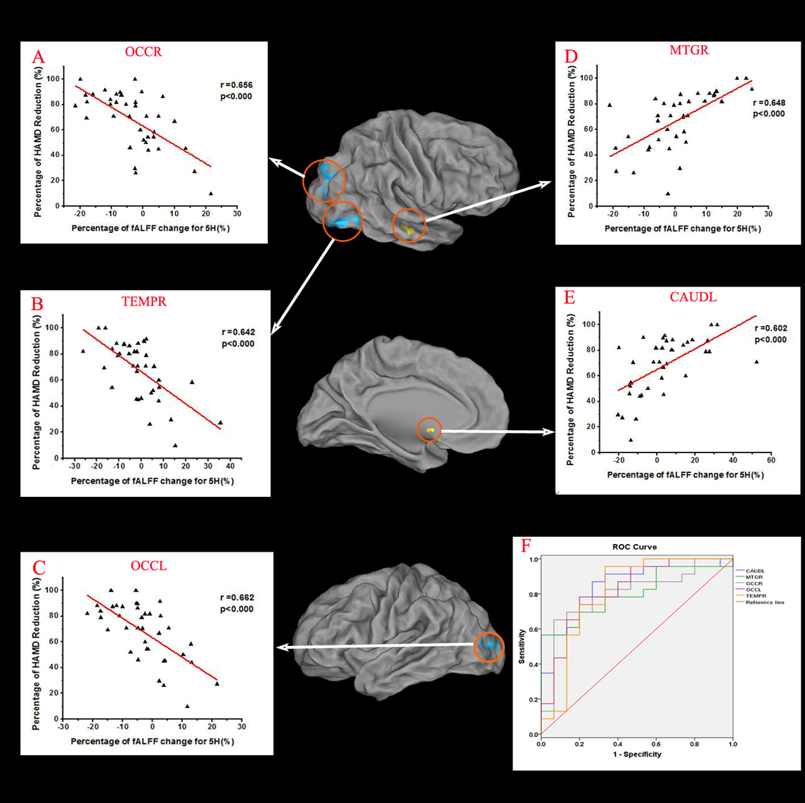**Supplementary Fig. S5:** Brain regions where resting stateactivity measured 5 hours after antidepressant administration correlated with HAMD reduction at end point (8 weeks) holding predictive value for clinical response and ROC curve. The fALFF alterations for two clusters in the bilateral occipital lobe (OCCR and OCCL, figure A andC ) and one cluster in the right temporal lobe (TEMPR, figure B) were negatively correlated with the HAMD reduction. The fALFF alterations of two clusters, one cluster in the left caudate(CAUDL, figure E) and one cluster in the left middle temporal lobe (MTGR, figure D), were positively correlated with the HAMD reduction., were negatively correlated with the HAMD reduction. Receiver Operating Characteristic (ROC) analyses showed the area under the ROC curve (AUC) of the ⊿fALFF-5 H for all five ROIs was above 0.8 (0.80-0.89) (figure F)

|  |  |  |  |  |  |  |  |
| --- | --- | --- | --- | --- | --- | --- | --- |
| **Brain region** | **Hemisphere** | **Brodmann area** | **Cluster size**  **(voxels)** | ***t*** | **MNI**  **(x y z)** | | |
| ***Positive correlation*** |  |  |  |  |  | | |
| **Caudate** | **L** |  | **24** | **4.10** | **-3** | **6** | **-6** |
| **Middle Temporal Gyrus** | **R** | **21** | **33** | **4.00** | **60** | **-30** | **-12** |
| **Cerebellum Posterior Lobe** | **R, L** |  | **24** | **3.95** | **3** | **-78** | **-18** |
| ***Negative correlation*** |  |  |  |  |  |  |  |
| **Occipital Lobe, Cuneus** | **R** | **19** | **68** | **5.39** | **21** | **-84** | **39** |
| **Middle Temporal Gyrus** | **R** | **19** | **52** | **4.56** | **48** | **-81** | **-6** |
| **Middle Occipital Gyrus** | **L** | **19** | **65** | **4.29** | **-24** | **-96** | **9** |

**Supplementary Table S5:** Changes measured 5 hours after escitalopram treatment which correlated with the HAMD reduction at end point (week 8).

**Supplementary Table S6:** Sensitivity, specificity, positive predictive value (PPV), negative predictive value (NPV), and area under the Receiver Operating Characteristics curve (AUC) of 5H's fALFF change as a predictor of later remission.

|  |  |  |  |  |  |  |  |  |  |  |
| --- | --- | --- | --- | --- | --- | --- | --- | --- | --- | --- |
| **ROIs** |  | | | | **ROC** | | | **Cut-off of 5H fALFF change** | | |
|  | **Sensitivity%** | **Specificity%** | **PPV%** | **NPV%** | **Area** | **P** | **95%CI** | **Cut-off value%** | **Sensitivity%** | **Specificity%** |
| **CAUDL** | **78.26** | **73..33** | **81.82** | **68.75** | **0.841** | **0.000** | **0.711-0.971** | **>-1.35** | **82.6** | **73.3** |
| **MTGR** | **69.57** | **66.67** | **76.19** | **58.82** | **0.803** | **0.002** | **0.665-0.941** | **>3.65** | **56.5** | **100** |
| **OCCR** | **86.96** | **60.00** | **76.92** | **75.00** | **0.800** | **0.002** | **0.651-0.949** | **<-1.58** | **78.3** | **73.3** |
| **OCCL** | **82.61** | **60.00** | **76.00** | **69.23** | **0.823** | **0.001** | **0.682-0.964** | **<-2.52** | **78.3** | **80** |
| **TEMPR** | **73.91** | **66.67** | **77.27** | **62.50** | **0.890** | **0.001** | **0.646-0.971** | **<2.92** | **95.7** | **66.7** |
|  |  |  |  |  |  |  |  |  |  |  |

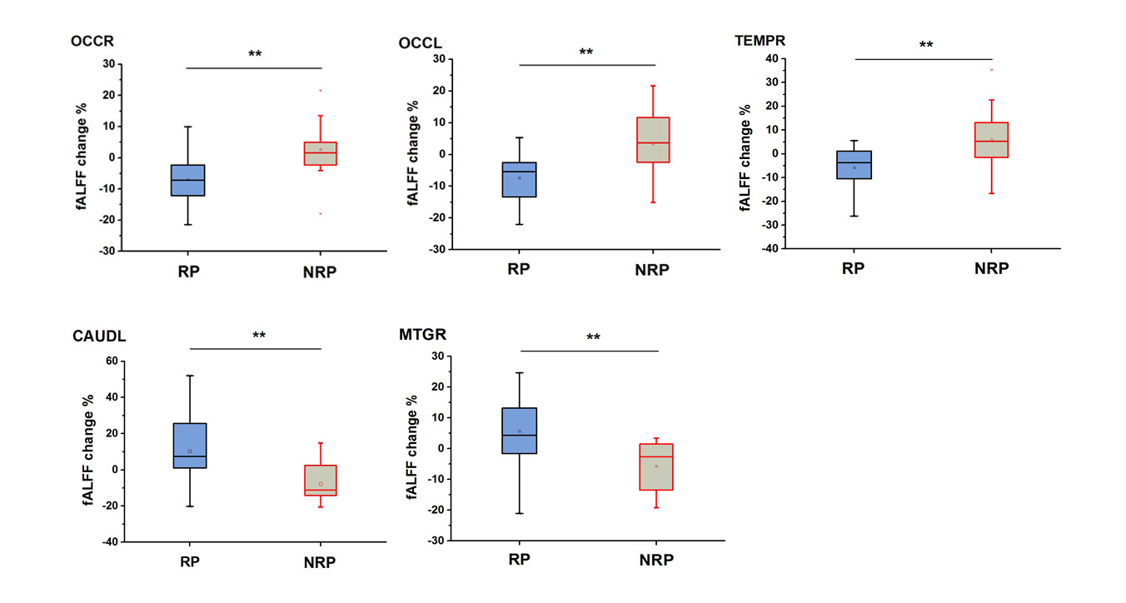

**Supplementary Fig. S6:** 5H after a single dose of escitalopram, all five ROIs showed contrary reaction between RP and NRP. For three clusters of OCCL, OCCR and TEMPR (fALFF change negatively correlated with HAMD reduction), the RP showed the obvious reduction of the mean percentage of fALFF change, while NRP showed the significant increase. For the other two clusters of CAUDL and MTGR (fALFF change positively correlated with HAMD reduction), the mean percentage of fALFF change increased in RP, while decreased in NRP. **represented p<0.001.