SUPPLEMENTARY MATERIAL
Methods
Stability
First, to determine whether cross-sectional network structure and connectedness at admission were estimated reliably, we conducted a split-half permutation test using Spearman correlations (Table 5; Courrieu, Brand-D’abrescia, Peereman, Spieler, & Rey, 2010) on the admission network only. To accomplish this, we randomly divided participants into two equally sized samples, calculated networks for each sample and correlated the edges and centrality indices of the two split-half admission networks. We then repeated this process 10,000 times to establish the distribution of Spearman values to assess the reliability of the network. Because the samples only contain half the participants, we assume that split-half reliability estimates are reduced compared to the reliability of the entire sample.
Second, we established bootstrapped 95th percentile confidence intervals for the edges by sampling the data with replacement, calculating edges to create a distribution of edge values (Epskamp, Borsboom, & Fried, 2016). Confidence intervals for centrality are unavailable because bootstrapping results in biased sampling distributions for centrality indices. Therefore, an alternative approach is to correlate centrality values calculated from a subset of the data with centrality values from the entire data set. For example, if strength centrality from 50% of the nodes correlates poorly with strength centrality from 100% of the nodes, then strength centrality would be considered unstable. Following guidelines (Epskamp et al., 2016), we calculated centrality stability using both a subset of nodes and a subset of participants.
Results
Covariance Tables
We provide all covariance tables that can be used to recreate the networks (Table S2-S5).
Stability
The split-half permutation stability analysis showed excellent stability for edges and strength centrality (Table S1). Betweenness and closeness centrality showed fair-to-poor stability. Within T2, betweenness the lower bound of the interquartile range shown was close to zero, suggesting unacceptably low stability.
The bootstrapped confidence intervals for the edges at admission, suggests that the edges are fairly stable and a number of edges have values significantly higher than zero (Figure S1A). Strength centrality at admission showed fairly robust stability when correlating centrality within subsamples with fewer nodes with centrality from the whole sample (Figure S2A). However, betweenness and closeness again showed fairly poor as subsamples included fewer nodes (Figure S2A). All forms of centrality at admission showed higher stability when subsamples consisted of removing participants, though similar results emerged, with strength centrality showing excellent stability and closeness and betweenness showing fair-to-poor stability (Figure S2C).
Comparing stability between admission and discharge, across all stability analyses edges and centrality indices at discharge appear to have somewhat less stability at discharge (Table S1, Figures S1 and S2).

Table S1. Mean and interquartile range from split-half permutation stability analysis.
Admission | Mean | Interquartile Range
Edges | 0.75 | 0.68 | - | 0.81
Strength | 0.91 | 0.82 | - | 0.96
Closeness | 0.64 | 0.34 | - | 0.87
Betweenness | 0.62 | 0.29 | - | 0.87
Discharge
Edges | 0.66 | 0.58 | - | 0.74
Strength | 0.83 | 0.70 | - | 0.93
Closeness | 0.63 | 0.29 | - | 0.86
Betweenness | 0.42 | 0.03 | - | 0.74

Table S2. Admission covariance table; all participants.
 | D-Anhedonia | D-Sad Mood | D-Sleep | D-Energy | D-Appetite | D-Guilt | D-Concentration | D-Motor | D-Suicide | A-Nervous | A-Control Worry | A-Too Much Worry | A-Relax | A-Restless | A-Irritable | A-Afraid
D-Anhedonia | 1.05 | 0.74 | 0.55 | 0.65 | 0.51 | 0.59 | 0.52 | 0.24 | 0.34 | 0.47 | 0.45 | 0.45 | 0.47 | 0.18 | 0.28 | 0.37
D-Sad Mood | 0.74 | 1.02 | 0.54 | 0.64 | 0.47 | 0.71 | 0.46 | 0.22 | 0.43 | 0.52 | 0.52 | 0.52 | 0.48 | 0.19 | 0.30 | 0.41
D-Sleep | 0.55 | 0.54 | 1.17 | 0.63 | 0.47 | 0.48 | 0.48 | 0.24 | 0.30 | 0.39 | 0.41 | 0.40 | 0.42 | 0.23 | 0.30 | 0.30
D-Energy | 0.65 | 0.64 | 0.63 | 1.04 | 0.55 | 0.55 | 0.51 | 0.25 | 0.36 | 0.40 | 0.37 | 0.39 | 0.38 | 0.14 | 0.27 | 0.29
D-Appetite | 0.51 | 0.47 | 0.47 | 0.55 | 1.24 | 0.47 | 0.47 | 0.32 | 0.27 | 0.36 | 0.36 | 0.37 | 0.36 | 0.21 | 0.28 | 0.31
D-Guilt | 0.59 | 0.71 | 0.48 | 0.55 | 0.47 | 1.13 | 0.47 | 0.23 | 0.42 | 0.51 | 0.53 | 0.57 | 0.46 | 0.23 | 0.33 | 0.39
D-Concentration | 0.52 | 0.46 | 0.48 | 0.51 | 0.47 | 0.47 | 1.16 | 0.42 | 0.30 | 0.43 | 0.44 | 0.43 | 0.46 | 0.35 | 0.33 | 0.40
D-Motor | 0.24 | 0.22 | 0.24 | 0.25 | 0.32 | 0.23 | 0.42 | 0.97 | 0.19 | 0.23 | 0.20 | 0.23 | 0.26 | 0.39 | 0.29 | 0.35
D-Suicide | 0.34 | 0.43 | 0.30 | 0.36 | 0.27 | 0.42 | 0.30 | 0.19 | 0.93 | 0.24 | 0.27 | 0.25 | 0.27 | 0.13 | 0.23 | 0.26
A-Nervous | 0.47 | 0.52 | 0.39 | 0.40 | 0.36 | 0.51 | 0.43 | 0.23 | 0.24 | 1.00 | 0.79 | 0.77 | 0.71 | 0.41 | 0.37 | 0.57
A-Control Worry | 0.45 | 0.52 | 0.41 | 0.37 | 0.36 | 0.53 | 0.44 | 0.20 | 0.27 | 0.79 | 1.14 | 0.97 | 0.77 | 0.44 | 0.36 | 0.66
A-Too Much Worry | 0.45 | 0.52 | 0.40 | 0.39 | 0.37 | 0.57 | 0.43 | 0.23 | 0.25 | 0.77 | 0.97 | 1.14 | 0.77 | 0.44 | 0.38 | 0.67
A-Relax | 0.47 | 0.48 | 0.42 | 0.38 | 0.36 | 0.46 | 0.46 | 0.26 | 0.27 | 0.71 | 0.77 | 0.77 | 1.09 | 0.54 | 0.40 | 0.61
A-Restless | 0.18 | 0.19 | 0.23 | 0.14 | 0.21 | 0.23 | 0.35 | 0.39 | 0.13 | 0.41 | 0.44 | 0.44 | 0.54 | 1.09 | 0.40 | 0.44
A-Irritable | 0.28 | 0.30 | 0.30 | 0.27 | 0.28 | 0.33 | 0.33 | 0.29 | 0.23 | 0.37 | 0.36 | 0.38 | 0.40 | 0.40 | 1.04 | 0.40
A-Afraid | 0.37 | 0.41 | 0.30 | 0.29 | 0.31 | 0.39 | 0.40 | 0.35 | 0.26 | 0.57 | 0.66 | 0.67 | 0.61 | 0.44 | 0.40 | 1.19

Table S3. Admission covariance table; only participants with admission and discharge data.
 | D-Anhedonia | D-Sad Mood | D-Sleep | D-Energy | D-Appetite | D-Guilt | D-Concentration | D-Motor | D-Suicide | A-Nervous | A-Control Worry | A-Too Much Worry | A-Relax | A-Restless | A-Irritable | A-Afraid
D-Anhedonia | 1.03 | 0.74 | 0.51 | 0.63 | 0.49 | 0.56 | 0.48 | 0.21 | 0.32 | 0.44 | 0.44 | 0.45 | 0.43 | 0.18 | 0.26 | 0.34
D-Sad Mood | 0.74 | 0.99 | 0.49 | 0.63 | 0.45 | 0.67 | 0.42 | 0.17 | 0.39 | 0.49 | 0.49 | 0.49 | 0.43 | 0.15 | 0.26 | 0.37
D-Sleep | 0.51 | 0.49 | 1.18 | 0.60 | 0.45 | 0.42 | 0.45 | 0.23 | 0.28 | 0.37 | 0.39 | 0.38 | 0.36 | 0.22 | 0.27 | 0.26
D-Energy | 0.63 | 0.63 | 0.60 | 1.01 | 0.53 | 0.53 | 0.45 | 0.19 | 0.33 | 0.37 | 0.34 | 0.36 | 0.34 | 0.13 | 0.25 | 0.26
D-Appetite | 0.49 | 0.45 | 0.45 | 0.53 | 1.24 | 0.48 | 0.45 | 0.26 | 0.25 | 0.34 | 0.36 | 0.35 | 0.32 | 0.20 | 0.28 | 0.29
D-Guilt | 0.56 | 0.67 | 0.42 | 0.53 | 0.48 | 1.12 | 0.43 | 0.22 | 0.39 | 0.50 | 0.50 | 0.55 | 0.41 | 0.20 | 0.30 | 0.35
D-Concentration | 0.48 | 0.42 | 0.45 | 0.45 | 0.45 | 0.43 | 1.14 | 0.40 | 0.26 | 0.42 | 0.44 | 0.39 | 0.44 | 0.34 | 0.31 | 0.35
D-Motor | 0.21 | 0.17 | 0.23 | 0.19 | 0.26 | 0.22 | 0.40 | 0.93 | 0.15 | 0.22 | 0.19 | 0.22 | 0.27 | 0.40 | 0.25 | 0.31
D-Suicide | 0.32 | 0.39 | 0.28 | 0.33 | 0.25 | 0.39 | 0.26 | 0.15 | 0.85 | 0.23 | 0.26 | 0.25 | 0.27 | 0.13 | 0.22 | 0.25
A-Nervous | 0.44 | 0.49 | 0.37 | 0.37 | 0.34 | 0.50 | 0.42 | 0.22 | 0.23 | 0.97 | 0.77 | 0.73 | 0.68 | 0.41 | 0.35 | 0.54
A-Control Worry | 0.44 | 0.49 | 0.39 | 0.34 | 0.36 | 0.50 | 0.44 | 0.19 | 0.26 | 0.77 | 1.13 | 0.96 | 0.75 | 0.45 | 0.34 | 0.64
A-Too Much Worry | 0.45 | 0.49 | 0.38 | 0.36 | 0.35 | 0.55 | 0.39 | 0.22 | 0.25 | 0.73 | 0.96 | 1.13 | 0.74 | 0.44 | 0.36 | 0.63
A-Relax | 0.43 | 0.43 | 0.36 | 0.34 | 0.32 | 0.41 | 0.44 | 0.27 | 0.27 | 0.68 | 0.75 | 0.74 | 1.07 | 0.55 | 0.39 | 0.57
A-Restless | 0.18 | 0.15 | 0.22 | 0.13 | 0.20 | 0.20 | 0.34 | 0.40 | 0.13 | 0.41 | 0.45 | 0.44 | 0.55 | 1.06 | 0.38 | 0.41
A-Irritable | 0.26 | 0.26 | 0.27 | 0.25 | 0.28 | 0.30 | 0.31 | 0.25 | 0.22 | 0.35 | 0.34 | 0.36 | 0.39 | 0.38 | 1.04 | 0.40
A-Afraid | 0.34 | 0.37 | 0.26 | 0.26 | 0.29 | 0.35 | 0.35 | 0.31 | 0.25 | 0.54 | 0.64 | 0.63 | 0.57 | 0.41 | 0.40 | 1.15

Table S4. Discharge covariance table; all participants.
 | D-Anhedonia | D-Sad Mood | D-Sleep | D-Energy | D-Appetite | D-Guilt | D-Concentration | D-Motor | D-Suicide | A-Nervous | A-Control Worry | A-Too Much Worry | A-Relax | A-Restless | A-Irritable | A-Afraid
D-Anhedonia | 0.88 | 0.61 | 0.43 | 0.52 | 0.37 | 0.52 | 0.47 | 0.26 | 0.24 | 0.35 | 0.37 | 0.38 | 0.35 | 0.23 | 0.20 | 0.27
D-Sad Mood | 0.61 | 0.79 | 0.37 | 0.49 | 0.36 | 0.59 | 0.41 | 0.24 | 0.28 | 0.39 | 0.42 | 0.41 | 0.34 | 0.23 | 0.21 | 0.28
D-Sleep | 0.43 | 0.37 | 1.04 | 0.50 | 0.39 | 0.37 | 0.41 | 0.24 | 0.21 | 0.29 | 0.31 | 0.27 | 0.30 | 0.26 | 0.24 | 0.20
D-Energy | 0.52 | 0.49 | 0.50 | 0.95 | 0.43 | 0.48 | 0.44 | 0.24 | 0.25 | 0.34 | 0.33 | 0.30 | 0.29 | 0.23 | 0.23 | 0.21
D-Appetite | 0.37 | 0.36 | 0.39 | 0.43 | 0.99 | 0.40 | 0.37 | 0.25 | 0.21 | 0.24 | 0.28 | 0.25 | 0.22 | 0.20 | 0.25 | 0.22
D-Guilt | 0.52 | 0.59 | 0.37 | 0.48 | 0.40 | 1.00 | 0.47 | 0.25 | 0.32 | 0.43 | 0.43 | 0.43 | 0.36 | 0.23 | 0.27 | 0.33
D-Concentration | 0.47 | 0.41 | 0.41 | 0.44 | 0.37 | 0.47 | 1.01 | 0.37 | 0.22 | 0.35 | 0.37 | 0.36 | 0.41 | 0.37 | 0.25 | 0.28
D-Motor | 0.26 | 0.24 | 0.24 | 0.24 | 0.25 | 0.25 | 0.37 | 0.63 | 0.15 | 0.22 | 0.22 | 0.22 | 0.25 | 0.30 | 0.17 | 0.20
D-Suicide | 0.24 | 0.28 | 0.21 | 0.25 | 0.21 | 0.32 | 0.22 | 0.15 | 0.52 | 0.17 | 0.16 | 0.16 | 0.16 | 0.13 | 0.15 | 0.18
A-Nervous | 0.35 | 0.39 | 0.29 | 0.34 | 0.24 | 0.43 | 0.35 | 0.22 | 0.17 | 0.81 | 0.58 | 0.55 | 0.50 | 0.32 | 0.29 | 0.40
A-Control Worry | 0.37 | 0.42 | 0.31 | 0.33 | 0.28 | 0.43 | 0.37 | 0.22 | 0.16 | 0.58 | 0.82 | 0.67 | 0.52 | 0.31 | 0.30 | 0.44
A-Too Much Worry | 0.38 | 0.41 | 0.27 | 0.30 | 0.25 | 0.43 | 0.36 | 0.22 | 0.16 | 0.55 | 0.67 | 0.82 | 0.51 | 0.30 | 0.29 | 0.42
A-Relax | 0.35 | 0.34 | 0.30 | 0.29 | 0.22 | 0.36 | 0.41 | 0.25 | 0.16 | 0.50 | 0.52 | 0.51 | 0.80 | 0.44 | 0.31 | 0.34
A-Restless | 0.23 | 0.23 | 0.26 | 0.23 | 0.20 | 0.23 | 0.37 | 0.30 | 0.13 | 0.32 | 0.31 | 0.30 | 0.44 | 0.72 | 0.28 | 0.26
A-Irritable | 0.20 | 0.21 | 0.24 | 0.23 | 0.25 | 0.27 | 0.25 | 0.17 | 0.15 | 0.29 | 0.30 | 0.29 | 0.31 | 0.28 | 0.69 | 0.26
A-Afraid | 0.27 | 0.28 | 0.20 | 0.21 | 0.22 | 0.33 | 0.28 | 0.20 | 0.18 | 0.40 | 0.44 | 0.42 | 0.34 | 0.26 | 0.26 | 0.75

Table S5. Discharge covariance table; only participants with admission and discharge data.
 | D-Anhedonia | D-Sad Mood | D-Sleep | D-Energy | D-Appetite | D-Guilt | D-Concentration | D-Motor | D-Suicide | A-Nervous | A-Control Worry | A-Too Much Worry | A-Relax | A-Restless | A-Irritable | A-Afraid
D-Anhedonia | 0.87 | 0.62 | 0.43 | 0.51 | 0.39 | 0.52 | 0.49 | 0.28 | 0.26 | 0.35 | 0.38 | 0.38 | 0.34 | 0.24 | 0.20 | 0.27
D-Sad Mood | 0.62 | 0.79 | 0.37 | 0.48 | 0.37 | 0.60 | 0.42 | 0.26 | 0.28 | 0.39 | 0.42 | 0.42 | 0.35 | 0.24 | 0.21 | 0.28
D-Sleep | 0.43 | 0.37 | 1.04 | 0.50 | 0.39 | 0.38 | 0.44 | 0.26 | 0.22 | 0.30 | 0.32 | 0.27 | 0.28 | 0.27 | 0.25 | 0.19
D-Energy | 0.51 | 0.48 | 0.50 | 0.94 | 0.45 | 0.48 | 0.45 | 0.25 | 0.26 | 0.32 | 0.32 | 0.31 | 0.28 | 0.22 | 0.22 | 0.20
D-Appetite | 0.39 | 0.37 | 0.39 | 0.45 | 0.98 | 0.40 | 0.38 | 0.26 | 0.22 | 0.25 | 0.28 | 0.24 | 0.22 | 0.20 | 0.27 | 0.22
D-Guilt | 0.52 | 0.60 | 0.38 | 0.48 | 0.40 | 1.00 | 0.46 | 0.25 | 0.33 | 0.44 | 0.43 | 0.43 | 0.36 | 0.24 | 0.28 | 0.34
D-Concentration | 0.49 | 0.42 | 0.44 | 0.45 | 0.38 | 0.46 | 1.01 | 0.38 | 0.23 | 0.35 | 0.37 | 0.37 | 0.42 | 0.39 | 0.27 | 0.29
D-Motor | 0.28 | 0.26 | 0.26 | 0.25 | 0.26 | 0.25 | 0.38 | 0.61 | 0.15 | 0.23 | 0.23 | 0.22 | 0.24 | 0.31 | 0.17 | 0.21
D-Suicide | 0.26 | 0.28 | 0.22 | 0.26 | 0.22 | 0.33 | 0.23 | 0.15 | 0.53 | 0.18 | 0.17 | 0.16 | 0.16 | 0.14 | 0.15 | 0.18
A-Nervous | 0.35 | 0.39 | 0.30 | 0.32 | 0.25 | 0.44 | 0.35 | 0.23 | 0.18 | 0.82 | 0.58 | 0.56 | 0.51 | 0.33 | 0.30 | 0.40
A-Control Worry | 0.38 | 0.42 | 0.32 | 0.32 | 0.28 | 0.43 | 0.37 | 0.23 | 0.17 | 0.58 | 0.82 | 0.68 | 0.51 | 0.32 | 0.31 | 0.44
A-Too Much Worry | 0.38 | 0.42 | 0.27 | 0.31 | 0.24 | 0.43 | 0.37 | 0.22 | 0.16 | 0.56 | 0.68 | 0.82 | 0.51 | 0.30 | 0.29 | 0.42
A-Relax | 0.34 | 0.35 | 0.28 | 0.28 | 0.22 | 0.36 | 0.42 | 0.24 | 0.16 | 0.51 | 0.51 | 0.51 | 0.79 | 0.43 | 0.30 | 0.34
A-Restless | 0.24 | 0.24 | 0.27 | 0.22 | 0.20 | 0.24 | 0.39 | 0.31 | 0.14 | 0.33 | 0.32 | 0.30 | 0.43 | 0.73 | 0.27 | 0.27
A-Irritable | 0.20 | 0.21 | 0.25 | 0.22 | 0.27 | 0.28 | 0.27 | 0.17 | 0.15 | 0.30 | 0.31 | 0.29 | 0.30 | 0.27 | 0.70 | 0.26
A-Afraid | 0.27 | 0.28 | 0.19 | 0.20 | 0.22 | 0.34 | 0.29 | 0.21 | 0.18 | 0.40 | 0.44 | 0.42 | 0.34 | 0.27 | 0.26 | 0.76

Figure S1. Edge values at admission and discharge with confidence intervals.
B
A
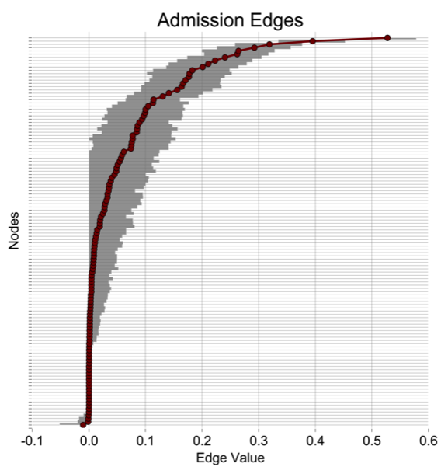 | 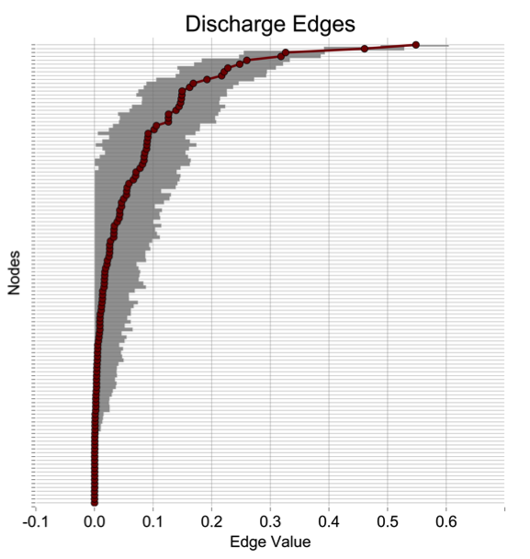

Figure S2. Centrality stability
B
A
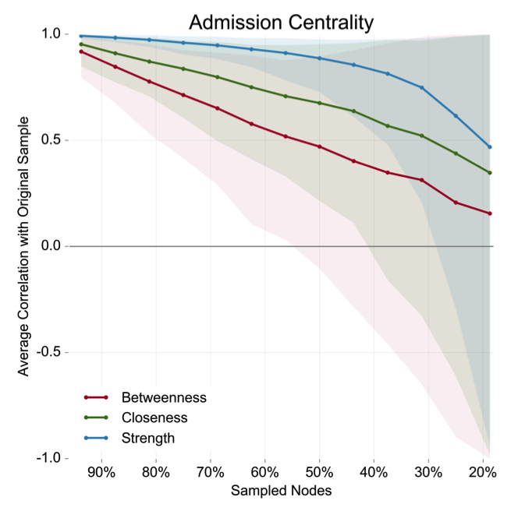  C | 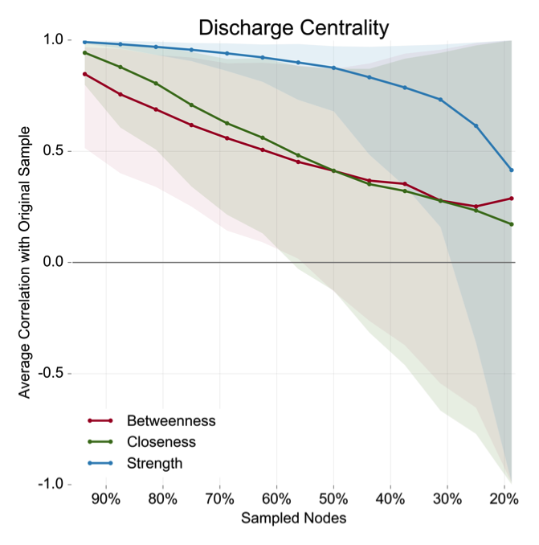  D
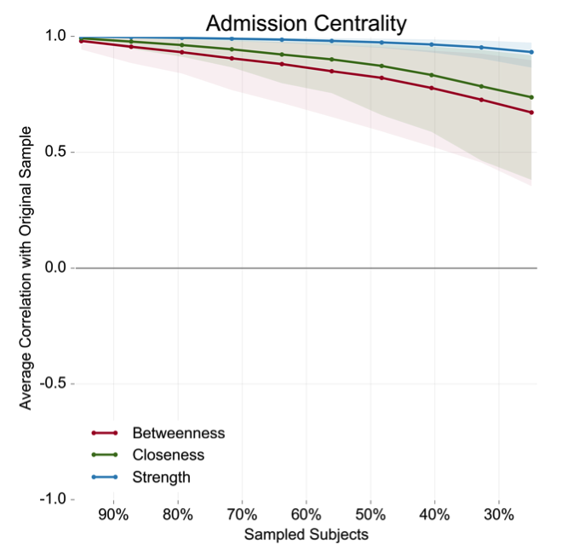 | 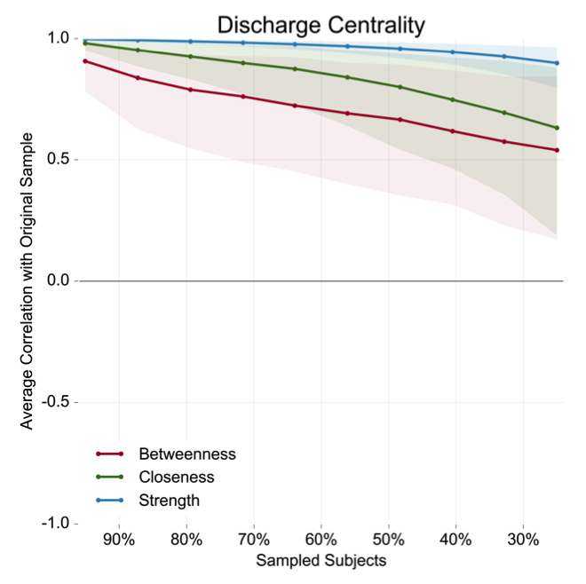
Note: For the top panel (A and B) stability is represented by correlations between centrality values calculated within the entire sample at admission (A) or discharge (B) and centrality values calculated within subsamples with increasingly fewer nodes. For the bottom panel (C and D), stability is represented by correlations between full sample centrality at admission (C) and discharge (D) and centrality calculated within subsamples with increasingly fewer participants.

