The CHRM3 gene is implicated in abnormal thalamo-orbital frontal cortex functional connectivity in first-episode treatment-naive patients with schizophrenia
Qiang Wang¹*, Wei Cheng²*, Miaoxin Li³*, Hongyan Ren¹, Xun Hu⁴, Wei Deng¹, Mingli Li¹, Xiaohong Ma⁵, Liansheng Zhao⁵, Yingcheng Wang⁵, Bo Xiang¹, Beatrice Wu, Pak C Sham³, JianFeng Feng²**, and Tao Li¹**

1. Mental Health Center & , State Key Laboratory of Biotherapy, Psychiatric laboratory, West China Hospital, Sichuan University, Chengdu, Sichuan, P R China
2. Centre for Computational Systems Biology, Fudan University, Shanghai, PR China.
3. State Key Laboratory of Brain and Cognitive Sciences, Centre for Genomic Sciences and Department of Psychiatry, University of Hong Kong, Pokfulam, S.A.R. China
4. Biobank, West China Hospital, Sichuan University, Chengdu, Sichuan, P R China
5. State Key Laboratory of Biotherapy, Psychiatric laboratory, West China Hospital, Sichuan University, Chengdu, Sichuan, P R China

Subjects
Three hundred and eleven subjects, including 161 schizophrenia patients (82 males, 79 females) and 150 healthy controls (80 males, 70 females), were recruited in this study. All patients were recruited at the Mental Health Center of West China Hospital, Sichuan University from August 2005 to October 2012. Healthy controls were recruited from the local area through poster advertisement. Both groups were matched for sex, age and education level. All participants were right-handed based on the Annett Handedness Scale (Annett, 1970). The study was approved by the ethical committee of the West China Hospital of Sichuan University.
The patients were interviewed by an experienced psychiatrist using the Structured Clinical Interview for DSM-IV (SCID-P; First et al. 1997). DSM-IV criteria for schizophrenia or schizophreniform psychosis were used for diagnosis (APA, 1994). Patients diagnosed with schizophreniform psychosis were followed up for at least 6 months and all met the DSM-IV criteria for schizophrenia. Psychopathology associated with schizophrenia was evaluated using the positive and negative syndrome scales (PANSS), which provided the total score and five factor scores including negative, positive, excited, emotion, disorganized (Gaag et al. 2006). All controls were screened with the SCID non-patient version (SCID-NP; First et al. 1997) for the lifetime absence of psychiatric illnesses. Subjects with organic brain disorders, alcohol and/or drug abuse, pregnancy or any other severe physical illness such as brain tumor or epilepsy were excluded from the study.

Imaging data acquisition
All participants were scanned using a 3-T MRI system (Excite, General Electric, USA). Functional MRI (fMRI) images were obtained using a gradient-echo-planar imaging (EPI) sequence (repetition time [TR]/echo time [TE], 2000/30 ms; flip angle, 90x; slice thickness, 5 mm; no slice gap; in-plane resolution, 3.75 × 3.75 mm²; matrix size, 64 × 64; field of view [FOV], 240 × 240 mm²; slice number, 30]. Each resting-state fMRI scan contained 200 image volumes. During the fMRI scan, the participants were instructed to lie still with their eyes closed, remain relaxed, and refrain from focusing on any particular thought.

Data processing

Imaging data processing
To remove the sources of spurious correlations present in resting-state BOLD data, all fMRI time series underwent high-pass temporal filtering (0.01 Hz), removal of nuisance signals from ventricles, deep white matter, and six rigid-body motion correction parameters, followed by low-pass temporal filtering (0.08 Hz). In addition, given the growing concerns that excessive movement can influence between-group differences, therefore, we used four procedures to achieve motion correction. In the first step, we carried out three-dimensional (3D) motion correction by aligning each functional volume to the mean image of all volumes, and any data affected by head motion of >3 mm or a rotation of > were excluded from the analysis. In the second step, we implemented additional careful volume censoring (“scrubbing”) for movement correction as reported by Power et al. to ensure that head-motion artifacts do not drive the observed effects(Power et al., 2012). The mean framewise displacement (FD) was computed with an FD threshold for displacement of 0.5. In addition to the frame corresponding to the displaced time point, one preceding and two succeeding time points were also deleted to reduce the “spill-over” effect of head movements. Third, subjects with >10% displaced frames flagged were completely excluded from the analysis, as such high level of movement is likely to have influenced several volumes. Finally, the mean displacements were computed as root mean square of the translation and rotation parameters (computed as the average of the absolute value of the Euler angle of the rotation of each brain volume compared to the previous volume). We used the root mean square displacement as a covariate when comparing the two groups during statistical analysis.

Genotyping and quality controls
DNA was extracted from whole blood samples using the standard isolation method. Genotyping was performed on the HumanOmniZhongHua-8 BeadChip (Illumina, San Diego, CA). Genotyping data were systematically filtered according to their genotyping rates, minor allele frequency (MAF), and Hardy-Weinberg equilibrium tests (only in controls). Participants with low genotyping rate (<97%), markers with >5% missing rate per individual and/or with MAF > 0.05, and markers that failed to pass the Hardy-Weinberg equilibrium tests (p ≤ 10^{–6}) were excluded from further analysis. Furthermore, the gender of each participant, with genotyping data on gender-specific loci, was confirmed by the genotyping platform, and participants with lower genotype call rates were excluded from the analysis if participant pairs with identical genotypes were found. After systematic filtering, 1,09,923 SNPs and four individuals (two patients and two healthy controls) were excluded from the study based on the above criteria. All quality control analyses were performed using PLINK(Purcell et al., 2007). The standard pipeline was used to detect outliers, and population stratification was carried out using EIGENSTART.(Price et al., 2006) The first two components of the PCA results were included as covariates in the subsequent association test.
Table S1 Significant regions in the voxel-based whole brain analysis.
No. | Areas | Cluster size  #Voxels | Peak MA value | MNI coordinates (Peak)
Cluster 1 | Rectus_L, Frontal_Sup_Orb_L | 45 | 92 | -12 48 -18
Cluster 2 | Thalamus_L | 69 | 33 | -12 -12 6
Cluster 3 | Thalamus_R | 50 | 21 | 12 -12 6

Table S 2 GWAS results of top significant interaction (SNPs x diagnosis) of 4 functional connectivities using LMM
Trait | CHR | SNP | BP | ß | P | SNPType | Nearest Genes(2k)
REC.L_THA.R | 1 | rs6700381 | 239519108 | 0.284291401 | 1.76802E-08 | genotyped | CHRM3
REC.L_THA.L | 1 | rs6700381 | 239519108 | 0.285472805 | 2.7211E-08 | genotyped | CHRM3
REC.L_THA.R | 14 | rs970014 | 21222926 | 0.034867879 | 1.43218E-07 | genotyped | FAM12A
REC.L_THA.R | 14 | rs970015 | 21222991 | 0.034867879 | 1.43218E-07 | genotyped | FAM12A
REC.L_THA.R | 1 | rs10925873 | 239515374 | 0.270743258 | 1.88038E-07 | imputed | CHRM3
REC.L_THA.R | 14 | rs12886881 | 21227181 | 0.038104375 | 2.08755E-07 | imputed | FAM12A
REC.L_THA.R | 14 | rs10131121 | 21231575 | 0.038104375 | 2.08755E-07 | imputed | FAM12A
REC.L_THA.L | 1 | rs10925873 | 239515374 | 0.274818027 | 2.20459E-07 | imputed | CHRM3
REC.L_THA.R | 14 | rs2073343 | 21230530 | 0.037192459 | 2.31507E-07 | imputed | FAM12A
REC.L_THA.L | 14 | rs970014 | 21222926 | 0.057383566 | 2.90297E-07 | genotyped | FAM12A
REC.L_THA.L | 14 | rs970015 | 21222991 | 0.057383566 | 2.90297E-07 | genotyped | FAM12A
REC.L_THA.L | 14 | rs12886881 | 21227181 | 0.063068255 | 3.03992E-07 | imputed | FAM12A
REC.L_THA.L | 14 | rs10131121 | 21231575 | 0.063068255 | 3.03992E-07 | imputed | FAM12A
REC.L_THA.L | 14 | rs2073343 | 21230530 | 0.061855731 | 3.15751E-07 | imputed | FAM12A
ORBsup.L_THA.R | 15 | rs4778338 | 24089570 | 0.400215192 | 5.62538E-07 | imputed | NDN
ORBsup.L_THA.R | 15 | rs17813715 | 24089841 | 0.400215192 | 5.62538E-07 | imputed | NDN
ORBsup.L_THA.R | 3 | rs10510929 | 64734036 | -1.65849E-05 | 5.92998E-07 | imputed | MAGI1
ORBsup.L_THA.L | 5 | rs2541312 | 82819185 | 0.357347032 | 6.18444E-07 | genotyped | XRCC4
ORBsup.L_THA.R | 5 | rs644685 | 18066953 | -0.260297783 | 6.33189E-07 | imputed | LOC646241
ORBsup.L_THA.R | 15 | rs35037564 | 24094041 | 0.396905153 | 6.49534E-07 | imputed | NDN
REC.L_THA.R | 1 | rs10158639 | 239507300 | 0.266653336 | 6.84596E-07 | imputed | CHRM3
ORBsup.L_THA.R | 15 | rs7173902 | 24088014 | 0.396116607 | 7.30939E-07 | imputed | NDN
ORBsup.L_THA.R | 15 | rs8039055 | 24088507 | 0.396116607 | 7.30939E-07 | imputed | NDN
ORBsup.L_THA.R | 15 | rs12438172 | 24088975 | 0.396116607 | 7.30939E-07 | imputed | NDN
ORBsup.L_THA.R | 15 | rs12438220 | 24089140 | 0.396116607 | 7.30939E-07 | imputed | NDN
ORBsup.L_THA.R | 15 | rs1120970 | 24089418 | 0.396116607 | 7.30939E-07 | imputed | NDN
REC.L_THA.L | 14 | rs61976922 | 21228552 | 0.055205849 | 7.46137E-07 | imputed | FAM12A
ORBsup.L_THA.R | 15 | rs4778336 | 24084757 | 0.402900646 | 7.86501E-07 | imputed | NDN
ORBsup.L_THA.L | 1 | rs6700381 | 239519108 | 0.254473276 | 8.06227E-07 | genotyped | CHRM3
REC.L_THA.R | 15 | rs4778338 | 24089570 | 0.37339048 | 8.17569E-07 | imputed | NDN
REC.L_THA.R | 15 | rs17813715 | 24089841 | 0.37339048 | 8.17569E-07 | imputed | NDN
ORBsup.L_THA.R | 14 | rs970014 | 21222926 | 0.013820692 | 8.21771E-07 | genotyped | FAM12A
ORBsup.L_THA.R | 14 | rs970015 | 21222991 | 0.013820692 | 8.21771E-07 | genotyped | FAM12A
REC.L_THA.L | 1 | rs10158639 | 239507300 | 0.270178628 | 8.24164E-07 | imputed | CHRM3
REC.L_THA.R | 15 | rs35037564 | 24094041 | 0.369778403 | 9.0214E-07 | imputed | NDN
ORBsup.L_THA.R | 15 | rs17757180 | 24082747 | 0.398621058 | 9.14497E-07 | genotyped | NDN
ORBsup.L_THA.R | 15 | rs6576643 | 24082586 | 0.398621058 | 9.14497E-07 | imputed | NDN
ORBsup.L_THA.L | 8 | rs2921048 | 8320834 | 0.090284692 | 9.18676E-07 | imputed | PRAGMIN
ORBsup.L_THA.L | 8 | rs2980770 | 8320938 | 0.090284692 | 9.18676E-07 | imputed | PRAGMIN
REC.L_THA.R | 15 | rs7173902 | 24088014 | 0.368958481 | 9.52346E-07 | imputed | NDN
REC.L_THA.R | 15 | rs8039055 | 24088507 | 0.368958481 | 9.52346E-07 | imputed | NDN
REC.L_THA.R | 15 | rs12438172 | 24088975 | 0.368958481 | 9.52346E-07 | imputed | NDN
REC.L_THA.R | 15 | rs12438220 | 24089140 | 0.368958481 | 9.52346E-07 | imputed | NDN
REC.L_THA.R | 15 | rs1120970 | 24089418 | 0.368958481 | 9.52346E-07 | imputed | NDN
REC.L_THA.R | 3 | rs55964533 | 141007602 | 0.003508191 | 9.74855E-07 | imputed | SPSB4
REC.L_THA.R | 3 | rs56357034 | 141007644 | 0.003508191 | 9.74855E-07 | imputed | SPSB4
REC.L_THA.R | 5 | rs249496 | 102201590 | -0.109453165 | 1.02522E-06 | genotyped | SLCO6A1
REC.L_THA.R | 15 | rs34440064 | 24086224 | 0.347687206 | 1.36796E-06 | imputed | NDN
REC.L_THA.R | 7 | rs17144737 | 21631483 | 0.485124845 | 1.41211E-06 | imputed | SP4
ORBsup.L_THA.R | 8 | rs13264265 | 2095689 | 0.036292518 | 1.47865E-06 | imputed | MYOM2
ORBsup.L_THA.R | 1 | rs6700381 | 239519108 | 0.246835195 | 1.49915E-06 | genotyped | CHRM3
ORBsup.L_THA.R | 14 | rs2073343 | 21230530 | 0.010504713 | 1.52707E-06 | imputed | FAM12A
ORBsup.L_THA.R | 8 | rs1520930 | 64700894 | 0.153726933 | 1.56925E-06 | imputed | IFITM8P
ORBsup.L_THA.R | 14 | rs12886881 | 21227181 | 0.013290404 | 1.68489E-06 | imputed | FAM12A
ORBsup.L_THA.R | 14 | rs10131121 | 21231575 | 0.013290404 | 1.68489E-06 | imputed | FAM12A
ORBsup.L_THA.R | 5 | rs249496 | 102201590 | -0.07461314 | 1.69045E-06 | genotyped | SLCO6A1
REC.L_THA.L | 10 | rs242972 | 119225250 | -0.00925799 | 1.69143E-06 | imputed | PDZD8
ORBsup.L_THA.R | 1 | rs443061 | 6810718 | 0.616273331 | 1.90901E-06 | imputed | DNAJC11
ORBsup.L_THA.L | 8 | rs2921044 | 8325753 | 0.080772375 | 2.00573E-06 | genotyped | PRAGMIN
ORBsup.L_THA.L | 8 | rs2921045 | 8325744 | 0.080772375 | 2.00573E-06 | imputed | PRAGMIN
REC.L_THA.R | 3 | rs16851316 | 141006582 | -0.03202482 | 2.19835E-06 | imputed | SPSB4
ORBsup.L_THA.L | 1 | rs10925873 | 239515374 | 0.246491066 | 2.21804E-06 | imputed | CHRM3
REC.L_THA.R | 15 | rs4778336 | 24084757 | 0.367922707 | 2.33038E-06 | imputed | NDN
REC.L_THA.R | 3 | rs6779015 | 141007003 | -0.022223825 | 2.35361E-06 | genotyped | SPSB4
REC.L_THA.L | 8 | rs2921048 | 8320834 | 0.081128554 | 2.4008E-06 | imputed | PRAGMIN
REC.L_THA.L | 8 | rs2980770 | 8320938 | 0.081128554 | 2.4008E-06 | imputed | PRAGMIN
ORBsup.L_THA.R | 15 | rs34440064 | 24086224 | 0.36212592 | 2.44197E-06 | imputed | NDN
ORBsup.L_THA.L | 8 | rs2979182 | 8325448 | 0.081375547 | 2.45955E-06 | imputed | PRAGMIN
REC.L_THA.R | 15 | rs17757180 | 24082747 | 0.364462739 | 2.51157E-06 | genotyped | NDN
REC.L_THA.R | 15 | rs6576643 | 24082586 | 0.364462739 | 2.51157E-06 | imputed | NDN
REC.L_THA.R | 14 | rs2145870 | 21218664 | 9.37541E-05 | 2.59448E-06 | imputed | FAM12A
REC.L_THA.R | 14 | rs2145871 | 21218700 | 9.37541E-05 | 2.59448E-06 | imputed | FAM12A
ORBsup.L_THA.R | 1 | rs10925873 | 239515374 | 0.24057791 | 2.62095E-06 | imputed | CHRM3
ORBsup.L_THA.R | 3 | rs10937420 | 189795575 | 0.224104876 | 2.65706E-06 | genotyped | TP63
ORBsup.L_THA.R | 3 | rs4334626 | 189790012 | 0.224104876 | 2.65706E-06 | imputed | TP63
ORBsup.L_THA.R | 3 | rs35423000 | 189790480 | 0.224104876 | 2.65706E-06 | imputed | TP63
ORBsup.L_THA.R | 3 | rs9836307 | 189790557 | 0.224104876 | 2.65706E-06 | imputed | TP63
ORBsup.L_THA.R | 3 | rs9873955 | 189790606 | 0.224104876 | 2.65706E-06 | imputed | TP63
ORBsup.L_THA.R | 3 | rs1403414 | 189791147 | 0.224104876 | 2.65706E-06 | imputed | TP63
ORBsup.L_THA.R | 3 | rs6444415 | 189791727 | 0.224104876 | 2.65706E-06 | imputed | TP63
ORBsup.L_THA.R | 3 | rs6781725 | 189792069 | 0.224104876 | 2.65706E-06 | imputed | TP63
REC.L_THA.R | 6 | rs2743021 | 104509741 | 0.119602333 | 2.68577E-06 | imputed | HACE1
ORBsup.L_THA.L | 3 | rs10510929 | 64734036 | -0.009493685 | 2.71903E-06 | imputed | MAGI1
ORBsup.L_THA.L | 1 | rs10158639 | 239507300 | 0.248174063 | 2.75059E-06 | imputed | CHRM3
REC.L_THA.R | 8 | rs1520930 | 64700894 | 0.140367048 | 2.79227E-06 | imputed | IFITM8P
ORBsup.L_THA.R | 20 | rs6091231 | 49494019 | 0.308823165 | 2.87335E-06 | genotyped | ADNP
ORBsup.L_THA.R | 1 | rs10158639 | 239507300 | 0.242374115 | 3.27937E-06 | imputed | CHRM3
REC.L_THA.R | 13 | rs3903948 | 80619400 | 0.380967111 | 3.35011E-06 | genotyped | LOC729485
REC.L_THA.L | 14 | rs2142187 | 78057835 | -0.627231472 | 3.87943E-06 | imputed | ALKBH1
REC.L_THA.R | 14 | rs61976922 | 21228552 | 0.019372949 | 3.92E-06 | imputed | FAM12A
REC.L_THA.L | 1 | rs3842542 | 82316524 | -0.256594027 | 4.19544E-06 | imputed | TTLL7
REC.L_THA.L | 8 | rs2921044 | 8325753 | 0.074226312 | 4.54624E-06 | genotyped | PRAGMIN
REC.L_THA.L | 8 | rs2921045 | 8325744 | 0.074226312 | 4.54624E-06 | imputed | PRAGMIN
ORBsup.L_THA.L | 14 | rs970014 | 21222926 | 0.047380093 | 4.67913E-06 | genotyped | FAM12A
ORBsup.L_THA.L | 14 | rs970015 | 21222991 | 0.047380093 | 4.67913E-06 | genotyped | FAM12A
ORBsup.L_THA.L | 20 | rs41308639 | 2473587 | -0.513125749 | 4.73571E-06 | imputed | TMC2
REC.L_THA.L | 6 | rs7767963 | 66245983 | -0.007756585 | 4.91813E-06 | genotyped | RLOC442229
REC.L_THA.L | 6 | rs12525235 | 66236140 | -0.007756585 | 4.91813E-06 | imputed | RLOC442229
REC.L_THA.L | 6 | rs12530329 | 66240459 | -0.007756585 | 4.91813E-06 | imputed | RLOC442229
REC.L_THA.L | 6 | rs16896773 | 66241831 | -0.007756585 | 4.91813E-06 | imputed | RLOC442229
REC.L_THA.L | 6 | rs57672364 | 66244363 | -0.007756585 | 4.91813E-06 | imputed | RLOC442229
REC.L_THA.L | 6 | rs10080847 | 66247059 | -0.007756585 | 4.91813E-06 | imputed | RLOC442229
TATREC.L_THA.RS | 1 | rs6700381 | 239519108 |  | 5.13E-08 | genotyped | CHRM3
TATREC.L_THA.RS | 14 | rs970014 | 21222926 |  | 4.14E-07 | genotyped | FAM12A
TATREC.L_THA.RS | 14 | rs970015 | 21222991 |  | 4.14E-07 | genotyped | FAM12A
TATREC.L_THA.RS | 1 | rs10925873 | 239515374 |  | 4.87E-07 | imputed | CHRM3
TATREC.L_THA.RS | 14 | rs12886881 | 21227181 |  | 6.03E-07 | imputed | FAM12A
TATREC.L_THA.RS | 14 | rs10131121 | 21231575 |  | 6.03E-07 | imputed | FAM12A
TATREC.L_THA.RS | 14 | rs2073343 | 21230530 |  | 6.69E-07 | imputed | FAM12A
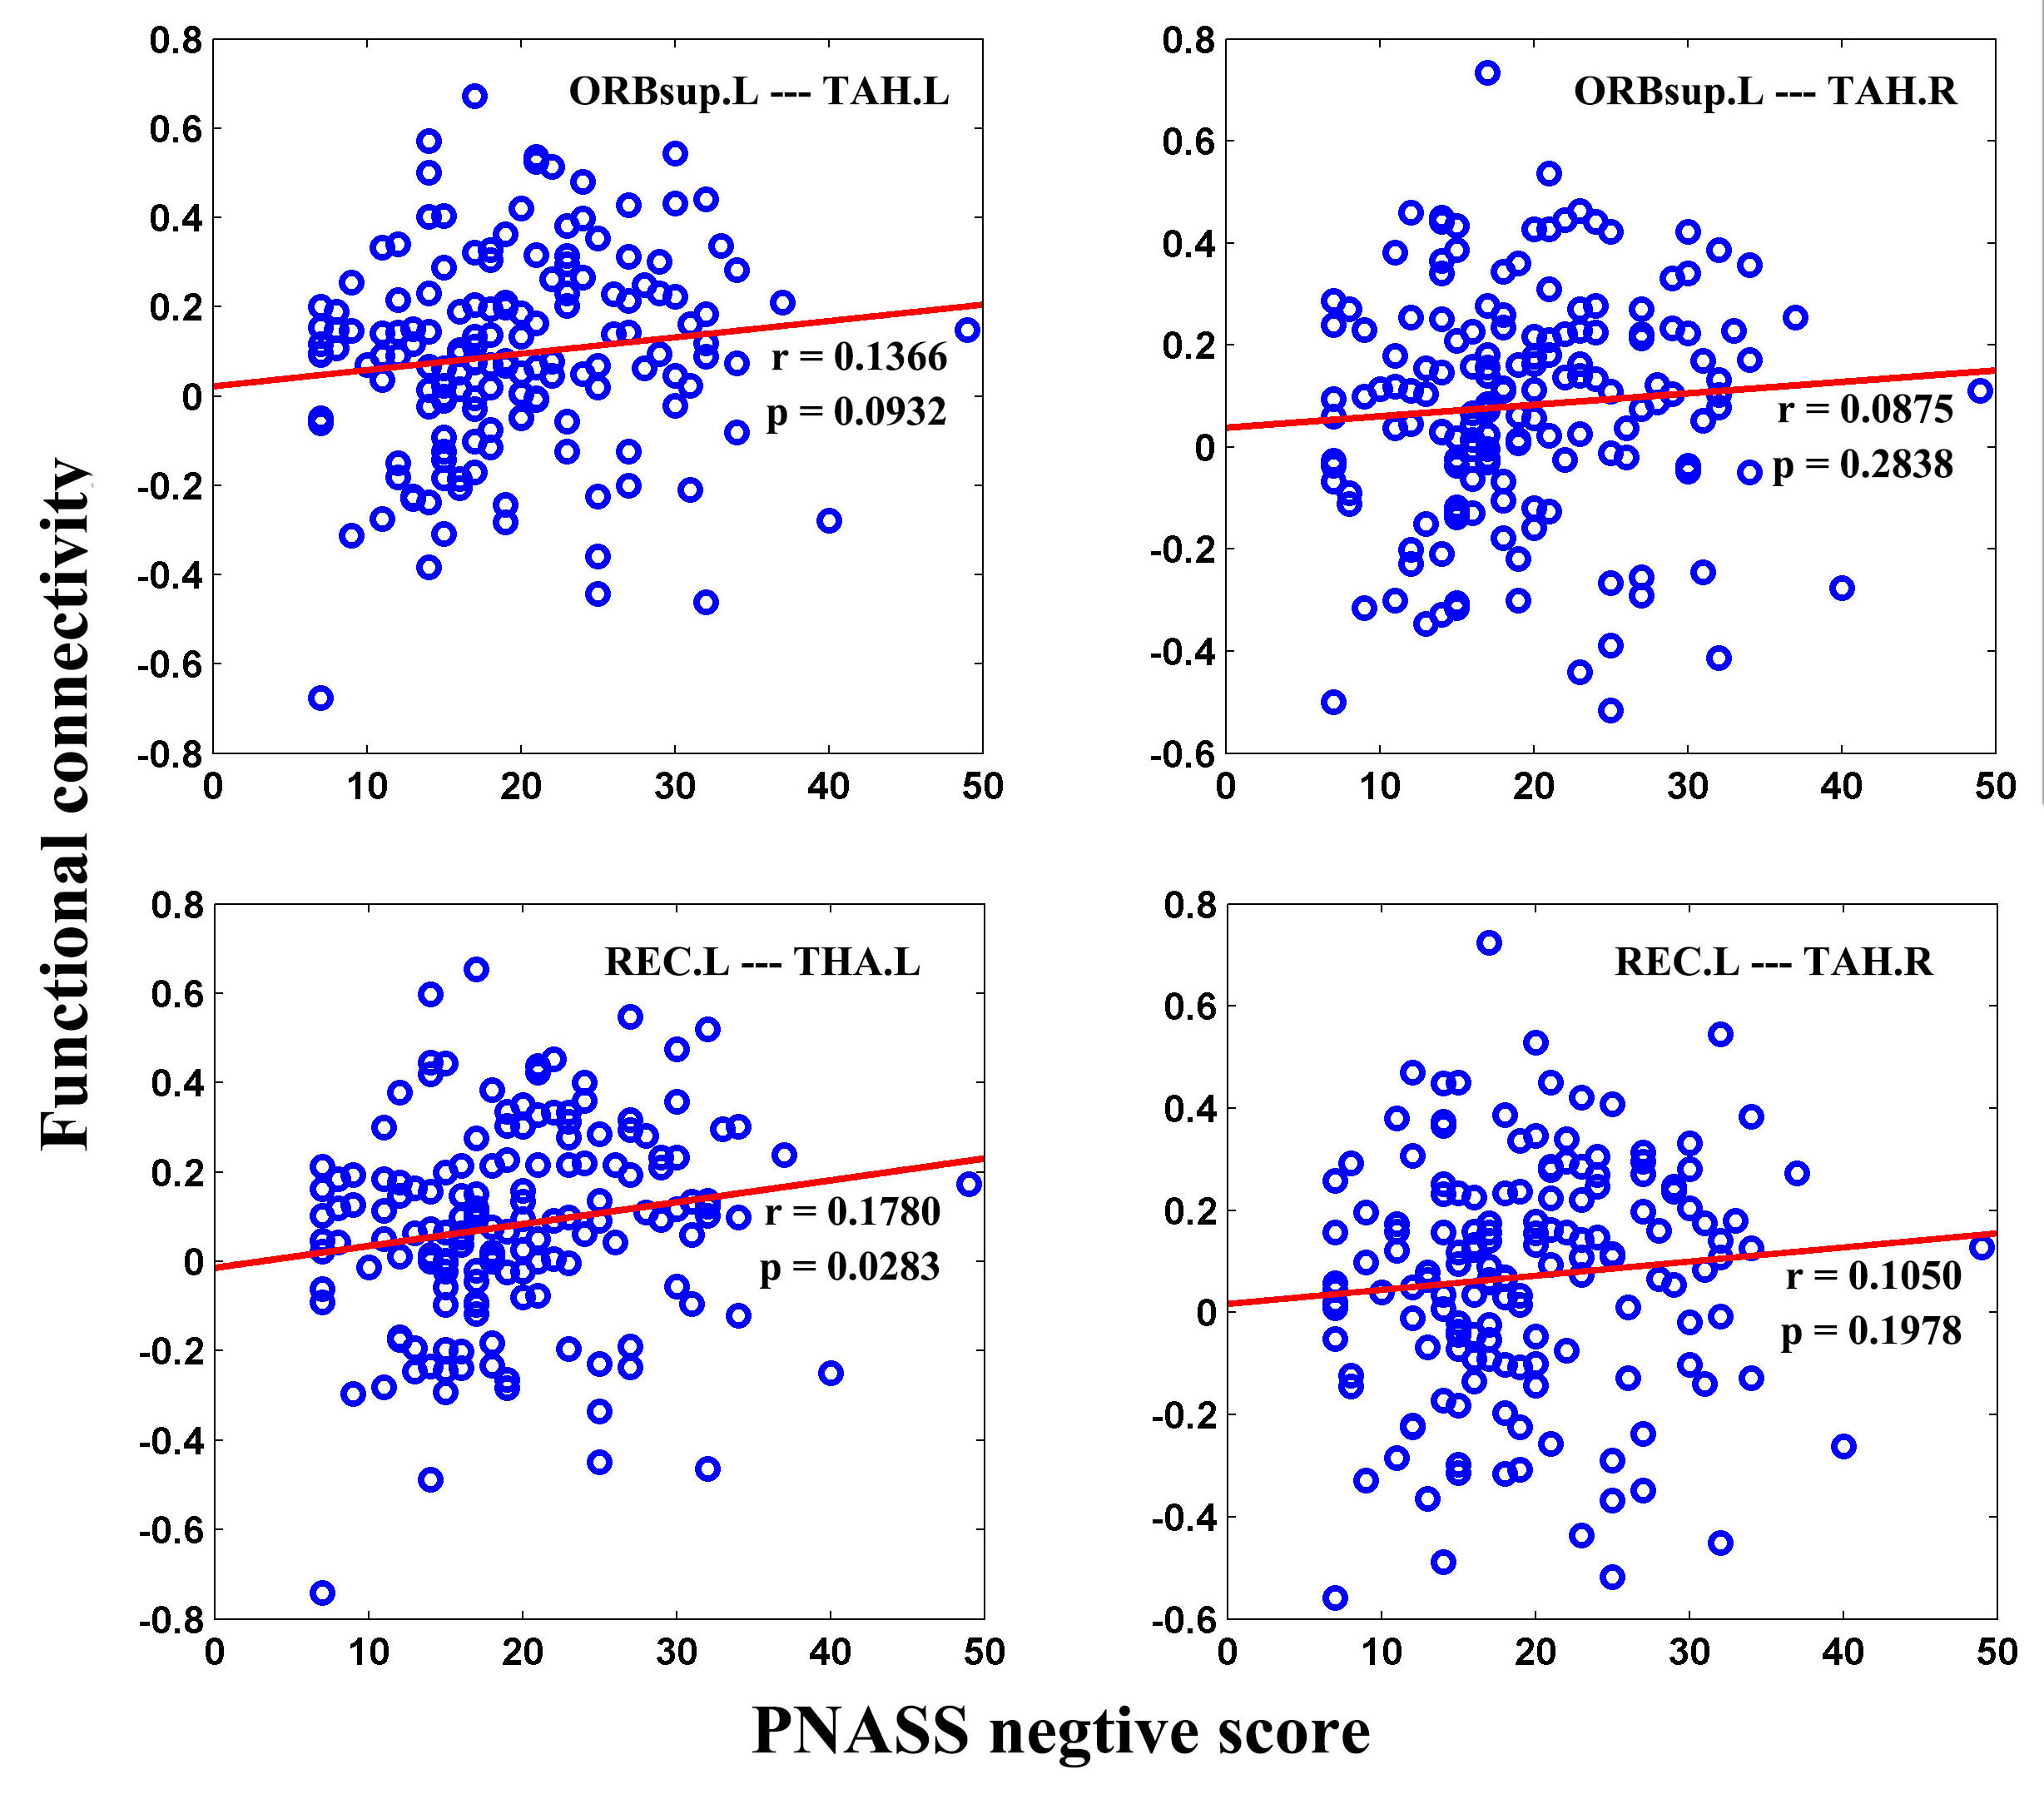
Figure S 1 the correlation of negative symptoms with altered functional connectivities using the cluster-based ROI-wise functional connectivity measures identified. There is a weak correlation between negative symptoms and the connectivities of REC.L-THA.L, but the correlation could not survive after multiple corrections. There are no any correlation amongst other clinical manifestations and altered functional connectivities.

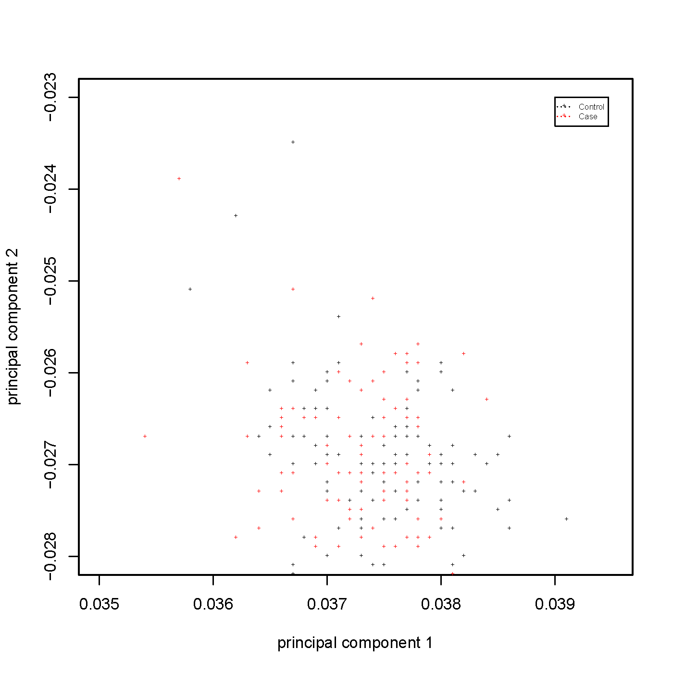
Figure S 2 The plot of the first two principal components of 127 patients with schizophrenia and 100 controls as output from EIGENSOFT(Price et al., 2006). Each data point represents an individual.

Figure S3 QQ plot of linear mixed model of 4 univariate analysis.

References
Power JD, Barnes KA, Snyder AZ, Schlaggar BL & Petersen SE (2012). Spurious but systematic correlations in functional connectivity MRI networks arise from subject motion. Neuroimage 59, 2142-2154.
Price AL, Patterson NJ, Plenge RM, Weinblatt ME, Shadick NA & Reich D (2006). Principal components analysis corrects for stratification in genome-wide association studies. Nature Genetics 38, 904-909.
Purcell S, Neale B, Todd-Brown K, Thomas L, Ferreira MAR, Bender D, Maller J, Sklar P, De Bakker PIW & Daly MJ (2007). PLINK: a tool set for whole-genome association and population-based linkage analyses. The American Journal of Human Genetics 81, 559-575.

