**SUPPLEMENTARY MATERIAL**

**Supplementary Methods**

**Event-Related Potential (ERP) Trimmed Mean Approach.**A 10% trimmed mean approach was used for averaging which has been shown to improve signal-to-noise (SNR) in averaged data. Unlike traditional ERP averaging, where each sample in the time series is summed across trials and divided by the total number of trials, trimmed mean ERP calculation involves sorting the data across trials at each point in the time series, then calculating a weighted mean of the middle percentage of sorted values (80% in this case). Therefore, traditional SNR calculation, which involves root-mean-square amplitude for each individual trial, is not possible when using a trimmed mean. Leonowicz et al.(Leonowicz et al., 2005) evaluated this trimmed mean approach with a pseudo-SNR calculation where the ratio of the variance in the ERP after time 0 was compared to variance in an equal number of points in the baseline interval. Conceptually, variance after time 0 is equated to “signal” and variance in the baseline is considered “noise”. Such an approach is misleading with these response-locked ERPs, since there is signal in the baseline period (as can be seen in the group average Figure S1 ERPs).

To overcome these challenges, a bootstrap approach was implemented to estimate the mean-square error (MSE = bias + variance) of the peak amplitude for various trial numbers from 6 up to 100 in 5% increments starting with 0% (i.e., the mean) going all the way to 50% (i.e., the median). As a result of 10,000 bootstrap iterations, we observed that 10% was the best linear unbiased estimator of the ERP based on smallest MSE across the trial numbers tested. Other than the use of real data (instead of simulated samples), this approach is similar to that outlined in “Understanding Robust Exploratory Data Analysis” (Chapter 10), where the benefits of such trimmed mean location estimators are described (Hoaglin et al., 1983).

**Post-Error Slowing:** Post-error slowing was calculated for incongruent trial errors, separately for the P75 and P25 conditions. To measure post-error slowing within an individual participant, the median RT for all correct trials was subtracted from the median RT for correct trials following error trials separately for each probability level (P75, P25). Post-error slowing median RT difference scores were compared using a 2-way repeated measures ANOVA model with a between-subjects factor of group (HC, OCD, HD) and within-subjects factors of incongruent probability (P75, P25).

**Statistical Analysis**

**Age Relationships:** We used Pearson correlations to assess the relationship between ERN amplitude and normal aging in HC participants and to assess the relationships between symptom severity and age.

**Supplementary Results**

**Table S1: Incongruent Reaction Time (RT).** Means and standard error in milliseconds (ms).

|  |  |  |  |  |  |  |  |  |
| --- | --- | --- | --- | --- | --- | --- | --- | --- |
|  | Hoarding Disorder (HD) | | Obsessive-Compulsive Disorder (OCD) | | Hoarding and Obsessive-Compulsive Disorder (OCD) | | Healthy Controls (HC) | |
|  |
|  | n= 14 | | n = 27 | | n = 10 | | n = 45 | |
| Probability | M | SE | M | SE | M | SE | M | SE |
|  |  |  |  |  |  |  |  |
| P25 | 351.05 | 12.94 | 309.70 | 9.32 | 343.78 | 15.31 | 334.58 | 7.22 |
| P75 | 377.24 | 16.23 | 324.66 | 11.69 | 351.08 | 19.20 | 348.50 | 9.05 |

**Table S2: Group Differences in Age-Corrected Error Reaction Time (RT) z-scores**

|  |  |  |  |  |
| --- | --- | --- | --- | --- |
|  | | | | |
| ANOVA Results | **df** | **F** | **p-value** |  |
| Hoarding (Present, Absent) | 1, 92 | 2.36 | 0.1283 |  |
| OCD (Present, Absent) | 1, 92 | 1.36 | 0.2465 |  |
| Hoarding X OCD | 1, 92 | 0.27 | 0.6047 |  |
| Hoarding X Probability | 1, 92 | 0.01 | 0.9432 |  |
| OCD X Probability | 1, 92 | 0.97 | 0.3279 |  |
| Hoarding X OCD X Probability | 1, 92 | 2.43 | 0.1222 |  |

**Table S3: Post-Error Slowing**

|  |  |  |  |
| --- | --- | --- | --- |
|  | Group | Mean | Std. Dev |
| P25 | HC | 20.40 | 32.31 |
|  | HD | 14.61 | 31.57 |
|  | OCD | 18.24 | 34.47 |
|  | Total | 18.39 | 32.51 |
| P75 | HC | 17.12 | 30.29 |
|  | HD | 1.97 | 21.27 |
|  | OCD | 17.73 | 25.28 |
|  | Total | 13.62 | 27.51 |

As can be seen in Supplementary Table S3, all groups exhibited post-error slowing, but there were no significant group (*F*(1, 96) = 1.37, p = .259), probability (*F*(1,96) = 3.266, p = .074), or group X probability interaction (*F*(2,96) = 1.25, p = .291) effects. Though not significant, the increased overall slowness in the HD group is demonstrated here, and may be related to the (non-significant) increase in errors in the P75 condition. Slowed RT may be implicated in the detection of errors or to prevent future error repetition (Holroyd and Coles, 2002).

**Table S4: Average number of incongruent error trials on which the ERN is calculated per group**

HD- (25%)= 36.07±19.45

HD- (75%)= 53.29±35.79

HD+ (25%)=37.42±22.91

HD+ (75%)=58.92±46.08

OCD- (25%)= 36.80±20.26

OCD- (75%)= 55.59±39.38

OCD+ (25%)= 35.78±20.50

OCD+ (75%)= 53.27±37.39

**Relationship Between Age and Symptom Severity:** We examined the relationship between age and symptom severity for the OCD and combined HD groups only, as the HC group was selected to be low on measures of symptom severity. Age was positively correlated with hoarding symptom severity in the entire sample of HD and OCD participants as measured by the SI-R (r = 0.319, p = 0.027, N = 48) and was negatively correlated with obsessive-compulsive symptom severity in this sample as measured by the YBOCS (r = -0.529, p <0.001, N = 45). In the HD group alone, there was no relationship between age and severity of hoarding symptoms (r = .10, p = .63), and a significant negative correlation between age and YBOCS total score in the HD group (r = -0.53, p = 0.014, N = 21). In the OCD group alone, there was no significant relationship between age and YBOCS total score (r= -0.15, p = 0.47, N = 24). Age was not significantly correlated with depressive or anxiety symptom severity as measured by the BDI (r = -.05, p = .742, N = 38) and the BAI (r = -.05, p = .781, N = 41) in the entire patient sample.

**Distribution of Grand Averaged Waveforms across Participants:** Butterfly plots of all individual subject ERPs at electrode FCz (black lines) and all the subjects with fewer than 12 trials (red lines) do not indicate major outliers among the 6-12 trial subjects:



**Supplementary Figure S1:** Butterfly plot of all individual participants. ERN peaks can be observed between 0-100ms in response-locked grand averaged waveforms. Black: participants with >12 error trials. Red: participants with 6-12 error trials.

**Effects of Age on ERN:** Age was not significantly associated with average ERN amplitude in the HC participants (r = 0.068, p = 0.66) (Supplementary Figure S2, left panel). However, there was some variability in the HC age-ERN relationship across the 3 electrode sites and 2 probability conditions (min r = -0.014, max r = 0.177, average r = 0.065), and age-corrected ERN z-scores were applied in patient samples to assess potential differences in pathological age-related trajectories between patient groups. Regression analysis of age-corrected ERN z-scores revealed a significant slope difference between HD and OCD patient groups (F(2,45)=4.847, p=0.012). Results displayed in Supplementary Figure S2, right panel indicate a significant distinction in the pathophysiological trajectory of z-score ERN amplitude over and above normal aging, such that only the HD positive participants showed a significant age relationship in which reduced ERNs were most pronounced in young HD patients and tended to normalize in older HD patients (HD: r = -0.479, p=0.0179; OCD: r = -0.008, p = 0.959).

**Supplementary Figure S2:** Left: in healthy control participants, the relationship between age and ERN amplitude (μV) is not significant (*r* = 0.068, p = 0.66). Right: a significant slope difference is observed between HD and OCD groups in the association between age and age-corrected ERN amplitudes (z-score) that control for normal aging. HD+OCD subjects (plotted in magenta) contributed to both HD and OCD correlation estimates. Only HD demonstrate a significant decrease in ERN amplitude abnormalities over time (HD: r = -0.479, p=0.0179; OCD: r = -0.008, p = 0.959).

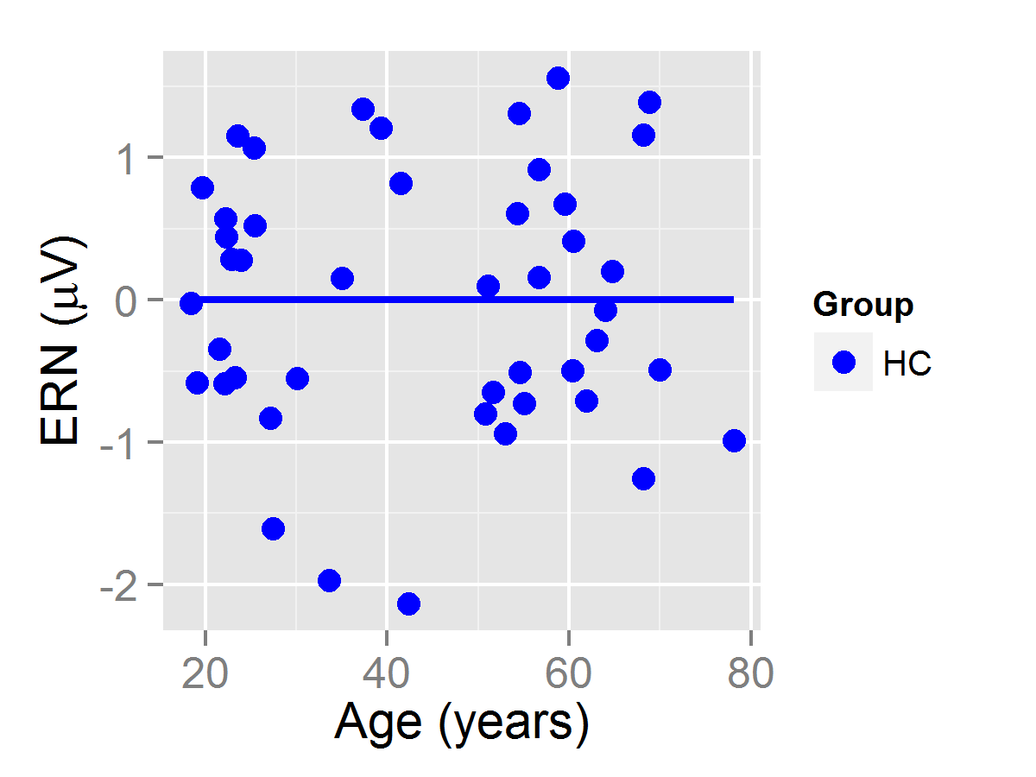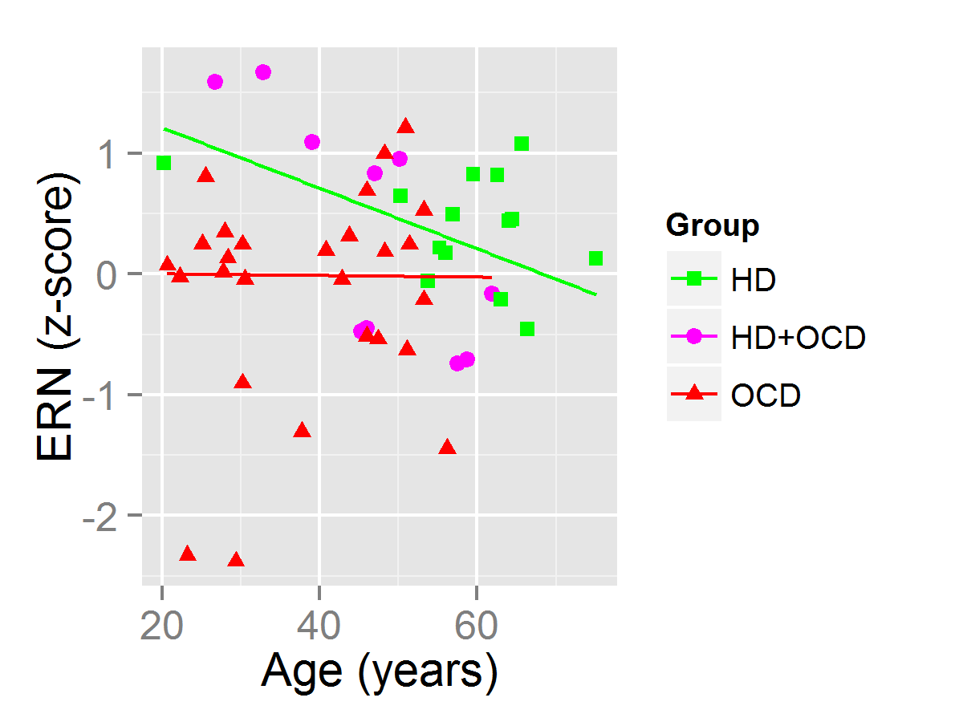

**Effects of gender on ERN:** Because there were significant differences in gender ratios by group, we conducted post-hoc secondary analyses, restricting the sample to female participants only, as females represent the larger proportion of total participants and a significantly greater proportion of the HD group in particular. As in the main analyses that included both males and females, HD participants showed significantly reduced ERNz amplitudes relative to non-HD participants (Supplementary Figure S3; Table S5), and the HD effect reached statistical significance in the overall model (p = 0.0276).

E:\Gamma\exps\HoardingEEG\peak files\femalesOCDHRzline.tif

**Supplementary Figure S3:** Mean (± standard errors) ERN amplitude age-corrected z-scores in the female subjects only, averaged across probability and electrode in incongruent trials, plotted for each group. Note larger age-corrected ERN deficits (i.e., less negative ERN) in HD and HD+OCD relative to HC and OCD participants. HC = Healthy Controls; HD = Hoarding Disorder; OCD = Obsessive-Compulsive Disorder, HD+OCD = combined HD and OCD.

**Table S5: ERNz in Females only**

|  |  |  |  |
| --- | --- | --- | --- |
| Probability | Group | Mean | Std. Error |
| P25 | HC (N = 25) | 0.04140 | 0.1878 |
|  | HD (N = 11) | 0.4994 | 0.2832 |
|  | HD+OCD (N=9) | 0.4977 | 0.3130 |
|  | OCD (N = 13) | -0.2547 | 0.2605 |
| P75 | HC | 0.02397 | 0.1770 |
|  | HD | 0.5847 | 0.2668 |
|  | HD+OCD | 0.09142 | 0.2950 |
|  | OCD | -0.2814 | 0.2454 |

**Effects of Group on ERN:** Our statistical model compared OCD and Hoarding Disorder (HD) dummy-coded between-subjects factors. This analysis allows us to directly test the OCD*HD interaction effect to determine if the HD effect depends on the subjects’ OCD status. We did not observe a significant interaction (p = 0.767). To further emphasize what this lack of interaction means, we also explicitly compared the HD+OCD patients (n=10) to HD-only patients (n=14) with a t-test (t = -0.1037, df = 22, p = 0.9814). There was not significant statistical evidence of a difference between these sub-groups. We have included Supplementary Figure S4 to further illustrate this.

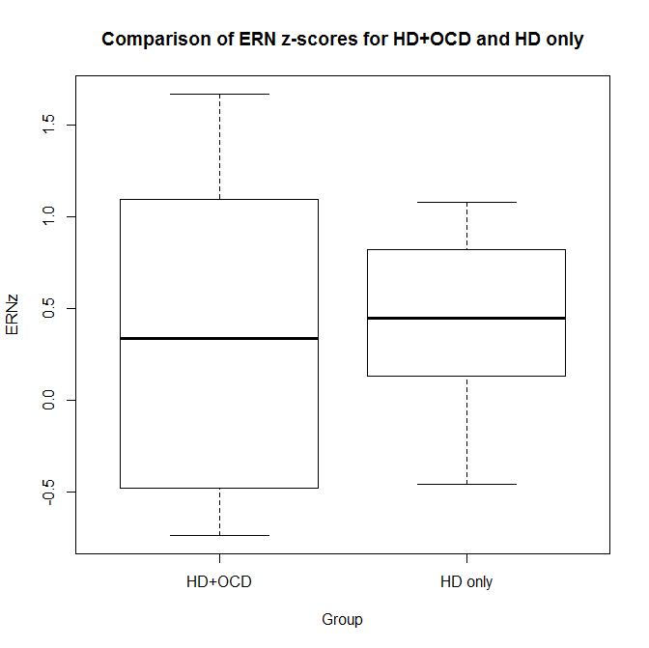

**Supplementary Figure S4:** Boxplot comparisons of the mean (± standard errors) ERN amplitude age-corrected z-scores, averaged across probability and electrode in incongruent trials, plotted for HD+OCD and HD only groups. Note similar age-corrected ERN amplitudes in HD and HD+OCD. HD = Hoarding Disorder; HD+OCD = combined HD and OCD.

**Supplementary References**

HOAGLIN, D. C., MOSTELLER, F. & TUKEY, J. W. 1983. *Understanding robust and exploratory data analysis*, Wiley.

HOLROYD, C. B. & COLES, M. G. 2002. The neural basis of human error processing: reinforcement learning, dopamine, and the error-related negativity. *Psychol Rev,* 109**,** 679-709.

LEONOWICZ, Z., KARVANEN, J. & SHISHKIN, S. L. 2005. Trimmed estimators for robust averaging of event-related potentials. *J Neurosci Methods,* 142**,** 17-26.