Supplemental Information

Joint ICA

We used joint ERP/fMRI data fusion using the FIT Toolbox (1). A typical ICA model assumes the source signals are non-observable, statistically independent, non-Gaussian, with an unknown but linear mixing process (2). Instead of running ICA on fMRI and EEG separately, as in traditional ICA analyses, joint ICA uses a shared mixing matrix combining the fMRI and EEG sources to generate maximally independent components. This has the benefit of modeling the potential coupling between the different modalities amongst the common covarying activations across subjects. The inputs were first normalized to have the same average sum-of-squares so as to ensure equal contributions from each modality, then concatenated together in the mixing matrix and submitted to joint ICA.

Inclusion/Exclusion Criteria:
BDD inclusion/exclusion criteria: Individuals who met criteria for BDD as determined by the BDD Diagnostic Module (3), modeled after the DSM-IV, were eligible. All were required to have a score of ≥20 on the BDD-YBOCS.

AN inclusion/exclusion criteria: AN participants were weight-restored (BMI of ≥18.5); but they must have previously met full DSM-IV criteria for AN. We chose to study weight-restored AN individuals to avoid confounds of starvation on brain activity. Eligible participants also had to meet all other current criteria for AN on the MINI, except for amenorrhea.

HC inclusion/exclusion criteria: HC could not meet any criteria for Axis I disorders, including substance use disorders, on the MINI.

Inclusion/exclusion criteria for all participants: Participants were free from psychoactive medications for at least 8 weeks prior to entering the study. All had normal or corrected visual acuity, as verified by Snellen eye chart. Exclusion criteria included other concurrent Axis I disorders aside from major depressive disorder, dysthymia, panic disorder, social phobia, or generalized anxiety disorder, as mood and anxiety disorders are so frequently comorbid in this population.

Face/House Stimuli Generation
For faces, we used digitized gray-scale photographs of male and female faces. The faces, validated for neutral emotional expression, came from the Macbrain database, Facial Emotional Stimuli, the University of Pennsylvania and the Psychological Image Collection at Stirling (http://pics.psych.stir.ac.uk/). We Fourier transformed these 256x256–pixel photographs using Scion Imaging Software (http://www.scioncorp.com). Next, we deleted the central 30x30 pixels of the transformed images for the high-pass filtered images and deleted all but the central 30x30 pixels for the low-pass filtered images. We then inversely Fourier transformed these images to create each of the final high-pass or low-pass filtered images. Each face measured 8.5cm x 8.5cm, and subtended a visual angle of 4.8°.

EEG Artifact Detection
We extracted and removed eye blink and movement artifacts using temporal ICA in BrainAnalyzer (www.brainproducts.com). In addition, channels and segments were visually inspected to account for artifacts missed through automatic detection. We used an interpolation algorithm to reconstruct channels marked as bad by the artifact detection algorithms.

fMRI Preprocessing
Image processing included motion correction, skull stripping, spatial smoothing of 5-mm full width at half maximum gaussian kernel, mean-based intensity normalization of all volumes by the same factor, high-pass temporal filtering, and registration to standard space. We co-registered functional images of each subject to corresponding matched-bandwidth images in native space and performed a second stage registration to their higher resolution MPRAGE scans. These were finally registered to structural 2mm standard images, defined by the Montreal Neurological Institute (MNI) averaged 152 standard brain.

Dual Regression
Multiple linear regression of the masked Group ICA maps against the preprocessed individual 4D resampled data sets yielded a subject specific time course for each component separately. Next, multiple linear regression of these time courses was carried out against the pre-processed individual 4D data sets in the standard space resolution (i.e., 2 mm), thereby providing better spatial specificity. This resulted in subject specific z-maps for each of the 6 components (P100 HSF, NSF, LSF, and N170 HSF, NSF, and LSF).

Behavioral analyses and results

EEG:
We performed a two-way repeated measures ANOVA to compare accuracy and response times for faces and houses, with group (AN, BDD, and HC) as the between groups factor and spatial frequency (LSF, NSF, HSF) as the within-groups factor. There were no significant main effect of group for accuracy (Faces: F_{2,42}=.07, p=.79, Houses: F_{2,42}=.13, p=.87) or reaction times (Faces: F_{2,42}=.9, p=.41, Houses: F_{2,42}=.43, p=.65). There were significant effects of spatial frequency on both accuracy (Faces: F_{3,42}=11.2 , p<.0001, LSF>HSF (p=.01); Houses: F_{3,42}=18.6 , p<.0001, LSF>HSF (p=.01)) and reaction time (Faces: F_{3,42}=159.8 , p<.0001, HSF> NSF (p=.001) and LSF (p<.0001); Houses: F_{3,42}=180.3 , p<.0001, HSF> NSF (p=.01) and LSF (p<.0001)) in both faces and houses tasks.

fMRI:
In our fMRI paradigm, we found similar results: no significant main effect of group for accuracy (Faces: F_{2,42}=.08, p=.78, Houses: F_{2,42}=2.6, p=.11) or reaction times (Faces: F_{2,42}=.1, p=.75, Houses: F_{2,42}=1.9, p=.17). There were significant effects of spatial frequency on reaction time (Faces: F_{3,42}=14.2 , p<.0001, HSF> LSF (p<.0001) and NSF (p=.04); Houses: F_{3,42}=13.74, p<.0001, HSF> LSF (p<.0001) and NSF (p<.0001)) in both faces and houses tasks, and accuracy (Faces: F_{3,42}=7.81, p=.001, HSF<LSF (p=.002) and NSF (p=.02); Houses: F_{3,42}=712, p=.494) for the faces task.

AN |  | Accuracy |  |  |  | Mean Reaction Time (s)
 |  | Faces | SE | Houses | SE | Faces | SE | Houses | SE
 | LSF | .965 | .041 | .976 | .019 | .809 | .110 | .829 | .139
 | NSF | .955 | .037 | .975 | .019 | .859 | .148 | .852 | .147
 | HSF | .953 | .034 | .963 | .021 | .958 | .145 | .972 | .142
BDD | LSF | .974 | .024 | .988 | .018 | .827 | .114 | .793 | .111
 | NSF | .971 | .017 | .972 | .030 | .868 | .109 | .826 | .157
 | HSF | .959 | .035 | .959 | .038 | .972 | .131 | .970 | .149
Controls | LSF | .986 | .016 | .984 | .023 | .765 | .092 | .783 | .117
 | NSF | .968 | .023 | .972 | .022 | .794 | .091 | .803 | .133
 | HSF | .959 | .030 | .968 | .038 | .899 | .121 | .941 | .143
Table S1. Behavioral performance during face and house EEG tasks. Accuracy data represents the proportion correct. LSF=low spatial frequency; NSF=normal spatial frequency; HSF=high spatial frequency.

Fig. S1. Behavioral performance during EEG face and house tasks. Accuracy data (y axis) represents the proportion correct. Reaction time data (y axis) is in seconds. AN=anorexia nervosa; BDD=body dysmorphic disorder; HSF=high spatial frequency; NSF=normal spatial frequency; LSF=low spatial frequency

Correlation results with clinical variables
We calculated correlations between individual subject spatial map average intensity values and scores on the EDE (for AN) and BDD-YBOCS (BDD), for NSF and LSF joint P100 and N170 components. We Bonferroni-corrected for multiple comparisons (α=.05/8=.00625).

In addition, for each condition for which there were significant between-group differences in brain activity we performed post hoc correlation analyses with the following clinical variables in BDD and AN participants: BABS, HAMA MADRS, and BMI. We corrected for multiple comparisons using false discovery rate (FDR) correction with a q threshold of .05. We calculated leverage statistics for all and removed outliers. None of the correlations survived correction for multiple comparisons.

A)
EDE
Stimuli |  |  | r value | p value
Faces | P100 | LSF | .207 | .459
 |  | NSF | -.013 | .962
 | N170 | LSF | -.554 | .04
 |  | NSF | -.1 | .724
Houses | P100 | LSF | .059 | .841
 |  | NSF | -.119 | .673
 | N170 | LSF | .011 | .971
 |  | NSF | .079 | .78

BDD-YBOCS
Stimuli |  |  | r value | p value
Faces | P100 | LSF | .101 | .73
 |  | NSF | .115 | .683
 | N170 | LSF | -.1 | .723
 |  | NSF | -.103 | .715
Houses | P100 | LSF | -.014 | .96
 |  | NSF | .108 | .701
 | N170 | LSF | -.135 | .645
 |  | NSF | -.279 | .334
B)
HAMA
Group | Stimuli |  |  | r value | p value
AN | Faces | N170 | LSF | -.643 | .16
 | Houses | P100 | LSF | .157 | .963
 |  | N170 | LSF | -.025 | .98
 |  | N170 | HSF | -.075 | .972
BDD | Faces | N170 | LSF | -.045 | .976
 | Houses | P100 | LSF | -.05 | .976
 |  | N170 | LSF | .098 | .976
 |  | N170 | HSF | -.282 | .976
MADRS
Group | Stimuli |  |  | r value | p value
AN | Faces | N170 | LSF | -.526 | .352
 | Houses | P100 | LSF | .147 | .9632
 |  | N170 | LSF | .028 | .98
 |  | N170 | HSF | -.007 | .98
BDD | Faces | N170 | LSF | -.184 | .976
 | Houses | P100 | LSF | -.263 | .976
 |  | N170 | LSF | -.008 | .976
 |  | N170 | HSF | -.315 | .976
BMI
Group | Stimuli |  |  | r value | p value
AN | Faces | N170 | LSF | .332 | .866
 | Houses | P100 | LSF | -.26 | .866
 |  | N170 | LSF | -.219 | .866
 |  | N170 | HSF | .22 | .866
BDD | Faces | N170 | LSF | .012 | .976
 | Houses | P100 | LSF | -.068 | .976
 |  | N170 | LSF | -.046 | .976
 |  | N170 | HSF | -.183 | .976
BABS
Group | Stimuli |  |  | r value | p value
AN | Faces | N170 | LSF | .368 | .866
 | Houses | P100 | LSF | .11 | .972
 |  | N170 | LSF | .257 | .866
 |  | N170 | HSF | .092 | .972
BDD | Faces | N170 | LSF | -.543 | .592
 | Houses | P100 | LSF | .228 | .976
 |  | N170 | LSF | .094 | .976
 |  | N170 | HSF | .343 | .976

Table S2. A) EDE and BDD-YBOCS correlation measures (r and p values) for faces and houses for ERP components (P100 and N170) and spatial frequencies (LSF and NSF) for a priori hypotheses. B) Post-hoc correlations of clinical variables (HAMA, MADRS, BMI, and BABS) with jICA components that were significantly different among groups (Faces LSF N170, Houses LSF P100, Houses LSF N170, Houses HSF N170). No correlations were statistically significant after FDR correction, q=.05.

A) 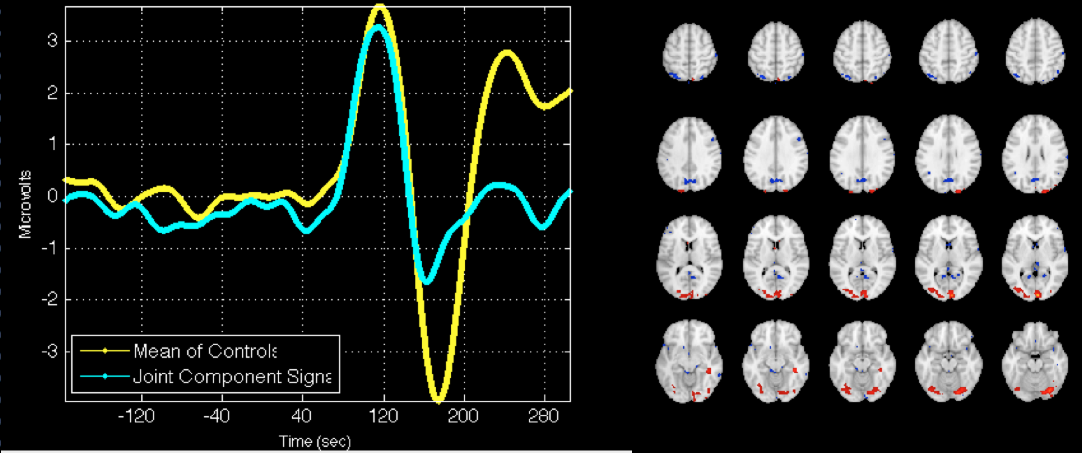
B)
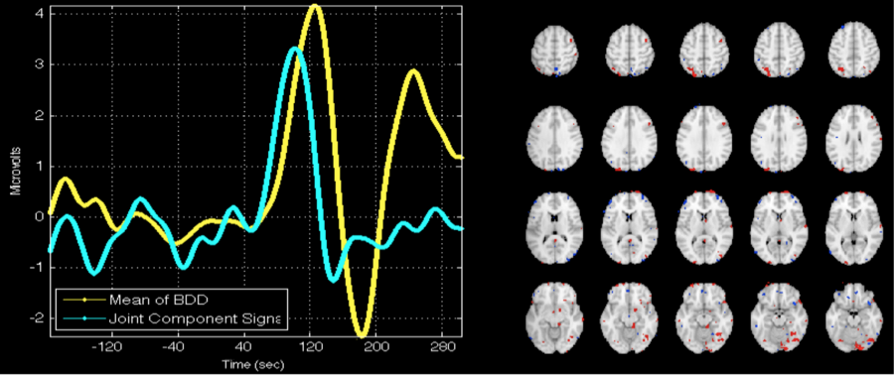
C)
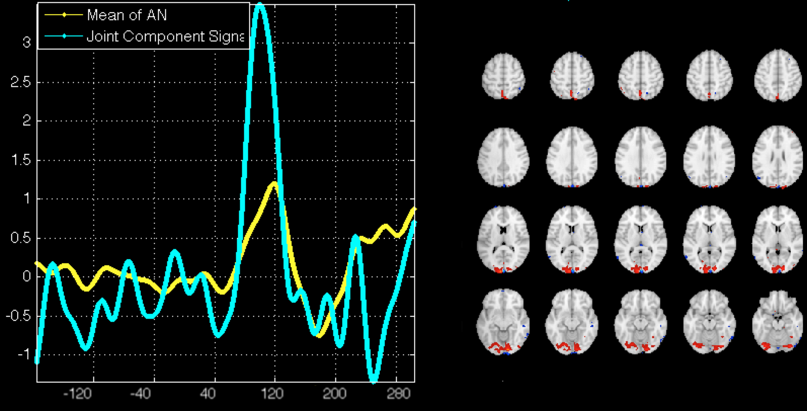
Fig. S2. A) Healthy control within group P100 component (high spatial frequency) (left) with fMRI fusion counterpart activation map (right), showing correspondence with areas linked to the visual ERP components. Yellow shows the group ERP, cyan shows the P100 component. Activations lie primarily in visual areas including the lingual gyrus and middle occipital cortex (|Z|>3.5).
B) Same as A), except for BDD within group
C) Same as A), except for AN within group

A)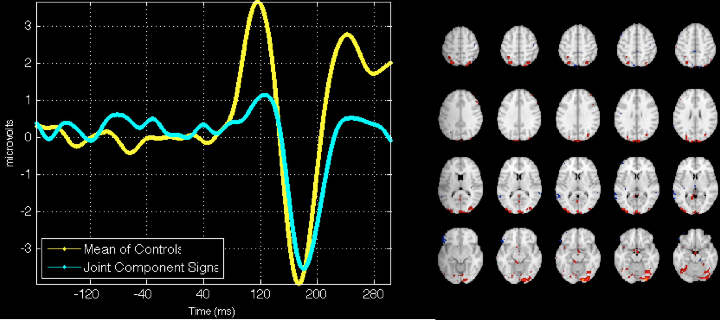
B)
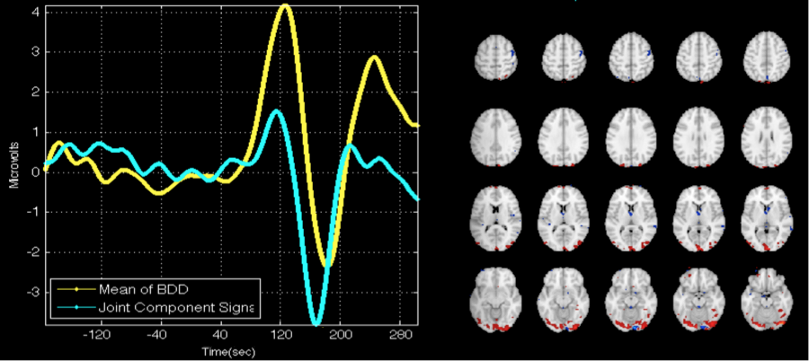
C) 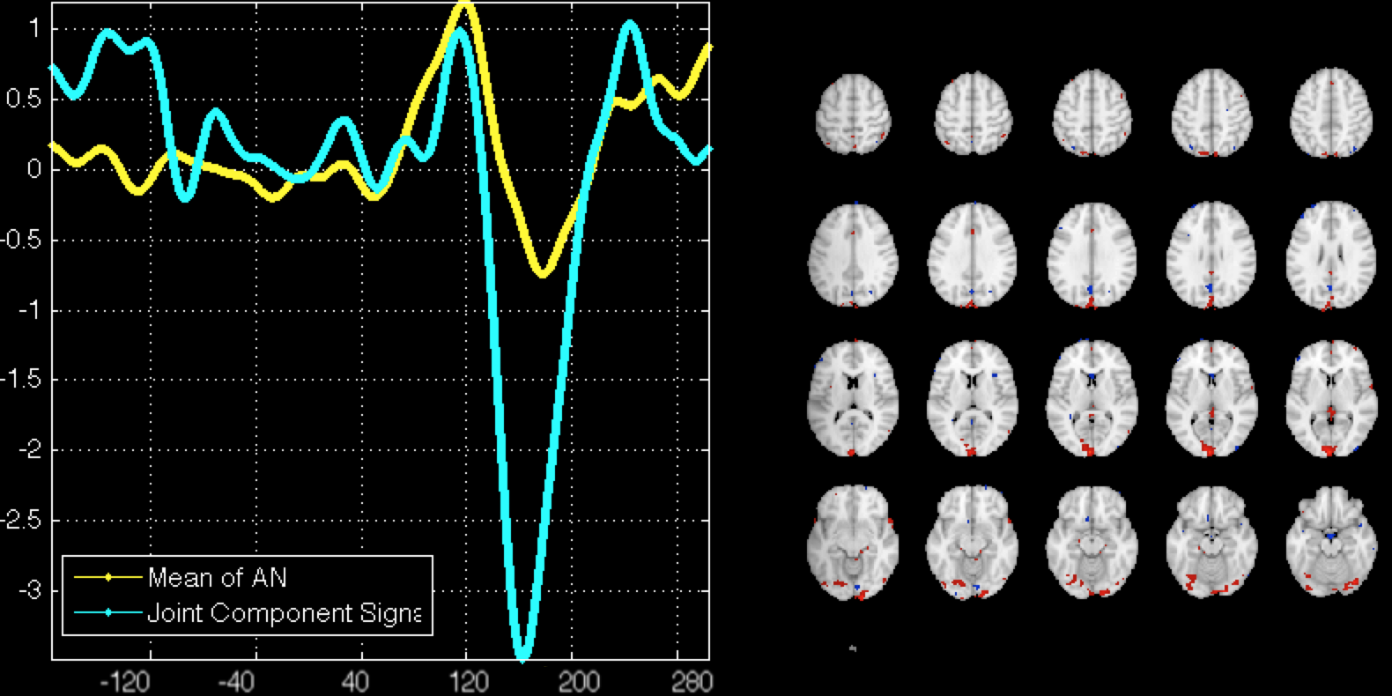
Fig. S3. A) Example of N170 component (High Spatial Frequency) (left) with fMRI fusion counterpart activation map (right), showing correspondence with areas linked to the visual ERP components. Yellow shows the group ERP, cyan shows the P100 component. Activations lie primary in visual areas, including the occipital fusiform gyrus and temporal fusiform gyrus (|Z|>3.5).
B) Same as A), except for BDD within group
C) Same as A), except for AN within group

ERP-fMRI Fusion movie
We generated a spatiotemporal movie using the FIT toolbox that show fMRI spatial snapshots as a linear sum of the individual maps weighted by their ERP timecourses.
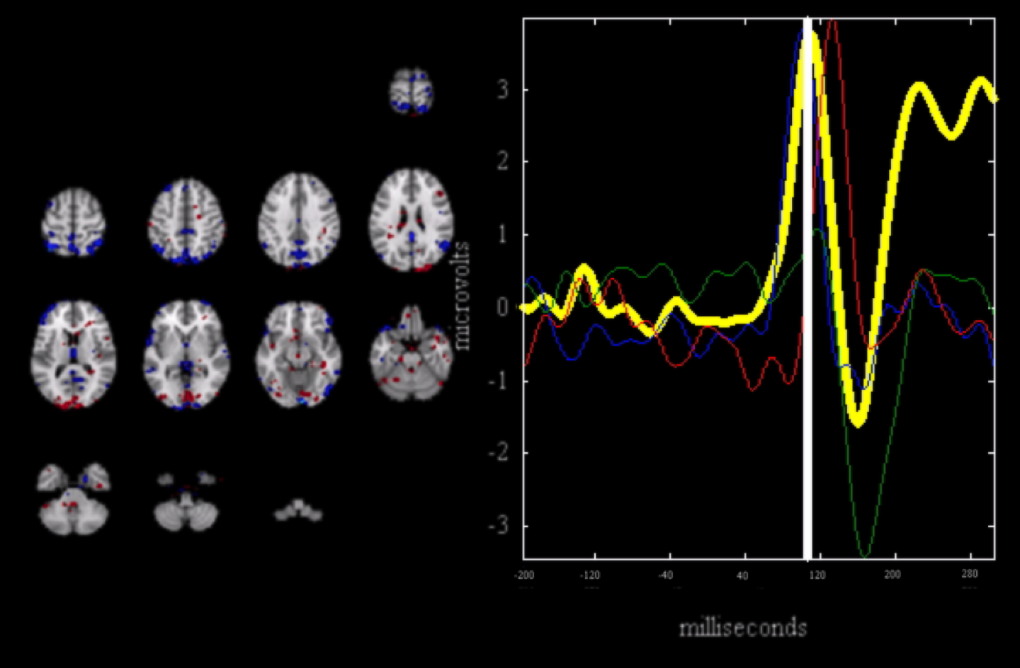
Fig. S4: LSF Faces Controls P100 component movie snapshot. The displayed spatial map is the linear sum of the individual fMRI maps (Z>4.0) associated with the visual independent components of interest (P100 and N170), weighted by their respective ERP time courses at the peak of the P100.
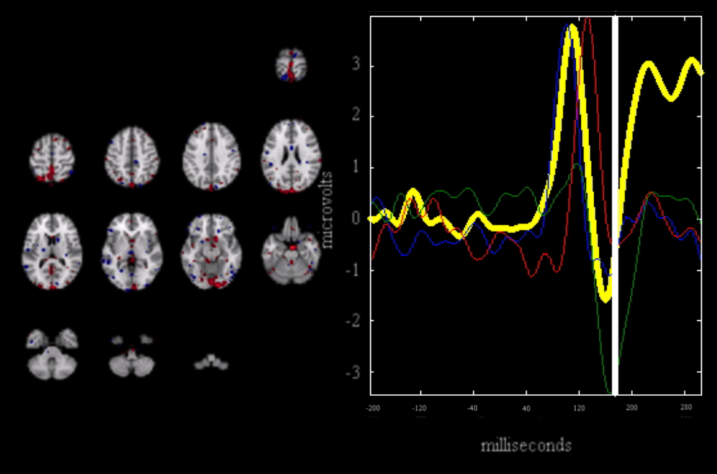Fig. S5: LSF Faces Controls N170 component movie snapshot. The displayed spatial map is the linear sum of the individual fMRI maps (Z>4.0) associated with the visual components of interest (P100 and N170), weighted by their respective ERP time courses at the peak of the N170.

Fig. S6: Post-hoc analysis of AN-BDD comparison. N170 joint component for LSF house stimuli. The BDD group (blue) demonstrated hypoactivity compared with AN in left lateral occipital cortex, p<.016. See table S7 for local max coordinates.

Healthy controls > AN
Brain Region | x | y | z | p
Left precuneus | -4 | -54 | 66 | .008
Left lateral occipital cortex | -18 | -74 | 60 | .008
Healthy controls > BDD
Brain Region | x | y | z | p
Left lateral occipital cortex | -32 | -72 | 50 | .004
Right occipital pole | 6 | -88 | 42 | .004
Precuneus | 0 | -80 | 40 | .004
Right superior parietal lobule | 30 | -52 | 70 | .004
Table S3.
Local Max MNI coordinates for the N170 joint component for LSF face stimuli. P values are from permutation tests for differences between patient groups and controls.

Healthy controls > AN
Brain Region | x | y | z | p
Right occipital fusiform gyrus | 22 | -88 | -18 | .006
Left occipital pole | -8 | -96 | -8 | .006
Right inferior temporal gyrus | 46 | -24 | -24 | .006
Right middle temporal gyrus | 56 | -22 | -14 | .006
Healthy controls > BDD
Brain Region | x | y | z | p
Right inferior temporal gyrus | 52 | -24 | -24 | .003
Right occipital fusiform gyrus | 20 | -88 | -18 | .003
Left inferior temporal gyrus | -56 | -20 | -26 | .003
Right frontal orbital cortex | 18 | 24 | -16 | .003
Table S4.
Local Max MNI coordinates for the P100 joint component for LSF house stimuli. P values are from permutation tests for differences between patient groups and controls.

BDD > healthy controls
Brain Region | x | y | z | p
Right frontal medial cortex | 2 | 34 | -30 | .006
Left post. temp. fusiform cortex | -38 | -12 | -36 | .006
Left subcallosal cortex | -2 | 4 | -16 | .006
Right frontal pole | 20 | 36 | -24 | .006
Table S5.
Local Max MNI coordinates for the N170 joint component for HSF house stimuli. P values are from permutation tests for differences between patient groups and controls.

Healthy controls > BDD
Brain Region | x | y | z | p
Right occipital fusiform cortex | 22 | -90 | -12 | .002
Left superior parietal lobule | -42 | -46 | 62 | .002
Left frontal pole | -30 | 66 | 16 | .002
Right temp. occipital fusiform | 32 | -56 | -16 | .002
Table S6.
Local Max MNI coordinates for the N170 joint component for LSF house stimuli. P values are from permutation tests for differences between BDD and controls.

AN > BDD
Brain Region | x | y | z | p
Right lateral occipital cortex | 20 | -74 | 58 | .0007
Left lateral occipital cortex | -16 | -64 | 64 | .004
Left precuneus | -6 | -78 | 52 | .004
Table S7.
Local Max MNI coordinates for the N170 joint component for LSF house stimuli. P values are from permutation tests for differences between BDD and AN.

Subject | Specific Appearance Concerns
2001 | Nose, eyes
2002 | Skin, nose
2007 | Hair, teeth
2011 | Face
2012 | Weight, thighs
2016 | Teeth, gums
2025 | Skin, weight
2027 | Legs
2028 | Muscle shape
2030 | Weight
2031 | Height
2032 | Shape of eyes
2033 | Skin, body
2034 | Face
2036 | Skin, weight
Table S8.
Areas of concern for BDD participants

References

1. Calhoun VD, Adali T, Pearlson GD, Kiehl K a (2006): Neuronal chronometry of target detection: fusion of hemodynamic and event-related potential data. Neuroimage 30: 544–53.
2. Calhoun VD, Adali T (2009): Feature-based fusion of medical imaging data. IEEE Trans Inf Technol Biomed 13: 711–20.
3. American Psychiatric Association (2013): Diagnostic and Statistical Manual of Mental Disorders DSM-5, 5th ed. American Psychiatric Publishing, p 991.

