Supplementary Material
Supplementary Table S1. Current medication type/dosage (mg/day) of the study participants
Supplementary Fig. S1 The logistic regression diagnostics showed 3 influential data points (Case No. 42, 173, and 200) and 1 outlier (Case No. 135). TRS = treatment-resistant schizophrenia.

Supplementary Table S1. Current medication type/dosage (mg/day) of the study participants
 |  | Non-TRS |  |  |  | TRS
Variable |  | (N = 104) |  |  |  | (N = 108)
 | n | Mean | (SD) |  | n | Mean | (SD)
Typical antipsychotics (CPZ equivalents) | 50 | 401.7 | (232.4) |  | 14 | 663.0 | (452.6)
Atypical antipsychotics
Amisulpride | 9 | 411.1 | (78.2) |  | 0 | - | -
Olanzapine | 4 | 13.8 | (4.8) |  | 4 | 11.3 | (4.8)
Quetiapine | 1 | 800.0 | - |  | 4 | 725.0 | (95.7)
Risperidone | 29 | 4.3 | (1.7) |  | 7 | 4.7 | (1.7)
Ziprasidone | 3 | 93.3 | (23.1) |  | 0 | - | -
Zotepine | 6 | 175.0 | (52.4) |  | 4 | 225.0 | (104.1)
Aripiprazole | 2 | 12.5 | (3.5) |  | 0 | - | -
Clozapine | 0 | - | - |  | 83 | 303.9 | (91.9)
TRS, treatment-resistant schizophrenia; CPZ, chlorpromazine.

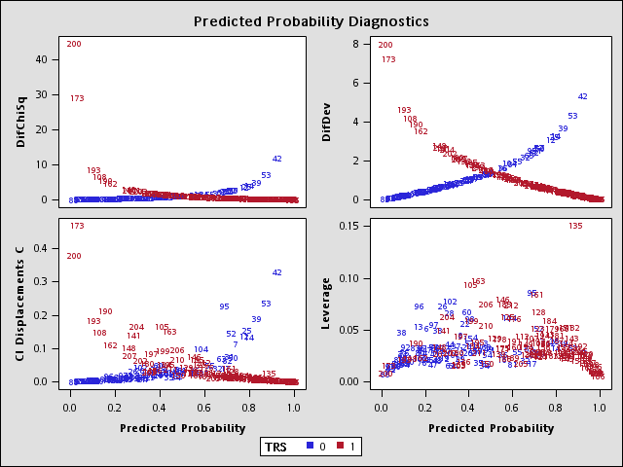
Supplementary Fig. S1 The logistic regression diagnostics showed 3 influential data points (Case No. 42, 173, and 200) and 1 outlier (Case No. 135). TRS = treatment-resistant schizophrenia.

