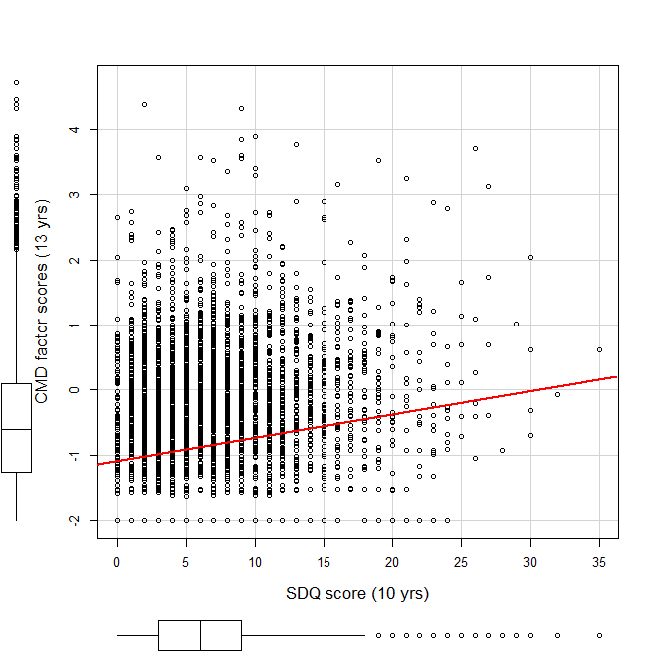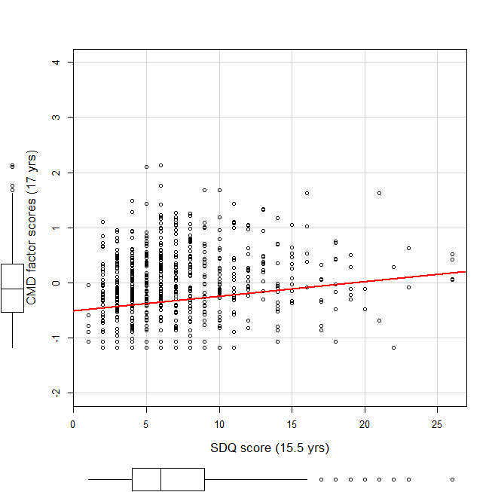
Note: Boxplots are included for both variables; red line is fitted linear regression line; SDQ= Strengths and difficulties questionnaire; CMD= common mental distress

Supplementary Fig. S2: Relationship between prior SDQ sum-score and CMD factor score in the ALSPAC cohort (left panel) and ROOTS cohort (right panel)

