SUPPLEMENTARY MATERIAL

Abnormal resting-state connectivity of motor and cognitive networks in early manifest Huntington’s disease

R. C. Wolf, F. Sambataro, N. Vasic, M. S. Depping, P. A. Thomann, G. B. Landwehrmeyer, S. D. Süssmuth and M. Orth

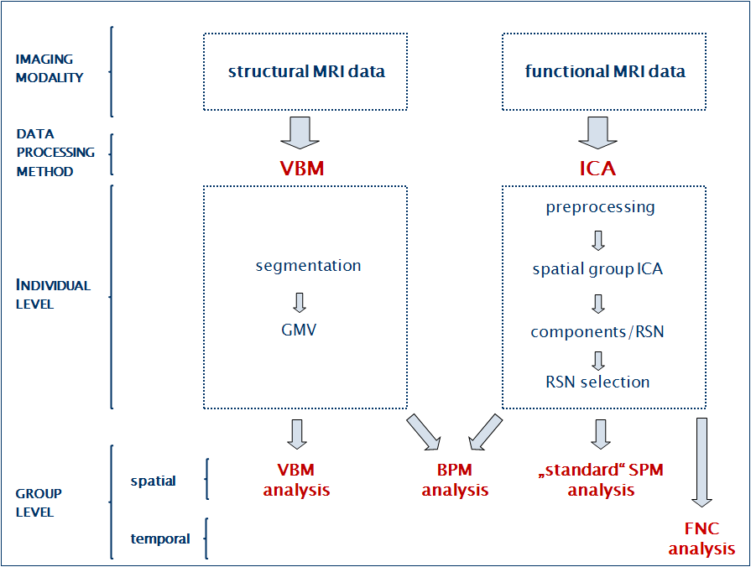
Fig. S1. Data analysis flowchart. BPM: Biological Parametric Mapping; FNC: Functional Network Connectivity; GMV: Gray Matter Volume; ICA: Independent Component Analysis; MRI: Magnetic Resonance Imaging; RSN: Resting-state Network; SPM: Statistical Parametric Mapping

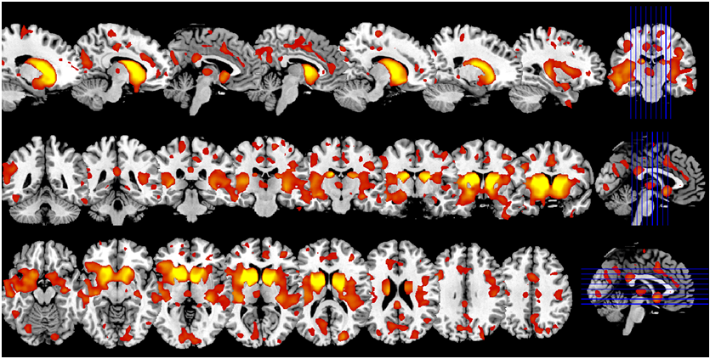

Fig. S2. Brain regions with decreased gray matter volume (GMV) in manifest HD individuals compared to healthy controls. Results of the 2nd level ANOVA, p<0.001 (uncorrected at the voxel level), p<0.05 corrected for spatial extent. In contrast to Fig. 2 (see main text), for illustration purposes the 2nd level maps were thresholded at t=3.4 (corresponding p<0.001, uncorrected for height) and rendered onto the anatomical template implemented in MRIcron (http://www.mccauslandcenter.sc.edu/mricro/mricron/). Hemispheric laterality is according to neurological convention (left = left).

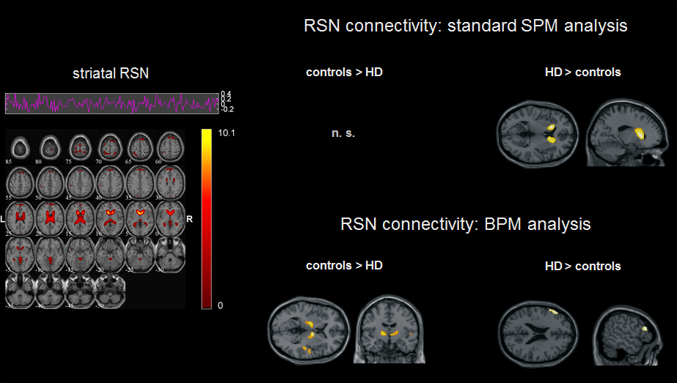
Fig. S3. Functional connectivity differences between HD patients and controls within the “striatal” RSN. Results derived from the “standard” SPM (top) and the BPM between-group analyses (bottom), p<0.001 (uncorrected at the voxel level), p<0.05 corrected for spatial extent. “Standard” SPM analyses were covaried for age and gender; BPM analyses were covaried for age, gender, GMV and TIV.
Left: Spatiotemporal pattern of the “striatal” RSN, as provided by the GIFT software. The color bar indicates Z-values. For illustrative purposes, IC’s were thresholded at Z=1.
Right: Between-group differences, rendered onto the anatomical template implemented in SPM8. N. s. indicates non-significant findings.

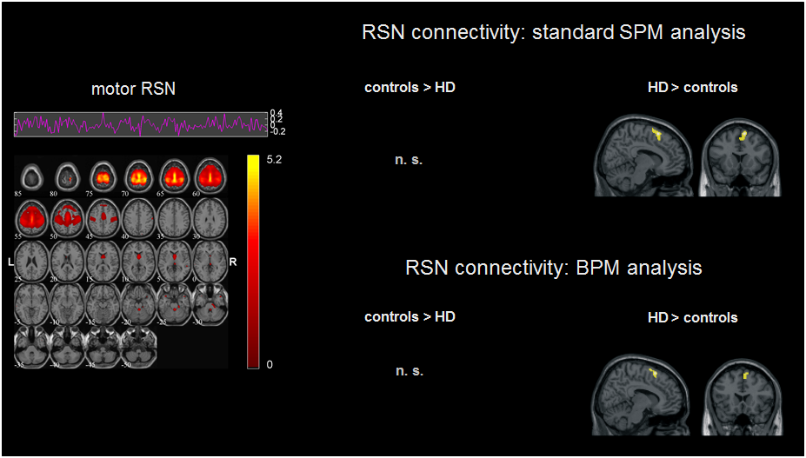
Fig. S4. Functional connectivity differences between HD patients and controls within the “motor” RSN. Results derived from the “standard” SPM (top) and the BPM between-group analyses (bottom), p<0.001 (uncorrected at the voxel level), p<0.05 corrected for spatial extent. “Standard” SPM analyses were covaried for age and gender; BPM analyses were covaried for age, gender, GMV and TIV.
Left: Spatiotemporal pattern of the “motor” RSN, as provided by the GIFT software. The color bar indicates Z-values. For illustrative purposes, IC’s were thresholded at Z=1.
Right: Between-group differences, rendered onto the anatomical template implemented in SPM8. N. s. indicates non-significant findings.

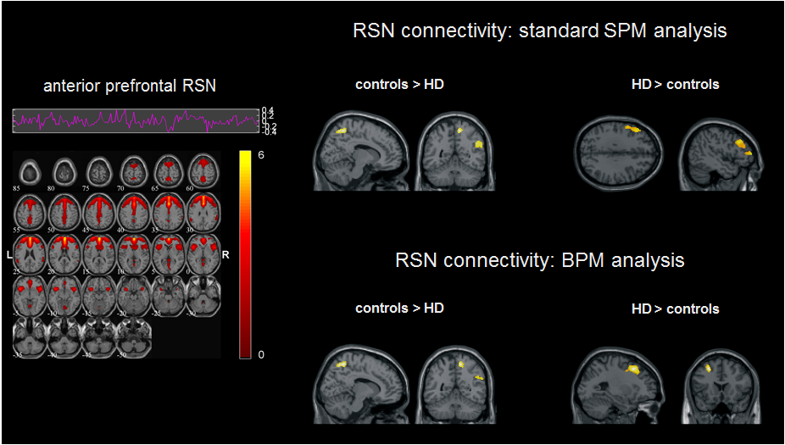
Fig. S5. Functional connectivity differences between HD patients and controls within the “anterior prefrontal” RSN. Results derived from the “standard” SPM (top) and the BPM between-group analyses (bottom), p<0.001 (uncorrected at the voxel level), p<0.05 corrected for spatial extent. “Standard” SPM analyses were covaried for age and gender; BPM analyses were covaried for age, gender, GMV and TIV.
Left: Spatiotemporal pattern of the “anterior prefrontal” RSN, as provided by the GIFT software. The color bar indicates Z-values. For illustrative purposes, IC’s were thresholded at Z=1.
Right: Between-group differences, rendered onto the anatomical template implemented in SPM8.

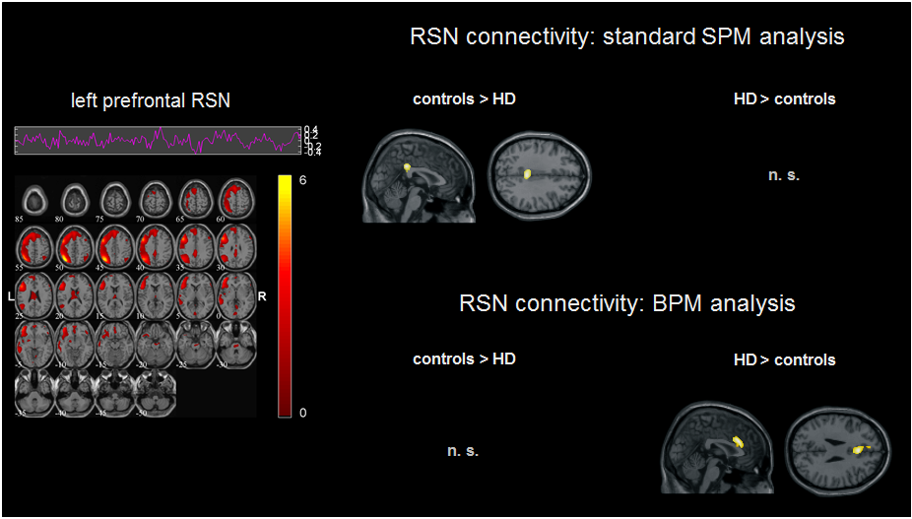
Fig. S6. Functional connectivity differences between HD patients and controls within the “left lateral prefrontal” RSN. Results derived from the “standard” SPM (top) and the BPM between-group analyses (bottom), p<0.001 (uncorrected at the voxel level), p<0.05 corrected for spatial extent. “Standard” SPM analyses were covaried for age and gender; BPM analyses were covaried for age, gender, GMV and TIV.
Left: Spatiotemporal pattern of the “left prefrontal” RSN, as provided by the GIFT software. The color bar indicates Z-values. For illustrative purposes, IC’s were thresholded at Z=1.
Right: Between-group differences, rendered onto the anatomical template implemented in SPM8. N. s. indicates non-significant findings.

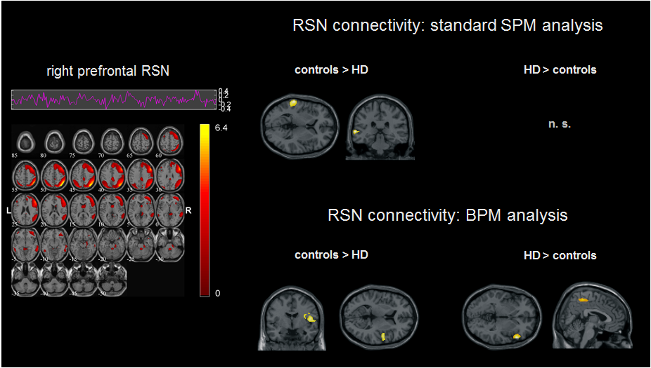
Fig. S7. Functional connectivity differences between HD patients and controls within the “right lateral prefrontal” RSN. Results derived from the “standard” SPM (top) and the BPM between-group analyses (bottom), p<0.001 (uncorrected at the voxel level), p<0.05 corrected for spatial extent. “Standard” SPM analyses were covaried for age and gender; BPM analyses were covaried for age, gender, GMV and TIV.
Left: Spatiotemporal pattern of the “right prefrontal” RSN, as provided by the GIFT software. The color bar indicates Z-values. For illustrative purposes, IC’s were thresholded at Z=1.
Right: Between-group differences, rendered onto the anatomical template implemented in SPM8. N. s. indicates non-significant findings.

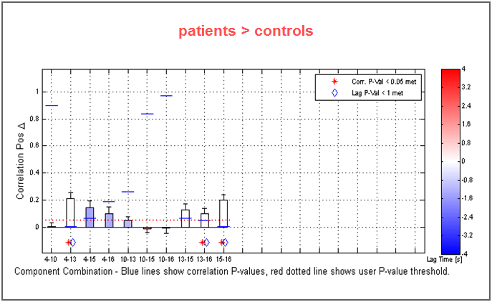
Fig. S8. Functional network connectivity between RSN.
The graphs indicate RSN combinations, where blue lines show correlation p values and red lines show the p-value threshold (p<0.05, uncorrected). The red star below the respective RSN combinations indicates significant correlation. Δ denotes differences between the groups.

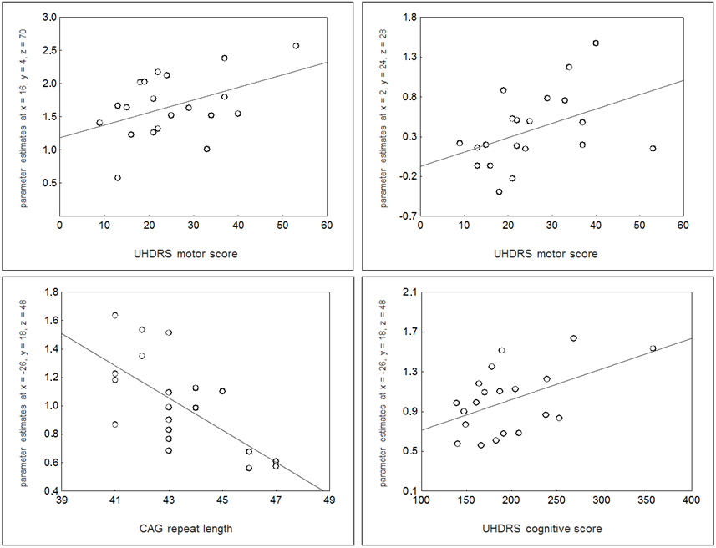
Fig. S9. Correlation plots showing the relationship between measures of brain activity and clinical scores in early HD patients (see main text for further details). Top left: correlation between SMA activity and UHDRS motor score; top right: correlation between ACC activity and UHDRS motor score; bottom left: correlation between left middle frontal cortex activity and CAG repeat length; bottom right: correlation between left middle frontal cortex activity and UHDRS cognitive score.

 |  | standard SPM analysis |  |  |  |  |  |  | BPM analysis
RSN |  | anatomical region | x | y | z | Z | no. of voxels |  | anatomical region | x | y | z | Z | no. of voxels
striatal | controls > HD | no significant differences |  |  |  |  |  |  | right thalamus | 10 | -4 | 6 | 4.59 | 77
 |  |  |  |  |  |  |  |  | left thalamus | -14 | -6 | 8 | 3.84 | 125
 |  |  |  |  |  |  |  |  | right superior temporal gyrus | 48 | -14 | 6 | 3.37 | 67
 | HD > controls | left caudate nucleus | -16 | 10 | 12 | 4.86 | 282 |  | left inferior frontal gyrus | -52 | 18 | 20 | 3.65 | 273
 |  | right caudate nucleus | 18 | 22 | 4 | 5.10 | 400
motor | controls > HD | no significant differences |  |  |  |  |  |  | no significant differences
 | HD > controls | supplementary motor area | 10 | 16 | 62 | 4.09 | 74 |  | supplementary motor area | 10 | 16 | 62 | 4.46 | 48
anterior prefrontal | controls > HD | no significant differences |  |  |  |  |  |  | right precuneus | 10 | -48 | 68 | 3.83 | 137
 | HD > controls | left middle frontal gyrus | -26 | 20 | 48 | 5.11 | 355 |  | left middle frontal gyrus | -26 | 22 | 46 | 4.37 | 160
 |  | left middle frontal gyrus | -48 | 28 | 36 | 4.12 | 366
 |  | Ieft inferior frontal gyrus | -54 | 4 | 38 | 3.98
left lateral prefrontal | controls > HD | middle cingulate gyrus | 4 | -34 | 32 | 4.26 | 154 |  | no significant differences
 | HD > controls | no significant differences |  |  |  |  |  |  | anterior cingulate | 0 | 18 | 26 | 3.88 | 118
 |  |  |  |  |  |  |  |  | medial frontal gyrus | 4 | 60 | 22 | 4.23 | 67
right lateral prefrontal | controls > HD | left middle temporal gyrus | -64 | -28 | 4 | 3.98 | 66 |  | right precentral gyrus | 48 | 0 | 14 | 3.57 | 58
 | HD > controls | no significant differences |  |  |  |  |  |  | right inferior frontal gyrus | 54 | 24 | -2 | 4.05 | 90
 |  |  |  |  |  |  |  |  | right paracentral lobule | 4 | -40 | 56 | 3.56 | 81

Table S1. Brain areas showing functional connectivity differences between controls and HD patients. Results of 2nd level t-tests (standard SPM analysis [left], BPM analysis [right]), p<0.001 uncorrected at the voxel level, p<0.05 corrected for spatial extent. Standard SPM analyses were covaried for age, gender, medication status and movement (see main text for further details). BPM analyses were covaried for covaried for age, gender, medication status, movement, TIV and GMV.

