Supplementary Figures
Figure S1: Difference (& 95% CI) from baseline group (both parents born in Sweden) in risk of suicide in relation to school-level average foreign-born

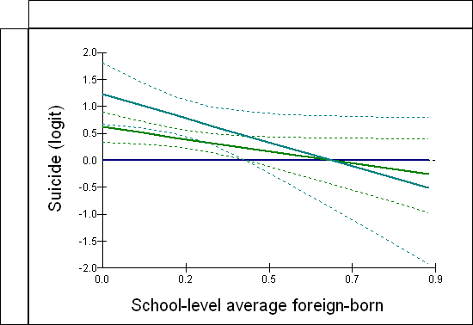

___ Both parents born Sweden
___ 1 parent born abroad
___ 2 parents born abroad

Differences from baseline group for ethnicity were significant primarily within the lower half of the school-level average, with greater uncertainty around estimates at the higher end of the school-level average as these were based on relatively small proportions of the sample

Figure S2: Difference (& 95% CI) from baseline group (0 markers of deprivation) in risk of suicide in relation to school-level average deprivation

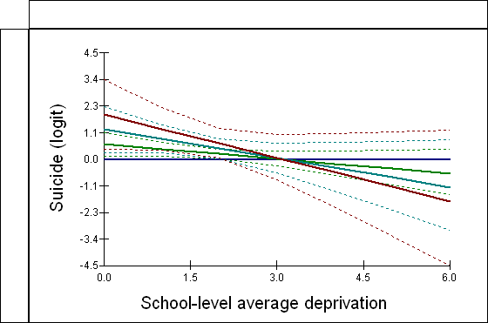

___ 0 markers of deprivation
___ 1 marker of deprivation
___ 2 markers of deprivation
___ 3 markers of deprivation

Differences from baseline group for deprivation were significant primarily within the lower half of the school-level average, with greater uncertainty around estimates at the higher end of the school-level average as these were based on relatively small proportions of the sample

