SUPPLEMENTARY MATERIAL

Probability discounting analyses
In order to confront our data with previous results showing that pathological gamblers have lower probability discounting rates (Madden et al., 2009; Andrade and Petry, 2012) than controls, we fitted our data with the following 2-parameters hyperbolic function (Holt, 2003; Shead and Hodgins, 2009) :
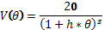
where :
V is the certainty equivalent amount.
20 is the amount of the positive outcome for the risky gamble.
is the odds agains winning (1-p) / p, and represent the average number of losses expected before a win on a gamble of probability p.
h is the k-value or discounting rate.
s is a scaling parameter.

Estimation of the free parameters h and s was made using the same procedure previously applied for the estimation of the weighting function parameters (see Methods – Data analysis). Pathological gamblers had an average k-value (h parameter) of 0.85, whereas the controls had an average k-value of 1.85. A two-sample t-test revealed that this difference was marginally significant (t = -1.90; p = 0.065). The average s parameter was 0.52 for pathological gamblers and 0.93 for controls. Again, no significant difference was found (t= -0.96; p=0.34) between the two groups.
The k-values were not significantly correlated with the SOGS scores among pathological gamblers (r = 0.3; p = 0.22) but were correlated with the GABS scores, both in the PG group (r = 0.52 ; p = 0.026) and the control group (r = 0.48; p = 0.029).
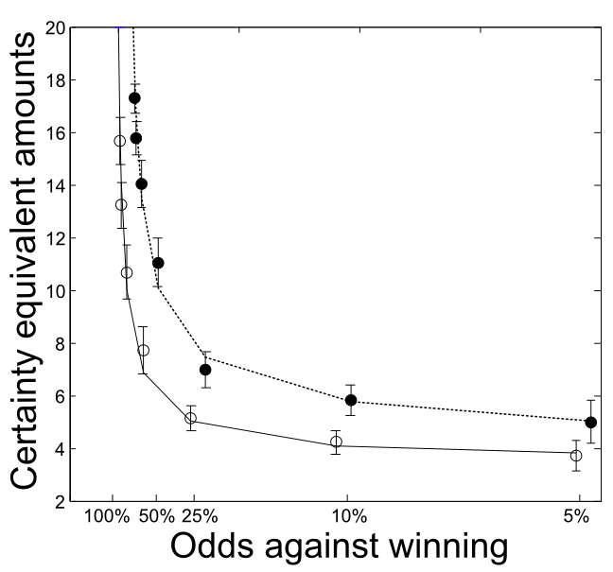
Fig. S1. Certainty equivalent amounts as a function of odds against winning for each probability tested. The filled dots represent real data points and the dotted curve represents the fitted hyperbolic function of pathological gamblers. The empty dots represent real data points and the black curve represents the fitted hyperbolic function of controls (error bars = s.e.m).

Andrade, L.F., Petry, N.M., 2012. Delay and probability discounting in pathological gamblers with and without a history of substance use problems. Psychopharmacology 219, 491-9.
Holt, D., 2003. Is discounting impulsive? Evidence from temporal and probability discounting in gambling and non-gambling college students. Behavioural Processes 64, 355-367.
Madden, G.J., Petry, N.M., Johnson, P.S., 2009. Pathological gamblers discount probabilistic rewards less steeply than matched controls. Experimental and clinical psychopharmacology 17, 283-90.
Shead, N.W., Hodgins, D.C., 2009. Probability discounting of gains and losses: implications for risk attitudes and impulsivity. Journal of the experimental analysis of behavior 92, 1-16.

