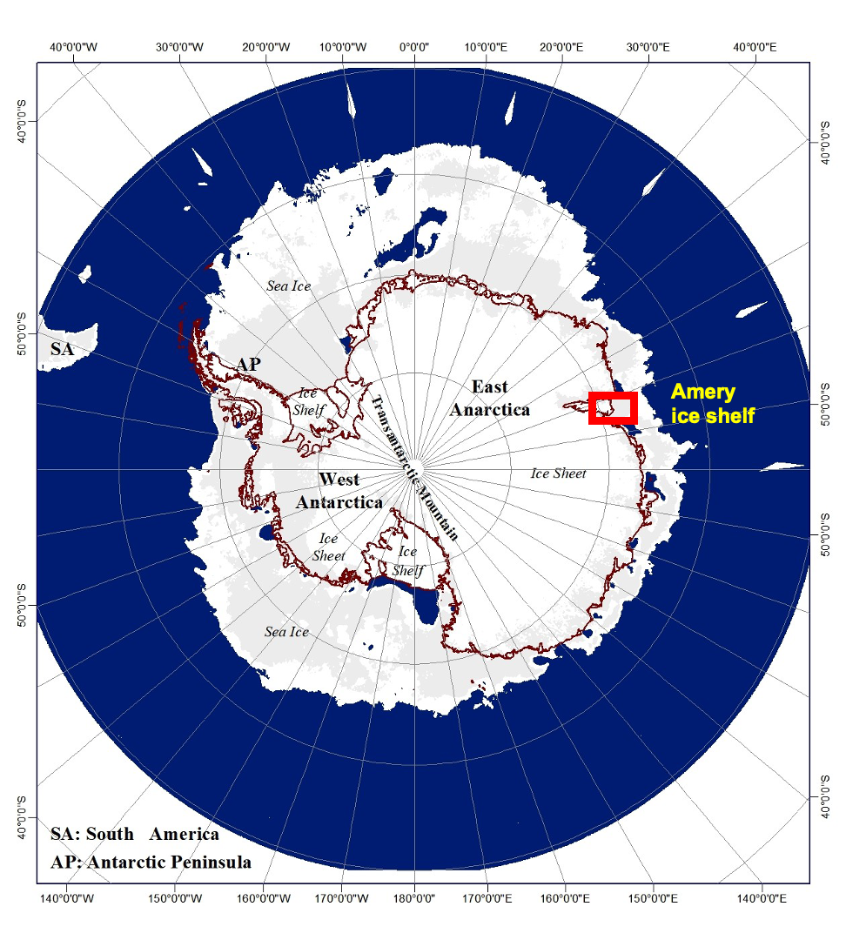

Supplementary Fig. 1: Antarctica with a typical winter sea ice condition. Red rectangle marks the region of Amery ice shelf.



Supplementary Fig. 2: Flowchart of the methodology.



(a)

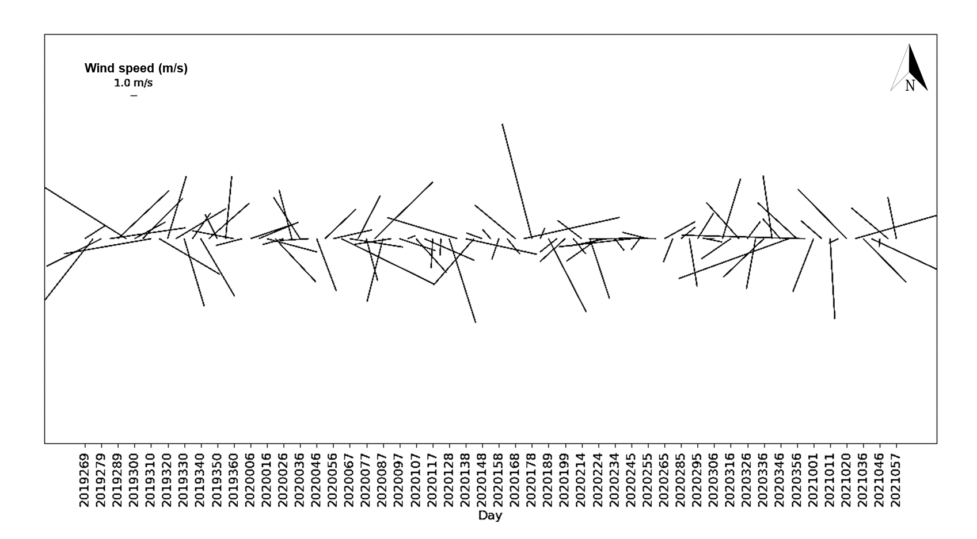

(b)

Supplementary Fig. 3: Wind speed at the position of D28 iceberg from September 2019 to February 2021 (a) time series, and (b) the corresponding stick plot. Stick plots are also speed versus time, but they also show the direction of the flow, which makes them a representation of the velocity versus time plot. The values on the vertical axis do not correspond well to the stick lengths since they have different directions from the horizontal axis. Therefore, in the top left corner of the stick plots, the name of the parameter, unit, and reference length of the stick are shown instead of the vertical axis.



(a)

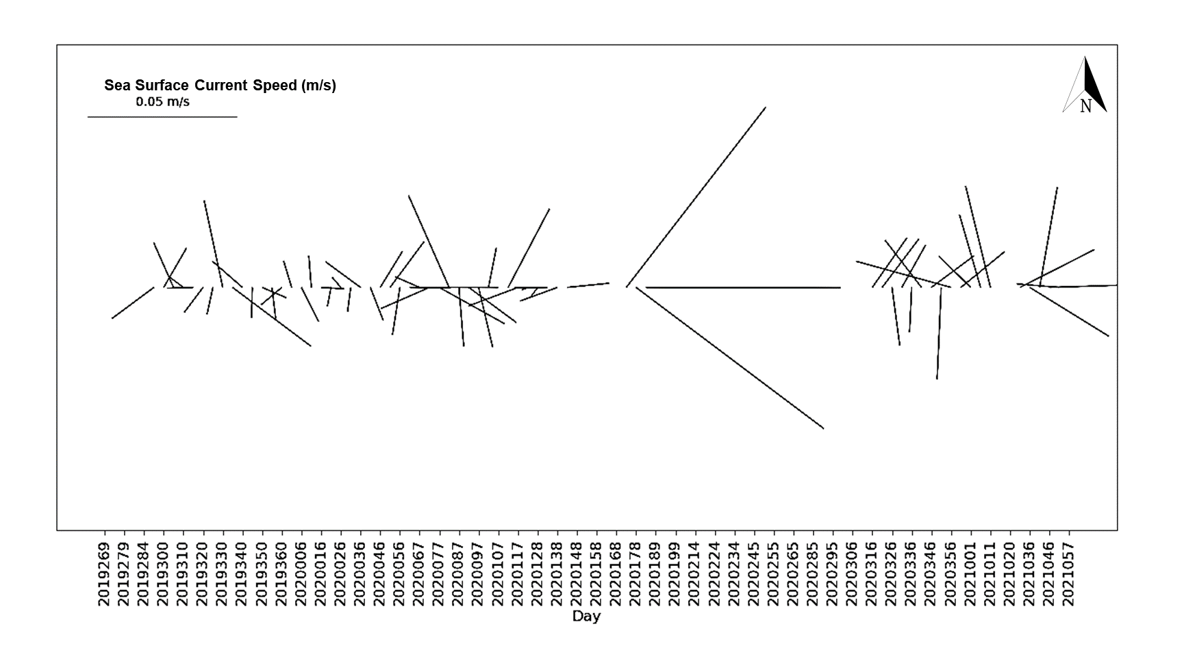

(b)

Supplementary Fig. 4: Time series of the (a) sea surface current speed at the position of the D28. The data gap is due to sea ice coverage in the iceberg vicinity during Austral winter, and (b) The corresponding stick plot.

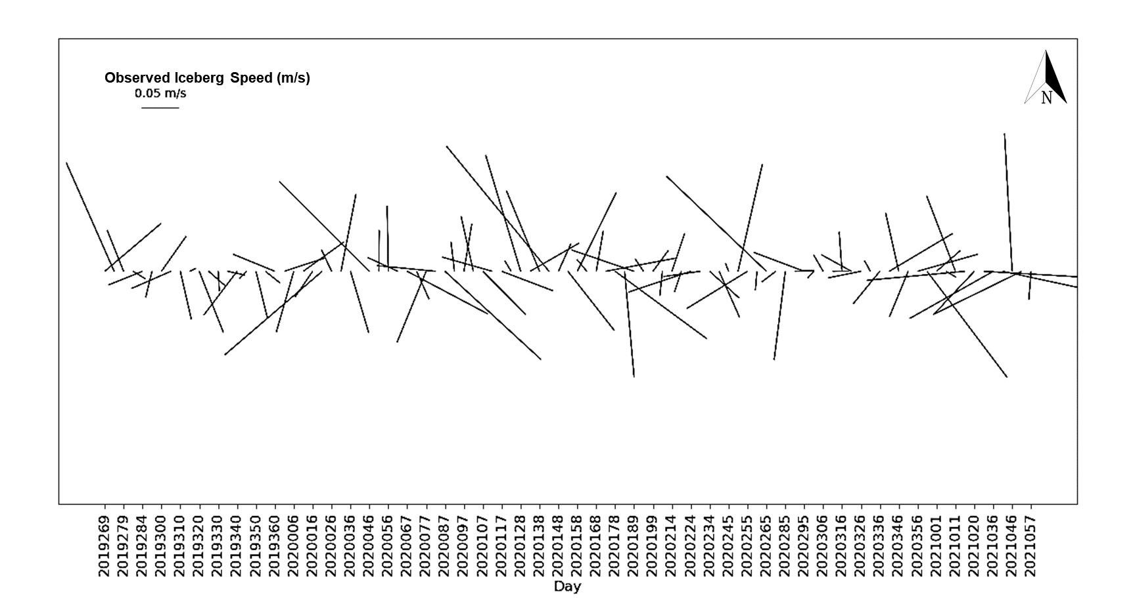

(a)

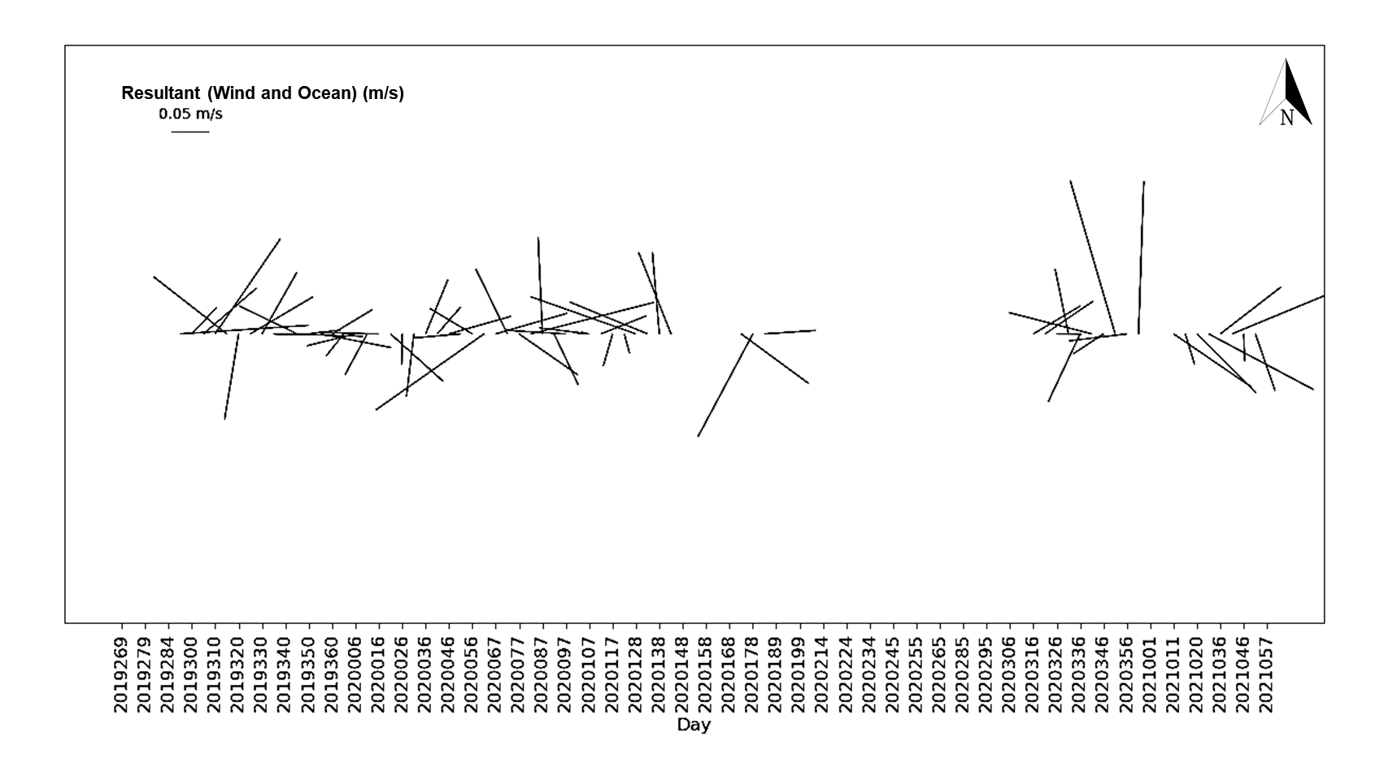

(b)

Supplementary Fig. 5: Time series stick plots of (a) observed iceberg speed, and (b) the theoretical iceberg velocity derived from wind and ocean data.

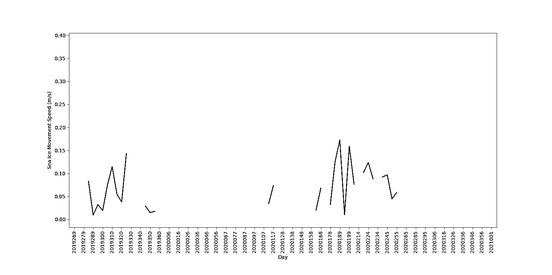

(a)

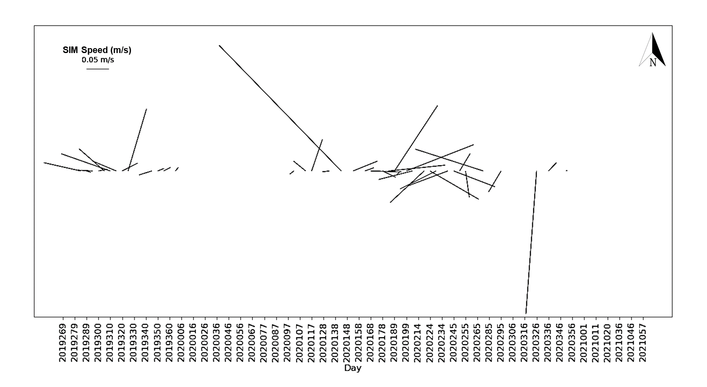

(b)

Supplementary Fig. 6: (a) Time series of SIM speed from September 2019 to February 2021, and (b) Same as (a) but in stick plot (that is, with directional information).

Table 1

Values of D28 speed, wind speed, ocean current, SIM speed and sea ice concentration at different positions of D28.

|  |  |  |  |  |  |  |  |  |
| --- | --- | --- | --- | --- | --- | --- | --- | --- |
| Sl. No. | Day | latitude | longitude | Observed Iceberg Speed (m/s) | Wind Speed (m/s) | Ocean Current Speed (m/s) | SIM (m/s) | Sea Ice Conc. |
| 1 | 2019269 | -68.5896 | 72.16268 |  | 3.531572987 |  |  |  |
| 2 | 2019274 | -68.4678 | 71.97228 | 0.036418981 | 11.4890435 |  |  |  |
| 3 | 2019279 | -68.3504 | 71.61843 | 0.045518519 | 9.05345994 |  |  | 72 |
| 4 | 2019289 | -68.2942 | 71.00967 | 0.040717593 | 11.31805044 |  | 0.082969874 | 67.6 |
| 5 | 2019284 | -68.3186 | 71.20272 | 0.019583333 | 10.35033186 |  | 0.009486833 | 68 |
| 6 | 2019295 | -68.2774 | 70.91747 | 0.008229167 | 14.92775547 | 0.017471789 | 0.032249031 | 73.6 |
| 7 | 2019300 | -68.2935 | 70.84846 | 0.007842593 | 5.163381157 | 0.015260708 | 0.019313208 | 78.8 |
| 8 | 2019305 | -68.2594 | 70.89388 | 0.009875 | 8.37965424 | 0.016431741 | 0.074242845 | 77.2 |
| 9 | 2019310 | -68.2949 | 70.8202 | 0.01162037 | 13.05707318 | 0.006534122 | 0.114477072 | 77.6 |
| 10 | 2019315 | -68.2666 | 70.83327 | 0.007449074 | 10.38815738 | 0.0087511 | 0.055027266 | 76.8 |
| 11 | 2019320 | -68.2503 | 70.86198 | 0.005048611 | 9.662178406 | 0.010439888 | 0.038052595 | 81.2 |
| 12 | 2019325 | -68.1641 | 70.92892 | 0.023305556 | 8.642278587 | 0.00923665 | 0.142705991 | 78.4 |
| 13 | 2019330 | -68.2118 | 70.91144 | 0.012490741 | 10.41169716 | 0.029801809 |  | 82.8 |
| 14 | 2019335 | -68.2191 | 70.89113 | 0.002738426 | 4.686361609 | 0.032914124 |  | 79.2 |
| 15 | 2019340 | -68.2119 | 70.95159 | 0.006122685 | 9.866226717 | 0.013385186 |  | 74.4 |
| 16 | 2019345 | -68.1822 | 70.99254 | 0.008659722 | 7.90738907 | 0.010149584 | 0.029 | 76.8 |
| 17 | 2019350 | -68.1704 | 71.0169 | 0.003872685 | 3.998004203 | 0.008900052 | 0.015 | 77.6 |
| 18 | 2019355 | -68.1361 | 71.02178 | 0.008912037 | 9.28810955 | 0.01047815 | 0.017464249 | 79.2 |
| 19 | 2019360 | -68.1195 | 70.97023 | 0.006594907 | 6.24555458 | 0.009047544 |  | 78.8 |
| 20 | 2020001 | -68.1065 | 70.98672 | 0.003111497 | 4.016885231 | 0.009338293 | 0.009848858 | 80.8 |
| 21 | 2020006 | -68.0046 | 71.15981 | 0.031365741 | 6.781769437 | 0.01278756 |  | 86.4 |
| 22 | 2020011 | -68.0151 | 71.0705 | 0.009113426 | 6.364715975 | 0.010702564 |  | 92.8 |
| 23 | 2020016 | -67.9238 | 71.06048 | 0.023743056 | 7.631908616 | 0.007756864 |  | 97.6 |
| 24 | 2020021 | -67.9218 | 71.18411 | 0.012099537 | 8.737712617 | 0.006433763 |  | 92 |
| 25 | 2020026 | -67.8118 | 71.40949 | 0.036141204 | 3.224722141 | 0.004576832 |  | 82.4 |
| 26 | 2020031 | -67.7862 | 71.46006 | 0.008314815 | 7.448415222 | 0.008231797 |  | 92.8 |
| 27 | 2020036 | -67.6603 | 71.72091 | 0.041650463 | 7.255911798 | 0.014534259 |  | 85.2 |
| 28 | 2020041 | -67.8607 | 72.43208 |  | 4.270219165 | 0.011909517 |  | 64.4 |
| 29 | 2020046 | -67.5525 | 72.09687 | 0.044951089 | 8.242828432 | 0.014125036 |  | 56 |
| 30 | 2020051 | -67.414 | 71.95076 | 0.038884259 | 6.344181692 | 0.01910575 |  | 50.4 |
| 31 | 2020056 | -67.311 | 72.23216 | 0.0389375 | 5.866468478 | 0.016150796 |  | 42.4 |
| 32 | 2020062 | -67.2436 | 72.43674 | 0.022565586 | 15.19275024 | 0.013665658 |  | 25.2 |
| 33 | 2020067 | -67.2923 | 72.62171 | 0.022537037 | 7.936125502 | 0.009025595 |  | 26 |
| 34 | 2020072 | -67.3261 | 73.16308 | 0.055155093 | 7.147420529 | 0.017801508 |  | 36.4 |
| 35 | 2020077 | -67.296 | 73.26703 | 0.013071759 | 6.485331854 | 0.025079761 |  | 65.6 |
| 36 | 2020082 | -67.2613 | 73.52094 | 0.02712037 | 12.00210386 | 0.033657501 |  | 70 |
| 37 | 2020087 | -67.154 | 73.66306 | 0.031421296 | 9.643280584 | 0.019734279 |  | 64.8 |
| 38 | 2020092 | -67.0222 | 74.01947 | 0.049905093 | 5.497123112 | 0.019800535 |  | 80.4 |
| 39 | 2020097 | -66.9146 | 73.88289 | 0.031349537 | 5.654379475 | 0.020500618 |  | 74 |
| 40 | 2020102 | -66.7455 | 73.74531 | 0.0463125 | 1.174186966 | 0.013641325 | 0.011661904 | 85.2 |
| 41 | 2020107 | -66.5746 | 73.31602 | 0.062972222 | 6.769038811 | 0.018763157 |  | 80 |
| 42 | 2020112 | -66.3902 | 73.03564 | 0.056347222 | 8.034904078 | 0.029720296 | 0.034525353 | 73.6 |
| 43 | 2020117 | -66.3298 | 72.42578 | 0.065888889 | 4.359041938 | 0.017658017 | 0.073539105 | 72.4 |
| 44 | 2020123 | -66.2968 | 71.67621 | 0.066047454 | 2.511162282 | 0.002135495 |  | 82 |
| 45 | 2020128 | -66.3635 | 71.32553 | 0.040752315 | 13.04686373 | 0.004298254 |  | 72.4 |
| 46 | 2020133 | -66.5092 | 70.27296 | 0.116435185 | 10.81512317 | 0.011164084 | 0.015297059 | 70.4 |
| 47 | 2020138 | -66.6947 | 69.6566 | 0.080238426 | 10.78603146 | 0.013261749 |  | 68 |
| 48 | 2020143 | -66.8952 | 68.27277 | 0.151719907 | 9.074142391 | 0.014167687 | 0.385686401 | 67.2 |
| 49 | 2020148 | -66.8141 | 67.3919 | 0.092861111 | 2.507422467 |  |  | 75.2 |
| 50 | 2020153 | -66.7708 | 66.73202 | 0.068849537 | 1.781684805 |  | 0.058137767 | 82.8 |
| 51 | 2020158 | -66.714 | 65.61656 | 0.116011574 | 3.234439682 |  |  | 88 |
| 52 | 2020163 | -66.6253 | 64.71837 | 0.095784722 | 2.95774931 |  | 0.020615528 | 87.6 |
| 53 | 2020168 | -66.5628 | 64.65077 | 0.017773148 | 7.76255183 |  | 0.068007353 | 93.2 |
| 54 | 2020173 | -66.5843 | 64.10034 | 0.057474537 | 14.5101758 | 0.076434437 |  | 79.6 |
| 55 | 2020178 | -66.5374 | 62.54786 | 0.161863426 | 17.59043608 | 0.078741803 | 0.032015621 | 67.6 |
| 56 | 2020184 | -66.5278 | 61.80028 | 0.064891975 | 1.677498698 | 0.065285249 | 0.125227792 | 69.6 |
| 57 | 2020189 | -66.4116 | 61.09911 | 0.079236111 | 12.21873382 |  | 0.172467388 | 76 |
| 58 | 2020194 | -66.5289 | 60.39822 | 0.07931713 | 3.199344801 |  | 0.010049876 | 85.6 |
| 59 | 2020199 | -66.5338 | 60.00071 | 0.041407407 | 5.050508154 |  | 0.159154013 | 82.4 |
| 60 | 2020204 | -66.4761 | 59.40406 | 0.063988426 | 2.8827892 |  | 0.076419893 | 82.8 |
| 61 | 2020214 | -66.4191 | 59.13691 | 0.015818287 | 4.45993067 |  |  | 88.8 |
| 62 | 2020219 | -66.3745 | 59.0808 | 0.013048611 | 9.318151968 |  | 0.101788997 | 90.4 |
| 63 | 2020224 | -66.3883 | 58.9539 | 0.013773148 | 5.723358917 |  | 0.123600162 | 86.8 |
| 64 | 2020229 | -66.3386 | 59.08133 | 0.018627315 | 5.470674465 |  | 0.08845903 | 85.2 |
| 65 | 2020234 | -66.3458 | 59.00929 | 0.007793981 | 2.201110161 |  |  | 91.2 |
| 66 | 2020239 | -66.3475 | 58.98227 | 0.002868056 | 5.031425964 |  | 0.092179173 | 94.8 |
| 67 | 2020245 | -66.3487 | 58.87838 | 0.009087577 | 10.79970459 |  | 0.096767763 | 91.2 |
| 68 | 2020250 | -66.3408 | 58.77158 | 0.011395833 | 2.032392682 |  | 0.044598206 | 90.8 |
| 69 | 2020255 | -66.2499 | 58.94638 | 0.030037037 | 3.888732494 |  | 0.0585235 | 89.6 |
| 70 | 2020260 | -66.1202 | 58.73818 | 0.040430556 | 5.557767643 |  |  | 81.6 |
| 71 | 2020265 | -66.1151 | 58.71744 | 0.002571759 | 5.201263666 |  |  | 76.4 |
| 72 | 2020275 | -65.7605 | 57.56744 | 0.076972222 | 3.747601714 |  | 0.157079598 | 70.8 |
| 73 | 2020285 | -65.4678 | 56.82363 | 0.055614583 | 2.708093968 |  |  | 64.8 |
| 74 | 2020290 | -65.5867 | 56.29669 | 0.065208333 | 7.183975323 |  |  | 80.8 |
| 75 | 2020295 | -65.5705 | 56.22781 | 0.008594907 | 4.507549467 |  | 0.05375872 | 80.8 |
| 76 | 2020300 | -65.5875 | 55.93478 | 0.032092593 | 2.46828104 |  |  | 66.4 |
| 77 | 2020306 | -65.5468 | 56.00112 | 0.010717593 | 1.699311277 |  |  | 64.4 |
| 78 | 2020311 | -65.4763 | 55.53109 | 0.054365741 | 9.275626467 |  |  | 57.6 |
| 79 | 2020316 | -65.4925 | 55.42912 | 0.011891204 | 5.301944155 | 0.02025669 |  | 63.6 |
| 80 | 2020321 | -65.451 | 55.42286 | 0.010902778 | 7.203136382 | 0.02041197 |  | 60.8 |
| 81 | 2020326 | -65.3965 | 55.12582 | 0.03543287 | 3.210870864 | 0.019599534 | 0.316191398 | 60.4 |
| 82 | 2020331 | -65.459 | 55.07596 | 0.01724537 | 7.564274256 | 0.016359878 |  | 68.8 |
| 83 | 2020336 | -65.4348 | 55.13015 | 0.008659722 | 8.233102453 | 0.015040742 | 0.025079872 | 65.2 |
| 84 | 2020341 | -65.4086 | 54.96191 | 0.019606481 | 9.426519324 | 0.019970607 |  | 64 |
| 85 | 2020346 | -65.3609 | 54.85749 | 0.016939815 | 3.947635245 | 0.017890607 |  | 45.6 |
| 86 | 2020351 | -65.3827 | 54.83442 | 0.00624537 | 17.27891032 | 0.030773732 | 0.002236068 | 56 |
| 87 | 2020356 | -65.305 | 54.72614 | 0.023569444 | 7.92705858 | 0.03291615 |  | 63.6 |
| 88 | 2020361 | -65.2851 | 53.97056 | 0.069247685 | 18.30347356 | 0.018842753 |  | 58.8 |
| 89 | 2021001 | -65.3076 | 53.88313 | 8.7963E-05 | 8.411879616 | 0.015005165 |  | 44.8 |
| 90 | 2021006 | -65.3485 | 53.74236 | 0.018787037 | 4.071747927 | 0.025430864 |  | 29.6 |
| 91 | 2021011 | -65.3613 | 53.80312 | 0.007449074 | 11.88792483 | 0.035020557 |  | 54.4 |
| 92 | 2021017 | -65.3826 | 53.73092 | 0.008069059 | 1.519605353 |  |  | 58.4 |
| 93 | 2021020 | -65.3438 | 53.63265 | 0.0246875 | 10.24085779 |  |  | 67.6 |
| 94 | 2021031 | -65.5919 | 51.86401 | 0.092455808 | 13.18711333 | 0.027895793 |  | 97.6 |
| 95 | 2021036 | -65.7009 | 51.36578 | 0.060990741 | 9.059697392 | 0.031177654 |  | 92.4 |
| 96 | 2021041 | -65.8505 | 50.34108 | 0.116969907 | 16.83367977 | 0.034040142 |  | 74.4 |
| 97 | 2021046 | -66.0466 | 49.4443 | 0.108634259 | 1.246334458 | 0.030651277 |  | 88 |
| 98 | 2021051 | -66.197 | 48.6447 | 0.093428241 | 7.058269868 | 0.01426178 |  |  |
| 99 | 2021057 | -66.3199 | 48.04986 | 0.058688272 | 6.275849995 |  |  | 79.2 |