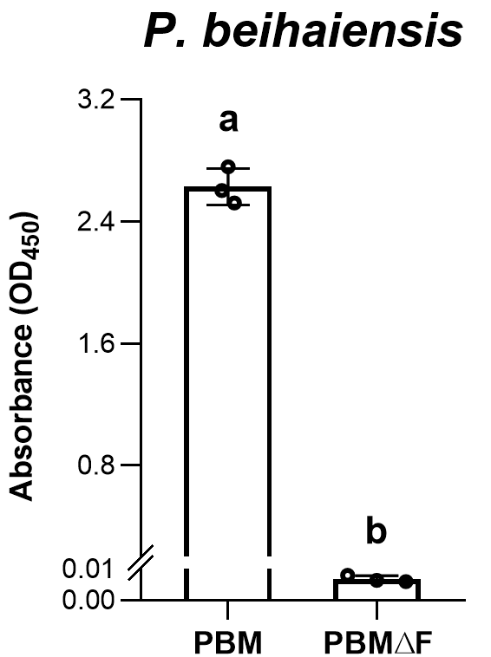
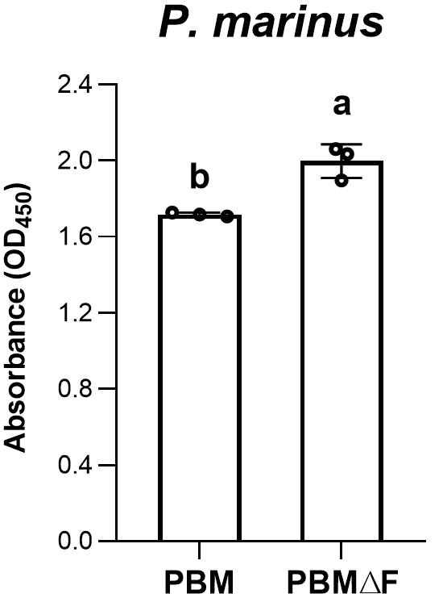
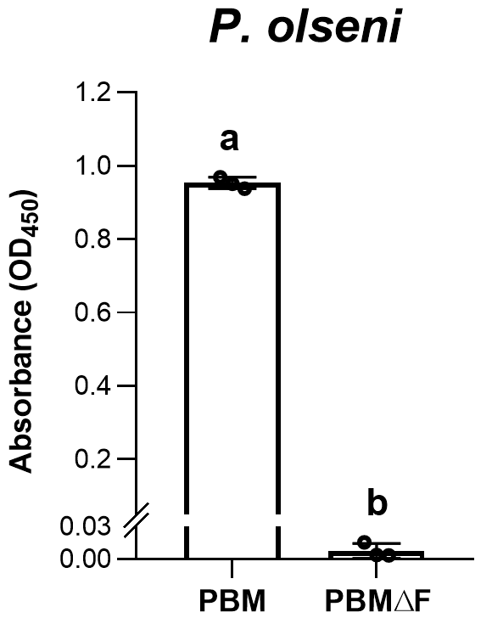
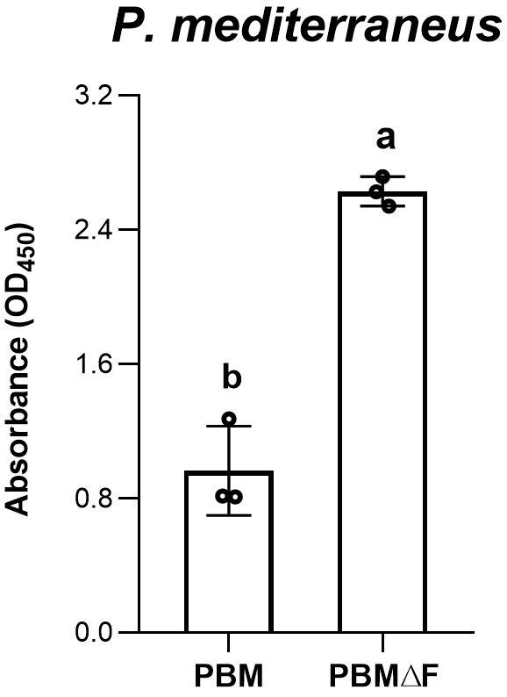
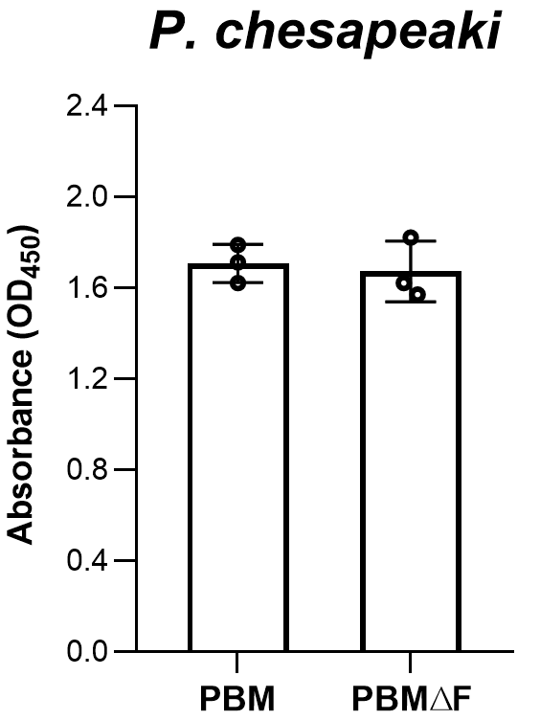
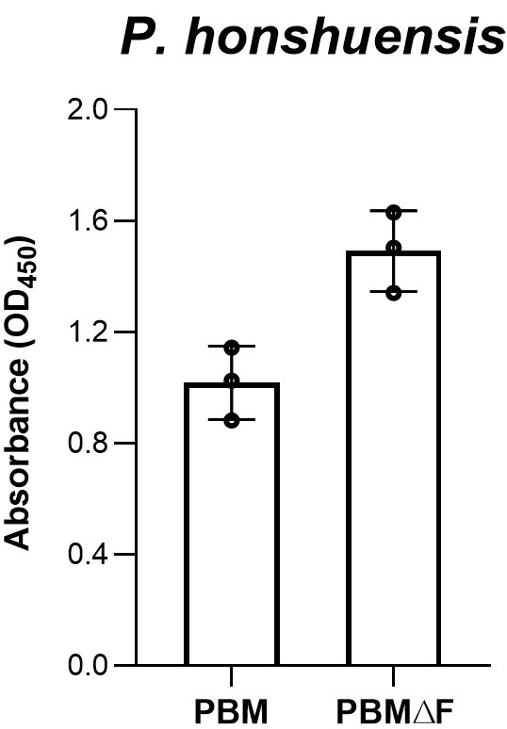
Supplementary Fig S3. Proliferation of Perkinsus spp. in PBM and PBM∆F

Trophozoites of 6 Perkinsus species [P. marinus PRA-240, P. olseni PRA-181, P. chesapeaki PRA-66, P. mediterraneus Pmed-G2, P. honshuensis PRA-177, and P. beihaiensis PRA-431 (Table 2)] were maintained in PBM and harvested at the logarithmic proliferation phase. Harvested cells were washed and resuspended in PBM∆F, and cell densities were counted by a Bürker-Türk hemocytometer. Trophozoites of each species were inoculated into fresh PBM∆F and PBM∆F supplemented with 2% (v/v) FBS (namely PBM), at the final cell density in media of 8.0 × 10⁴ cells/mL for P. marinus, 2.0 × 10⁵ cells/mL for P. olseni, 2.0 × 10⁴ cells/mL for P. chesapeaki, 5.0 × 10⁴ cells/mL for P. mediterraneus, 6.0 × 10⁴ cells/mL for P. honshuensis, and 2.0 × 10⁵ cells/mL for P. beihaiensis. Triplicate wells in a 24-well plate were prepared for each group, and the proliferation, expressed as ABS at 450 nm, was evaluated using the CCK-8 (Dojindo Laboratory, Kumamoto, Japan) after 12 days of incubation. Statistical analyses were conducted by Tukey’s post-hoc test, and different letters denote statistically significant differences (p < 0.01).

