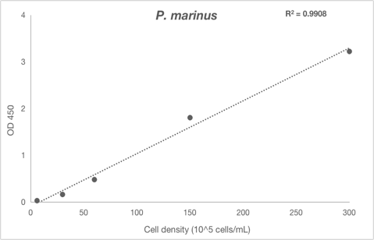
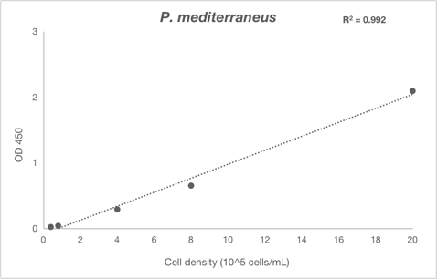
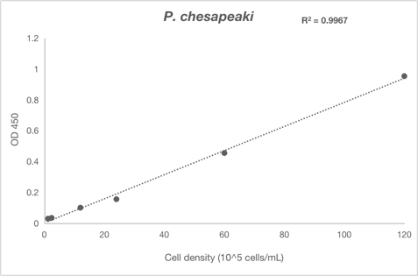
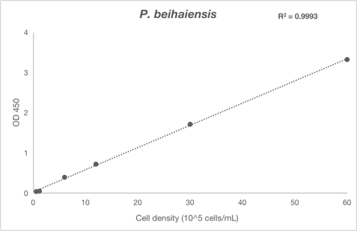
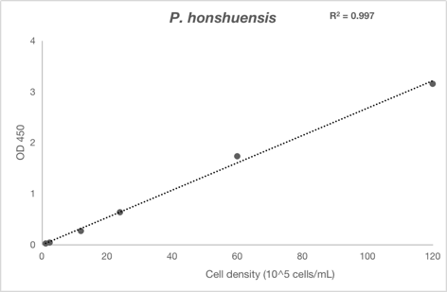
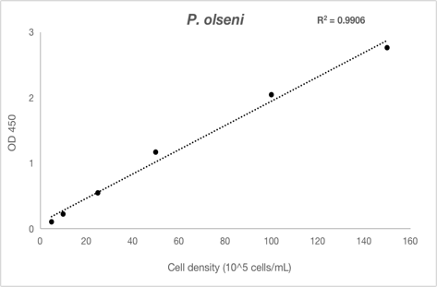
Supplementary Fig S1. Evaluation of Perkinsus spp. trophozoite density using a tetrazolium-based cell proliferation kit

Cell suspensions of 6 Perkinsus trophozoites (Table 2) in the logarithmic phase were serially diluted with fresh PBM∆F, and 100 µL of each cell density suspension was inoculated into three wells of a 96-well cell culture plate. Ten microliters of the reaction solution of the Cell Counting kit-8 (Dojindo Laboratories, Kumamoto, Japan) was dispensed into each well, and the plate was incubated at 25 °C for 3-4 hours. Then, the absorbance of each well was measured at 450 nm using a microplate reader (model MRP-A4, Tosoh, Tokyo, Japan). The obtained data revealed that absorbances at 450 nm were positively correlated with trophozoite densities of all examined Perkinsus species.

