Table S1. The best-fit partitioning scheme and corresponding models used on the BL phylogenetic tree.
Subset partitions | Sites | Best model
nad3 codon1, atp6 codon1, nad6 codon1, nad2 codon1, atp8 codon2, atp8 codon1 | 972 | GTR+I+G
cox1 codon2, cox2 codon2, cytb codon2, cox3 codon2, atp6 codon2, nad3 codon2 | 1698 | TVM+I+G
cox1 codon3, cox3 codon3, cox2 codon3, nad3 codon3, cytb codon3, atp6 codon3 | 1698 | TRN+G
nad6 codon3, nad2 codon3, atp8 codon3 | 575 | TRN+G
cox1 codon1, cox2 codon1, cytb codon1, cox3 codon1 | 1353 | GTR+I+G
nad4L codon1, nad4 codon1, nad1 codon1, nad5 codon1 | 1462 | GTR+I+G
nad4L codon2, nad5 codon2, nad4 codon2, nad1 codon2 | 1462 | GTR+G
nad1 codon3, nad5 codon3, nad4L codon3, nad4 codon3 | 1462 | TRN+I+G
nad2 codon2, nad6 codon2 | 523 | TVM+G

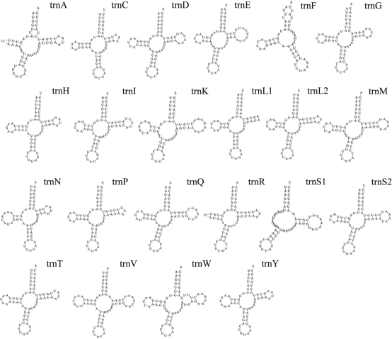

Figure S1 The secondary structure of 22 tRNA in Penicillidia jenynsii.

