Supplementary material
Table S1. Taxa included in the median-joining network (Figure S1) and phylogenetic tree reconstruction (Figure S2) of mitochondrial cytochrome b gene lineages of Plasmodium spp.
Lineage  (MalAvi) | Host | Locality | GenBank  accession no. | Reference
BT7 | Parkesia noveboracensis (Passeriformes: Parulidae) | USA | MF817784 | Smith et al., 2018
COLPAL03 | Columba palumbus (Columbiformes: Columbidae) | Germany | MT888851 | Schumm et al., 2021
CXPIP09 | Larus argentatus (Charadriiformes: Laridae) | Japan* | - | Inumaru et al., 2017
DENPET03 | Rynchops niger (Charadriiformes: Laridae) | Brazil | KJ469132 | Roos et al., 2015
FALTIN14 | Falco tinnunculus (Falconiformes: Falconidae) | China | MT281523 | Huang et al., 2020
PARUS67 | Parus major (Passeriformes: Paridae) | Sweden | KU695264 | Dubiec et al., 2016
PHPAT01 | Rynchops niger (Charadriiformes: Laridae) | Brazil | - | Roos et al., 2015
SFC6 | Muscicapa striata (Passeriformes: Muscicapidae) | Europe | DQ368389 | Pérez-Tris et al., 2007
SGS1 | Larus spp. (Charadriiformes: Laridae) | Poland | - | Zagalska-Neubauer and Bensch, 2016
STEHIR01 | Sterna hirundo (Charadriiformes: Laridae) | Argentina | ON872158 | Present study
STEHIR02 | Sterna hirundo (Charadriiformes: Laridae) | Argentina | ON872159 | Present study
TURDUS1 | Cyanistes caeruleus (Passeriformes: Paridae) | Europe | HQ537478 | Szöllősi et al., 2011
*captivity

For phylogenetic tree reconstruction, DNA sequences were aligned by CLUSTALW using MEGA version 10 (Kumar et al., 2018). The best-fit model of DNA sequence evolution was selected using jModeltest 2.1.7 (Darriba et al., 2012). According to the Akaike information criterion, we used the General Time Reversible model including invariable sites and variation among sites (GTR+I+G; Gu et al., 1995). Phylogenetic reconstruction was performed with BEAST 1.8.4. (Drummond et al., 2012). Tree priors were selected using the interface BEAUTi 1.8.4. with strict clock and a Yule speciation process (Yule, 1925; Gernhard, 2008). Markov chain Monte Carlo (MCMC) simulations were run with 25,000,000 generations and one tree was recorded every 1000 generations. In all, 10% of the trees were discarded as burn-in in TreeAnnotator (BEAST package). We validated the results of the Bayesian analyses in Tracer 1.6. (Drummond and Rambaut, 2007). The phylogenetic tree was constructed with FigTree 1.4.3 (Rambaut, 2007). Values < 0.70 are indicated by a dash.

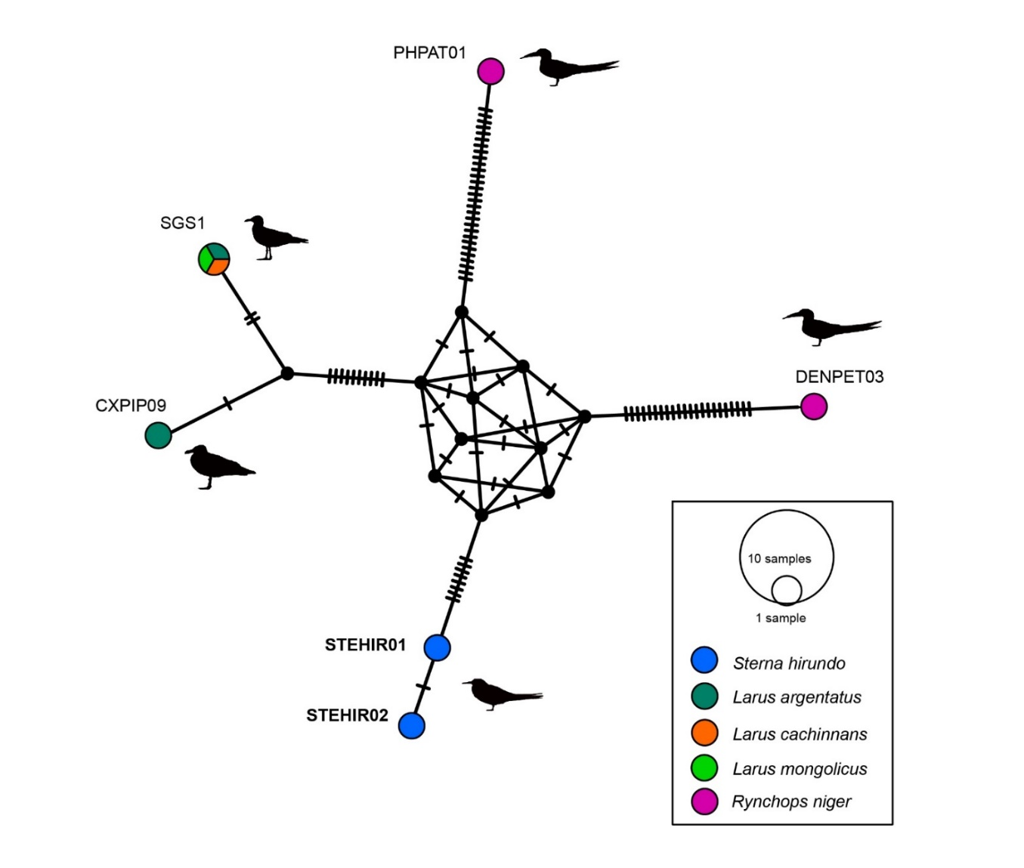
Fig. S1. Median-joining network of mitochondrial cytochrome b gene lineages of Plasmodium spp. (the two lineages found in the present study and reference lineages from Laridae family from wildlife present in MalAvi database, all of 479 bp, are presented). Circles represent distinct genetic lineages, and the circle sizes are proportional to the lineage frequencies. One hatch mark represents one mutation. Lineage names are noted at the associated circles

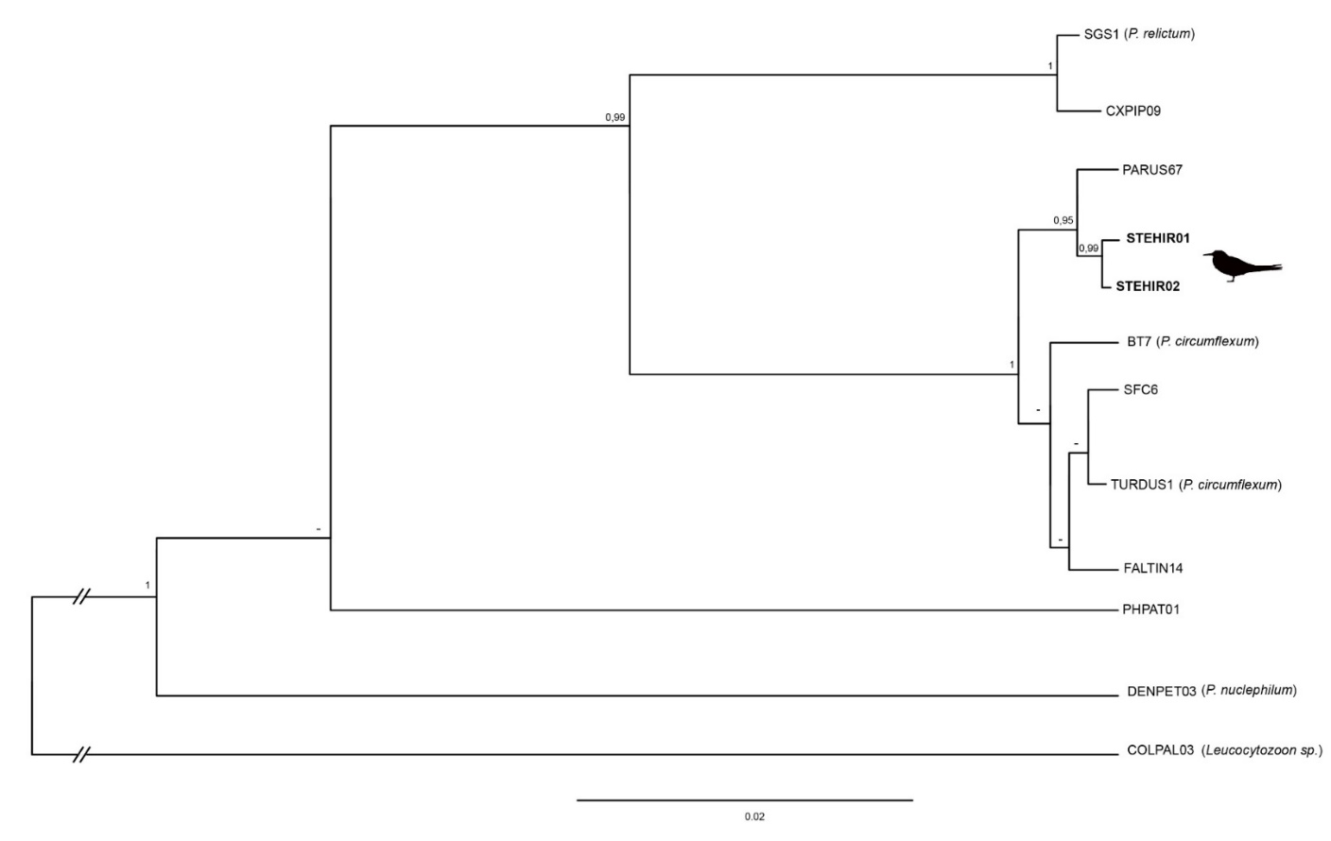

Fig. S2 Phylogeny of mitochondrial cytochrome b gene lineages of Plasmodium spp. from Laridae family present in MalAvi database (only from wildlife) and the first five reference lineages from MalAvi blastn inferred using Bayesian analysis. Branch support values indicate Bayesian posterior probabilities. Lineages found in the present study are shown in bold. Leucocytozoon sp. (MT888851) was included as outgroup.

References Supplementary material
Darriba, D, Taboada, GL, Doallo, R, and Posada, D (2012). jModelTest 2: more models, new heuristics and parallel computing. Nature methods 9, 772-772. https://doi.org/10.1038/nmeth.2109
Dubiec, A, Podmokła, E, Zagalska-Neubauer, M, Drobniak, SM, Arct, A, Gustafsson, L, and Cichoń, M (2016) Differential prevalence and diversity of haemosporidian parasites in two sympatric closely related non-migratory passerines. Parasitology 143, 1320-1329. https://doi.org/10.1017/S0031182016000779
Drummond, AJ, Rambaut, A (2007) BEAST: Bayesian evolutionary analysis by sampling trees. BMC Ecology and Evolution 7, 214. https://doi.org/10.1186/1471-2148-7-214
Drummond, AJ, Suchard, MA, Xie, D, and Rambaut, A (2012) Bayesian phylogenetics with BEAUti and the BEAST 1.7. Molecular Biology and Evolution 29, 1969–1973. https://doi.org/10.1093/molbev/mss075
Gu, X, Fu, YX, and Li, WH (1995) Maximum likelihood estimation of the heterogeneity of substitution rate among nucleotide sites. Molecular Biology and Evolution 12, 546–557. https://doi.org/10.1093/oxfordjournals.molbev.a040235
Gernhard, T (2008) Yule process. Journal of Theoretical Biology 253,769–778
Huang, X, Jönsson, J, and Bensch, S (2020). Persistence of avian haemosporidians in the wild: a case study to illustrate seasonal infection patterns in relation to host life stages. International Journal for Parasitology 50, 611-619. https://doi.org/10.1016/j.ijpara.2020.05.006
Inumaru, M, Murata, K, and Sato, Y (2017). Prevalence of avian haemosporidia among injured wild birds in Tokyo and environs, Japan. International Journal for Parasitology: Parasites and Wildlife 6, 299-309. https://doi.org/10.1016/j.ijppaw.2017.09.007
Kumar, S, Stecher, G, Li, M, Knyaz, C, and Tamura, K (2018). MEGA X: molecular evolutionary genetics analysis across computing platforms. Molecular biology and evolution 35, 1547. https://doi.org/10.1093/molbev/msy096
Pérez-Tris, J, Hellgren, O, Križanauskienė, A, Waldenström, J, Secondi, J, Bonneaud, C, Fjeldså, J, Hasselquist, H, and Bensch, S (2007) Within-Host Speciation of Malaria Parasites. PLoS One 2, e235. https://doi.org/10.1371/journal.pone.0000235
Rambaut, A (2007) FigTree. https://tree.bio.ed.ac.uk/software/figtree/
Roos, FL, Belo, NO, Silveira, P, and Braga, EM. (2015). Prevalence and diversity of avian malaria parasites in migratory Black Skimmers (Rynchops niger, Laridae, Charadriiformes) from the Brazilian Amazon Basin. Parasitology research 114, 3903-3911. https://doi.org/10.1007/s00436-015-4622-9
Schumm, YR, Bakaloudis, D, Barboutis, C, Cecere, JG, Eraud, C, Fischer, D, Hering, J, Hillerich, K, Lormée, H, Mader, K, Masello, JF, Metzger, B, Rocha, G, Spina, F, and Quillfeldt, P (2021). Prevalence and genetic diversity of avian haemosporidian parasites in wild bird species of the order Columbiformes. Parasitology research 120, 1405-1420. https://doi.org/10.1007/s00436-021-07053-7
Smith, JD, Gill, SA, Baker, KM, and Vonhof, MJ (2018) Prevalence and diversity of avian Haemosporida infecting songbirds in southwest Michigan. Parasitology Research 117, 471-489. https://doi.org/10.1007/s00436-017-5724-3
Szöllősi, E, Cichoń, M, Eens, M, Hasselquist, D, Kempenaers, B, Merino, S, Nilsson, JÅ, Rosivall, B, Rytkönen, S, Török, J, Wood, MJ, and Garamszegi, LZ (2011) Determinants of distribution and prevalence of avian malaria in blue tit populations across Europe: separating host and parasite effects. Journal of Evolutionary Biology 24, 2014-2024. https://doi.org/10.1111/j.1420-9101.2011.02339.x
Yule, GU (1925) Yule process. Philosophical Transactions of the Royal Society B: Biological Sciences 213, 21–87
Zagalska-Neubauer, M, and Bensch, S (2016). High prevalence of Leucocytozoon parasites in fresh water breeding gulls. Journal of Ornithology, 157, 525-532. https://doi.org/10.1007/s10336-015-1291-5

