Supplement

Unravelling the trophic interaction between a parasitic barnacle (Anelasma squalicola) and its host the Southern lanternshark (Etmopterus granulosus) using stable isotopes

A.J.M. Sabadel^{a,*}, P. Cresson^{b} B. Finucci^{c} and J. Bennettª
ªDepartment of Zoology, University of Otago, PO Box 56, Dunedin 9045, New Zealand
^{b}IFREMER, Channel and North Sea Fisheries Research Unit, 150 Quai Gambetta, BP 699, 62 321 Boulogne sur Mer, France.
^{c}NIWA, 301 Evans Bay Parade, Hataitai 6021, Wellington, New Zealand
*Corresponding author: amandine.sabadel@otago.ac.nz

Figures
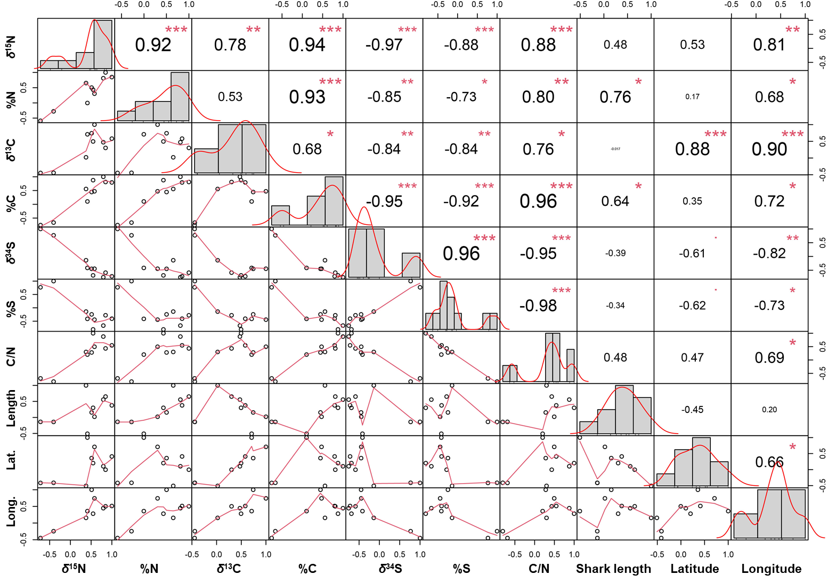
Figure S1. Correlation table of E. granulosus’ muscle tissues stable isotope values, elemental compositions and C/N ratios. Values were also compared with shark length (Length) and shark location: latitude (Lat.) and longitude (Long.). Coefficients in upper triangle corresponds to R values and red stars represents the level of significance: no star = not significant, * = p value < 0.05, ** = 0.05 <p value < 0.001 and *** = p values << 0.001.
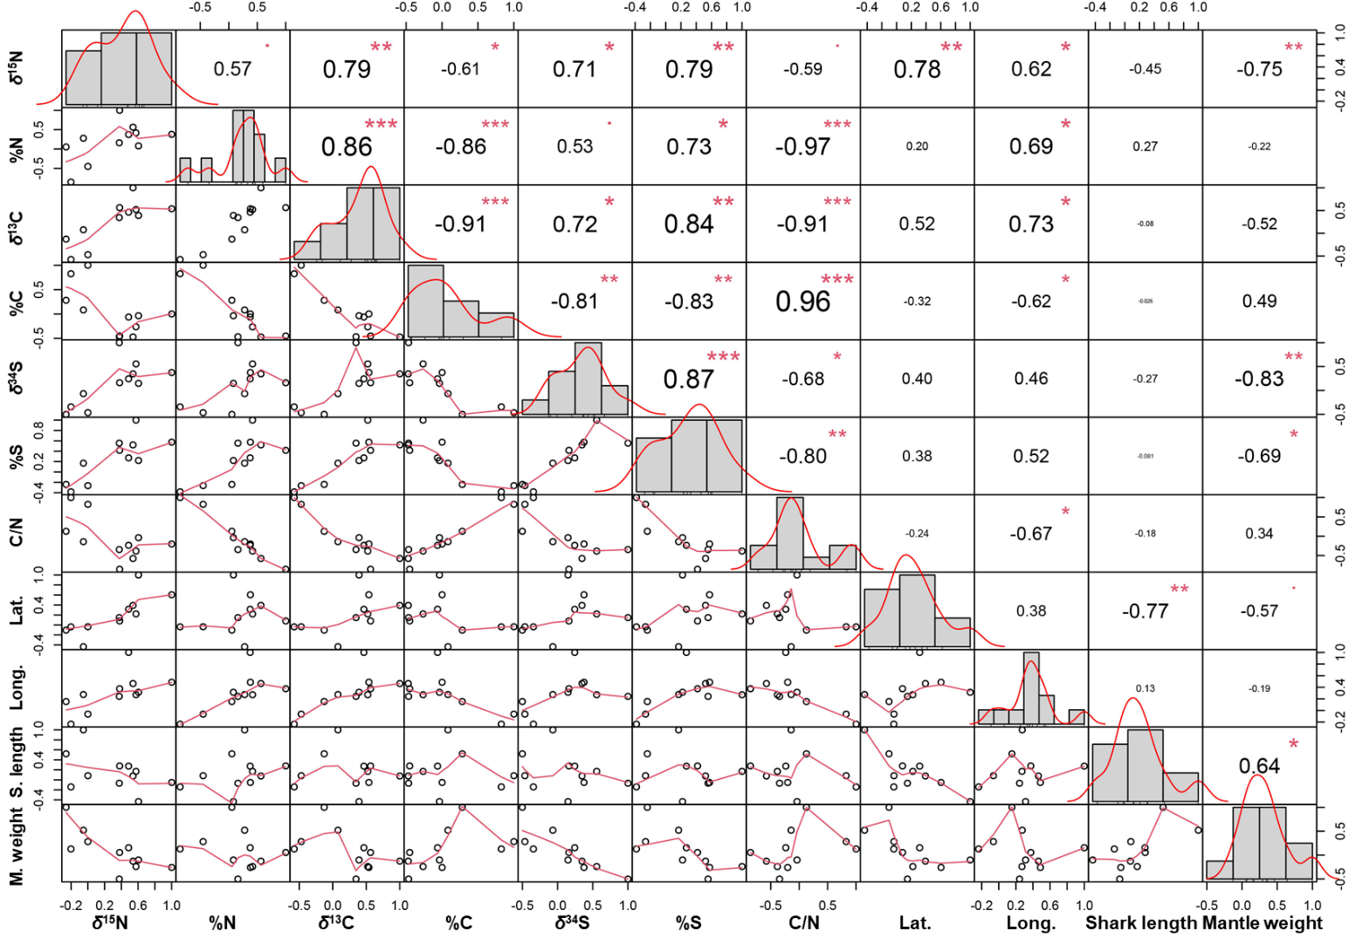
Figure S2. Correlation table of A. squalicola’s ‘protein tissues’ stable isotope values, elemental compositions and C/N ratios. Values were also compared with shark length (Length) and shark location: latitude (Lat.) and longitude (Long.) and barnacle weights (Mantle weight). Coefficients in upper triangle corresponds to R values and red stars represents the level of significance: no star = not significant, * = p value < 0.05, ** = 0.05 <p value < 0.001 and *** = p values << 0.001.
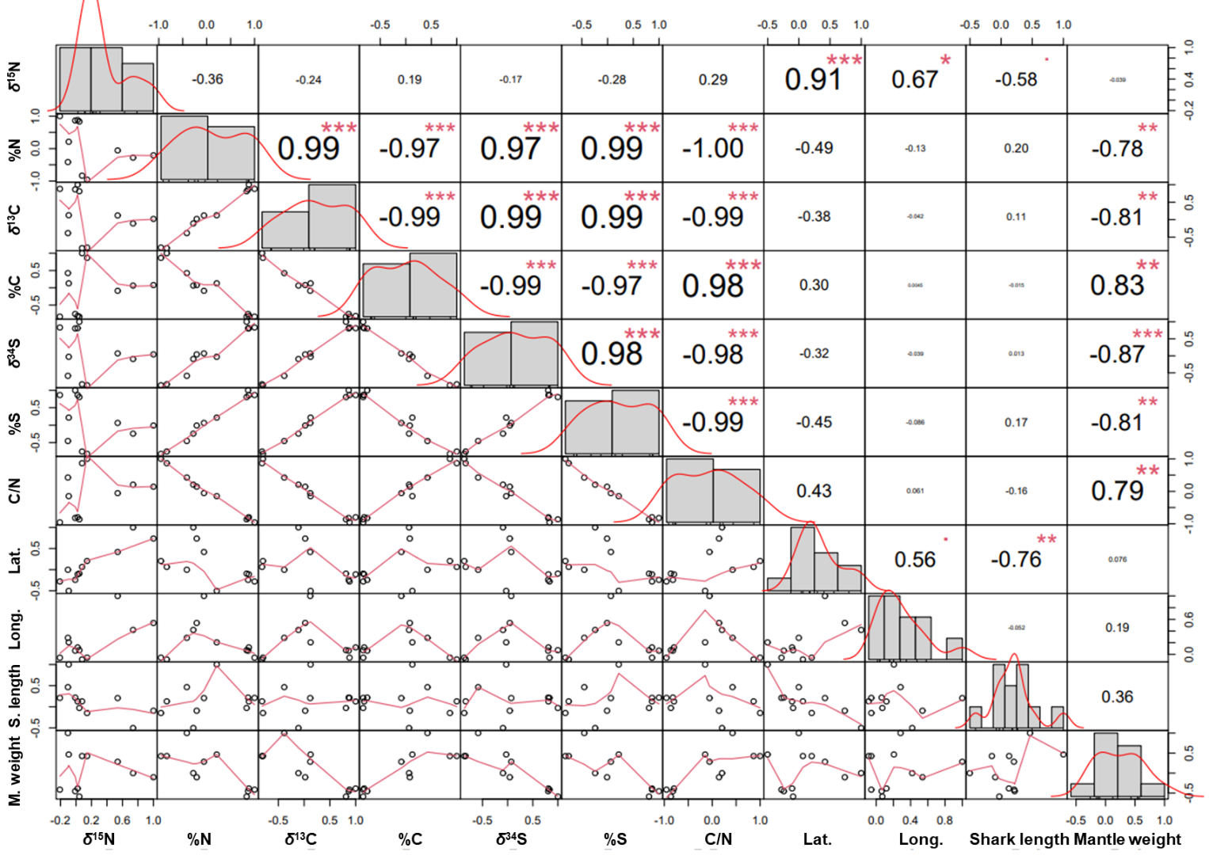
Figure S3. Correlation table of A. squalicola’s peduncle tissues stable isotope values, elemental compositions and C/N ratios. Values were also compared with shark length (Length) and shark location: latitude (Lat.) and longitude (Long.) and barnacle weights (Mantle weight). Coefficients in upper triangle corresponds to R values and red stars represents the level of significance: no star = not significant, * = p value < 0.05, ** = 0.05 <p value < 0.001 and *** = p values << 0.001.
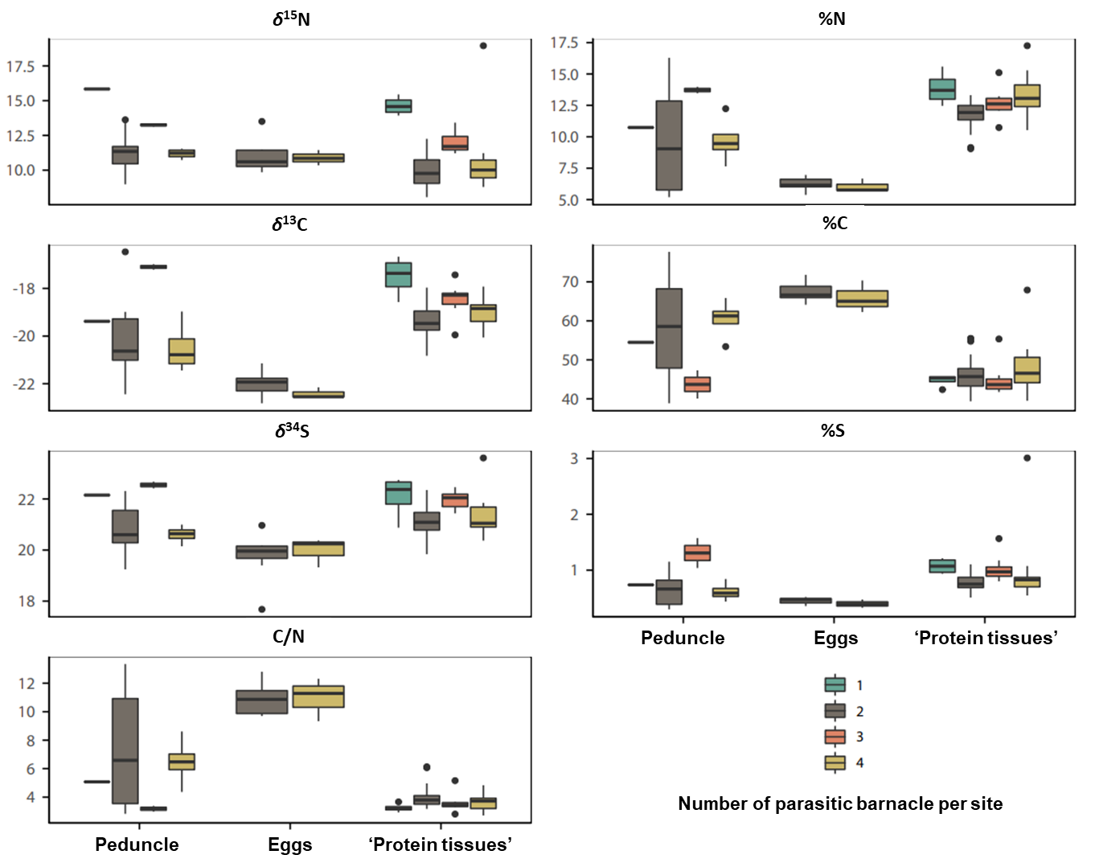
Figure S4. Boxplot highlighting the relationship between the number of A. squalicola per infection site on stable isotope values (δ¹⁵N, δ¹³C and δ³⁴S), elemental compositions (%N, %C and %S) and the C/N ratio.
Tables

Table S1. Difference between host shark or parasitic barnacle tissues vs host shark ‘healthy’ muscle tissues for the different stable isotope values, elemental composition, and C/N ratio.
Host Shark |  | δ¹⁵N (‰) | %N | δ¹³C (‰) | %C | δ³⁴S (‰) | %S | C/N
Δ‘unhealthy'-‘healthy’ muscle | Avg. | -1.0 | -3.3 | -0.7 | 0.7 | 0.7 | -0.1 | 0.8
 | SD | 0.9 | 1.5 | 0.4 | 1.6 | 0.6 | 0.2 | 0.4
ΔEye-‘healthy’ muscle | Avg. | -0.7 | 2.1 | 0.5 | n/a | -1.9 | -0.3 | n/a
 | SD | n/a | n/a | n/a | n/a | n/a | n/a | n/a
Parasitic barnacle
ΔPeduncle-‘healthy’ muscle | Avg. | -0.4 | -5.6 | -1.1 | 9.2 | 1.0 | -0.1 | 3.2
 | SD | 1.4 | 3.0 | 1.8 | 11.2 | 1.0 | 0.3 | 3.1
ΔEggs-‘healthy’ muscle | Avg. | -1.2 | -9.6 | -3.6 | 19.5 | 0.0 | -0.4 | 7.7
 | SD | 1.1 | 1.5 | 0.5 | 4.4 | 0.4 | 0.1 | 1.1
ΔProtein tissues-‘healthy’ muscle | Avg. | -1.8 | -3.7 | -0.4 | -0.9 | 1.2 | -0.1 | 0.8
 | SD | 1.3 | 1.1 | 0.7 | 4.4 | 0.7 | 0.2 | 0.5

Table S2. ANOVA tests isotopic ratios. Results for eyes should be taken with caution, as based on only one value.
Variable | Statistic | p value |  | Post hoc
δ¹⁵N | F_{109,8} = 2.14 | 0.04 | * | Eye^{ab} = Inner mantleª = MCP^{ab} = Rootlets^{ab} = Mantle^{ab} = Eggs^{ab} = ‘Unhealthy' shark muscle^{ab} = Peduncle^{ab} = ‘Healthy' shark muscle^{b}
%N | F_{109,8} = 24.64 | <2.2 10⁻¹⁶ | *** | Eggsª< Peduncle^{b}< Mantle^{c} = Inner mantle^{c} = MCP^{cd} = Rootlets^{c} = ‘Unhealthy' shark muscle^{cd} = Eye^{abc} < ‘Healthy' shark muscle^{d}
δ¹³C | F_{108,8} = 14.16 | 6.3 10⁻¹⁴ | *** | Eggsª < Peduncle^{b}= ‘Unhealthy' shark muscle^{bc} = Inner mantle^{bc} = Eye^{bc} = Rootlets^{bc} = Mantle^{bc} < MCP^{c} = ‘Healthy' shark muscle^{c}
%C | F_{109,8} = 18.48 | <2.2 10⁻¹⁶ | *** | MCPª = ‘Healthy' shark muscle ª = Eyeª = Inner mantleª = Rootletsª = Mantleª = ‘Unhealthy' shark muscleª < Peduncle^{b} < Eggs^{c}
δ³⁴S | F_{109,8} = 7.78 | 3.2 10⁻⁸ | *** | Eggsª ≤ Eye^{ab} = ‘Healthy' shark muscle ^{ab} = ‘Unhealthy' shark muscle^{ab} < Peduncle^{bc} = Rootlets^{bc} = Inner mantle^{bc} = Mantle^{bc} = MCP^{bc}
%S | F_{109,8} = 3.98 | 3.6 10⁻⁴ | *** | Eggsª ≤ Peduncle^{ab} = Inner mantle^{ab} ≤ Rootlets^{b} = MCP^{b} ≤ ‘Unhealthy' shark muscle^{ab} < Mantle^{b} = ‘Healthy' shark muscle ^{b} = Eye^{ab}
C:N | F_{109,8} = 32.43 | <2.2 10⁻¹⁶ | *** | ‘Healthy' shark muscle ª = Eyeª = MCPª = Rootletsª = ‘Unhealthy' shark muscleª = Inner mantleª = Mantleª < Peduncle^{b} < Eggs^{c}

