Supplementary material

High overlap of zoonotic helminths between wild mammalian predators and rural dogs – an emerging One Health concern?
Ants Tull, Harri Valdmann, Egle Tammeleht, Triin Kaasiku, Riinu Rannap and Urmas Saarma*

Department of Zoology, Institute of Ecology and Earth Sciences, University of Tartu, Juhan Liivi 2,
50409 Tartu, Estonia.

Author for correspondence: Urmas Saarma; E-mail: urmas.saarma@ut.ee

Table of contents

Table S1. Models predicting coinfection prevalence among predators | p3
Table S2. Models predicting infection prevalence with Eucoleus spp./Trichuris spp. among predators | p4
Table S3. Models predicting infection intensity with Eucoleus spp./Trichuris spp. among predators | p5
Table S4. Models predicting infection prevalence with Toxocara canis among red foxes | p6
Table S5. Models predicting infection prevalence with Eucoleus spp./Trichuris spp. among golden jackals | p7
Table S6. Model predicting infection intensity with Eucoleus spp./Trichuris spp. among golden jackals | p7
Table S7. Total parasite frequencies (%) and helminth overlap for different canids | p8
Figure S1. Helminth prevalence in scats of foxes, jackals, rural dogs and all mammalian predators | p9
Figure S2. Helminth mono- and coinfections among infected scats of foxes, jackals, rural dogs and all mammalian predators | p9
Figure S3. Proportion of different helminth coinfection categories among coinfected scats of foxes, jackals, rural dogs and all predators | p10
Figure S4. Prevalence of various helminth coinfections among all coinfected predators | p10

Table S1. Models predicting coinfection prevalence among predators. Only models with the highest Akaike weight (ΔAICc<2) are described. Statistically significant results are marked in bold.
Models | Factors | Statistics | Weight | Sum of weights (RVI)
1. RODENT | RO | β_{RODENT}=0.9, SE=0.3, p=0.0002 | 0.22 | 1
2. PLANT+RODENT | P | β_{PLANT}=0.3, SE=0.3, p=0.3 | 0.13 | 0.37
 | RO | β_{RODENT}=0.9, SE=0.3, p=0.0001 |  | 1
3. RODENT+FISH | RO | β_{RODENT}=0.9, SE=0.2, p=0.0001 | 0.11 | 1
 | F | β_{FISH}=-0.7, SE=0.9, p=0.4 |  | 0.33
4. RODENT+GAME | RO | β_{RODENT}=0.9, SE=0.3, p=0.0003 | 0.09 | 1
 | G | β_{GAME}=-0.2, SE=0.3, p=0.6 |  | 0.29

Table S2. Models predicting infection prevalence with Eucoleus spp./Trichuris spp. among predators. Only models with ΔAICc<2 are described. Statistically significant results are marked in bold.
Models | Factors | Statistics | Weight | Sum of weights (RVI)
1. REPTILE+RODENT | REP | β_{REPTILE}=1.7, SE=0.7, p=0.006 | 0.25 | 0.98
 | RO | β_{RODENT}=1.1, SE=0.3, p=0.00002 |  | 1
2. BIRD+REPTILE+RODENT | B | β_{BIRD}=0.3, SE=0.2, p=0.18 | 0.22 | 0.45
 | REP | β_{REPTILE}=1.9, SE=0.7, p=0.005 |  | 0.98
 | RO | β_{RODENT}=1.1, SE=0.3, p=0.00001 |  | 1
3. GAME+REPTILE+RODENT | G | β_{GAME}=-0.3, SE= 0.3, p=0.35 | 0.14 | 0.34
 | REP | β_{REPTILE}=1.7, SE=0.7, p=0.007 |  | 0.98
 | RO | β_{RODENT}=1.0, SE=0.3, p=0.00007 |  | 1
4. BIRD+GAME+REPTILE+RODENT | B | β_{BIRD}=0.3, SE=0.3, p=0.2 | 0.10 | 0.45
 | G | β_{GAME}=-0.2, SE=0.3, p=0.5 |  | 0.34
 | REP | β_{REPTILE}=1.8, SE=0.7, p=0.005 |  | 0.98
 | RO | β_{RODENT}=1.1, SE=0.3, p=0.00005 |  | 1
5. PLANT+REPTILE+RODENT | P | β_{PLANT}=-0.1, SE= 0.3, p=0.8 | 0.09 | 0.28
 | REP | β_{REPTILE}=1.8, SE=0.7, p=0.006 |  | 0.98
 | RO | β_{RODENT}=1.1, SE=0.2, p=0.00002 |  | 1
Table S3. Models predicting infection intensity with Eucoleus spp./Trichuris spp. among predators. Only models with ΔAICc<2 are described. Statistically significant results are marked in bold.
Models | Factors | Statistics | Weight | Sum of weights (RVI)
1. GAME | G | β_{GAME}=0.6, SE= 0.3, p=0.048 | 0.12 | 0.82
2. GAME+REPTILE | G | β_{GAME}=0.7, SE= 0.3, p=0.028 | 0.10 | 0.82
 | REP | β_{REPTILE}=0.7, SE=0.5, p=0.2 |  | 0.43
3. GAME+BIRD | G | β_{GAME}=0.6, SE= 0.3, p=0.05 | 0.09 | 0.82
 | B | β_{BIRD}=-0.3, SE=0.3, p=0.2 |  | 0.43

Table S4. Models predicting infection prevalence with Toxocara canis among red foxes. Only models with ΔAICc<2 are described. Statistically significant results are marked in bold.
Models | Factors | Statistics | Weight | Sum of weights (RVI)
1. PLANT+GAME | P | β_{PLANT}=1.4, SE=0.6, p=0.017 | 0.16 | 0.84
 | G | β_{GAME}=0.9, SE=0.6, p=0.1 |  | 0.53
2. INSECT | I | β_{INSECT}=-0.6, SE= 0.8, p=0.4 | 0.14 | 0.33
3. PLANT+INSECT | P | β_{PLANT}=1.4, SE=0.6, p=0.02 | 0.07 | 0.84
 | I | β_{INSECT}=-0.6, SE= 0.8, p=0.4 |  | 0.33
4. PLANT+GAME+BIRD | P | β_{PLANT}=1.4, SE=0.6, p=0.018 | 0.07 | 0.84
 | G | β_{GAME}=0.9, SE=0.6, p=0.1 |  | 0.53
 | B | β_{BIRD}=0.4, SE=0.5, p=0.5 |  | 0.32
5. PLANT+GAME+INSECT | P | β_{PLANT}=1.4, SE=0.6, p=0.017 | 0.07 | 0.84
 | G | β_{GAME}=0.9, SE=0.6, p=0.1 |  | 0.53
 | I | β_{INSECT}=-0.5, SE=0.8, p=0.5 |  | 0.33
6. PLANT+GAME+RODENT | P | β_{PLANT}=1.5, SE=0.5, p=0.016 | 0.06 | 0.84
 | G | β_{GAME}=1.0, SE=0.6, p=0.1 |  | 0.53
 | RO | β_{RODENT}=0.2, SE=0.6, p=0.7 |  | 0.27
7. BIRD+RODENT | B | β_{BIRD}=0.3, SE=0.5, p=0.5 | 0.06 | 0.32
 | RO | β_{RODENT}=-0.1, SE=0.5, p=0.8 |  | 0.27
Table S5. Models predicting infection prevalence with Eucoleus spp./Trichuris spp. among golden jackals. Only models with the highest Akaike weight (ΔAICc<2) are described. Statistically significant results are marked in bold.
Models | Factors | Statistics | Weight | SUM OF WEIGHTS (RVI)
1. RODENT | RO | β_{RODENT}=2.6, SE=0.7, p=0.0002 | 0.43 | 1
2. RODENT+GAME | G | β_{GAME}=0.2, SE=0.8, p=0.8 | 0.32 | 0.25
 | RO | β_{RODENT}=2.6, SE=0.8, p=0.0007 |  | 1

Table S6. Model predicting infection intensity with Eucoleus spp./Trichuris spp. among golden jackals. Only models with the highest Akaike weight (ΔAICc<2) are described. Statistically significant results are marked in bold.

Model | Factors | Statistics | Weight | SUM OF WEIGHTS (RVI)
1. GAME+RODENT | G | β_{GAME}=2.6, SE=1.2, p=0.03 | 0.56 | 0.75
 | RO | β_{RODENT}=4.1, SE=1.3, p=0.0008 |  | 0.97

Table S7.
Total parasite frequencies (%) and helminth overlap for different canids. Euc/Tri: Eucoleus spp./Trichuris spp. Data for urban and rural dogs are from Tull et al. 2020 and Tull et al. 2022, respectively.
Parasite | urban dog vs rural dog |  | urban dog vs red fox |  | urban dog vs jackal |  | rural dog vs red fox |  | rural dog vs jackal |  | jackal vs red fox
Taeniidae | 3 | 76 | 3 | 100 | 3 | 57 | 76 | 100 | 76 | 57 | 57 | 100
Euc/Tri | 2 | 18 | 2 | 105 | 2 | 14 | 18 | 105 | 18 | 14 | 14 | 105
Toxocara canis | 22 | 5 | 22 | 18 | 22 | 3 | 5 | 18 | 5 | 3 | 3 | 18
Toxascaris leonina | 0 | 0 | 0 | 1 | 0 | 3 | 0 | 1 | 0 | 3 | 3 | 1
Uncinaria stenocephala | 23 | 17 | 23 | 24 | 23 | 18 | 17 | 24 | 17 | 18 | 18 | 24
Total | 50 | 116 | 50 | 248 | 50 | 95 | 116 | 248 | 116 | 95 | 116 | 95
Helminth overlap | 29.8% |  | 30.7% |  | 34.4% |  | 84.2% |  | 99.6% |  | 84.1%

References
Tull, A., Moks, E., Laurimaa, L., Keis, M., Süld, K., 2020. Endoparasite infection hotspots in Estonian urban areas. J. Helminthol. 94, e104, 1–9. https://doi.org/10.1017/S0022149X19000920
Tull, A., Valdmann, H., Rannap, R., Kaasiku, T., Tammeleht, E., Saarma, U., 2022. Free-ranging rural dogs are highly infected with helminths, contaminating environment nine times more than urban dogs. J. Helminthol. 96, e19. https://doi.org/10.1017/S0022149X22000116

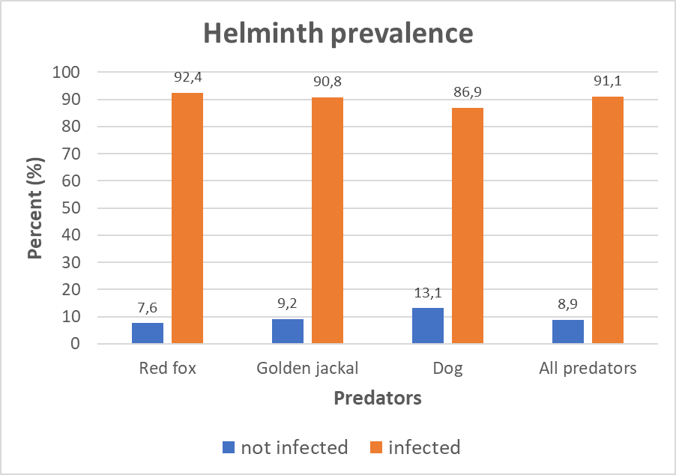
Fig. S1. Helminth prevalence in scats of red foxes (n = 131), golden jackals (n = 65), rural dogs (n = 84) and all mammalian predators (n = 315).

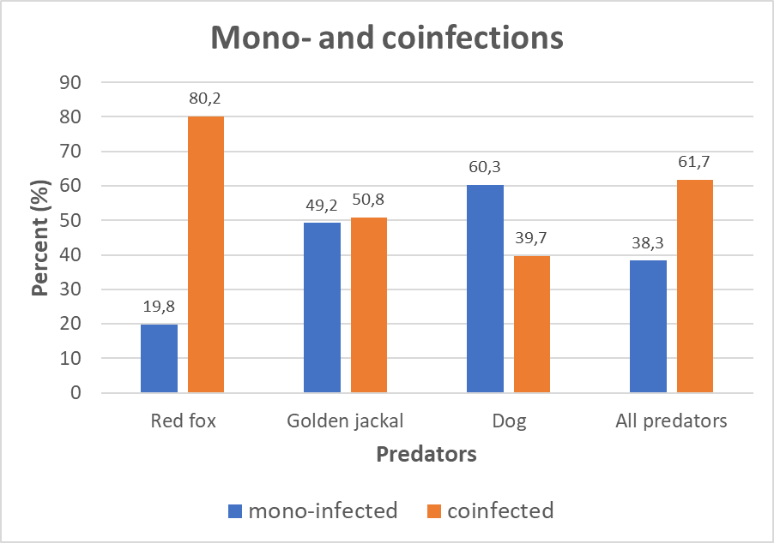
Fig. S2. Helminth mono- and coinfections among infected scats of red foxes (n = 121), golden jackals (n = 59), rural dogs (n = 73) and all mammalian predators (n = 287).

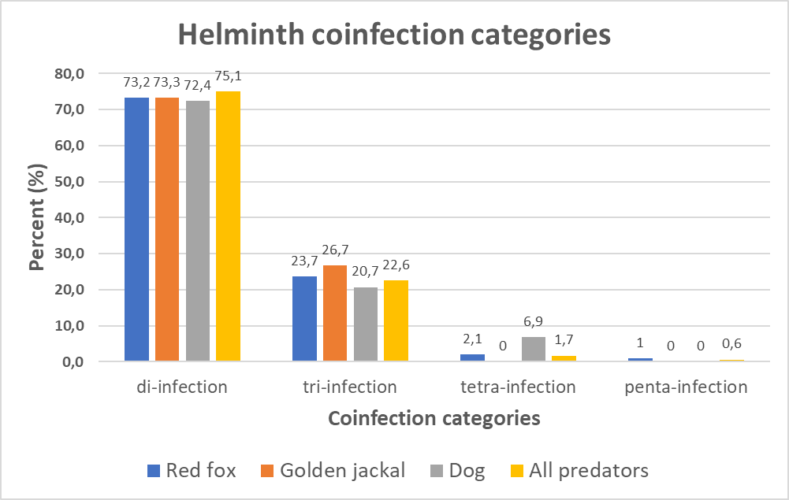
Fig. S3. Proportion of different helminth coinfection categories among coinfected scats of red foxes (n = 97), golden jackals (n = 30), rural dogs (n = 29) and all predators (n = 177).

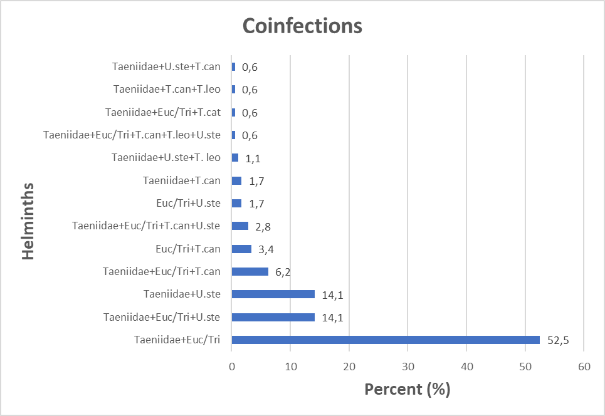
Fig. S4. Prevalence of various helminth coinfections among all coinfected predators (n = 177). Euc/Tri: Eucoleus spp./Trichuris spp; T.can: Toxocara canis; T.cat: Toxocara cati; T.leo: Toxascaris leonina; U. ste: Uncinaria stenocephala.

