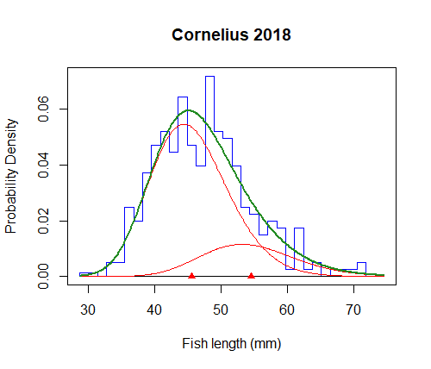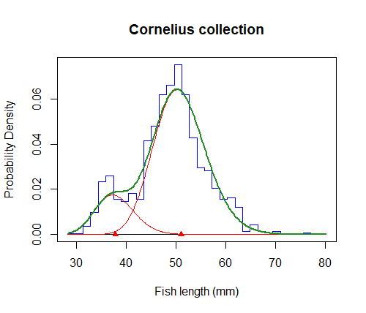
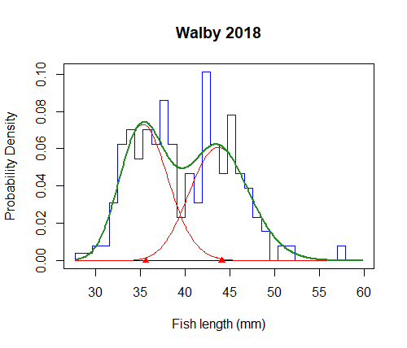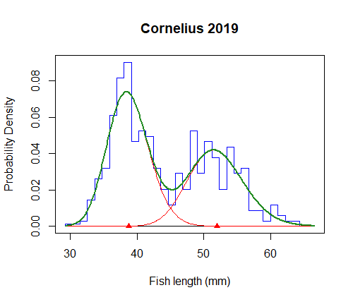
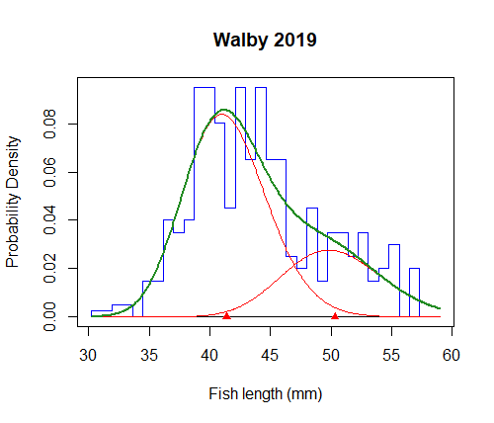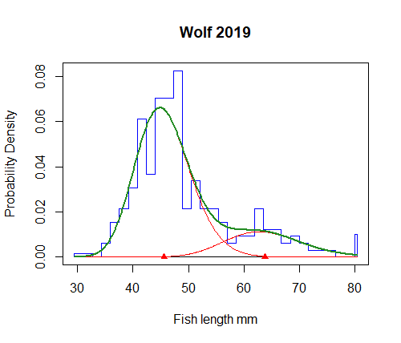
Figure S1: Probability Density plots to assess adult stickleback size distribution for the sample lakes. The blue bars represent the size bins, the green curve represents a smoothed curve of the bins, and the red distributions are the age groups as calculated by the model (mixdist).

Table S1: R-packaged used for statistical analyses and plot creation
R-package | Used for…
xlsx (Dragulescu and Arendt, 2020) | Importing excel files
mixdist (Macdonald and Du, 2018) | Age class analysis
lme4 (Bates et al. 2015) | Linear mixed effects modelling
emmeans (Lenth 2021) | Post-hoc comparisons
ggplot2 (Wickham 2016) | Plot creation – Data visualization
sjPlot (Luedecke 2021) | Plot creation from regression model
scales (Wickham and Seidel 2020) | Plot creation – Scales function for visualization

Table S2: Mean Parasite number and mean parasite weight per fish for1-year-old stickleback from the Cohort 2018 and Cohort 2019. SD = standard deviation
Lake | Parasite number  Cohort 2018 |  | Parasite weight per fish (g) – Cohort 2018 |  | Parasite number  Cohort 2019 |  | Parasite weight per fish (g) – Cohort 2019
 | Mean | SD | Mean | SD | Mean | SD | Mean | SD
Walby | 1.56 | 0.9 | 0.13 | 0.11 | 1.9 | 1.5 | 0.2 | 0.09
Cornelius | 2.18 | 2.79 | 0.12 | 0.11 | 1.44 | 1.14 | 0.1 | 0.09
Wolf | NA | NA | NA | NA | 1.69 | 1.06 | 0.22 | 0.08

References (Supplementary Material)
Bates D, Maechler M, Bolker B and Walker S (2015) Fitting Linear Mixed-Effects Models using lme4. Journal of Statistical Software, 6, 1-48. doi:10.18637/jss.v067.i01
Dragulescu A and Arendt C (2020) xlsx: Read, Write, Format Excel 2007 and Excel 97/2000/XP/2003 Files. Rpackage version 0.6.5. Available at https://CRAN.R-project.org/package=xlsx
Length RV (2021) emmeans: Estimated Marginal Means, aka Least-Squares Means. Rpackage version 1.6.0. Available at https://CRAN.R-project.org/package=emmeans
Lüdecke, D (2021) sjPlot: Data Visualization for Statistics in Social Science. Rpackage version 2.8.7. Available at https://CRAN.R-project.org/package=sjPlot
Macdonald P and with contributions from Du J (2018) mixdist: Finite Mixture Distribution Moels. Rpackage version 0.5-5. Available at https://CRAN.R-project.org/package=mixdist\
Wickham H (2016) ggplot2: Elegant Graphics for Data Analysis. Springer-Verlag, New York, USA
Wickham D and Seidel D (2020) scales: Scale Functions for Visualization. Rpackage version 1.1.1. Available at https://CRAN.R-project.org/package=scales

