Supplementary material
Supplementary Figure S1. Docking box.

Superposing of CcHDAC1 (blue) and its template 4LXZ (beige). The ligand can be seen inside the green cube, where molecular docking was then performed.

Supplementary Figure S2.

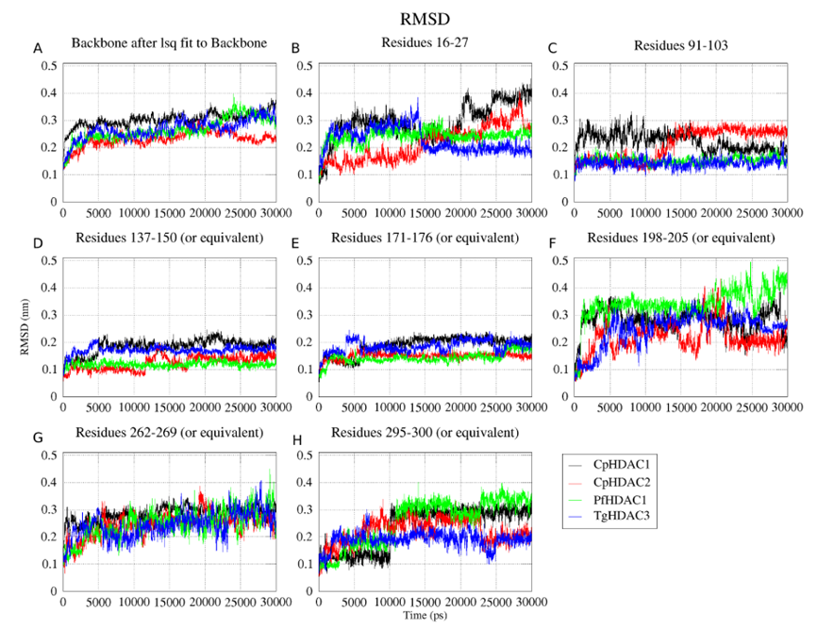Root-mean-square deviation (RMSD) values (y-axis) along the time frame (x-axis) for CpHDAC1, CpHDAC2, PfHDAC1 and TgHDAC3 models. RMSD for all atoms of the protein backbone (A) and RMSD for all atoms of residues neighboring the ligand binding region (B-H).

