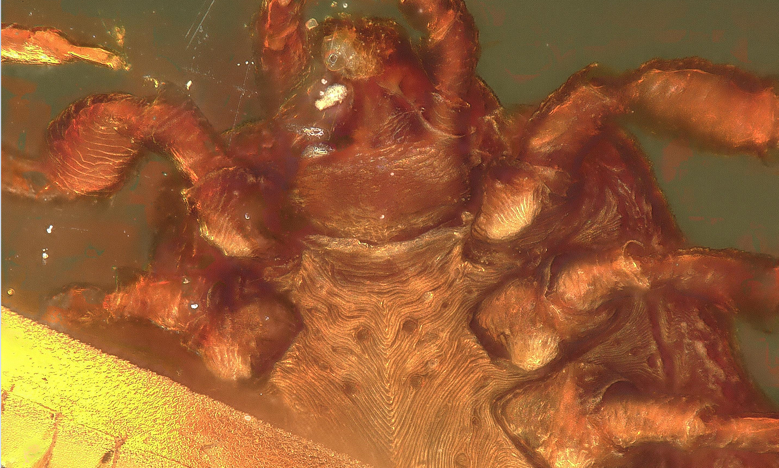
Supplementary figure 1: Ventral close-up of the mouth parts of Ixodes antiquorum. The tissue attached to mouth parts can be observed as a opaque inclusion.

Supplementary figure 2: MicroCT scan of the hypostome of Cornupalpatum burmanicum. Indicated is the dorsal view on the left and the ventral view on the right.
Supplementary figure 3: Tarsi from Cornupalpatum burmanicum grasping a barb from a feather.

Supplementary figure 4: MicroCT scan of the legs of Deinocroton copia sp. nov. The tarsi articulations with notch-like processes and riffled dorsal and ventral line can also be observed.

Supplementary video: A rendering of the microCT scan of the palps of Deinocroton copia sp. nov.

