Supplementary Information - Chemotactic and temperature-dependent responses of the Strongyloidoidea superfamily of nematodes

Alex Dulovic^{1,2}*, Mat Norman^{1,3}, Dorothee Harbecke¹ and Adrian Streit¹
¹Max Planck Institute for Developmental Biology, Tübingen, Baden Württemberg, Germany; ²Present Address: NMI Natural and Medical Sciences Institute at the University of Tübingen, Baden Württemberg, Germany; ³Present Address: UBC Faculty of Medicine, Vancouver, British Columbia, Canada

* Author for correspondence: Alex Dulovic, Email: alex.dulovic@nmi.de

S1 Figure - Illustration of plate set up for all chemotaxic assays
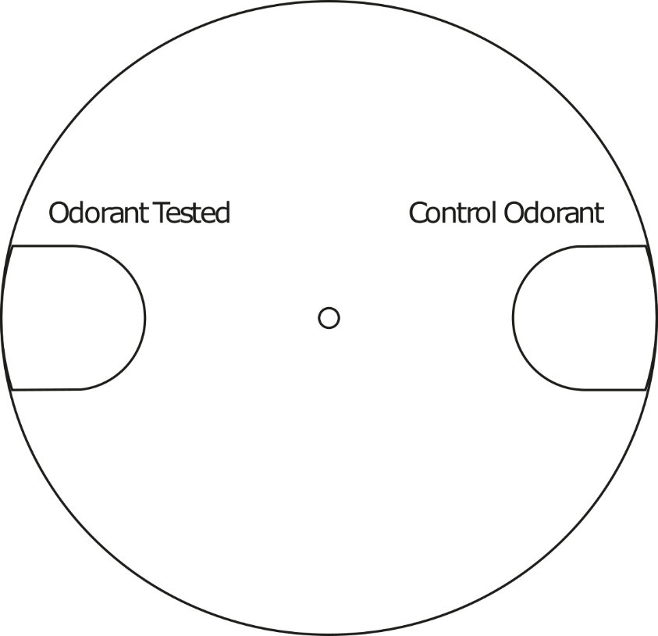

Basic set up used in all assays. Worms are spotted in the centre circle and allowed to crawl towards either odoroant. Only those within the odorant scoring zones are counted.
S2 Figure – Chemoattraction/repulsion is odorant specific and not hygroscopic or gustatory

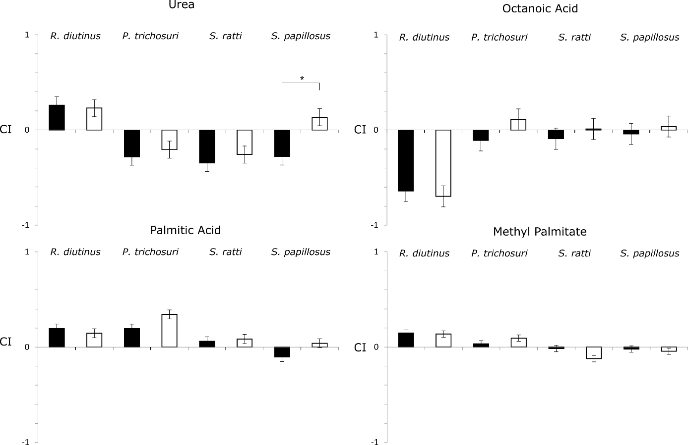

4 odorants were examined to determine if changes in odorant location resulted in changes in chemotactis, and to exclude potential cofounders such as hygroscopy from causing chemotactis. Odorants were spotted either on the agar (black) or on the lid of the plate (white). Statistical significance was determined by two-way ANOVA. Only one odorant (urea) had a significant difference for a single species (p-value 0.01).

S3 Figure – S. ratti shows no attraction to fur
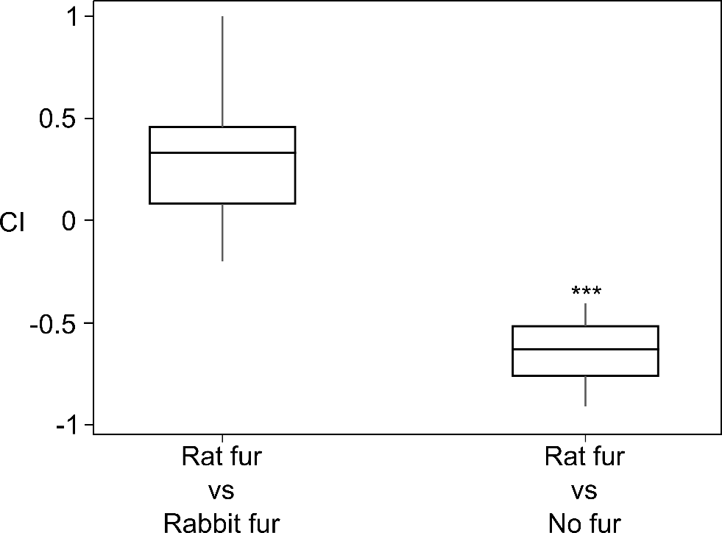

S. ratti showed no attraction to fur and showed no difference in response between host and non-host fur. Initially S. ratti was spotted on plates with host (rat) fur and non-host (rabbit) fur on opposite sides. Having seen that the majority of worms were attracted to neither fur, we then spotted S. ratti on plates with host fur and no fur. CI indicates chemotactic index with 1 indicating strong attraction towards rat fur and -1 indicating strong attraction towards rabbit/no fur. Statistical significance was determined by Mann-Whitney U (two-sided) with *** indicating a p-value <0.001

