SUPPLEMENTARY FIGURES
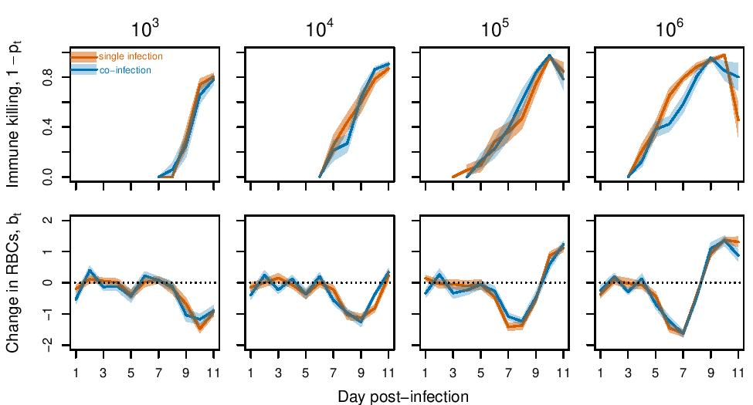
Figure S1. Average time profiles, estimated from data, of immune effects on malaria population growth (top row; ${1-p}_{t}$) and change in RBCs not directly attributable to malaria (bottom row; $b_{t}$) for different initial doses of Plasmodium chabaudi chabaudi AS. Orange lines and shading indicate mean +/- 1 standard error of the mean for single infections. Blue lines and shading indicate mean +/- 1 standard error of the mean for co-infection by Nippostrongylus brasiliensis. Values above the dotted line at $b_{t}$=0 indicate an increase in RBCs (due to erythropoiesis or release from the spleen); values below the dotted line indicate removal of uninfected RBCs (via splenic retention or immune killing by the host, or hemorrhaging induced by the helminth).

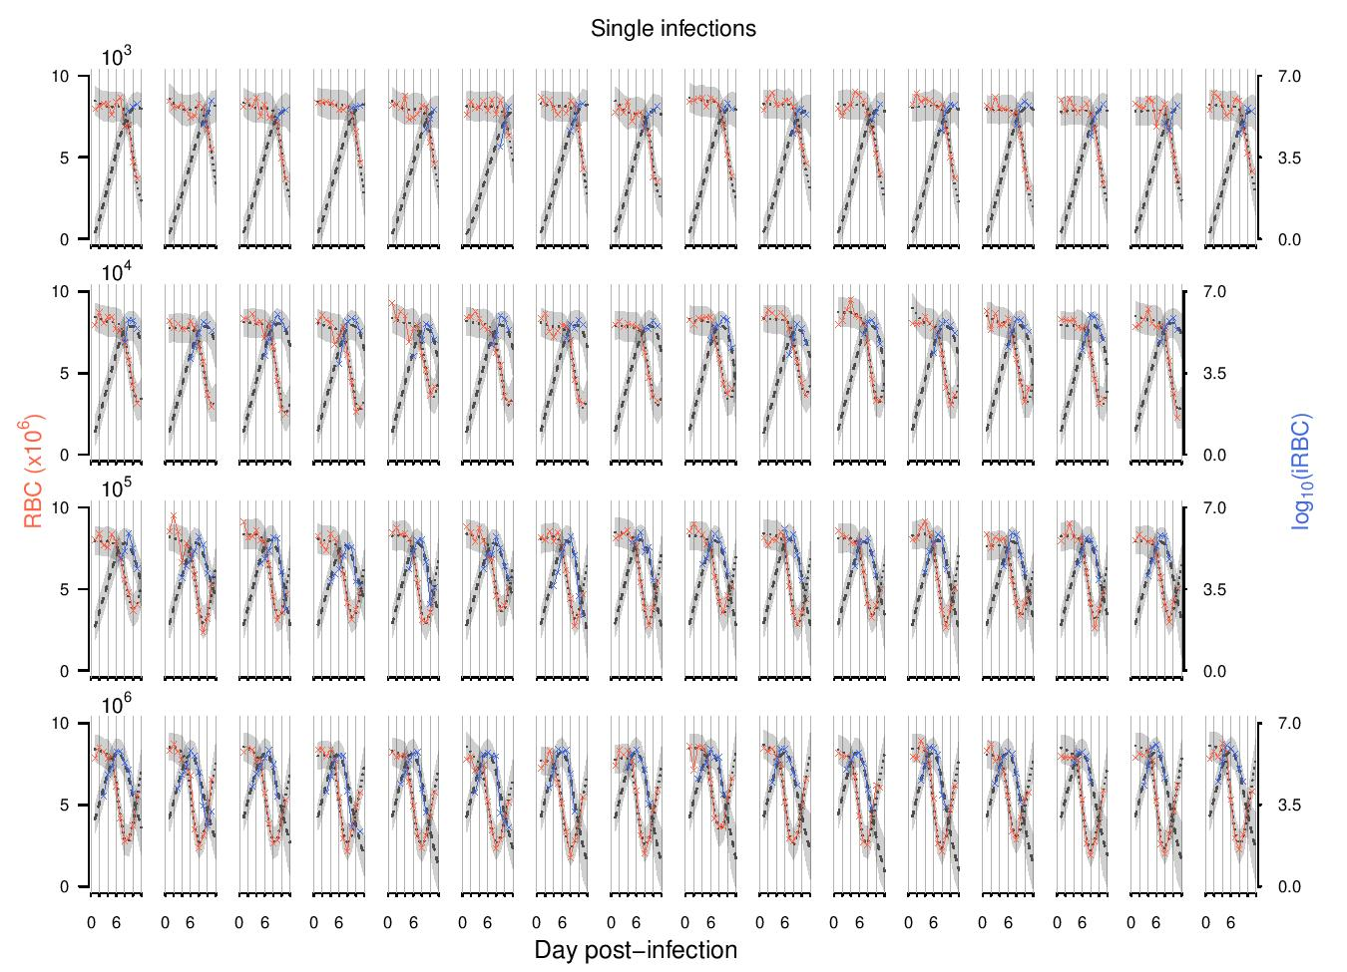
Figure S2. The fit of the mechanistic model to data from single infections. Shown in crosses and solid lines are the observed densities of RBCs (red) and infected RBCs (iRBCs; blue) for individual mice, singly infected with malaria parasites at 10³, 10⁴, 10⁵, and 10⁶ infected cells. Each row corresponds to the initial infection dose given at the top of the leftmost plot. The dotted and dashed lines show the median model predictions for RBCs and iRBCs, respectively, and gray bands delineate 95% predictive intervals of the model, incorporating uncertainty in parameter estimation and sampling.

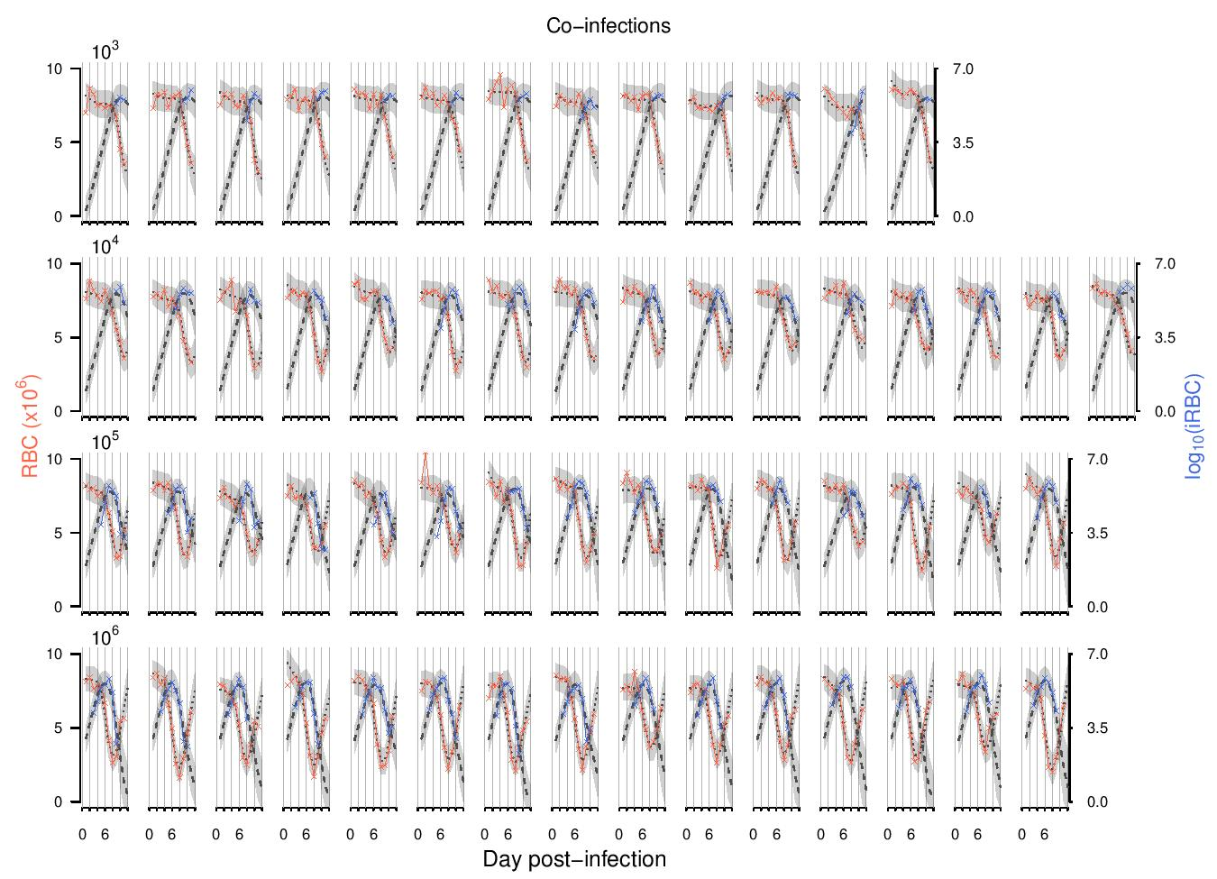
Figure S3. The fit of the mechanistic model to data from co-infections. Shown in crosses and solid lines are the observed densities of RBCs (red) and iRBCs (blue) for individual mice, infected with malaria parasites at 10³, 10⁴, 10⁵, and 10⁶ infected cells and simultaneously infected with N. brasiliensis. Each row corresponds to the initial (malaria) infection dose given at the top of the leftmost plot. The dotted and dashed lines show the median model predictions for RBCs and iRBCs, respectively, and gray bands delineate 95% predictive intervals of the model, incorporating uncertainty in parameter estimation and sampling.

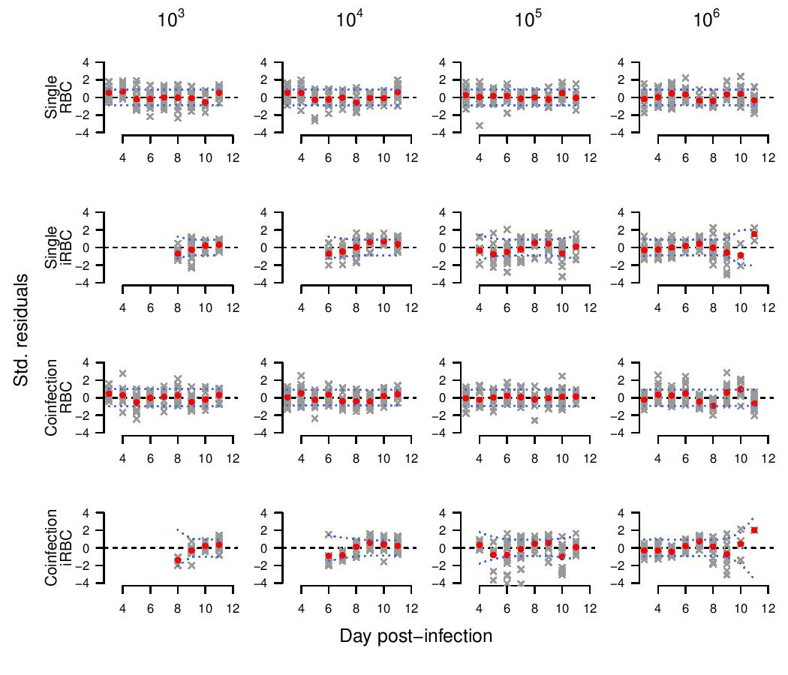
Figure S4. Standardized model residuals for RBC and iRBC densities (following Miller et al. 2010 and Kamiya et al. 2020). Residuals for individual datasets are shown in gray crosses and red dots show the mean. Blue dotted lines indicate the Bonferroni-corrected 95% confidence intervals; a poor fit is indicated by the mean residual lying outside of these intervals. The fit of the model was accurate, without a significant sign of bias.
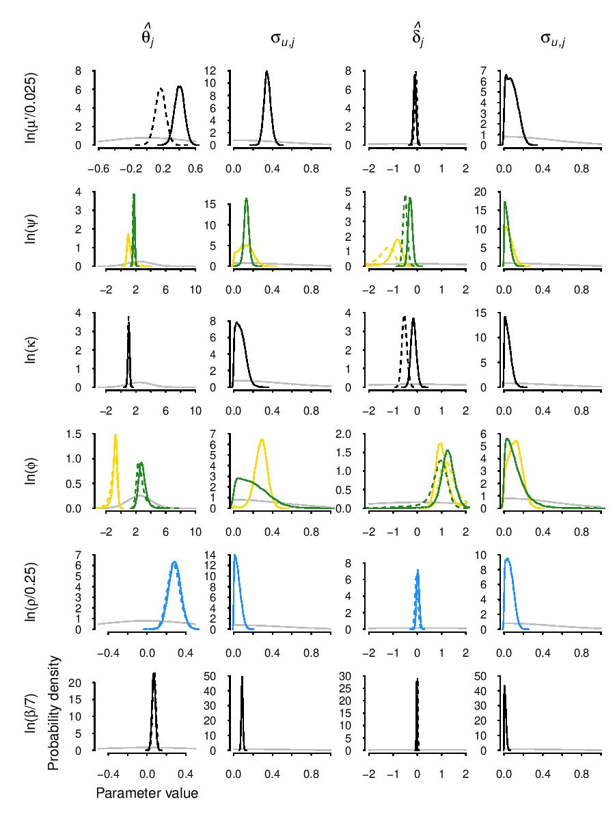
Figure S5. Graphical summary of prior (grey) and posterior distributions. The dashed and solid lines represent single and co-infection, respectively. The mathematical descriptions of prior distributions are provided in Table 1 in the main text.

